Name- Shrutika Sonawane 20141128

Installing R and RStudio on Windows

Go to CRAN R project website. Click on the Download R for Windows link

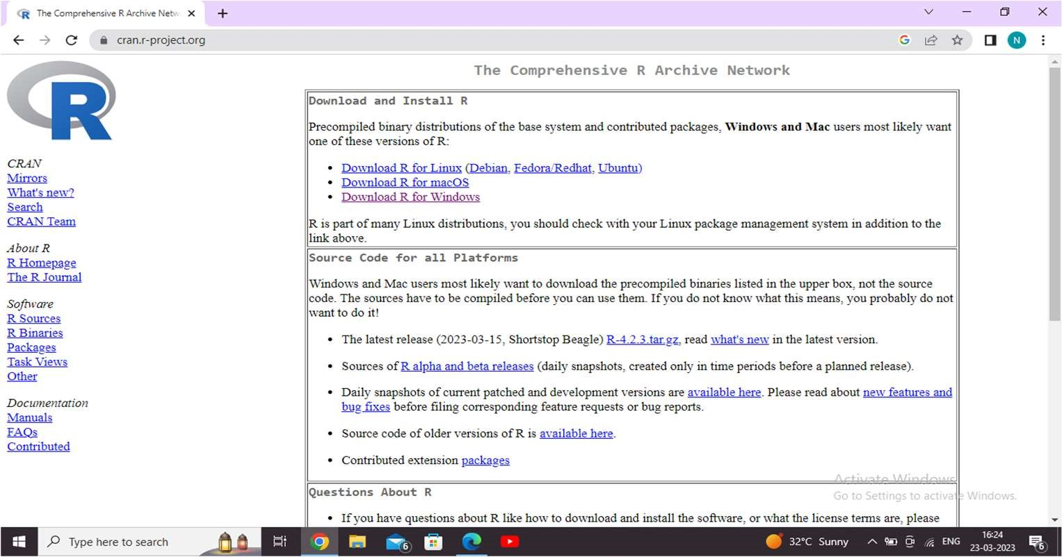

Click Download R X.X.X for Windows (X.X.X stand for the latest version of R. eg: 3.6.1) and save the executable .exe file. Run the .exe file. Wait for the installation process to complete.

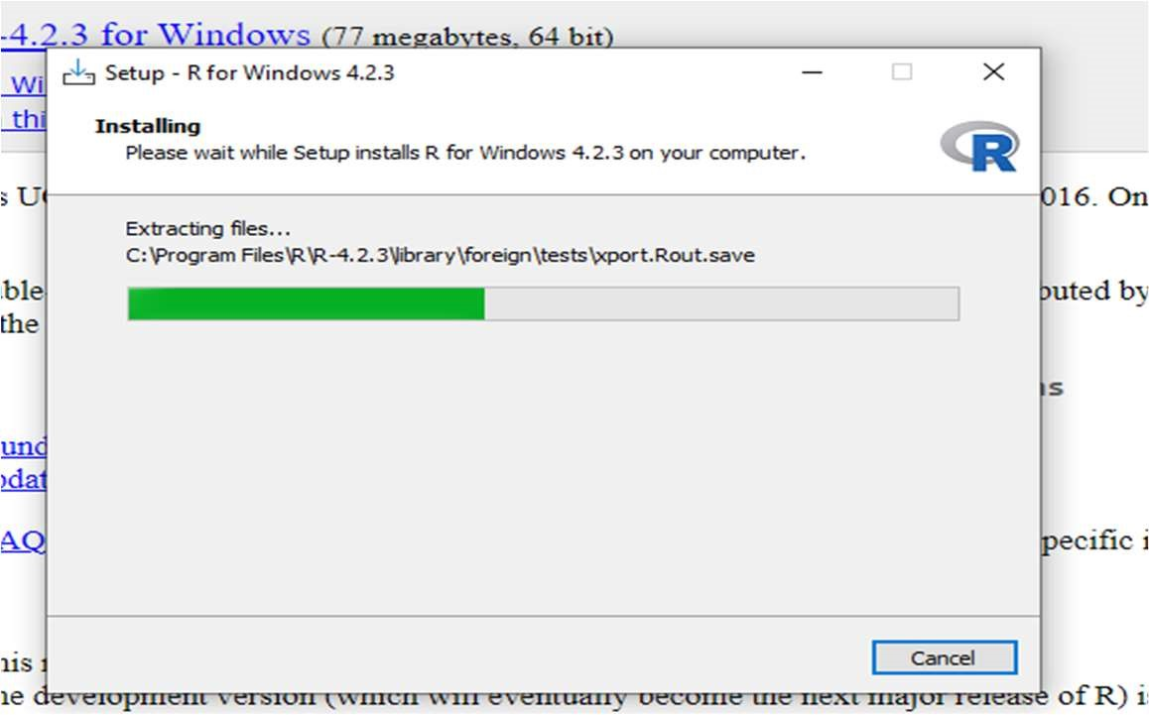

Click on Finish to complete the installation.

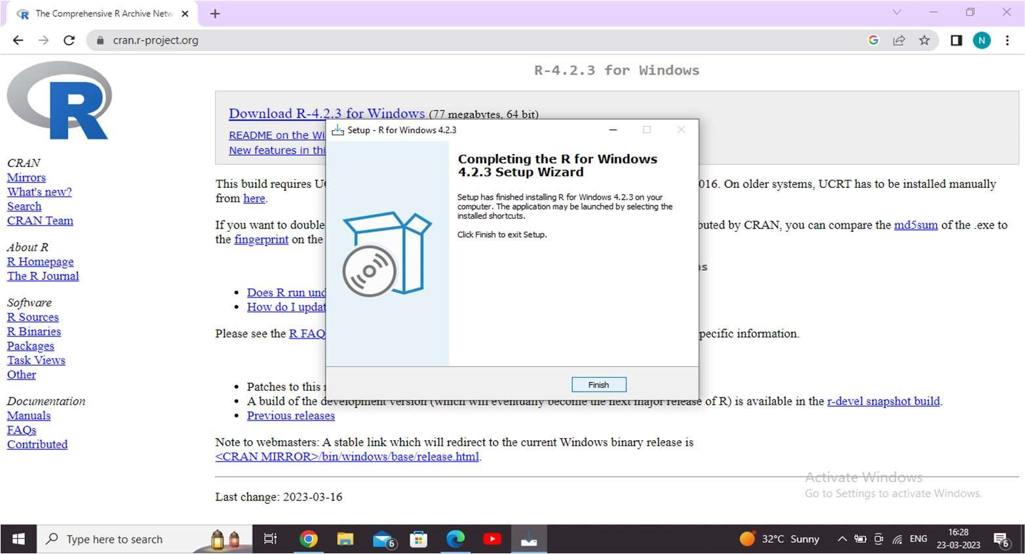

Install RStudio on Windows

With R-base installed, let’s move on to installing RStudio. To begin, go to download RStudio and click on the download button for RStudio desktop.

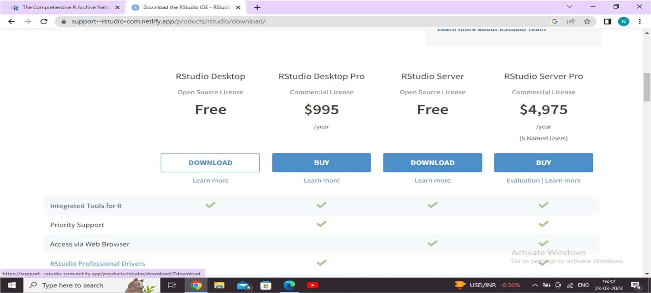

Select the folder for the start menu shortcut or click on do not create shortcuts and then click Next.

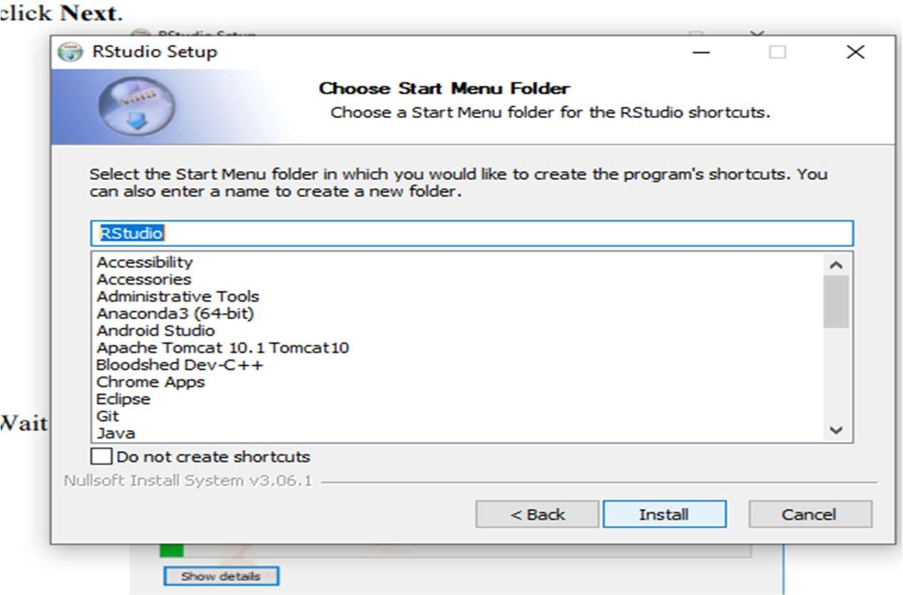

Click Finish to end the installation.

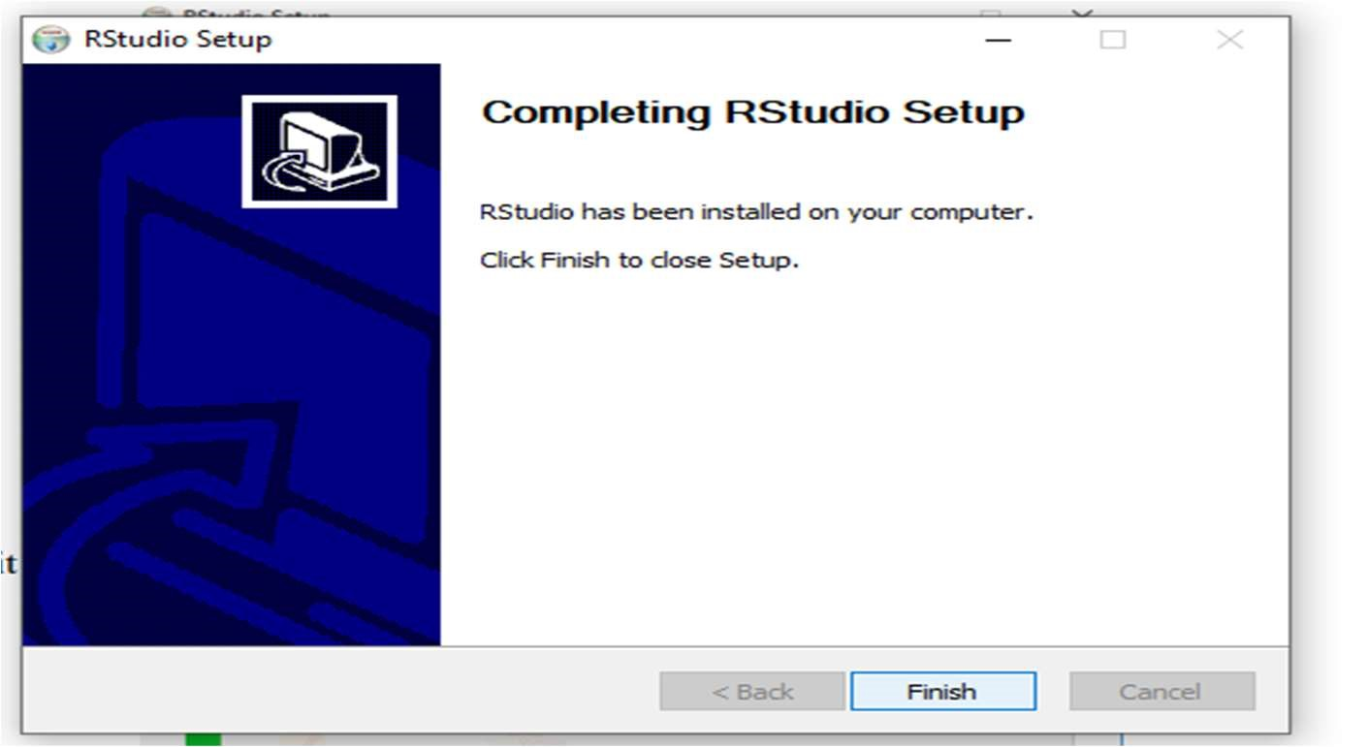

Data Types in R

1. Numeric 2. Integer 3. Complex 4. Character 5. Logical

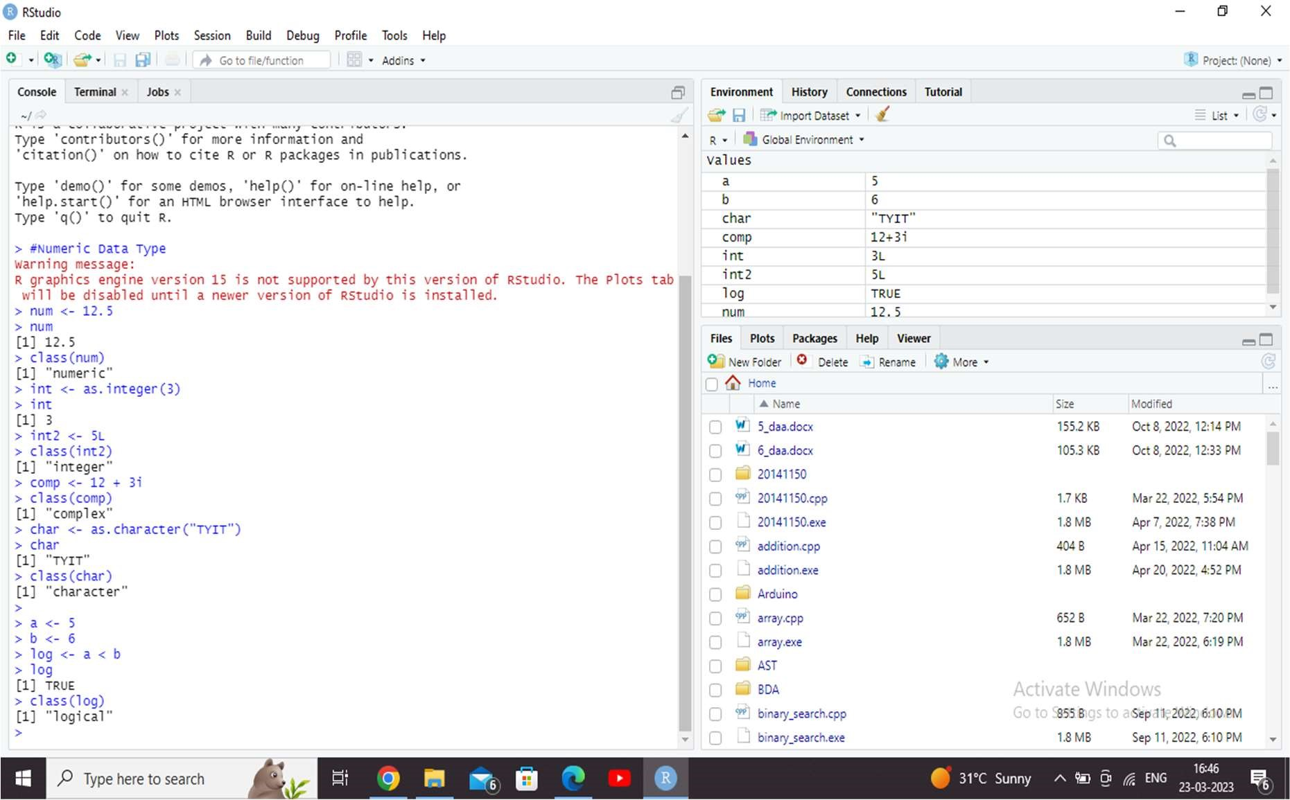

Data Structures in R

R has the following basic data structures:

1. Vector
2. List

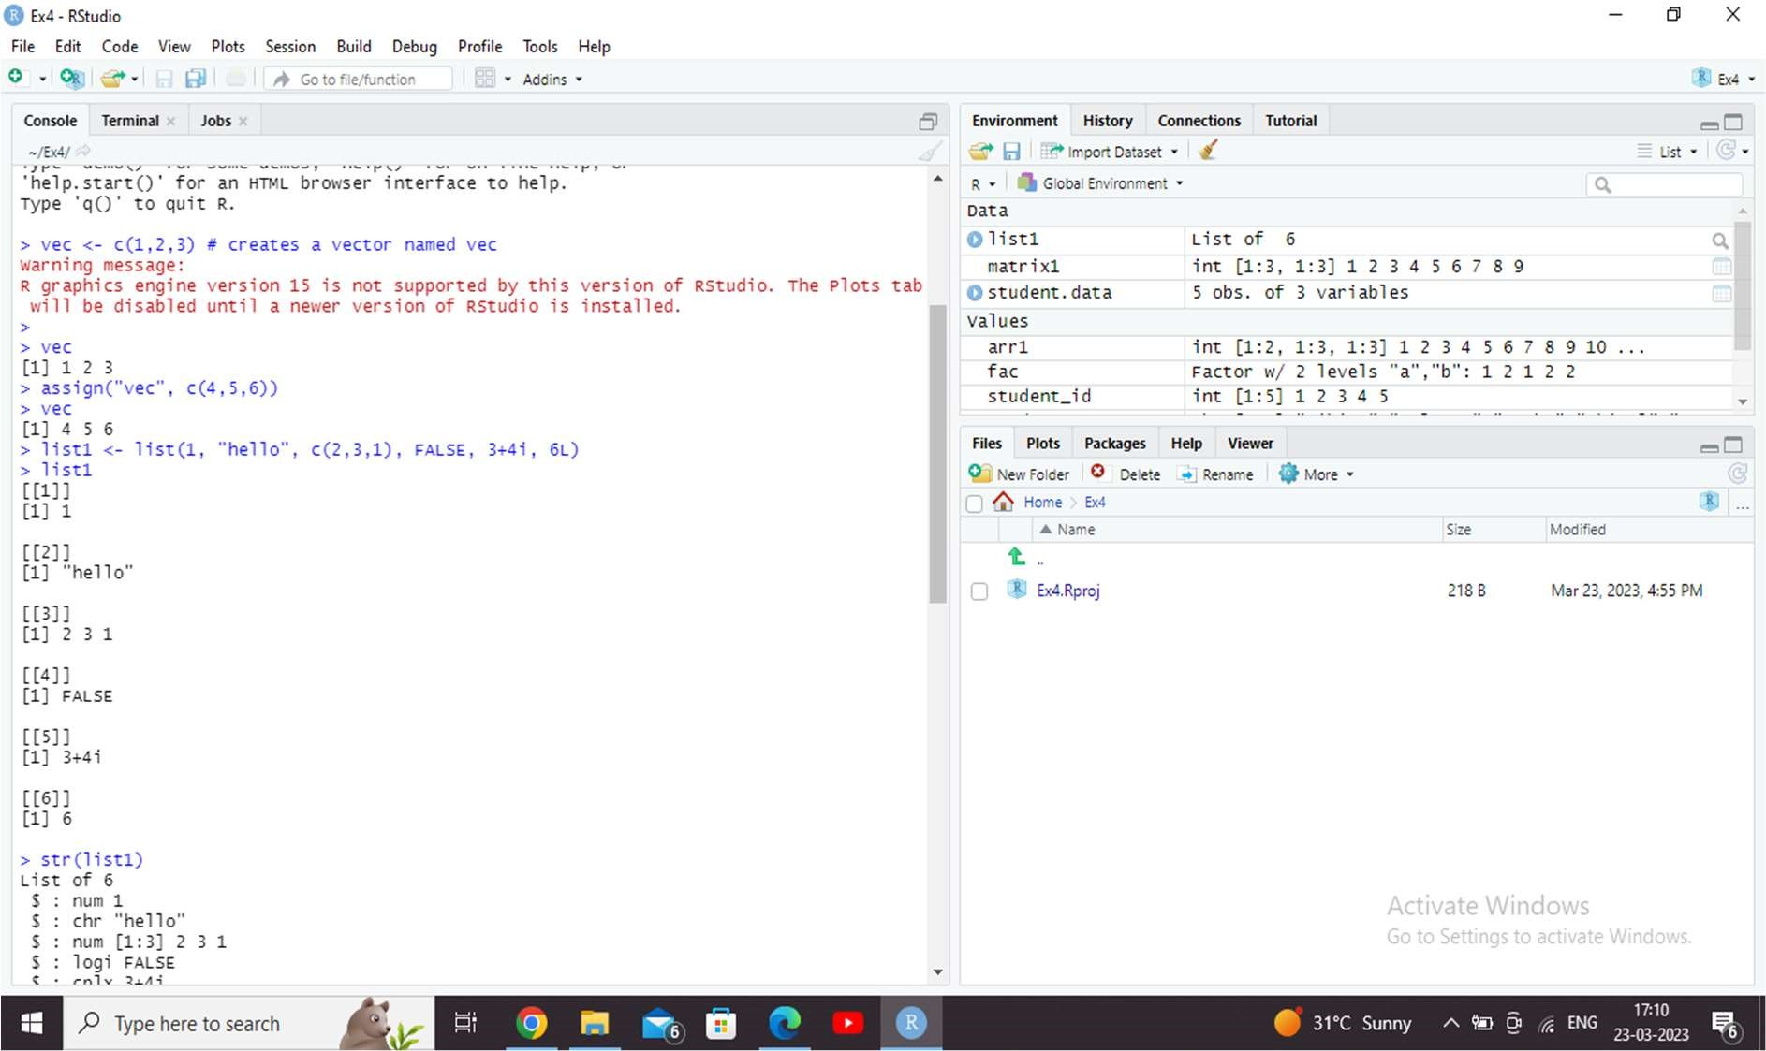

1. Matrix
2. Data frame

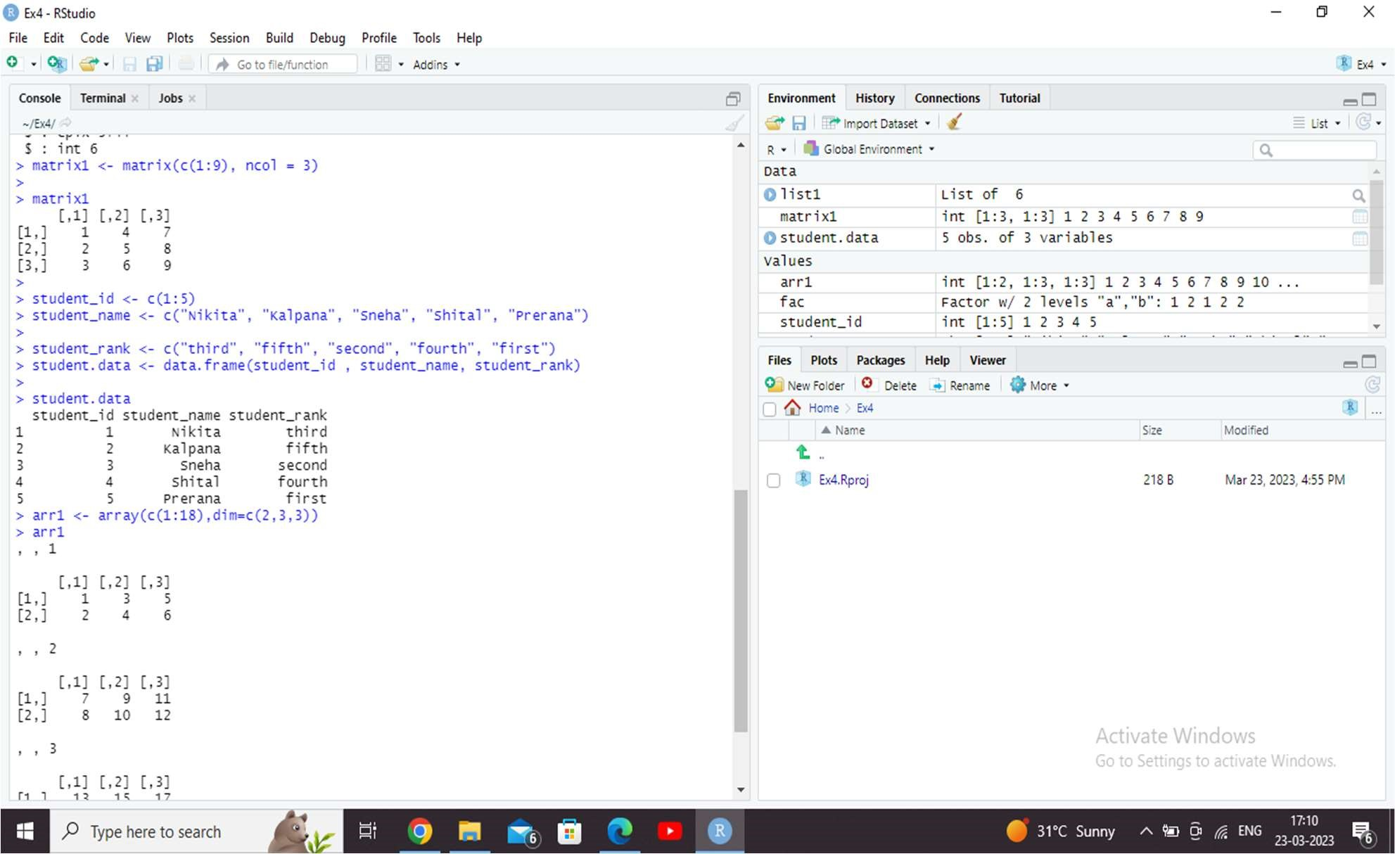

1. Array
2. Factor

