Experiment No. 20141128

Download Tableau Desktop

Start the Installation Wizard. Accept the License Agreement.

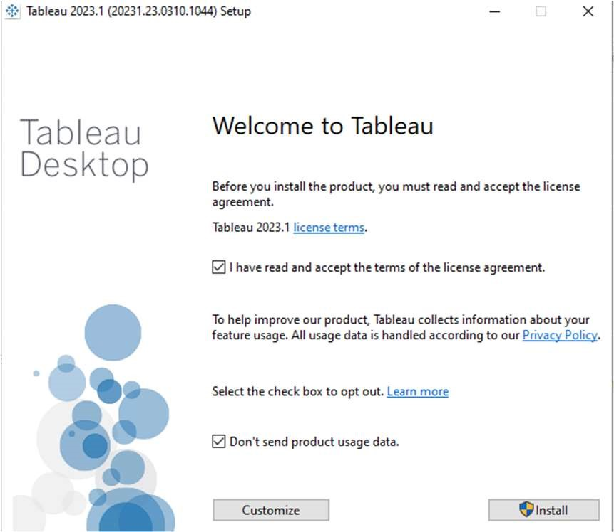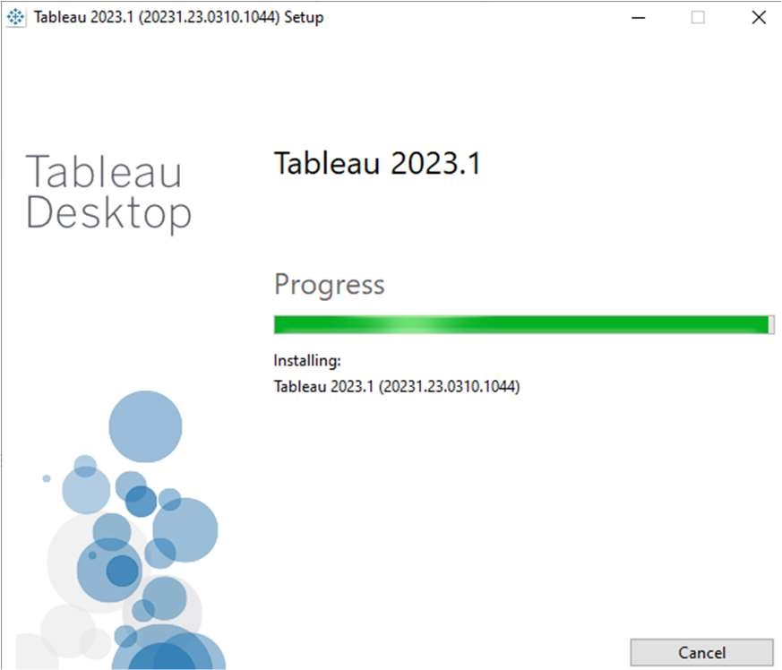

Start Trial. Provide Your Details.

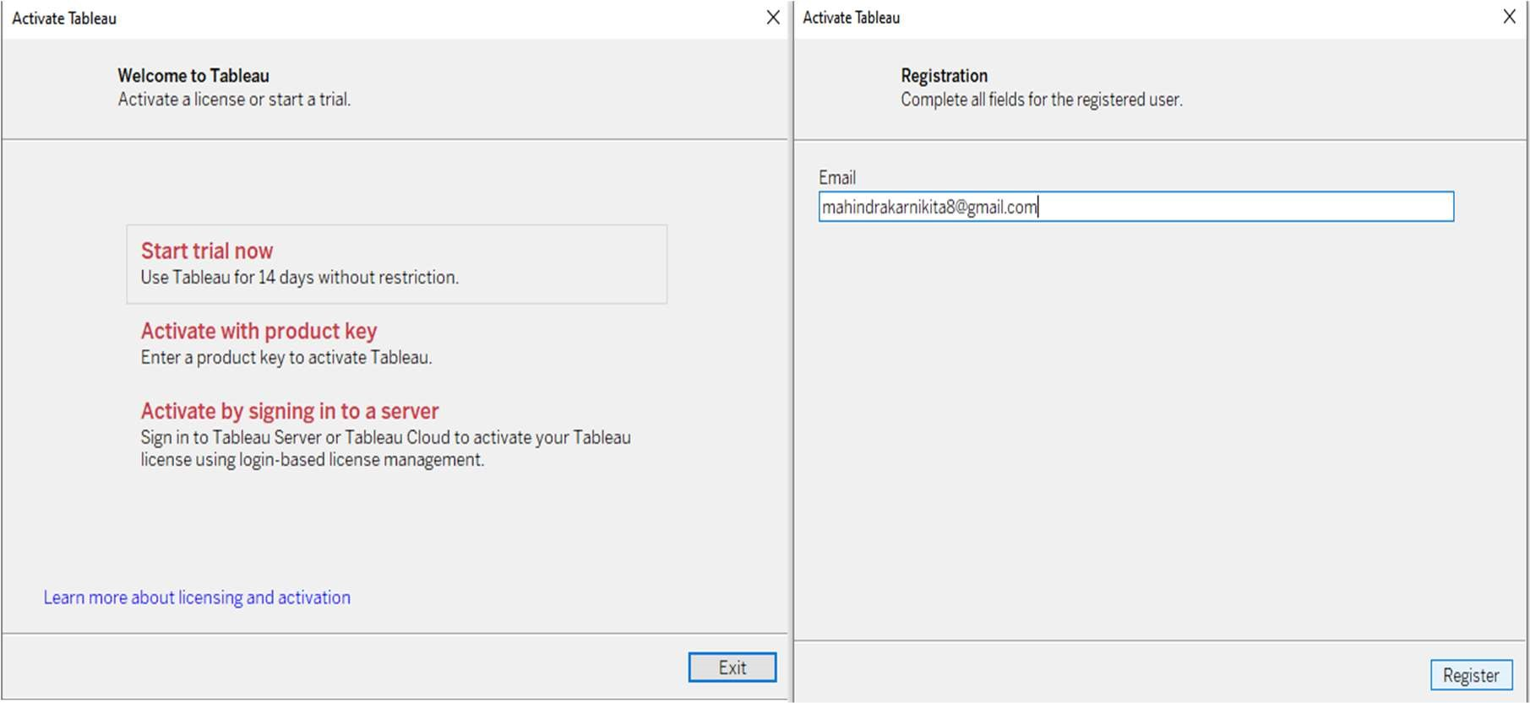

Registration Complete.

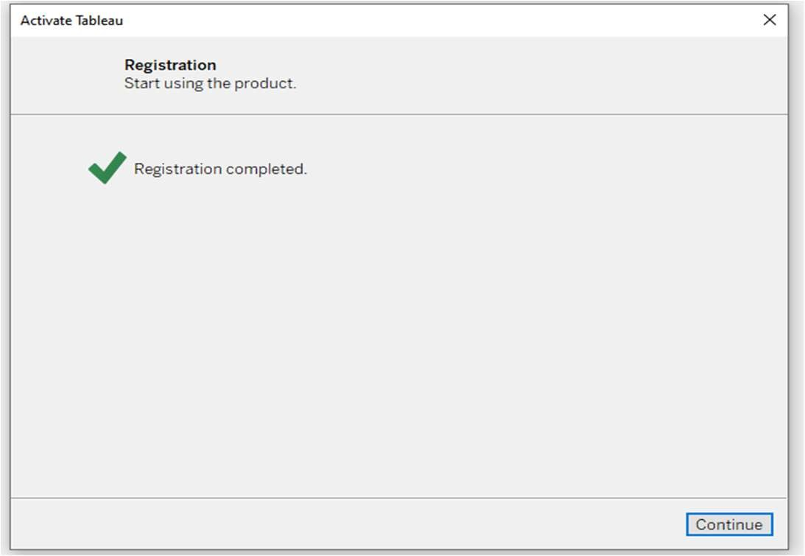

Verify the Installation

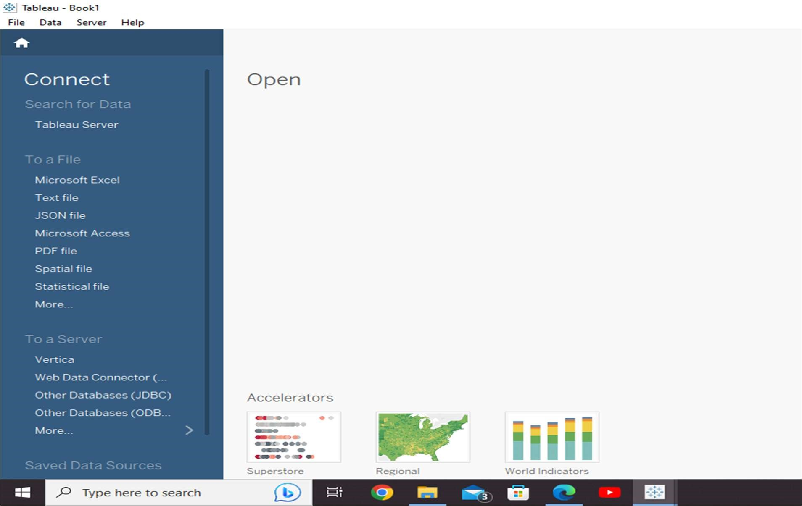

Connect to a Data Source

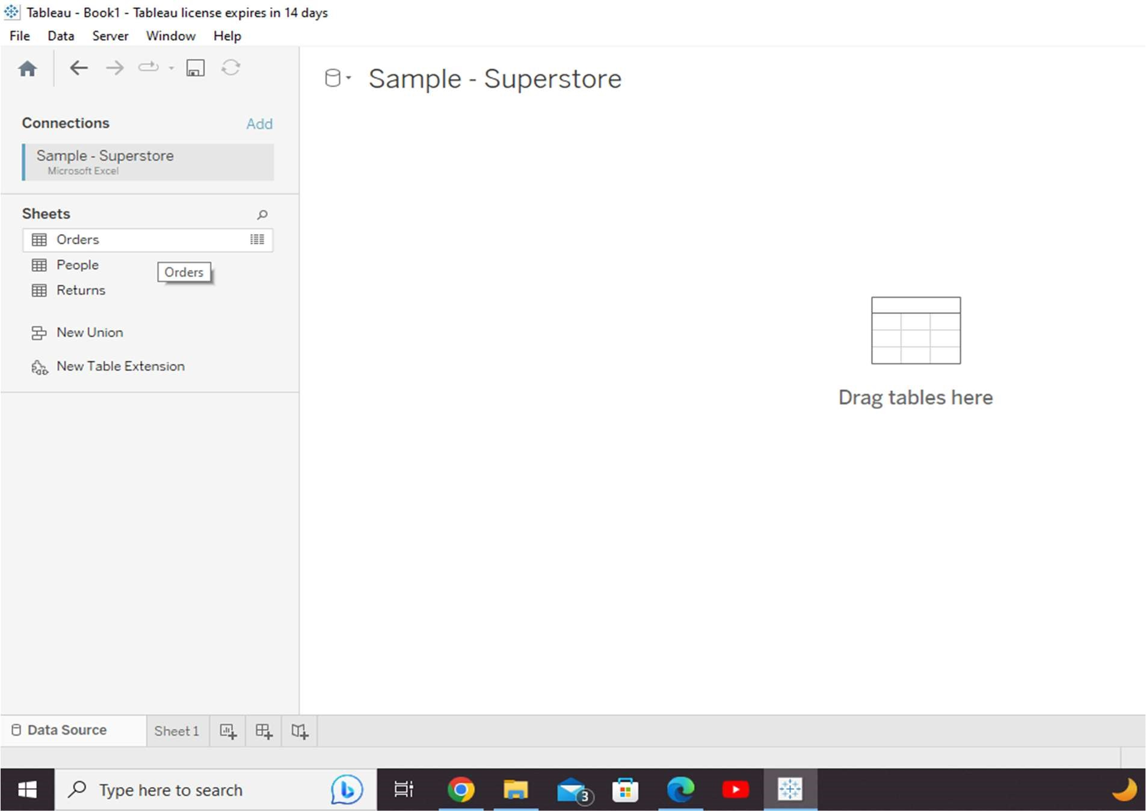

Choose the Dimensions and Measures

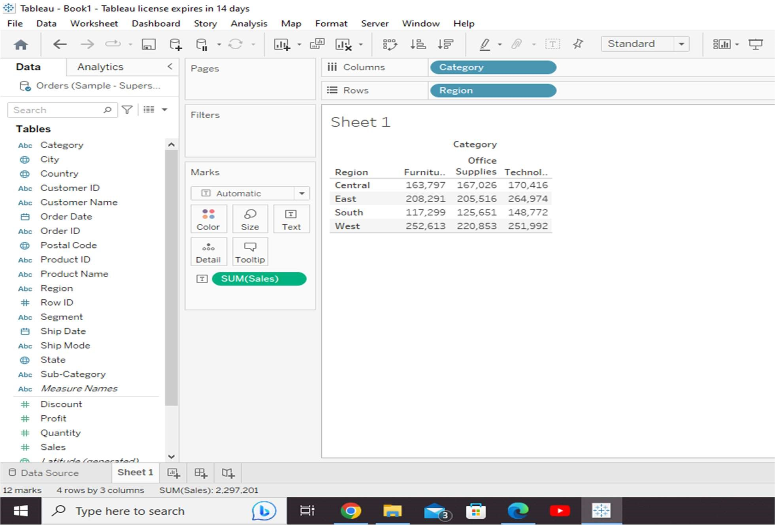

Apply Visualization Technique

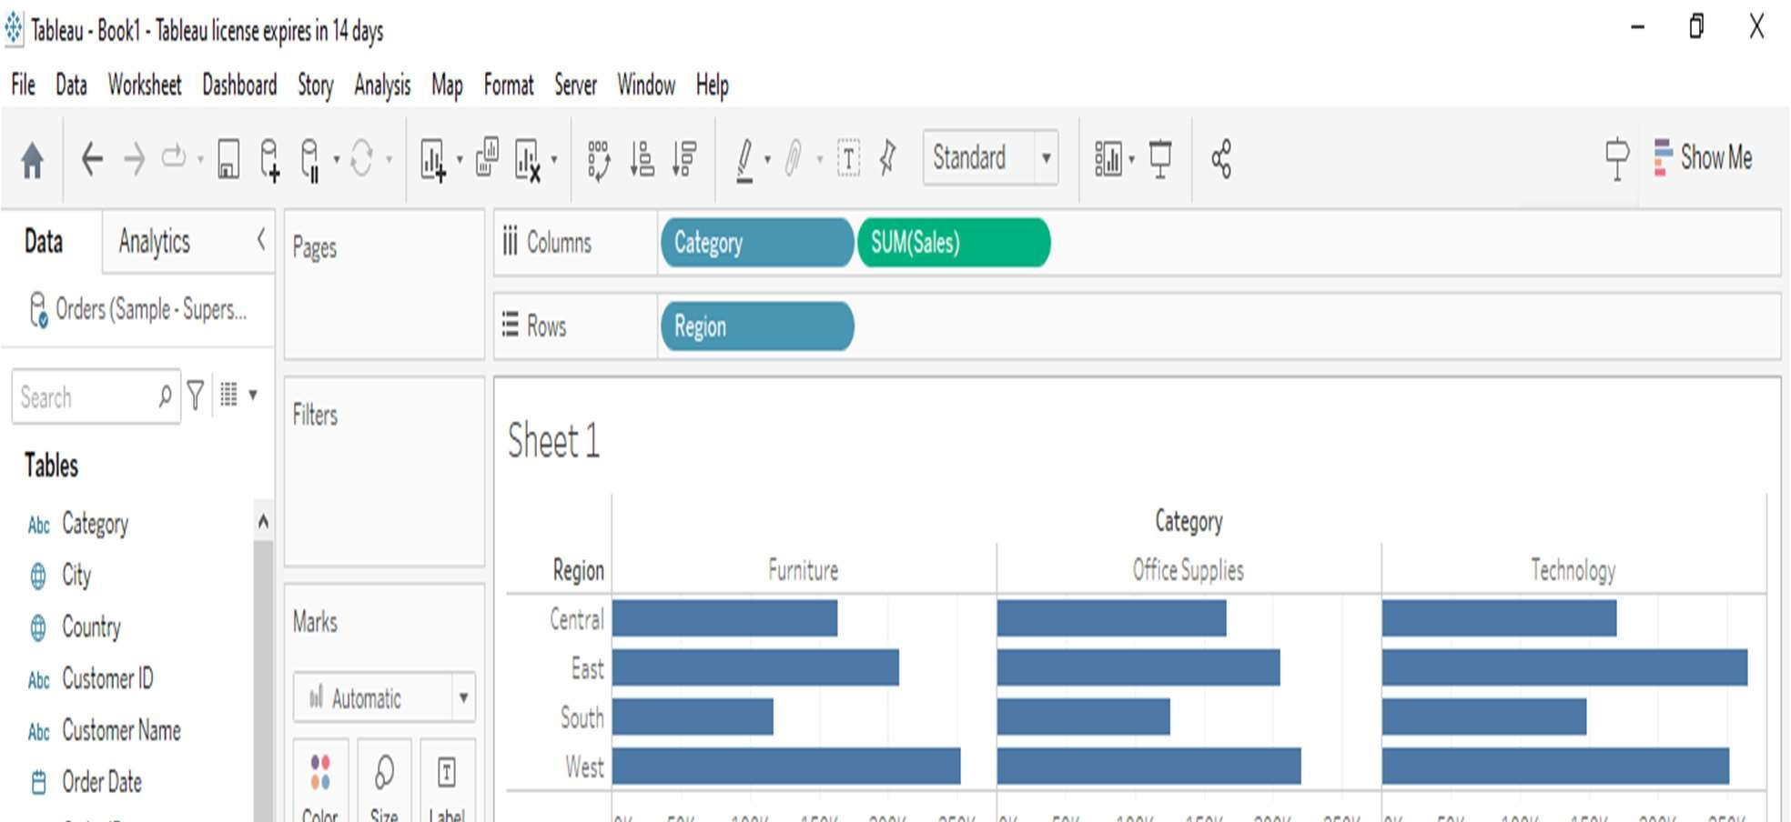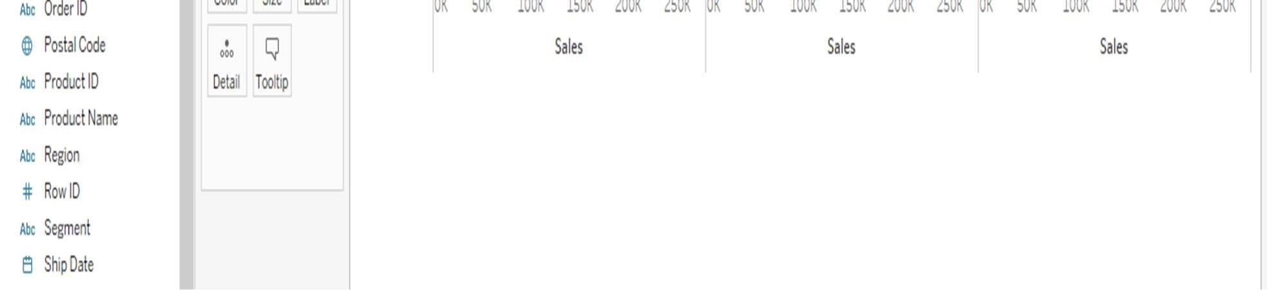

You can apply a technique of adding another dimension to the existing data. This will add more colours to the existing bar chart as shown in the following screenshot

