Experiment No. 15 20141128

Creating a Dashboard

Using the Sample-superstore, plan to create a dashboard showing the sales and profits for different segments and Sub-Category of products across all the states.

Step 1 − Create a worksheet. Drag the dimension Segment to the columns shelf and the dimension Sub-Category to the Rows Shelf. Drag and drop the measure Sales to the Color shelf and the measure Profit to the Size shelf. Right-click and rename this worksheet as Sales_Profits.

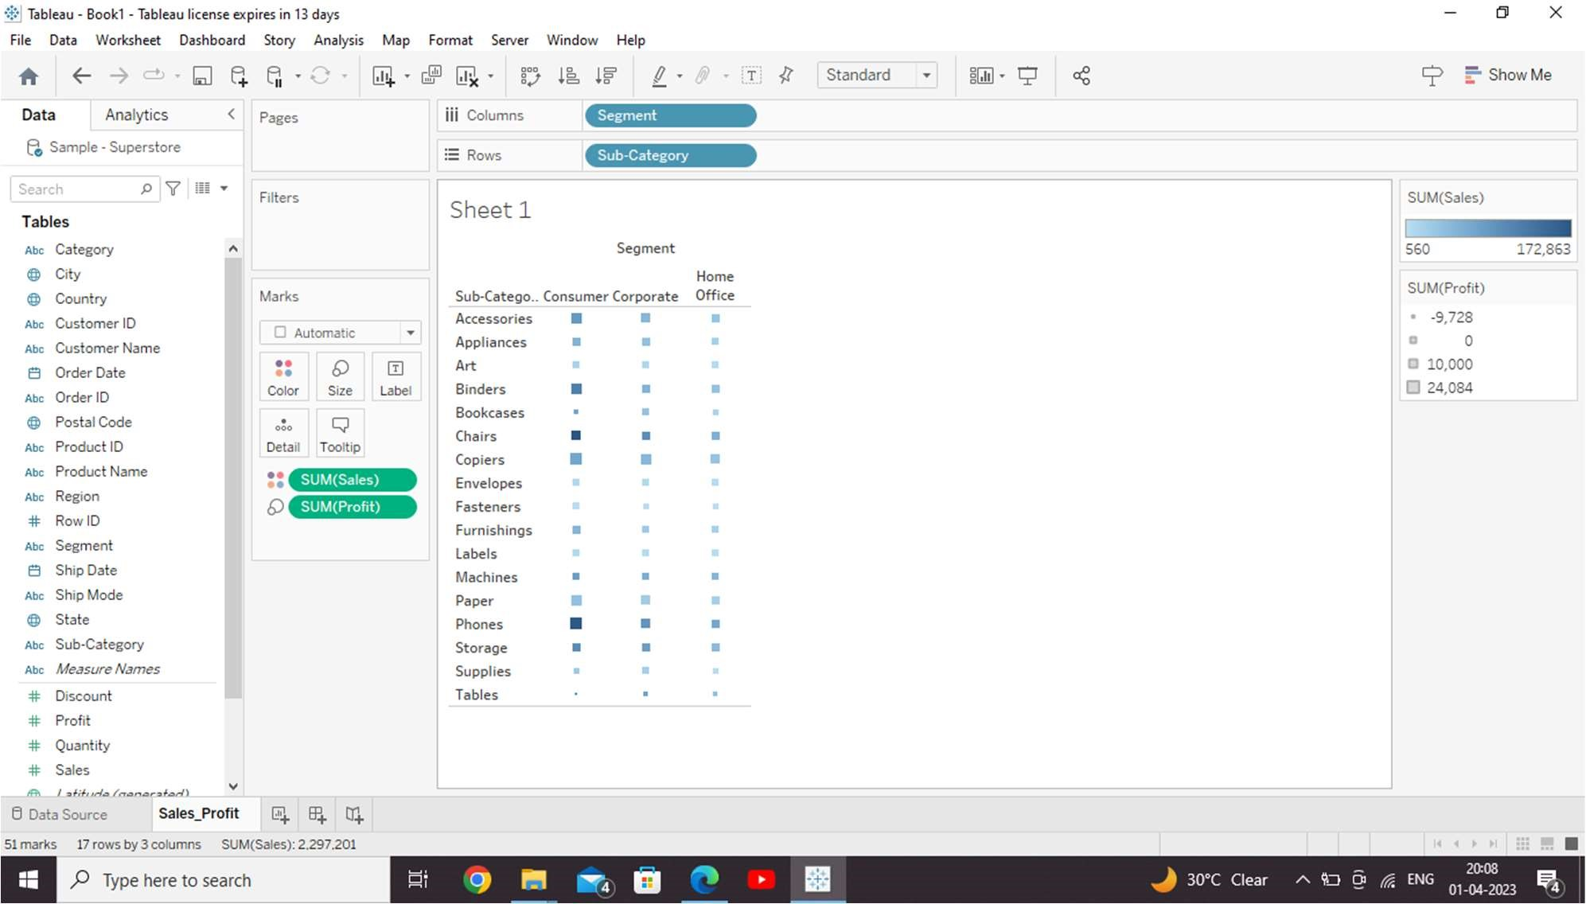

Step 2 − Create another sheet to hold the details of the Sales across the States. For this, drag the dimension State to the Rows shelf and the measure Sales to the Columns shelf as shown in the following screenshot. Next, apply a filter to the State field to arrange the Sales in a descending order. Right-click and rename this worksheet as Sales_state.

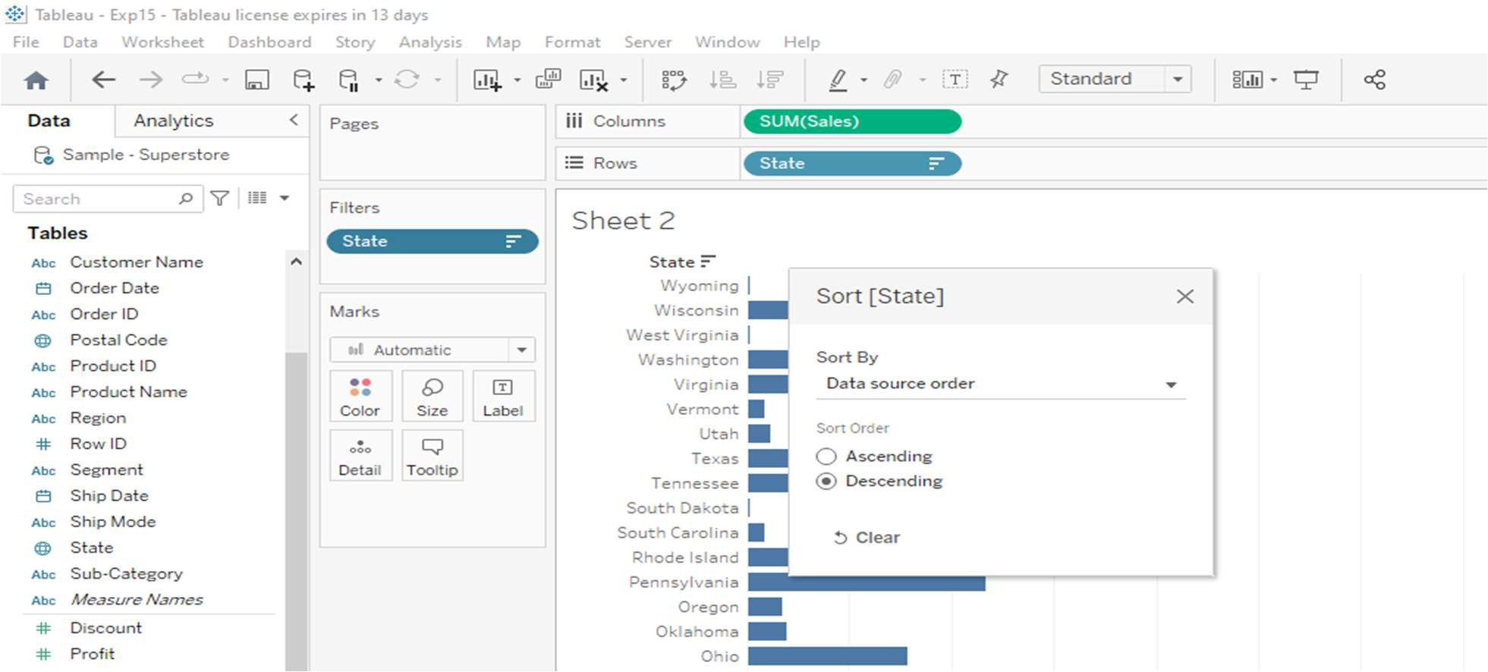

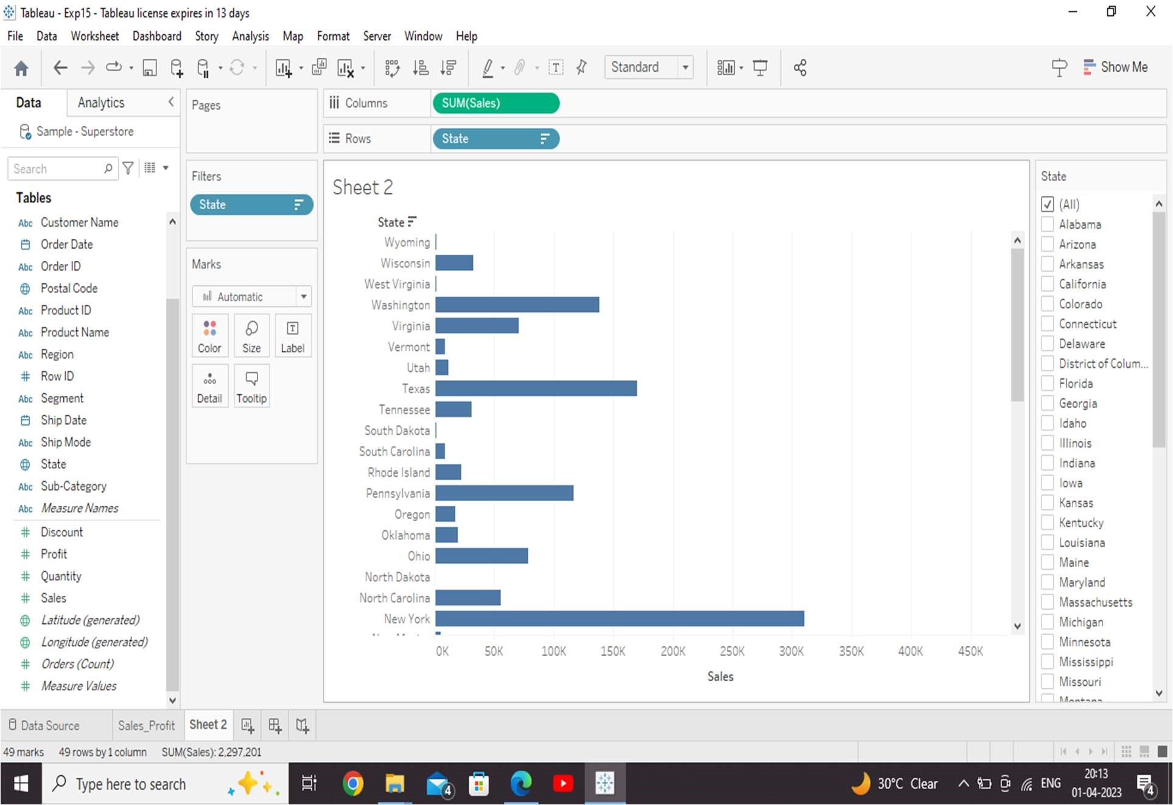

Step 3 − Next, create a blank dashboard by clicking the Create New Dashboard link at the bo om of the workbook. Right-click and rename the dashboard as Profit_Dashboard.

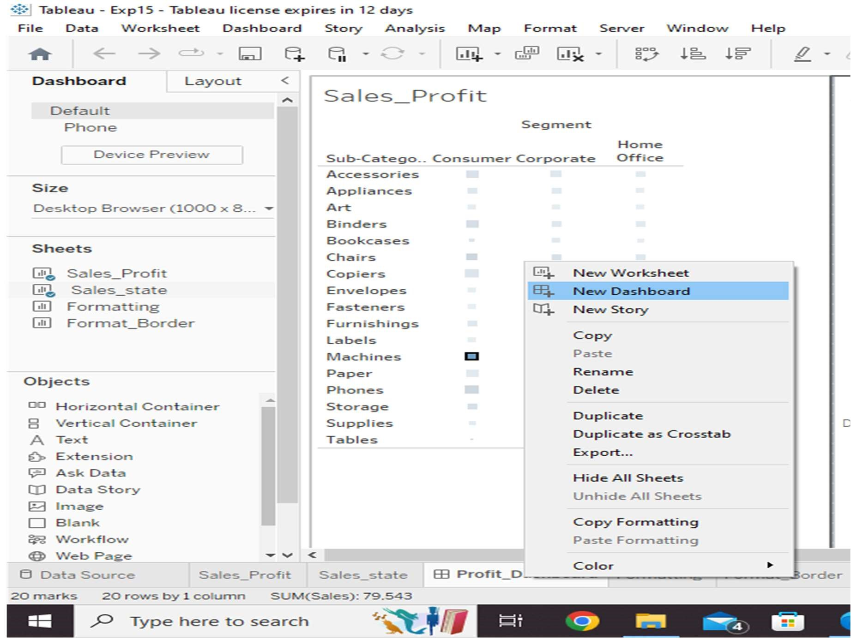

Step 4 − Drag the two worksheets to the dashboard. Near the top border line of Sales Profit worksheet, you can see three small icons. Click the middle one, which shows the prompt Use as Filter on hovering the mouse over it.

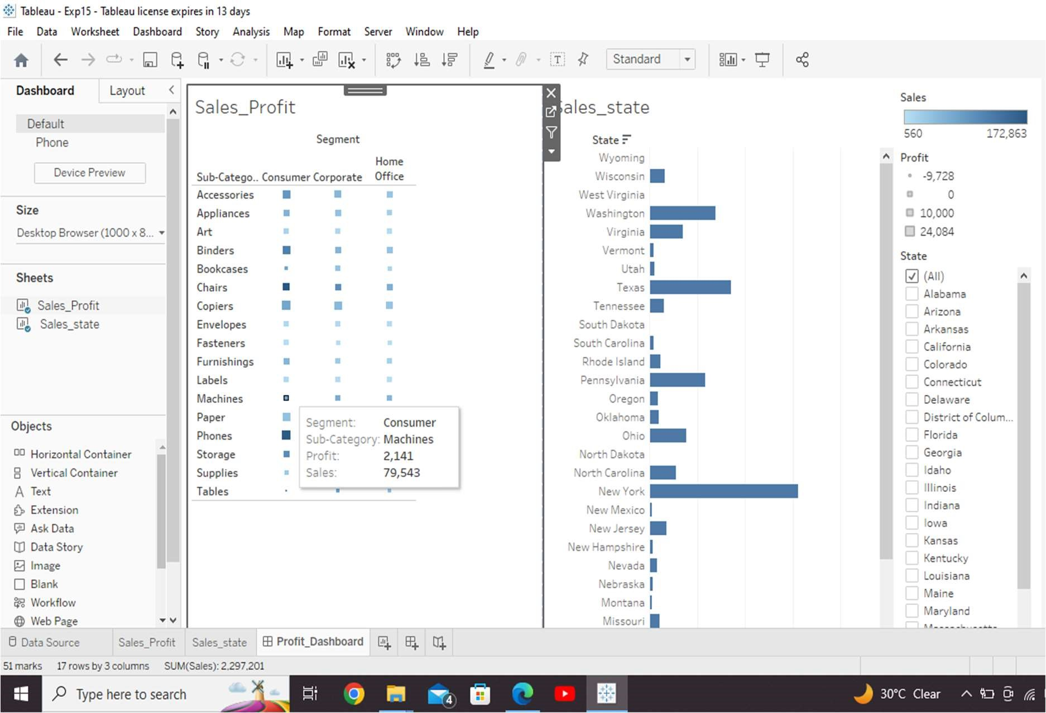

Step 5 − Now in the dashboard, click the box represen ng Sub-Category named Machines and segment named Consumer.

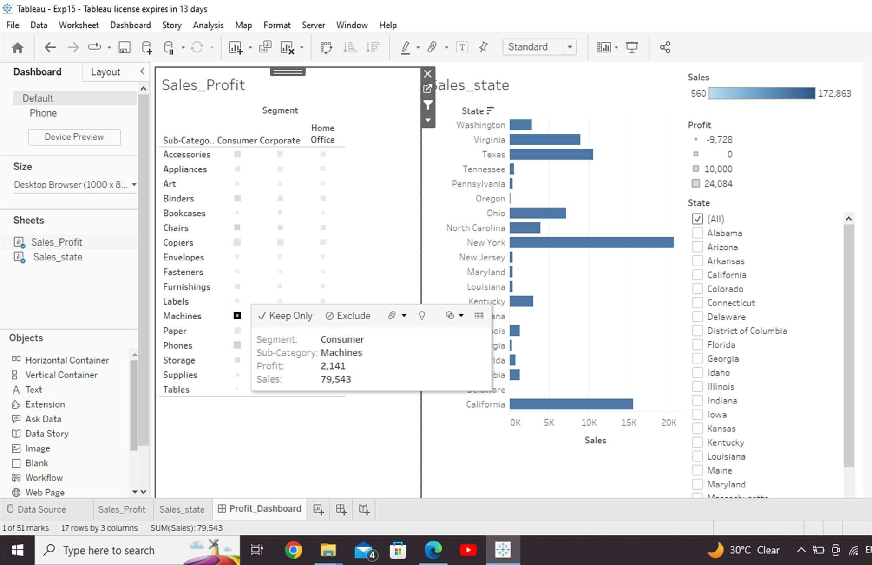

Tableau – Formatting

The following diagram shows the Format Menu which lists the options.

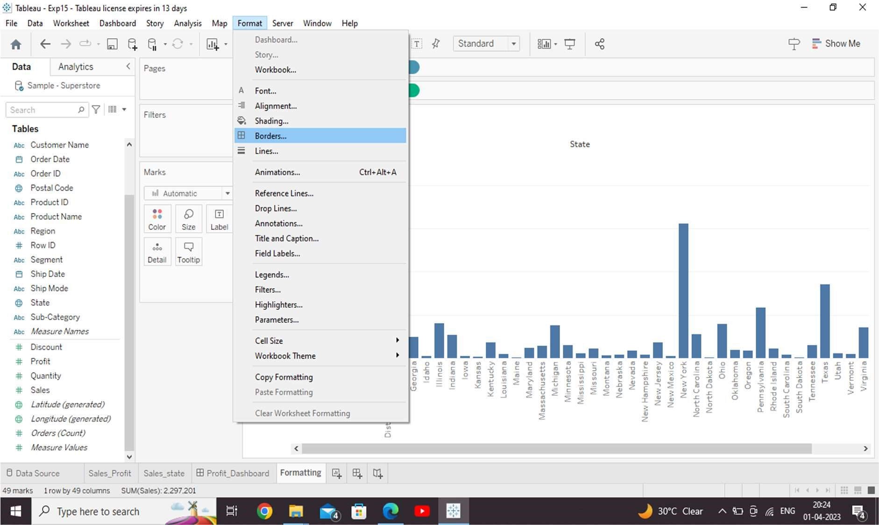

Formatting the Axes

You can create a simple bar chart by dragging and dropping the dimension SubCategory into the Columns Shelf and the measure Profit into the Rows shelf. Click the vertical axis and highlight it. Then right-click and choose format.

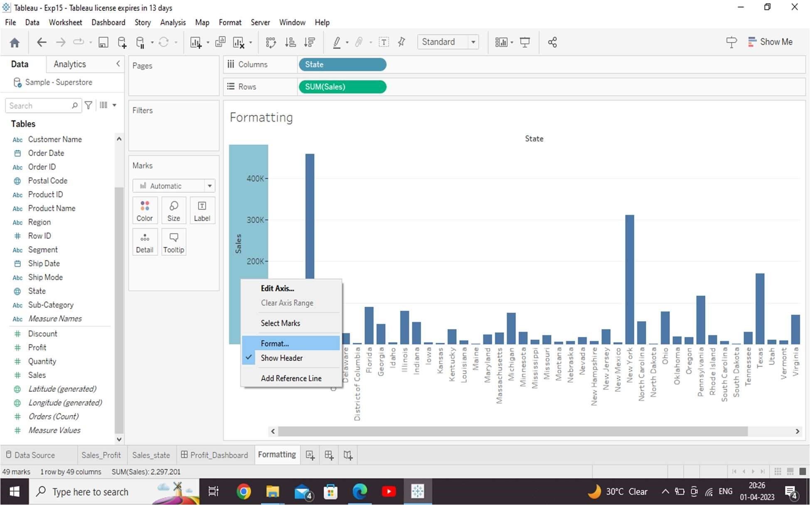

Change the Font

Click the font drop-down in the Format bar, which appears on the left. Choose the font type as Arial and size as 8pt. as shown in the following screenshot.

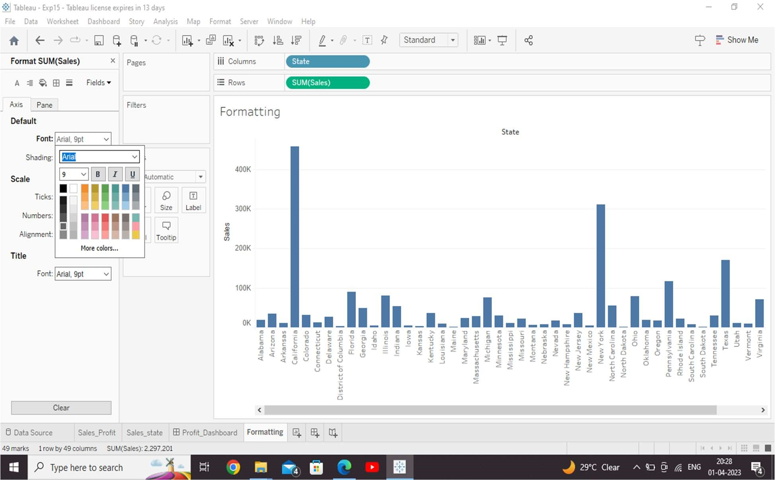

Change the Shade and Alignment

You can also change the orientation of the values in the axes as well as the shading color as shown in the following screenshot.

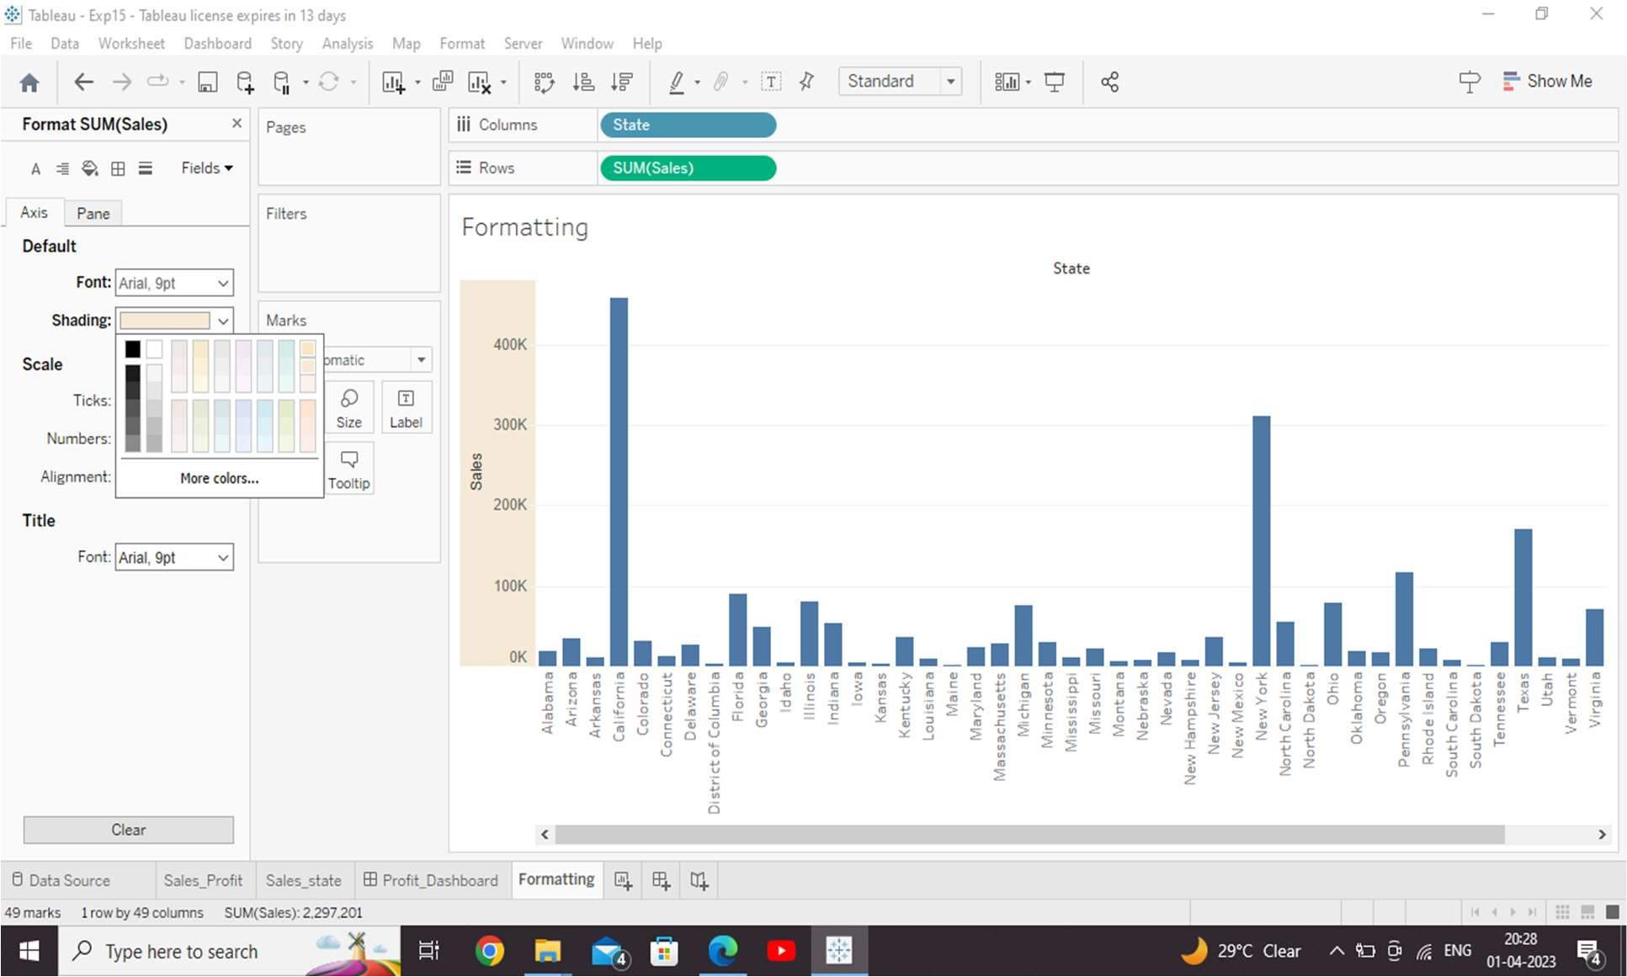

Format Borders

Consider a crosstab chart with Sub-Category in the Columns shelf and State in the Rows shelf. Now, you can change the borders of the crosstab table created by using the formatting options. Right-click on crosstab chart and choose Format. The Format Borders appear in the left pane. Choose the options as shown in the following screenshot.

