Functional Specification Document
Generic Document Review and Approval System
Structured 10-Page FSD for DOCX-to-HTML Skill Validation

Item | Value | Owner | Notes
Document Type | Functional Specification Document | Product Team | Draft for review
System | Document Review and Approval System | Business Applications | Generic sample
Version | 0.7 | Business Analyst | Intentionally incomplete
Prepared For | Internal Skill Testing | Documentation Team | Use to test conversion
Status | Draft | Project Team | Contains open questions and gaps

Source Fidelity Note
This structured FSD preserves the intent, open questions, gaps, and draft status from the source document. Missing requirements are flagged instead of assumed.

1. Business Context and Problem Statement
The organization receives a high volume of documents that require review, comments, status updates, approval decisions, and audit tracking. Reviewers currently switch between email attachments, shared folders, spreadsheet trackers, and separate comment threads. This creates inconsistent review outcomes and slows approval decisions.
The proposed system provides a centralized experience for document intake, review queue visibility, embedded document viewing, search, threaded comments, status transitions, notifications, and audit history.

1.1 Identified Pain Points
- Reviewers spend too much time identifying the latest document version.
- Comments are stored across multiple locations and are difficult to consolidate.
- Approvers cannot quickly identify pending documents requiring action.
- Users need search within long documents when searchable text is available.
- Audit users need a reliable history of reviewers, decisions, and timestamps.
- Missing metadata creates routing issues.
Important Open Decision
The final workflow requires confirmation from Legal Operations and Compliance. Final approval rules must not be assumed.

2. Scope and Delivery Boundaries

2.1 In Scope
- Document upload and metadata capture
- Review queue management and filtering
- Embedded viewer for supported document formats
- Search within documents when searchable text is available
- Threaded review comments
- Approval, rejection, and request-changes decisions
- Basic notifications for assignments and decisions
- Audit history for key workflow actions

2.2 Out of Scope
- Document authoring and version merging
- Digital signature and advanced redaction
- Retention policy configuration
- External vendor portal access
- Machine-generated legal interpretation
- Bulk approval and reporting unless confirmed for a future phase

2.3 Assumptions and Constraints
- DOCX and PDF are supported only where the platform can extract or display content.
- Content extracted from images depends on explicit OCR support.
- Password-protected file support is not confirmed.
- Mobile and browser support requirements are unclear.

3. Users, Roles, and Permissions
The role list is a draft and may not include every role. Some permissions require business confirmation.
Role | Typical Tasks | Can Upload | Can Approve | Open Items
Document Submitter | Uploads source documents and metadata | Yes | No | Upload size limit not confirmed
Reviewer | Reviews content, adds comments, requests changes | No | No | Comment visibility rules not final
Approver | Accepts or rejects reviewed documents | No | Yes | Delegated approval not defined
Administrator | Manages queues and configuration | Yes | Yes | Admin audit permissions unclear
Auditor | Reviews history and decisions | No | No | Export format not confirmed

3.1 Permission Principles
- Only authorized users may view restricted documents.
- Review controls display only when the user has appropriate permission.
- Permission-related failures are recorded in audit history.
- Administrator permissions and audit access require confirmation.

4. Functional Requirements
ID | Requirement
FR-001 | Provide a document intake page where users upload a document and enter required metadata.
FR-002 | Validate required metadata before a document is submitted for review.
FR-003 | Display documents that need review in a review queue.
FR-004 | Provide an embedded viewer for supported document formats.
FR-005 | Provide search within the document viewer when searchable text is available.
FR-006 | Highlight matching search results.
FR-007 | Provide next and previous navigation between search results.
FR-008 | Support page thumbnails or section navigation when available.
FR-009 | Enable reviewers to add comments to a document.
FR-010 | Display unresolved and resolved comments.
FR-011 | Enable approvers to approve, reject, or request changes.
FR-012 | Maintain audit history for uploads, comments, status changes, and approval decisions.
FR-013 | Send notifications when a document is assigned, returned, approved, or rejected.
FR-014 | Support filtering the review queue by status, document type, owner, due date, and priority.
FR-015 | Prevent unauthorized users from viewing restricted documents.

5. User Stories and Acceptance Criteria

US-101: Document Upload
As a business user, I want the document upload capability so that I can complete the document review lifecycle with fewer manual steps.
- The system displays document upload controls when the user has permission.
- The system validates required information before saving the transaction.
- The system displays a meaningful message when an action cannot be completed.
- The system records the activity in audit history.
- The system does not expose restricted information to unauthorized users.

US-102: Review Queue
As a business user, I want the review queue capability so that I can complete the document review lifecycle with fewer manual steps.
- The system displays review queue controls when the user has permission.
- The system validates required information before saving the transaction.
- The system displays a meaningful message when an action cannot be completed.
- The system records the activity in audit history.
- The system does not expose restricted information to unauthorized users.

US-103: Document Search
As a business user, I want the document search capability so that I can complete the document review lifecycle with fewer manual steps.
- The system displays document search controls when the user has permission.
- The system validates required information before saving the transaction.
- The system displays a meaningful message when an action cannot be completed.
- The system records the activity in audit history.
- The system does not expose restricted information to unauthorized users.

US-104: Inline Comments
As a business user, I want the inline comments capability so that I can complete the document review lifecycle with fewer manual steps.
- The system displays inline comments controls when the user has permission.
- The system validates required information before saving the transaction.
- The system displays a meaningful message when an action cannot be completed.
- The system records the activity in audit history.
- The system does not expose restricted information to unauthorized users.

US-105: Approval Decision
As a business user, I want the approval decision capability so that I can complete the document review lifecycle with fewer manual steps.
- The system displays approval decision controls when the user has permission.
- The system validates required information before saving the transaction.
- The system displays a meaningful message when an action cannot be completed.
- The system records the activity in audit history.
- The system does not expose restricted information to unauthorized users.

US-106: Audit History
As a business user, I want the audit history capability so that I can complete the document review lifecycle with fewer manual steps.
- The system displays audit history controls when the user has permission.
- The system validates required information before saving the transaction.
- The system displays a meaningful message when an action cannot be completed.
- The system records the activity in audit history.
- The system does not expose restricted information to unauthorized users.
Open point: Detailed behavior for document search and inline comments requires product owner review.

6. Key Procedures

Upload a Document
- Open the document intake page.
- Select Upload Document.
- Choose a file from the local system.
- Enter document type, owner, priority, and due date.
- Select Submit for Review.
- Result: The system updates the document status and records the activity in audit history.

Search Within a Document
- Open a document from the review queue.
- Select the search field in the viewer toolbar.
- Enter the search text.
- Review highlighted matches.
- Use Previous and Next to move between matches.
- Result: The system updates the document status and records the activity in audit history.

Add a Review Comment
- Open the document in the viewer.
- Select the relevant page or section.
- Add a comment in the comments panel.
- Select Save Comment.
- Verify that the comment appears in the comment list.
- Result: The system updates the document status and records the activity in audit history.

Approve or Reject a Document
- Open a document assigned for approval.
- Review document content and comments.
- Select Approve, Reject, or Request Changes.
- Enter a decision note if required.
- Submit the decision.
- Result: The system updates the document status and records the activity in audit history.

7. Field Definitions and Workflow Transitions

7.1 Field Definitions
Field | Type | Required | Validation | Gap/Question
Document Title | Text | Yes | Maximum length not documented | Confirm max length
Document Type | Dropdown | Yes | Valid values not final | Need final list
Owner | User picker | Yes | Must be active user | Delegation rules unclear
Priority | Dropdown | No | Low, Normal, High proposed | Values not approved
Due Date | Date | No | Cannot be past date | Timezone handling unclear
Review Status | System value | Yes | Controlled by workflow | Detailed transitions missing
Comment Text | Text area | No | Character limit not documented | Need limit
Decision Note | Text area | Conditional | Required for reject? | Confirm rule
Attachment | File | No | File types not final | Security scan behavior missing

7.2 Workflow Transitions
Current Status | User Action | Next Status | Actor | Notes
Draft | Submit for Review | In Review | Submitter | Required fields must be complete
In Review | Request Changes | Changes Requested | Reviewer | Comment required not confirmed
In Review | Mark Review Complete | Pending Approval | Reviewer | All mandatory review items must be complete
Pending Approval | Approve | Approved | Approver | Decision note optional?
Pending Approval | Reject | Rejected | Approver | Decision note likely required, not confirmed
Changes Requested | Resubmit | In Review | Submitter | Resubmission notification required
Any Active Status | Cancel | Cancelled | Admin | Permissions not documented

8. Notifications, Nonfunctional Requirements, and Test Scenarios

8.1 Notifications
- Notify the assigned reviewer when a document enters In Review.
- Notify the owner when changes are requested.
- Notify the approver when a document is ready for approval.
- Notify the submitter when a document is approved or rejected.
- Do not send duplicate reminders if the document was already acted on.
- Reminder frequency is not confirmed.

8.2 Nonfunctional Requirements
Area | Requirement / Current Status
Performance | Review queue should load efficiently; exact load-time targets are not documented.
Accessibility | Support keyboard navigation, screen reader labels, visible focus indicators, and accessible status messages.
Security | Enforce role-based access and prevent unauthorized viewing of restricted documents.
Auditability | Record upload, assignment, comment, status change, decision, and permission-related failures.
Availability | Availability targets are not documented.
Localization | Date, time, and language requirements are not finalized.

8.3 Sample Test Scenarios
ID | Scenario | Expected Result | Gap
TC-001 | Upload valid document | Document is submitted for review | File size limit missing
TC-002 | Upload unsupported file | System displays unsupported file message | Supported type list missing
TC-003 | Search document text | Matches are highlighted | Search indexing behavior unclear
TC-004 | Add comment | Comment appears in panel | Comment edit rule missing
TC-005 | Approve document | Status changes to Approved | Decision note rule unclear
TC-006 | Unauthorized access | Access is denied | Error message text missing

9. Wireframes, Content Gaps, and Final Reviewer Notes

9.1 Generic Document Review Dashboard Wireframe
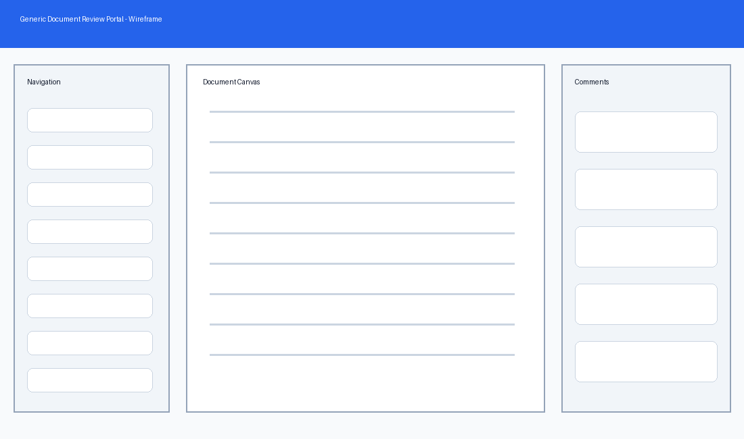
Figure 1. Generic Document Review Dashboard Wireframe. This wireframe is illustrative and does not represent a proprietary interface.

9.2 Generic Search and Comments Wireframe
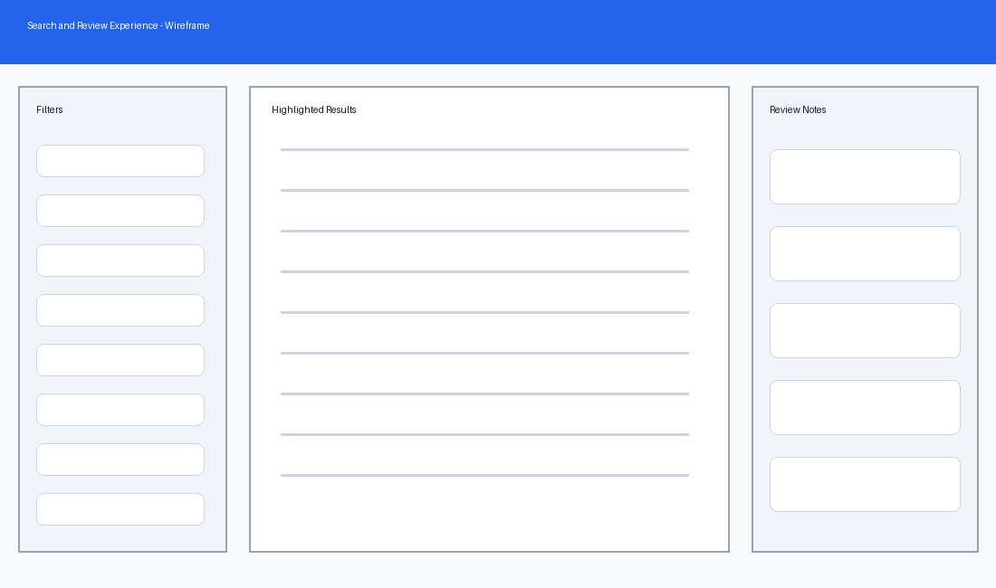
Figure 2. Generic Search and Comments Wireframe. This wireframe is illustrative and does not represent a proprietary interface.

9.3 Known Content Gaps
- Final role and permission matrix is incomplete.
- Detailed approval rules are not confirmed.
- File type and file size limits are not documented.
- Search performance requirements are missing.
- Detailed error message copy is missing.
- Accessibility acceptance criteria need review.
- Notification templates are not provided.
- Data retention and archival rules are not documented.
- Mobile and browser support requirements are unclear.
- Reporting requirements are not finalized.

9.4 Final Reviewer Notes
This FSD is designed for skill testing. The expected generated output should convert the content into a clean HTML documentation structure with an overview, enhancement summary, procedures where supported, tables, image placeholders, and content gap analysis. The generated output should not assume missing requirements.

