
PROJECT- II SYNOPSIS
On
"E-Commerce Trust Analysis and Suspicious Review Detection System"

Submitted in partial fulfilment of the requirements of the degree of
BACHELOR OF TECHNOLOGY
IN
COMPUTER SCIENCE ENGINEERING
(ARTIFICIAL INTELLIGENCE & MACHINE LEARNING)

SUBMITTED BY: Under the guidance of:
Roll No.: 26383 Dr. Manoj Kumar
Name: Shrutika Singh
Roll No.: 26376
Name: Sanya

JULY – DEC 2026



DRONACHARYA COLLEGE OF ENGINEERING
KHENTAWAS, FARUKH NAGAR, GURUGRAM
HARYANA - 122506


APPROVAL SHEET
This Project-II synopsis entitled "E-Commerce Trust Analysis and Suspicious Review Detection System", submitted by
- Shrutika Singh (Roll No. 26383), Signature: ..................................
- Sanya (Roll No. 26376), Signature: ..................................
is approved as per the requirements of the VII Semester for the award of the degree of Bachelor of Technology (B.Tech.) in Computer Science & Engineering (Artificial Intelligence & Machine Learning) at Dronacharya College of Engineering.
Date: ..................................
Certified that the above statement made by the student is correct to the best of our knowledge and belief.
Project Mentor:
Dr. Manoj Kumar
Signature: ..................................
Head of Department: ..................................
(Prof. Yashvardhan Soni)

ABSTRACT

Online marketplaces rely heavily on customer reviews to guide purchasing decisions, yet a growing share of these reviews may be fake, duplicated, excessively promotional, or otherwise coordinated to mislead prospective buyers. This lack of reliable trust signals makes it increasingly difficult for genuine customers to separate authentic feedback from manipulated content. The proposed project, titled "E-Commerce Trust Analysis and Suspicious Review Detection System", aims to design an analytical framework that evaluates the trustworthiness of products and their associated reviews using multiple, complementary indicators rather than a single feature. The system is intended to analyse review-level characteristics such as duplication and textual similarity, reviewer-level behaviour such as posting frequency and rating patterns, product-level behaviour such as sudden review bursts and rating concentration, and temporal activity patterns that may indicate coordinated posting. The proposed methodology will combine statistical analysis, text-similarity techniques such as TF-IDF and cosine similarity, and anomaly-detection approaches to identify suspicious patterns within the review data. The project intends to work with a large-scale e-commerce review dataset containing approximately 593,182 reviews across around 33 attributes and six product categories, planned for use during implementation and evaluation. Using these indicators, the proposed system will compute a Product Trust Score on a scale of 0 to 100, along with a supporting explanation that highlights the factors influencing the score, such as duplicate-review activity, rating consistency, reviewer concentration, temporal irregularities, and review helpfulness. The final output is expected to be presented through an interactive dashboard that allows users to view trust scores, suspicious-review indicators, and rating distributions in an accessible format. This synopsis presents the problem background, literature review, proposed system architecture, methodology, implementation plan, and schedule of work for the project, which is intended to be developed and evaluated during the VII semester of the Project-II course.
Keywords: E-commerce, online reviews, fake review detection, trust score, review behaviour analysis, anomaly detection, TF-IDF, cosine similarity.

LIST OF FIGURES
The following figures appear in this synopsis. Page numbers follow the printed pagination (roman numerals for front matter; Arabic numerals from Chapter 1).
Fig. No. | Description | Page No.
Fig. 1.1 | Categories of Suspicious Review Indicators | 2
Fig. 1.2 | The Trust Gap in Online Reviews | 3
Fig. 3.1 | Proposed System Architecture | 14
Fig. 3.2 | Module Interaction and Data Flow | 15
Fig. 4.1 | Overall Methodology Flowchart | 26
Fig. 4.2 | Trust Score Generation Flowchart | 26

LIST OF TABLES
The following tables appear in this synopsis. Page numbers follow the printed pagination (roman numerals for front matter; Arabic numerals from Chapter 1).
Table No. | Description | Page No.
Table 2.1 | Comparison of Existing Approaches and Proposed System | 11
Table 2.2 | Technique Comparison by Practical Criteria | 12
Table 2.3 | Summary of Key Studies Reviewed | 13
Table 3.1 | Hardware Requirements | 16
Table 3.2 | Software Requirements | 17
Table 3.3 | Expected Dataset Field Categories | 17
Table 4.1 | Proposed Data-Cleaning Actions by Issue Type | 22
Table 4.2 | Major Analytical Features | 22
Table 4.3 | Illustrative (Hypothetical) Trust Score Composition | 25
Table 4.4 | Approximate Planned Duration per Implementation Stage | 27
Table 4.5 | Project Implementation Schedule | 28
Table 4.6 | Implementation Risk Analysis | 29
Table 5.1 | Objectives-to-Coverage Mapping | 33

TABLE OF CONTENTS
Approval Sheet ii
Abstract iii
List of Figures iv
List of Tables v
Table of Contents vi
Chapter 1: Introduction 1
1.1 Overview of E-Commerce 1
1.2 Importance of Online Reviews 1
1.3 Problem of Fake and Suspicious Reviews 2
1.4 Need for E-Commerce Trust Analysis 3
1.5 Problem Statement 3
1.6 Objectives 4
1.7 Scope of the Proposed System 4
1.8 Expected Outcome 5
1.9 Motivation for the Project 5
1.10 Organisation of the Synopsis 6
1.11 Illustrative Scenarios 6
1.12 Key Terms and Definitions 6
1.13 Comparison with Traditional (Offline) Trust Signals 7
Chapter 2: Literature Review 8
2.1 E-Commerce Review Systems 8
2.2 Fake Review Detection 8
2.3 Review Text Analysis 8
2.4 Reviewer Behaviour Analysis 9
2.5 Rating-Based Analysis 9
2.6 Behavioural and Temporal Analysis 9
2.7 Existing Approaches 9
2.8 Limitations of Existing Approaches 10
2.9 Research Gap 11
2.10 Proposed Improvement 11
2.11 Summary of Literature Review 11
2.12 Comparative Analysis of Detection Techniques 12
2.13 Ethical and Privacy Considerations 12
2.14 Summary Table of Key Studies 13
Chapter 3: Proposed System 14
3.1 System Architecture / Block Diagram 14
3.2 Module-wise Description 15
3.3 Hardware and Software Requirements 16
3.4 Data Dictionary 17
3.5 Security Considerations 18
3.6 Deployment Considerations (Proposed) 18
3.7 Alternative Design Considered 18
3.8 Assumptions and Constraints 19
3.9 Advantages and Disadvantages 19
Chapter 4: Methodology 21
4.1 Techniques / Methods 21
4.2 Algorithms 23
4.3 Flowcharts 26
4.4 Plan of Implementation 26
4.5 Schedule of Work 28
4.6 Proposed Evaluation Strategy 28
4.7 Risk Analysis and Mitigation 29
4.8 Proposed Testing Strategy 29
4.9 Expected Deliverables 30
4.10 Tools Justification 30
Chapter 5: Conclusion 31
5.1 Conclusion 31
5.2 Expected Benefits 31
5.3 Limitations of the Proposed Study 31
5.4 Future Scope 32
5.5 Summary 32
5.6 Personal Learning Outcomes 32
5.7 Mapping of Objectives to Proposed Coverage 33
Chapter 6 -- References 34

Chapter 1: Introduction

1.1 Overview of E-Commerce
Electronic commerce has become one of the most significant channels through which goods and services are bought and sold. Online marketplaces allow sellers to list products for a very large and geographically distributed customer base, while buyers are able to compare prices, features, and the experiences of previous customers before making a purchase decision. This shift has fundamentally changed the way trust is established between buyers and sellers: instead of relying on physical inspection or personal recommendation, customers largely depend on the information made available on the platform itself, particularly product ratings and written reviews.
The growth of e-commerce has been accompanied by an expansion in the variety of products sold online, ranging from everyday consumer goods to specialised electronics, apparel, and services. Sellers on these platforms may range from large, well-established brands to small, independent vendors, and buyers frequently have no prior relationship with either the seller or the specific product being considered. In this environment, publicly visible feedback -- ratings, review counts, and written comments -- effectively substitutes for the direct, in-person cues (packaging, sales staff, word of mouth) that traditionally informed offline purchase decisions.
As e-commerce platforms continue to grow, the volume of user-generated content associated with products, most notably customer reviews, has increased substantially. This information forms an important part of the decision-making process for new buyers, but it also creates an opportunity for manipulation, since reviews can be created, duplicated, or coordinated without genuine purchase or usage experience. The scale of modern platforms, where a single popular product may accumulate thousands of reviews, makes it increasingly difficult for an individual buyer -- or even a platform operator -- to manually assess the credibility of the underlying review base.

1.2 Importance of Online Reviews
Online reviews act as a substitute for the direct product interaction that is available in physical retail. A large proportion of online shoppers consult reviews and ratings before completing a purchase, and reviews often influence perceptions of product quality, seller reliability, and overall satisfaction. Positive reviews can significantly increase the likelihood of a sale, while negative or inconsistent reviews can discourage potential buyers. Because of this influence, reviews have become a valuable and, at times, targeted resource within the e-commerce ecosystem.
Reviews typically serve several distinct functions simultaneously. First, they provide descriptive information that supplements or clarifies the seller-provided product listing, such as real-world sizing, durability, or ease of use. Second, they provide an evaluative signal, expressed through star ratings, that allows for quick, at-a-glance comparison between similar products. Third, they build a form of social proof: a product with a large number of positive reviews is often perceived as safer to purchase than one with few or no reviews, independent of the actual quality difference between the two. Because each of these functions influences buyer behaviour, any manipulation of the underlying review data can distort purchasing decisions across all three dimensions at once.

1.3 Problem of Fake and Suspicious Reviews
Not all reviews present on e-commerce platforms reflect genuine customer experiences. Some reviews may be fabricated, duplicated across multiple listings, excessively promotional, or posted by accounts exhibiting coordinated or unusual behaviour. Such reviews can artificially inflate or deflate a product's perceived quality, mislead buyers, and undermine confidence in the platform as a whole. Detecting such content is a recognised challenge because suspicious reviews are deliberately designed to resemble authentic ones, and no single indicator is sufficient to reliably separate genuine reviews from manipulated ones.
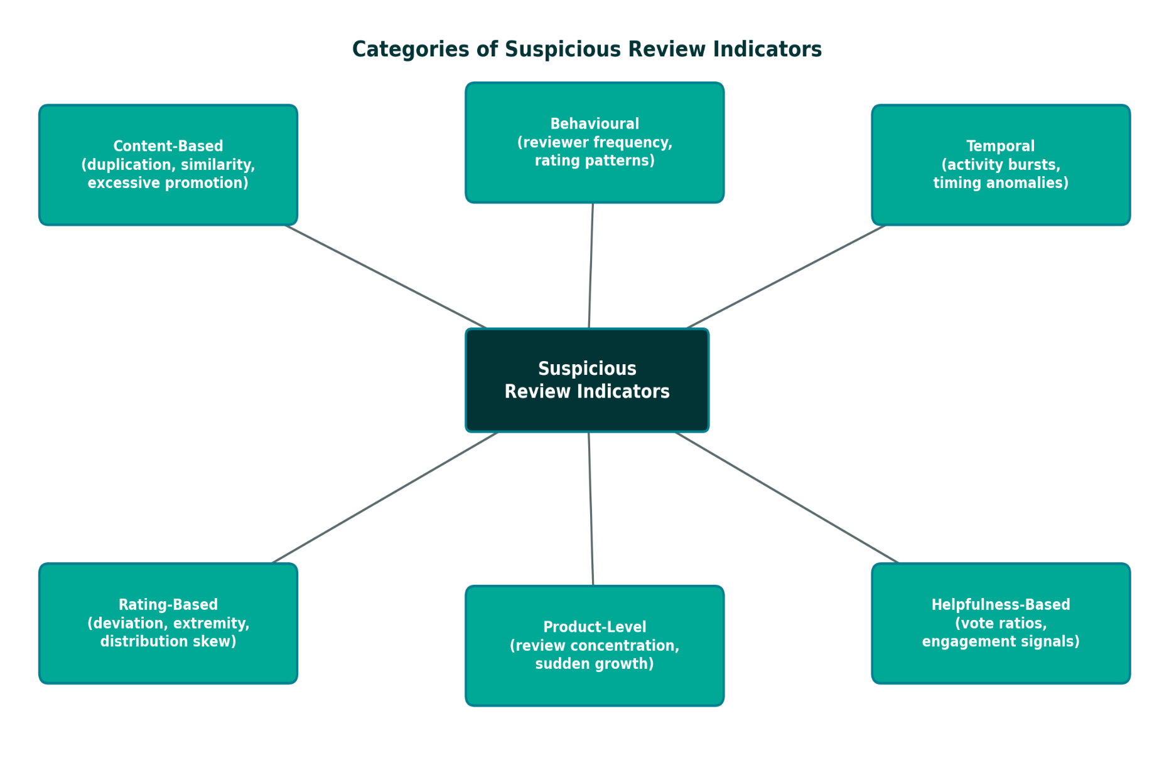
Suspicious review activity can broadly be grouped into a small number of recurring patterns. Duplicated or near-duplicated reviews occur when the same or very similar text is posted across multiple products or by multiple accounts, often as part of an automated or templated campaign. Excessively promotional reviews use language that more closely resembles marketing copy than a genuine customer account, frequently emphasising generic superlatives rather than specific product details. Coordinated posting refers to clusters of reviews submitted within a short time window, often by accounts created around the same period, which may indicate an organised effort to influence a product's rating. Rating-content mismatches occur when the sentiment expressed in the review text does not align with the numerical rating given, which can indicate careless or automated review generation. Each of these patterns, considered individually, can also occur naturally through coincidence; it is the combination and concentration of such patterns that provides a more reliable basis for suspicion.
Fig. 1.1: Categories of Suspicious Review Indicators

1.4 Need for E-Commerce Trust Analysis
Given the scale of modern e-commerce platforms, manual verification of reviews is impractical. There is a need for an analytical approach that can process large volumes of review data and highlight patterns that may indicate reduced trustworthiness, without requiring manual inspection of every individual review. Rather than attempting to make a binary judgement on each review, an aggregated, multi-factor trust assessment can provide buyers and platform administrators with a more transparent and interpretable view of product and review reliability.
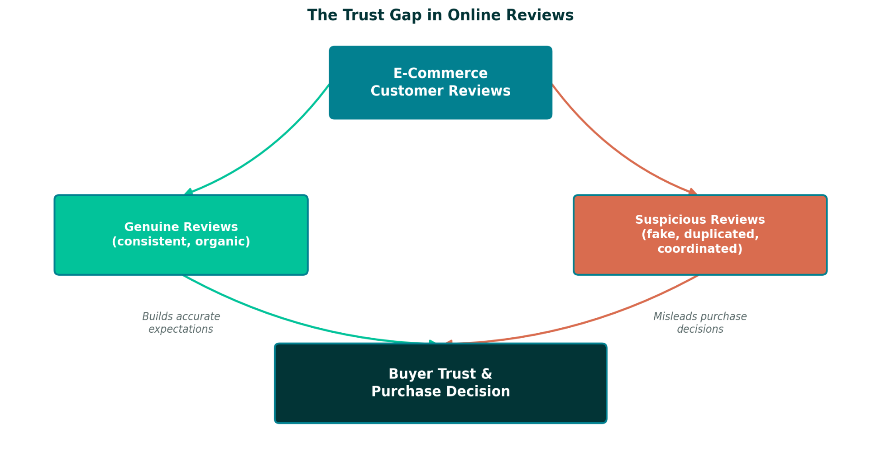
From a buyer's perspective, trust analysis addresses a specific and recurring pain point: the inability to distinguish, at a glance, between a product whose high rating reflects genuine broad satisfaction and one whose rating may be inflated through manipulated review activity. From a platform-operator's perspective, an automated trust-analysis layer can help prioritise which products or reviewer accounts warrant closer manual investigation, making moderation efforts more efficient. From a marketplace-integrity perspective, visible and consistently applied trust indicators can discourage the submission of manipulated reviews in the first place, since sellers and reviewers are aware that such activity is more likely to be flagged.

Fig. 1.2: The Trust Gap in Online Reviews

1.5 Problem Statement
Existing e-commerce platforms provide limited visibility into the reliability of the reviews associated with a product. Buyers are generally unable to determine whether a high rating reflects genuine customer satisfaction or is influenced by duplicated, promotional, or otherwise suspicious review activity. There is a need for a system that can analyse large-scale review data across multiple dimensions -- review content, reviewer behaviour, product-level patterns, and temporal activity -- and combine these dimensions into an understandable trust indicator that supports more informed purchasing decisions.
More specifically, the problem addressed by this project can be stated as follows: given a large collection of e-commerce product reviews, design and propose an analytical methodology that (a) identifies statistical and behavioural patterns associated with suspicious review activity at the review, reviewer, and product level; (b) combines these patterns into a single, interpretable Trust Score for a given product; and (c) communicates the basis for that score to an end user in an accessible, non-technical form.

1.6 Objectives
The specific objectives of the proposed project are listed below.
- To study the characteristics of e-commerce review data and the common patterns associated with suspicious review activity.
- To design a multi-factor analytical framework that evaluates reviews using review-level, reviewer-level, product-level, and temporal indicators.
- To apply data cleaning and feature engineering techniques suited to large-scale e-commerce review datasets.
- To propose duplicate-review and text-similarity detection methods using techniques such as TF-IDF and cosine similarity.
- To design a weighted Trust Score methodology (0-100) that combines multiple analytical indicators into a single, interpretable measure.
- To propose an explanation mechanism that communicates the major factors contributing to a given trust score.
- To design a dashboard/user-interface concept for presenting the trust score and associated indicators to end users.
Each of these objectives corresponds to a distinct stage of the proposed system pipeline described in Chapter 3, and together they are intended to guide the implementation activities planned for the subsequent phase of the project, as outlined in the schedule of work in Chapter 4.

1.7 Scope of the Proposed System
The proposed system is intended to operate on structured e-commerce review datasets containing information such as review text, ratings, reviewer identifiers, product identifiers, timestamps, and helpfulness votes. The analysis will focus on identifying statistical and behavioural patterns associated with suspicious activity rather than making definitive claims about the authenticity of any individual review. The scope covers data cleaning, feature engineering, multi-level pattern analysis, trust-score computation, and a proposed dashboard for presenting results.
In Scope
- Analysis of structured, text-based review data, including ratings, review text, timestamps, and reviewer/product identifiers.
- Statistical, behavioural, and text-similarity-based analysis of review, reviewer, and product-level patterns.
- Computation of an aggregated, explainable Trust Score for a given product.
- A conceptual dashboard design for presenting the trust score and its contributing indicators.
Out of Scope
- Analysis of images, videos, or other non-textual media attached to reviews.
- Platform-specific metadata that may not be present in a general-purpose review dataset (for example, internal seller account information).
- Legal or definitive determination of review authenticity; the system provides an analytical indicator, not a verified judgement.
- Real-time production deployment at platform scale, which is identified only as a direction for future work.

1.8 Expected Outcome
The project is expected to result in a working analytical prototype capable of processing a large e-commerce review dataset and generating a Product Trust Score along with supporting indicators such as suspicious-review percentage, duplicate-review counts, rating distribution, and reviewer-behaviour summaries. The system is intended to provide an explanation for each score, helping users understand which factors influenced the assessment. The final evaluation and validation of the proposed methodology will be carried out during the implementation phase of the project.
At the synopsis stage, the expected outcome is described at the level of intended functionality and design rather than measured performance. Once implemented, the prototype is expected to demonstrate, on a representative sample of the selected dataset, that the proposed multi-factor approach can surface a manageable, prioritised set of products and reviewers for further inspection, rather than requiring exhaustive manual review of the entire dataset.

1.9 Motivation for the Project
The motivation for this project stems from the observation that review-based trust signals, despite their central role in e-commerce, are rarely made transparent to the end user. Star ratings are typically presented as a single aggregated number, with little indication of how consistent, recent, or verifiable the underlying reviews are. At the same time, existing academic and industry work on fake-review detection tends to focus narrowly on binary classification (genuine versus fake) using models that are difficult for a non-technical buyer to interpret. This project is motivated by the goal of bridging that gap: applying established analytical techniques -- statistical analysis, text similarity, and behavioural feature engineering -- in a way that produces an output genuinely useful to an ordinary shopper, not only to a data scientist or platform engineer.
A secondary motivation is academic and practical skill development: the project provides an opportunity to apply and integrate data cleaning, exploratory data analysis, feature engineering, text processing, and dashboard design within a single, coherent, real-world-motivated system, consistent with the learning objectives of the Project-II course.

1.10 Organisation of the Synopsis
The remainder of this synopsis is organised as follows. Chapter 2 presents a review of existing literature on e-commerce review systems, fake-review detection, and related behavioural and temporal analysis techniques, and identifies the research gap addressed by this project. Chapter 3 describes the proposed system, including its architecture, module-wise design, and the hardware and software expected to be used during implementation. Chapter 4 presents the proposed methodology in detail, covering data-handling techniques, algorithms, flowcharts, the implementation plan, and the schedule of work. Chapter 5 concludes the synopsis with a summary of expected benefits, limitations, and directions for future work. Chapter 6 lists the references consulted in preparing this synopsis.

1.11 Illustrative Scenarios
To make the problem being addressed more concrete, this section describes two brief, illustrative scenarios of the kind the proposed system is intended to help distinguish between. These scenarios are hypothetical and are presented only to clarify the motivation for the project; they do not represent actual data or results.
Scenario A -- Organic Review Growth
A product accumulates reviews gradually over several months, with ratings spread across the typical range, written by reviewer accounts with varied posting histories and review lengths that reflect genuine, individual product experiences. Helpful-vote ratios are moderate and roughly consistent with the platform average. Under the proposed methodology, such a product would be expected to receive a comparatively high Trust Score, since none of the review-, reviewer-, product-, or temporal-level indicators described in Section 4.1 would be expected to deviate substantially from typical patterns.
Scenario B -- Coordinated Review Activity
A product receives a large concentration of five-star reviews within a short time window, many of which share similar phrasing or structure, posted by accounts with limited prior review history and little variation in rating behaviour. Under the proposed methodology, such a product would be expected to receive a comparatively lower Trust Score, with the explanation component highlighting elevated duplicate/similarity indicators, unusual temporal concentration, and low reviewer-history diversity as the primary contributing factors.
These two scenarios illustrate the intended behaviour of the proposed system at a conceptual level; the actual sensitivity and accuracy of the system in distinguishing such cases can only be established once the methodology described in Chapter 4 has been implemented and evaluated.

1.12 Key Terms and Definitions
For clarity, the following terms are used throughout this synopsis with the specific meanings defined below.
- Trust Score -- A proposed aggregated numerical measure, on a scale of 0 to 100, intended to reflect the overall reliability of a product's review collection based on multiple combined indicators.
- Suspicious Review -- A review exhibiting one or more statistical or behavioural patterns (such as duplication, extreme sentiment, or unusual timing) that are more commonly associated with manipulated content, without implying certainty of inauthenticity.
- Reviewer Concentration -- The degree to which a product's reviews originate from a small number of reviewer accounts rather than a broad, diverse base of reviewers.
- Temporal Burst -- A sudden, statistically unusual increase in review-posting activity for a product within a short time window, relative to its historical baseline.
- Helpfulness Ratio -- The proportion of votes on a review that mark it as helpful, out of the total number of votes received, where available in the dataset.
- TF-IDF (Term Frequency-Inverse Document Frequency) -- A numerical text-representation technique that weights terms by how distinctive they are to a given document relative to a larger collection.
- Cosine Similarity -- A measure of similarity between two numerical vectors, based on the cosine of the angle between them, commonly used to compare text represented in TF-IDF form.
- Anomaly Detection -- A class of analytical techniques used to identify data points that differ substantially from the majority of a dataset, without necessarily relying on labelled examples.

1.13 Comparison with Traditional (Offline) Trust Signals
It is useful to briefly contrast the online review-based trust signals discussed throughout this chapter with the trust signals traditionally available to offline shoppers, since this contrast further motivates the need for a dedicated analytical approach. In a physical retail setting, a buyer's trust in a product is typically informed by direct physical inspection, the reputation of a known, local seller, in-person word-of-mouth recommendations from people the buyer already trusts, and formal guarantees such as store-return policies or manufacturer warranties. Each of these signals is difficult to fabricate at scale: physical inspection cannot be faked remotely, and word-of-mouth recommendations are bounded by the size of a person's genuine social circle.
Online, these traditional signals are replaced almost entirely by aggregated ratings and written reviews from largely anonymous, geographically dispersed users the buyer has no other relationship with. This substitution is what makes the review system both extremely valuable -- it allows trust to be established at a scale physical retail cannot match -- and uniquely vulnerable to manipulation, since a review, unlike a physical product or a known acquaintance's opinion, can be generated cheaply and at scale by an actor with no genuine connection to the product. This distinction reinforces the motivation, introduced in Section 1.9, for an analytical layer that can approximate some of the natural scrutiny that offline trust signals provide, using statistical and behavioural analysis of the data that is actually available online.

Chapter 2: Literature Review
This chapter reviews existing academic and technical literature relevant to e-commerce review systems, fake and suspicious review detection, and related behavioural, temporal, and text-analysis techniques. The review is organised by analytical dimension -- review systems, text analysis, reviewer behaviour, rating patterns, and temporal activity -- followed by a discussion of existing approaches as a whole, their limitations, the resulting research gap, and the improvement proposed by this project.

2.1 E-Commerce Review Systems
Most e-commerce platforms allow verified or unverified customers to submit a star rating along with an optional written review. These systems were originally designed to help other buyers gauge product quality, but their open nature also makes them susceptible to manipulation, since review submission generally requires minimal verification beyond a purchase or an account.
Review systems typically aggregate individual ratings into a single average score displayed prominently alongside the product listing, with the full set of written reviews accessible separately. This design choice -- prioritising a single aggregated number -- is efficient for quick browsing but obscures the underlying distribution and any anomalies within it. A product with 1,000 reviews averaging 4.5 stars can arrive at that average through many different underlying distributions, some of which may be far more consistent with genuine customer sentiment than others. Understanding this gap between the aggregated score and the underlying data is a recurring motivation in review-trust literature.

2.2 Fake Review Detection
Early research on opinion spam, notably by Jindal and Liu (2008), established that fake or deceptive reviews form a distinct and detectable category of content within review platforms, often characterised by duplication, extreme sentiment, or unusual reviewer activity. Their work categorised opinion spam into several types, including duplicate reviews, reviews unrelated to the product, and reviews written purely to promote or damage a product's reputation, and demonstrated that features such as review duplication and reviewer-level statistics could help identify such content even without deep linguistic analysis.
Subsequent studies extended this work using linguistic and behavioural cues to identify deceptive content. A recurring theme in this line of research is that no single feature category is sufficient on its own; text, rating, and behavioural signals each capture a different aspect of the manipulation problem, and combining them tends to outperform any single-category approach.

2.3 Review Text Analysis
Ott, Choi, Cardie, and Hancock (2011) demonstrated that deceptive opinion spam can be distinguished from genuine reviews using text-based features, showing that linguistic style, word choice, and structural patterns in review text carry useful signals for detecting fabricated content. Their study, which used crowd-sourced deceptive reviews compared against genuine hotel reviews, found that classifiers trained on n-gram and part-of-speech features could achieve meaningfully better-than-chance separation between genuine and deceptive text, providing an early empirical basis for text-similarity and stylistic approaches to review-trust analysis.
Feng, Xing, Gogar, and Choi (2012) further examined the distributional footprints of deceptive reviews, analysing how the statistical distribution of writing style and content features differs between genuine and deceptive review populations, reinforcing the idea that aggregate, corpus-level patterns -- not only individual-review features -- carry useful signal for suspicious-content detection.

2.4 Reviewer Behaviour Analysis
Behavioural studies, including the work of Mukherjee, Venkataraman, Liu, and Glance (2013) on filtering mechanisms used by review platforms, indicate that reviewer-level signals such as review frequency, rating patterns, and activity concentration are useful additional indicators that complement text-based analysis. Their analysis of a real-world review-filtering system found that reviewer behavioural features were, in practice, at least as influential as textual features in determining which reviews were filtered.
Lim, Nguyen, Jindal, Liu, and Lauw (2010) proposed a set of reviewer-centred behavioural indicators, including rating deviation from a product's average, early-review targeting, and rating-content mismatch, and showed that scoring reviewers along these dimensions could effectively surface accounts responsible for a disproportionate share of suspicious activity. This reviewer-scoring approach is conceptually close to the reviewer-level indicators proposed in Section 4.1 of this synopsis.

2.5 Rating-Based Analysis
Rating distributions and deviations from expected patterns have been used in several studies as indicators of manipulation, particularly when a product exhibits unusually concentrated extreme ratings within a short time span, or when individual reviewers consistently rate products in a manner inconsistent with the general population of reviewers. Bimodal rating distributions -- an unusually high concentration of both five-star and one-star ratings, with comparatively few moderate ratings -- have also been noted in the literature as a pattern sometimes associated with coordinated positive and negative review campaigns competing on the same listing.

2.6 Behavioural and Temporal Analysis
Temporal analysis, which studies review activity over time, has been used to identify sudden bursts of review submissions that may correspond to coordinated campaigns. Combined with reviewer and product-level features, temporal indicators strengthen the reliability of suspicious-pattern detection. Rayana and Akoglu (2015) proposed a framework that bridges reviewer-product networks with metadata such as timestamps and ratings, showing that combining network structure with temporal and behavioural metadata improves the detection of collectively acting groups of spam reviewers compared to approaches that consider these signals in isolation.
Wang, Xie, Liu, and Yu (2011) modelled the review ecosystem as a graph connecting reviewers, reviews, and stores, and proposed a review-graph-based approach to identify spammer accounts based on their structural position and relationships within this graph, illustrating how network-level analysis can complement feature-based statistical methods.

2.7 Existing Approaches
Existing approaches to review-trust analysis generally fall into a small number of categories, each summarised below.
Rule-Based Rating Filters
The simplest approaches apply fixed thresholds or heuristics to ratings or review counts -- for example, flagging products whose ratings fall outside an expected range, or reviewers who post more than a fixed number of reviews within a short period. These methods are computationally inexpensive and easy to implement but are also easy to circumvent once the thresholds are known, and they generally ignore the content of the reviews themselves.
Supervised Text-Classification Models
A large body of work trains machine-learning classifiers -- ranging from traditional models such as Naive Bayes and Support Vector Machines to more recent deep-learning architectures -- on labelled datasets of genuine and deceptive reviews. While often effective within the domain of their training data, these methods require substantial labelled data, which is difficult and expensive to obtain for real e-commerce platforms, and their performance can degrade when applied to review text from a different domain or writing style than the one used for training.
Graph-Based Reviewer-Network Analysis
Graph-based methods, such as those proposed by Wang et al. (2011) and Rayana and Akoglu (2015), model relationships between reviewers, reviews, and products as a network and apply graph-analysis techniques to identify tightly connected or structurally anomalous clusters that may indicate coordinated spam activity. These methods can be powerful for detecting organised campaigns but are computationally more intensive and require sufficiently rich relational data to construct a meaningful graph.
Unsupervised Anomaly-Detection Methods
Unsupervised approaches, including statistical outlier detection and algorithms such as Isolation Forest, identify reviewers, reviews, or products whose feature values deviate substantially from the majority of the dataset, without requiring labelled training examples. These methods are attractive when labelled fake-review data is unavailable, though they can be sensitive to the choice of features and threshold parameters, and do not inherently provide an explanation for why a given case was flagged.

2.8 Limitations of Existing Approaches
- Many approaches rely on a single feature category (text, rating, or behaviour) rather than combining multiple indicators.
- Supervised methods typically require large, accurately labelled datasets of confirmed fake reviews, which are difficult to obtain.
- Few approaches provide an interpretable, end-user-facing explanation for why a product or review was flagged.
- Existing systems are often platform-specific and not easily generalised to a large, heterogeneous e-commerce dataset.
- Graph-based methods, while powerful, can be computationally expensive and depend on the availability of rich relational data that may not always be present in a standard review export.
- Most existing systems output a binary or categorical label (genuine/fake, flagged/not flagged) rather than a graded, continuous trust measure that reflects degrees of confidence.

2.9 Research Gap
Based on the reviewed literature, there is a gap in approaches that combine review-level, reviewer-level, product-level, and temporal indicators into a single, transparent trust score that is understandable to an ordinary buyer rather than only to a data analyst. Most existing work focuses on binary fake/genuine classification rather than a graded, explainable trust assessment. In addition, relatively little published work focuses specifically on presenting the output of such analysis through an accessible, buyer-facing interface, as opposed to an internal moderation tool intended for platform administrators.

2.10 Proposed Improvement
The proposed system aims to address this gap by combining multiple analytical dimensions -- duplicate/similarity detection, reviewer behaviour, product-level concentration, rating consistency, temporal activity, and helpfulness -- into a single weighted Trust Score, accompanied by a human-readable explanation of the contributing factors. This multi-factor, explainable approach is intended to provide a more complete and accessible trust assessment than methods that rely on a single indicator, while remaining computationally lighter than full graph-based network analysis, making it more practical to implement within the scope of a Project-II timeline.
Table 2.1: Comparison of Existing Approaches and Proposed System
Approach | Strengths | Limitations
Rating-threshold filtering | Simple to apply; requires no textual analysis | Ignores review content and reviewer behaviour; easily bypassed
Text-based spam/opinion detection | Captures linguistic cues of deceptive writing | Often needs labelled training data; limited to text features alone
Reviewer-behaviour analysis | Detects coordinated or abnormal posting patterns | Does not consider review content or product-level context
Rating-distribution analysis | Highlights abnormal rating concentration | Cannot distinguish genuine popularity from manipulation alone
Graph/network-based spammer detection | Captures coordinated group behaviour across reviewers and products | Computationally intensive; requires well-connected graph data
Proposed System -- Multi-Factor Trust Analysis | Combines review, reviewer, product, and temporal indicators into one explainable score | Cannot guarantee detection of highly sophisticated, coordinated fraud

2.11 Summary of Literature Review
The literature reviewed in this chapter establishes that suspicious review activity manifests through several complementary signal types -- textual, behavioural, rating-based, temporal, and relational -- and that combining multiple signal types generally outperforms approaches relying on any single category. It also highlights those recurring limitations -- dependence on labelled data, limited interpretability, and platform-specific design -- that the proposed system, described in Chapters 3 and 4, is intended to address through a multi-factor, explainable, and dataset-agnostic Trust Score methodology.

2.12 Comparative Analysis of Detection Techniques
Table 2.2 summarises how the major categories of existing detection techniques compare along four practical criteria relevant to this project: whether labelled data is required, how interpretable the output is to a non-technical user, the approximate computational cost, and how well the technique is expected to generalise across different product categories and datasets.
Table 2.2: Technique Comparison by Practical Criteria
Technique Category | Needs Labelled Data? | Interpret-ability | Computational Cost | Generalis-ability
Rule-based rating filters | No | High | Low | Low
Supervised text classification | Yes | Low-Medium | Medium-High | Medium
Graph-based network analysis | No (typically) | Medium | High | Medium
Unsupervised anomaly detection | No | Medium | Medium | Medium-High
Proposed multi-factor Trust Score | No | High | Medium | Medium-High

As summarised in the table, the proposed approach is positioned to avoid the dependence on labelled data associated with supervised methods, while aiming for higher interpretability than either supervised classifiers or graph-based network analysis, at a moderate computational cost that is expected to be feasible within the resources described in Section 3.3.

2.13 Ethical and Privacy Considerations
Any system that analyses reviewer behaviour must be designed with attention to privacy and fairness. The proposed system is intended to operate only on data fields already present in a publicly available or platform-exported review dataset (such as review text, ratings, and timestamps), and does not propose to collect additional personal information about reviewers beyond what is already associated with their public review activity. Reviewer identifiers used in the proposed analysis are intended to be treated as opaque keys for aggregation purposes rather than being linked to any personally identifying information.
A further ethical consideration is the risk of false positives: a genuine reviewer or product could, by coincidence, exhibit patterns that resemble those associated with suspicious activity. For this reason, the proposed system is designed to produce a graded Trust Score and explanation rather than a definitive accusation, and is intended to support human review and decision-making rather than to automatically remove reviews or penalise accounts without further verification. This design choice is discussed further in the context of system limitations in Section 5.3.

2.14 Summary Table of Key Studies
Table 2.3 consolidates the key studies discussed in this chapter, summarising the year, primary analytical focus, and principal technique associated with each, for ease of reference.
Table 2.3: Summary of Key Studies Reviewed
Study | Year | Primary Focus | Principal Technique
Jindal & Liu | 2008 | Opinion spam categorisation | Duplicate detection, reviewer statistics
Ott, Choi, Cardie & Hancock | 2011 | Deceptive review text | Linguistic/stylistic classification
Lim, Nguyen, Jindal, Liu & Lauw | 2010 | Reviewer-level spam scoring | Rating-deviation behavioural indicators
Feng, Xing, Gogar & Choi | 2012 | Corpus-level review patterns | Distributional/statistical analysis
Wang, Xie, Liu & Yu | 2011 | Spammer network detection | Reviewer-product graph analysis
Mukherjee, Venkataraman, Liu & Glance | 2013 | Real-world filter behaviour | Behavioural feature analysis
Rayana & Akoglu | 2015 | Collective spam detection | Network + metadata fusion
Liu, Ting & Zhou | 2008 | General anomaly detection | Isolation Forest

As the table illustrates, the studies reviewed collectively span text-based, behavioural, statistical, and network-based techniques, spanning more than a decade of research; the proposed system draws primarily on the duplicate-detection, behavioural-scoring, and statistical/anomaly-detection strands of this literature, while adapting the graph-based insight that coordinated activity is often visible in aggregate patterns even without constructing a full reviewer-product graph.

Chapter 3: Proposed System
This chapter presents the proposed system for the E-Commerce Trust Analysis and Suspicious Review Detection System. It describes the intended architecture, a module-wise breakdown of the system, the hardware and software expected to be used during implementation, and the anticipated advantages and limitations of the proposed approach. As this is a synopsis, the system described here represents the planned design; the working implementation will be developed and evaluated in subsequent stages of the project.

3.1 System Architecture / Block Diagram
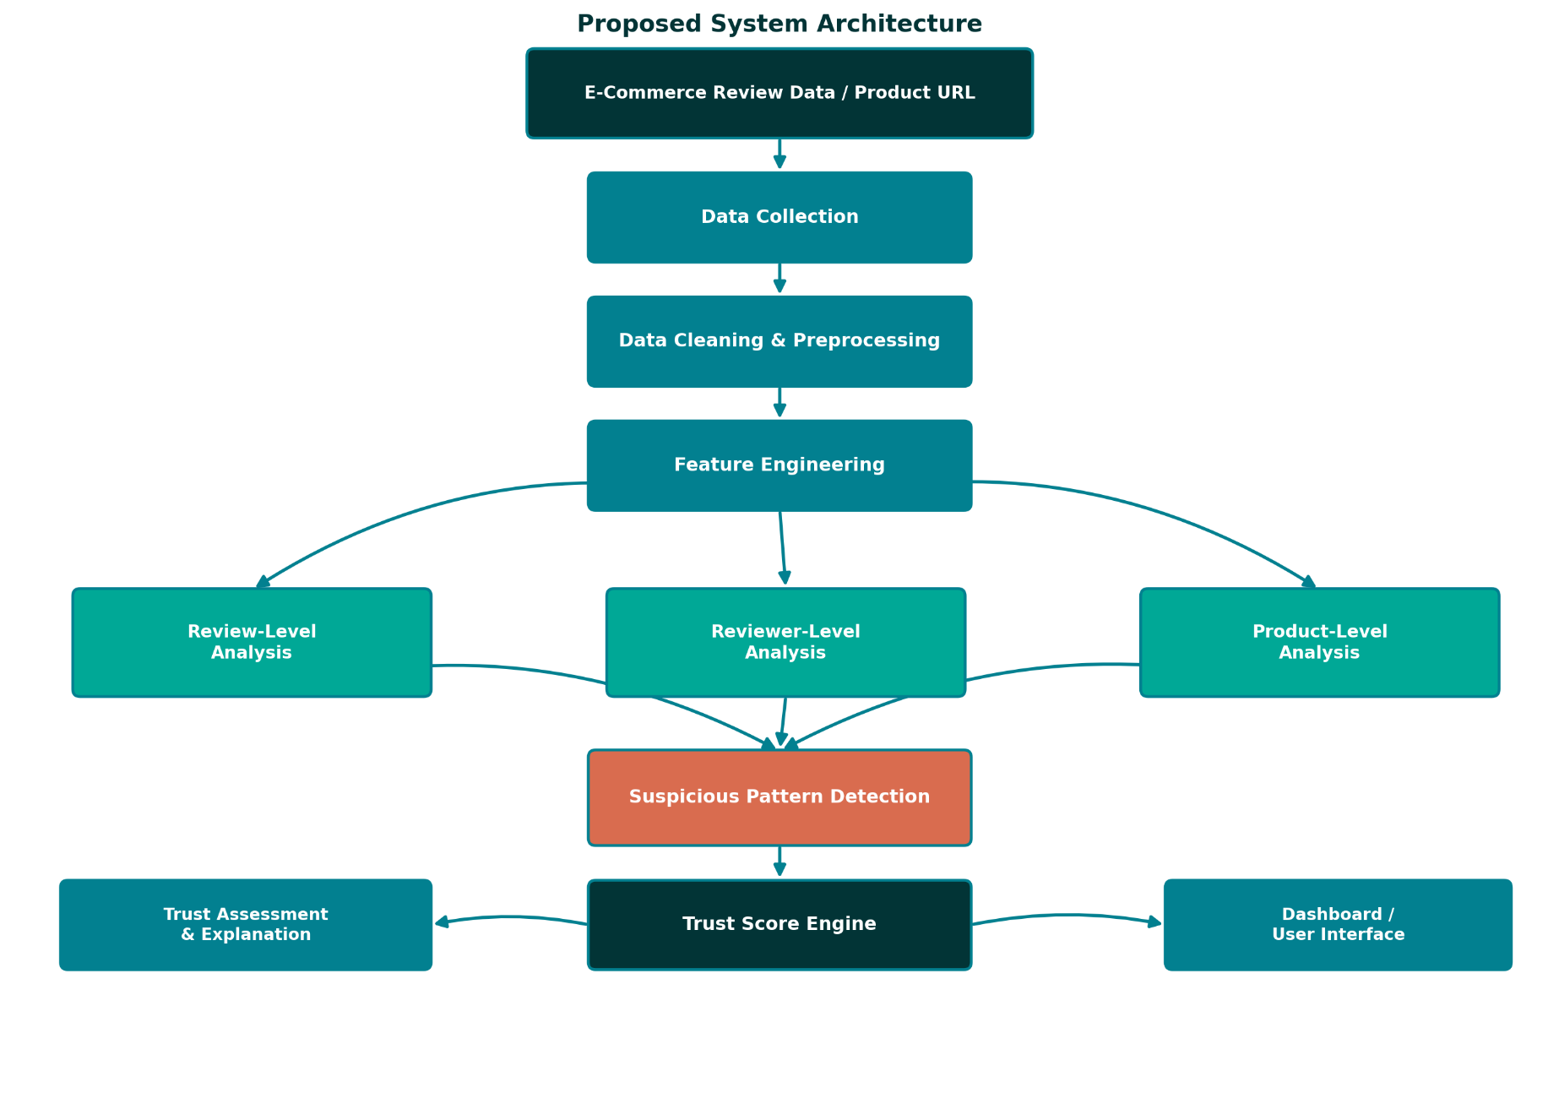
The proposed system follows a layered architecture in which raw review data is progressively cleaned, transformed, and analysed across three complementary levels -- review, reviewer, and product -- before being combined into a single trust assessment. The architecture is designed so that each analytical stage can be developed and tested independently, and so that additional indicators can be incorporated in later stages without redesigning the overall pipeline.

Fig. 3.1: Proposed System Architecture
As shown in Fig. 3.1, review data (or a product identifier/URL) is first passed through a data-collection stage, followed by cleaning and preprocessing to handle missing values, duplicates, and inconsistent formats. Feature engineering then derives review-level, reviewer-level, and product-level attributes, which are analysed in parallel branches. The outputs of these three branches feed into a suspicious-pattern-detection stage, whose results are used by the Trust Score engine to compute a final score. The score and its explanation are intended to be presented through a dashboard/user interface.
This layered design has two intended benefits. First, separating data preparation from analysis, and analysis from scoring, keeps each stage conceptually simple and independently testable -- a property that is particularly useful given that the system will be built incrementally over the course of the implementation schedule described in Section 4.5. Second, keeping the three analytical branches (review, reviewer, product) parallel and independent means that a weakness or limitation in one branch, such as an incomplete reviewer history, does not entirely prevent the other branches from contributing to the final score.

3.2 Module-wise Description
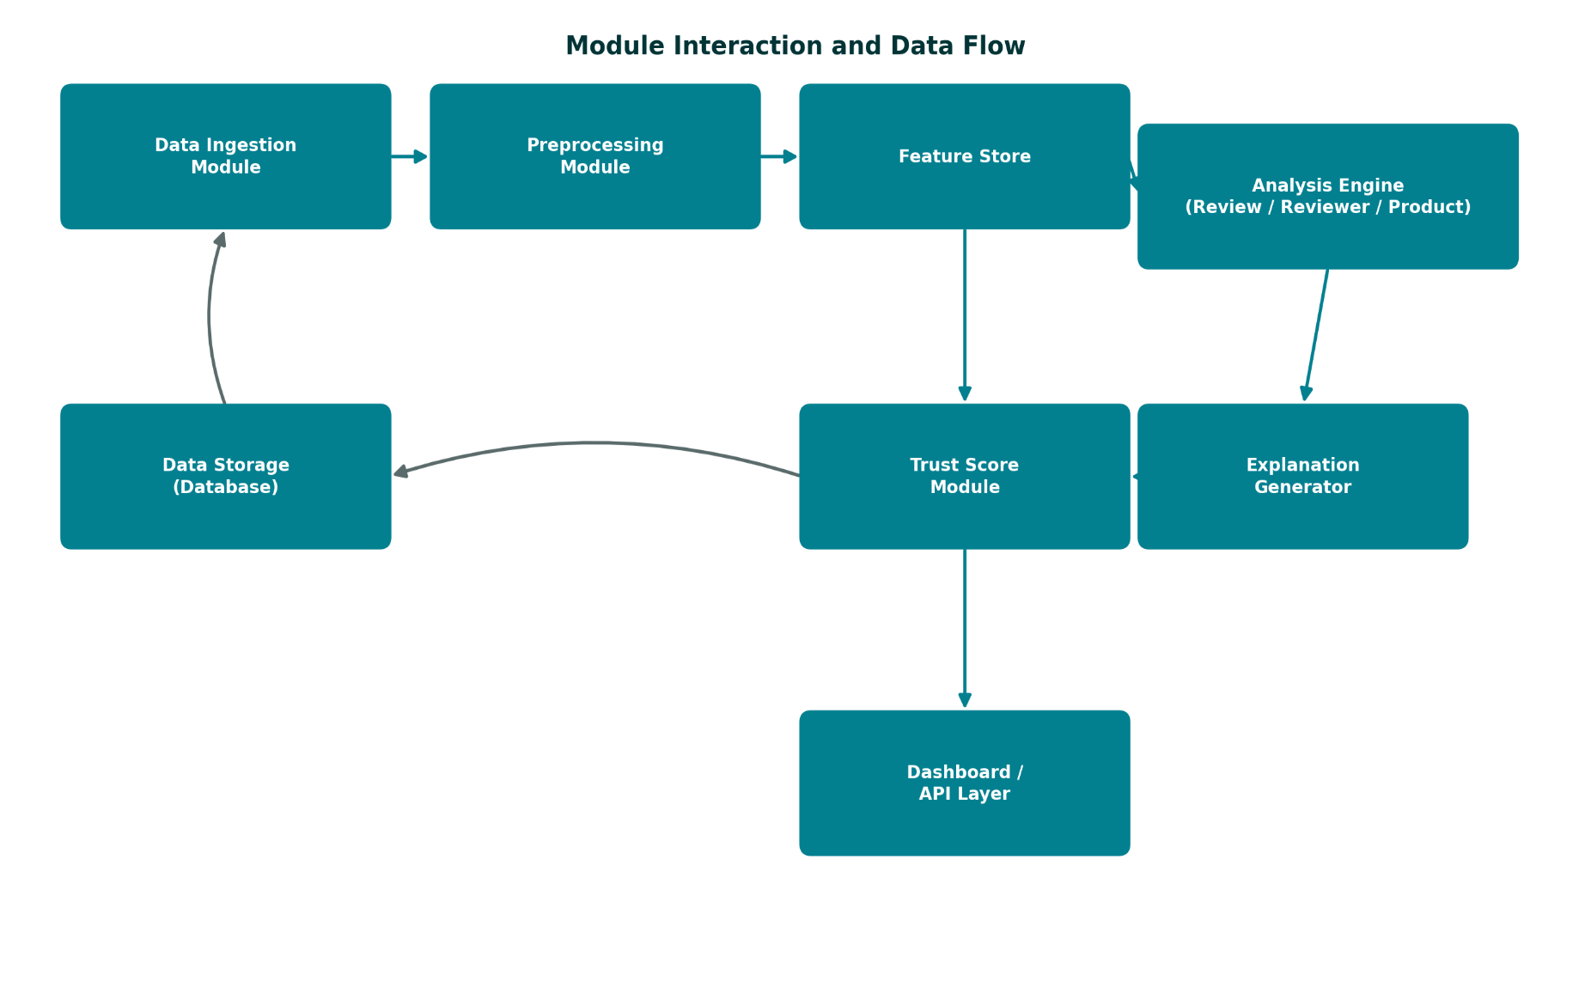
The system architecture in Fig. 3.1 can be further decomposed into functional modules with more specific responsibilities, and their expected interactions, as illustrated in Fig. 3.2.

Fig. 3.2: Module Interaction and Data Flow
Data Ingestion Module
Responsible for reading the raw review dataset (in the planned case, a structured file containing approximately 593,182 reviews across roughly 33 attributes) and loading it into a working format suitable for downstream processing. This module is also responsible for basic schema validation, confirming that expected fields such as rating, review text, and timestamps are present before further processing begins.
Preprocessing Module
Applies the data-cleaning operations described in Section 4.1, including handling of missing values, removal of duplicate records, correction of data types, and standardisation of category and date fields, producing a cleaned dataset ready for feature engineering.
Feature Store
Stores the engineered review-level, reviewer-level, product-level, and temporal features described in Table 4.2, in a structured form that can be efficiently queried by the analysis engine and the trust-score module without repeating feature computation for each request.
Analysis Engine
Implements the review-level, reviewer-level, and product-level analytical logic described in Section 3.1, applying the statistical and text-similarity techniques discussed in Section 4.2 to identify suspicious patterns within each level.
Trust Score Module
Combines the outputs of the analysis engine using the proposed weighted-scoring approach described in Section 4.2, producing a single Trust Score (0-100) for a given product.
Explanation Generator
Translates the individual indicator values that contributed to a given Trust Score into a short, human-readable summary, of the kind illustrated in Section 4.2, so that the reasoning behind a score is accessible to a non-technical user.
Dashboard / API Layer
Presents the Trust Score, its explanation, and supporting indicators (such as rating distribution and suspicious-review percentage) to the end user, and is intended to expose the same information programmatically through an API for potential integration with other tools.

3.3 Hardware and Software Requirements
Table 3.1: Hardware Requirements
Component | Proposed Specification
Processor | Intel Core i5 (8th generation) or equivalent, or higher
RAM | 8 GB minimum (16 GB recommended for large-scale data processing)
Storage | Minimum 20 GB free space for datasets, libraries, and project files
Internet Connection | Required for dataset access, library installation, and reference research
Display | Standard HD display; no specialised graphics hardware required for the proposed analytical workload

Table 3.2: Software Requirements
Component | Proposed Technology
Programming Language | Python 3.x
Data Handling | Pandas, NumPy
Machine Learning / Analysis | Scikit-learn (proposed, where appropriate)
Text Processing | NLP/text-processing libraries such as NLTK or Scikit-learn text utilities (proposed)
Data Visualisation | Matplotlib, Seaborn (proposed, for exploratory analysis and reporting)
Database | SQL/relational database technology for structured data storage
Dashboard / Frontend | Streamlit or React (proposed implementation technology)
Version Control | Git, for tracking implementation changes during development
Development Environment | Jupyter Notebook / VS Code

3.4 Data Dictionary
Table 3.3 summarises the expected structure of the planned dataset at a conceptual level, describing the categories of fields anticipated rather than an exhaustive, dataset-specific schema, since the exact column names will be confirmed once the dataset is finalised during implementation, as noted in Section 4.1.
Table 3.3: Expected Dataset Field Categories
Field Category | Description | Example Fields
Identifiers | Unique keys used to link reviews, reviewers, and products | Review ID, Product ID, Reviewer ID
Review Content | The textual and rating content of the review itself | Review title, review text, star rating
Temporal | Date/time information used for temporal-pattern analysis | Review date, account creation date
Engagement | Signals reflecting how other users interacted with a review | Helpful votes, total votes
Verification | Fields indicating purchase or account verification status, where available | Verified purchase flag
Product Metadata | Descriptive information about the product being reviewed | Product category, product name

3.5 Security Considerations
Although the proposed system is an analytical prototype rather than a production platform, a small number of security-related considerations are relevant to its design. Access to the underlying review dataset and to any computed reviewer-level indicators is intended to be restricted to the development and evaluation environment described in Section 3.3, rather than being exposed publicly. Where the proposed dashboard/API layer (Section 3.2) is used to present results, only aggregated, product-level output such as the Trust Score and its explanation is intended to be exposed, rather than raw reviewer-level indicators, reducing the risk of the system being used to profile or target individual reviewer accounts.

3.6 Deployment Considerations (Proposed)
At the synopsis stage, the proposed system is intended to run as a local analytical prototype within the development environment described in Section 3.3, rather than being deployed to a production server or cloud platform. This scope is consistent with the goals of the Project-II course, which emphasises demonstrating a complete, working methodology rather than operating a publicly accessible service. Nonetheless, it is useful to note, for completeness, how the proposed architecture would extend toward a deployed setting, since this consideration also informs the future-scope discussion in Section 5.4.
The modular design described in Section 3.2 is intended to be compatible with a small-scale cloud deployment, in which the Data Ingestion, Preprocessing, and Feature Store modules could run as a scheduled batch job, while the Trust Score Module and Dashboard/API Layer could run as a lightweight web service. Such a deployment is not planned as part of the current project scope, but the module boundaries have been chosen, in part, so that this extension would not require a fundamental redesign of the underlying pipeline.

3.7 Alternative Design Considered
During the design of the proposed architecture, an alternative approach was considered in which a single end-to-end machine-learning model -- for example, a deep-learning text classifier trained directly on review text and a fake/genuine label -- would replace the layered, multi-factor pipeline described in Section 3.1. This alternative was set aside in favour of the proposed layered design for three main reasons, summarised below.
- Interpretability: a single end-to-end classifier typically produces a label or probability with limited insight into which specific factors drove the prediction, whereas the proposed layered design produces per-indicator values that feed directly into the explanation described in Section 3.2, aligning with objective six in Section 1.6.
- Label availability: end-to-end supervised models require a labelled training set of confirmed fake and genuine reviews, which, as discussed in Section 2.8, is difficult to obtain reliably for a general-purpose e-commerce dataset; the proposed statistical and behavioural approach does not require such labels.
- Modularity and risk management: the layered design allows each analytical component (Section 3.2) to be implemented, tested, and, if necessary, simplified independently within the project timeline (Section 4.5), whereas an end-to-end model is comparatively more difficult to partially implement or debug incrementally.
This alternative remains a reasonable direction for future work, as noted in Section 5.4, once sufficient labelled data or computational resources are available to support it; it was not selected as the primary approach for the current, single-semester scope of this project.

3.8 Assumptions and Constraints
Assumptions
- The selected dataset provides sufficient fields (rating, review text, timestamps, reviewer and product identifiers) to compute the proposed indicators.
- A reasonable proportion of reviews in the dataset are genuine, so that behavioural and statistical baselines computed from the data are meaningful.
- The computing resources listed in Table 3.1 are sufficient to process the dataset within an acceptable time frame using the proposed tools.
Constraints
- The proposed methodology is limited to the fields available in the selected dataset and cannot incorporate platform-side signals (such as IP address or device fingerprinting) that are not typically included in public review datasets.
- The project timeline, described in Section 4.5, constrains the depth of algorithmic exploration possible, particularly for more advanced techniques identified as future work in Section 5.3.
- As a synopsis-stage proposal, all performance-related expectations described in this document are illustrative and subject to revision once implementation and evaluation begin.

3.9 Advantages and Disadvantages
Advantages
- Combines multiple indicators (review, reviewer, product, and temporal) into a single multi-factor trust assessment rather than relying on one signal.
- Designed to be explainable, providing users with the reasons behind a given trust score rather than an opaque label.
- Capable of detecting suspicious patterns at the review, reviewer, and product level rather than in isolation.
- The analytical approach is intended to scale to large datasets containing hundreds of thousands of reviews.
- The modular design outlined in Section 3.2 allows individual components to be developed, tested, and refined independently.
Disadvantages
- Cannot guarantee perfect or complete detection of fake or manipulated reviews.
- Output quality is dependent on the completeness and quality of the underlying review dataset.
- Data availability may vary across different e-commerce platforms, limiting direct generalisation.
- Highly sophisticated, well-coordinated review fraud may remain difficult to detect using statistical and behavioural indicators alone.
- The proposed weighting scheme for the Trust Score requires careful tuning, and poorly chosen weights could bias the score toward one indicator category.

Chapter 4: Methodology
This chapter presents the proposed methodology for the E-Commerce Trust Analysis and Suspicious Review Detection System in detail, covering the techniques and methods planned for data handling, the algorithms proposed for pattern detection and scoring, the associated flowcharts, the plan of implementation, the schedule of work, the proposed evaluation strategy, and an assessment of implementation risks.

4.1 Techniques / Methods
Data Collection
The proposed system will work with a large-scale e-commerce review dataset planned to contain approximately 593,182 reviews, described by around 33 attributes, and spanning approximately six product categories. The dataset is expected to include information such as review identifiers, product identifiers, reviewer identifiers, ratings, review titles and text, review dates, helpful-vote counts, verified-purchase indicators where available, product category, and related product and reviewer information. These characteristics represent the planned dataset selected for the proposed project; exact field names will be confirmed once the dataset is finalised during implementation.
Data collection is expected to be a one-time bulk-loading exercise rather than a continuous, real-time scraping process, since the proposed prototype is intended to demonstrate the analytical methodology on a fixed, representative dataset rather than operate as a live production monitoring system. Continuous, real-time ingestion is identified as a possible direction for future work in Section 5.3.
Data Cleaning
Before analysis, the dataset will be examined for data-quality issues that are common in large, real-world review collections. The proposed cleaning steps include:
- Identifying and handling missing values in fields such as review text, rating, or timestamps.
- Detecting and removing exact and near-duplicate records that do not represent independent observations.
- Resolving inconsistent values, such as differing category labels or malformed dates.
- Correcting data types to ensure that numerical, categorical, and date fields are handled appropriately during analysis.
Missing values will be handled differently depending on field importance. For fields central to the trust-score calculation, such as rating or review text, records with missing values may need to be excluded from the affected analytical step, since imputing a rating or fabricating review text could distort the resulting indicators. For less central fields, such as an optional review title, missing values may simply be treated as an empty value without materially affecting downstream analysis. This field-by-field approach is intended to avoid a uniform cleaning policy that could either discard too much usable data or introduce artificial values into the dataset.

Table 4.1: Proposed Data-Cleaning Actions by Issue Type
Data Issue | Proposed Handling
Missing rating or review text | Exclude record from the affected analytical step
Missing, non-critical field (e.g., title) | Treat as empty; retain record
Exact duplicate record | Remove, retaining a single instance
Near-duplicate review text | Flag via similarity check (Section 4.2); retain but mark for analysis
Inconsistent category label | Standardise using a controlled category mapping
Malformed or missing date | Exclude from temporal analysis only; retain for other analyses

Feature Engineering
Feature engineering will convert the cleaned dataset into structured indicators grouped into four categories, summarised in Table 4.2.
Table 4.2: Major Analytical Features
Feature Group | Representative Indicators
Review Features | Review length, star rating, helpfulness ratio, textual similarity to other reviews
Reviewer Features | Number of reviews posted, rating behaviour, review frequency, activity concentration
Product Features | Number of reviews received, average rating, rating variance, review concentration
Temporal Features | Reviews per day/week/month, sudden activity bursts relative to historical average

Within the review-feature group, review length is expected to be computed as a simple word or character count, providing a coarse proxy for review effort and detail; extremely short, generic reviews are more commonly associated with low-effort or automated posting. The helpfulness ratio, where available, will be computed as the number of helpful votes divided by the total number of votes received, giving an indication of how other genuine users have independently assessed the review's usefulness. Textual similarity will be computed pairwise between reviews for a given product (and, where feasible, across the dataset) using the TF-IDF and cosine-similarity approach described in Section 4.2.
Within the reviewer-feature group, review frequency will be computed relative to the reviewer's account activity span, so that a reviewer who posts many reviews over several years is distinguished from one who posts the same number of reviews within a single week. Rating behaviour will summarise the distribution of ratings given by a reviewer across all of their reviews, allowing the identification of reviewers whose ratings are unusually uniform (for example, exclusively five-star) compared to the general population.
Within the product-feature group, rating variance will capture how consistent a product's ratings are, while review concentration will measure what share of a product's total reviews arrive within a short time window, which is a useful precursor to the temporal-feature analysis described next.
Within the temporal-feature group, review activity will be aggregated at daily, weekly, and monthly granularity to establish a baseline pattern for a given product, against which sudden bursts -- periods where review volume substantially exceeds the established baseline -- can be identified.
Suspicious Pattern Detection
Suspiciousness will be assessed through a combination of the indicators above rather than a single feature. A review, reviewer, or product may be flagged for further consideration when multiple indicators simultaneously deviate from typical patterns observed in the dataset -- for example, a reviewer posting an unusually high number of near-identical reviews within a short time frame, or a product experiencing a sudden, statistically unusual burst of five-star ratings.
The proposed system will treat suspicious-pattern detection as a scoring problem rather than a strict filtering problem: rather than removing or hiding reviews that cross a fixed threshold, each review, reviewer, and product will receive a continuous suspicion indicator that feeds into the overall Trust Score calculation described below. This design choice avoids making an irreversible or overly confident judgement about any individual review based on a single rule.
Trust Score Generation
The individual indicators computed above will be combined into a single Trust Score using a proposed weighted-combination approach, described further in Section 4.2. The intention is for the score to reflect the overall reliability of a product's review collection rather than making a definitive judgement about any single review.

4.2 Algorithms
Duplicate Detection
Review text will be normalised (lower-casing, punctuation removal, whitespace normalisation) and compared using text-similarity measures to identify identical or highly similar reviews that may indicate repeated or coordinated posting. The general procedure proposed for this step is summarised below in pseudocode form.
for each pair of reviews (r1, r2) within the same product:
normalise text(r1), text(r2)
compute similarity = cosine_similarity(tfidf(r1), tfidf(r2))
if similarity > duplicate_threshold:
flag (r1, r2) as near-duplicate pair
Applying this comparison across every pair of reviews in a very large dataset is computationally expensive; as a proposed optimisation, comparisons will be restricted within each product (and, where useful, within a rolling time window), which substantially reduces the number of pairwise comparisons required while still capturing the most relevant duplicate patterns.
Statistical Analysis
Descriptive statistics -- mean, median, variance, and distribution shape -- will be used to characterise rating behaviour and to identify values that deviate substantially from the norm for a given reviewer or product. These statistics will be computed both globally (across the full dataset) and locally (within a specific product category), since expected rating behaviour may vary meaningfully between product categories.
Outlier Detection
Proposed methods for identifying unusual values include the interquartile range (IQR) method, Z-score-based thresholds, and other statistical threshold techniques applied to features such as review frequency and rating deviation. Under the IQR method, a value is conventionally treated as a potential outlier if it falls below Q1 minus 1.5 times the interquartile range, or above Q3 plus 1.5 times the interquartile range, where Q1 and Q3 are the first and third quartiles of the feature's distribution. This method is proposed as a first-pass, computationally inexpensive screening step, to be applied per feature before combination into the overall Trust Score.
Text Similarity
Term Frequency-Inverse Document Frequency (TF-IDF) is proposed to convert review text into numerical vectors, after which cosine similarity will be used to measure the similarity between review pairs, supporting the duplicate- and near-duplicate-detection process. Under the TF-IDF representation, each review is expressed as a vector in which each dimension corresponds to a term in the overall review vocabulary, weighted by how frequently that term appears in the given review relative to how commonly it appears across all reviews; terms that appear in many reviews (such as common stop words) receive a lower weight than terms that are distinctive to a smaller subset of reviews. Cosine similarity then measures the angle between two such vectors, producing a value between 0 and 1 that is high when two reviews share a similar distribution of distinctive terms, regardless of review length.
Clustering / Anomaly Detection
As a planned technique for later stages of the project, anomaly-detection algorithms such as Isolation Forest, or clustering-based approaches, may be explored to identify reviewers or products whose behavioural feature patterns differ substantially from the majority of the dataset. Isolation Forest, proposed by Liu, Ting, and Zhou (2008), works by randomly partitioning the feature space and measuring how quickly a given data point becomes isolated from the rest of the dataset; points that are isolated with fewer partitions are considered more anomalous. This approach is attractive for the proposed system because it does not require labelled training examples and scales reasonably well to the feature volumes expected from the selected dataset. These techniques are identified here as proposed options to be evaluated during implementation, not as components that have already been applied.
Trust Score Algorithm
The proposed Trust Score will combine indicators from each feature group using a weighted-sum approach, expressed conceptually as:
Trust Score = w1 (review quality) + w2 (reviewer behaviour) + w3 (rating consistency) + w4 (product behaviour) + w5 (temporal consistency) + w6 (duplicate/similarity indicators)
Here, w1 through w6 represent illustrative weights whose specific values are proposed for the synopsis stage only; the final weights will be determined and tuned during implementation and evaluation, based on how well they separate typical review patterns from atypical ones in the selected dataset. Each individual indicator is planned to be normalised onto a common 0-100 scale (for example, using min-max scaling within each product category) before the weights are applied, so that indicators measured on very different original scales -- such as a review count and a similarity percentage -- contribute proportionally rather than being dominated by whichever indicator happens to have the largest raw numerical range.
For example, a product might receive an illustrative score such as 78 out of 100, with an accompanying explanation citing low duplicate-review activity, a normal rating distribution, moderate reviewer concentration, no major temporal review burst, and good review helpfulness. Such an example is intended only to illustrate how the proposed system would communicate its output, and does not represent an actual computed result.
Table 4.3 illustrates, purely for explanatory purposes, how such a score might be assembled from individual normalised indicator values and illustrative weights. The specific numbers shown are hypothetical and are included only to clarify the mechanics of the proposed weighted-sum approach; actual indicator values and tuned weights will only be available once the methodology is implemented and run against real data.
Table 4.3: Illustrative (Hypothetical) Trust Score Composition
Indicator Group | Normalised Value (0-100) | Illustrative Weight | Weighted Contribution
Review quality (w1) | 82 | 0.20 | 16.4
Reviewer behaviour (w2) | 75 | 0.15 | 11.3
Rating consistency (w3) | 80 | 0.20 | 16.0
Product behaviour (w4) | 70 | 0.15 | 10.5
Temporal consistency (w5) | 85 | 0.15 | 12.8
Duplicate/similarity indicators (w6) | 74 | 0.15 | 11.1
Illustrative Total Trust Score |  |  | ~78

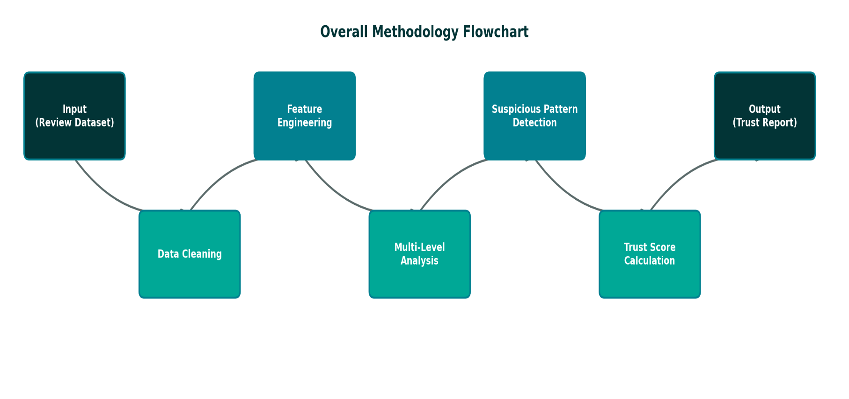
4.3 Flowcharts

Fig. 4.1: Overall Methodology Flowchart

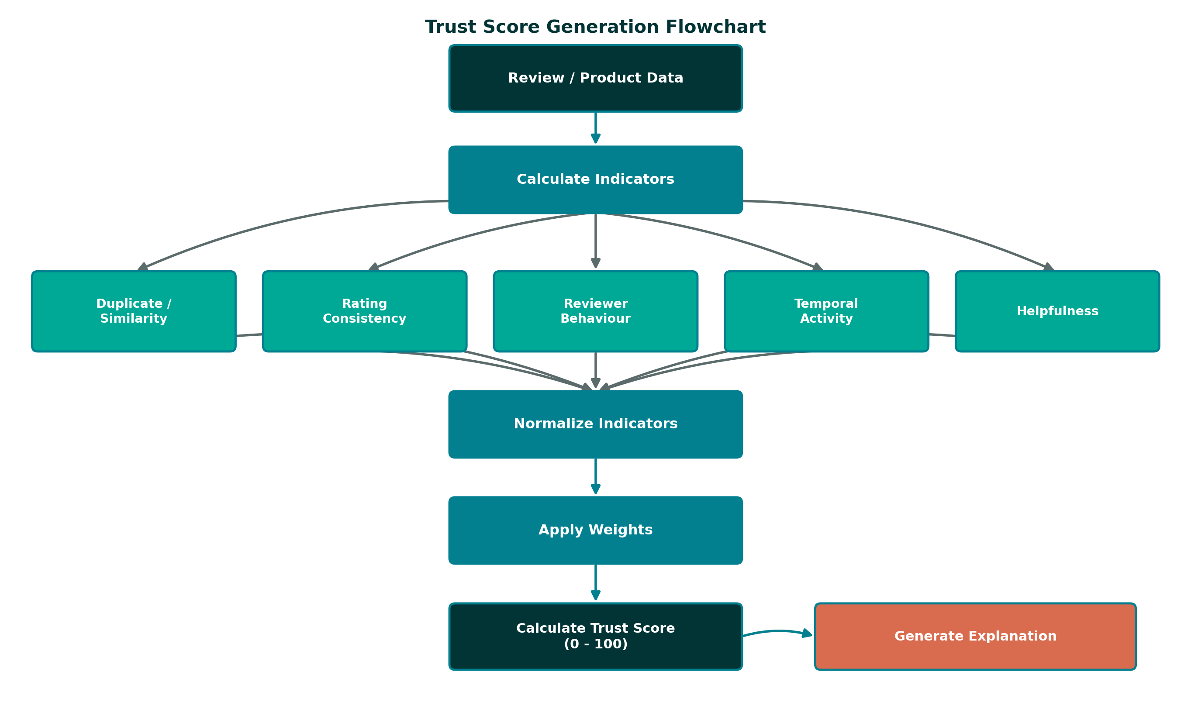
Fig. 4.2: Trust Score Generation Flowchart

4.4 Plan of Implementation
The implementation of the proposed system is planned to proceed through the following stages:
- Requirement analysis and finalisation of the project scope.
- Detailed literature review of fake-review-detection and trust-analysis techniques.
- Selection and acquisition of the e-commerce review dataset.
- Data preprocessing, including cleaning, handling of missing values, and standardisation.
- Exploratory data analysis to understand rating distributions, reviewer activity, and category-level patterns.
- Feature engineering across review-level, reviewer-level, product-level, and temporal dimensions.
- Design and implementation of suspicious-pattern-detection logic.
- Design and implementation of the Trust Score methodology, including weighting and explanation generation.
- Backend development to support data processing and score computation.
- Dashboard/user-interface development for presenting trust scores and indicators.
- Testing of individual components and of the system as a whole.
- Evaluation of the proposed methodology against sample cases from the dataset.
- Preparation of project documentation and the final report.
These stages represent the planned sequence of work; none of the implementation activities listed above have been completed at the synopsis stage.
Table 4.4 maps these implementation stages to their approximate planned duration, expressed in weeks, consistent with the month-level schedule presented in Section 4.5.
Table 4.4: Approximate Planned Duration per Implementation Stage
Implementation Stage | Approximate Duration
Requirement analysis and scope finalisation | 1 week
Literature review | 2-3 weeks
Dataset selection and acquisition | 1-2 weeks
Data preprocessing and cleaning | 2 weeks
Exploratory data analysis | 1-2 weeks
Feature engineering | 2-3 weeks
Suspicious-pattern-detection design and implementation | 2 weeks
Trust Score methodology design and implementation | 2 weeks
Backend development | 2-3 weeks
Dashboard/UI development | 2 weeks
Testing (unit, integration, end-to-end) | 1-2 weeks
Evaluation | 1-2 weeks
Documentation and final report preparation | 2 weeks

4.5 Schedule of Work
The following schedule outlines the proposed timeline for the Project-II work, spanning July to December 2026.
Table 4.5: Project Implementation Schedule
Phase | Activity | Jul | Aug | Sep | Oct | Nov | Dec
1 | Requirement Analysis | ✓
2 | Literature Review | ✓ | ✓
3 | Dataset Preparation |  | ✓
4 | Feature Engineering |  | ✓ | ✓
5 | Suspicious-Pattern & Trust-Score Design |  |  | ✓ | ✓
6 | System Development (Backend + Dashboard) |  |  |  | ✓ | ✓
7 | Testing & Evaluation |  |  |  |  | ✓
8 | Documentation & Submission |  |  |  |  | ✓ | ✓

4.6 Proposed Evaluation Strategy
Since no implementation has yet been carried out, this section describes how the proposed methodology is planned to be evaluated once implemented, rather than presenting actual evaluation results. Three complementary evaluation approaches are proposed.
Sample-Based Manual Review
A random sample of products spanning the full range of computed Trust Scores (high, medium, and low) will be manually inspected to assess whether the assigned score and its explanation appear reasonable given the underlying reviews, providing a qualitative sanity check on the overall methodology.
Sensitivity Analysis of Weights
The weighted-sum Trust Score formula described in Section 4.2 will be tested under several different weight configurations to assess how sensitive the resulting scores are to the specific choice of weights, helping to identify a configuration that is not overly dominated by any single indicator category.
Comparison Against Known Indicators
Where the selected dataset includes fields such as verified-purchase status or existing helpful-vote counts, these fields will be used as a partial, indirect reference point -- for example, checking whether products with a high proportion of unverified, low-helpfulness reviews tend to receive lower proposed Trust Scores -- without treating these fields as ground-truth labels of authenticity.

4.7 Risk Analysis and Mitigation
The following risks have been identified as potentially affecting the proposed implementation, along with the corresponding mitigation strategies planned for each.
Table 4.6: Implementation Risk Analysis
Risk | Likelihood | Proposed Mitigation
Incomplete or inconsistent dataset fields | Medium | Apply robust cleaning steps (Section 4.1) and fall back to generalised feature computation where specific fields are missing
Class imbalance (few confirmed-suspicious examples for evaluation) | Medium | Rely primarily on unsupervised/statistical evaluation (Section 4.6) rather than supervised metrics alone
Weighting scheme biased toward one indicator category | Medium | Sensitivity analysis of weights during evaluation, as described in Section 4.6
Implementation delays relative to the schedule in Section 4.5 | Low-Medium | Prioritise core pipeline (cleaning through trust score) before dashboard polish
Dataset access or licensing restrictions | Low | Identify backup public datasets (Section 6, References 14-15) during dataset-preparation phase

4.8 Proposed Testing Strategy
In addition to the evaluation strategy described in Section 4.6, which assesses the quality of the Trust Score methodology itself, a conventional software-testing strategy is proposed to verify that each module described in Section 3.2 behaves correctly.
Unit Testing
Individual functions -- such as the data-cleaning routines, feature-computation functions, and the TF-IDF/cosine-similarity duplicate-detection routine -- are planned to be tested in isolation using small, hand-constructed input examples with known expected outputs, to verify correctness before integrating them into the larger pipeline.
Integration Testing
Once individual modules are verified, they will be tested together in sequence -- for example, confirming that cleaned output from the Preprocessing Module is correctly consumed by the Feature Store, and that Feature Store output is correctly consumed by the Analysis Engine -- to catch interface-level issues between modules.
End-to-End Testing
Finally, the complete pipeline, from raw data ingestion through to Trust Score and explanation output, will be tested on a small, representative subset of the dataset to confirm that the system behaves as expected across the full workflow illustrated in Fig. 4.1, before being run against the complete dataset.

4.9 Expected Deliverables
At the conclusion of the implementation phase, the following deliverables are expected to be produced:
- A cleaned and documented version of the selected e-commerce review dataset, along with the data-cleaning scripts used to produce it.
- A feature-engineering module implementing the review-, reviewer-, product-, and temporal-level indicators described in Section 4.1.
- An implementation of the proposed Trust Score algorithm, including the weighting and explanation-generation logic described in Section 4.2.
- A working dashboard prototype presenting Trust Scores and their explanations for products in the evaluation sample.
- A final project report documenting the implementation, evaluation results, and any deviations from the plan presented in this synopsis.

4.10 Tools Justification
The proposed toolset described in Table 3.2 was selected based on suitability for the analytical workload described in this chapter, rather than by default familiarity alone. Python was selected as the primary implementation language because of its mature ecosystem for data analysis and machine learning, including the specific libraries discussed below, and because its readability is expected to aid documentation and future maintenance of the codebase. Pandas and NumPy were selected for data cleaning and feature engineering because they provide efficient, vectorised operations well suited to a dataset of the planned scale (approximately 593,182 records), avoiding the performance cost of row-by-row processing in plain Python.
Scikit-learn was selected for its ready-made implementations of TF-IDF vectorisation, cosine similarity, and Isolation Forest, each of which is proposed for use in Section 4.2, reducing implementation risk compared to writing these algorithms from first principles. A relational database technology was selected over flat-file storage alone for the Data Storage module (Fig. 3.2) because it is expected to simplify querying of engineered features by product or reviewer during both development and evaluation. Streamlit was proposed for the dashboard layer specifically because it allows a data-centric interface to be built directly from Python analytical code with comparatively little additional front-end development effort, which is well suited to the project's single-semester timeline.

Chapter 5: Conclusion

5.1 Conclusion
This synopsis has presented the proposed design of an E-Commerce Trust Analysis and Suspicious Review Detection System intended to help buyers assess the trustworthiness of products and their associated reviews. Rather than relying on a single indicator, the proposed system combines review-level, reviewer-level, product-level, and temporal signals into a unified, explainable Trust Score. The document has outlined the background and motivation for the problem, reviewed relevant existing approaches, proposed a branched system architecture with a module-wise breakdown, and described the methodology, algorithms, evaluation strategy, and implementation plan that will guide the development of the project during the VII semester.
The proposed approach is deliberately positioned between two extremes commonly seen in the literature: simple rule-based rating filters, which are easy to implement but easily bypassed, and complex supervised or graph-based models, which can be more accurate but require labelled data or rich relational structure that may not always be available. By combining several lightweight, complementary indicators into a single weighted score, the project aims to strike a practical balance between analytical depth and implementation feasibility within the scope of a Project-II timeline.

5.2 Expected Benefits
If implemented as proposed, the system is expected to provide buyers with a more transparent view of product and review reliability than a simple star rating alone. By presenting an explainable trust score alongside supporting indicators, the system aims to help users identify products whose review collections show signs of manipulation, while giving platform administrators an additional analytical tool for monitoring suspicious review activity at scale.
- Buyers gain a single, interpretable indicator that summarises review reliability without needing to read through large numbers of individual reviews.
- Platform administrators gain a prioritisation tool that can help direct manual moderation effort toward the products and reviewers most likely to warrant closer inspection.
- The explanation component is expected to increase user trust in the score itself, since the basis for a given assessment is made visible rather than presented as an opaque number.
- The modular architecture described in Chapter 3 is expected to make the system easier to extend with additional indicators or data sources in future iterations.

5.3 Limitations of the Proposed Study
As with any analytical approach to a problem as inherently ambiguous as review authenticity, the proposed system has a number of acknowledged limitations. The Trust Score is a statistical and behavioural indicator, not a verified determination of authenticity, and it is possible for genuine reviews to be flagged as unusual (a false positive) or for well-coordinated manipulation to escape detection (a false negative). The proposed weighting scheme, while designed to be tuned during evaluation, ultimately reflects a set of modelling choices that may not generalise equally well across all product categories represented in the dataset. Finally, since the project is scoped as a synopsis followed by a single-semester implementation, the depth of evaluation possible is necessarily narrower than would be expected of a fully deployed, production-grade trust-analysis system.

5.4 Future Scope
Beyond the scope of the current proposal, the system could be extended in several directions during future development:
- Advanced NLP techniques, including transformer-based language models, for deeper review-text understanding.
- Real-time monitoring of incoming reviews to flag suspicious activity as it occurs rather than in periodic batches.
- Multi-platform support, extending the analysis to review data collected from more than one e-commerce platform.
- Reviewer network analysis to detect coordinated groups of accounts acting together.
- Explainable AI techniques to provide more granular, model-driven justifications for trust scores.
- Adaptive trust scoring that adjusts weights automatically based on evolving review patterns.
- A browser extension or mobile application that surfaces trust scores directly on product pages while shopping.
Each of these directions represents a natural extension of the architecture proposed in Chapter 3 rather than a fundamental redesign, since the modular separation between data ingestion, feature engineering, analysis, and scoring is intended to accommodate additional data sources and more advanced analytical techniques without requiring the overall pipeline to be rebuilt from scratch.

5.5 Summary
In summary, this synopsis has proposed a multi-factor, explainable approach to e-commerce review-trust analysis, motivated by a clear gap in existing literature and platform practice. The proposed system, methodology, implementation plan, and schedule of work presented in this document form the basis for the Project-II implementation to be carried out over the VII semester, culminating in a working prototype, its evaluation, and the final project documentation.

5.6 Personal Learning Outcomes
Beyond the specific deliverables of the project, the implementation phase is expected to provide practical experience across several skill areas relevant to the Bachelor of Technology programme in Computer Science Engineering (Artificial Intelligence & Machine Learning). These include large-scale data cleaning and preprocessing using Python and Pandas; feature engineering across heterogeneous data types (text, numerical, and temporal); application of text-similarity and statistical anomaly-detection techniques; design of an interpretable, explainable scoring system rather than a black-box classifier; and end-to-end system design spanning data ingestion through to a user-facing dashboard. These outcomes are consistent with the broader learning objectives of the Project-II course, which emphasises the ability to independently plan, design, and (in the subsequent implementation phase) build a complete, real-world-motivated analytical system.

5.7 Mapping of Objectives to Proposed Coverage
Table 5.1 maps each objective stated in Section 1.6 to the corresponding chapter and section of this synopsis where it is addressed, confirming that the proposed design, as documented, provides at least a conceptual pathway toward every stated objective.
Table 5.1: Objectives-to-Coverage Mapping
Objective (Section 1.6) | Primarily Addressed In
Study characteristics of review data and suspicious patterns | Section 1.3, Section 2.2-2.7
Design multi-factor analytical framework | Section 3.1-3.2, Section 4.1
Apply data cleaning and feature engineering | Section 4.1
Propose duplicate/text-similarity detection (TF-IDF, cosine similarity) | Section 4.2
Design weighted Trust Score methodology (0-100) | Section 4.2, Section 4.6
Propose an explanation mechanism | Section 3.2 (Explanation Generator), Section 4.2
Design a dashboard/user-interface concept | Section 3.2 (Dashboard/API Layer)

Chapter 6 -- References
1. Jindal, N., & Liu, B. (2008). Opinion Spam and Analysis.
Proceedings of the 2008 International Conference on Web Search and Data Mining (WSDM).
Foundational study establishing patterns of duplicate and deceptive review content in e-commerce platforms.
2. Ott, M., Choi, Y., Cardie, C., & Hancock, J. T. (2011). Finding Deceptive Opinion Spam by Any Stretch of the Imagination.
Proceedings of the 49th Annual Meeting of the Association for Computational Linguistics (ACL).
Demonstrates the use of linguistic and text-based features to distinguish deceptive reviews from genuine ones.
3. Mukherjee, A., Venkataraman, V., Liu, B., & Glance, N. (2013). What Yelp Fake Review Filter Might Be Doing?
Proceedings of the International AAAI Conference on Web and Social Media (ICWSM).
Analyses reviewer-behaviour signals used by real-world review-filtering systems.
4. Lim, E.-P., Nguyen, V.-A., Jindal, N., Liu, B., & Lauw, H. W. (2010). Detecting Product Review Spammers Using Rating Behaviors.
Proceedings of the 19th ACM International Conference on Information and Knowledge Management (CIKM).
Proposes reviewer-centred behavioural scoring indicators, including rating deviation and early-review targeting.
5. Feng, S., Xing, L., Gogar, A., & Choi, Y. (2012). Distributional Footprints of Deceptive Product Reviews.
Proceedings of the International AAAI Conference on Web and Social Media (ICWSM).
Studies corpus-level statistical differences between genuine and deceptive review populations.
6. Wang, G., Xie, S., Liu, B., & Yu, P. S. (2011). Review Graph Based Online Store Review Spammer Detection.
Proceedings of the 2011 IEEE International Conference on Data Mining (ICDM).
Models reviewers, reviews, and stores as a graph to identify spammer accounts by structural position.
7. Rayana, S., & Akoglu, L. (2015). Collective Opinion Spam Detection: Bridging Review Networks and Metadata.
Proceedings of the 21st ACM SIGKDD International Conference on Knowledge Discovery and Data Mining (KDD).
Combines reviewer-product network structure with rating and temporal metadata to detect collectively acting spam groups.
8. Liu, F. T., Ting, K. M., & Zhou, Z.-H. (2008). Isolation Forest.
Proceedings of the 2008 IEEE International Conference on Data Mining (ICDM).
Original paper describing the Isolation Forest anomaly-detection algorithm proposed for behavioural outlier analysis.
9. Manning, C. D., Raghavan, P., & Schutze, H. (2008). Introduction to Information Retrieval.
Cambridge University Press.
Standard reference textbook covering TF-IDF weighting and vector-space text-similarity models.
10. McAuley Lab, University of California San Diego — Amazon Review Data.
https://cseweb.ucsd.edu/~jmcauley/datasets/amazon_v2/
Large-scale public e-commerce review dataset resource referenced for planning the dataset characteristics used in this proposal.

