**PREDICTION SYSTEM ON CAREER GUIDANCE**

**NAME:** Shruti Katkade

**BATCH CODE:** LISUM01

**SUBMISSION DATE:** 02/07/2021

**SUBMITTED TO:** Data Glacier

**SNAPSHOTS:**

**STEP 1-**

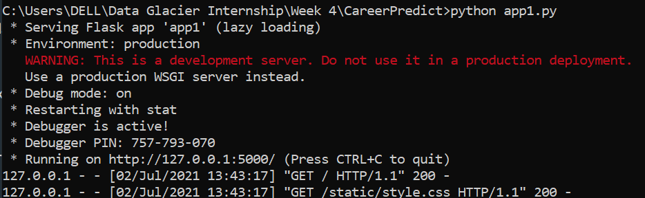

**STEP 2-**

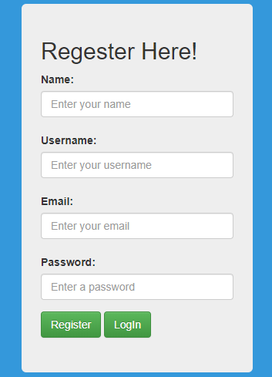

**STEP 3-**

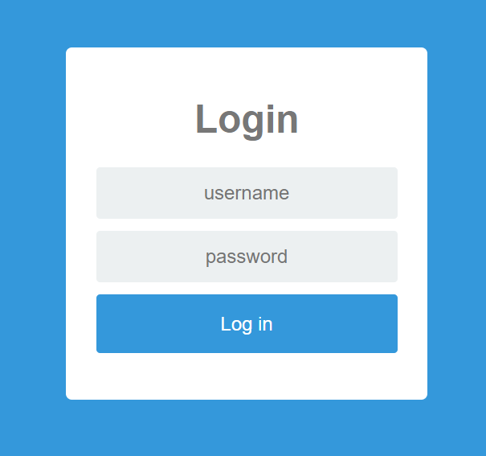

**STEP 4-**

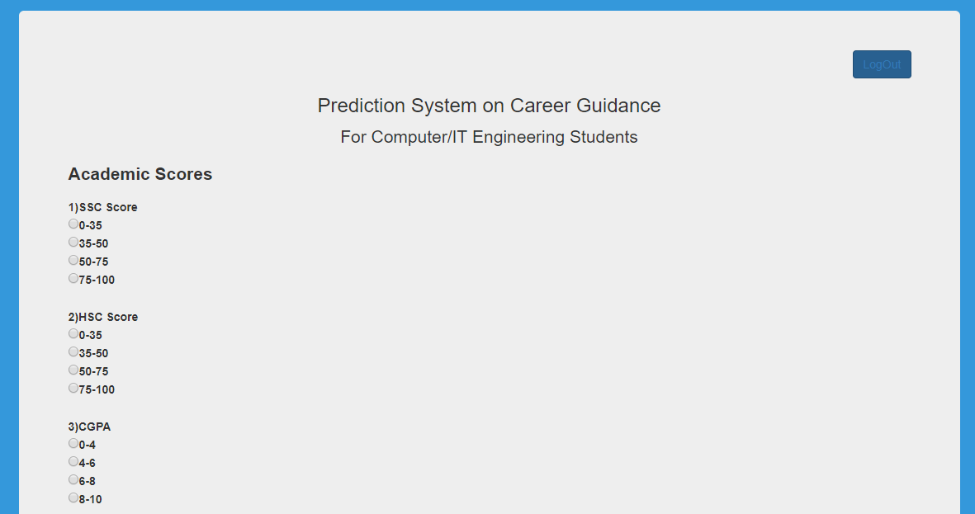

**STEP 5-**

