CHAPTER 1
INTRODUCTION

INTRODUCTION
Individuals with visual impairments rely heavily on assistive technologies to interact with the world around them. One of the most widely used systems for this purpose is Braille, a tactile writing system that allows blind and partially sighted people to read and write through touch. However, in the digital age, there is an increasing need for more advanced and efficient solutions that can bridge the gap between traditional Braille text and modern communication systems. One such solution is the conversion of Braille to speech, enabling visually impaired individuals to access written information audibly. The development of a Braille to speech conversion system combines multiple fields of technology, including image processing and machine learning, to translate tactile Braille symbols into audible speech. Python, with its rich libraries and frameworks, offers an ideal platform for implementing such a system. By capturing images of Braille text and processing them using image recognition techniques, the system can decode the Braille patterns and convert them into corresponding speech output

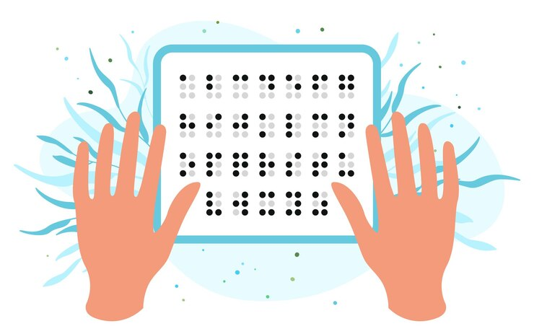
Fig(1):what is Braille

What is braille- Braille is a tactile writing system used by people who are visually impaired. It is traditionally written with embossed paper. Braille users can read computer screens and other electronic supports using refreshable braille displays. They can write braille with the original slate and stylus or type it on a braille writer, such as a portable braille notetaker or computer that prints with a braille embosser. Braille can help deaf-blind people access information in books and magazines, although it is not intended for use in one on one conversation. Some deaf-blind people do choose to use braille as a method to communicate with others.

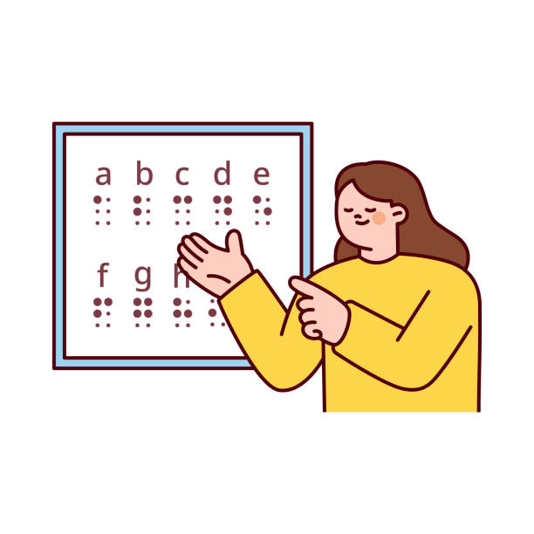

Braille Display- The Braille display uses raised symbols representing unique Braille letters. Using a Braille display makes it possible to use a computer and the internet. Although Braille cells are used world-wide, the meaning of each cell depend on the language that they are being used to depict. In English Braille there are three levels of encoding: Grade 1,a letter-by-letter transcription used for basic literacy; Grade 2, an addition of abbreviations and contractions; and Grade 3, contains over 300 abbreviations and contractions that reduce the amount of Braille codes needed to represent written text.

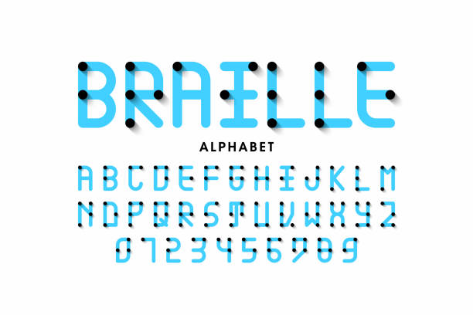
Braille Display- The Braille display uses raised symbols representing unique Braille letters. Using a Braille display makes it possible to use a computer and the internet. Although Braille cells are used world-wide, the meaning of each cell depend on the language that they are being used to depict. In English Braille there are three levels of encoding: Grade 1,a letter-by-letter transcription used for basic literacy; Grade 2, an addition of abbreviations and contractions; and Grade 3, contains over 300 abbreviations and contractions that reduce the amount of Braille codes needed to represent written text

Braille Code Versions:
- Grade 1: consists of the 26 standard letters of the alphabet and punctuation. It’s mainly used by people who just started reading braille.
- Grade 2: consists of the 26 standard letters of the alphabet, punctuation and contractions. The contractions are employed to save space because a braille page cannot fit as much text as a standard printed page. Books, signs in public places, menus, and most other braille materials are written in Grade 2 braille.
- Grade 3: is used only in personal letters, diaries, and notes. It is a kind of shorthand, with entire words shortened to a few letters.
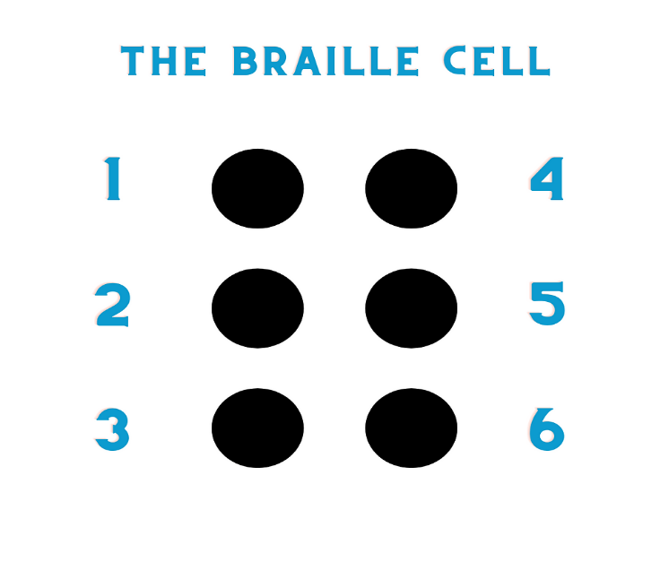

Basic Braille Cell- A Braille Cell is made up of six dots that fit under the fingertips, arranged in two columns of three dots each. Each cell represents a letter, a word, a combination of letters, a numeral or a punctuation mark. In Braille, an alphabet is made up by a combination of six dots. Each character in Braille consists of one or more (to a maximum of six) raised dots. The position of the different dots represents the different letters of the alphabet. The first ten letters of the alphabet are formed using the top four dots (1, 2, 4, 5). Adding a dot 3 makes the next ten letters and adding a dot 6 to that makes the last six letters.
This approach significantly enhances accessibility for individuals with visual impairments, enabling them to access printed materials without relying on Braille literacy alone. Moreover, it eliminates the need for bulky and expensive Braille-to-text hardware systems by providing a cost-effective software-based solution. In addition, the use of image processing ensures that even complex Braille structures can be accurately identified and translated into speech, offering a seamless reading experience. The convergence of Python’s programming capabilities with advanced image processing techniques not only provides a practical tool for visually impaired individuals but also underscores the importance of using technology to improve inclusivity and accessibility. Existing solutions for Braille-to-speech conversion are often expensive and not easily accessible to a broad audience

This project aims to develop a Braille-to-Speech conversion system that helps visually impaired individuals convert Braille input into human-readable speech. Braille, a tactile writing system used by the visually impaired, consists of patterns of raised dots. The proposed system will allow users to input Braille characters, which are then translated into speech using Python programming, enabling better communication and access to information. The proposed system uses Python and image processing techniques to convert Braille into speech, providing an affordable, open-source solution. The system works by capturing images of Braille characters using a camera, processing the images to recognize the raised-dot patterns, converting the recognized patterns into text, and then using a text-to-speech engine to generate audible speech. By integrating image processing with Python, the system offers a flexible platform that can be adapted for various environments and languages.

OBJECTIVE

1. To study and explore the various techniques for Braille to speech conversion.
The objective of this study is to conduct a comprehensive and systematic exploration of the various techniques, algorithms, and technologies used for Braille to speech conversion. Braille, being a tactile writing system used by visually impaired individuals, presents unique challenges and opportunities when translating it into audible speech. This study aims to delve deeply into understanding how Braille characters, which are typically represented as raised dots in specific patterns, can be accurately and efficiently converted into spoken words using a range of methods..
2. To design a system that converts Braille into speech in real-time
The aim of this project is to design and develop an efficient system that is capable of converting Braille text into audible speech in real-time. This system will focus on accurately recognizing Braille patterns, whether they are input through tactile sensors, scanned images, or electronic Braille displays, and immediately transforming them into corresponding spoken words. The real-time aspect is crucial, as it ensures minimal delay between input detection and speech output, providing a seamless and intuitive experience for users.
3. To enhance the accessibility of communication for visually impaired individuals
The primary goal of this project is to enhance the accessibility of communication for visually impaired individuals by developing innovative solutions that bridge the gap between Braille literacy and auditory comprehension. Communication is a fundamental human need, and for visually impaired persons, accessing written or printed information remains a significant challenge. By introducing technologies that can seamlessly convert Braille into speech or integrate Braille interpretation with auditory outputs, the project seeks to empower these individuals with greater independence, ease of information access, and improved quality of life.

4. To provide an affordable and efficient solution using Python, Open CV and open-source platform
The objective of this project is to provide an affordable, efficient, and scalable solution for Braille to speech conversion by utilizing Python programming language, OpenCV for image processing, and other open-source platforms and tools. By leveraging the flexibility and power of open-source technologies, the project aims to significantly reduce development costs while maintaining high performance, reliability, and adaptability. Python, being a versatile and widely supported language, offers extensive libraries and frameworks that are ideal for rapid prototyping and deployment of machine vision and speech synthesis applications

5. To simulate and verify the operation of proposed system
The purpose of this objective is to simulate and verify the operation of the proposed Braille to speech conversion system in order to ensure its accuracy, efficiency, and reliability before real-world implementation. Simulation allows for a thorough evaluation of the system's performance under various conditions and input scenarios, enabling the identification and resolution of potential errors or inefficiencies at an early stage. By using appropriate development environments, testing frameworks, and simulation tools, the behavior of the system — from Braille pattern recognition to real-time speech output — will be closely examined and validated.

6. To develop an efficient Braille recognition system using advanced image processing techniques.
The objective is to develop an efficient Braille recognition system by leveraging advanced image processing techniques to accurately detect and interpret Braille characters from captured images. Key tasks include preprocessing the input images through techniques like noise reduction, binarization, and contrast enhancement, followed by precise segmentation of individual Braille cells. The aim is to achieve high accuracy, low error rates, and fast processing speeds, thereby making the recognition system suitable for real-time applications.

7. To test the system on various datasets and real-world samples to evaluate its accuracy, speed, and reliability
The objective is to rigorously test the developed Braille-to-speech conversion system on a variety of datasets and real-world samples to thoroughly evaluate its accuracy, speed, and reliability. This involves creating a comprehensive testing framework where the system is exposed to different types of Braille inputs, including printed Braille documents, embossed papers, and handwritten Braille samples captured under varying environmental conditions such as lighting changes, background noise, and image distortions.

8. To integrate text-to-speech (TTS) functionality for converting recognized Braille text into natural, intelligible speech
The objective is to integrate text-to-speech (TTS) functionality into the Braille-to-speech conversion system to transform the recognized Braille text into natural, clear, and intelligible speech output. This component aims to ensure that once the Braille characters are accurately detected and translated into readable text, the information is immediately conveyed audibly to the user smoothly and understandably.

9. To document the development process and findings comprehensively for future researchers and developers.
The objective is to meticulously document the entire development process, methodologies, system design decisions, challenges encountered, solutions implemented, and the final findings of the Braille-to-speech conversion project. Comprehensive documentation will include detailed explanations of the algorithms used, image processing techniques applied, text-to-speech integration, system architecture diagrams, testing procedures, and performance evaluation results

PROBLEM WITH EXISTING SYSTEM

The current solutions for Braille-to-speech conversion suffer from several key limitations that prevent them from being universally accessible, affordable, and efficient for visually impaired individuals. These existing systems, while serving as potential tools for Braille literacy and communication, present challenges that hinder their widespread adoption and usability in real-world scenarios.

- High Cost of Existing Hardware-Based Systems
Many current systems for Braille-to-speech conversion are hardware-dependent, requiring specialized equipment such as Braille scanners, refreshable Braille displays, and custom-built Braille keyboards. These devices, while effective, come with a hefty price tag that makes them unaffordable for many visually impaired individuals, particularly in developing countries. The financial burden associated with purchasing and maintaining such specialized hardware often limits their accessibility, leaving a significant portion of the population without a viable solution for Braille-to-speech conversion. Additionally, many of these systems are not scalable or flexible enough to adapt to different languages or Braille formats, further limiting their effectiveness.

- Lack of Affordability and Accessibility
Even though some Braille-to-speech solutions have been developed in recent years, the majority of them are proprietary and designed for specific user groups, thereby excluding large segments of the population. The cost of licensing, maintenance, and software updates required for these systems often adds to the financial strain, making them difficult to integrate into everyday life. Furthermore, accessibility in terms of user interface design and customization options for individuals with various levels of visual impairment is often neglected, limiting the ability of users to personalize the system to their specific needs. Individuals with limited financial resources or those in underdeveloped regions remain underserved by these high-cost solutions.

- Limited Accuracy with Complex Braille Formats
Another significant issue with existing systems is their limited accuracy when dealing with complex Braille formats or specialized Braille notations, such as mathematical and scientific symbols, musical notations, or other technical Braille systems. While traditional Braille characters used for basic reading and writing are often well-supported by most existing technologies, advanced Braille characters—often required in academic and professional contexts—present challenges for conversion systems. The lack of versatility in recognizing non-standard Braille patterns or complex multi-cell configurations severely restricts the system's practical use in higher education or technical fields where specialized Braille symbols are frequently used. As a result, users of these systems are often forced to compromise on the types of content they can effectively access.

- Poor Image Processing in Camera-Based Systems
In systems that rely on image processing for Braille recognition, the accuracy of the system is heavily dependent on the quality of the captured images. Issues such as poor lighting conditions, image distortions, motion blur, and background noise can significantly affect the recognition accuracy, leading to incorrect translations of Braille patterns. Current camera-based systems struggle with processing Braille images under less-than-ideal conditions, often requiring ideal lighting and high-quality cameras to function optimally. For many visually impaired users, this dependence on ideal conditions becomes a major obstacle, as real-world environments are rarely free from distractions or challenges that affect image quality.

- Lack of Support for Multi-Language Braille Conversion
Most of the existing systems are language-specific and only support Braille-to-speech conversion for a limited number of languages or regions. This creates a significant barrier for users who require multi-lingual support or live in areas where Braille is used in non-standard forms. As languages like Arabic, Hindi, or Japanese employ different Braille patterns than English or European languages, the lack of cross-linguistic support means that users with diverse linguistic backgrounds are excluded from using such technologies.

- Limited Real-Time Performance and Processing Speed
While some systems do provide Braille-to-speech functionality, many of them lack the ability to perform real-time translation effectively. Existing systems are often slow in recognizing and processing Braille characters, causing significant delays between capturing the Braille input and hearing the corresponding speech output. This latency makes it difficult for users to rely on these systems for real-time interaction and makes the system less practical for everyday use, such as reading books, menus, or signs while on the go. Slower processing times also impede the system’s usability in scenarios where users require immediate feedback or when interacting with dynamic content.

- Difficulty in Customization and Usability
Many of the available Braille-to-speech systems lack the flexibility and ease of use required to cater to different user needs. Customization options—such as adjusting speech speed, pitch, or volume—are often limited, leaving users with little control over the system’s output. Moreover, the user interfaces of many systems are not designed with accessibility in mind, resulting in frustration and user errors. For visually impaired individuals, intuitive navigation and ease of use are essential for daily engagement with the technology, yet existing solutions often fail to meet these expectations. Complexity in operation and a lack of clear instructions further alienate users, especially those who may not be tech-savvy or familiar with specialized assistive technologies.

- Inadequate Real-World Testing
Existing systems often undergo limited testing in controlled environments that do not adequately simulate the complexities of real-world usage. Factors like variable lighting, hand tremors, ambient noise, and image distortions in everyday settings can drastically affect the system's performance. Inadequate testing in these real-world conditions can lead to false positives, missed Braille patterns, or misinterpretations, significantly hindering the system's effectiveness. Without proper field testing and user feedback, the systems fail to address the practical challenges visually impaired individuals face in daily life.

  - PROPOSED IMPROVEMENTS
While existing Braille-to-speech systems provide a valuable service for visually impaired individuals, the aforementioned limitations necessitate the development of an improved solution that offers greater accessibility, accuracy, and ease of use. The following proposed improvements aim to overcome these challenges and enhance the effectiveness of Braille-to-speech conversion systems.
1. Cost Reduction and Accessibility
One of the primary goals of the proposed system is to create an affordable solution that can be widely accessible to visually impaired individuals, regardless of their geographic location or financial situation. By utilizing open-source platforms like Python and popular image processing libraries such as OpenCV, the system significantly reduces the cost of deployment. Unlike proprietary hardware-based solutions, this approach does not require expensive specialized devices, making it an ideal choice for individuals in developing countries or those with limited resources. Additionally, by providing a software-based solution, it can be easily distributed and accessed via smartphones, tablets, or personal computers, increasing the reach and accessibility for a broader audience.
2. Enhanced Image Processing for Improved Accuracy
To address the dependency on image quality in existing systems, the proposed system will incorporate advanced image processing techniques that significantly improve the accuracy of Braille recognition. By integrating methods like adaptive thresholding, edge detection algorithms (Canny, Sobel), and noise reduction to the image preprocessing pipeline, the system will be able to handle low-light conditions, distorted images, and real-world variances more effectively. The use of machine learning techniques, such as convolutional neural networks (CNNs), will further enhance the system's capability to recognize Braille patterns even in challenging environments. Additionally, the integration of dynamic image correction techniques, including perspective transformation and image de-skewing, will allow the system to process captured images of Braille text from various angles and positions, ensuring reliable recognition regardless of how the user holds the Braille document or object.

3. Real-Time Performance and Speed Enhancement
To improve the real-time conversion of Braille into speech, the system will focus on optimizing processing speed without compromising accuracy. By utilizing efficient image processing algorithms and employing parallel processing techniques, the system will be able to detect and recognize Braille characters almost instantaneously. Additionally, integration with low-latency TTS engines such as pyttsx3 or gTTS will help reduce the delay between recognition and speech output, providing users with a seamless and responsive experience. The implementation of edge computing or cloud-based processing can further reduce the computational load on user devices, making the system even more efficient.
4. Multi-Language and Multi-Format Support
A major limitation of existing Braille-to-speech systems is their inability to support multiple languages and Braille formats. The proposed system will be designed with multi-lingual support in mind, allowing for the recognition and conversion of Braille text in different languages such as English, Arabic, Hindi, Spanish, and others. This feature will be made possible by integrating a language model into the Braille recognition process, allowing the system to detect which language is being used and apply the corresponding Braille rules.
Moreover, the system will be capable of handling complex Braille formats (such as mathematical Braille, musical Braille, and scientific notations), which are often not supported by traditional systems. This will be achieved by expanding the Braille character database to include a wider range of symbols and notations and by incorporating advanced symbol recognition algorithms to ensure accurate translation.
5. Expanded Support for Educational and Professional Use
The proposed improvements will also make the system more suitable for educational and professional applications. By supporting more complex Braille formats, integrating with learning management systems, and offering multi-lingual capabilities, the system will allow visually impaired students and professionals to access a broader range of academic, technical, and professional resources.

6. Robust Image Preprocessing Techniques
Advanced preprocessing methods such as adaptive thresholding and edge detection (using algorithms like Canny) will be implemented to enhance Braille dot detection, even under varied lighting and image quality conditions.
7. Accurate Braille Dot Detection
Using precise contour detection and shape analysis, the system ensures that Braille dots are differentiated clearly from the background, minimizing errors in Braille character recognition.
8. Direct Braille-to-Text Mapping
The proposed system introduces an advanced all-wheel drive mechanism that enhances vehicle mobility and stability in various road conditions. Unlike traditional vehicles that rely on front-wheel or rear-wheel drive, this system ensures equal power distribution to all wheels, providing improved traction and control. This feature is particularly beneficial in off-road conditions, slippery terrains, and emergency situations where precise vehicle control is crucial. Unlike conventional systems that require manual adjustments for different terrains, this improvement ensures automatic adaptation to varying road conditions, enhancing both safety and performance.
9. Open-Source Expandability
As the system is built entirely using open-source technologies, future developers and users can easily customize, expand, or localize the system according to different Braille standards or languages without starting from scratch. The entire system is built using widely available, open-source Python libraries like OpenCV for image processing and gTTS/pyttsx3 for text-to-speech conversion, eliminating the need for proprietary software or licenses. The Python code is organized into modular components (image acquisition, preprocessing, recognition, TTS output), allowing developers and researchers to easily modify, upgrade, or replace specific parts of the system without overhauling the entire project.
10. Fast Processing for Near Real-Time Output
The image processing pipeline is optimized for speed, allowing the Braille-to-text conversion and subsequent speech output to happen quickly with minimal delay, providing a real-time experience to users.

11. Handling Image Distortions and Skew
The system applies de-skewing and perspective correction techniques to ensure that Braille patterns are recognized correctly, even when the image is captured at an angle or under uneven lighting.

  - PROPOSED SOLUTION
The proposed system is designed to provide a cost-effective, efficient, and accessible Braille-to-Speech conversion method for visually impaired individuals. It utilizes Python programming, image processing techniques, and text-to-speech (TTS) conversion to accurately and reliably translate Braille input into audible speech output.
1. Robust Image Acquisition
Capture clear and high-resolution images of Braille documents using a standard camera to ensure the quality needed for accurate processing. To ensure accurate Braille recognition, the system begins with the acquisition of high-quality images of Braille text using a standard or mobile camera. Emphasis is placed on capturing images under good lighting conditions, minimizing noise, blur, and distortions. Proper image acquisition lays a strong foundation for all subsequent image processing steps, directly influencing the reliability and accuracy of Braille dot detection and recognition.
2. Image Preprocessing
Apply preprocessing techniques such as grayscale conversion, thresholding, noise removal, and contrast enhancement to improve image clarity and prepare it for Braille pattern detection. After acquiring the image, the system applies essential preprocessing steps to enhance the quality and prepare it for accurate Braille dot detection. Techniques such as grayscale conversion reduce complexity by eliminating color information, thresholding sharpens the distinction between dots and the background, and noise removal eliminates irrelevant details. Additional contrast enhancement is applied to ensure clear visibility of Braille patterns, making the image suitable for reliable feature extraction.
3. Braille Dot Detection
Use OpenCV methods (like contour detection, edge detection) to identify the position and structure of Braille dots accurately within the preprocessed image. The preprocessed image undergoes Braille dot detection using image processing techniques like edge detection (e.g., Canny or Sobel filters) and contour extraction. These methods identify and isolate the raised dots from the background.

4. Braille Cell Segmentation
Segment the detected dots into proper six-dot Braille cells, ensuring that each Braille character is isolated correctly for further recognition. Once individual Braille dots are detected, the system organizes these dots into structured Braille cells based on their spatial arrangement. Proper segmentation ensures that each group of six dots is accurately mapped to a single Braille character. Techniques like grid-based alignment and dot clustering are used to distinguish between separate characters, ensuring that the translation from dots to text remains consistent and precise.
5. Direct Braille-to-Text Mapping
Map the segmented Braille cells directly to corresponding alphabetic characters, numbers, or punctuation marks using a pre-defined Braille code database. After successful segmentation, the system directly maps the identified Braille cells to their corresponding text characters (letters, numbers, or punctuation marks). This mapping relies on a predefined database of Braille codes, ensuring accurate translation of the tactile patterns into readable text. The system uses pattern recognition algorithms to match the detected cell configurations with the correct Braille character, enabling seamless conversion of the tactile input into written language.
6. Error Handling and Validation
Implement validation techniques to verify the detected patterns and correct minor recognition errors, improving overall system reliability. To improve the accuracy and reliability of the system, error handling and validation techniques are implemented during the Braille recognition process. After the direct Braille-to-text mapping, the system verifies the output by comparing it with a set of predefined rules or dictionaries. Any inconsistencies or ambiguous character detections are flagged and corrected using validation algorithms. This ensures that minor recognition errors, such as misinterpreted dots or distorted patterns, are identified and rectified, providing a more reliable output for the user.
7. Text Formatting and Structuring
Arrange the recognized characters into meaningful words and sentences, preserving the natural flow of the original content as much as possible. Once the Braille characters are successfully converted into text, the system ensures that the recognized text is properly structured to maintain readability and coherence. This involves arranging the recognized characters into words, sentences, and paragraphs, preserving the original layout as much as possible.
8. Reliable Text-to-Speech (TTS) Conversion
Use Python-based text-to-speech libraries (like gTTS or pyttsx3) to convert the recognized text into natural, intelligible speech output. Once the Braille input is converted into structured text, the system utilizes a text-to-speech (TTS) engine to generate audible speech. The TTS system ensures high-quality, natural-sounding speech by integrating with libraries like pyttsx3 or gTTS in Python.
9. User-Friendly Audio Output
Deliver clear, adjustable speech output through speakers or headphones, allowing users to control the volume, language, or speech speed according to their preferences. To enhance the user experience, the system ensures that the generated speech is clear and easy to understand. The audio output is designed to be delivered via speakers or headphones, with adjustable volume and voice settings to suit individual preferences.
10. Open-Source Platform and Expandability
Build the system using open-source tools and libraries (Python, OpenCV, TTS engines), ensuring the solution remains cost-effective, flexible, and easy to improve or expand in the future. The system is built on open-source technologies, ensuring that it remains accessible, adaptable, and cost-effective. Python, along with libraries such as OpenCV and gTTS, forms the core of the system, making it easy for developers to modify and enhance the solution

CHAPTER 2
LITERATURE SURVEY

2.1 LITERATURE REVIEW

Sr  No. | Title of  Paper | Authors | Year of Publication | Name of  Journal | Conclusion
1 | Automate Extraction of Braille Text to Speech from an Image. | Vishnu Preetham Revelli, Gauri Sharma, S．Kiruthika devi | 2022 | Advances in Engineering Software, vol. 172 | The paper discusses how the model uses a custom CNN to classify Braille characters from new images.
2 | Translation of Six Tuple Grade-1 Braille Alphabet to English Alphabet | Vishwanath Venkatesh Murthy, M Hanumanthappa | 2021 | International Journal of Innovative Technology and Exploring Engineering | The paper discusses how The system's accuracy is evaluated by comparing the recognized characters
3 | Image to Speech Conversion for Visually Impaired | Asha G. Hagargund, Sharsha Vanria Thota, Mitadru Bera, Eram Fatima Shaik. | 2017 | International Journal of Latest Research in Engineering and Technology | The paper shows how  image text to speech for the visually impaired.
4 | Qualitative Analysis Framework for Converting Braille to Voice using Image Recognition | Archana.M, Dhivya.S | 2019 | International Journal of Latest Research in Engineering and Technology | This paper presents a solution to help visually impaired individuals who communicate in Tamil by converting Braille content.
5 | EXTRACTING TEXT FROM IMAGE AND BRAILLE TO SPEECH CONVERSION | R. Sathish Kumar, K. Sujai, R. Ajay , S. Vishva | 2023 | Eur. Chem. Bull. 2023,12(Special Issue 4) | The paper shows that Advancing Braille and TTS ensures accessibility and inclusivity.
6 | Text Reader for Visually Impaired Person using Image Processing/Open-CV | Aparna. V. Mote1, Rutuja Akhare2, Vaishnavi Barde3, Gitanjali Bhujbal4 | 2023 | International Journal of Latest Research in Engineering and Technology | The system successfully translates text to speech for visually impaired individuals using OCR
7 | Real-Time  Text to  Braille  and Audio Convertor | Sharavana K1, E Sivasubramanian2, Arpitha N3, Monish M Gowda4, Gajanan Manjunath Naik5, Vijayalakshmi6 | 2020 | International Research Journal of Engineering and Technology | The paper proposes real-time text-to-Braille and audio conversion.
8 | Speech to Braille Conversion Using Python | Gousiya Begum, N. Musrat Sultana, D.Hinduja | 2023 | International Research Journal of Engineering and Technology | The project enables speech-to-Braille conversion for the visually and hearing-impaired.

CHAPTER 3 Methodology

Flowchart for Braille-to-Speech System

Start

Capture Braille Image (Camera)

Preprocessing:
- Convert to Grayscale
- Apply Bilateral Filter (Noise Removal)
- Canny Edge Detection (Edge Detection)
- Warping & Cropping (Focus on Text Region)
- Thresholding (Prepare for Recognition)

Braille Character Recognition:
- Contour Detection (Dots)
- Group into Braille Cells
- Extract Dot Patterns
- Map Patterns to Text

Text-to-Speech Conversion:
- Send Text to TTS Engine (pyttsx3 / gTTS)
- Customize Voice, Speed, Language

Audio Output:
- Play Speech via Speakers/Headphones

End
Methodology for Braille-to-Speech System

The proposed Braille-to-Speech system is designed with a series of modular components, each responsible for a critical function, as outlined . The overall workflow ensures accurate recognition of Braille text and its seamless conversion into speech output.
The proposed system aims to bridge the communication gap for visually impaired individuals by converting Braille script into audible speech. The methodology follows a structured pipeline as illustrated in Figure 1, comprising five major stages:

1. Image Acquisition

The system's operation begins with capturing a clear and high-quality image of the Braille document. Key aspects involved are:
- Camera Selection: A high-resolution camera (preferably >12 MP) is used to ensure fine details like small raised dots are distinguishable. Mobile device cameras or dedicated document scanners with macro focus capabilities may be employed.
- Lighting Conditions: Proper illumination (preferably diffuse lighting) is crucial to minimize shadows and glare, which could interfere with accurate dot recognition.
- Positioning: The camera should be aligned perpendicularly to the Braille document to avoid perspective distortions.
- Multiple Capture Attempts: To enhance reliability, multiple images might be captured in quick succession, allowing the system to select the clearest one based on focus and contrast metrics. Once the image is captured successfully, it is passed to the preprocessing stage for enhancement.

2. Preprocessing

Preprocessing prepares the raw input for effective Braille character recognition by systematically refining the image:
- Colour to Grayscale Conversion:
  - The image is first converted from RGB (color) to grayscale.
  - Grayscale images simplify the processing pipeline, reduce computational complexity, and are compatible with most OpenCV functions.

- Noise Removal:
  - A bilateral filter is applied, which smooths the image while preserving important edge details such as the contours of the Braille dots.
  - Compared to Gaussian or median filters, bilateral filtering better retains edges, making it ideal for dot preservation.
- Edge Detection:
  - Canny Edge Detection is used because it effectively identifies sharp transitions in intensity, crucial for detecting the outlines of the Braille dots.
  - Key parameters like the lower and upper threshold values are carefully tuned to ensure only significant edges (dots) are detected while ignoring background textures.
- Warping and Cropping:
  - Using detected contours, the region containing Braille text is isolated.
  - Perspective transformation (warping) corrects any skewed angles, ensuring that the Braille cells are properly aligned for analysis.
  - Cropping removes unnecessary background regions, focusing the system's attention solely on the text area.

- Thresholding:
  - Adaptive or global thresholding converts the grayscale image into a binary image (black and white).
  - This enhances contrast between the dots and the background, making subsequent feature extraction more reliable.
  - The output resembles a clean, scanned document — ideal for analysis.
This pre-processed image is now clean, aligned, and optimized for dot pattern recognition.

3. Braille Character Recognition

The core recognition process focuses on detecting and decoding the Braille dots into meaningful characters:
- Contour Detection:
- Using the binary image, contours corresponding to the raised dots are identified.
- Small, circular contours are filtered based on size, area, and circularity criteria to isolate only valid Braille dots.

- Cell Identification:
- Braille writing is structured in cells, each containing a grid of up to six dots (in a 2x3 matrix).
- The detected dots are grouped based on proximity into clusters that represent individual Braille cells.
- Clustering algorithms like K-means or simple distance-based grouping can be employed to segment the dots.

- Dot Pattern Extraction:
- Within each cell, the system determines the presence (1) or absence (0) of dots at standard Braille positions.
- Each unique combination of dots corresponds to a specific character, number, or symbol according to the Braille encoding standards.
- Character Mapping:
- A predefined Braille-to-Text dictionary or lookup table is used to translate the detected dot patterns into their textual equivalents.
- Special handling can be implemented for contractions (Grade 2 Braille) or mathematical symbols if the project scope includes them.
- The output at this stage is a correctly ordered text stream.

4. Text-to-Speech (TTS) Conversion

The recognized text is now converted into spoken words to make it accessible:
- TTS Engine Selection:
  - Two options can be used:
  - pyttsx3: Offline TTS engine, works without internet, and provides greater control over voice properties.
  - gTTS (Google Text-to-Speech): Online engine with high-quality, natural-sounding voices, but requires internet connectivity.
- Speech Synthesis Process:
  - The recognized text is fed into the selected TTS engine.
  - Language and accent settings are configured according to user preferences (e.g., English US, English UK, Hindi, etc.).
  - Optional parameters like speech rate, pitch, and volume can be adjusted for better clarity.
- Saving Audio:
  - The generated speech can either be played immediately or saved as an audio file (e.g., MP3 or WAV) for later playback.

5. Audio Output
The final processed speech is delivered to the user through an audio interface:
- Output Devices:
  - Built-in speakers, wired headphones, or Bluetooth-enabled devices can be used depending on user requirements.
- Additional Features:
  - Replay Option: Allows users to hear the content again.
  - Volume Control: Users can adjust the volume according to the environment.
  - Multi-Language Support: Enables switching between different languages if the Braille text is multilingual.
  - User Feedback Mechanisms: (optional) Simple sounds or vibrations can be added to notify users about successful/failed recognition.

Chapter 4
Implementation

Implementation

Implementing a Braille-to-Speech system involves several steps that require both hardware (for image acquisition) and software (for image processing, character recognition, and text-to-speech conversion). Here's a high-level implementation plan using Python and OpenCV for image processing, as well as pyttsx3 or gTTS for text-to-speech conversion.

Python libraries:
- OpenCV: For image processing.
- PyTTSx3 or gTTS: For text-to-speech conversion.
- NumPy: For handling image arrays.
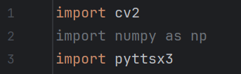

Step-by-Step Implementation

1. Image Acquisition (Capturing Braille Image)
You can use a camera (or a pre-captured image) to acquire the image of Braille text. Here, we’ll assume you already have the image file for simplicity.
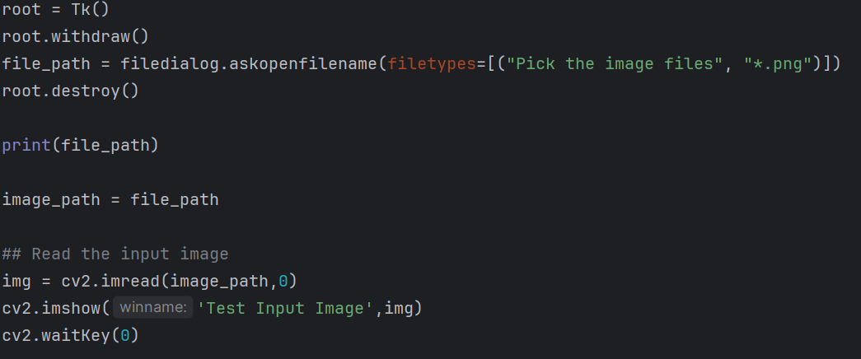

2. Preprocessing (Image Conversion and Noise Removal)

This step involves converting the image to grayscale, applying edge detection, and performing noise removal and thresholding.

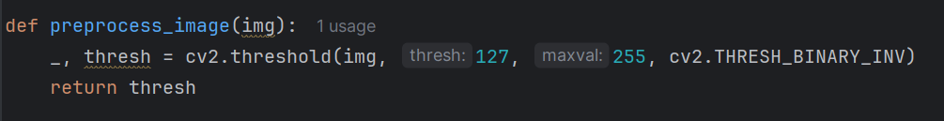

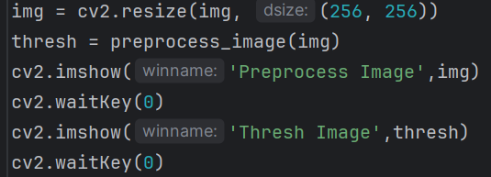
3. Braille Character Recognition (Pattern Matching)
In this step, we detect Braille characters by identifying the positions of raised dots in a 2x3 grid and mapping them to their respective letters.
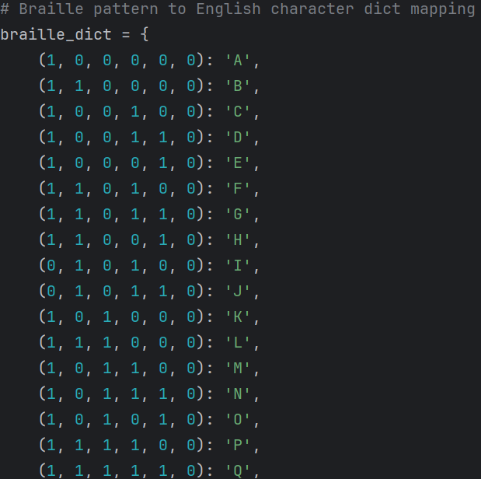

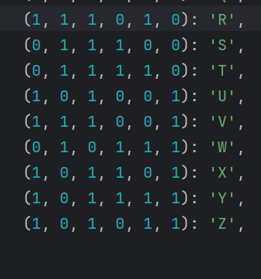
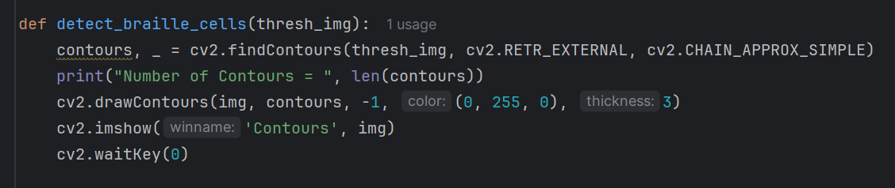

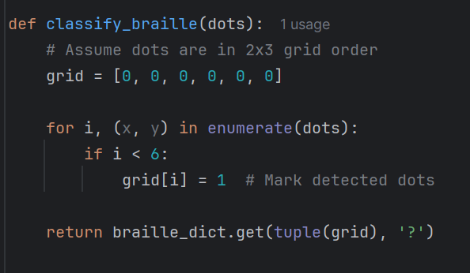

4. Text-to-Speech Conversion
Once the Braille characters are recognized and converted to text, we can use the pyttsx3 or gTTS library to convert the text to speech.

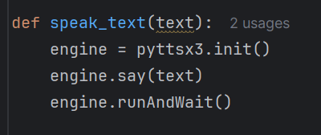

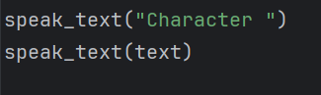

5. Audio Output
The audio output step is handled by the pyttsx3 or gTTS library. The pyttsx3 engine directly plays the speech, while gTTS saves it as an audio file (output.mp3) which can be played through a media player.

CHAPTER 5
HARDWARE DESCRIPTION

Components Require
- High resolution camera
- Webcam

1. High Resolution camera:
A high-resolution camera is a camera that captures images with a large number of pixels, resulting in greater detail and clarity. The resolution of a camera is typically measured in megapixels (MP), where one megapixel equals one million pixels
How Higher Resolution Impacts Images:
- More Detail: A higher resolution image contains more pixels, allowing it to capture finer details, textures, and subtle variations in colour and tone. This results in sharper and more lifelike images.
- Larger Prints: Higher resolution images can be printed at larger sizes without appearing pixelated or blurry. Each pixel in the digital image translates to a dot of ink on the print. More pixels mean more dots, leading to a smoother and more detailed print.
- Greater Cropping Flexibility: With a high-resolution image, you can crop a portion of the image and still retain a significant amount of detail. This is because the original image has enough pixels to allow for a smaller section to still have a usable resolution.
- Better Digital Zoom (to an extent): While optical zoom is always preferable for maintaining image quality when magnifying a scene, a higher resolution image can allow for some digital zoom with less noticeable degradation. Digital zoom essentially crops into the existing pixels and enlarges them, which can lead to blurriness. However, starting with more pixels means the cropped area still has a decent number of pixels.
Different Resolution Standards:
You might encounter different terms used to describe video and camera resolutions, such as:
- HD (720p): 1280 x 720 pixels (approximately 0.9 megapixels)
- Full HD (1080p): 1920 x 1080 pixels (approximately 2 megapixels)
- 2K (QHD or 1440p): 2560 x 1440 pixels (approximately 3.7 megapixels)
- 4K (UHD): 3840 x 2160 pixels (approximately 8.3 megapixels)
- 8K: 7680 x 4320 pixels (approximately 33 megapixels)
The higher the resolution of the camera, the more accurate the output is.
2. Webcam:

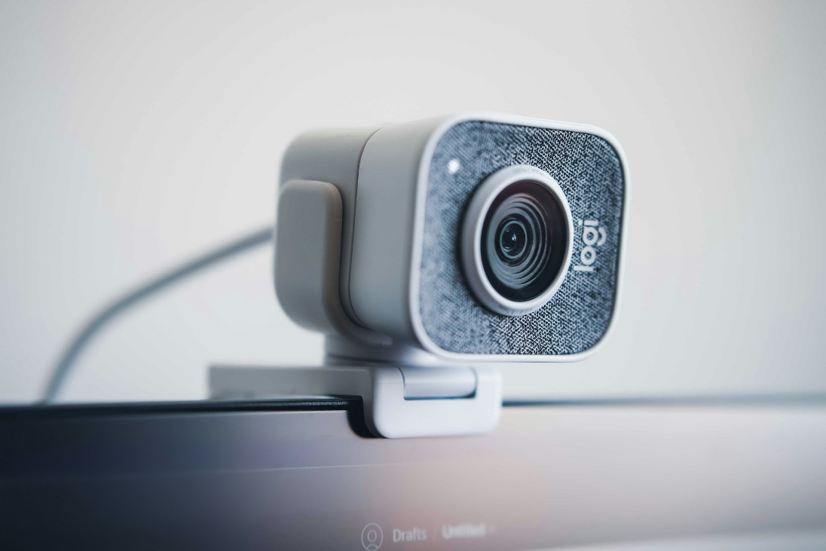
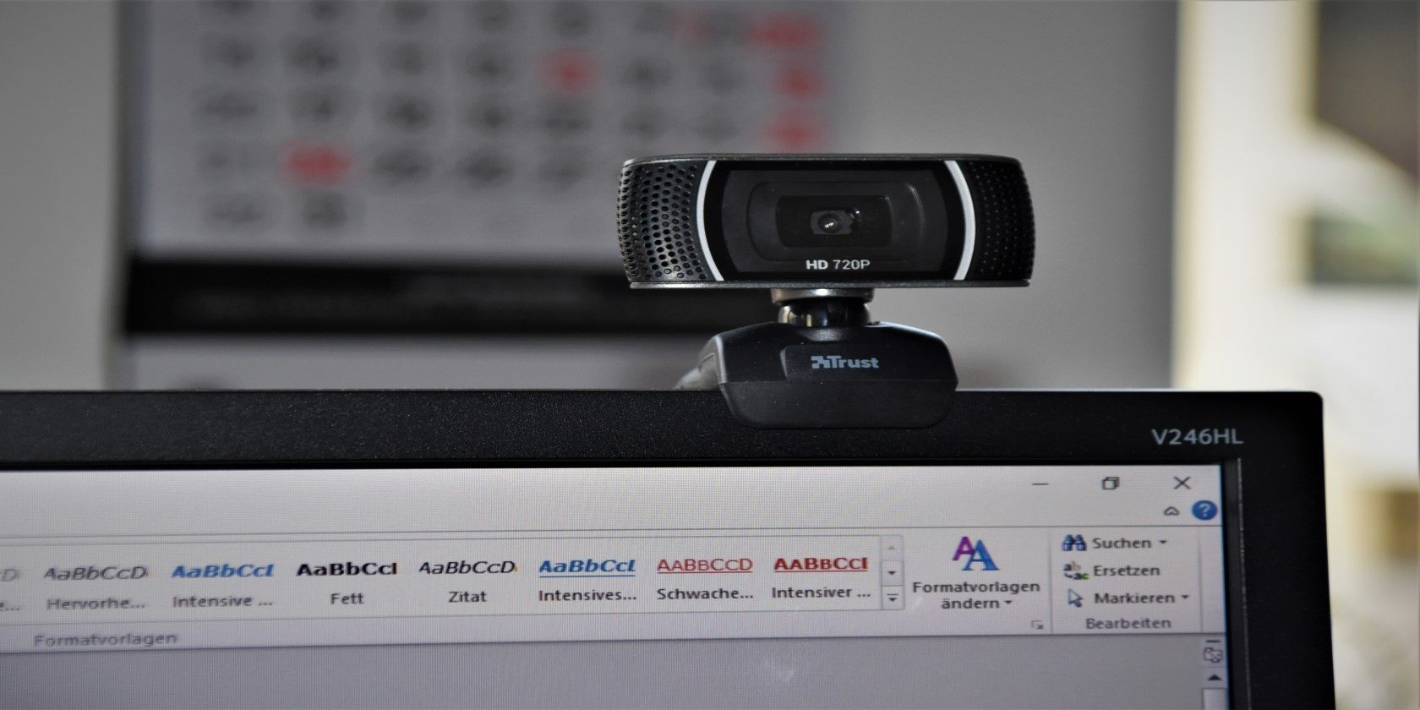

CHAPTER 6
SOFTWARE DESCRIPTION

6.1 Python:
Python programming language a versatile and highly readable tool that empowers you to build all sorts of things, from simple scripts to complex web applications and even dive into cutting-edge fields like data science and artificial intelligence. It is a dynamically type-checked and garbage-collected language. It supports multiple programming paradigms, including structured (particularly procedural), object-oriented & functional programming. It is often described as a "batteries included" language due to its comprehensive standard library.
- Why Python?
1. High-Level Language:
At its core, Python is a high-level programming language. What does this mean? It means that it’s syntax is designed to be very close to human language, making it easier for us to understand and write code. You don't need to worry about the intricate details of the computer's hardware as much as you would with lower-level languages. Python handles a lot of the underlying complexities for you.
2. Interpreted Language:
Python is an interpreted language. Unlike languages like C++ or Java that need to be compiled into machine code before running, Python code is executed line by line by an interpreter. This makes the development process faster because you can write and test your code incrementally without a separate compilation step. It also contributes to Python's portability, as the same code can often run on different operating systems as long as a Python interpreter is available.
3. Dynamically Typed:
Python employs dynamic typing. This means you don't need to explicitly declare the data type of a variable when you create it. The Python interpreter figures out the type (like integer, string, etc.) at runtime based on the value assigned to the variable.

4. Readability and Simple Syntax:
One of Python's most celebrated features is its emphasis on code readability. Its syntax is clean, concise, and uses English-like keywords. Indentation (whitespace) is not just for formatting; it's a crucial part of the language's structure, defining code blocks. This enforced readability makes Python code easier to write, understand, and maintain, especially when working on larger projects or collaborating with others.
5. Versatile and Multi-Paradigm:
Python is incredibly versatile and supports multiple programming paradigms. You can write code using:
- Procedural programming: Following a sequence of instructions.
- Object-oriented programming (OOP): Organizing code around "objects" that encapsulate data and behaviour. Python's OOP features include classes, inheritance, and polymorphism.
- Functional programming: Emphasizing the use of functions as first-class citizens.
This multi-paradigm approach allows you to choose the style that best suits the problem you're trying to solve.
6. Extensive Standard Library:
Python boasts a rich and comprehensive standard library. This is a vast collection of pre-built modules and functions that provide a wide range of functionalities right out of the box. Whether you need to work with files, network protocols, operating system interfaces, regular expressions, or even build simple web servers, chances are Python's standard library has you covered. This significantly speeds up development as you don't have to write everything from scratch.
7. Large and Active Community:
Python has a massive and incredibly active community of developers around the world. This is a huge advantage because it means:
- Abundant resources: You can find countless tutorials, documentation, online forums, and Stack Overflow discussions to help you learn and solve problems.
- Third-party libraries and frameworks: The community has contributed a vast ecosystem of powerful third-party libraries and frameworks that extend Python's capabilities even further. Think of libraries
like NumPy and Pandas for data analysis, Django and Flask for web development, TensorFlow and PyTorch for machine learning, and many more
6.2 Pycharm IDE:
PyCharm is a powerful Integrated Development Environment (IDE) specifically designed for Python development.
To reiterate the key points:
- It's a comprehensive tool that provides a wide range of features for writing, running, debugging, and managing Python code.
- It offers intelligent code editing with syntax highlighting, code completion, error detection, and quick fixes.
- It helps you manage your projects, work with virtual environments, and integrate with version control systems like Git.
- It has excellent debugging capabilities to help you find and fix errors in your code.
- The Professional Edition extends these features with support for web development frameworks (like Django and Flask), scientific computing libraries, database tools, and more.



6.3 Anaconda Navigator:
While Anaconda Navigator is a general management tool for the Anaconda distribution, PyCharm is a dedicated Integrated Development Environment (IDE) specifically for writing and debugging Python code.
- Anaconda Navigator helps you manage your Python installation and launch development environments.
- PyCharm is where you actually write and run your Python code, offering advanced features like code completion, error highlighting, debugging tools, and more.
PyCharm can be configured to use Anaconda as its Python interpreter and to work with conda environments.
This means you can leverage Anaconda's package and environment management capabilities from within the PyCharm IDE.
How Anaconda And Pycharm Work Together:
- Anaconda Provides the Foundation: When you install Anaconda, it comes with its own Python distribution and a package manager (conda). This provides a self-contained environment for your Python projects.
- Anaconda Navigator Launches PyCharm:Anaconda Navigator can detect and list PyCharm (if installed) as one of the applications you can launch. This provides a convenient way to start your IDE from within the Anaconda ecosystem.
- PyCharm Uses Anaconda Environments: The crucial link is that PyCharm can be configured to use the Python interpreter from one of your Anaconda environments. This is highly recommended because:
Isolation: It ensures that your PyCharm project uses the specific set of packages you've installed in that Anaconda environment, avoiding conflicts with other projects or your base Python installation.
Reproducibility: It makes it easier to share your project with others, as you can specify the exact Anaconda environment they need to recreate.

6.4 Python Libraries:

1. OpenCV:
OpenCV (Open Source Computer Vision Library) is a powerful and widely used open-source library for computer vision, image processing, and machine learning. Originally developed by Intel, it's now supported by Willow Garage and later Itseez (which was acquired by Intel). OpenCV is written in C++ but provides bindings for various programming languages, including Python, Java, and MATLAB. The Python bindings (often referred to as cv2 after the import statement) make it incredibly accessible for a wide range of users.
OpenCV in Python provides a vast array of functions and tools covering various aspects of computer vision:
1. Core Image Processing Operations:
- Image Input/output (I/O):Reading images from files (cv2.imread), writing images to files (cv2.imwrite). It supports various image formats (JPEG, PNG, TIFF, etc.).
- Basic Image Manipulation:
  - Accessing and modifying pixel values.
  - Getting image properties (width, height, number of channels, data type).
  - Region of Interest (ROI) manipulation (selecting and operating on specific parts of an image).
  - Splitting and merging image channels (cv2.split, cv2.merge).
- Colour Space Conversions: Converting images between different colour spaces (e.g., RGB to grayscale cv2.cvtColor, RGB to HSV, and BGR to RGB). Different colour spaces are useful for specific tasks.
- Geometric Transformations:
  - Resizing (cv2.resize).
  - Translation (shifting the image) (cv2.warpAffine).
  - Rotation (cv2.getRotationMatrix2D, cv2.warpAffine).
  - Affine transformations(preserving parallelism of lines) (cv2.getAffineTransform, cv2.warpAffine).
  - Perspective transformations (changing the viewpoint) (cv2.getPerspectiveTransform, cv2.warpPerspective).
  - Image pyramids (creating multi-scale representations).
- Image Filtering:
  - Smoothing: Blurring images to reduce noise using various filters like average blur (cv2.blur), Gaussian blur (cv2.GaussianBlur), median blur (cv2.medianBlur), and bilateral filter (cv2.bilateralFilter - preserving edges).
  - Sharpening: Enhancing edges and details.
  - Morphological Operations: Performing operations based on image shape, like erosion (cv2.erode), dilation (cv2.dilate), opening (cv2.morphologyEx with cv2.MORPH_OPEN), and closing (cv2.morphologyEx with cv2.MORPH_CLOSE). These are useful for noise removal and object separation.
- Image Gradients and Edge Detection:
  - Calculating image gradients using Sobel (cv2.Sobel), Scharr (cv2.Scharr), and Laplacian (cv2.Laplacian) operators.
  - Detecting edges using algorithms like Canny
2. Pyttsx3:
Pyttsx3 is a cross-platform text-to-speech (TTS) library in Python.Think of it as a way for your Python programs to "speak" text aloud. It works offline and supports multiple TTS engines available on your system.
Here's a breakdown of what makes pyttsx3 useful and how it works:
Key Features and Concepts:
- Text-to-Speech Conversion: The primary function of pyttsx3 is to convert written text into spoken words.
- Cross-Platform Compatibility: It's designed to work on various operating systems like Windows, macOS, and Linux without requiring significant code changes.
- Offline Operation: Unlike some online TTS services, pyttsx3 relies on the TTS engines already installed on your computer, meaning it can function without an internet connection.
- Multiple TTS Engine Support: pyttsx3 acts as a wrapper around different speech synthesis engines. This allows you to choose and utilize the available voices and capabilities of the underlying engine on your system. Common engines include:
- SAPI5 (Speech API 5): Primarily used on Windows. It often offers a variety of voices and configuration options.
- NSSpeechSynthesizer: The built-in speech synthesizer on macOS.
- Espeak: A software speech synthesizer that supports multiple languages and is commonly used on Linux.
- Voice Control: You can often select different voices available on your system (if the underlying engine supports it). This might involve specifying a voice ID or name.
- Speech Rate Control: pyttsx3 allows you to adjust the speed at which the text is spoken (words per minute).
- Volume Control: You can typically control the volume of the speech output.
- Blocking and Non-Blocking Speech:
  - engine.say (): Queues the text to be spoken but doesn't block the execution of your program. The speech might happen in the background.
  - engine.runAndWait (): Blocks the execution of your program until all queued speech commands are completed. This is often used to ensure the speech finishes before the program proceeds.

6.5 Image Processing:
What is Image Processing?
At its core, image processing is the manipulation and analysis of digital images using algorithms. The goal of image processing is to:
- Improve the visual quality of an image: Making it more suitable for human viewing or further analysis (e.g., noise reduction, contrast enhancement).
- Extract useful information from an image: Identifying objects, features, or patterns that are not immediately obvious (e.g., object detection, image segmentation).
- Transform or represent images in a different format: Preparing images for storage, transmission, or further processing (e.g., image compression).
Think of it as applying a series of operations to an input image to get a modified or interpreted output image or a set of characteristics/features.
The Image as a Digital Entity:
Before diving into the techniques, it's crucial to understand how computers represent images:
- Pixels: A digital image is composed of a grid of discrete elements called pixels (picture elements). Each pixel represents the brightness and colour at a specific point in the image.
- Resolution: The number of pixels in an image (width x height) determines its resolution. Higher resolution means more detail.
- Colour Representation:
  - Grayscale: Each pixel has a single value representing its intensity (typically ranging from 0 for black to 255 for white for an 8-bit image).
  - Colour Images: Pixels typically have multiple values representing colour channels. The most common is RGB (Red, Green, Blue), where each pixel has three values indicating the intensity of each primary colour. Other colour spaces like HSV (Hue, Saturation, and Value) or CMYK (Cyan, Magenta, Yellow, Key/Black) are also used.
- Data Type: Pixel values are stored as numerical data types (e.g., integers, floating-point numbers).

- Key Stages of Image Processing:
Image processing tasks often involve a sequence of steps:
- Image Acquisition: This is the process of obtaining a digital image. This can be done through various means like:
  - Digital cameras
  - Scanners
  - Medical imaging devices (MRI, CT scans)
  - Satellite and aerial imagery
  - Video capture
- Image Pre-processing: This stage aims to improve the image data to suppress unwanted distortions or enhance certain image features for further processing. Common pre-processing techniques include:
  - Noise Reduction: Removing or minimizing random variations in pixel intensity using filters like Gaussian blur, median filter, or bilateral filter.
  - Contrast Enhancement: Adjusting the intensity range of the image to improve visibility of details. Techniques include histogram equalization, contrast stretching, and gamma correction.
  - Geometric Correction: Correcting geometric distortions caused by the image acquisition process (e.g., perspective correction, image registration).
  - Image Resizing and Cropping: Adjusting dimensions or selecting a specific region of interest.
- Image Segmentation: This process divides an image into multiple regions or segments, often corresponding to different objects or parts of objects. Common techniques include:
  - Thresholding: Separating pixels based on their intensity values (e.g., creating a binary image).
  - Edge-Based Segmentation: Detecting boundaries between regions based on sharp changes in intensity.
  - Region-Based Segmentation: Grouping pixels with similar properties (e.g., colour, texture) into regions (e.g., region growing, split and merge).
  - Clustering-Based Segmentation: Using clustering algorithms (like K-means) to group pixels with similar features.
  - Deep Learning-Based Segmentation: Utilizing convolutional neural networks (CNNs) for semantic and instance segmentation.
- Feature Extraction: This stage involves identifying and extracting relevant features from segmented regions or the entire image. These features can be numerical descriptors that capture important characteristics of the image content. Examples include:
  - Shape Features: Area, perimeter, circularity, and aspect ratio.
  - Texture Features: Statistical measures of pixel intensity variations (e.g., using Gray-Level Co-occurrence Matrix - GLCM).
  - Colour Features: Histograms, mean colour, standard deviation of colour channels.
  - Local Features: Distinctive points and their descriptors that are invariant to certain transformations (e.g., SIFT, SURF, ORB).
- Image Analysis and Interpretation: This stage involves using the extracted features or segmented regions to understand and interpret the image content. This can involve:
  - Object Recognition: Identifying and classifying objects present in the image using machine learning algorithms (e.g., Support Vector Machines, Convolutional Neural Networks).
  - Pattern Recognition: Detecting specific patterns or structures within the image.
  - Image Understanding: Deriving a high-level understanding of the scene depicted in the image.
  - Decision Making: Using the analysed information to make informed decisions (e.g., in autonomous systems or medical diagnosis).
- Image Representation and Description: This involves summarizing the information extracted from the image in a meaningful way. This could be:
  - Generating textual descriptions of the image content.
  - Creating symbolic representations of the objects and their relationships.
  - Storing extracted features in a database for later retrieval or analyse.

CHAPTER 7
APPLICATION
AND
ADVANTAGES

7.1 APPLICATION

The Braille-to-Speech Conversion system has various applications aimed at enhancing the lives of visually impaired individuals:

- Assistive Devices for Visually Impaired Individuals
- Helps blind and partially sighted persons to access Braille text audibly.
- Reduces reliance on traditional Braille literacy and promotes easier communication.

- Affordable Educational Tools
- Can be used in schools, colleges, and training centers to support the education of visually impaired students.
- Enables visually impaired learners to access textbooks and study materials without needing specialized Braille versions.

- Library and Public Institution Services
- Public libraries and community centers can implement this technology to make printed Braille books accessible through audio output.

- Portable Mobile Applications
- Development into smartphone apps allows users to scan Braille text using their phone’s camera and hear the output instantly, improving daily life activities.

- Wearable Technology Integration
- Can be integrated with wearable devices like smart glasses, gloves, or portable scanners to provide real-time Braille reading in any environment.

- Home and Personal Use
- Visually impaired individuals can use this system at home to independently read product labels, medicines, and personal notes written in Braille.

- Healthcare Sector
- Hospitals and pharmacies can use the system to help patients independently access medical information written in Braille on packaging or documents.

- Content Digitization and Archiving
- Institutions can digitize old Braille documents into audio formats for easier storage, sharing, and accessibility.

- Smart City and IoT Integration
- Future integration with smart city initiatives can allow public spaces (like bus stops, banks, etc.) to have Braille text accompanied by audio outputs through simple installations.

- Learning and Braille Literacy Improvement
- Beginners learning Braille can use the system for immediate audio feedback, helping both children and adults improve their reading skills.

  - ADVANTAGES

- Increased Accessibility:
- The system bridges the gap between printed text and auditory comprehension for visually impaired individuals, enabling broader access to educational, professional, and leisure reading materials.

- It reduces reliance on traditional Braille literacy, which can be a barrier for individuals who have not received formal Braille education.

- By supporting multiple languages and fonts through image processing, the system can accommodate a wider range of printed materials.

- Audio output allows for dynamic interaction, including adjustable reading speeds and voice modulation, further catering to individual user preferences

- Cost-Effective Solution:
- Traditional Braille-to-text hardware, such as refreshable Braille displays and optical Braille readers, are often prohibitively expensive and not accessible to many users.

- The software-based approach leverages open-source Python libraries and readily available imaging hardware (e.g., smartphone cameras), significantly reducing overall costs.

- Maintenance and upgrades are easier and less expensive compared to hardware-based solutions, as updates can be deployed through software patches.

- Scalability is enhanced, allowing the solution to be implemented widely in schools, homes, and workplaces without substantial financial investment.

- Portability and Ease of Use:
- The system can be deployed on commonly available devices like smartphones, tablets, and laptops, eliminating the need for specialized hardware.

- A user-friendly graphical interface can be developed to simplify interaction for users with varying levels of technical proficiency.

- Lightweight application design ensures that the system requires minimal processing power and storage, making it compatible with low- to mid-range devices.

- Portability enables users to access printed information in diverse environments, such as classrooms, public spaces, libraries, or while traveling.

- Efficient Processing:
- Image processing techniques like edge detection, binarization, contour mapping, and character segmentation are optimized for quick recognition of Braille patterns.

- Python’s efficient libraries (e.g., OpenCV, NumPy) are utilized to handle intensive computations, ensuring minimal latency between input capture and speech output.

- Parallel processing and multi-threading capabilities can be leveraged to further speed up Braille recognition and audio generation tasks.

- The system’s real-time performance minimizes delays, providing an experience comparable to natural reading speeds for the end-users.

7.3 DISADVANTAGES

- Image Quality Dependency:
- The performance of the Braille-to-speech system is highly sensitive to the quality of input images captured by the camera or scanner.

- Poor lighting conditions can cause shadows or overexposure, making it difficult to detect the fine dots that represent Braille characters.

- Motion blur, resulting from unsteady hands or moving cameras, can distort the Braille patterns, leading to incorrect symbol recognition.

- Image distortions such as skewed angles, noise, or background clutter can introduce significant errors in segmentation and feature extraction processes.

- Limited Accuracy with Complex Braille Structures:
- The system performs reliably when handling standard literary Braille, which includes simple letters and numbers.

- Complex Braille representations, such as Nemeth Code (used for mathematical and scientific notation) or Music Braille, present intricate patterns that are difficult for basic image recognition models to interpret accurately.

- Specialized Braille contractions and formatting rules (e.g., shorthand or Grade 2 Braille) may be inconsistently handled without dedicated decoding algorithms.

- Enhancing recognition accuracy for these complex formats would require incorporating domain-specific datasets, advanced OCR models, and additional training, thus increasing the system's complexity.

- Language Limitations:
- Initial implementations of the system may focus on a single language (such as English Braille), restricting its usability for speakers of other languages.

- Braille systems differ significantly across regions (e.g., English Braille vs. Hindi Braille vs. Arabic Braille), requiring custom models and datasets for multilingual support.

- Extending support to multiple languages involves challenges in dataset collection, training for unique Braille character sets, and ensuring accurate mapping to corresponding speech outputs.

- Future versions must incorporate dynamic language selection features and multilingual speech synthesis engines to widen accessibility.

- Environmental Constraints:
- Ambient lighting variations (such as too bright, too dim, or color-tinted lighting) can interfere with accurate Braille dot detection during image capture.

- Background noise can affect the clarity of speech output, especially if the system is used in a public or noisy environment without noise cancellation features.

- Background objects or patterns resembling Braille structures could cause false detections or misclassifications, reducing the system’s reliability.

- Ensuring robust operation under diverse environmental conditions may require implementing adaptive image enhancement techniques and noise-tolerant speech synthesis modules

CHAPTER 8
CONCLUSION
&
FUTURE SCOPE

8.1 FUTURE SCOPE

- Expansion to Multi-Lingual Braille-to-Speech Conversion:
- The system can be expanded to support multiple Braille languages, such as Bharati Braille, Arabic Braille, and French Braille.
- Customized recognition models and speech synthesis engines will be developed to accommodate the distinct encoding standards of each language.
- This expansion will broaden the system’s accessibility, ensuring it is useful for visually impaired users from diverse linguistic backgrounds.

- Integration with Other Assistive Technologies:
- The Braille-to-speech system can be integrated with speech recognition, screen readers, and haptic feedback devices to enhance user interaction.
- Voice commands could be added for system customization, such as adjusting the speed of speech or switching languages.
- Integration with existing technologies would create a multi-modal experience, offering both auditory and tactile feedback to users.

- Development of Mobile Applications for Increased Accessibility:
- A dedicated mobile application would increase the system’s portability, allowing users to convert Braille to speech using smartphones or tablets.
- The app could feature offline processing, making it accessible in areas with limited or no internet connectivity.
- Additional features like adjustable reading speeds, customizable voices, and language-switching can be incorporated to cater to individual preferences.

- Integration of Real-Time Braille-to-Speech Conversion via Wearable Devices:
- The system could be integrated into wearable devices, such as smart glasses or wristbands with embedded cameras, enabling real-time Braille reading.
- Wearables would allow users to access printed Braille text hands-free, enhancing mobility and convenience in dynamic environments.
- Real-time conversion would offer seamless access to information in places like public spaces, schools, and workplaces.

- Support for Multi-Lingual Braille Recognition and Speech Generation:
- Future versions of the system can detect and switch between multiple languages during a single session, automatically adapting to the Braille system being used.
- This would be especially useful in multilingual regions or for users who are fluent in several languages.
- The ability to dynamically handle multiple languages would make the system more versatile and user-friendly in a global context.

- Optimizing the System for Mobile Platforms to Increase Accessibility:
- Optimizations can be made to ensure the system runs efficiently on mobile devices, reducing processing time and memory usage.
- Techniques such as lightweight deep learning models, cloud-assisted processing, and real-time image processing algorithms could be implemented.
- By optimizing for mobile platforms, the system would be accessible to a larger user base, including those with mid-range or budget smartphones.

8.2 RESULTS

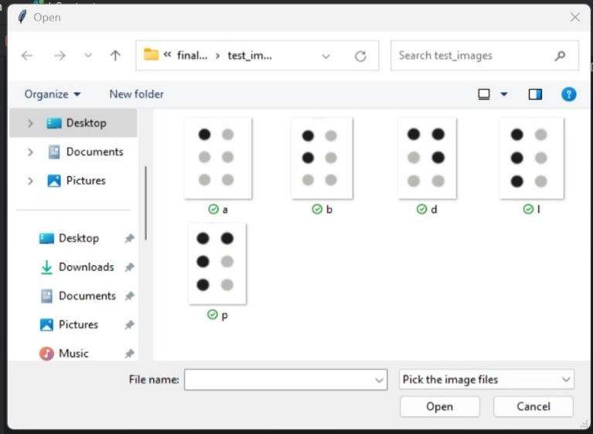
Screenshot (1): Image Acquisition
- Image acquisition is the process of capturing an image using a sensing device like a camera or scanner and converting it into a digital form for further processing.

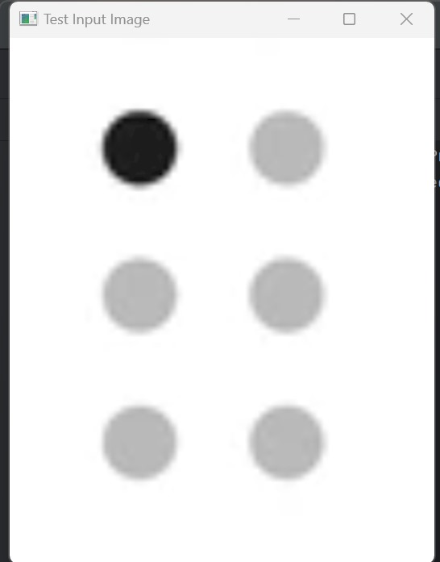
Screenshot (2): Selected Test Input Image
- The system begins by selecting a well-focused Braille image to enable precise detection of raised dot patterns.

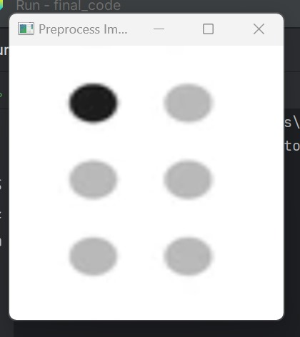
Screenshot (3): Image Preprocessing
- Image preprocessing enhances the captured Braille image by applying techniques like grayscale conversion, noise removal, and thresholding for better recognition.

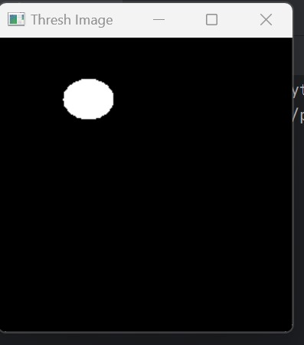
Screenshot (4): Image Threshold
- Thresholding simplifies the Braille image by converting it into a binary format, highlighting the raised dots for easier contour detection during processing.

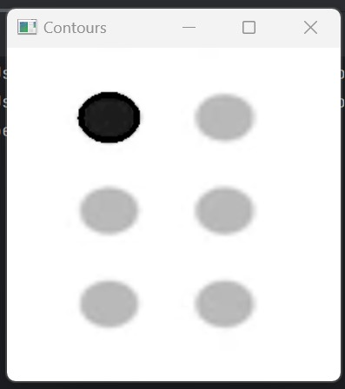
Screenshot (5): Contours Detection
- Contour detection identifies the outlines of Braille dots in the processed image, helping to locate and recognize individual Braille characters accurately.

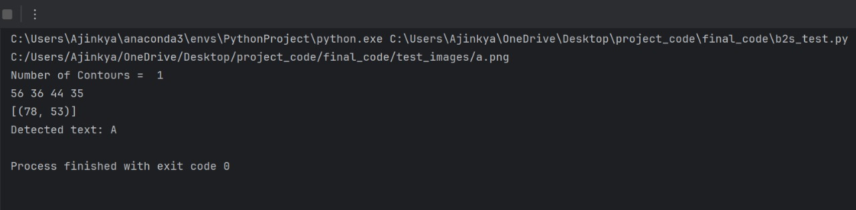
Screenshot (6): Text To Speech
- The text-to-speech module transforms the decoded Braille text into spoken audio, enabling real- time auditory access to written information for visually impaired individuals.

8.3 CONCLUSION

This project will present a Python-based Braille-to-speech conversion system that leverages image processing and text-to-speech technologies to provide an affordable and accessible solution for visually impaired individuals. The system successfully recognizes Braille characters from captured images and converts them into speech, making it an effective tool for improving communication and access to information for the visually impaired community. Also, the proposed system will offer visually impaired individuals a user-friendly and affordable tool to enhance their communication abilities.

References

- Revelli, Vishnu P., and Gauri Sharma. "Automate Extraction of Braille Text to Speech from an Image." Advances in Engineering Software, vol. 172, 2022, p. 103180, https://doi.org/10.1016/j.advengsoft.2022.103180. Accessed 18 Sept. 2024.

- Rajamani, Sathish & Sujai, K & Ajay, R & Vishva, S. (2023). EXTRACTING TEXT FROM IMAGE AND BRAILLE TO SPEECH CONVERSION. European Chemical Bulletin. 12. 11585-11596. 10.48047/ecb/2023.12.si4.10432023.24/05/2023.

- Sharavana K et.al., “Real-Time Text to Braille and Audio Convertor”, International Research Journal of Engineering and Technology, Volume: 07 Issue: 08 | Aug 2020.

- A. G. Hagargund et.al.. “Image to Speech Conversion for Visually Impaired”, International Journal of Latest Research in Engineering and Technology (IJLRET), ISSN: 2454-5031, Volume 03 - Issue 06 || June 2017 || PP. 09-15.

- Archana.M, “Qualitative Analysis Framework for Converting Braille to Voice using Image Recognition”, International Journal of Recent Technology and Engineering (IJRTE), ISSN: 2277-3878,Volume-8 Issue-3, September 2019.

- Lee, Dayeon, and Jinsoo Cho. "Automatic Object Detection Algorithm-Based Braille Image Generation System for the Recognition of Real-Life Obstacles for Visually Impaired People." Sensors, vol. 22, no. 4, 2021, p. 1601, https://doi.org/10.3390/s22041601. Accessed 18 Sept. 2024.

- A. V. Mote et.al., “Text Reader for Visually Impaired Person using Image Processing/Open-CV”, Ijraset Journal For Research in Applied Science and Engineering Technology, https://doi.org/10.22214/ijraset.2023.53004.

- Latif, Ghazanfar, et al. "Learning at Your Fingertips: An Innovative IoT-Based AI-Powered Braille Learning System." Applied System Innovation, vol. 6, no. 5, 2023

p.91, https://doi.org/10.3390/asi6050091. Accessed 18 Sept. 2024.

- Sreejith Set.al.,” BRAILE-READING DEVICE FOR THE DEAF AND BLIND IN REAL TIME SPEECH”, International Research Journal of Modernization in Engineering Technology and Science, Volume:05/Issue:06/June-2023.

- Vishwanath Venkatesh Murthy, M Hanumanthappa, “Translation of Six Tuple Grade-1 Braille Alphabet to English Alphabet”, International Journal of Innovative Technology and Exploring Engineering (IJITEE) ISSN: 2278-3075 (Online), Volume-10 Issue-9, July 2021.

PROGRAM CODE

import cv2
import numpy as np
import pyttsx3
from tkinter import *
from tkinter import filedialog
from matplotlib import pyplot as plt
from imutils import contours
import imutils
from skimage import io
import os,time
import warnings

# Braille pattern to English character dict mapping
braille_dict = {
(1, 0, 0, 0, 0, 0): 'A',
(1, 1, 0, 0, 0, 0): 'B',
(1, 0, 0, 1, 0, 0): 'C',
(1, 0, 0, 1, 1, 0): 'D',
(1, 0, 0, 0, 1, 0): 'E',
(1, 1, 0, 1, 0, 0): 'F',
(1, 1, 0, 1, 1, 0): 'G',
(1, 1, 0, 0, 1, 0): 'H',
(0, 1, 0, 1, 0, 0): 'I',
(0, 1, 0, 1, 1, 0): 'J',
(1, 0, 1, 0, 0, 0): 'K',
(1, 1, 1, 0, 0, 0): 'L',
(1, 0, 1, 1, 0, 0): 'M',
(1, 0, 1, 1, 1, 0): 'N',
(1, 0, 1, 0, 1, 0): 'O',
(1, 1, 1, 1, 0, 0): 'P',
(1, 1, 1, 1, 1, 0): 'Q',
(1, 1, 1, 0, 1, 0): 'R',
(0, 1, 1, 1, 0, 0): 'S',
(0, 1, 1, 1, 1, 0): 'T',
(1, 0, 1, 0, 0, 1): 'U',
(1, 1, 1, 0, 0, 1): 'V',
(0, 1, 0, 1, 1, 1): 'W',
(1, 0, 1, 1, 0, 1): 'X',
(1, 0, 1, 1, 1, 1): 'Y',
(1, 0, 1, 0, 1, 1): 'Z',
}

def preprocess_image(img):
_, thresh = cv2.threshold(img, 127, 255, cv2.THRESH_BINARY_INV)
return thresh

def detect_braille_cells(thresh_img):
contours, _ = cv2.findContours(thresh_img, cv2.RETR_EXTERNAL, cv2.CHAIN_APPROX_SIMPLE)
print("Number of Contours = ", len(contours))
cv2.drawContours(img, contours, -1, (0, 255, 0), 3)
cv2.imshow('Contours', img)
cv2.waitKey(0)

dots = []
for cnt in contours:
x, y, w, h = cv2.boundingRect(cnt)
print(x,y,w,h)
if 5 < w < 250 and 5 < h < 250: # filter likely dots
cx, cy = x + w//2, y + h//2
dots.append((cx, cy))

# print(dots)

# Sort and group dots into 2x3 grids
dots = sorted(dots, key=lambda p: (p[1], p[0])) # sort top to bottom, then left to right
# print(dots)

return dots

def classify_braille(dots):
# Assume dots are in 2x3 grid order
grid = [0, 0, 0, 0, 0, 0]

for i, (x, y) in enumerate(dots):
if i < 6:
grid[i] = 1 # Mark detected dots

return braille_dict.get(tuple(grid), '?')

def speak_text(text):
engine = pyttsx3.init()
engine.say(text)
engine.runAndWait()

# ---- Main Execution ----
root = Tk()
root.withdraw()
file_path = filedialog.askopenfilename(filetypes=[("Pick the image files", "*.png")])
root.destroy()

print(file_path)

image_path = file_path

## Read the input image
img = cv2.imread(image_path,0)
cv2.imshow('Test Input Image',img)
cv2.waitKey(0)

img = cv2.resize(img, (256, 256))
thresh = preprocess_image(img)
cv2.imshow('Preprocess Image',img)
cv2.waitKey(0)
cv2.imshow('Thresh Image',thresh)
cv2.waitKey(0)

patterns = detect_braille_cells(thresh)
print(patterns)

text = classify_braille(patterns)

print("Detected text:", text)

speak_text("Character ")
speak_text(text)

