Project Name
FaceLock – Biometric Authentication Module
This is a standalone AUTH MODULE that shows:
- How face-based login works in real systems
- How backend + frontend communicate
- How JWT auth is issued

🎯 PROJECT GOAL (VERY SIMPLE)
User can:
- Register with face
- Login using face
- Get JWT token
- Access a protected API
🧱 TECH STACK (MINIMAL & FREE)
Backend
- ASP.NET Core Web API (.NET 8)
- OpenCV (Emgu.CV) ✅ FREE
- EF Core
- SQL Server / LocalDB
- JWT Authentication
Frontend
- React
- Camera access (browser)
- Simple UI
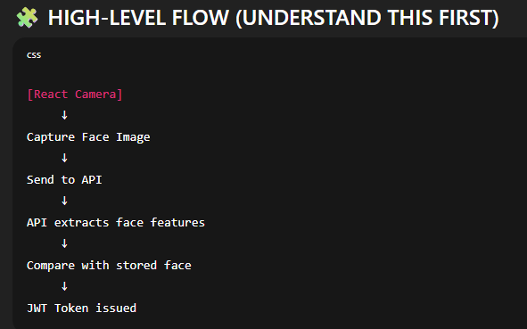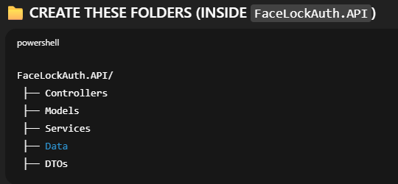
What each folder is for (just understand, don’t code yet):
- Controllers → API endpoints
- Models → DB entities
- Services → Business logic (face match, auth)
- Data → DbContext
- DTOs → Request/Response models

