**30-DAYS-OF-CODE**

**DAY-6 TO 7**

**DAY 6 - 30/04/22:** Loops

**DAY 7 - 01/05/22:** Loops/Jump Statements

**QUESTIONS**

1. Program to display the multiplication table of a given integer
2. Write a program  to display the pattern like right angle triangle using an asterisk
3. Write a program to make such a pattern like right angle triangle with a number which will repeat a number in a row.

 1

 22

 333

 4444

1. Write a program to display the pattern like a pyramid using asterisk and each row contain an odd number of asterisks.
2. Write a program to check whether a given number is a perfect number or not

**ANSWERS**

*Answer 1.*

#include<iostream>

using namespace std;

int main() {

    int num;

    cout<<"Enter Number: ";

    cin>>num;

    for(int a=1;a<=10;a++) {

        cout<<num<<" * "<<a<<" = "<<num*a<<endl;

    }

  return 0;

}

*Answer 2.*

#include <iostream>

using namespace std;

int main() {

  int n;

  cin>>n;

  for(int i=1; i<=n; i++) {

      for(int j=1; j<=i; j++) {

          cout<<"*";

      }

      cout<<endl;

  }

  return 0;

}

*Answer 3.*

#include <iostream>

using namespace std;

int main() {

  int n;

  cin>>n;

  for(int i=1; i<=n; i++) {

      for(int j=1; j<=i; j++) {

          cout<<i;

      }

      cout<<endl;

  }

  return 0;

}

*Answer 4.*

#include <iostream>

using namespace std;

int main() {

   int i,j,n;

   cin>>n;

   for(i=0;i<n;i++) {

     for(j=1;j<=n-i;j++)

     cout<<" ";

     for(j=1;j<=2*i-1;j++)

       cout<<"*";

     cout<<endl;

   }

  return 0;

}

*Answer 5.*

#include <iostream>

using namespace std;

int main() {

int i, num, sum = 0;

cout << "\nEnter a number : ";

cin >> num;

for(i=1; i<num; i++) {

if(num%i == 0) {

sum += i;

}

}

if(sum == num) {

cout << endl << num <<  " is a Perfect Number\n";

} else {

cout << endl << num << " is not a Perfect Number\n";

}

return 0;

}

**EXTRA QUESTIONS**

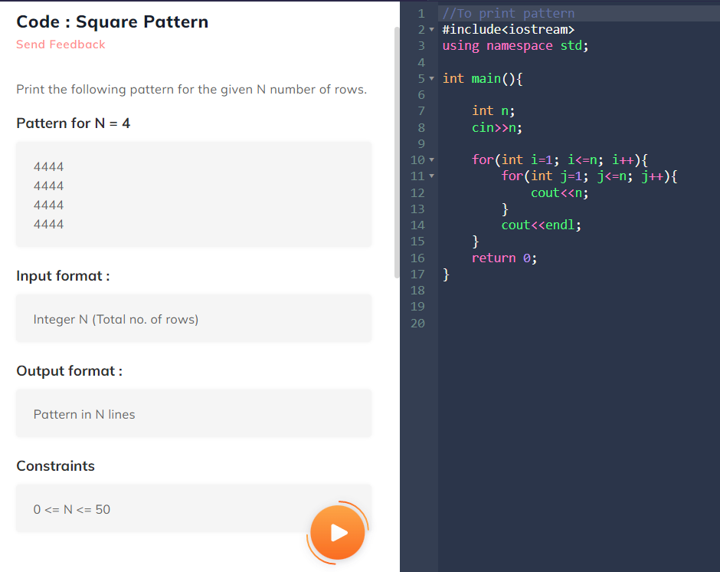

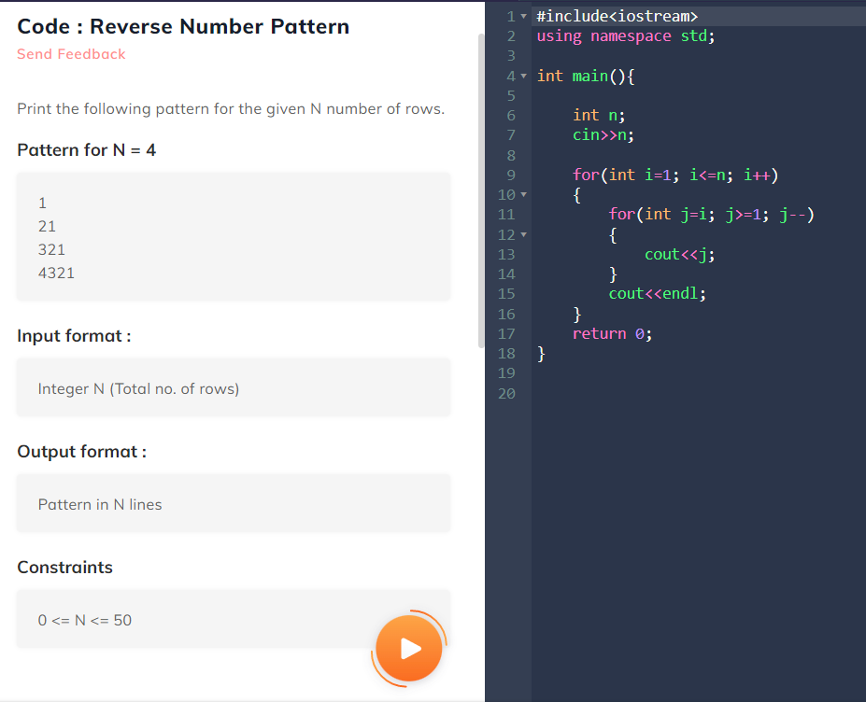

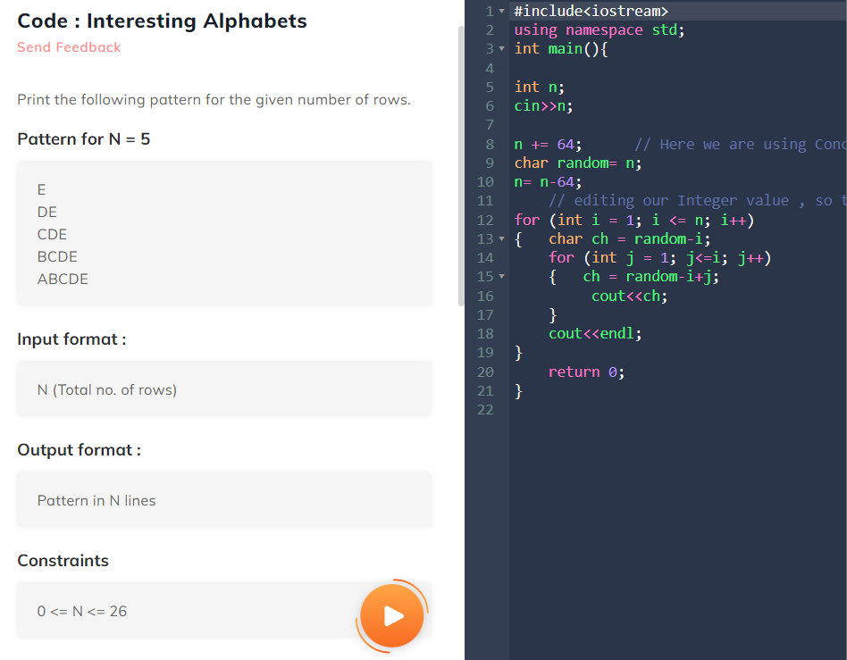

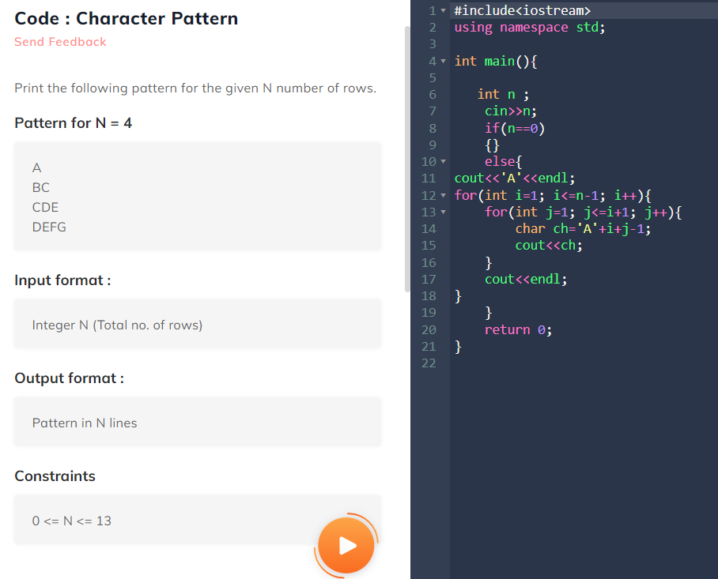

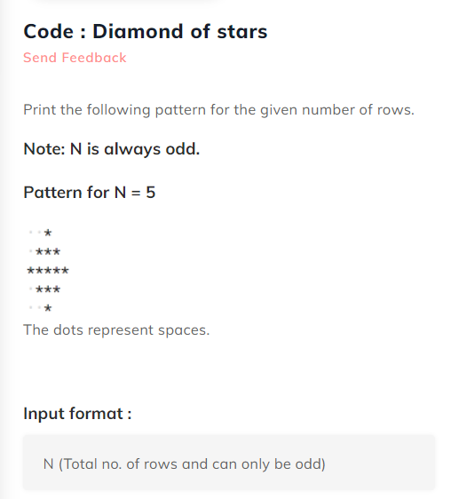

#include <iostream>

using namespace std;

int main() {

    int p,n,i,j,k,l;

    cin>>n;

    if(n%2==0)

    {}

    else{

for(int i=1; i<=(n/2)+1; i++){

    for(k=1; k<=(n/2)-i+1; k++){ //space

        cout<<" ";

    }

    for(j=1; j<=i; j++){

        cout<<"*";

    }

    for(l=i-1; l>=1; l--){

     cout<<"*";

    }

    cout<<endl;

}

for(int i=(n/2);i>=1; i--){

    for(k=1; k<=(n/2)-i+1; k++){ //space

        cout<<" ";

    }

    for(j=1; j<=i; j++){

       cout<<"*";

    }

    for(l=i-1; l>=1; l--){

    cout<<"*";

    }

    cout<<endl;

}

    }

   return 0;

}

