Real-Time Speech-to-Sign Language Translation using 3D Avatar

Raina Solanki  Department of Information Technology PVG’s College of Engineering and Technology, Pune Savitribai Phule Pune University, India  rainasolanki1405@gmail.com | Shruti Kulkarni  Department of Information Technology PVG’s College of Engineering and Technology, Pune Savitribai Phule Pune University, India  shrutichandrashekhar19@gmail.com
Shravani Joshi  Department of Information Technology PVG’s College of Engineering and Technology, Pune Savitribai Phule Pune University, India  shravnijoshi2212@gmail.com | Samruddhi Garge  Department of Information Technology PVG’s College of Engineering and Technology, Pune Savitribai Phule Pune University, India  samruddhi0857@gmail.com
Sonam Aslekar
Faculty Department of Information Technology PVG’s College of Engineering and Technology, Pune Savitribai Phule Pune University, India , India
sva_it@pvgcoet.ac.in

Abstract — Sign language translation systems play a critical role in bridging communication gaps between hearing and speech-impaired individuals. This paper presents a real-time speech-to-sign language translation framework that converts spoken English into American Sign Language (ASL) and renders the output through a dynamic three-dimensional avatar. The system integrates Whisper-based automatic speech recognition (ASR), Seq2Seq LSTM-based gloss generation, and skeletal motion reconstruction using landmark keypoints derived from the WLASL dataset via MediaPipe. Unlike conventional video playback systems, gestures are dynamically reconstructed from pose and hand landmarks, enabling modular gloss sequencing and reduced memory overhead. Experimental observations demonstrate stable low-latency performance and deterministic gloss prediction suitable for real-time assistive communication applications. The proposed architecture establishes a scalable and computationally efficient framework for multimodal speech-to-sign translation.
Index Terms — Sign Language Translation, Gloss Generation, MediaPipe, Speech Recognition, Avatar Rendering, Neural Networks

- INTRODUCTION
Modern human–computer interaction systems increasingly seek to reduce communication barriers through intelligent multimodal interfaces. Spoken language dominates digital interaction, yet it creates accessibility challenges for individuals who rely on sign language. Real-time speech-to-sign translation systems therefore play a vital role in assistive communication technologies. The primary challenge lies in designing solutions that are scalable, computationally efficient, and independent of heavy storage or specialized hardware.
Conventional speech-to-sign systems typically rely on prerecorded gesture videos or static lookup-table mappings. Although such methods provide visual output, they suffer from large memory overhead, limited vocabulary flexibility, and reduced composability. Video-based rendering further introduces latency and restricts dynamic gesture generation [10]. Recent advances in speech recognition and landmark detection enable alternative approaches where gestures can be reconstructed computationally rather than retrieved from stored video sequences [1].
Gloss representations provide an effective intermediate layer between spoken language and sign visualization by capturing sign-level semantics while simplifying linguistic variability. Additionally, pose estimation frameworks such as MediaPipe allow efficient extraction of skeletal and hand landmarks without requiring expensive motion capture systems. Combining these techniques enables lightweight, real-time sign visualization architectures.
This work proposes a real-time speech-to-sign language translation framework integrating neural gloss generation with MediaPipe-based skeletal avatar rendering. The system replaces video playback with keypoint-driven animation, reducing memory overhead while maintaining modularity and real-time performance. The design aims to:
- Provide real-time speech-driven sign visualization via a 3D avatar
- Generate gloss sequences using a neural inference model

- Reconstruct gestures dynamically using pose and hand landmarks
- Reduce memory overhead through keypoint-based motion representation
- Maintain a modular and extensible system architecture.

- CONTRIBUTIONS
The main contributions of our work:
- Design of a real-time speech-to-sign translation architecture integrating automatic speech recognition, neural gloss generation, and avatar-based visualization.
- Development of a neural gloss inference model trained on structured text–gloss datasets, enabling learned semantic mapping instead of static lookup-table approaches.
- Implementation of a modular backend framework comprising dataset loading, tokenization, normalization, training, and inference components for scalable gloss prediction.
- Proposal of a MediaPipe-based skeletal motion reconstruction pipeline, allowing dynamic sign gesture synthesis using pose and hand landmark keypoints rather than prerecorded videos
- Demonstration of a memory-efficient avatar rendering strategy, reducing storage overhead by representing gestures as coordinate sequences instead of full video data while maintaining real-time performance.

- RELATED WORK
A. Speech-Based Sign Language Translation
Speech-to-sign translation systems commonly rely on rule-based mappings or prerecorded gesture videos. While effective for limited vocabularies, such approaches suffer from scalability constraints and storage overhead. Recent research explores neural sequence models for text-to-gloss transformation, enabling learned semantic mappings suitable for flexible translation.

B. Neural Gloss Generation
Gloss generation is frequently formulated as a sequence learning problem using encoder–decoder architectures [2],[5]. LSTM-based Seq2Seq models capture contextual dependencies between text and gloss sequences [2], [3], offering improved generalization compared to static lookup mechanisms. However, prediction stability and dataset coverage remain key challenges [4].

C. Avatar-Based Sign Visualization
Traditional visualization systems rely on video playback or motion capture-based animation. Landmark detection frameworks such as MediaPipe [8] enable lightweight skeletal reconstruction using pose and hand keypoints, reducing memory requirements while supporting dynamic gesture synthesis [6],[7],[9].

D. Our Position
The proposed system integrates speech recognition, Seq2Seq LSTM-based gloss inference, and MediaPipe-driven avatar rendering within a unified real-time pipeline, replacing video playback with keypoint-based motion reconstruction.

- PROBLEM FORMULATION
We consider a real-time speech-driven sign language translation system, where the input is a continuous speech signal $S(t)$. The automatic speech recognition module converts the speech signal into a textual sequence $T$:
$$T=f_{ASR}(S(t))$$
where $T=\{w_{1},w_{2},...,w_{n}\}$represents the recognized word sequence.
The gloss generation component transforms the text sequence into a gloss sequence $G$using a neural sequence model parameterized by $θ$:
$$G=f_{θ}(T)$$
where $G=\{g_{1},g_{2},...,g_{m}\}$denotes the predicted gloss tokens.
The objective is to learn model parameters $θ$that minimize the expected prediction loss over dataset $D$:
$$\underset{θ}{min⁡}F(θ) \\ F(θ)=E_{(T,G)∼D}\left[l(G,f_{θ}(T))\right]$$
where $l$ denotes the sequence prediction loss function and $D$contains paired text–gloss samples.
Each predicted gloss token $g_{i}$ is mapped to a skeletal motion sequence $K_{i}$ derived from MediaPipe landmark representations. The final avatar motion sequence $M$ is constructed as:
$$M=\overset{∣G∣}{\underset{i=1}{⨁}}K_{i}$$
where $⨁$ denotes temporal concatenation of keypoint sequences.
The system goal is therefore to minimize gloss prediction error while ensuring real-time inference and efficient motion reconstruction.

- DATASET & PREPROCESSING
A. Datasets
The proposed system utilizes structured sign language datasets for gloss generation and gesture visualization:
• ASLG-PC12 Dataset: A paired text–gloss dataset used to train the Seq2Seq LSTM-based gloss inference model. The dataset provides sentence-level mappings between natural language text and gloss representations.
• WLASL Dataset: A large-scale word-level American Sign Language dataset [6] containing video samples of sign gestures. This dataset is used for extracting skeletal and hand landmark keypoints required for avatar-based motion reconstruction.

Together, these datasets enable both linguistic translation and visual gesture synthesis.

B. Text Processing and Normalization
The textual sequence obtained from the speech recognition module undergoes normalization to ensure consistency of model inputs. Preprocessing operations include:
- Case normalization
- Removal of punctuation and special characters.
- Tokenization into word-level units
Given a recognized text sequence:
$$T=\{w_{1},w_{2},...,w_{n}\}$$the tokenizer converts tokens into numerical representations suitable for neural inference.

C. Gloss Representation
Gloss sequences act as an intermediate semantic representation between text and sign gestures. The neural gloss inference model predicts:
$$G=\{g_{1},g_{2},...,g_{m}\}$$where each gloss token corresponds to a sign unit learned from the ASLG-PC12 dataset.
D. Skeletal Keypoint Extraction For avatar visualization, sign gestures are represented using landmark keypoints extracted from WLASL video samples. MediaPipe is employed to detect:
- Body pose landmarks
- Hand landmarks
- Finger joint coordinates
Each sign gesture is encoded as a sequence of three-dimensional coordinates:
$$K=\{(x_{1},y_{1},z_{1}),...,(x_{n},y_{n},z_{n})\}$$
This representation enables lightweight storage and dynamic motion reconstruction.

E. Motion Preprocessing
Extracted landmark sequences are preprocessed to ensure temporal consistency and rendering stability. Operations include:
- Frame normalization
- Landmark scaling
- Noise reduction
Each gloss token is mapped to its corresponding keypoint sequence for avatar animation

- METHODOLOGY

This section describes the speech recognition pipeline, gloss inference mechanism, neural translation model, skeletal keypoint representation, and avatar animation workflow.
The objective of this design is to ensure computational efficiency, modular processing, and stable real-time gesture synthesis through landmark-driven motion reconstruction.

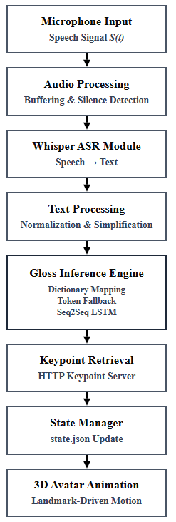
Figure I. System Architecture

Figure I illustrates the modular pipeline of the proposed framework. The system transforms continuous speech input into gloss representations and subsequently reconstructs sign gestures using skeletal keypoint descriptors for avatar animation.

A. Speech Recognition Module
The system accepts a continuous speech waveform $S(t)$captured via microphone input. A Whisper-based ASR model [1] converts the audio signal into a textual sequence
$$T=f_ASR (S(t))$$Audio preprocessing includes normalization, amplitude scaling, and silence-based segmentation to detect sentence boundaries during live inference.
B. Text Normalization and Simplification
Recognized text is normalized by lowercasing, removing non-alphabetic characters, and standardizing whitespace:
$$T_{norm}=\text{Normalize}(T)$$
Function words are removed to reduce linguistic variability:
$$T_{simp}=\text{Simplify}(T_{norm})$$

C. Gloss Inference Mechanism
Gloss generation follows a deterministic dictionary-first strategy:
- Exact phrase-level mapping
- Word-level fallback mapping
Unknown tokens are safely converted into uppercase forms to maintain stable output behavior:
$$G=\{g_{1},g_{2},...,g_{m}\}$$

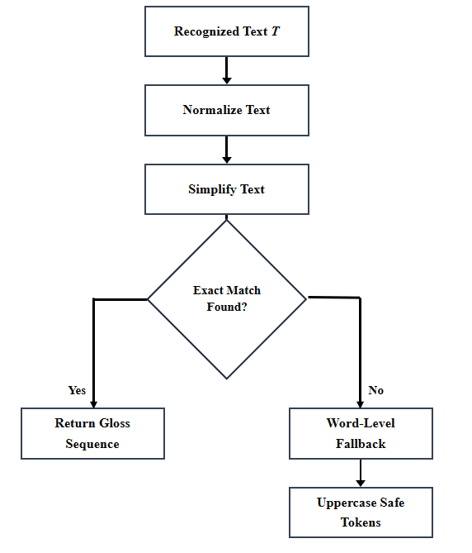
Figure II. Gloss Inference Pipeline

Figure II illustrates the gloss inference pipeline. The recognized text is normalized and simplified before dictionary-based matching. If an exact match is found, the gloss sequence is returned. Otherwise, a word-level fallback mechanism generates stable uppercase tokens.

D. Neural Gloss Translation Model
For comparative evaluation, gloss prediction is modeled using a Seq2Seq LSTM encoder–decoder architecture [2]. Given encoded input tokens $X$, the model predicts gloss tokens:
$$G=f_{θ}(X)$$
Training minimizes cross-entropy loss with teacher forcing:
$$L=-\sum_{t}{log⁡P(}g_{t}∣X)$$

E. Skeletal Keypoint Representation
Sign gestures are represented using skeletal landmarks extracted offline from WLASL videos via MediaPipe Holistic [8]. Each frame yields pose and hand landmark coordinates:
$$K=\{(x_{i},y_{i},z_{i})\}$$
Missing landmarks are replaced with zero-valued placeholders to preserve structural consistency.

F. Keypoint Retrieval Mechanism
For each predicted gloss token $g_{i}$, the corresponding motion descriptor $K_{i}$is retrieved dynamically:
$$K_{i}=\text{HTTP}(/keypoints/g_{i}.json)$$
This enables lightweight motion storage and modular gesture reconstruction.

G. Avatar Animation Signaling
Generated gloss tokens are written to a runtime descriptor:
$$\text{state.json}=\{id,tokens,ts\}$$
The identifier increments with each update:
$$id_{new}=id_{old}+1$$
The avatar engine observes state transitions to trigger animations asynchronously.

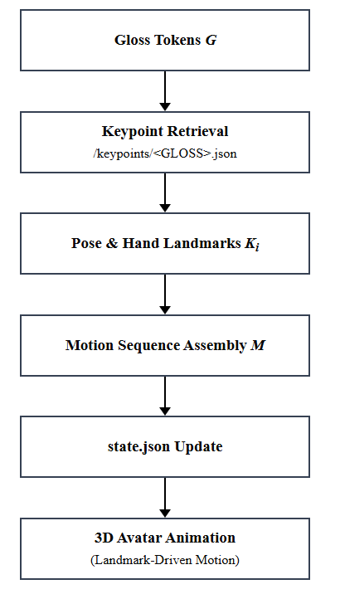
Figure III. Avatar Motion Reconstruction Pipeline

Figure III illustrates the landmark-driven avatar animation process. Predicted gloss tokens trigger dynamic retrieval of skeletal keypoint descriptors, which are assembled into motion sequences and written to a runtime state descriptor. The avatar engine monitors state updates to render real-time 3D sign animations.

H. Motion Reconstruction
The final avatar motion sequence is constructed through temporal concatenation:
$$M=\overset{∣G∣}{\underset{i=1}{⨁}}K_{i}$$
This allows dynamic gesture synthesis without prerecorded videos.

- ALGORITHM AND PSEUDOCODE

Algorithm 1: Speech Recognition and Gloss Generation
Input: Continuous speech waveform $S(t)$
Output: Gloss sequence $G$
- Capture microphone audio stream
- Buffer audio frames
- Detect silence boundary using RMS threshold
- Concatenate buffered audio into waveform
- Apply Whisper ASR → obtain text $T$
- Normalize text $T_{norm}$
- Simplify text $T_{simp}$
- Perform dictionary-based gloss inference
- Generate gloss tokens $G=\{g_{1},g_{2},...,g_{m}\}$
- Return gloss sequence

Algorithm 2: Neural Gloss Prediction
Input: Normalized text sequence $T$
Output: Predicted gloss tokens $G$
- Tokenize input sequence using vocabulary mapping
- Apply embedding transformation
- Encode sequence using LSTM encoder
- Initialize decoder with encoder states
- Generate output tokens sequentially
- Apply linear projection to vocabulary space
- Stop at <EOS> token
- Decode token sequence → obtain gloss $G$

Algorithm 3: Keypoint Retrieval and Avatar Signaling
Input: Gloss sequence $G=\{g_{1},g_{2},...,g_{m}\}$
Output: Avatar motion sequence $M$
- Receive gloss sequence from inference module
- Remove auxiliary labels (e.g., daily, fallback)
- Split gloss sentence into tokens $g_{i}$
- Convert tokens to uppercase representation
- Filter tokens not present in supported vocabulary
- Initialize empty motion sequence $M$
- for each gloss token $g_{i}$ do
- Construct keypoint file path:
$$/keypoints/g_{i}.json$$

- Retrieve motion descriptor $K_{i}$ via HTTP server
- Load pose landmarks and hand landmarks
- Append motion descriptor $K_{i}$ to sequence $M$
- end for
- Serialize animation request into runtime descriptor:
state.json = { id, tokens, ts }
- Increment animation identifier:
$$id_{new}=id_{old}+1$$
- Write updated state to shared storage
- Avatar engine monitors state changes
- Upon identifier update → trigger animation playback

- IMPLEMENTATION DETAILS

The proposed speech-to-sign translation system was implemented using lightweight modular components:
• Speech Recognition: Whisper ASR for microphone-based speech transcription.
• Machine Learning Framework: PyTorch for neural gloss prediction (Seq2Seq, LSTM).
• Keypoint Extraction: MediaPipe Holistic with OpenCV for skeletal landmark detection.
• Audio Processing: SoundDevice and NumPy for real-time microphone capture and buffering.
• Motion Representation: JSON-based skeletal keypoint descriptors derived from WLASL samples.
• Visualization / Rendering: Three.js for landmark-driven skeletal animation.
• Runtime Communication: Lightweight HTTP server for keypoint retrieval and avatar synchronization.
• Environment: Python-based backend executed on a desktop system with real-time microphone input.

Key operational parameters:
Sampling Rate = 16 kHz,
Frame Buffering = Streaming audio blocks,
Max Sequence Length = 12 tokens,
Optimizer = Adam,
Loss Function = Cross-Entropy Loss.

- EXPERIMENTS

A. Setup
The proposed speech-to-sign translation system was evaluated under real-time interactive conditions using microphone-based speech input. Audio streams were captured at a sampling rate of 16 kHz and processed using the Whisper ASR model. Experiments focused on short spoken phrases and sentences representative of everyday communication.
Gloss generation was evaluated using the dictionary-first inference strategy with rule-based simplification. Gesture visualization was performed using skeletal keypoint descriptors derived from WLASL samples. Avatar animations were triggered through runtime state updates served via a lightweight HTTP server.
System behavior was observed across multiple speech inputs to evaluate recognition stability, gloss consistency, and animation responsiveness.

- EVALUATION METRICS
We report system-level and functional performance indicators relevant to real-time speech-to-sign translation. We measure:
- Inference latency: Time delay between speech termination and gloss generation / avatar animation trigger.
- Recognition stability: Consistency of textual outputs produced by the Whisper ASR module for repeated spoken inputs.
- Gloss consistency: Deterministic behavior of the gloss inference engine under exact match and fallback conditions.
- Animation responsiveness: Temporal continuity and smoothness of landmark-driven avatar playback following state updates.
- System robustness: Stability of the pipeline under unknown tokens and vocabulary mismatches via the fallback safety mechanism.

- RESULTS AND ANALYSIS

- LIMITATIONS AND FUTURE WORK

Current Limitations
- Gloss prediction quality remains dependent on dataset vocabulary coverage, limiting translation flexibility for complex or unseen linguistic inputs.
- Deterministic dictionary-first inference may generate simplified gloss sequences for grammatically rich or ambiguous sentences.
- Landmark-driven gesture synthesis is bounded by the fidelity and consistency of extracted MediaPipe keypoint descriptors.
- Avatar motion realism is constrained by coordinate-based playback without advanced temporal smoothing or physics-based animation.
- Real-time performance may vary across hardware configurations due to microphone quality and runtime processing overhead.
Future Directions
- Expansion of gloss datasets and semantic mappings to improve linguistic coverage and inference robustness.
- Integration of context-aware neural language models to enhance gloss prediction for complex sentence structures.
- Improvement of motion naturalness through temporal interpolation, smoothing filters, and biomechanical constraints.
- User-centered evaluation studies to assess translation clarity, usability, and accessibility effectiveness.
- Deployment of the framework within interactive assistive applications supporting continuous and spontaneous communication scenarios.

- CONCLUSION

The proposed framework demonstrates that real-time speech-to-sign translation can be achieved through a modular and computationally efficient pipeline integrating speech recognition, gloss inference, and landmark-driven avatar animation. Experimental observations indicate that replacing prerecorded gesture videos with skeletal keypoint descriptors significantly reduces memory overhead while preserving interactive responsiveness. The deterministic gloss inference strategy combined with fallback safety mechanisms ensures stable system behavior across diverse speech inputs. Overall, the architecture establishes a scalable and practical approach for assistive multimodal communication systems.

APPENDIX A
APPENDIX: NOTATION SUMMARY
S(t) — Continuous speech signal captured from microphone input
T — Textual sequence produced by the speech recognition module
G — Predicted gloss sequence representing sign-level semantics
Kᵢ — Skeletal keypoint descriptor corresponding to gloss token gᵢ
M — Final avatar motion sequence formed via temporal concatenation
θ — Neural model parameters for Seq2Seq gloss prediction

REFERENCES
[1] A. Radford et al., “Robust Speech Recognition via Large-Scale Weak Supervision,”
[2] I. Sutskever, O. Vinyals, and Q. V. Le, “Sequence to Sequence Learning with Neural Networks,” in Proc. NeurIPS, 2014.
[3] D. Bahdanau, K. Cho, and Y. Bengio, “Neural Machine Translation by Jointly Learning to Align and Translate,” in Proc. ICLR, 2015.
[4] A. Vaswani et al., “Attention Is All You Need,” in Proc. NeurIPS, 2017.
[5] S. Hochreiter and J. Schmidhuber, “Long Short-Term Memory,” Neural Computation, vol. 9, no. 8, pp. 1735–1780, 1997.
[6] Z. Huang et al., “Video-Based Sign Language Recognition Without Temporal Segmentation,” arXiv:1805.03040, 2018.
[7] O. Koller, H. Ney, and R. Bowden, “Deep Learning of Mouth Shapes for Sign Language,”
[8] C. Lugaresi et al., “MediaPipe: A Framework for Building Perception Pipelines,”
[9] T. Pfister et al., “Flowing ConvNets for Human Pose Estimation in Videos,” in Proc. ICCV, 2015.
[10] K. Simonyan and A. Zisserman, “Two-Stream Convolutional Networks for Action Recognition in Videos,” in Proc. NeurIPS, 2014.

