WEEK 2 REPORT
Data Visualization and Insight Communication using R
Dataset: Publicly available Telco Customer Churn dataset | Records: 7,043 | Target: Churn

1. Objective
The purpose of this report is to communicate the main patterns in the Telco Customer Churn dataset through clear, audience-friendly visualizations. The same cleaned dataset from Week 1 was used so that the visual analysis remains consistent with the preprocessing decisions.

2. Churn Distribution
churn_table <- table(clean_data$Churn)
barplot(churn_table,
main = "Customer Churn Distribution",
ylab = "Number of Customers")
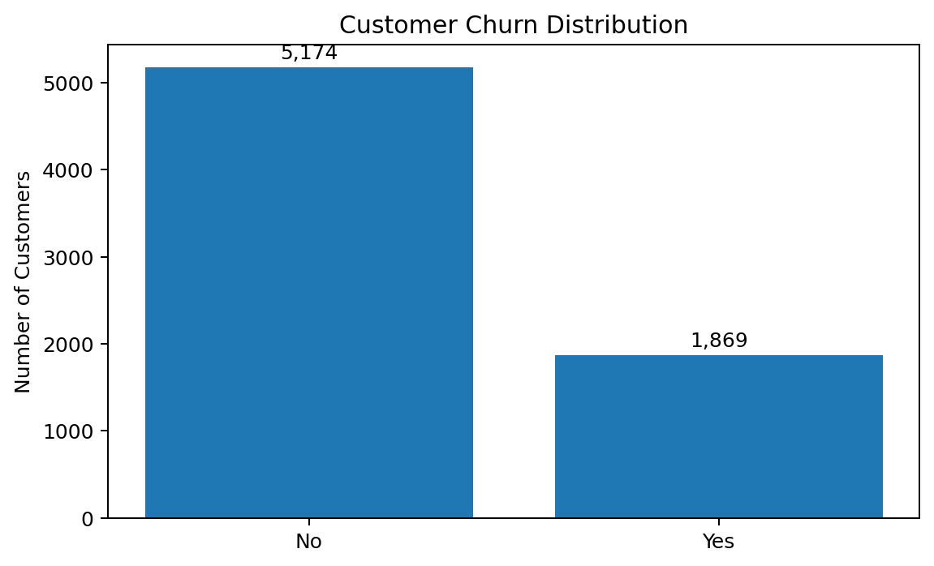
Interpretation: 5,174 customers did not churn while 1,869 churned. Churn therefore represents 26.54% of the customer base.

3. Contract Type and Churn
contract_churn <- table(clean_data$Contract, clean_data$Churn)
barplot(contract_churn,
beside = TRUE,
main = "Contract Type vs Churn",
ylab = "Customers",
legend.text = TRUE)
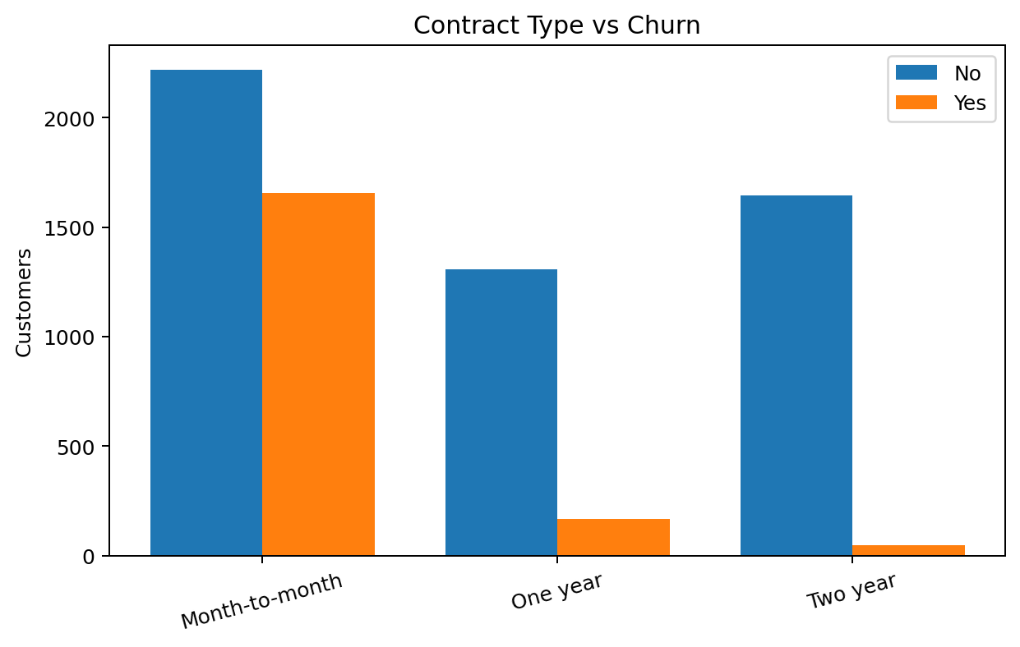
Contract type is strongly associated with churn. Month-to-month customers have a churn rate of 42.71%, compared with 11.27% for one-year contracts and only 2.83% for two-year contracts. This is one of the most actionable findings because contract structure may influence customer retention.

4. Average Tenure by Churn
aggregate(tenure ~ Churn, data = clean_data, FUN = mean)
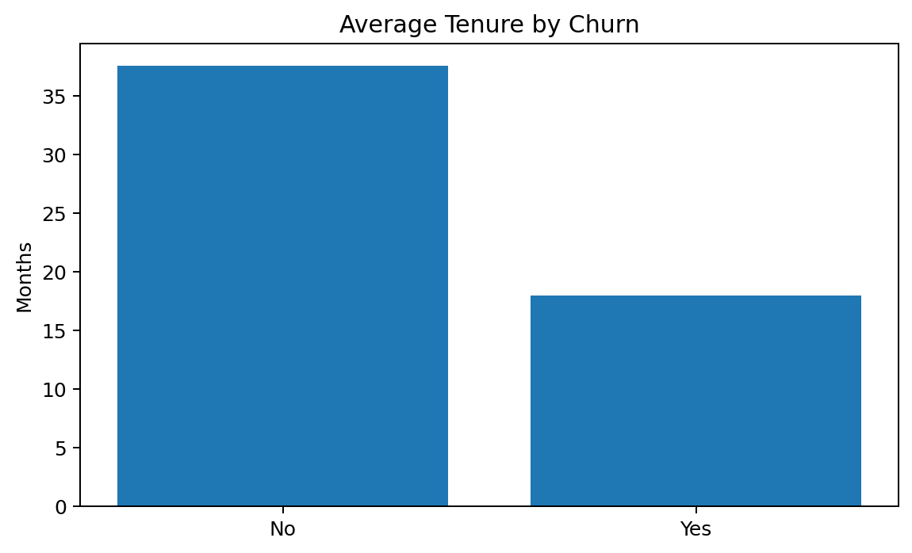
Interpretation: non-churned customers have an average tenure of 37.57 months, while churned customers average only 17.98 months.

5. Average Monthly Charges
aggregate(MonthlyCharges ~ Churn, data = clean_data, FUN = mean)
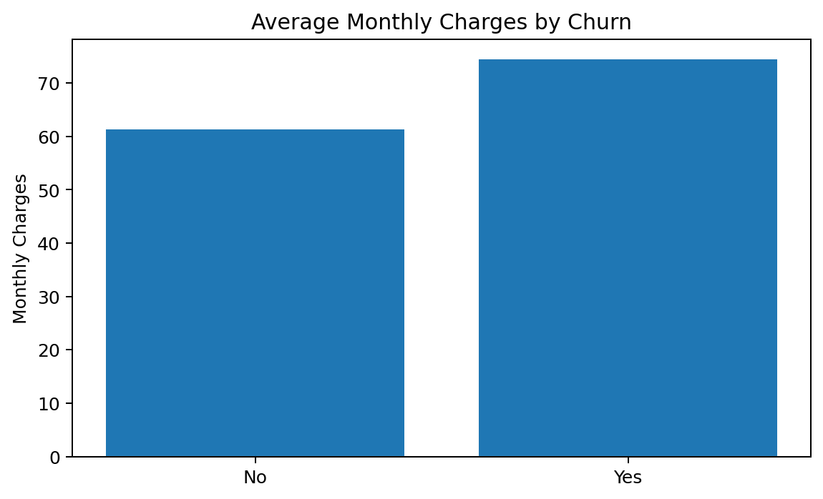
Interpretation: churned customers pay higher average monthly charges (74.44) than retained customers (61.27), suggesting price or service-value concerns may deserve attention.

6. Average Total Charges
aggregate(TotalCharges ~ Churn, data = clean_data, FUN = mean)
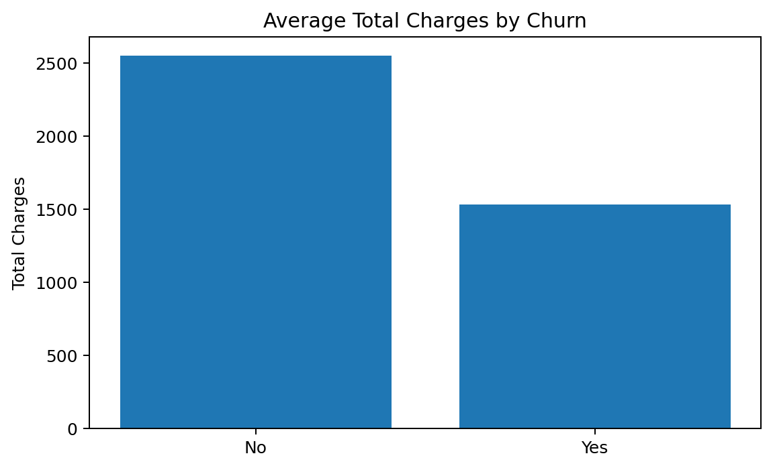
Interpretation: churned customers have lower average total charges because they tend to leave earlier, consistent with their much lower average tenure.

7. Correlation Analysis
numeric_data <- clean_data[, c(
"SeniorCitizen","tenure","MonthlyCharges","TotalCharges"
)]
cor_matrix <- cor(numeric_data, use = "complete.obs")
round(cor_matrix, 2)
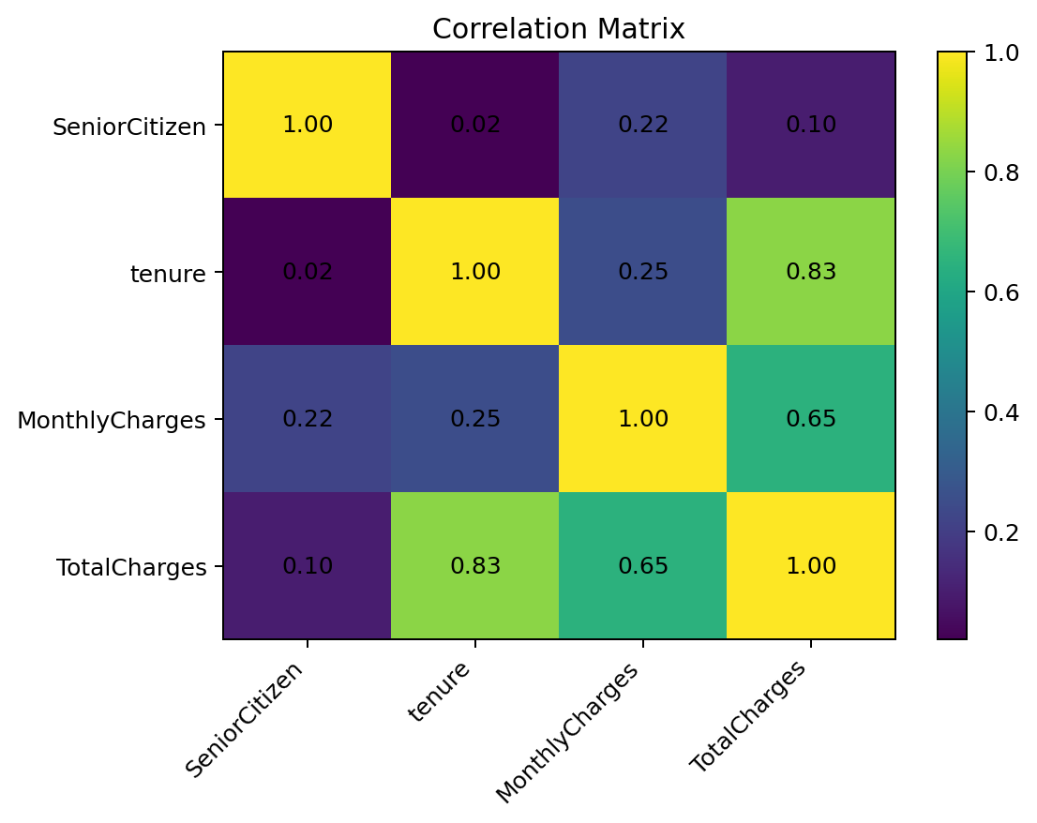
Tenure and TotalCharges have the strongest relationship among the numerical variables (r = 0.83). MonthlyCharges and TotalCharges are also positively related (r = 0.65). The relationship between SeniorCitizen and tenure is very weak (r = 0.02).

8. Communication Summary
The visualizations show that churn is concentrated among month-to-month customers, shorter-tenure customers and customers paying higher monthly charges. The charts were selected to make these patterns understandable to a non-technical audience without requiring statistical knowledge.

