WEEK 3 REPORT
Statistical Analysis and Predictive Modeling using R
Dataset: Publicly available Telco Customer Churn dataset | Records: 7,043 | Target: Churn

1. Objective and Hypotheses
Week 3 evaluates whether customer characteristics are statistically associated with churn and develops a binary classification model. Because Churn has two outcomes (No/Yes), logistic regression was selected.
Primary hypothesis for contract type:
H0: Contract type and churn are independent.
H1: Contract type and churn are associated.

2. Hypothesis Test: Contract vs Churn
contract_test <- chisq.test(
table(clean_data$Contract, clean_data$Churn)
)
contract_test
R OUTPUT
Pearson's Chi-squared test
X-squared = 1184.6
df = 2
p-value < 2.2e-16
Since the p-value is far below 0.05, the null hypothesis is rejected. There is strong statistical evidence of an association between contract type and churn.

3. Train/Test Split
set.seed(123)
train_index <- sample(
seq_len(nrow(model_data)),
size = 0.8 * nrow(model_data)
)
train_data <- model_data[train_index, ]
test_data <- model_data[-train_index, ]
R OUTPUT
Training rows: 5,634
Testing rows: 1,409

4. Logistic Regression Model
logistic_model <- glm(
Churn ~ tenure + MonthlyCharges + TotalCharges +
Contract + InternetService + PaymentMethod,
data = train_data,
family = binomial
)
summary(logistic_model)
Predictor | Estimate | p-value | Interpretation
tenure | -0.0549 | < 0.001 | Higher tenure is associated with lower churn odds.
MonthlyCharges | -0.0049 | 0.211 | Not statistically significant in this specification.
TotalCharges | 0.000314 | < 0.001 | Positive coefficient; interpret alongside tenure due to strong correlation.
Contract: One year | -0.806 | < 0.001 | Lower churn tendency than month-to-month reference.
Contract: Two year | -1.785 | < 0.001 | Much lower churn tendency than month-to-month reference.
Fiber optic | 0.987 | < 0.001 | Higher churn tendency than DSL reference.
InternetService: No | -0.918 | < 0.001 | Lower churn tendency than DSL reference.
Electronic check | 0.429 | < 0.001 | Higher churn tendency than automatic bank transfer reference.

The model uses factor variables, so coefficients for categories are interpreted relative to a reference category. A negative coefficient indicates lower log-odds of churn relative to the reference, while a positive coefficient indicates higher log-odds.

5. Prediction and Confusion Matrix
probabilities <- predict(
logistic_model,
newdata = test_data,
type = "response"
)
predictions <- ifelse(probabilities >= 0.5, "Yes", "No")
predictions <- factor(predictions, levels = levels(test_data$Churn))
actual <- test_data$Churn
confusion_matrix <- table(
Actual = actual,
Predicted = predictions
)
confusion_matrix
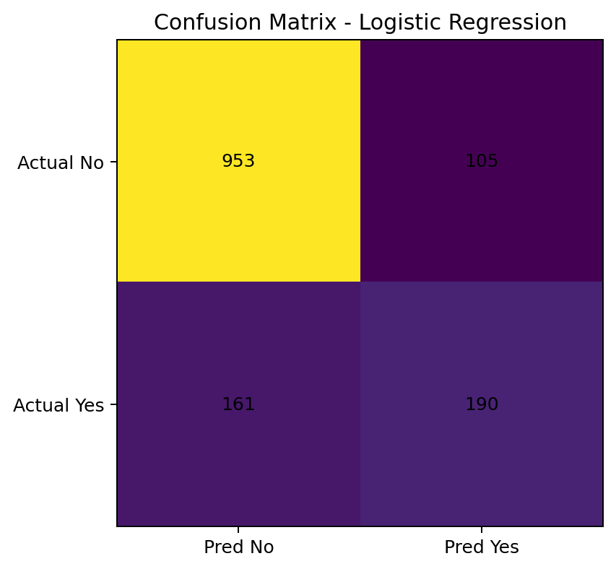
Metric | Value
Accuracy | 81.12%
Precision (Churn = Yes) | 64.41%
Recall/Sensitivity (Churn = Yes) | 54.13%
Specificity | 90.08%
F1-score | 58.82%

The model correctly classifies 81.12% of test observations. It is substantially better at identifying non-churners than churners: sensitivity for churn is 54.13% while specificity is 90.08%. This is important because a business focused on retention may prefer a lower classification threshold to identify more at-risk customers.

6. ROC-AUC
R OUTPUT
AUC: 0.8521
An AUC of 0.8521 indicates strong ranking/discrimination ability: the model can generally distinguish churners from non-churners much better than random guessing (AUC = 0.50).
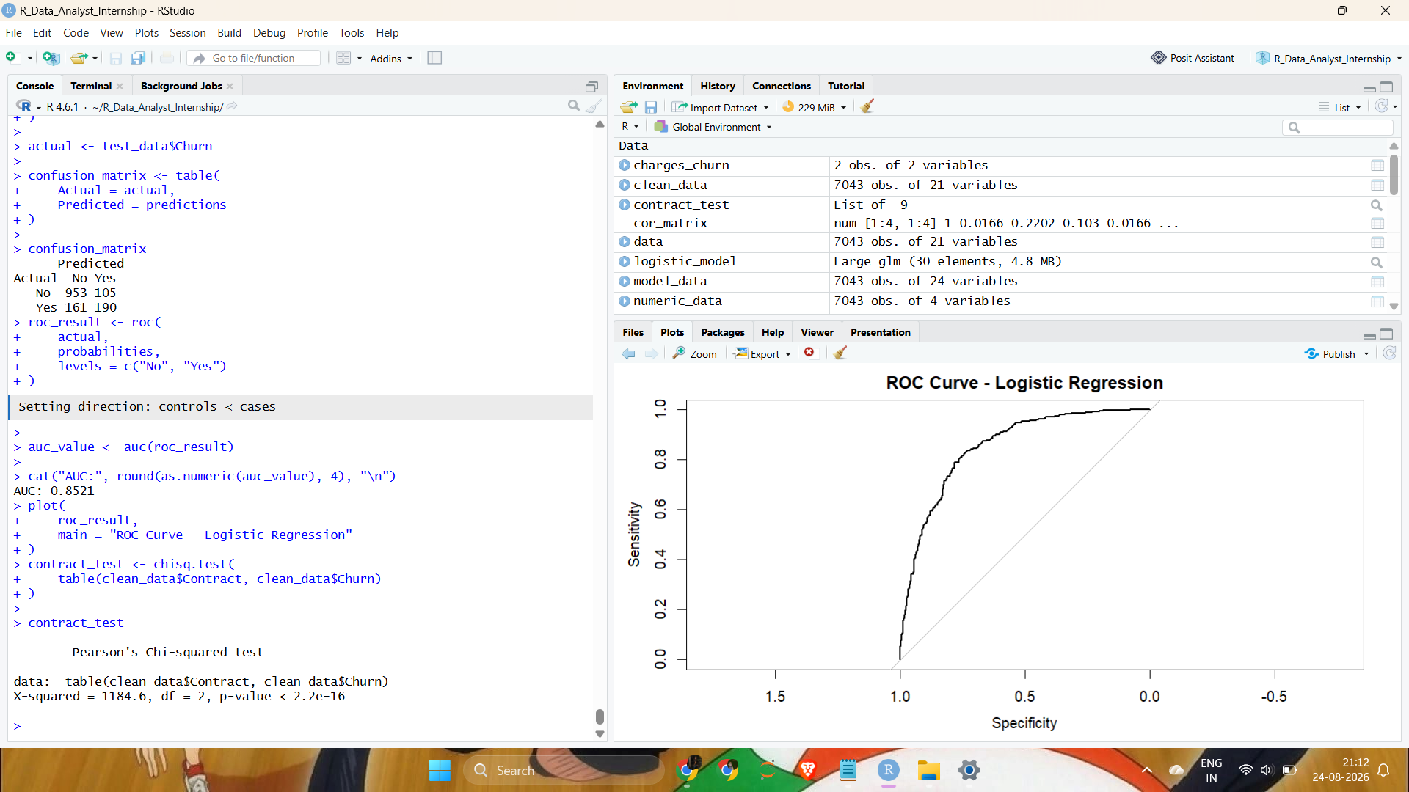

7. Five-Fold Cross-Validation
folds <- sample(
rep(1:5, length.out = nrow(train_data))
)
# Train on four folds and validate on the remaining fold
# Repeat for all five folds and average the accuracies.
R OUTPUT
Five-fold CV accuracies: 0.7986, 0.7782, 0.7853, 0.8012, 0.7913
Mean 5-Fold CV Accuracy: 0.7909
The mean cross-validation accuracy is 79.09%. The relatively small spread across folds suggests reasonably stable performance, although the held-out test accuracy is higher at 81.12%.

8. Model Diagnostics and Improvements
A modelling limitation is the strong correlation between tenure and TotalCharges (r = 0.83). Both variables carry related information, so a future model could compare versions with and without TotalCharges. The class imbalance (73.46% No vs 26.54% Yes) also means accuracy alone is not sufficient. Future work should evaluate precision-recall trade-offs, class weights or resampling, and threshold tuning.

