WEEK 4 FINAL REPORT
Comprehensive Telco Customer Churn Analysis using R
Dataset: Publicly available Telco Customer Churn dataset | Records: 7,043 | Target: Churn

Executive Summary
This final report integrates the data cleaning, exploratory analysis, visualization, statistical testing and predictive modelling performed across Weeks 1–3. The project analyzes 7,043 telecom customer records to understand churn behavior and identify variables that can support retention decisions. The analysis found that 26.54% of customers churned. Month-to-month customers had the highest churn rate at 42.71%, compared with 11.27% for one-year contracts and 2.83% for two-year contracts. Churned customers also had much shorter average tenure (17.98 months versus 37.57 months) and higher average monthly charges (74.44 versus 61.27). A logistic regression model achieved 81.12% test accuracy and an AUC of 0.8521, while five-fold cross-validation produced mean accuracy of 79.09%.

1. Introduction
Customer churn is an important business problem because losing customers can reduce recurring revenue and increase acquisition costs. The objective of this project was to use R to prepare customer data, discover meaningful patterns, statistically test relationships and build a model capable of identifying customers with higher churn risk.

2. Data Preparation
The dataset contains 7,043 records and 21 variables after cleaning. Numerical variables include SeniorCitizen, tenure, MonthlyCharges and TotalCharges. Categorical variables include contract, internet service, security/support services and payment method.
Cleaning Step | Approach | Result
Missing values | Investigated TotalCharges; 11 missing records had tenure = 0 | Retained all 7,043 records and treated these charges as 0
Outliers | IQR rule | 0 outliers detected for tenure, MonthlyCharges and TotalCharges
Normalization | Min-max scaling | Numerical scaled features constrained to 0–1
Categorical encoding | R factor representation | Compatible with glm() and reference-category interpretation
Train/test split | 80/20 with set.seed(123) | 5,634 training; 1,409 testing

3. Exploratory Findings
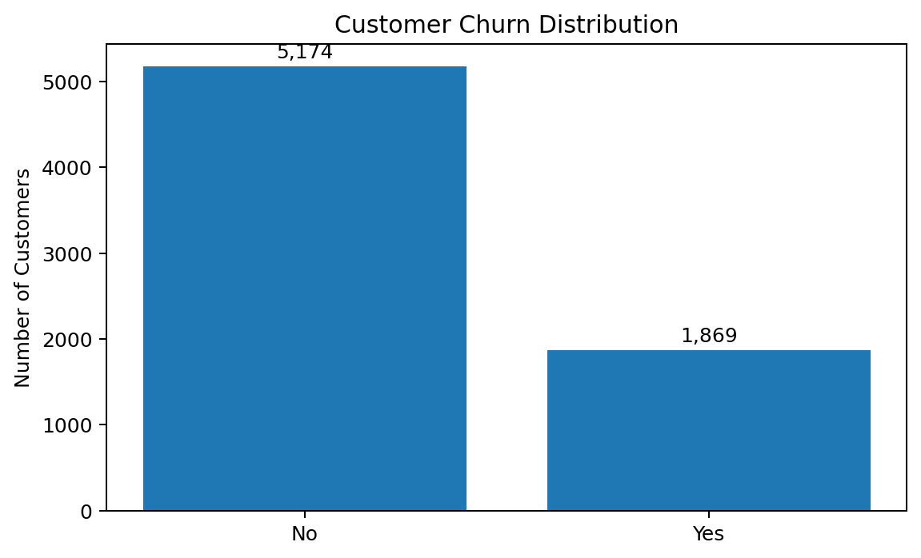
The target is imbalanced: 73.46% did not churn and 26.54% churned.
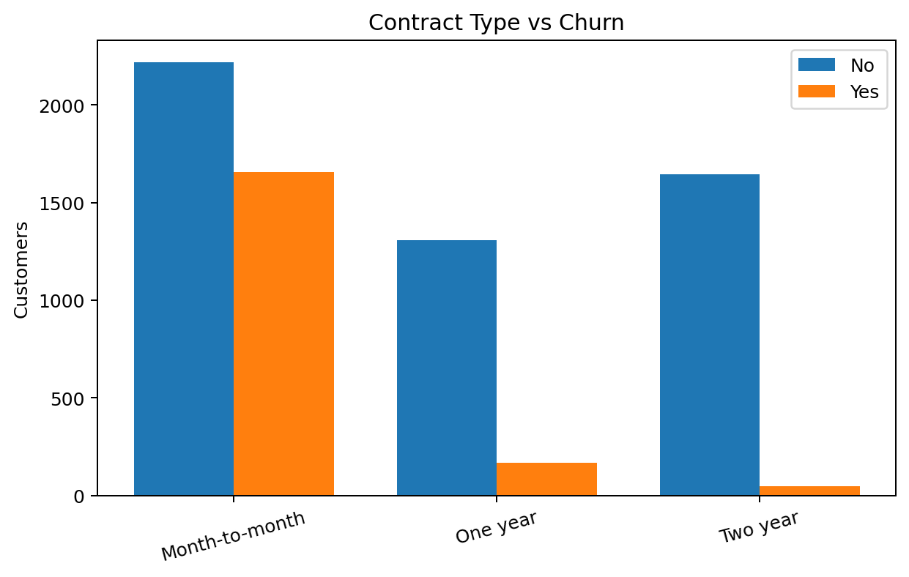
Contract type is the strongest practical segmentation identified in the preliminary analysis. Month-to-month customers show substantially higher churn.
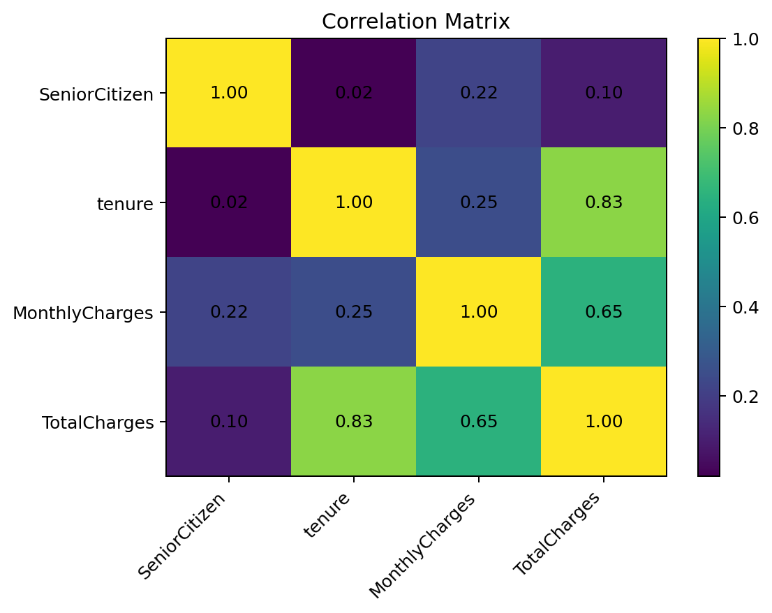
Tenure and TotalCharges are strongly correlated (0.83), so their joint use in a model should be interpreted carefully.

4. Statistical Analysis
A Pearson chi-square test was used to assess whether contract type and churn are independent. The result was X² = 1184.6 with 2 degrees of freedom and p < 2.2e-16. Therefore, contract type and churn are statistically associated.

5. Predictive Model
Logistic regression was selected because the target variable is binary. The final model included tenure, MonthlyCharges, TotalCharges, Contract, InternetService and PaymentMethod. The model used R's binomial family and was evaluated on a held-out test set.
Evaluation | Result
Test accuracy | 81.12%
Precision for churn | 64.41%
Recall for churn | 54.13%
Specificity | 90.08%
F1-score | 58.82%
ROC-AUC | 0.8521
Mean 5-fold CV accuracy | 79.09%

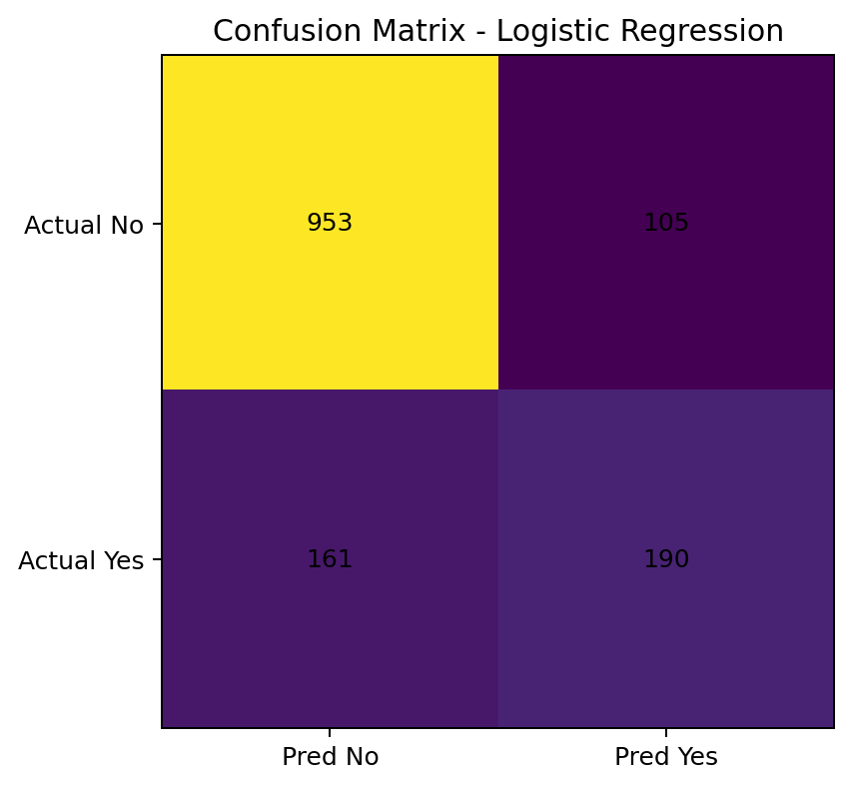

6. Business Interpretation
The findings suggest that retention efforts should prioritize month-to-month customers, newer customers and customers facing higher monthly charges. The model can be used as a screening tool to rank customers by churn probability, but the 54.13% recall at the default 0.50 threshold shows that some churners are missed.

7. Recommendations
- Prioritize retention campaigns for month-to-month customers because their observed churn rate is 42.71%.
- Focus early-life customer engagement because churned customers have much shorter average tenure.
- Investigate pricing, service bundles and perceived value for customers with high monthly charges.
- Use predicted churn probabilities rather than only a Yes/No classification when prioritizing retention resources.
- Tune the probability threshold according to business cost: missing a likely churner may be more expensive than contacting an additional low-risk customer.
- Compare models with and without TotalCharges because tenure and TotalCharges are strongly correlated.
- Evaluate class-weighted logistic regression or alternative classifiers and compare precision, recall, F1 and AUC.

8. Challenges and Lessons Learned
The main data-quality challenge was the missing TotalCharges field. Investigating the affected rows showed that all missing values belonged to customers with zero tenure, which supported a domain-based imputation decision rather than deleting records. Another modelling challenge was categorical redundancy: InternetService = No corresponds to 'No internet service' levels in OnlineSecurity and TechSupport, which can create singularities in a regression model. The final model therefore avoided those redundant predictors. The project also demonstrated why accuracy should be combined with confusion-matrix metrics and AUC when the target classes are imbalanced.

9. Conclusion and Future Work
The project demonstrates an end-to-end R analytics workflow: data cleaning, transformation, exploratory analysis, visualization, hypothesis testing, classification, cross-validation and interpretation. The results show strong evidence that contract type, tenure, internet service and payment method are useful churn-related variables. Future work could compare logistic regression with random forest or gradient boosting, tune the classification threshold, apply class weighting, perform calibration analysis and deploy the model in a dashboard for customer-retention teams.

10. Key R Workflow
# Cleaning
str(data)
summary(data)
colSums(is.na(data))
# EDA
table(clean_data$Churn)
aggregate(tenure ~ Churn, data = clean_data, FUN = mean)
aggregate(MonthlyCharges ~ Churn, data = clean_data, FUN = mean)
# Hypothesis test
chisq.test(table(clean_data$Contract, clean_data$Churn))
# Logistic regression
logistic_model <- glm(
Churn ~ tenure + MonthlyCharges + TotalCharges +
Contract + InternetService + PaymentMethod,
data = train_data,
family = binomial
)
# Test predictions
probabilities <- predict(logistic_model, newdata=test_data, type="response")
predictions <- ifelse(probabilities >= 0.5, "Yes", "No")

