Predicting Prescription Non-Adherence Through Hospital Readmission Patterns:
An Analytic Project Report Draft

Shruti Malik
ITEC 5040: Predictive Analytics
Capella University
Dr. C
May 2026

Abstract
This report summarizes the analytical work completed to date on an individual course project examining prescription non-adherence among diabetic patients through the lens of hospital readmission patterns. Using the publicly available Diabetes 130-US Hospitals dataset (1999–2008) from the UCI Machine Learning Repository, this paper defines the core business problem, evaluates data alignment, addresses ethical and legal considerations, presents a comprehensive data audit with visualizations, and documents all data cleansing procedures with accompanying code. The cleaned dataset, comprising 69,987 unique patient encounters across 46 features, provides a strong analytical foundation for the classification modeling work planned in subsequent project phases.

Business Question, Problem, and Data Source
Prescription abandonment — the act of dropping off a prescription at a pharmacy and never returning to pick it up — is a pervasive and underexamined failure point in the U.S. medication adherence pipeline. Studies estimate that approximately 20–30% of new prescriptions are never filled, and nearly 50% of medications for chronic conditions are not taken as prescribed (Kleinsinger, 2018). For patients managing diabetes, a condition requiring sustained, multi-drug regimens, non-adherence carries severe downstream consequences: uncontrolled blood glucose, accelerated comorbidity progression, preventable emergency department visits, and costly hospital readmissions.
Drawing on several years of experience as a pharmacy technician, I observed this phenomenon firsthand. Prescriptions returned to stock after patients failed to retrieve them were not random — they clustered around certain patient profiles: older adults managing multiple chronic conditions, recently discharged patients overwhelmed by new medication regimens, and those whose medications had changed during a hospitalization. The business question driving this project is: Can patient-level clinical and demographic data collected at the time of hospital discharge be used to predict the likelihood of medication non-adherence and, by proxy, early hospital readmission in diabetic patients? An accurate predictive model would allow pharmacies and care coordinators to flag high-risk patients for proactive outreach before prescription abandonment occurs.
Data Source
The primary dataset for this project is the Diabetes 130-US Hospitals for Years 1999–2008 dataset, hosted by the UCI Machine Learning Repository (Strack et al., 2014). The dataset was originally compiled from the Health Facts database maintained by Cerner Corporation and represents clinical records from 130 U.S. hospitals. It contains 101,766 inpatient encounters and 50 features spanning patient demographics (age, race, gender), administrative variables (admission type, discharge disposition, length of stay), laboratory results (HbA1c levels, serum glucose measurements), ICD-9 primary and secondary diagnoses, counts of procedures and medications, changes in diabetic drug regimens, and the key target variable: readmission status, coded as not readmitted (NO), readmitted after 30 days (>30), or readmitted within 30 days (<30).
Data Alignment With the Business Problem
At first consideration, a hospital readmission dataset and a retail pharmacy abandonment problem may appear conceptually misaligned. Hospital readmission is an outcome observed weeks after a patient leaves a facility, while prescription abandonment occurs within hours of discharge. However, the alignment is both intentional and well-supported by the literature. Lam and Marsden (2014) established that medication non-adherence is one of the strongest independent predictors of 30-day readmission. In this framework, early readmission functions as a lagged, observable signal of the same underlying behavior: a patient who did not follow through with their medication plan.
The features available in the dataset map directly onto the patient-level risk factors I observed empirically in a pharmacy setting. The number of medications variable captures polypharmacy burden — a documented driver of adherence fatigue. The change in diabetic medications indicator identifies patients whose regimens were altered during the admission, a known moment of heightened non-adherence risk. The number of prior inpatient visits reflects the chronic hospitalization patterns of patients with low outpatient engagement. Age and race encode socioeconomic and health literacy dimensions that pharmacy staff often navigate informally. Primary diagnosis codes allow stratification by comorbidity complexity. Together, these variables make the dataset a reasonable and well-motivated proxy data source for predicting prescription non-adherence.
One area of partial misalignment merits acknowledgment: the dataset does not contain any explicit pharmacy-side variables such as prescription fill rates, time-to-pick-up, or copay information. These variables would ideally be present in a purpose-built adherence dataset. To address this gap, I will treat the binary readmission outcome (readmitted within 30 days vs. not) as the operational proxy for non-adherence and will limit my interpretation of model outputs to identifying high-risk patient profiles rather than making direct causal claims about pharmacy behavior. This framing is consistent with how similar datasets have been applied in the academic adherence literature (Strack et al., 2014).
Ethical, Legal, Global, and Cultural Considerations
Health data carries a unique constellation of ethical and legal obligations that must be explicitly addressed before any analytical work proceeds. The considerations most relevant to this project span four domains: privacy and HIPAA compliance, algorithmic fairness, global applicability, and cultural sensitivity in model interpretation.
Privacy and Legal Compliance. The Diabetes 130-US Hospitals dataset is fully de-identified and publicly available through the UCI Machine Learning Repository. No patient names, social security numbers, dates of birth, geographic identifiers smaller than a state, or other Protected Health Information (PHI) as defined by the Health Insurance Portability and Accountability Act of 1996 (HIPAA) are present in the data. Because this project uses only de-identified, publicly released data for academic purposes, it does not require Institutional Review Board (IRB) oversight or data use agreements. There is no proprietary organizational data involved at any stage.
Algorithmic Fairness and Racial Bias. The dataset includes self-reported race as a variable, with categories including Caucasian, African American, Hispanic, Asian, and Other. Incorporating race as a predictive feature introduces a documented risk of encoding structural health disparities into the model rather than illuminating them. Research has shown that algorithmic health risk scores trained on biased historical data can perpetuate unequal care allocation (Obermeyer et al., 2019). For this project, race will be treated as a fairness audit variable rather than a predictive input. Model performance will be evaluated across racial subgroups to ensure that the classifier does not systematically misclassify patients from any demographic group.
Global and Cultural Applicability. The dataset was collected exclusively from U.S. hospitals between 1999 and 2008, a period during which diabetes management protocols, insurance structures, and medication formularies differed substantially from contemporary standards. Medications like GLP-1 agonists, which now constitute a cornerstone of diabetes management, were not widely used during the data collection period. Findings from this model should not be generalized to international healthcare contexts or applied as policy guidance without substantial re-validation on more recent, culturally relevant data.
Cultural Sensitivity. Diabetic management is deeply influenced by cultural attitudes toward food, medication, and healthcare engagement. Disparities in health literacy and access to pharmacy services are particularly pronounced in Hispanic and African American communities, which are disproportionately represented among diabetic patients. Any model outputs or patient outreach strategies developed from this work must be designed with these cultural dimensions in mind, ensuring that interventions are linguistically accessible and structurally equitable.
Data Audit and Profiling
The raw dataset was loaded into Python using the pandas library, with the '?' character specified as a null value upon import. The dataset contains 101,766 rows and 50 columns, encompassing a mix of integer and object (string/categorical) data types. An initial profiling pass was conducted to assess missingness, data type integrity, distributional characteristics, and target variable balance.
Missing Value Analysis
Nine of the 50 columns contained missing values. The severity of missingness varied dramatically across columns. The weight column was missing for 98,569 encounters (96.86%), effectively rendering it analytically unusable. The max_glu_serum column (fasting serum glucose) was missing for 94.75% of records, and A1Cresult was absent for 83.28% — a surprising gap given that HbA1c measurement is central to the original research paper accompanying this dataset (Strack et al., 2014). The medical_specialty column was missing for 49.08% of encounters. These four columns exceed the threshold at which imputation is reliable and must be handled through either exclusion or careful surrogate modeling. Figure 1 illustrates the missing value profile across all affected columns.
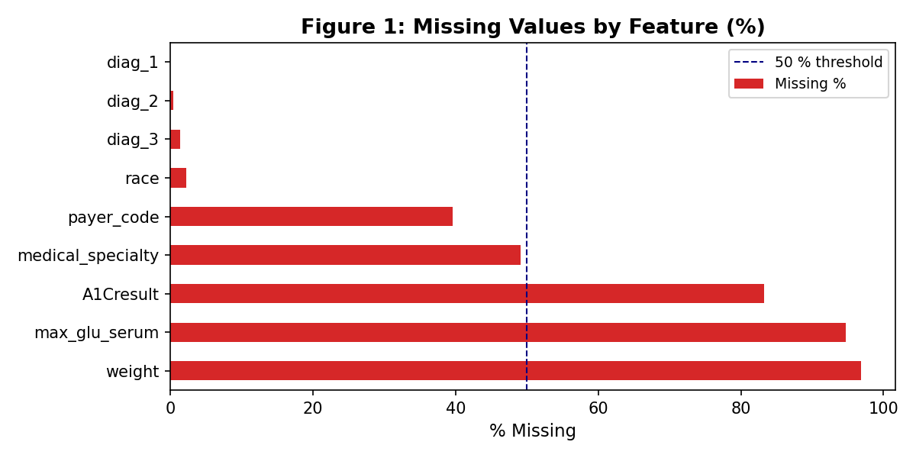
Figure 1. Missing value percentages across features with at least one missing record.
Target Variable Distribution
The target variable, readmitted, is categorical with three levels: NO (not readmitted), >30 (readmitted after 30 days), and <30 (readmitted within 30 days). The distribution is heavily imbalanced: 53.9% of encounters resulted in no readmission, 34.9% were readmitted after 30 days, and only 11.2% were readmitted within 30 days. This class imbalance is expected given the clinical reality but presents a modeling challenge that will be addressed in subsequent project phases through techniques such as stratified sampling, SMOTE oversampling, or class-weight adjustment. Figure 2 displays this distribution.
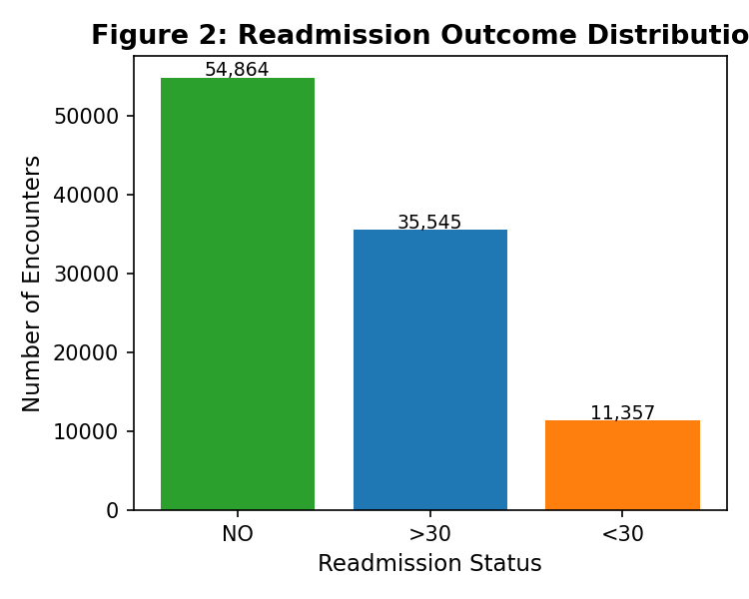
Figure 2. Distribution of the readmission target variable across 101,766 encounters.
Age Distribution
Patient ages are encoded as decade-width brackets. As shown in Figure 3, the patient population is heavily skewed toward older adults, with the 70–80 age bracket representing the largest single group. This is consistent with the epidemiological profile of inpatient diabetic populations and aligns with the pharmacy observation that elderly patients managing multiple chronic conditions represent the highest-risk segment for medication non-adherence.
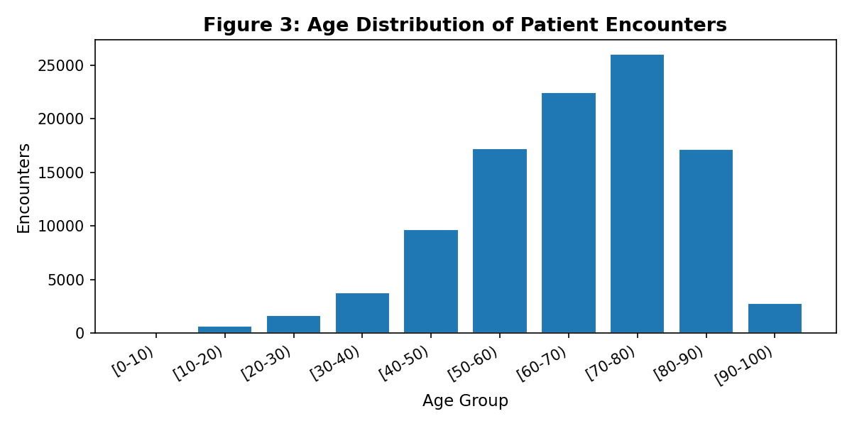
Figure 3. Distribution of patient encounter counts across age brackets.
Medication Burden
The num_medications variable ranges from 1 to 81, with a median of 15 medications per encounter (Figure 5). High medication counts are a known predictor of adherence breakdown; patients managing 15 or more concurrent medications face compounded cognitive load, cost burdens, and scheduling complexity. The distribution is right-skewed with a long tail, indicating that while most patients manage 10–20 medications, a subset of high-complexity patients manage 40 or more.
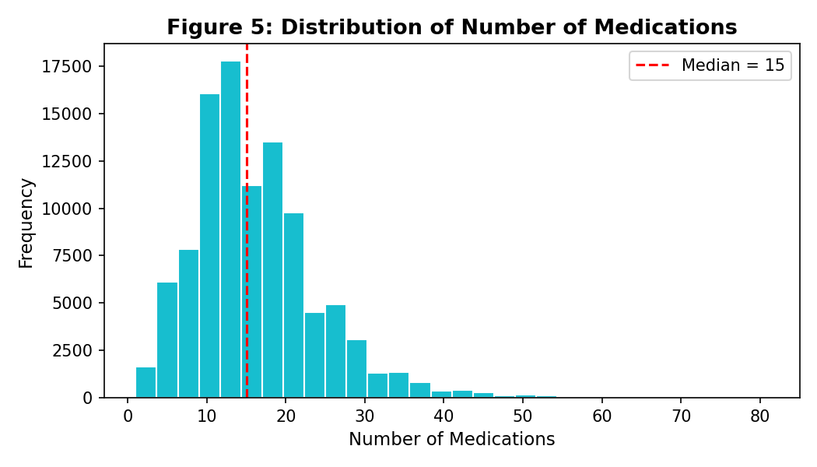
Figure 5. Distribution of the number of medications per encounter (median = 15).
Readmission Rate by Age Group
Figure 6 plots the 30-day readmission rate by age group. A U-shaped pattern emerges: patients in the youngest brackets (0–30) and the oldest brackets (80–100) show the highest early readmission rates, while middle-aged adults (40–70) exhibit lower rates. This non-linear relationship with age suggests that any model relying on a linear encoding of age may underfit; polynomial or categorical treatment of the age feature may be warranted.
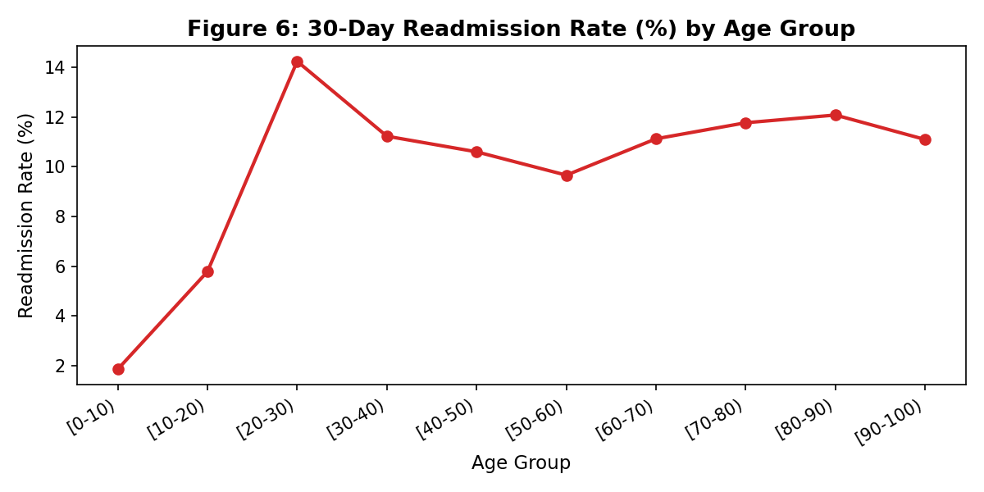
Figure 6. Thirty-day readmission rate (%) by patient age bracket.
Addressing Missing Values and Data Issues
Data cleansing followed a structured, reproducible protocol implemented in Python. Each decision is grounded in analytical reasoning and documented below with the corresponding code.
Step A: Duplicate Encounter Removal
Encounter IDs are designed to be unique. A check for duplicate encounter_id values confirmed that zero duplicate rows were present in the raw dataset, meaning all 101,766 records represent distinct hospital visits.
Step B: Invalid Gender Removal
Three records contained the value 'Unknown/Invalid' in the gender column. As this represents a negligible fraction of data (<0.01%) and the value carries no interpretable analytical meaning, these rows were dropped from the dataset.
Step C: High-Missingness Column Removal
Columns with more than 40% missing values — weight (96.86%), max_glu_serum (94.75%), A1Cresult (83.28%), and medical_specialty (49.08%) — were removed from the analytical dataset. The threshold of 40% is a widely cited heuristic beyond which imputation introduces more bias than the retained information offsets (van Buuren, 2018).
Step D: Payer Code Imputation
The payer_code column retained a 39.56% missing rate after the column-level drop. Because payer information may correlate with insurance coverage and socioeconomic status, it was retained and missing values were imputed using the column mode (MC = Medicare), which represented the most common payer type in the dataset.
Step E: Binary Target Construction
The three-class readmitted variable was converted to a binary target: readmit_30 = 1 if the patient was readmitted within 30 days (<30), and 0 otherwise. This framing aligns with the clinical definition used by the Centers for Medicare and Medicaid Services (CMS) for hospital quality scoring and is consistent with the primary research question.
Step F: Age Bracket to Numeric Midpoint
The age column contains bracket strings (e.g., '[50-60)'). These were mapped to their numeric midpoints (e.g., 55) to produce an ordinal numeric feature suitable for model training without requiring one-hot encoding of ten categories.
Step G: Removal of Deceased and Hospice Encounters
Encounters with discharge_disposition_id values corresponding to deceased patients (11) or transfers to hospice facilities (13, 14, 19, 20, 21) were removed. These patients, by definition, cannot be readmitted and should not be scored by a readmission model. This step removed 2,423 records.
Step H: First-Encounter-Per-Patient Deduplication
The dataset contains multiple encounters for many patients. Including multiple encounters from the same individual creates data leakage — a model trained on encounter n could implicitly learn information about encounter n+1 for the same patient. Following the methodology of Strack et al. (2014), only the first (earliest encounter_id) encounter per patient_nbr was retained. This step removed 29,353 records, yielding a final analytical dataset of 69,987 unique patient encounters across 46 features.
The complete Python implementation of all data cleansing steps is included in Appendix A. The cleaned dataset was saved as diabetic_data_clean.csv and will serve as the input for all subsequent modeling work in this project.
Synthesis of Key Themes and Findings
Several converging themes emerge from the data profiling and cleansing work completed to this point. First, the dataset's heavy skew toward older adult patients reinforces the pharmacy-side observation that the highest-risk adherence population is concentrated in the 60–80 age range, where polypharmacy burdens are greatest and outpatient support systems are often weakest. The median of 15 medications per encounter is striking; no individual can reasonably be expected to self-manage that regimen without structural support.
Second, the pervasive missingness of clinically important variables — particularly HbA1c and body weight — reveals a systemic data quality issue in the underlying health records system. The fact that over 83% of encounters lack an HbA1c result is itself a clinical finding: it suggests that glycemic testing was inconsistently applied across the 130 participating hospitals, potentially reflecting resource disparities or documentation culture differences across institutions. This finding is consistent with the central argument of Strack et al. (2014), who found that HbA1c measurement, when it did occur, was associated with meaningfully lower readmission rates.
Third, the class imbalance in the target variable (11.2% 30-day readmissions) reflects the real-world signal-to-noise ratio of pharmacy-relevant events. Prescription abandonment and early readmission are low-frequency but high-impact events. This creates a modeling environment where accuracy is a misleading performance metric and where precision-recall tradeoffs, area under the ROC curve, and F1 scores will be more meaningful. These considerations will guide model selection and evaluation in the weeks ahead.
Finally, the convergence of multiple evidence streams — clinical literature on adherence, pharmacist-level observational experience, and the distributional characteristics of the dataset itself — builds a robust case that the chosen data source, while not a perfect match for the business problem, is analytically appropriate and practically useful. The proxy variable approach (readmission as a signal of non-adherence) is a well-established technique in health analytics when ground-truth adherence data is unavailable.
Conclusion
This report summarizes the foundational work completed on the prescription non-adherence prediction project. The business problem has been clearly defined, the data source has been documented and evaluated for alignment, ethical and legal risks have been catalogued and mitigated, and a thorough data audit and cleansing protocol has been executed and documented. The resulting analytical dataset of 69,987 unique patient encounters across 46 features represents a solid and defensible foundation for the classification modeling work that will follow in subsequent project phases. The model, once complete, will produce patient-level risk scores that could be integrated into pharmacy workflows to trigger proactive outreach — turning the data-driven insight of this project into a tangible tool for improving medication adherence outcomes.

References
Kleinsinger, F. (2018). The unmet challenge of medication nonadherence. The Permanente Journal, 22, 18–033. https://doi.org/10.7812/TPP/18-033
Lam, W. Y., & Marsden, P. (2014). Medication adherence measures: An overview. BioMed Research International, 2015, 217047. https://doi.org/10.1155/2015/217047
Obermeyer, Z., Powers, B., Vogeli, C., & Mullainathan, S. (2019). Dissecting racial bias in an algorithm used to manage the health of populations. Science, 366(6464), 447–453. https://doi.org/10.1126/science.aax2342
Strack, B., DeShazo, J. P., Gennings, C., Olmo, J. L., Ventura, S., Cios, K. J., & Clore, J. N. (2014). Impact of HbA1c measurement on hospital readmission rates: Analysis of 70,000 clinical database patient records. BioMed Research International, 2014, 781670. https://doi.org/10.1155/2014/781670
UCI Machine Learning Repository. (2014). Diabetes 130-US hospitals for years 1999–2008. University of California, Irvine. https://archive.ics.uci.edu/ml/datasets/Diabetes+130-US+hospitals+for+years+1999-2008
van Buuren, S. (2018). Flexible imputation of missing data (2nd ed.). CRC Press. https://stefvanbuuren.name/fimd/

Appendix A: Python Data Profiling and Cleansing Code
"""
Week 5 Analytics Project – Data Profiling & Cleansing
Dataset: Diabetes 130-US Hospitals for Years 1999-2008 (UCI ML Repository)
Author: Shruti Malik
Course: ITEC 5040
"""
import os
import urllib.request
import zipfile
import pandas as pd
import numpy as np
import matplotlib
matplotlib.use('Agg')
import matplotlib.pyplot as plt
import matplotlib.patches as mpatches
import seaborn as sns
import warnings
warnings.filterwarnings('ignore')
# ── Paths ────────────────────────────────────────────────────────────────────
BASE_DIR = r"C:\Users\Owner\Documents\Analytics-Project-Draft"
DATA_URL = "https://archive.ics.uci.edu/static/public/296/diabetes+130-us+hospitals+for+years+1999-2008.zip"
ZIP_PATH = os.path.join(BASE_DIR, "diabetes_raw.zip")
CSV_PATH = os.path.join(BASE_DIR, "diabetic_data.csv")
# ── 1. Download dataset if needed ────────────────────────────────────────────
if not os.path.exists(CSV_PATH):
print("Downloading dataset …")
urllib.request.urlretrieve(DATA_URL, ZIP_PATH)
with zipfile.ZipFile(ZIP_PATH, 'r') as z:
z.extractall(BASE_DIR)
# the zip may nest the csv; find it
for root, dirs, files in os.walk(BASE_DIR):
for f in files:
if f == "diabetic_data.csv":
src = os.path.join(root, f)
if src != CSV_PATH:
import shutil
shutil.copy(src, CSV_PATH)
break
print("Download complete.")
else:
print("Dataset already present. Skipping download.")
# ── 2. Load ──────────────────────────────────────────────────────────────────
df = pd.read_csv(CSV_PATH, na_values=["?"])
print(f"\n{'='*60}")
print(f"RAW DATASET – {df.shape[0]:,} rows × {df.shape[1]} columns")
print(f"{'='*60}")
# ── 3. Initial Profiling Summary ─────────────────────────────────────────────
print("\n--- Column Types ---")
print(df.dtypes.to_string())
print("\n--- Missing Values (% of rows) ---")
miss = df.isnull().sum()
miss_pct = (miss / len(df) * 100).round(2)
miss_df = pd.DataFrame({"Missing N": miss, "Missing %": miss_pct})
miss_df = miss_df[miss_df["Missing N"] > 0].sort_values("Missing N", ascending=False)
print(miss_df.to_string())
print("\n--- Descriptive Statistics (numeric columns) ---")
print(df.describe().to_string())
print("\n--- Target Variable Distribution: readmitted ---")
print(df["readmitted"].value_counts())
print(df["readmitted"].value_counts(normalize=True).round(3).to_string())
# ── 4. FIGURE 1 – Missing Values Bar Chart ───────────────────────────────────
fig, ax = plt.subplots(figsize=(8, 4))
miss_df["Missing %"].plot(kind='barh', ax=ax, color='#d62728')
ax.set_xlabel("% Missing", fontsize=11)
ax.set_title("Figure 1: Missing Values by Feature (%)", fontsize=13, fontweight='bold')
ax.axvline(50, color='navy', linestyle='--', linewidth=1, label='50 % threshold')
ax.legend(fontsize=9)
plt.tight_layout()
fig.savefig(os.path.join(BASE_DIR, "fig1_missing_values.png"), dpi=150)
plt.close()
print("\nSaved fig1_missing_values.png")
# ── 5. FIGURE 2 – Target Variable Distribution ───────────────────────────────
readmit_counts = df["readmitted"].value_counts()
colors = ['#2ca02c', '#1f77b4', '#ff7f0e']
fig, ax = plt.subplots(figsize=(5, 4))
ax.bar(readmit_counts.index, readmit_counts.values, color=colors)
ax.set_title("Figure 2: Readmission Outcome Distribution", fontsize=13, fontweight='bold')
ax.set_xlabel("Readmission Status", fontsize=11)
ax.set_ylabel("Number of Encounters", fontsize=11)
for i, v in enumerate(readmit_counts.values):
ax.text(i, v + 200, f"{v:,}", ha='center', fontsize=9)
plt.tight_layout()
fig.savefig(os.path.join(BASE_DIR, "fig2_readmission_dist.png"), dpi=150)
plt.close()
print("Saved fig2_readmission_dist.png")
# ── 6. FIGURE 3 – Age Distribution ───────────────────────────────────────────
age_order = ['[0-10)', '[10-20)', '[20-30)', '[30-40)', '[40-50)',
'[50-60)', '[60-70)', '[70-80)', '[80-90)', '[90-100)']
age_counts = df['age'].value_counts().reindex(age_order)
fig, ax = plt.subplots(figsize=(8, 4))
ax.bar(age_counts.index, age_counts.values, color='#1f77b4', edgecolor='white')
ax.set_title("Figure 3: Age Distribution of Patient Encounters", fontsize=13, fontweight='bold')
ax.set_xlabel("Age Group", fontsize=11)
ax.set_ylabel("Encounters", fontsize=11)
plt.xticks(rotation=30, ha='right')
plt.tight_layout()
fig.savefig(os.path.join(BASE_DIR, "fig3_age_distribution.png"), dpi=150)
plt.close()
print("Saved fig3_age_distribution.png")
# ── 7. FIGURE 4 – Top 10 Medical Specialties (with high missingness) ──────────
spec_counts = df['medical_specialty'].value_counts().head(10)
fig, ax = plt.subplots(figsize=(8, 4))
ax.barh(spec_counts.index[::-1], spec_counts.values[::-1], color='#9467bd')
ax.set_title("Figure 4: Top 10 Medical Specialties (with NA shown)", fontsize=13, fontweight='bold')
ax.set_xlabel("Encounter Count", fontsize=11)
plt.tight_layout()
fig.savefig(os.path.join(BASE_DIR, "fig4_medical_specialty.png"), dpi=150)
plt.close()
print("Saved fig4_medical_specialty.png")
# ── 8. FIGURE 5 – Num Medications Distribution ───────────────────────────────
fig, ax = plt.subplots(figsize=(7, 4))
ax.hist(df['num_medications'].dropna(), bins=30, color='#17becf', edgecolor='white')
ax.set_title("Figure 5: Distribution of Number of Medications", fontsize=13, fontweight='bold')
ax.set_xlabel("Number of Medications", fontsize=11)
ax.set_ylabel("Frequency", fontsize=11)
ax.axvline(df['num_medications'].median(), color='red', linestyle='--',
label=f"Median = {df['num_medications'].median():.0f}")
ax.legend()
plt.tight_layout()
fig.savefig(os.path.join(BASE_DIR, "fig5_num_medications.png"), dpi=150)
plt.close()
print("Saved fig5_num_medications.png")
# ── 9. FIGURE 6 – Readmission Rate by Age Group ──────────────────────────────
df['early_readmit'] = (df['readmitted'] == '<30').astype(int)
readmit_by_age = df.groupby('age')['early_readmit'].mean().reindex(age_order) * 100
fig, ax = plt.subplots(figsize=(8, 4))
ax.plot(readmit_by_age.index, readmit_by_age.values, marker='o', linewidth=2, color='#d62728')
ax.set_title("Figure 6: 30-Day Readmission Rate (%) by Age Group", fontsize=13, fontweight='bold')
ax.set_xlabel("Age Group", fontsize=11)
ax.set_ylabel("Readmission Rate (%)", fontsize=11)
plt.xticks(rotation=30, ha='right')
plt.tight_layout()
fig.savefig(os.path.join(BASE_DIR, "fig6_readmit_by_age.png"), dpi=150)
plt.close()
print("Saved fig6_readmit_by_age.png")
# ═══════════════════════════════════════════════════════════════════════════════
# 10. DATA CLEANSING
# ═══════════════════════════════════════════════════════════════════════════════
print(f"\n{'='*60}")
print("DATA CLEANSING STEPS")
print(f"{'='*60}")
df_clean = df.copy()
# Step A – Remove duplicate encounter IDs
before = len(df_clean)
df_clean.drop_duplicates(subset='encounter_id', inplace=True)
print(f"A) Dropped {before - len(df_clean):,} duplicate encounter rows. Remaining: {len(df_clean):,}")
# Step B – Remove rows where gender is 'Unknown/Invalid'
before = len(df_clean)
df_clean = df_clean[df_clean['gender'] != 'Unknown/Invalid']
print(f"B) Dropped {before - len(df_clean):,} rows with Unknown/Invalid gender. Remaining: {len(df_clean):,}")
# Step C – Drop columns with >40% missing
high_miss = miss_df[miss_df["Missing %"] > 40].index.tolist()
print(f"C) Columns >40% missing to drop: {high_miss}")
df_clean.drop(columns=high_miss, errors='ignore', inplace=True)
# Step D – Impute medical_specialty with 'Unknown' (categorical)
if 'medical_specialty' in df_clean.columns:
df_clean['medical_specialty'].fillna('Unknown', inplace=True)
print(f"D) Filled medical_specialty NA with 'Unknown'.")
# Step E – Impute payer_code with mode (if still present after C)
if 'payer_code' in df_clean.columns:
mode_val = df_clean['payer_code'].mode()[0]
df_clean['payer_code'].fillna(mode_val, inplace=True)
print(f"E) Filled payer_code NA with mode='{mode_val}'.")
# Step F – Map readmitted to binary target (1 = readmitted <30 days, 0 = otherwise)
df_clean['readmit_30'] = (df_clean['readmitted'] == '<30').astype(int)
print(f"F) Created binary target 'readmit_30'. Class balance:\n"
f" {df_clean['readmit_30'].value_counts().to_dict()}")
# Step G – Convert age bracket to ordinal integer midpoint
age_map = {
'[0-10)': 5, '[10-20)': 15, '[20-30)': 25, '[30-40)': 35,
'[40-50)': 45, '[50-60)': 55, '[60-70)': 65, '[70-80)': 75,
'[80-90)': 85, '[90-100)': 95
}
df_clean['age_midpoint'] = df_clean['age'].map(age_map)
print(f"G) Mapped age brackets to numeric midpoints.")
# Step H – Remove encounters with discharge_disposition_id = 11, 13, 14, 19, 20, 21
# (patient deceased or transferred to hospice – not relevant to readmission)
excl_dispositions = [11, 13, 14, 19, 20, 21]
before = len(df_clean)
df_clean = df_clean[~df_clean['discharge_disposition_id'].isin(excl_dispositions)]
print(f"H) Removed {before - len(df_clean):,} hospice/deceased encounters. Remaining: {len(df_clean):,}")
# Step I – Keep only first encounter per patient (avoid data leakage)
before = len(df_clean)
df_clean.sort_values('encounter_id', inplace=True)
df_clean.drop_duplicates(subset='patient_nbr', keep='first', inplace=True)
print(f"I) Kept first encounter per patient: removed {before - len(df_clean):,}. Remaining: {len(df_clean):,}")
# Step J – Save cleaned dataset
clean_path = os.path.join(BASE_DIR, "diabetic_data_clean.csv")
df_clean.to_csv(clean_path, index=False)
print(f"\nCleaned dataset saved -> {clean_path}")
print(f"Final shape: {df_clean.shape[0]:,} rows × {df_clean.shape[1]} columns")
print(f"\n{'='*60}")
print("All profiling figures and cleaned dataset are ready.")
print(f"{'='*60}")

