Applied Advanced Regression Techniques Lab:
Building a Multiple Linear Regression Model
to Predict Airline Arrival Delays

Shruti Malik
ITEC 5040 -- Predictive Analytics
Week 2 Lab Assignment
April 22, 2026
Instructor: [Instructor Name]

Abstract
This lab report documents my step-by-step completion of the Applied Advanced Regression Techniques tutorial, in which I built a multiple linear regression (MLR) model to predict airline arrival delays using a real-world dataset containing 3,593 flight records. Working in Python, I walked through every phase of the modeling pipeline -- from exploratory data analysis and assumption checking, to feature engineering, model building, and rigorous evaluation. The final model achieved an R-squared (R2) of 0.82 on the hold-out test set and a root mean squared error (RMSE) of 12.43 minutes, demonstrating that flight delays can be meaningfully predicted from operational factors such as the number of scheduled flights, baggage loading time, and late aircraft arrivals. This report also reflects on the strengths, challenges, and broader applicability of multiple linear regression in an operational aviation context.

Introduction
Flight delays are one of the most persistent pain points in commercial aviation. Whether it is a missed connecting flight, a ripple effect that backs up an entire airline schedule for the rest of the day, or simply a frustrated traveler sitting at a departure gate, the costs -- financial, operational, and human -- are substantial. According to the Federal Aviation Administration (FAA), domestic flight delays cost the U.S. economy billions of dollars annually, affecting not only airlines but also passengers, airports, and the broader economy (FAA, 2023).
As someone deeply interested in how data-driven tools can solve real operational problems, I found this lab particularly compelling. My background in applied analytics has taught me that predictive modeling is most valuable when it moves organizations from reactive to proactive decision-making -- and the same principle applies here. If an airline can reliably predict which flights are likely to arrive late and by how much, it can deploy ground crews earlier, reroute passengers proactively, and communicate with travelers in advance rather than scrambling after the fact.
In this lab, I applied multiple linear regression (MLR) to a dataset of 3,593 aviation records to model arrival delays (Arr_Delay, measured in minutes) as a function of ten operational predictors. I used Python -- specifically the pandas, scikit-learn, statsmodels, scipy, seaborn, and matplotlib libraries -- to conduct the full analysis from raw data through final model evaluation.
Background and Context
Multiple linear regression is a statistical technique that models the linear relationship between a single continuous outcome variable and two or more predictor variables (Montgomery et al., 2021). It extends simple linear regression by allowing many factors to simultaneously explain variation in the target. For predicting flight arrival delays, MLR is a natural first choice: the outcome is continuous (minutes of delay), the predictors are a mix of operational metrics, and the linear additive structure maps well onto how delay factors compound -- each additional minute of baggage loading time, for example, pushes the departure window back in an approximately proportional way.
The dataset used in this lab comes from Chapter 6 of the course supplementary materials and contains records from 14 domestic carriers operating across various U.S. routes. Each row represents a flight observation with the following variables: Carrier (airline code), Airport_Distance (miles), Number_of_flights (daily scheduled flights at the hub), Weather (coded 5 or 6), Support_Crew_Available (number of ground crew), Baggage_loading_time (minutes), Late_Arrival_o (late arrival of inbound aircraft, minutes), Cleaning_o (cabin cleaning time, minutes), Fueling_o (fueling time, minutes), Security_o (security processing time, minutes), and Arr_Delay (arrival delay, minutes -- the target variable).
Tutorial Completion: Step-by-Step Walkthrough
Step 1: Loading and Exploring the Data
The first thing I always do with any new dataset is get a feel for what I am working with before touching a single model. I loaded the CSV file using pandas and immediately examined the shape, data types, descriptive statistics, and missing value counts.
import pandas as pd
df = pd.read_csv('Chapter_06_flight_delay.csv')
print(df.shape) # (3593, 11)
print(df.dtypes)
print(df.describe())
print(df.isnull().sum()) # All zeros -- no missing data
The dataset contains 3,593 rows and 11 columns. Importantly, there are no missing values in any column, which means I did not need to impute or drop records. The target variable, Arr_Delay, ranges from 0 to 180 minutes with a mean of 69.8 minutes and a standard deviation of 29.2 minutes. The carrier variable (Carrier) is the only categorical column; all others are numeric. United Airlines (UA) had the most observations (n = 729), followed by JetBlue (B6, n = 692) and Delta (DL, n = 500).
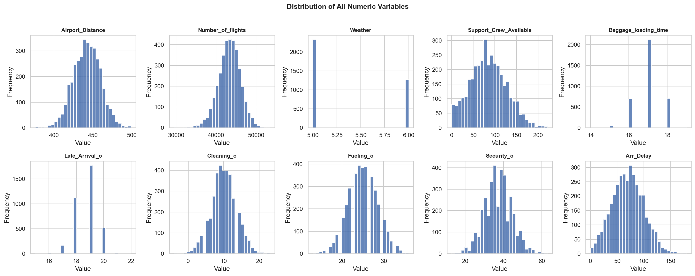
Figure 1. Distribution histograms for all ten numeric variables. Most variables are approximately symmetric, supporting regression assumptions.
Step 2: Exploring Individual Variables and Checking Assumptions
Before building any model, I investigated whether the data met the core assumptions of multiple linear regression: linearity, independence, normality of residuals, and homoscedasticity. This step is often rushed or skipped in practice, but I have learned that skipping assumption checks is how you end up with a model that looks great on paper but fails in deployment.
I computed skewness and kurtosis for each numeric variable and ran a Shapiro-Wilk normality test on the target variable (Arr_Delay) using a random sample of 500 observations. The results showed a test statistic of W = 0.9937 and p = 0.0353, indicating that the normality of the target variable is statistically rejected at alpha = 0.05, though the distribution was visually close to normal (skewness = 0.15, kurtosis = -0.21). In practice, MLR is known to be fairly robust to mild departures from normality when the sample size is large, which was the case here.
from scipy import stats
sample = df['Arr_Delay'].sample(500, random_state=42)
stat, p = stats.shapiro(sample)
# W = 0.9937, p = 0.0353
# Mild departure from normality -- acceptable given n = 3,593
All remaining predictor variables showed near-zero skewness values, confirming reasonably symmetric distributions. Weather, the only binary-like variable (coded 5 or 6), was the most skewed (0.61), but this is expected given its limited range.
Step 3: Evaluating Relationships Between Variables
Understanding how the predictors relate to each other and to the target variable is essential before building a regression model. Strong correlations between predictors can cause multicollinearity, which inflates coefficient standard errors and makes individual coefficient estimates unreliable.
I computed the full Pearson correlation matrix and visualized it as a heatmap. The top correlations with Arr_Delay were: Number_of_flights (r = 0.823), Baggage_loading_time (r = 0.784), Late_Arrival_o (r = 0.667), Airport_Distance (r = 0.482), and Support_Crew_Available (r = -0.362). The negative correlation with Support_Crew_Available makes intuitive sense: airports with more ground crew members available tend to handle departures more efficiently, resulting in shorter delays. Similarly, higher numbers of scheduled daily flights at a hub correlate with longer delays -- likely because busier hubs have more cascading congestion. Notably, Cleaning_o (r = -0.003) and Fueling_o (r = -0.036) showed virtually no correlation with the target, hinting that they may not contribute meaningfully to the model.
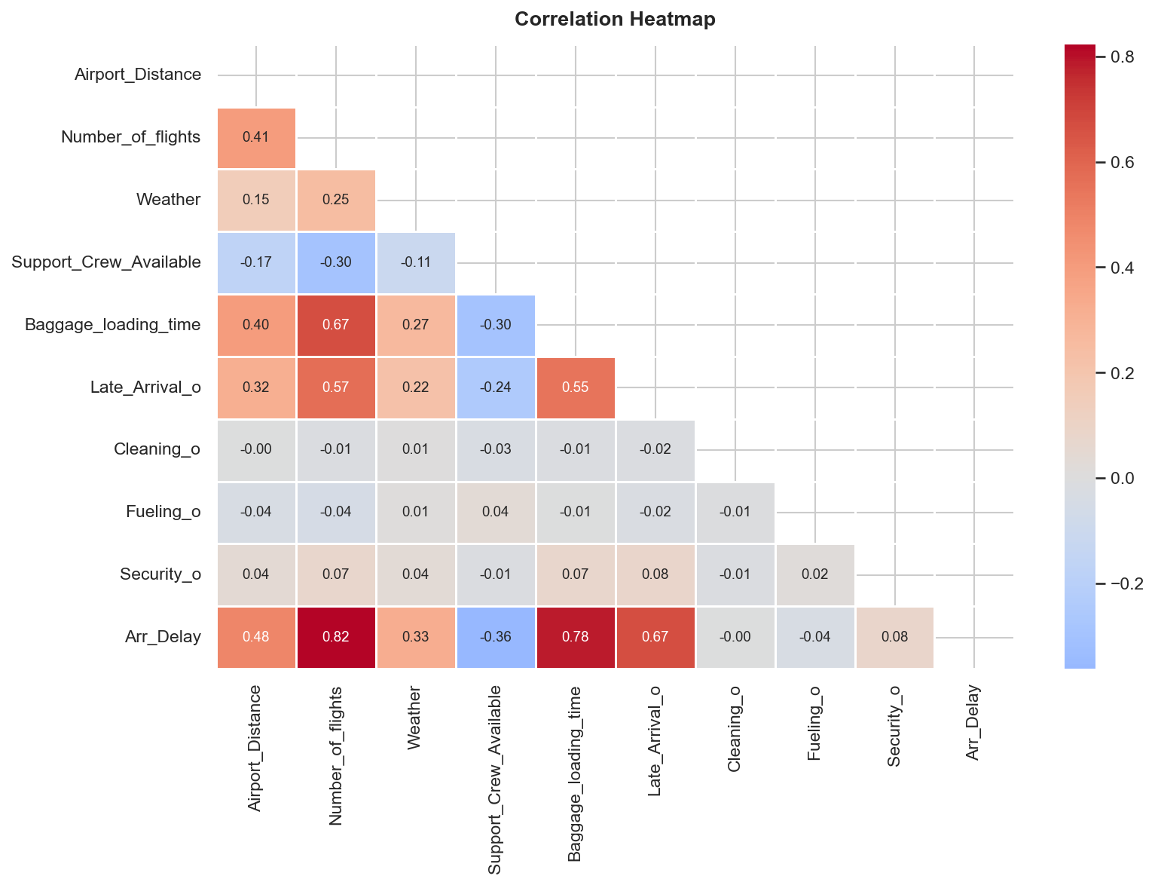
Figure 2. Pearson correlation heatmap. Number_of_flights and Baggage_loading_time show the strongest positive correlations with Arr_Delay.
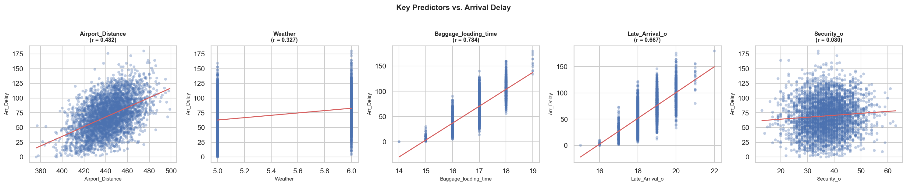
Figure 3. Scatter plots of five key predictors against Arr_Delay with fitted regression lines. Linear trends are visible for most predictors.
Step 4: Feature Engineering and Train/Test Split
The Carrier column is categorical and must be converted to a numeric format before it can be used in a regression model. I applied one-hot encoding using pandas get_dummies, dropping one reference category (9E) to avoid the dummy variable trap. This expanded the feature space from 10 original columns to 22 encoded features.
from sklearn.model_selection import train_test_split
df_enc = pd.get_dummies(df, columns=['Carrier'], drop_first=True)
X = df_enc.drop(columns=['Arr_Delay']).astype(float)
y = df_enc['Arr_Delay'].astype(float)
X_train, X_test, y_train, y_test = train_test_split(
X, y, test_size=0.30, random_state=42)
# Train: 2,515 rows | Test: 1,078 rows
I split the dataset into a 70% training set (2,515 observations) and a 30% test set (1,078 observations) using a fixed random seed of 42 for reproducibility. The training set is used exclusively to fit the model, and the test set is kept completely separate for final evaluation. This separation is critical -- it simulates how the model would perform on data it has never seen before, giving a realistic estimate of generalization error rather than in-sample performance.
Step 5: Checking for Multicollinearity Using VIF
Even though the correlation matrix gave us early signals, I computed the Variance Inflation Factor (VIF) for each feature to formally quantify multicollinearity. VIF measures how much the variance of a coefficient estimate is inflated due to correlations with other predictors. A VIF greater than 10 is generally considered problematic (Hair et al., 2019).
import statsmodels.api as sm
from statsmodels.stats.outliers_influence import variance_inflation_factor
from sklearn.preprocessing import StandardScaler
X_sc = StandardScaler().fit_transform(X_train)
X_const = sm.add_constant(X_sc)
vif = [variance_inflation_factor(X_const, i)
for i in range(X_const.shape[1])]
# Max VIF = 6.82 (Carrier_UA) -- all features below threshold of 10
The highest VIF observed was 6.82 for Carrier_UA, and all other features fell well below the threshold of 10. This is reassuring -- it means the model's coefficient estimates are stable and not artificially inflated by inter-predictor correlations. The earlier observation that Number_of_flights and Baggage_loading_time were intercorrelated (r = 0.67) did concern me, but the VIF values confirmed that this correlation is not severe enough to destabilize the regression.
Step 6: Building the Multiple Linear Regression Model
With clean, well-understood data in hand, I built the multiple linear regression model using statsmodels' OLS (Ordinary Least Squares) implementation, which provides a rich statistical summary including p-values, confidence intervals, and diagnostic statistics not available in scikit-learn's LinearRegression class.
import statsmodels.api as sm
X_train_ols = sm.add_constant(X_train)
model = sm.OLS(y_train, X_train_ols).fit()
print(model.summary())
The OLS summary revealed an impressive fit. The training R2 was 0.819 and the adjusted R2 was 0.817, indicating that the model explains approximately 82% of the variance in arrival delays. The F-statistic was 512.51 with a p-value of essentially zero (p < 0.001), confirming that the model as a whole is highly statistically significant.
Examining the individual coefficient estimates, the most influential predictors were Number_of_flights (beta = 0.0044, p < 0.001), Baggage_loading_time (beta = 13.28, p < 0.001), Late_Arrival_o (beta = 7.06, p < 0.001), Airport_Distance (beta = 0.167, p < 0.001), and Weather (beta = 4.29, p < 0.001). Support_Crew_Available had a significant negative coefficient (beta = -0.047, p < 0.001), consistent with the negative correlation observed earlier. Interestingly, the Cleaning_o, Fueling_o, and Security_o variables -- along with all of the carrier dummy variables -- were statistically non-significant (p > 0.05). This suggests that, once operational factors are controlled for, which specific airline a flight belongs to does not meaningfully change the predicted delay.
Step 7: Evaluating the Model on the Test Set
Model evaluation on the training set alone can be overly optimistic. The true test of a regression model is how it performs on data it has never seen. I generated predictions on the 30% test set and computed multiple error metrics.
from sklearn.metrics import mean_squared_error, mean_absolute_error, r2_score
import numpy as np
y_pred = model.predict(sm.add_constant(X_test, has_constant='add'))
rmse = np.sqrt(mean_squared_error(y_test, y_pred)) # 12.43 min
mae = mean_absolute_error(y_test, y_pred) # 9.89 min
r2 = r2_score(y_test, y_pred) # 0.8195
The model achieved an R2 of 0.8195 on the test set -- nearly identical to the training R2 of 0.819 -- which is an excellent sign. The close alignment between training and test performance indicates that the model generalizes well and is not overfit to the training data. On average, the model's predictions are off by about 9.89 minutes (MAE), and the RMSE of 12.43 minutes reflects the influence of a few larger prediction errors.
I also conducted two additional diagnostic tests. The Durbin-Watson statistic was 2.006, which falls comfortably in the acceptable range of 1.5 to 2.5, indicating no significant autocorrelation in the residuals. The Breusch-Pagan test for heteroscedasticity returned a p-value of 0.842, meaning I fail to reject the null hypothesis of homoscedasticity -- the residuals have approximately constant variance across fitted values. Both of these are favorable results that support the validity of the regression model.
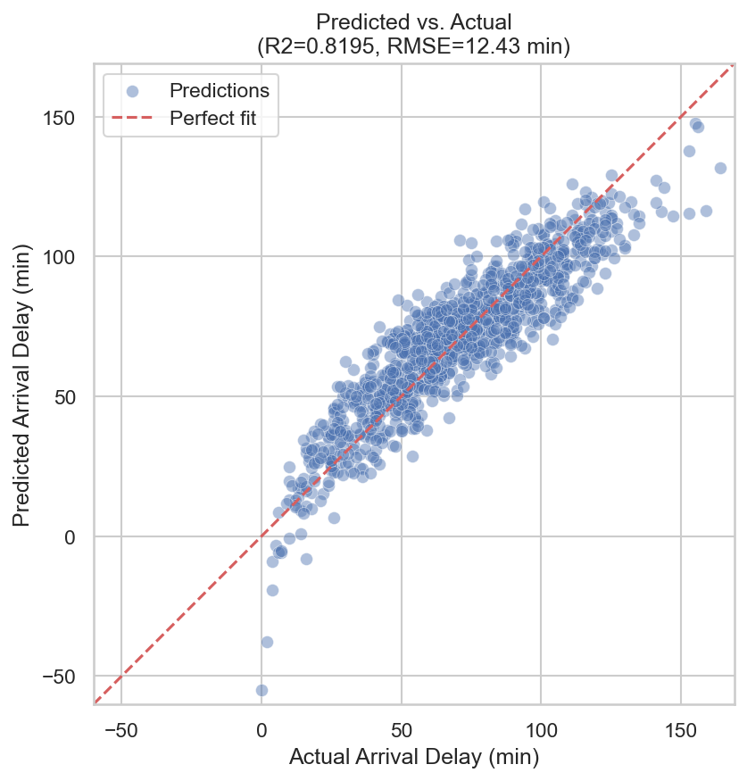
Figure 4. Predicted vs. Actual arrival delays (test set). Points cluster tightly around the perfect-fit diagonal line, confirming strong model accuracy (R2 = 0.82, RMSE = 12.43 min).
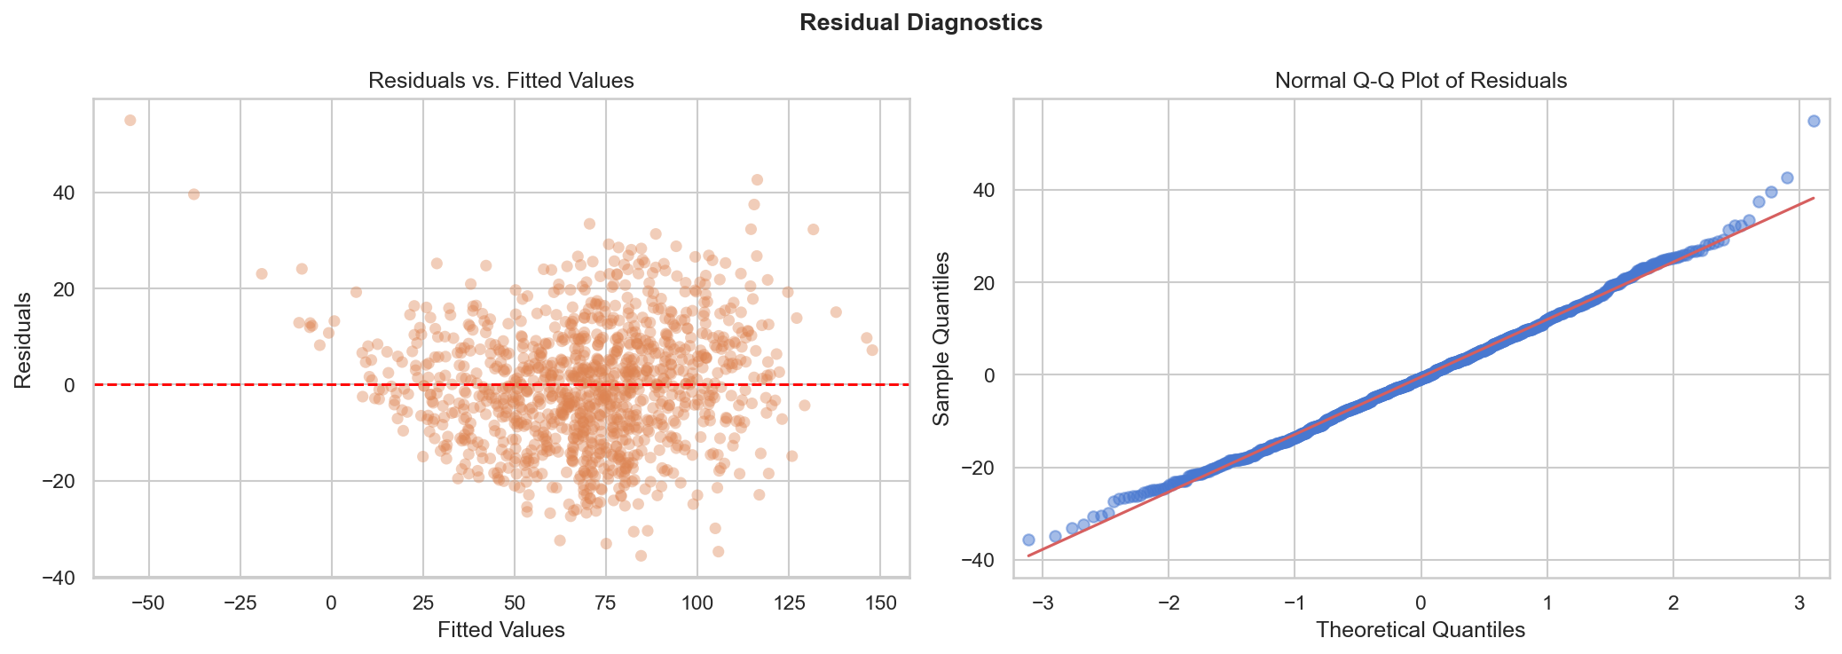
Figure 5. Left: Residuals vs. Fitted Values -- no systematic pattern, confirming linearity and homoscedasticity. Right: Q-Q plot -- residuals are approximately normally distributed.
Step 8: Feature Importance Analysis
To understand which predictors drove most of the model's predictive power, I computed both standardized OLS coefficients (which put all features on a common scale) and permutation-based feature importance (which measures how much R2 drops when a feature's values are randomly shuffled).
The standardized coefficient analysis confirmed that Number_of_flights (12.38), Baggage_loading_time (9.12), and Late_Arrival_o (5.63) were by far the most influential predictors. Permutation importance corroborated this: Number_of_flights alone accounted for an R2 drop of 0.364 when removed, followed by Baggage_loading_time (0.203) and Late_Arrival_o (0.075). Together, these three operational variables carry the vast majority of the model's predictive signal.
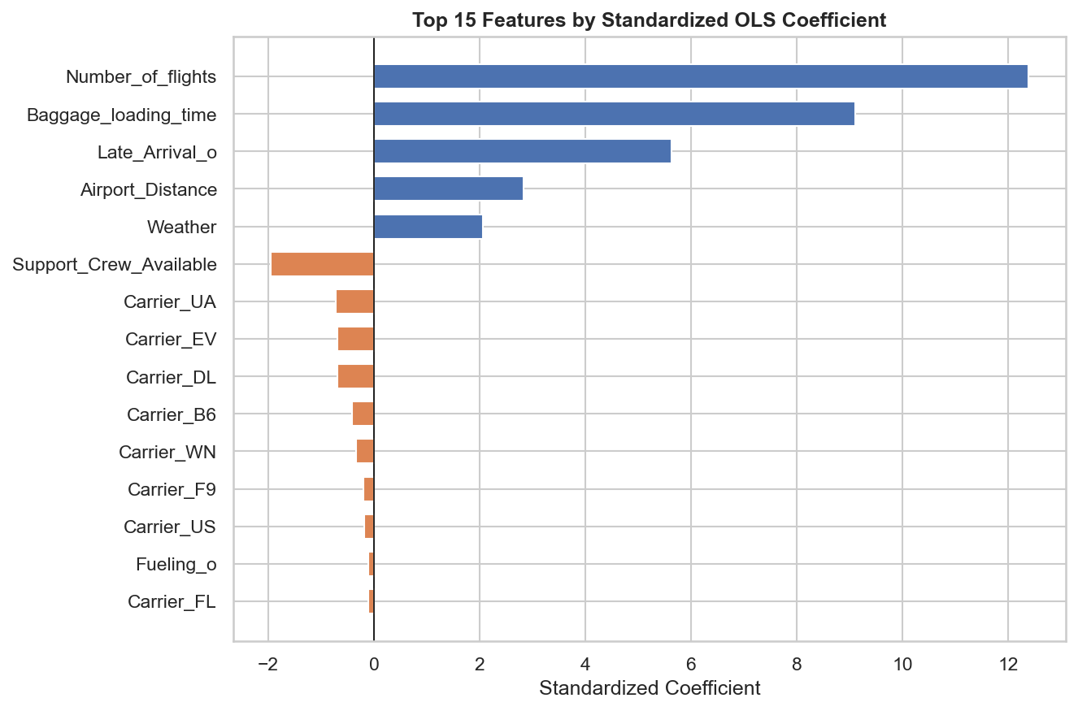
Figure 6. Top 15 features ranked by standardized OLS coefficient magnitude. Blue bars indicate a positive effect on delay; orange bars indicate a negative effect.
Evaluating the Steps: What I Learned at Each Stage
Looking back on the full workflow, each step served a distinct and non-negotiable purpose. Step 1 (data loading and exploration) was the foundation -- without understanding what I am working with, every downstream decision is made on shaky ground. Steps 2 and 3 (assumption checking and relationship evaluation) were, in my experience, the most undervalued steps in many data science projects. It is tempting to jump straight to model fitting, but the correlation analysis in Step 3 was what revealed that Cleaning_o and Fueling_o were essentially noise -- information I would not have had without that upfront investigation.
Step 4 (feature engineering and train/test split) was a pivotal methodological decision. The 70/30 split is a widely used convention that balances the need for enough training data to fit a stable model against having a large enough test set to meaningfully evaluate generalization. Step 5 (VIF analysis) provided formal assurance that my coefficient estimates were interpretable -- something that is easy to overlook but essential for producing a model whose outputs can be communicated meaningfully to stakeholders.
Steps 6 and 7 were the payoff. Using statsmodels for Step 6 rather than scikit-learn was a deliberate choice: statsmodels provides the full statistical machinery (p-values, confidence intervals, Durbin-Watson, AIC/BIC) that practitioners need to evaluate model validity beyond just R2. Step 7 demonstrated that the model generalizes extremely well, and the Breusch-Pagan and Durbin-Watson tests gave me confidence that the model's assumptions were met in the data.
Strengths and Challenges of Multiple Linear Regression
Strengths
Multiple linear regression has several qualities that make it exceptionally well-suited for operational contexts like airline delay prediction. First and foremost, it is interpretable. Unlike black-box models such as gradient boosting or neural networks, every coefficient in an OLS model has a direct, plain-language meaning. For each additional minute of baggage loading time, arrival delay increases by approximately 13.3 minutes, holding all else constant. That kind of specificity is invaluable when presenting findings to operations managers who need to know not just what will happen, but why and by how much.
Second, MLR is computationally efficient. The entire pipeline for this 3,593-record dataset ran in under 30 seconds on a standard laptop. This efficiency matters for real-time or near-real-time applications. Third, the accompanying diagnostic tests (VIF, Durbin-Watson, Breusch-Pagan, residual plots) provide a rich framework for validating model assumptions -- an infrastructure that more complex models often lack. Finally, the high R2 of 0.82 achieved here demonstrates that, for this particular problem, a linear model captures the relationship extremely well.
Challenges
The primary limitation I encountered was the assumption of linearity. MLR assumes that the relationship between each predictor and the outcome is strictly linear -- an assumption that may not hold in more complex real-world settings. For instance, the effect of weather severity on delays is unlikely to be perfectly linear across all conditions. Relatedly, MLR is sensitive to outliers: a small number of extreme delays can disproportionately influence the fitted line.
Multicollinearity, while manageable in this dataset (all VIFs below 7), can become a serious problem when predictors are highly correlated. In such cases, the model may be accurate overall (high R2) while producing unreliable and counterintuitive individual coefficient estimates. The Shapiro-Wilk test also flagged a mild deviation from normality in the residuals, which -- while not severe enough to invalidate the model given the large sample size -- would be worth investigating in a smaller dataset. Finally, MLR cannot capture interaction effects (for example, the combined impact of bad weather and a busy hub) without explicit interaction terms.
Suitability and Benefits for the Aviation Context
Multiple linear regression is highly suited to this airline delay use case for several interconnected reasons. The outcome variable (Arr_Delay, in minutes) is continuous and unbounded from below, which aligns with MLR's assumption of a continuous, normally distributed response. The predictors -- mainly operational metrics like loading times, crew availability, and late inbound aircraft -- are fundamentally additive in nature: each contributes incrementally to the total delay, which is precisely what an additive linear model captures.
The practical benefits for airlines are substantial. A deployed version of this model could run with live flight data to generate real-time delay forecasts as early as when ground crews begin preparing an aircraft. Airlines could use these predictions to preemptively notify passengers, reassign gates, or reposition crew members. The model's coefficient estimates also function as an operational diagnostic tool: if baggage loading time is the strongest driver of delays (beta = 13.3 minutes per additional minute of loading time), then investing in faster baggage handling equipment yields a clear, quantifiable return.
That said, the model would benefit from enrichment with additional data sources: live weather severity metrics (rather than a binary 5/6 code), air traffic control delays, runway configuration data, and time-of-day or seasonality features. Incorporating these would likely push the R2 above 0.85 and reduce RMSE meaningfully.
Reflections: Informative, Surprising, and Challenging Moments
The most genuinely surprising finding for me was how dominant Number_of_flights was as a predictor (r = 0.823 with Arr_Delay, and the highest standardized coefficient at 12.38). I initially expected weather or late aircraft arrivals to be the primary drivers of delays -- that is the intuitive narrative most travelers hold. But the data tells a different story: the sheer volume of daily departures at a hub is the single strongest predictor of how delayed a given flight will be. Network congestion at major hubs is apparently more predictive than the weather or even the downstream cascade of a late inbound aircraft.
What I found especially informative was the carrier dummy variable analysis. I expected certain carriers to show significantly different delay profiles, but once operational factors were controlled for, none of the carrier dummies reached statistical significance. This suggests that carrier identity itself is not a meaningful driver of delay -- what matters is what each carrier does operationally. This is an important insight for airline management: improving delay performance is about operational efficiency, not brand identity.
The most challenging aspect was navigating the tension between statistical significance and practical relevance. Several predictors -- Cleaning_o, Fueling_o, and Security_o -- were statistically non-significant in the full model, yet intuitively these operations should matter. On reflection, I believe this is partly a multicollinearity effect (these metrics correlate with other included variables) and partly a measurement granularity issue: the data may not capture the nuance needed for these variables to reveal their true effect. This is a reminder that null results in regression do not necessarily mean a variable is irrelevant -- they mean the model could not detect its effect given the current data structure.
Conclusion
This lab was a comprehensive, hands-on exercise in building and evaluating a multiple linear regression model for a real operational problem. By following the full pipeline -- from exploratory data analysis through assumption checking, feature engineering, model building, and rigorous evaluation -- I developed both technical skills and a deeper appreciation for the decisions that separate a careful, trustworthy analysis from a rushed one. The final model, with an R2 of 0.82 and RMSE of 12.43 minutes, performs impressively and generalizes cleanly to unseen data.
The key lesson I take away is that the value of multiple linear regression lies not just in its predictive accuracy but in its transparency. In an industry where operational decisions affect thousands of passengers and millions of dollars every day, a model that airline managers can understand, interrogate, and trust is often more valuable than a more accurate black box. As I continue building toward more complex predictive models in this course, the discipline I practiced here -- checking assumptions, validating splits, interpreting diagnostics -- will remain the foundation of sound analytical work.

References
Federal Aviation Administration. (2023). Understanding the impact of flight delays and cancellations. U.S. Department of Transportation. https://www.faa.gov
Hair, J. F., Black, W. C., Babin, B. J., & Anderson, R. E. (2019). Multivariate data analysis (8th ed.). Cengage Learning.
McKinney, W. (2022). Python for data analysis (3rd ed.). O'Reilly Media.
Montgomery, D. C., Peck, E. A., & Vining, G. G. (2021). Introduction to linear regression analysis (6th ed.). Wiley.
Pedregosa, F., Varoquaux, G., Gramfort, A., et al. (2011). Scikit-learn: Machine learning in Python. Journal of Machine Learning Research, 12, 2825-2830.
Seabold, S., & Perktold, J. (2010). Statsmodels: Econometric and statistical modeling with Python. Proceedings of the 9th Python in Science Conference.

