Security Alert Monitoring & Incident Response Report
Future Interns – Cyber Security Internship (Task 2)
Name of Candidate: Shruti Mate
Internship Provider: Future Interns
Domain: Cyber Security (SOC Operations)
Date of Execution: December 2025
Tool Used: Splunk Enterprise

1. Introduction
A Security Operations Center (SOC) is responsible for continuously monitoring organizational systems to detect, analyze, and respond to cybersecurity threats. SOC analysts review security alerts and log data to identify malicious activities and minimize potential risks.
This task simulates real-world SOC operations by using a SIEM platform to analyze system and network logs. The objective was to identify suspicious activities, classify incidents based on severity, and recommend appropriate response actions, similar to the responsibilities of a SOC analyst in a real organization.

2. Objective
The primary objectives of this task were:
- To gain hands-on experience with a SIEM tool
- To monitor and analyze security logs
- To identify and classify security incidents
- To understand incident response procedures
- To document findings in a professional SOC report

3. Tool Used
Splunk Enterprise
Splunk Enterprise is a widely used SIEM solution that enables real-time log ingestion, searching, and analysis of machine-generated data. In this task, Splunk was used to ingest simulated security logs and perform keyword-based searches to detect potential security incidents.

4. Log Source Description
The log file SOC_Task2_Sample_Logs.txt contained simulated security events, including:
- Successful and failed authentication attempts
- Network connection and access events
- File access activities
- Malware detection alerts
The logs were ingested as unstructured data (misc_text), requiring keyword-based searches and manual analysis to identify security incidents.

5. Incident Detection Methodology
The following approach was followed during the analysis:
- Upload the provided logs into Splunk
- Identify relevant keywords related to security events
- Analyze patterns such as repeated login failures and malware alerts
- Correlate events to identify suspicious behaviour
- Classify incidents based on severity
- Document impact and recommended response actions

6. Stakeholder Notification Draft
Subject: Security Incident Alert : Malware Activity Identified
Dear Management Team,
During routine security monitoring using the SIEM platform, multiple malware-related alerts were identified in system logs. These events have been classified as High Severity due to the detection of malicious indicators such as Trojan and Rootkit signatures.
Immediate actions have been recommended, including system isolation, enhanced monitoring, and malware remediation to prevent further impact. A detailed incident response report has been prepared outlining the findings and suggested corrective measures.
Please let us know if further clarification or action is required.
Regards,
Shruti Mate
SOC Analyst Intern
Future Interns

7. Identified Security Incidents

Incident 1: Malware Infection Detected
Search Query Used:
index=main "malware detected"
Description:
Multiple malware alerts were identified in the logs, including threats such as Trojan Detected, Rootkit Signature, and Worm Infection Attempt. These events indicate potential compromise of affected systems.
Severity: High
Impact:
Malware infections can result in data theft, system instability, and unauthorized access.
Recommended Response:
- Isolate affected systems
- Perform full malware scans
- Remove malicious files
- Apply security patches
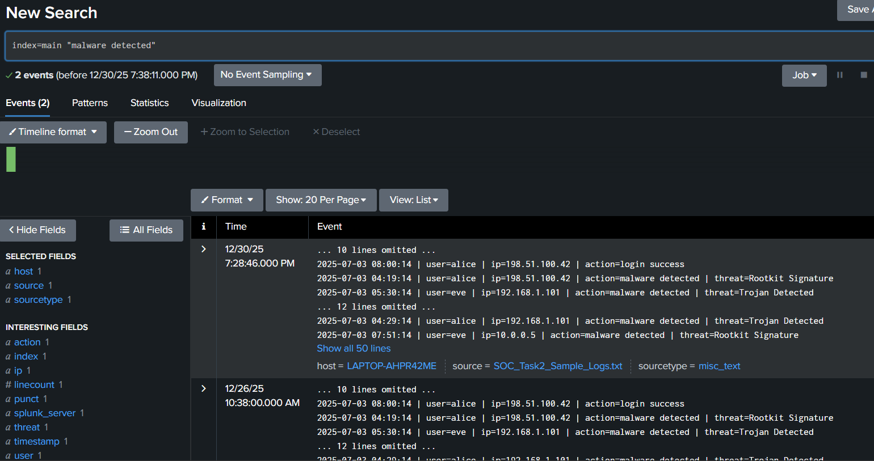

Incident 2: Multiple Failed Login Attempts
Search Query Used:
index=main "login failed"
Description:
Repeated failed login attempts were observed from specific IP addresses, suggesting possible brute-force or credential-guessing attacks.
Severity: Medium
Impact:
May lead to account compromise if attacks succeed.
Recommended Response:
- Enable account lockout mechanisms
- Enforce strong password policies
- Monitor and block suspicious IP addresses
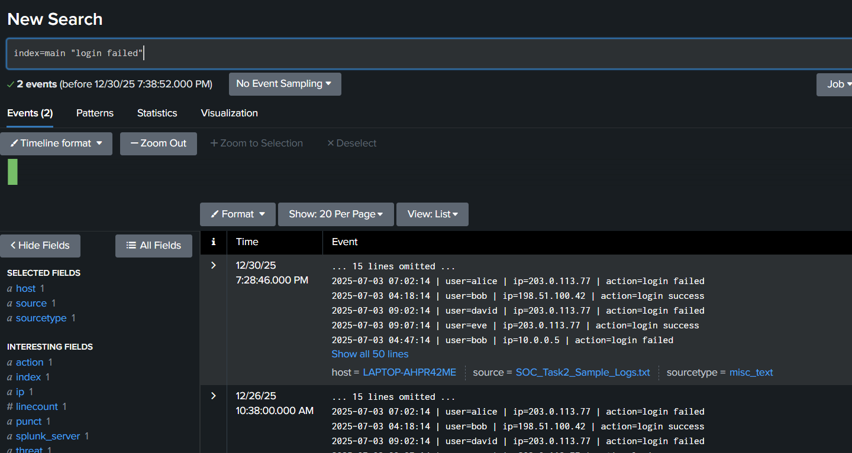

Incident 3: Suspicious IP Address Activity
Search Query Used:
index=main "203.0.113.77"
Description:
The same external IP address was involved in multiple activities such as login failures, malware detection, and file access, indicating coordinated malicious behavior.
Severity: Medium
Impact:
Suggests reconnaissance or multi-stage attack attempts.
Recommended Response:
- Block or restrict the suspicious IP
- Monitor network traffic
- Apply firewall and IDS/IPS rules
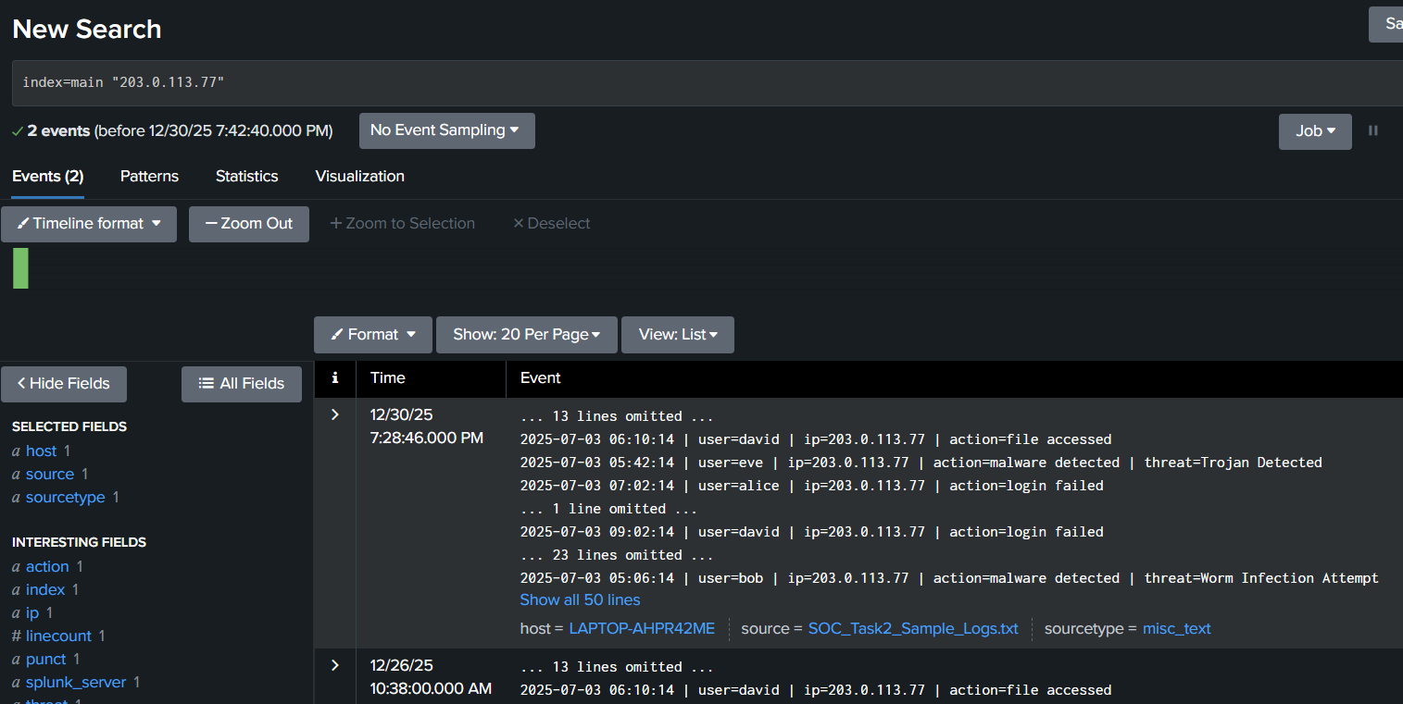

Incident 4: Unusual File Access Activity
Search Query Used:
index=main "file accessed"
Description:
Unusual file access events were detected that may indicate unauthorized or abnormal access to system resources.
Severity: Low
Impact:
Potential data exposure or misuse of sensitive files.
Recommended Response:
- Review user access permissions
- Implement strict access control policies
- Enable file activity monitoring
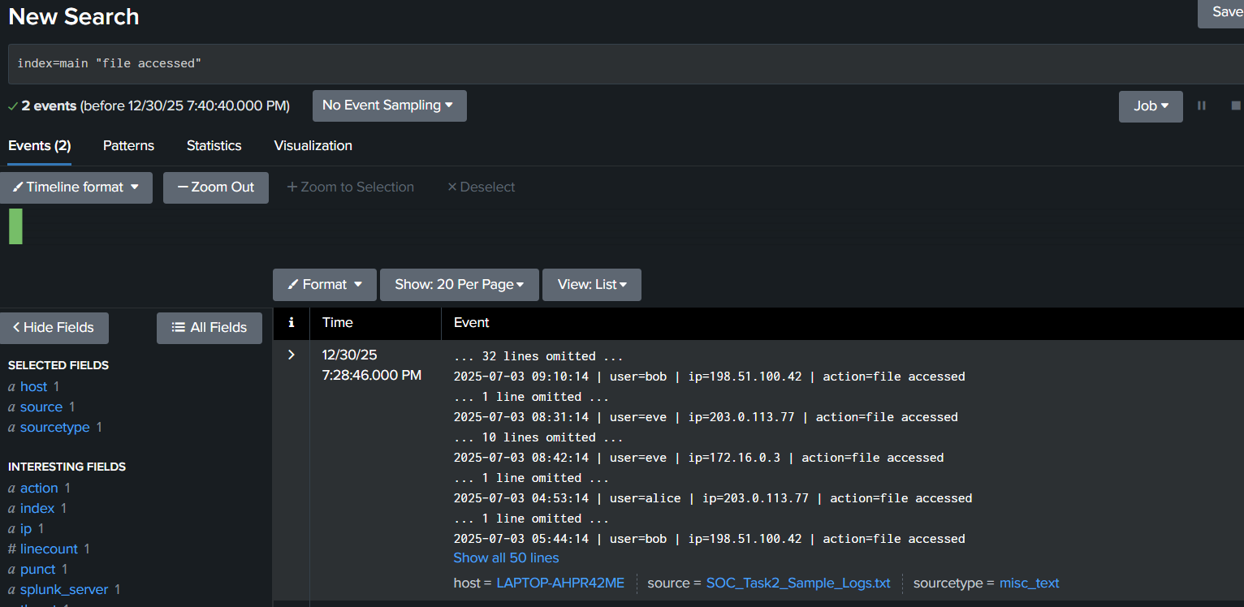

8. Incident Severity Classification Summary
Incident | Description | Severity
Malware Infection | Malware detected in logs | High
Failed Login Attempts | Possible brute-force attempts | Medium
Suspicious IP Activity | Repeated malicious actions | Medium
Unusual File Access | Possible unauthorized access | Low

9. Challenges Faced
- Understanding SIEM workflows in Splunk
- Working with unstructured log data
- Correlating multiple events to identify attack patterns

10. Learning Outcomes
Through this task, the following skills were developed:
- Understanding SOC operations and alert monitoring
- Practical experience with Splunk SIEM
- Incident classification and severity assessment
- Importance of timely incident response
- Professional documentation of security incidents

11. Conclusion
This task provided hands-on exposure to SOC alert monitoring and incident response activities. By analyzing security logs using Splunk, multiple security incidents were successfully identified and classified. The exercise demonstrated the importance of continuous monitoring, effective analysis, and timely response in maintaining a secure environment.

12. Screenshots & Evidence
Relevant screenshots were captured during Splunk analysis to support the findings. These include evidence of malware detection, failed login attempts, suspicious IP activity, and file access events.
- 
 