**ASSIGNMENT- CSS**

Q.1.

<!DOCTYPE html>

<html>

    <head>

    </head>

    <style>

        div.cls1{

            background-color: rgb(98, 0, 255);

            font-size:50px;

        }

        div.cls2{

            background-color: rgb(23, 0, 128);

        }

        div.cls3{

            background-color: rgb(0, 81, 128);

        }

        div.cls4{

            background-color: rgb(0, 217, 255);

              }

    </style>

    <div class="cls1">

        CSS background-color example!

    </div>

    <div class="cls2">

        This is a text inside a div element.

    </div>

    <div class="cls3">

        This paragraph has its own background color

    </div>

    <div class="cls4">

        We are still in the div elements

    </div>

</html>

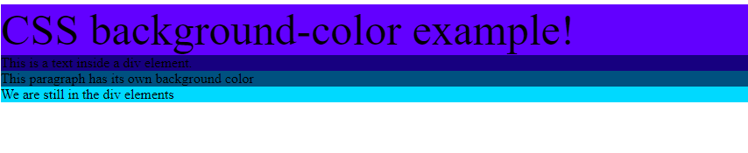

Q.2.

<!DOCTYPE html>

<style>

    div{

        background-color: rgb(116, 214, 206);

    }

    h2{

        text-decoration: line-through;

    }

    h3{

        text-decoration: underline;

    }

</style>

<html>

    <div>

        <h1>This is heading 1</h1>

        <h2>This is heading 2</h2>

        <h3>This is heading 3</h3>

        <h4>This is heading 4</h4>

   </div>

</html>



Q.3.

<!DOCTYPE html>

<html>

    <style>

    div{

        background-color: rgba(159, 220, 224, 0.993);

    }

    p.point{

        text-transform: uppercase;

    }

    </style>

    <div>

        <p class="point">This is some text

        </p>

        <p>This is some text

        </p>

        <p>This is some text

        </p>

    </div>

</html>



Q.4.

<!DOCTYPE html>

<html>

    <style>

     a{

        display: block;

         color: rgb(206, 90, 69);

         background-color: rgb(183, 241, 236);

     }

    </style>

    <body>

        <a href="www.google.co.in">This is a link</a>

    </body>

</html>



Q.5.

<!DOCTYPE html>

<html>

    <style>

        table,td{

            border: 1px solid black;

           border-collapse: collapse;

        }

    </style>

    <table>

        <tr>

            <th>

                <td>Firstname</td>

                <td>Lastname</td>

            </th>

        </tr>

        <tr>

            <th>

                <td>Peter</td>

                <td>Griffin</td>

            </th>

        </tr>

        <tr>

            <th>

                <td>Lois</td>

                <td>Griffin</td>

            </th>

        </tr>

    </table>

</html>

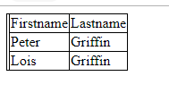

Q.6.

<!DOCTYPE html>

<html>

    <style>

        table,td{

            border: 1px solid black;

           border-color: rgb(21, 128, 0);

           ;

        }

        .new{

            background-color: rgb(21, 128, 0);

            color:white;

        }

    </style>

    <table >

        <tr class="new">

            <th>

                <td>Firstname</td>

                <td>Lastname</td>

                <td>Savings</td>

            </th>

        </tr>

        <tr>

            <th>

                <td>Peter</td>

                <td>Griffin</td>

                <td>$100</td>

            </th>

        </tr>

        <tr>

            <th>

                <td>Lois</td>

                <td>Griffin</td>

                <td>$150</td>

            </th>

        </tr>

        <tr>

            <th>

                <td>Joe</td>

                <td>Swanson</td>

                <td>$300</td>

            </th>

        </tr>

        <tr>

            <th>

                <td>Cleveland</td>

                <td>Brown</td>

                <td>$250</td>

            </th>

        </tr>

    </table>

</html>

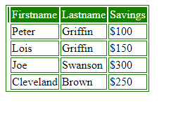

Q.7.

<!DOCTYPE html>

<html>

    <style>

        div.cls1{

            background-color: turquoise;

            border: 10px solid black;

        }

        div.cls2{

            background-color: turquoise;

            border: 5px solid black;

        }

        div.cls3{

            background-color: turquoise;

            border: 1px solid black;

        }

        p.cls4{

            background-color: turquoise;

            border:none;

        }

    </style>

    <div class="cls1">Some text.</div>

    <br>

    <div class="cls2">Some text.</div>

    <br>

    <div class="cls3">Some text.</div>

    <br>

    <p class="cls4">..</p>

</html>

