**ASSIGNMENT-2: JAVA SCRIPT (FUNCTIONS)**

Q.1.

<!DOCTYPE html>

<html lang="en">

<head>

    <meta charset="UTF-8">

    <meta http-equiv="X-UA-Compatible" content="IE=edge">

    <meta name="viewport" content="width=device-width, initial-scale=1.0">

    <title>Document</title>

</head>

<body>

    <script>

        var x=prompt("enter a number");

        function square(x){

            return x*x;

        }

        function double(x){

            return x*2;

        }

        function composedValue(){

        document.write("The value of compose(square,double) is" +square(double(x)));

        //used composed function

        }

        composedValue();

    </script>

</body>

</html>

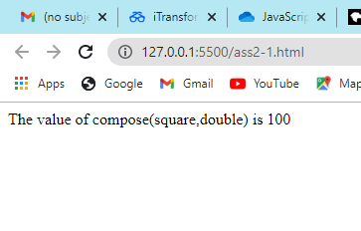

Q.2.

<!DOCTYPE html>

<html lang="en">

<head>

    <meta charset="UTF-8">

    <meta http-equiv="X-UA-Compatible" content="IE=edge">

    <meta name="viewport" content="width=device-width, initial-scale=1.0">

    <title>Document</title>

</head>

<body>

    <script>

        var x=prompt("enter a number");

        function square(x){

            return x*x;

        }

        function double(x){

            return x*2;

        }

        function compose(){

        document.write("The value of compose(square,double) is  "+square(double(x)) );

        document.write("<br> The value of compose(double,square) is  "+double(square(x)));

        }

        compose();

    </script>

</body>

</html>

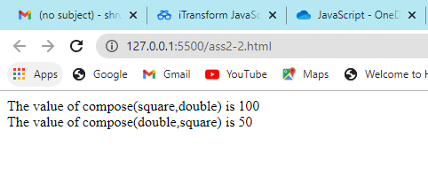

Q.3.

<!DOCTYPE html>

<html lang="en">

<head>

    <meta charset="UTF-8">

    <meta http-equiv="X-UA-Compatible" content="IE=edge">

    <meta name="viewport" content="width=device-width, initial-scale=1.0">

    <title>Document</title>

</head>

<body>

    <script>

        var array=prompt("enter an array");

        array = array.split(" ");

        document.write("The first value of array to pass test in function is: " +test(array));

        function test(array){

            for(i=0; i<array.length;i++){

                if((parseInt (array[i])) % 2 == 0)

                    return array[i];

            }

            return -1;

        }

    </script>

</body>

</html>

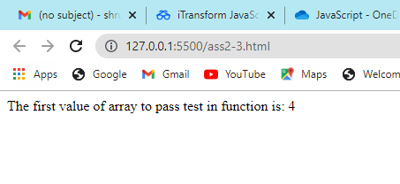

Q.4.

<!DOCTYPE html>

<html lang="en">

<head>

    <meta charset="UTF-8">

    <meta http-equiv="X-UA-Compatible" content="IE=edge">

    <meta name="viewport" content="width=device-width, initial-scale=1.0">

    <title>Document</title>

</head>

<body>

    <script>

        var array1 = prompt("Enter array1");

        var array2 = prompt("Enter array2 ");

        array1 = array1.split(" ");

        array2 = array2.split(" ");

        document.write("Array: "+array1+" ----> Squared Array: "+find_squares(array1));

        document.write("<br>Array: "+array2+" ----> Square Root Array: "+find_sqrroot(array2));

        function find_squares(array1){

            var newArray = [];

            for(i=0;i<array1.length;i++){

                var bool=array1[i]*array1[i];

                newArray.push(bool);

            }

            return newArray;

        }

        function find_sqrroot(array2){

            var newArray = [];

            for(i=0;i<array2.length;i++){

                var bool=Math.sqrt(array2[i]);

                newArray.push(bool);

            }

            return newArray;

        }

    </script>

</body>

</html>

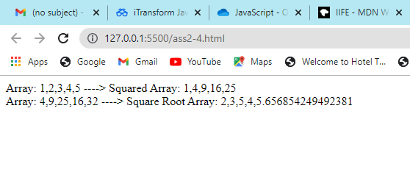

Q.5.

<!DOCTYPE html>

<html lang="en">

<head>

    <meta charset="UTF-8">

    <meta http-equiv="X-UA-Compatible" content="IE=edge">

    <meta name="viewport" content="width=device-width, initial-scale=1.0">

    <title>Document</title>

</head>

<body>

    <script>

        var array=[2,3,5,6,7,10];

        function isEven(num)

        {

            if(num%2==0)

            {

                return true;

            }

            else

            {

                return false;

            }

        }

        function map(array,isEven)

        {

            for(i=0;i<array.length;i++)

            {

                var res=isEven(array[i]);

                document.write("The value "+array[i]+" is "+res+"<br>");

            }

        }

        map(array,isEven);

    </script>

</body>

</html>

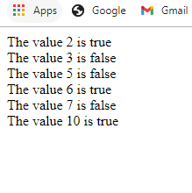

Q.6.

<!DOCTYPE html>

<html lang="en">

<head>

    <meta charset="UTF-8">

    <meta http-equiv="X-UA-Compatible" content="IE=edge">

    <meta name="viewport" content="width=device-width, initial-scale=1.0">

    <title>Document</title>

</head>

<body>

    <script>

        var arr1=[1,2,3,4,5,];

        var arr2=[1,4,9,16,25];

        function square(x)

        {

            return x*x;

        }

        function root(x)

        {

            return Math.sqrt(x);

        }

        function map(arr1,square)

        {

            document.write("The values of squares are :["+b+"]<br>");

        }

        function map(arr2,root)

        {

            var b=new Array();

            for(i=0;i<arr1.length;i++)

            {

                var res=root(arr2[i]);

                b[i]=res;

            }

            document.write("The values of square roots are :["+b+"]<br>");

        }

        map(arr1,square);

        map(arr2,root);

    </script>

</body>

</html>

