CN LAB EXPERIMENT-3

Develop a simple data link layer that performs the flow control using the sliding window protocol, and loss recovery using the Go-Back-N mechanism.
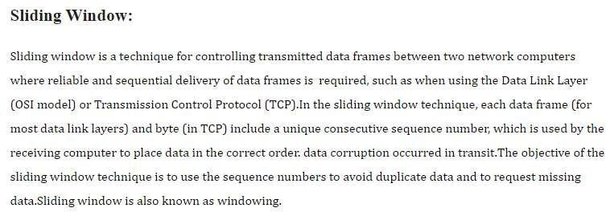

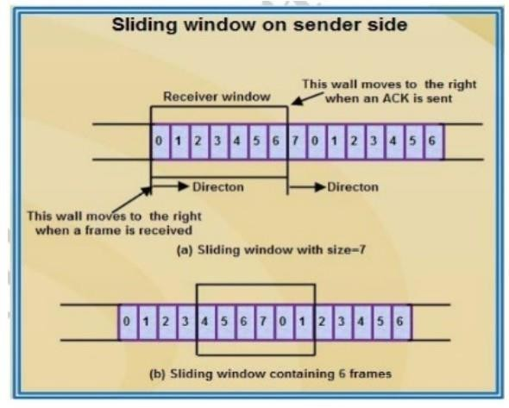

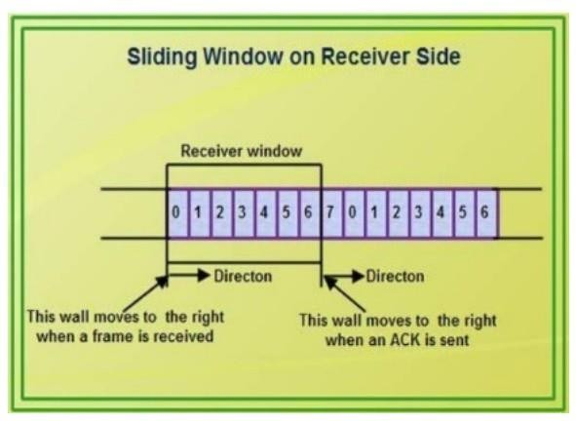
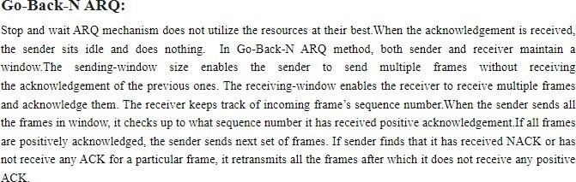

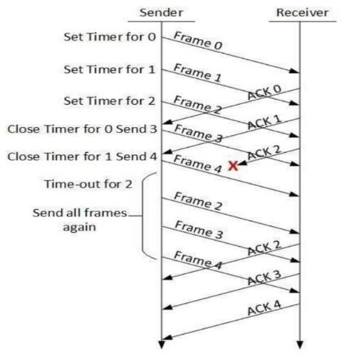

Program :-
import java.util.Scanner;
public class SlidingWindow {
public static void main(String[] args) {
Scanner sc = new Scanner(System.in);
int windowSize, sent = 0, ack, i;
int windowMin = 1, windowMax, maxSent = 0, frames;
System.out.print("Enter number of frames: ");
frames = sc.nextInt();
System.out.print("Enter window size: ");
windowSize = sc.nextInt();
windowMax = windowSize;
while (windowMin <= frames) {

for (i = sent; i < windowMax && i < frames; i++) {
System.out.println("Frame " + (i + 1) + " has been transmitted.");

if (maxSent < i + 1)
maxSent = i + 1;
}
sent = maxSent;
System.out.print("\nPlease enter the last Acknowledgement received: ");
ack = sc.nextInt();

windowMin = ack + 1;
windowMax = windowMin + windowSize - 1;

if (ack == frames) {
System.out.println("\nAll frames transmitted by sender and received by receiver!!!");

break;
}
}
sc.close();
}
}

Output:

