2.Proposed System

Scope

❖ Admin
Admin can manage Categories, employee, Companies and
other entities of database and has all access to privileges.

❖ Employee
Employee will manage their profile, can register him/her as
member, can review about company and also check for any container or consignment.
.

❖ Company
Company can register as a member, manage reviews ,loading container or consignment.
.
Objective

➢ Provide the system administrator with easy interface for
different administrative tasks such as Searching, Addition and Updating of different entities.
➢ The System should properly maintain user privilege i.e. it
should only allow registered members to access certain
features, which it should not allow for unregistered users.
➢ Only administrator will have all privileges.
➢ Members will have limited access privileges.

Constraints
➢  Higher internet connection required.
Advantages

➢ The basic aim of website is to provide guidance and useful piece of information to company and customer .
➢ Our website provides different services to customer.
➢ Employee can also give suggestions to company how they want work from them.

Limitation
➢ Inappropiate database management can lead to system inefficiency.
➢  Admin must upload proper details else it may lead to wrong results.

3. Environment Specification

Hardware & Software Requirement
- Maintenance is required at given fixed time duration.
- Power failure may happen so UPS is required.
- Data may be loss at some time because of virus or any take backup at some regular.
- It is a general system, hence there is unique form layout & format.
- This Project is to be developed as a part of curriculum & to be submitted within a period of 6 months.

Hardware Requirement
Given below is recommended hardware specification that required at client side to run software
- Input Device :- Keyboard , Mouse
- Output Device :- Android Phone
- Operating System :- Microsoft Windows 10 and android

Software Requirement
Given below is recommended specification of require software to develop the system.
- Operating System (phone) :- Android
- Front End :- AngularJs
- Back End :- Asp.Net
- Operating System (laptop) :- Microsoft Windows 10

4. System Planning

Feasibility Study

Feasibility study involves research relating to different aspects that is go into developing software. Feasibility study of the problem definition or requirement was done to determine if the requirement can be solved effectively given the budgetary, operational & technical and scheduled constraints in place. The aim is to identify the best solution under the circumstances by identifying the effects of the solution on the organisation.

The feasibility of our project has been judged on the basis of time, technology, resources available, behavioural feasibility & cost of development.

Duration Feasibility

➢ Project is initiated with given deadlines.
➢ The duration is allotted keeping in mind the entire task & is practically feasible.

Implementation Feasibility

A proper implementation is necessary to provide a reliable system to meet requirements of the organization. It is the stage in the project where the theoretical designs are turning to a working system. The most difficult stage in achieving a new successful system is to improve the performance of the existing system and to deliver system effective application.

Operational Feasibility

➢ It help to save time and fast processing.
➢ From the Admin perspective our application requires basic knowledge about policies of Cyber World.

Technical Feasibility

➢ Minimum system required for admin, user and visitor is computer connected with internet with compatible browser.
➢ The system is suitable for multi user operations. With the available resources robust system with data security can be developed. It uses PHP which has been tested & approved to be sufficiently robust, scalable & efficient to develop such an application. Hence technically there is no limitation for development of the system.

Resource Feasibility

➢ The system requires well trained software developers. Besides that network connectivity, MySQL servers are needed. Tools for documentation & editing are required.
➢ These resources are available and feasible.

Behavioural Feasibility

➢ Benefits of proposed system were assessed. Having realized the benefit of new system the users’ response was studied before the inception of system development. They reacted positively towards the proposal.
➢ Since all the users involved in project development are familiar with internet no explicit training will be required to learn the usage of new system. Simple guidance would suffice.

Economic Feasibility

➢ The cost of software and hardware required for system including storage of bulk of data server.
➢ No budgetary constraints were imposed on the system. More importantly since all free software were used only hardware, usage & internet costs were to be considered. These were quite limited & well within feasibility.

Based on above study it can be stated that designing & developing this system is certainly feasible if executed well within stated guidelines. So based on these positive results, the new system was approved for development.

Software Engineering Model

We followed Iterative Waterfall Model for software development so that we can add new functionalities as per requirement.

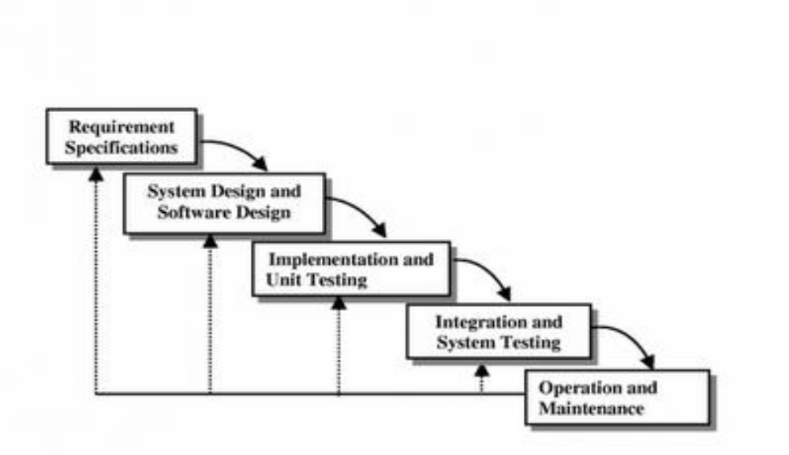

Following is detailed scheduling of task and time line chart of schedule.

Tasks | Start Date | Duration ( Days ) | End Date
Requirement Gathering | 22/07/2021 | 13 | 03/08/2021
Design | 04/08/2021,  14/08/2021 | 4+4=8 | 07/08/2021,  18/08/2021
Coding | 08/08/2021,  19/08/2021 | 6+27=33 | 13/08/2021,  15/09/2021
Testing | 16/09/2021 | 16 | 31/09/2021
Rework and documentation | 01/11/2021,  01/12/2021 | 30+24=54 | 30/11/2021,  24/12/2021

Project Schedule
Task Dependancy

