A Mini Project Report Phase I Report On
Phobia Treatment Using Virtual Reality

Submitted in Partial Fulfilment of the degree of Bachelor of Technology in Computer Engineering

Submitted by
Snehal Patil (43)
Shruti Pawar (45)

Under the guidance of
Prof. Iffat Kazi

Usha Mittal Institute of Technology
S.N.D.T. Women’s University
Juhu Tara Road, Santacruz(West),
Mumbai-400049
2025-2026

CERTIFICATE

This is to certify that Snehal Patil, Shruti Pawar have completed the Mini Project Phase I on the topic “Phobia Treatment Using Virtual Reality” satisfactorily in partial fulfilment for the Bachelor Degree in Computer Engineering under the guidance of Prof. Iffat Kazi during the year 2025-26 as prescribed by S.N.D.T Women’s University, Mumbai.

Guide Head of the Department
Prof. Iffat Kazi Dr.Rachana Dhannawat

Principal
Dr. Yogesh Nerkar

Examiner 1 Examiner 2

Contents

Abstract………………………………………………………………………………………………………………………….….1
- Introduction………………………………………………………………………………………………….……......2
- Objectives…………………………………………………………………………………………………………………3
- Literature Survey…………………………………………………………………………………………………….4
  - Immersive Phobia Therapy through Adaptive Virtual Reality and Biofeedback..……………. 4
  - CAEVR: Bio-signals-Driven Context-Aware Empathy in Virtual Reality……………………….……7
  - Battle Against Your Fears: Virtual Reality Serious Games and Physiological An-
alysis For Phobia Treatment…………………………………………………………………………………….12
  - Adaptive Virtual Reality Exposure Therapy with Biofeedback…………………………………….…18
  - The Application of AI Video Generation Technology in Virtual Reality (VR) And
Augmented Reality(AR)………………………………………………………………………………………..…23
- Comparative Table……………………………………………………………………………………………………….26
- References………………………………………………………………………………………………………………….…27

List of Tables

Figure 4.1 Comparative Study Table…………………………………………………………………………………..26

List of Figures

Figure 3.1: Flowchart of paper 3.1…………………………………………………………..………………………………5
Figure 3.3: Flowchart of paper 3.2…………………………………………………………………..………………………9
Figure 3.3: Flowchart of paper 3.3…………………………………………………………………………………………16
Figure 3.3: Flowchart of paper 3.4…………………………………………………………………………………………20 Figure 3.3: Flowchart of paper 3.5…………………………………………………………………………………………24

ABSTRACT
Anxiety disorders, and phobias in particular, affect a substantial portion of the global population, often causing significant disruptions to daily life, work, and overall wellbeing. Individuals suffering from phobias frequently experience intense fear and avoidance behaviors that can be difficult to manage. Cognitive Behavioural Therapy (CBT) has long been recognized as the gold standard for treating phobias due to its structured approach and evidence-based efficacy. However, traditional CBT often relies on real-world exposure to feared situations, which can present considerable challenges. Many patients experience high levels of anxiety during exposure, feel a lack of control, or face practical barriers such as accessibility and scheduling, leading to increased dropout rates and reduced treatment adherence.
Virtual Reality Exposure Therapy (VRET) has emerged as a promising alternative to traditional exposure methods. By creating immersive, computer-generated environments, VRET allows patients to confront their fears in a controlled, safe, and repeatable manner. Scenarios such as heights, enclosed spaces, or public speaking can be simulated with precision, enabling gradual and progressive exposure under therapist supervision. Despite these advantages, current VR therapy systems often have limitations. Many rely on fixed exposure sequences and lack the ability to dynamically respond to patient reactions, resulting in suboptimal emotional engagement and reduced personalization.
To overcome these challenges, we propose a smart, adaptive VR therapy framework that leverages artificial intelligence (AI) and biometric sensing to tailor the therapeutic experience in real time. By integrating data from biosensors, such as heart rate monitors and galvanic skin response (GSR) sensors, the system can continuously assess patient stress levels and adjust the intensity or nature of the VR environment accordingly. This patient-centric approach ensures that exposure is both safe and effective, reducing the likelihood of overwhelming the patient while maximizing therapeutic impact. Additionally, a therapist monitoring dashboard allows clinicians to oversee sessions, provide guidance, and validate progress, ensuring clinical rigor and enhancing treatment outcomes.

1

INTRODUCTION

Anxiety disorders and phobias impact a significant portion of the global population, often disrupting daily life. The established treatment, Cognitive Behavioural Therapy (CBT) with exposure therapy, is effective but faces practical challenges: real-world exposure can be inaccessible, costly, emotionally overwhelming, and difficult to control.

This project, “Phobia Treatment Using Virtual Reality," leverages the synergy of Artificial Intelligence (AI) and the Internet of Things (IoT) to create a transformative solution. We propose an intelligent system that moves beyond static Virtual Reality Exposure Therapy (VRET) by building a dynamic, adaptive, and personalized therapeutic experience.

The IoT framework forms the system's sensory layer, utilizing biometric sensors (e.g., heart rate monitors, GSR sensors) as connected devices. These sensors continuously stream real-time physiological data, providing an objective, quantifiable measure of a patient's anxiety state.

The AI/ML component acts as the analytical brain. Machine Learning algorithms process this IoT sensor data to recognize patterns of anxiety and stress in real-time. Based on this analysis, the AI intelligently adapts the VR environment—modifying the intensity, proximity, or number of phobic stimuli—to ensure the exposure remains within a therapeutic and manageable range for the patient.

This closed-loop AI-IoT integration creates a responsive and safe system that personalizes therapy moment-to-moment. It aims to increase accessibility, improve efficacy, prevent overwhelm, and enhance patient adherence, representing a significant advancement in data-driven mental healthcare.

2

OBJECTIVE

- Analyse limitations of traditional phobia treatments – To critically evaluate the challenges associated with conventional approaches such as Cognitive Behavioural Therapy (CBT) and real-world exposure, focusing on patient experience, treatment accessibility, and scalability.
- Explore the potential of Virtual Reality Exposure Therapy (VRET) – To investigate VRET as an innovative alternative that offers immersive, controlled, and customizable exposure experiences, potentially overcoming the limitations of traditional therapies.
- Propose AI/ML-driven enhancements – To examine how artificial intelligence and machine learning can be utilized to personalize therapy sessions, adapt exposure in real time, and optimize treatment efficacy for individual patients.
- Integrate biofeedback mechanisms – To leverage biometric sensors (e.g., heart rate, galvanic skin response) to monitor patient stress levels during therapy and dynamically adjust VR environments for a responsive, patient-centric approach.
- Design a conceptual VR-based phobia therapy framework – To develop a comprehensive system that combines AI-driven adaptive VR scenarios with therapist oversight, progress tracking, and cost-effective delivery methods for wider accessibility.
- Recommend future directions – To propose strategies for further optimizing VR therapy, ensuring it is more accessible, effective, and clinically acceptable, while addressing the evolving needs of patients and therapists.

3

LITERATURE SURVEY

Immersive Phobia Therapy through Adaptive Virtual Reality and Biofeedback
Authors: Alin Moldoveanu, Oana Mitruț, Nicolae Jinga, Cătălin Petrescu, Florica Moldoveanu, Victor Asavei, Ana Magdalena Anghel, and Livia Petrescu.
Publication: Applied Sciences, 2023, 13(18), 10365.
Introduction: The paper introduces PhoVR, a virtual reality exposure therapy (VRET) system designed to treat phobias such as acrophobia, claustrophobia, and glossophobia. It uses adaptive VR environments, real-time biofeedback, and gamified tasks to provide a safe and effective therapeutic experience.
Problem Statement: Phobias affect a significant portion of the global population, yet 8access to effective therapy remains limited. Traditional exposure therapy can be impractical, risky, or inaccessible. VRET offers a controlled alternative, but many existing systems lack adaptability, biofeedback integration, and therapist support.
Techniques Used:
- Virtual Reality Exposure Therapy (VRET): Gradual exposure to phobic stimuli in controlled VR environments.
- Biofeedback Integration: Real-time monitoring of electrodermal activity (EDA) and heart rate (HR) to assess anxiety levels.
- Gamification: Use of quests and interactive tasks (checkpoints, photo tasks, collection, pickup) to engage users.
- Dynamic Adaptation: Automatic or therapist-controlled adjustments to the VR environment based on user anxiety.
- Emotion Classification: Proprietary algorithm to classify physiological data and identify difficult moments.
- Relaxation Techniques: Access to support elements (music, videos, 360° images) during sessions.
- Speech Analysis: Integration of Microsoft Azure Speech-to-Text to analyse speech rate, volume, and fluency.
- Virtual Companion: Animated avatar to provide support and reduce isolation.

4
Workflow Diagram:
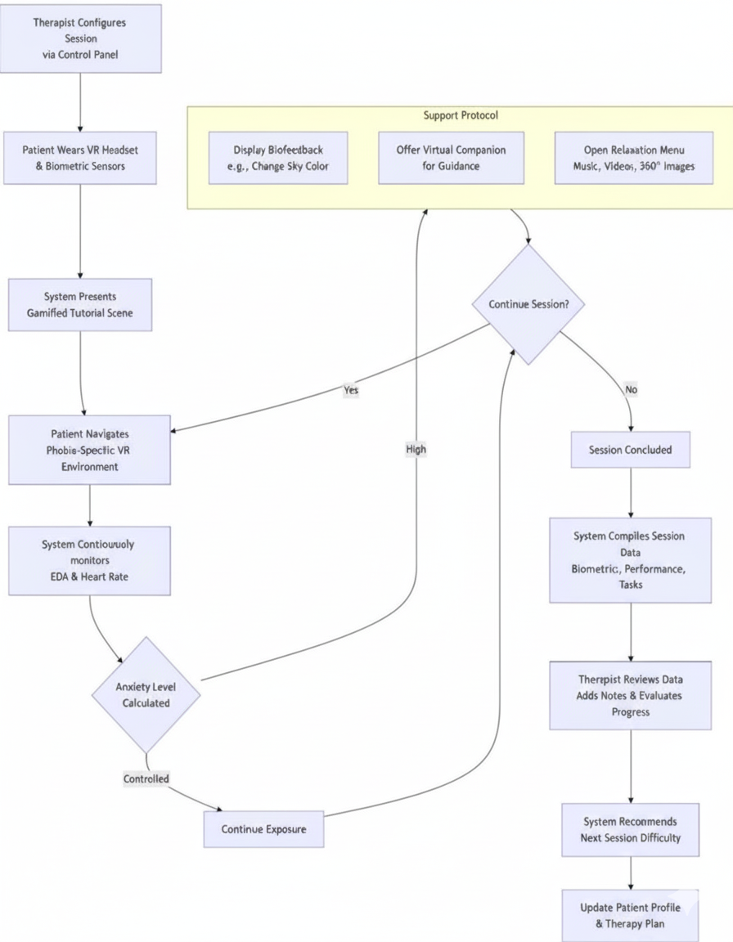
Figure 4.1: Flowchart
5

Findings/Observation:
- Proven Anxiety Induction: The VR environments (especially the Bridge and Tunnel scenes) caused statistically significant increases in physiological stress (electrodermal activity) in participants, even though none had a diagnosed phobia. This proves the scenes effectively trigger anxiety.
- Therapist Acceptance: 6 out of 7 psychotherapists (who were new to VR) were inspired and wanted to use the technology in their practice. All found the biometric data useful for monitoring patients.
- High Anxiety Baseline: Pre-test screening revealed 84% of participants had high baseline anxiety levels, confirming the test was relevant for an anxiety-management tool.
- Technical Performance: The system ran at an adequate frame rate on both desktop and standalone VR headsets to avoid dizziness, and the speech-to-text integration performed with over 98% accuracy.
Drawbacks:
- Technical Constraints: Lower frame rates on standalone VR devices (e.g., Oculus Quest 2) affect immersion.
- Motion Sickness: Controller-based navigation can induce dizziness.
- Limited Interaction: The Virtual audience cannot interact dynamically (e.g., ask questions).
- Therapist Control: Some therapists desired more control over session orchestration.
- Hardware Cost: Biometric sensors and high-end VR equipment are expensive.
Future Scope:
- Enhanced Realism: Use photorealistic environments and real-world imagery.
- AI-Driven Personalization: Automatically generate environments based on patient descriptions.
- Hardware Integration: Support consumer wearables (e.g., fitness trackers) to reduce costs.
- Longitudinal Studies: Conduct large-scale, long-term efficacy trials.
- Remote Therapy: Develop robust remote monitoring and teletherapy capabilities.
In Conclusion the paper represents a significant advancement in VR-based phobia therapy, combining immersive environments, real-time biofeedback, and gamified tasks to create an engaging and effective therapeutic experience.
6

2.CAEVR: Bio-signals-Driven Context-Aware Empathy in Virtual Reality
Authors and Publication: Kunal Gupta, Yuewei Zhang, Tamil Selvan Gunasekaran,
Nanditha
Krishna, Yun Suen Pai, Mark Billinghurst
Published in IEEE Transactions on Visualization and Computer Graphics, Vol. 30, No. 5, May 2024
Introduction: This paper presents CAEVR, a system that integrates bio signal-based emotion recognition with context-aware empathic virtual agents in VR. It aims to enhance user experience by adapting the environment and agent feedback based on real-time user emotions captured through EEG, EDA, and HRV sensors. The research addresses empathy and cognitive load in immersive VR applications.
Problem Statement: Current VR systems have limited ability to recognize and respond meaningfully to users' dynamic emotional changes. There is a lack of effective integration of physiological emotion recognition and context-aware empathic responses to improve user engagement, emotional well-being, and cognitive experience in VR.
Techniques Used:
- Real-time Bio signal Acquisition: The system utilized a 16-channel OpenBCI EEG cap to capture brainwave activity and a Shimmer GSR+ sensor to measure electrodermal activity (EDA) and photoplethysmography (PPG) for heart rate variability (HRV). These sensors streamed data at 125 Hz (EEG) and 128 Hz (EDA/PPG) via the Lab Streaming Layer (LSL) protocol, enabling synchronous integration with VR events.
- Machine Learning Emotion Recognition (BioEmoVR): A four-class ML model was developed to classify emotions into: Happy (Positive Valence-Positive Arousal), Stress
(Negative Valence-Positive Arousal), Bored (Negative Valence-Negative Arousal), and Relaxed (Positive Valence-Negative Arousal). The model achieved 91.67% accuracy using features extracted from EEG, EDA, and HRV signals, processed with NeuroKit2 and validated via 10-fold cross-validation.
- Self-Projected Appraisal : This technique inferred situational emotions (SE) based on user activities and VR context. For example, in the photography task, SPA triggered stress if the user was behind schedule or sadness if too few photos were taken, combining with physiological emotions (PE) for holistic emotion appraisal.
- Empathic Emotion Features : A framework of five Boolean categories—Empathic Emotion (EE), Comfort/Reassurance (CR), Motivation/Support (MS), Positive Reinforcement (PRE), and Urgency/Pressure (UP)—was used to tailor agent responses. EEFs were activated based on combinations of PE and SE to provide contextually appropriate empathic feedback.
- Adaptive VR Environment: The system altered environmental colours in real-time based on emotional state: Yellow (Happy), Red (Stress), Blue (Sad), and Green (Relaxed), leveraging colour-emotion associations to enhance emotional awareness and regulation.
7
- Empathic Virtual Agent: A Belief-Desire-Intention (BDI) model guided the agent’s dialogues and tone. The agent used Microsoft Azure TTS with empathic tones (e.g., "excited" for Happy, "empathetic" for Stress) and provided context-aware assistance, such as navigation help or photo management cues.
- User Study Design: A 2x2 within-subject study evaluated Emotion-Adaptive (EA) and Context-Aware Empathic (CAE) conditions using subjective (SAM, IPQ, GEQ, NASATLX), physiological (EEG, EDA, HRV), and behavioural measures.

8

Workflow Diagram:

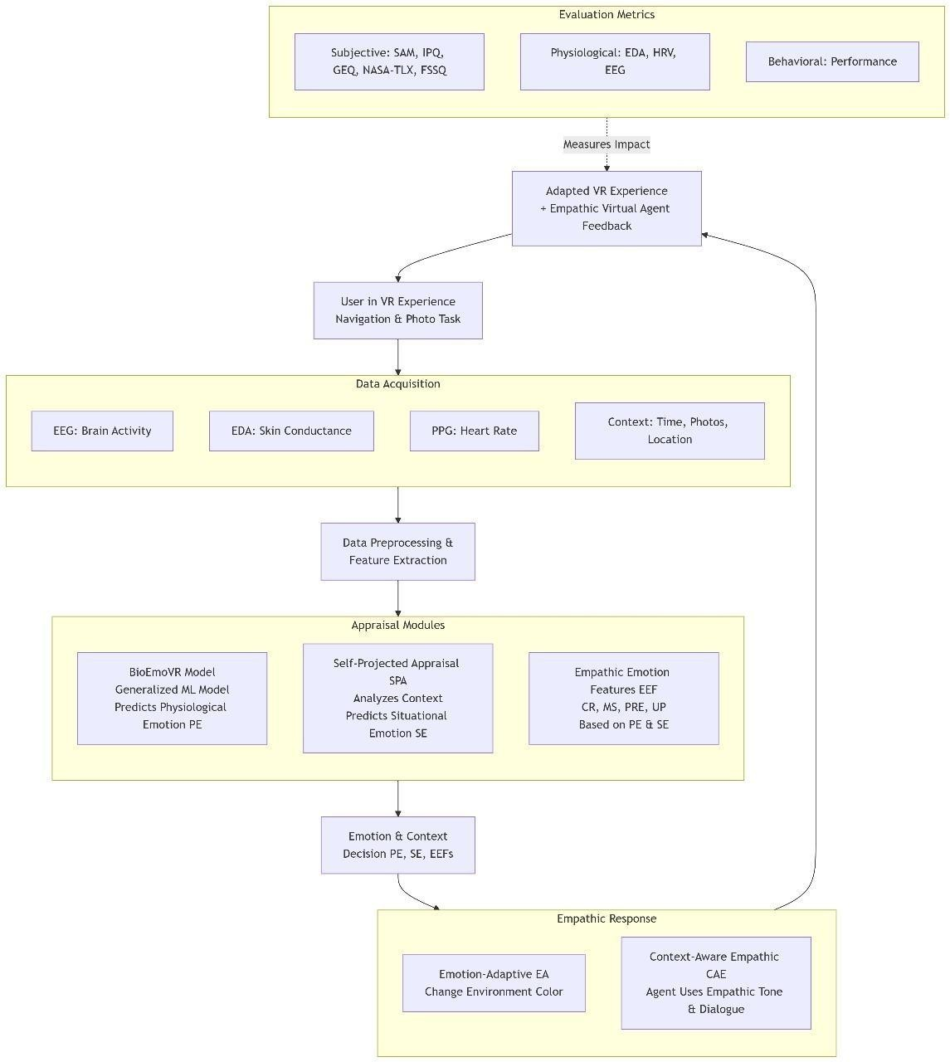

Figure 4.2: Flowchart

9

Findings:
- EA and CAE independently and combined significantly increased positive emotional valence and empathy towards the virtual agent.
- CAE significantly influenced task cognitive load, indicated by NASA-TLX and EEG frontal theta activity.
- Physiological measures (EDA, HRV, EEG) corroborated subjective emotional and cognitive effects.
- No significant impact on presence or flow state was found, likely due to high immersive engagement across conditions.

Advantages
- High-Accuracy Emotion Recognition: BioEmoVR’s 91.67% accuracy enables reliable real-time emotion detection.
- Context-Integration: SPA and EEFs allow the system to respond to both physiological and situational cues, enhancing personalization.
- Empathic Engagement: The CAE agent increased user empathy and motivation, demonstrating the potential for therapeutic and educational applications.
- Dynamic Adaptation: Real-time colour changes and agent dialogues improve emotional regulation and user experience.
- Broad Applicability: The framework is versatile for healthcare, education, metaverse, and remote collaboration.
Limitations & Disadvantages
- Small Sample Size: 15 participants limit statistical power and generalizability.
- Motion Artifacts: Physical movement in VR corrupted EEG signals, challenging real-time accuracy.
- Minimalistic Agent Design: The orb-shaped agent lacked expressive cues (e.g., facial expressions), potentially reducing emotional impact.
- Audio-Only Feedback: TTS-based dialogues may contribute to cognitive overload without visual or haptic support.
- High Baseline Engagement: The immersive environment may have overshadowed intervention effects on presence and flow.
10

Future Scope:
- Expressive Virtual Agents: Incorporate embodied agents with facial expressions and gestures for richer interactions.
- Advanced Signal Processing: Use cutting-edge artifact removal algorithms (e.g., deep learning) to improve bio signal accuracy.
- Multimodal Feedback: Combine visual, auditory, and haptic cues to reduce cognitive load and enhance empathy.
- Larger Studies: Conduct longitudinal studies with 30–50+ participants, including clinical populations.
- Domain Expansion: Apply CAEVR to rehabilitation, remote teamwork, mental health therapy, and cultural education

Conclusion:

The study demonstrates that integrating real-time emotion recognition with context-aware empathic virtual agents in VR significantly enhances users' positive emotions, empathy, and cognitive engagement, offering promising applications for emotionally adaptive immersive experiences.

11

3. Battle Against Your Fears: Virtual Reality Serious Games and Physiological Analysis for Phobia Treatment

Authors and Publication: Bernardo Marques, Diogo Moreira, Martim Neves, Susana
Brás,
José Maria Fernandes
Published in IEEE Computer Graphics and Applications, January/February 2025
Introduction: This paper presents a VR-based framework combining serious games and physiological monitoring to support exposure therapy for phobias. The system offers interactive, immersive environments tailored to different fears, using real-time biofeedback to adapt exposure safely and personally, enhancing both engagement and therapeutic effectiveness.to safely tailor exposure therapy.
Problem Statement: Phobias cause intense fear that disrupts daily life. Traditional exposure therapy is effective but often avoided because confronting real fears is intimidating. Current VR therapies lack enough interaction and adaptability. This paper presents an interactive VR system with real-time physiological feedback to safely tailor exposure therapy.
Techniques Used:
- VR Serious Games: The system utilizes VR Serious Games developed in the Unity 3D engine to create immersive and interactive therapeutic environments. Unlike passive VR experiences, these are designed as open-world games with structured narratives and objectives. For arachnophobia, a game tasks the user with capturing escaped spiders in an apartment and returning them to an aquarium, with difficulty escalating through levels by increasing spider count, speed, and hiding spots. For acrophobia, a game involves searching a park for a missing dog, which narratively integrates exposure elements like riding a glass elevator, climbing high walls, and crossing challenging bridges. This gamified approach promotes active participation and
provides essential periods of respite within the open world, allowing users to recover between exposures, which is crucial for a sustainable therapeutic process.
- Physiological Monitoring: The framework incorporates Physiological
Monitoring through a wearable device from Plux Bio signals, equipped with multiple sensors placed on the user's body. This device captures a variety of bio signals in real-time, including electrocardiogram (ECG) for heart rate, respiration, and potentially electromyography (EMG), electrodermal activity (EDA),
electroencephalography (EEG), and blood volume pulse. The device connects via Bluetooth to a central server, where a Python script accesses its application programming interface (API) to fetch the sensor data. This continuous physiological data collection provides an objective measure of the user's anxiety and emotional arousal in response to the virtual stimuli.
12
- Data Aggregation & Synchronization: A critical technical component is the Data Aggregation and Synchronization module, which employs a client-server architecture. A centralized server running Node.js manages this process. Clients, such as the VR headset and sensor systems, connect to this server via web-sockets, enabling real-time data exchange. This server synchronously combines the physiological signals from the wearable device with relevant in-game events and metrics from the VR serious game. This ensures that every physiological response is precisely timestamped and linked to the specific stimulus or event that caused it, creating a cohesive and meaningful dataset for accurate analysis and biofeedback.
- Adaptive Biofeedback: The system features an Adaptive Biofeedback mechanism that creates a dynamic feedback loop between the user's body and the virtual environment. This module continuously monitors the incoming bio signals, checking if they exceed predefined thresholds indicative of high stress or anxiety. When thresholds are breached, the system automatically triggers adjustments in the VR environment in real-time. For example, it can reduce the number of spiders, slow down the speed of a glass elevator, or otherwise decrease the intensity of the phobic stimulus. This ensures the exposure remains within a therapeutic range, preventing overwhelm and tailoring the challenge to the user's current physiological state.
- Visualization Dashboard: To empower clinicians, a Visualization Dashboard was developed using Python's Dash library, built on Flask. This interactive dashboard provides therapists with a visual interface to monitor key physiological metrics during and after sessions. It currently generates line charts displaying real-time and historical data for ECG, heart rate, and respiration. Therapists can zoom in on specific data segments for closer inspection and export the data for further analysis. This tool transforms raw physiological data into actionable insights, supporting therapists in making informed decisions about a patient's progress and treatment plan.
- User Interaction: User Interaction within the system is designed to be intuitive and engaging, leveraging the capabilities of the Meta Quest 2 VR headset. Users navigate the open-world environments and interact with objects and characters using the headset's motion controllers. The interaction is gamified through mission-based objectives, such as locating all the spiders or gathering clues from NPCs to find a missing dog. This active, controller-based exploration and problem-solving enhance immersion and agency, making the exposure process feel more like a purposeful activity than a passive medical procedure, thereby increasing user motivation and engagement.
13

Findings
The framework was evaluated through a series of events and user studies involving 79 participants with diverse backgrounds. The key findings are:
- Effective Stimulus Induction: The VR serious games successfully elicited measurable physiological stress responses (e.g., increased heart rate) in participants, even those without diagnosed phobias. This confirms that the virtual environments were effective in simulating anxiety-inducing scenarios.
- Positive User Engagement: Participants reported that the games were engaging, easy to use, and intuitive. The gamified approach—such as searching for spiders or rescuing a dog in an open-world setting—kept users motivated and actively involved rather than passively exposed.
- Biofeedback Acceptance: Users noticed and appreciated the real-time adjustments made by the system based on their physiological signals. Many reported that these subtle changes helped them regain control during stressful moments without needing to stop the session.
- Therapist Utility: The visualization dashboard provided therapists with quantifiable insights into patient responses, enabling more informed decision-making. The ability to manually override automated biofeedback was particularly valued, as it allowed clinicians to incorporate contextual and verbal feedback.
- Technical Robustness: The system effectively synchronized physiological data within game events, enabling precise analysis of how specific stimuli affected user arousal. Some limitations were noted in sensor comfort and data processing latency, but overall, the framework performed reliably.
Advantages
- Enhanced Engagement Through Gamification: Unlike static VR environments, the serious game format—with objectives, narratives, and interactive elements— promotes active participation and reduces monotony, thereby improving long-term adherence.
- Personalized and Adaptive Therapy: The use of real-time biofeedback allows the system to dynamically adjust stimulus intensity (e.g., reducing the number of spiders or slowing elevator speed) based on individual stress levels, ensuring exposure remains within a therapeutic window.
- Clinical Oversight and Flexibility: Therapists can monitor sessions in real-time via the visualization dashboard and manually intervene or adjust parameters. This balance between automation and professional judgment ensures patient safety and tailored treatment.
- Modular and Extensible Design: The framework supports multiple phobia types through interchangeable VR games and biosensors, making it a versatile tool for various anxiety disorders and even other therapeutic areas like stroke rehabilitation.
14
- Potential for Remote and Home-Based Use: The system’s design—using consumer grade VR hardware and wireless sensors—makes it suitable for decentralized therapy settings, including telehealth and at-home treatment under remote supervision

Future Scope
- Integration of Additional Biosensors: Future versions could include electrodermal activity (GSR), eye-tracking, EEG, and facial expression analysis to gain a more holistic understanding of emotional and physiological responses.
- Expansion to Other Phobias and Disorders: The framework can be extended to treat social anxiety, PTSD, claustrophobia, and more. It also shows potential for physical rehabilitation, such as upper-limb therapy for stroke survivors.
- Real-Time Data Streaming and Telehealth: Enabling live data streaming would allow therapists to monitor sessions remotely in real-time, supporting the growth of telehealth applications.
- Augmented and Mixed Reality Integration: Using devices like the Meta Quest 3, the system could incorporate AR elements—such as virtual spiders on real surfaces—to enhance realism and immersion.
- Larger-Scale Clinical Validation: Longitudinal studies with phobic patients are needed to rigorously evaluate the therapy’s efficacy, optimize protocols, and validate clinical outcomes.
- Cost Reduction and Accessibility: Exploring consumer-grade sensors and more affordable VR setups could make the system more accessible for widespread clinical and home use

15
Workflow Diagram

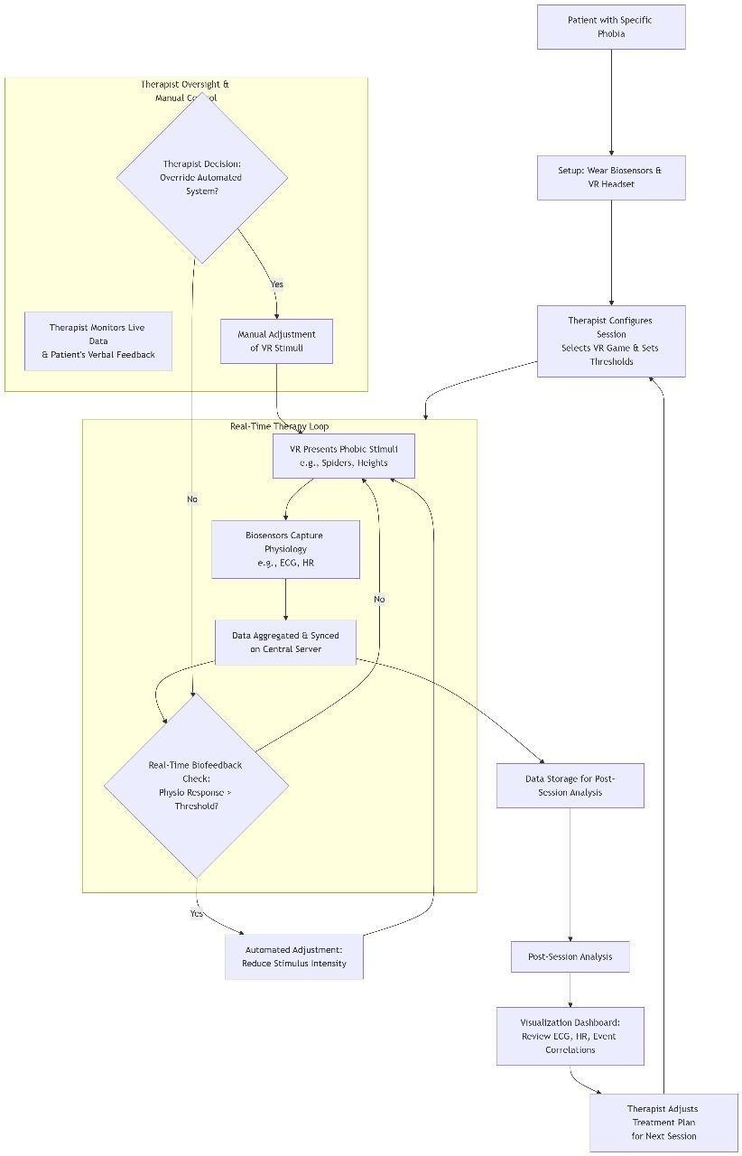
Figure 4.3: Flowchart
16
Conclusion
This research demonstrates a significant advancement in phobia treatment by merging immersive VR serious games with real-time physiological monitoring. The framework successfully creates a controlled, engaging, and adaptive therapeutic experience that can be personalized to each individual’s needs. Its dual support for both automated biofeedback and clinician oversight makes it a robust tool for modern mental health care.
By continuing to integrate new technologies—such as AI-driven analytics, augmented reality, and additional biosensors—this approach has the potential to become a mainstream solution for anxiety disorders and beyond, ultimately making effective, personalized exposure therapy more accessible and effective.

17

4.Adaptive Virtual Reality Exposure Therapy with Biofeedback

Authors: Hanna Zelis (Northwestern University), Troy Kubanka, Lloyd Williams (High Point University)
Publication: SoutheastCon 2025 (IEEE conference)
Introduction: This paper introduces an innovative system that enhances phobia exposure therapy by combining Virtual Reality (VR) with real-time biofeedback. It uses physiological data to dynamically adjust exposure intensity, creating a safe, controlled, and personalized therapeutic experience.
Problem Statement: Traditional exposure therapy struggles to create safe yet realistic environments, control exposure intensity in real time, prevent patient overwhelm, and personalize treatment to individual anxiety responses.
Techniques Used:
- 1.VR Hardware: Meta Quest 3 Headset: The Meta Quest 3 was explicitly chosen over other systems like the HTC Vive for specific reasons cited in the paper. Its standalone, wireless nature is highlighted as a key benefit, offering "greater accessibility for clinical and home usage." The high-resolution display contributes to a "smooth, immersive VR" experience and helps with "reduced motion sickness." Crucially, the paper states that the Meta Quest 3 allows for "easier biofeedback integration," which is the foundation of the entire adaptive system, enabling the "real-time exposure adjustments based on the user’s psychological state." Users interact with the environment using the head-mounted display (HMD) and hand controllers.
- Biofeedback Sensors: Heart Rate Monitor and GSR: These are the primary sensors for objectively measuring the patient's physiological state. The heart rate monitor detects and records "heartbeats per minute." The Galvanic Skin Response (GSR) sensor detects "fluctuations in skin conductance." The paper explicitly states the purpose of these sensors: to "track anxiety levels, emotional arousal, including stress and fear, and stress responses." By continuously gathering this data, the system can make informed decisions, as these physiological responses are "known to correlate with anxiety levels."
- Microcontroller: Arduino: The Arduino's role is clearly stated: it is the hardware interface for the biofeedback sensors. The paper specifies that the system uses "GSR sensors connected to an Arduino." This implies the Arduino is responsible for reading the raw analog signals from the GSR sensors, processing them (likely converting them into a digital value representing skin conductance), and then relaying this data to the main software application running the VR experience for analysis.

- Adaptive Logic: Switch-Case Logic: This is the core software algorithm that dictates how the system adapts. The paper provides a clear description: "Stress levels are categorized using switch case logic, triggering changes in the virtual environment." This means the system defines specific thresholds or ranges for the heart rate and GSR data. Based on which range ("case") the user's current data falls into, a predefined action is triggered. For example, if anxiety indicators rise (a high-stress case), the logic will command the VR environment to "reduce[] exposure intensity by simplifying the scene, increasing distance from the feared object, or adding calming elements." Conversely, a low-stress case will "prompt gradual exposure increases."
18

19

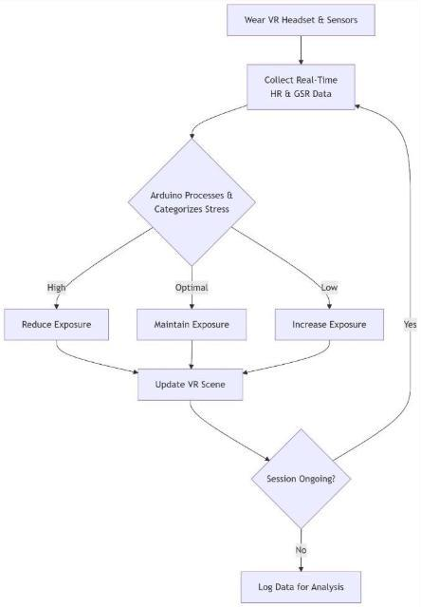
Workflow Diagram:

Figure 4.4: Flowchart

20

Findings
  - Successful Prototype Development: The team designed and built two distinct, functional VR environments targeting common phobias: one for acrophobia (fear of heights) and another for arachnophobia (fear of spiders). This demonstrates the system's versatility in creating different types of anxiety-inducing scenarios.
  - Validation of Measurement Sensitivity: During internal testing, individuals who self-identified as having these specific phobias exhibited markedly stronger physiological responses (as measured by the heart rate and GSR sensors) and higher self-reported anxiety compared to those without the phobias. This is a crucial finding as it validates that the biofeedback sensors are accurately detecting the intended stress reactions to the virtual stimuli, confirming that the system's input data is reliable.
  - Proof of Adaptive Functionality: Most importantly, the system demonstrated its core function: it successfully adjusted the exposure intensity in real-time based on the incoming biofeedback. This means the adaptive logic (the switch-case system) worked as intended, dynamically making the VR scene less intense when anxiety rose and more challenging when the user was calm, thereby proving the concept of a closed-loop, adaptive therapy system.
Future Scope
- Expand to More Phobia Types: The initial focus on spiders and heights is just a starting point. The future scope includes applying the same adaptive framework to treat a broader range of phobias, such as social anxiety disorder (social phobia), claustrophobia (fear of enclosed spaces), and fear of flying.
- Integrate Additional Biosensors: To create a more comprehensive picture of the user's anxiety state, future iterations plan to incorporate additional biosensors. Electroencephalography (EEG) could measure brain activity patterns associated with fear, and eye-tracking could provide data on attentional focus and avoidance behaviours, further refining the adaptive algorithm.
- Develop AI-Driven Analytics: Moving beyond simple threshold-based (switch-case) logic, the future goal is to employ machine learning and AI. An AI model could learn from vast datasets of physiological responses to predict a user's anxiety trajectory and personalize the exposure protocol in a more nuanced and effective way.
- Test Scalability: A key next step is to move beyond developer testing and small studies. Future work will focus on conducting larger clinical trials to rigorously validate efficacy and on refining the system for scalable deployment in real-world clinical practices and home environments.
- Enhance Data Privacy: As the system collects sensitive physiological and mental health data, ensuring privacy is paramount. Future developments will prioritize implementing robust encryption for data transmission, anonymization techniques for storage, and ensuring full compliance with healthcare data protection regulations like HIPAA.
21

In conclusion, this research presents more than just a technological tool; it introduces a promising, data-driven paradigm shift for exposure therapy. By seamlessly integrating real-time biofeedback with immersive VR, it moves the field towards truly personalized and adaptive treatment. This approach holds the significant potential to improve the efficacy of therapy by optimizing the exposure process for each individual while simultaneously enhancing patient safety and comfort, ultimately leading to better long-term outcomes for treating anxiety disorders.

22
5.The Application of AI Video Generation Technology in Virtual Reality (VR) and Augmented Reality (AR)

Author: Biqin Deng
Publication: IEEE 2024

Introduction
- The paper explores the transformative impact of AI video generation technology in Virtual Reality (VR) and Augmented Reality (AR).
- It explains how VR creates immersive, interactive 3D environments, while AR overlays virtual objects onto the real world, both increasingly empowered by AI to generate content automatically and realistically.
- Prior research focused on VR implementation, user experience, and AR's image recognition and modelling, setting the stage for innovations in content creation and improved interactivity.

Problem Statements
- Hardware constraints like comfort, resolution, and latency hinder VR/AR's user experience and widespread adoption.
- Challenges exist in AI video generation around achieving realism, fluency, and seamless integration of generated content into virtual or real environments.
- *Data privacy and security* are major concerns, especially due to the sensitive data VR/AR systems must process and AI models require for training.

Techniques Used
- Utilizes deep learning models such as CNNs for feature extraction and Generative
- Adversarial Networks (GANs) for video synthesis.[1]
- The model includes layers for data input, feature extraction, content generation, postprocessing (denoising, super-resolution, frame synchronization), and output to VR/AR devices.[1]
- Optimization methods involve data augmentation, advanced architectures (ResNet,
- EfficientNet), transfer learning, and enhanced post-processing to improve quality and reduce artifacts.

Limitations and Research Gaps
- Technological bottlenecks remain—generated videos may still contain artifacts, distortions, and lack complete realism or diversity. Deep learning model training can be affected by data sparsity and noise, leading to unreliable outputs under some conditions.
- There’s an ongoing need for better privacy and security measures due to increased data collection and user interaction required by the technologies.
- Current systems lack truly natural interaction mechanisms and real-time feedback integration in user experience.
23
Workflow Diagram:

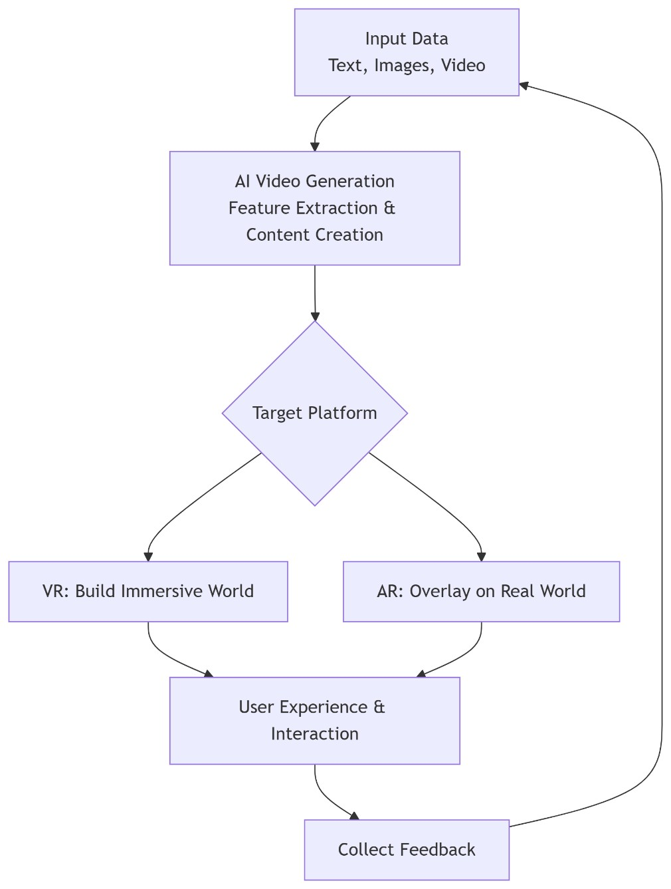
Figure 4.5: Flowchart
24
Findings:
- AI-generated video content in VR enables efficient creation of 360-degree panoramic videos with improved frame rates and reduced rendering times, enhancing user immersion.
- In AR, AI enables the creation of interactive video content, including educational experiences and virtual tourism, which improves user engagement and creative possibilities for developers.
- Performance data show clear improvements in preprocessing time, rendering time, and quality metrics compared to earlier methods, especially as data volumes scale.
- Optimized model architectures and strategies, like distributed training and model compression, were found to further improve quality and efficiency.

Future Scope:
- Lightweight, portable, and affordable VR/AR hardware will be key for mass adoption and improved user comfort.
- Enhanced integration of AI with 5G and other communication technologies will improve data transmission and reduce latency in real-time experiences.
- Further development of natural interaction mechanisms and real-time feedback loops will create more seamless, intuitive user interfaces.
- Expansion into fields like smart homes, social interaction, education, and content creation will broaden societal impact.
- Continued interdisciplinary research is needed to address unresolved challenges in realism, security, diversity, and interactive experience optimization.

Conclusion:
AI video generation technology has brought major improvements to both virtual reality (VR) and augmented reality (AR) fields, making experiences more immersive, interactive, and creative.

25
5.COMPARISON TABLE
26
Sr | Paper name | Publication | Author | Finding | Future Scope
1. | Immersive Phobia Therapy through Adaptive Virtual Reality and Biofeedback | IEEE | Alin Moldoveanu, Oana Mitrut, Nicolae Jinga ,Cătălin Petrescu, Victor Asavei, Ana Magdalena Anghel and Livia Petrescu | PhoVR system effectively combines gamified VR exposure, biofeedback, and adaptive environments to enhance engagement, comfort, and usability in treating multiple phobias. | Future work can focus on improving real-time adaptability, emotional alignment, and wider domain integration, such as healthcare, education, and interactive media
2. | CAEVR: Bio Signals-Driven Context-Aware Empathy in Virtual Reality | IEEE Transactions on Visualization and Computer Graphics | Kunal Gupta, Yuewei Zhang, Tamil Selvan Gunasekaran, Nanditha Krishna, YunSuenPai, MarkBillinghurst | VR with biofeedback dynamically adjusts exposure, improving therapy effectiveness and patient comfort. | Broaden to more phobias, add AI-driven personalization, and enable home-based therapy.
3. | Adaptive Virtual Reality Exposure Therapy with Biofeedback | IEEE Southeast Conference 2025 | Hanna Zelis, Troy Kubanka, Lloyd Williams | Integrating VR with real-time biofeedback (heart rate & GSR) enables adaptive exposure therapy, making treatment more personalized, safe, and effective. | Expand to more phobias, integrate additional biosensors and AI analytics, and explore large-scale clinical and home-based applications.
4. | The Application of AI Video Generation Technology in Virtual Reality | Guangzhou Institute of Science and Technology, Guangzhou 510540, China | Biqin Deng | Improved video content generation speeds up rendering, enhances immersion, and improves interactivity. Achieved higher resolution, better temporal coherence, and faster video streaming. | Lightweight hardware, robust AI-AR integration, enhanced interaction modes. Improved model architectures and multi-modal fusion.
5. | Battle Against Your Fears: Virtual Reality Serious Games and Physiological Analysis for Phobia Treatment | IEEE 2025 | Bernardo Marques, Diogo Moreira, Martim Neves, Susana Bras. | VR exposure therapy is as effective as real-world exposure but more acceptable to patients. Recent studies enhance it with physiological monitoring and game elements for better engagement. | Future work can leverage bio-signals and AI to make VR therapy more adaptive. Large-scale trials and AR/MR integration will strengthen validation and real-world impact.

6. References

- Alin Moldoveanu, Oana Mitruț, Nicolae Jinga, Cătălin Petrescu, Florica Moldoveanu, Victor Asavei, Ana Magdalena Anghel, and Livia Petrescu. Immersive Phobia Therapy through Adaptive Virtual Reality and Biofeedback
- Kunal Gupta, Yuewei Zhang, Tamil Selvan Gunasekaran, Nanditha Krishna, Yun Suen
Pai, Mark Billinghurst ,CAEVR: Bio-signals-Driven Context-Aware Empathy in Virtual Reality
- Bernardo Marques, Diogo Moreira, Martim Neves, Susana Brás, José Maria
Fernandes , Battle Against Your Fears: Virtual Reality Serious Games and Physiological Analysis for Phobia Treatment
- Hanna Zelis (Northwestern University), Troy Kubanka, Lloyd Williams (High Point University) , Adaptive Virtual Reality Exposure Therapy with Biofeedback
- Biqin Deng ,The Application of AI Video Generation Technology in Virtual Reality (VR) and Augmented Reality (AR)
- Yang, Y., Yu, M., & Jiang, G. Research on 3D mobile phone stereo image synthesis algorithm and virtual viewpoint synthesis algorithm based on AIV. Journal of ComputerAided Design & Computer Graphics
- Kim, H., & Cha, M. Neural Video Synthesis: From Static Images to Dynamic Videos. ACM Transactions on Graphics (TOG), 2021, 40(6), 1-12.
- Harvey, R., & De Rose, T. The Role of AI in Film and Television Production. Journal of Media Practice, 2020, 21(1), 5-20.
- Su, J., Zhu, X., & Zhang, C. AI-Driven Video Creation: Techniques, Challenges, and Future Directions. ACM Multimedia,In Proceedings of the IEEE conference on computer vision and pattern recognition 2024, (pp. 225-234).
- Vondrick, C., Pirsiavash, D., & Torralba, A. Generating Videos with Scene Dynamics. Advances in Neural Information Processing Systems, 2019, 29, 613-621.

27

