A
Project Report on

Fabrication Of Whitworth Quick Return Mechanism

Submitted in partial fulfillment of the requirement for the award of Diploma in Mechanical Engineering

Submitted By:

- SUDHIR P. BAHEKAR | 2122801
- HIMANSHU V. BAWANKULE | 2022009
- YASH R. THAKRE | 2022058
- STUTI N. SHAMBHARKAR | 2122806
- NAZMIN B. PATHAN | 2022040



Under the guidance of:

Prof. K. S. Thekedar

(MECHANICAL ENGINEERING DEPARTMENT)

DEPARTMENT OF MECHANICAL ENGINEERING
GOVERNMENT POLYTECHNIC, NAGPUR
(An Autonomous Institute of Government of Maharashtra)
SESSION: 2022- 23
CERTIFICATE

GOVERNMENT POLYTECHNIC, NAGPUR
(An Autonomous Institute of Government of Maharashtra)


This is to certify that,

SUDHIR P. BAHEKAR | 2122801
HIMANSHU V. BAWANKULE | 2022009
YASH R. THAKRE | 2022058
STUTI N. SHAMBHARKAR | 2122806
NAZMIN B. PATHAN | 2022040

of final year Mechanical Engineering students have submitted their project report entitled “Fabrication of Whitworth quick return mechanism” during academic session 2022-23 as a part of project work prescribed by Government Polytechnic, Nagpur for partial fulfillment for the diploma in Mechanical Engineering in sixth semester.

Signature of Guide HOD Mech. Engg. Principal

Seal

Date:
Attach TCS iON, 15 days certification program completion certificate

DECLARATION

I hereby declare that the Project Report entitled “Fabrication Of Whitworth quick return mechanism” is an authentic record of my own work as requirements of course ME414E Industrial Project for the award of Diploma in Mechanical Engineering, Government Polytechnic, Nagpur carried out by me.

SUDHIR P. BAHEKAR
2122801
Date: ____________________

I certify that the declaration made above by the candidate is true.

Prof. K.S. Thekedar
Department of
Mechanical Engineering
ACKNOWLEDGEMENT

It takes great pleasure for us in presenting this Industrial Project Thesis to the college. This word of acknowledgement is to express our deep sense of gratitude to all those luminaries and unseen hands without whose support, completion of this project work would have been just materialized.
We would like to thank Prof. K.S. Thekedar for their discipline and invaluable guidance that inspired us to solve all the difficulties that came across during Completion of the project work.
We would like to thank, Prof. Y. K. Gaiky, Head of Department of Mechanical Engineering for allowing us with all facilities that were available in the department during this project work.
Likewise, we would like to express our sincere thanks to, Dr. M. B. Daigavane, Principal of “Government Polytechnic Nagpur”, for extending all possible help and allowing us to use all resources that are available in the institute.
Finally, we are thankful to one and all those who have directly and indirectly helped us in the successful completion of this project work.
ABSTRACT

The Whitworth quick return mechanism is a mechanical linkage used to convert rotary motion into reciprocating motion, commonly found in machine tools and other industrial applications. This mechanism is designed to produce a faster return stroke than the forward stroke, making it ideal for applications where quick and efficient motion is required.

The fabrication and analysis of the Whitworth quick return mechanism involves designing and building the mechanical linkage using precision engineering techniques, such as computer-aided design (CAD) and computer numerical control (CNC) machining. Once fabricated, the mechanism is then tested and analyzed for performance, including factors such as speed, acceleration, and force.

The analysis of the mechanism can be conducted using a range of tools, including analytical methods such as mathematical modeling and simulation, as well as experimental techniques such as dynamometer testing and motion analysis. By analyzing the mechanism's performance, engineers can identify any areas for improvement and optimize the design for maximum efficiency and performance.

Overall, the fabrication and analysis of the Whitworth quick return mechanism is an important process for ensuring that this mechanical linkage meets the demands of modern industrial applications and delivers reliable and efficient performance.

Table of Contents
INTRODUCTION  THE MACHANISM  HISTORY  WHITWORTH QUICK RETURN MECHANISM ABOUT APPLICATION  MERITS AND DEMERITS  DIFFERENCE FROM OTHER MECHANISM | 9  10  11  12  13  14
2. LITERATURE SURVEY  2.1 LITERATURE REWEIW  2.2 FROM LITERATURE REVIEW  2.2 METHODOLOGY  2.3 CONCLUSION FROM LETERATURE | 15  16  20  21  22
3. EXPERIMENTAL DESIGN &SETUP  3.1 CHRONOLOGICAL DEVELOPMENT OF PROJECT  3.2 DESIGN OF MECHANISM  3.4 SCHEMATIC DIAGRAM OF EXPERIMENTAL SETUP  3.3 CODMPONENTS OF WHITWORTH MECHANISM | 23  24  25  26  28  29
4. METHODOLOGY  4.1 METHODOLOGY USED  4.2 DESIGN’S SELECTED FOR FABRICATION  4.3 WHY THIS DESIGN? | 30  31  32  33
5. FABRICATION & ANALYSIS  5.1 FABRICATION DETAILS  5.2 MATERIALS USED  5.3 EQUIPMENT USED:  5.4 ANALYTICAL DETAILS | 34  35  36  38  39
6. ANALYASIS OF COST | 40
7. RESULT & CONCLUSION | 43
8. REFERENCES | 45

CHAPTER - 1

INTRODUCTION

CHAPTER - 1

INTRODUCTION

ABOUT THE MECHANISM
Whitworth's Quick Return Mechanism is the second inversion of the slider - crank mechanism in which the crank is fixed. In this mechanism, the slider in the slotter bar is connected to the crank. The return stroke or ideal is faster than the forward stroke in this mechanism
The Whitworth mechanism is also known as the quick return mechanism. It represents a revolving crank slider and produces non-uniform stroke movement with slow forward movement and fast backward movement. This mechanism is used in tools, packaging and transport machinery. In shaping machine, the rotary movement of the drive is converted into the reciprocating movement. It is done by the mechanism contained within the column of the machine. The ram holding the tool makes the reciprocating movement. In a standard shaping machine, metal is cut in the forward cutting stroke, while the return stroke goes idle and no metal is cut during this period. To reduce the full machining time, it is important to reduce the time taken by the return stroke. This quick return mechanism converts rotary motion into reciprocating motion, but unlike the crank and slider, the forward reciprocating motion is at a different rate than the backward stroke. At the bottom of the drive arm, the peg only has to move through a few degrees to sweep the arm from left to right, but it takes the remainder of the revolution to bring the arm back. This mechanism is most commonly seen as the drive for a shaping or planing machine.

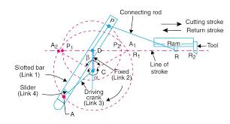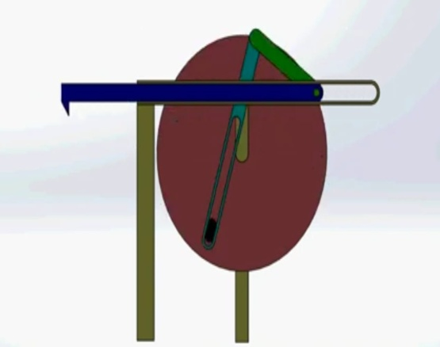

1.2 HISTORY

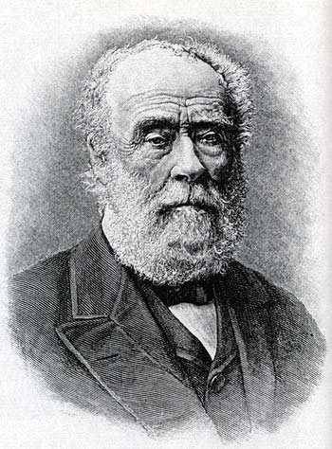

Sir Joseph Whitworth, 1st Baronet (21 December 1803 – 22 January 1887) was an English engineer, entrepreneur, inventor and philanthropist. In 1841, he devised the British Standard Whitworth system, which created an accepted standard for screw threads. Whitworth also created the “Whitworth quick return mechanism”

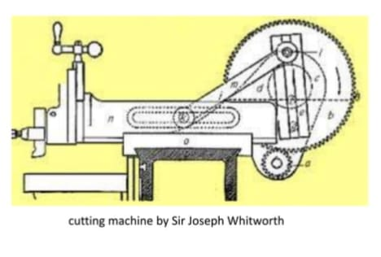
Fig1.3:- Sir Joseph Whitworth

Fig1.4:- Cutting machine by sir Joseph Whitworth

During the early-nineteenth century, cutting methods involved hand tools and cranks, which were often lengthy in duration. Joseph Whitworth changed this by creating the Whitworth quick return mechanism in the mid-1800s. Using kinematics, he determined that the force and geometry of the rotating joint would affect the force and motion of the connected arm. From an engineering standpoint, the Whitworth quick return mechanism impacted the technology of the Industrial Revolution by minimizing the duration of a full revolution, thus reducing the amount of time needed for a cut or press.

1.3 WHITWORTH QUICK RETURN MECHANISM APPLICATION:

Whitworth Quick return mechanisms are found throughout the engineering industry in different machines:

- Shaper machine
- Slotting machine
- Screw press
- Power-driven saw
- Mechanical actuator
- Revolver mechanisms
- Rotary combustion internal engine
- Air compressor
- Mechanical cutter.
- Water pumping system

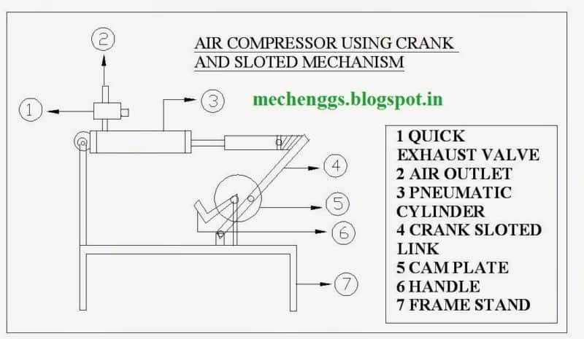
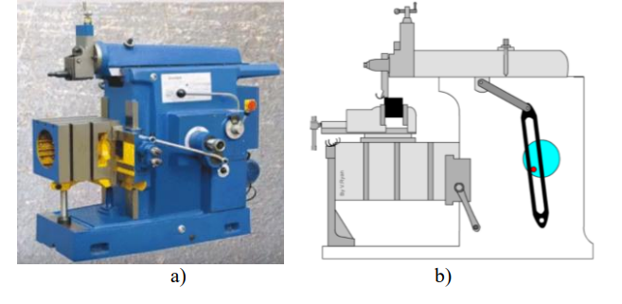
Fig1.6:- Air Compressor
Fig1.5:- Shaper Machine

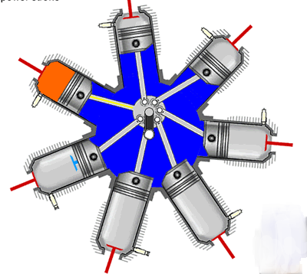
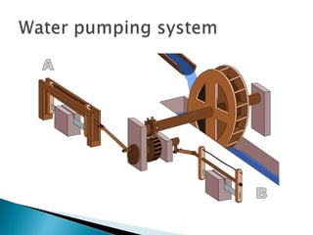
Fig1.8:- Rotory Engine
Fig1.7:- Water Pumping System

  - MERITS AND DEMERITS

MERITS
- During the return stroke, there is rapid movement.
- It can be used to convert rotary motion into reciprocating motion.
- The material removal operation is only carried out in forwarding stroke in some machines. As a result, the machine’s overall working time is reduced by the faster return stroke.
- The idle or return stroke is quicker.
- It reduces total machining time.

DEMERITS

The whitworth quick return mechanism has the following drawbacks:
- Because there is no contact with the work during the returning stroke, no cutting occurs, and the operation takes a long time to complete.
- In comparison to the return stroke, the forward stroke takes a long time.
- To carry out operations, additional power is required.
- Friction exists between the slider and the piston.
- Because of the heat generated inside the piston, it will not perform indefinitely, and wear and tear may occur.
1.5 DIFFERENCE BETWEEN WHITWORTH AND QUICK RETURN MECHANISM

What is the difference between Whitworth and quick return mechanism?

Some peoples always gate confuse between QRM (Quick Return Mechanism) and Whitworth quick return mechanism. But they are different from each other. Here are some differences between Whitworth QRM and Slotted bar QRM.

- In the quick return mechanism the arc of motion of the slotted bar is of the same angle in forward and return stroke, While in the case of Whitworth The arc of forwarding stroke and arc of return stroke is a different angle.
- In the quick return mechanism the slotted bar performs reciprocating motion in an arc and in the Whitworth mechanism the slotted bar performs the complete circular motion

- Whitworth is Crack- Crack type mechanism while Slotted bar is Crank-Rocker type mechanism.

- In Whitworth Crank is the fixed link while in Slotted bar Connecting rod is the fixed link.

- Whitworth QRM and Slotted QRM bar are different inversions of same mechanism (i.e. Slider Crank Mechanism)

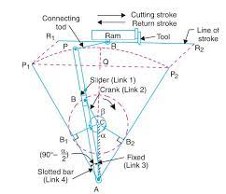
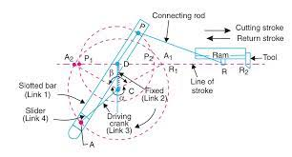
Fig1.9:- Whitworth Quick Return Mechanism
Fig1.10:- Quick Return Mechanism

Whitworth Quick Return Mechanism

CHAPTER - 2

LITERATURE SURVEY

CHAPTER - 2

LITERATURE REWEIW

This section provides an overview of the existing knowledge base and published work in the area the project is based on.
Research paper - 1

"Three Views on Kinematic Analysis of Whitworth Mechanism of a Shaping Machine,"
Katarina Monkova and Peter P. Monka
Technical University in Kosice, Faculty of manufacturing technologies, Presov, Slovakia
UTB Zlin, Faculty of technology, Vavreckova 275, Zlin, Czech Republic

The article deals with the kinematic analysis of a Whitworth mechanism. This mechanism is a part of a shaping machine that is used in real technical practice. Three approaches (analytical, graphical and solution with computer aid) to the specification of kinematics characteristics of a cutting tool motion are presented in the article. Also, the advantages and disadvantages of the presented approaches are briefly described in the paper. A comparison of results of kinematic analysis has shown that there are no differences in the achieved values; they are only in an accuracy that follows from the essence of individual approaches to the solution.

Research paper - 2

“Quick-return mechanism design and analysis projects”
Ron P. Podhorodeski, Scott B. Nokleby and Jonathan D. Wittchen Robotics and Mechanisms Laboratory, Department of Mechanical Engineering, University of Victoria,

Quick-return (QR) mechanisms feature different input durations for their working and return strokes. The time ratio (TR) of a QR mechanism is the ratio of the change in input displacement during the working stroke to its change during the return stroke. Several basic types of mechanism have a QR action. These types include slider-crank and four-bar mechanisms. A project on QR mechanism design, within a first course on the theory of mechanisms, has been found to be effective for exposing students to concepts of mechanism design and analysis. This paper reviews basic QR mechanisms, presents a project problem and solution examples, and discusses the value of inclusion of such project problems within theory-of-mechanism courses.

Research paper - 3

“Dynamic, Kinematic and Static Analysis of a Shaper Machine”

Prof. Dr. M. A. Nasser, Dr. M. A. Asy mnasser2@hotmail.com mohamedasy2010@yahoo.com Department of Production Engineering & Mechanical Design University of Menoufia Shebin El-Kom, Menoufia, Egypt

This paper presents the current state of virtual prototyping of a shaper machine tool; the work focuses on the design of the machine tool structure, main gear box, tool shank and tool holder systems. Shaper machine produced by the Egyptian Machine Tool Factory is selected for this study. The structural behaviour under static and dynamic loads is evaluated in order to obtain an optimized design of the shaper machine elements. Several software like Matlab, Excel, Ansys and Solidworks has been used for remodelling and analysis. Kinematic analysis defined position of shaper quick return mechanisms links, motion of ram, end of the rocker and machine crank as well as the displacement, velocity and acceleration of machine ram or cutting tool for different values of crank length and number of strokes per minutes. Finite element analyses of machine parts in static and modal domains are carried out on machine parts and their subassemblies. Using Virtual Prototyping techniques, engineers are able to shorten the design time and therefore shorten the time needed for pushing to market new products.

Knowledge from videos

How Whitworth Quick Return motion mechanism works
By Prithviraj P Shetty
https://youtu.be/XT4zt7sYPe0
From this animation video we decided the design for fabrication of whitworth quick return mechanism. It help us to visualize the details and movement of various parts of whitworth quick return mechanism
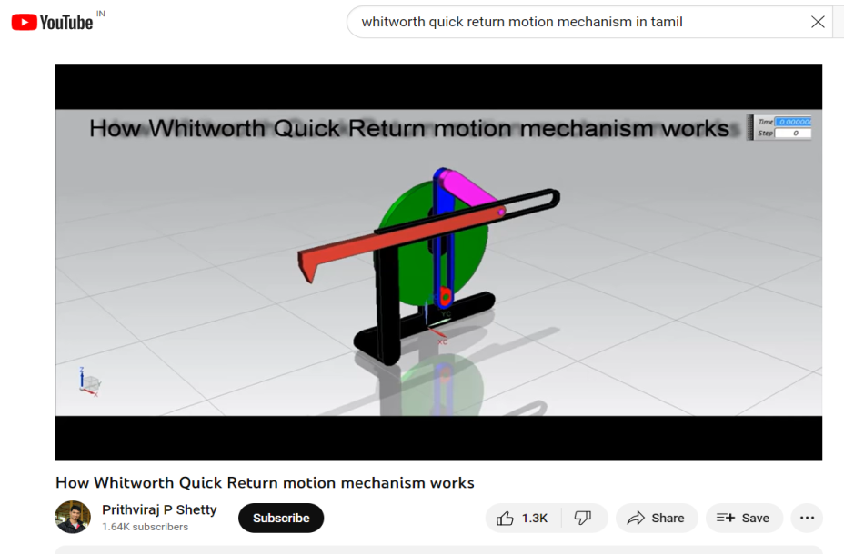

Fig 2.1:- Video Thumbnail Of Whitworth Mechanism

2.2 FROM LITERATURE REVIEW

2.2.1 Application’s
- Shaper machine
- Slotting machine
- Screw press
- Power-driven saw
- Mechanical actuator

2.2.2 Advantages
- During the return stroke, there is rapid movement.
- It can be used to convert rotary motion into reciprocating motion.
- The material removal operation is only carried out in forwarding stroke in some machines. As a result, the machine’s overall working time is reduced by the faster return stroke.
- The idle or return stroke is quicker.
- It reduces total machining time.

2.2.3 Limiations
- In comparison to the return stroke, the forward stroke takes a long time.
- To carry out operations, additional power is required.
- Friction exists between the slider and the piston.
- Because of the heat generated inside the piston, it will not perform indefinitely, and wear and tear may occur.

2.3 METHODOLOGY

FABRICATION
We try our best but we didn’t find any literature of videos which will give us the information about the fabrication of our project according to decided design of whitworth quick return mechanism. So we find some similar fabrication videos and articles which are similar to our project and from these videos and articles we got inspiration and knowledge for our project fabrication

ANALYSIS
As our project consist of both fabrication and analysis so we followed methodology which we found in above given research papers.
We done the kinematic analysis on our project.The goal of the kinematic analysis is to investigate the motion of individual components of mechanism (or their choices points) in dependence on the motion of drivers To investigate the motion means to determine the dependency of the position, velocity and acceleration of the examined members and important points on the motion of driven members or on the time. A point moving
in space describes a line called its path, which may be rectilinear or curvilinear. The motion of a body is determined by the paths of three of its points, not on a straight line. If the motion is in a plane, two points suffice, and if rectilinear, one point suffices to determine the motion. A kinematic analysis can be done in several ways such as analytical, graphical or computer-aided solution

2.4 CONCLUSION FROM LETERATURE

Three various approaches to the kinematic analysis of the Whitworth mechanism have been introduced along with their advantages and disadvantages. Based on the achieved resultscan be said that they are the same and decision, which of the approach will be used by a designer depends on his skills and possibilities. It is clear that modern trends force the designer to use the solution with computer aid because it is the most flexible to improve and to modify. By means of a virtual model, it is possible to reduce the time for analysis considerably. The simulation model allows to realize the complex processes through the use of computer in a while, which take days or weeks in real-time, and so it represents the ideal tool for the aid and the deciding on the various levels of the manufacturing. This model allows identifying the problematical points of the project, to determine the main risks of work, collisions, etc., too. That is why the simulation can be considered one of the
most effective tools for decision and solution testing.
On the other hand, it is also necessary to take into account that even though the virtual simulation of mechanism has a fixed place in engineering practice, it seldom corresponds to real conditions due to outside and inside influences, which can not be predicted and that can be very difficult defined in advance. The most important fact is that simulation and a computer-aided solution without the problem understanding can lead to big troubles after the project realization and loss of time or money spent on the project preparation. It can be concluded that simulation is not “panacea” for all problems. There are tasks, when it is better to apply other, the cheaper tools of problem-solving when the simulation appears as few effective. According to Pantazopoulos support and access to knowledge pools and use of modern technology, IT applications, and social media/special interest groups for knowledge diffusion are of vital importance. Institutional establishment, leadership drivers, and social vision can lead to the development of strong foundations of knowledge pools and shape their future perspectives.

CHAPTER - 3

EXPERIMENTAL DESIGN AND SETUP

CHAPTER - 3

CHRONOLOGICAL DEVELOPMENT OF PROJECT

3.1 Steps followed for planning of project development

To start of this project, a meeting with guide in the first week is done to manage the schedule of weekly meetings. The purpose is to inform the guide on the progress of the project and guided by the guide to solve difficulty.

Make research of literature review with the means of the internet, books, available published articles and materials that is related to the title.
- Also search for the videos related to the project and videos that can improve our knowledge in that field

- Designing phase start of by sketching few model models using manual sketch on A4 papers. Do it comparison for choose the best concept.

- Software applications are downloaded from internet to design the model based on the sketches. Software Creo parametric 2.0 helps to draw the better dimension.

- Also we had done some mathematical calculation for finding out the dimensions of various parts of whitworth mechanism

- After the completion of this phase we select raw material which is suitable for our project

- After that we start fabricating the project in the guidance of our guide and finally we done finishing touches so our project will look beautiful

- After completion of our project we have done some kinematical research related to the relative velocity between the various links of whitworth quick return mechanism
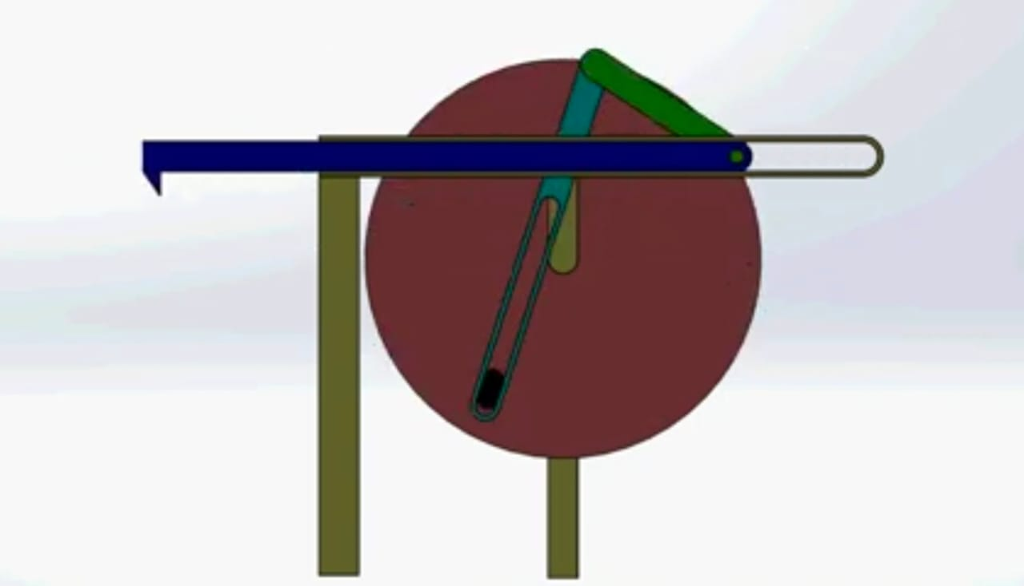
3.2 DESIGN OF MECHANISM

Fig 3.1:- Animatic Design Of Whitworth Quick Return Mechanism

3.3 CODMPONENTS OF WHITWORTH MECHANISM
Whitworth quick return mechanism is consists of the following component
- Crank:
The crank rotates with uniform angular velocity. It gets power from a pinion wheel or motor.

- Slotted bar &Slider:
It is a bar with a slot for guiding a slider into it. The slider is connected to the end of the crank. The slotted bar is pivoted at a fixed origin. Its other end is connected to the connecting rod.

- Connecting rod:-
The aim of connecting rod is to converts the rotary motion of the end of the slotted bar into reciprocating motion.

- Ram:-
The ram reciprocates in the horizontal direction. The shaper or slotting tool is mounted onto the ram.

- Belt

It is used to power transmission from driver pulley to mechanism

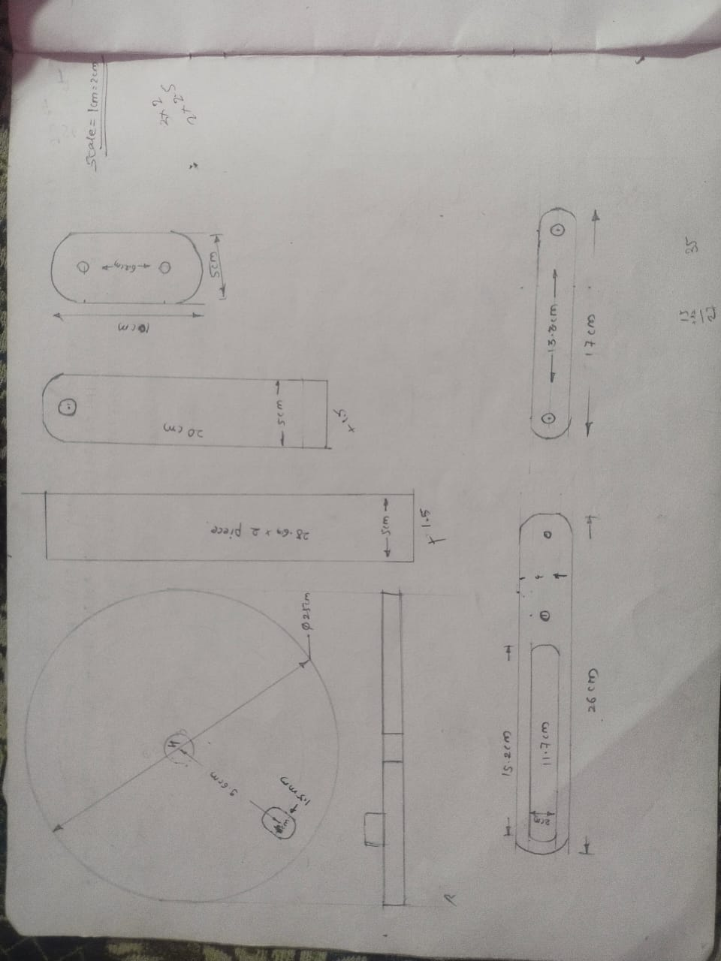
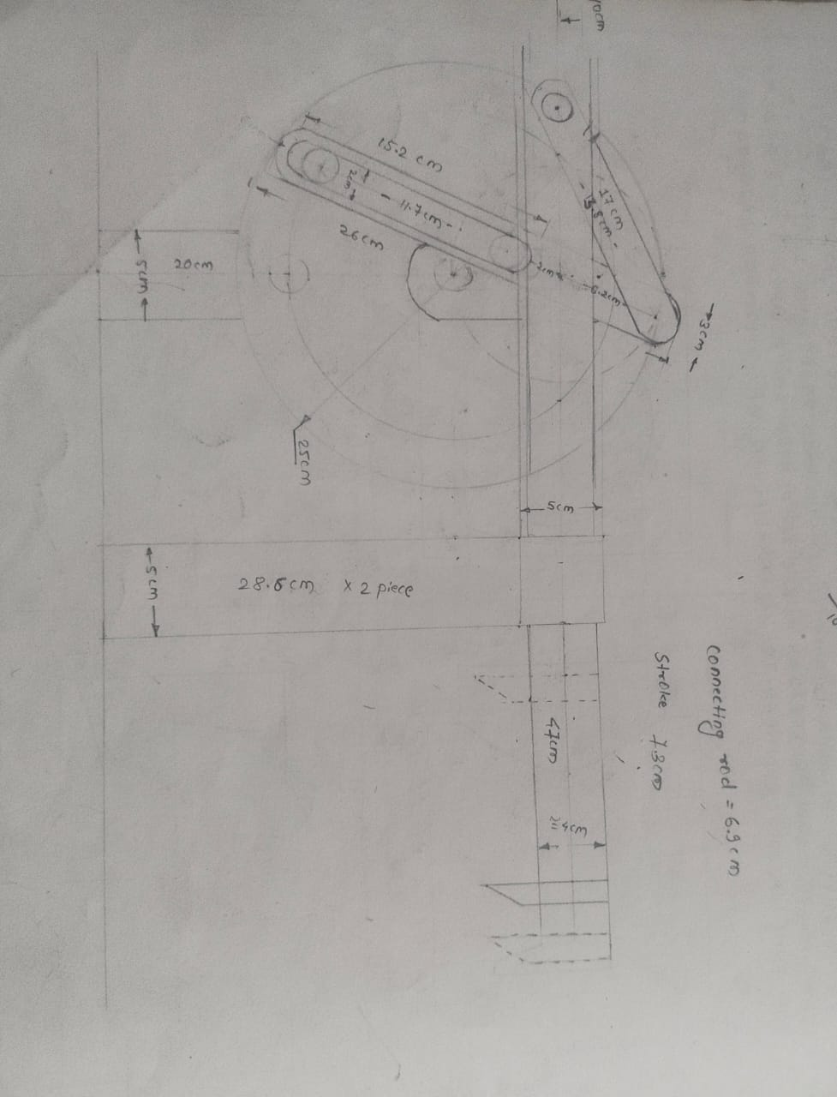
3.4 SCHEMATIC DIAGRAM OF EXPERIMENTAL SETUP

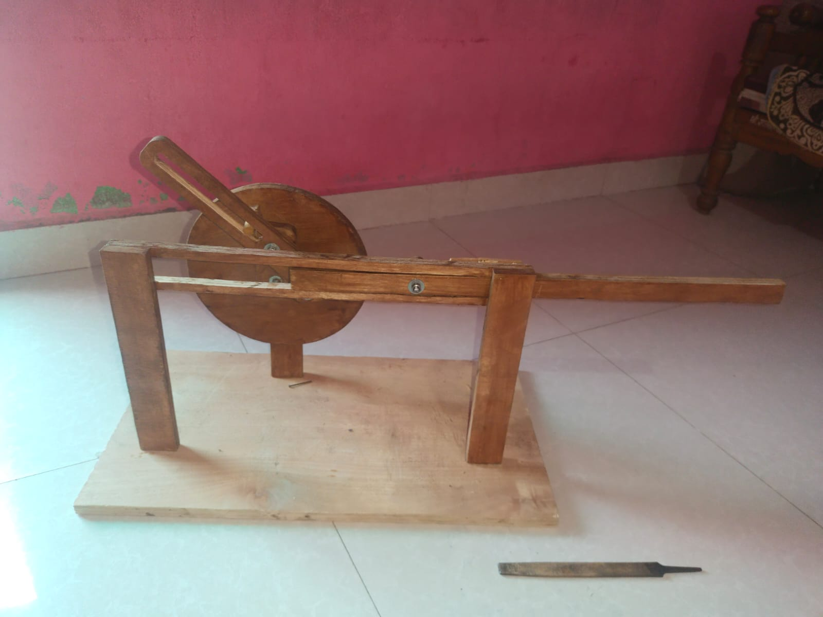
3.5 ACTUAL PHOTOGRAPH OF FABRICATED MECHANISM

CHAPTER – 4

METHODOLOGY

CHAPTER - 4

METHODOLOGY

To start of this project, a meeting with guide in the first week is done to manage the schedule of weekly meetings. The purpose is to inform the guide on the progress of the project and guided by the guide to solve difficulty. Briefing based on the introduction and next task of the project is given by guide. Make research of literature review with the means of the internet, books, available published articles and materials that is related to the title.

Designing phase start of by sketching few model models using manual sketch on A4 papers. Do it comparison for choose the best concept. Software applications are downloaded from internet to design the model based on the sketches. Software Creo parametric 2.0 helps to draw the better dimension. The preparation of mid-presentation of the project is next. Before presenting, the guide will see through the slide presentations and comment on corrections to be made. Then, presentation on the knowledge attained and instilled in the design phase is presented to a panel of three judges. Following up, is the fabrication of make some method for this project. Choose the material, make some list for the material and dimension. Doing it planning of fabrication process for this project. After that, start the fabrication process. It would take seven weeks to get this design and fabrication process alteration done. Make some analysis and testing for the project. Do it correction for error this project. Finish the fabrication process with painting process. After that, the final report writing and final presentation will be the last task to be accomplished. The guide will review the final presentation and revise mistakes to be amended. The final presentation then again will be presented to three panels. A draft report would then be submitted to the guide to be point out the flaws. Corrections are done and the real final report is handed over as a completion of the final year project.

4.2 Design’s selected for fabrication

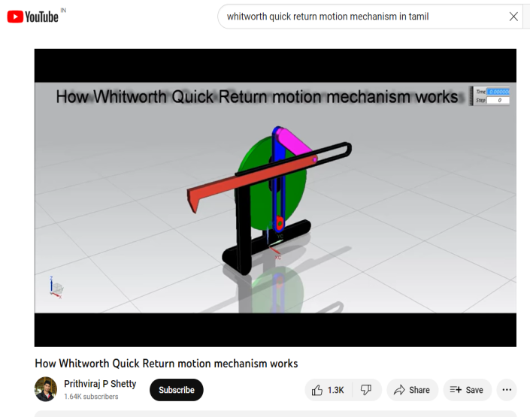
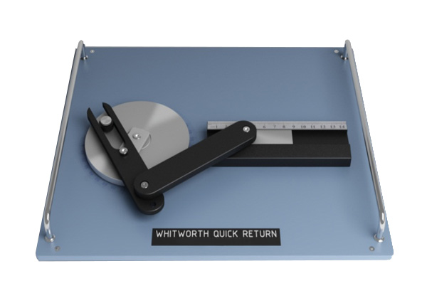

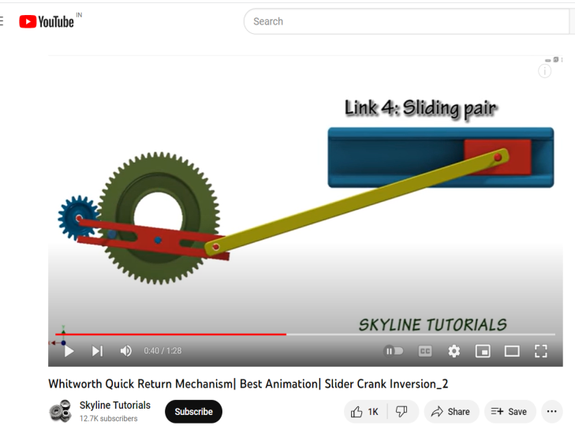


From the above design’s we finalize the following design for fabrication and anyalysis
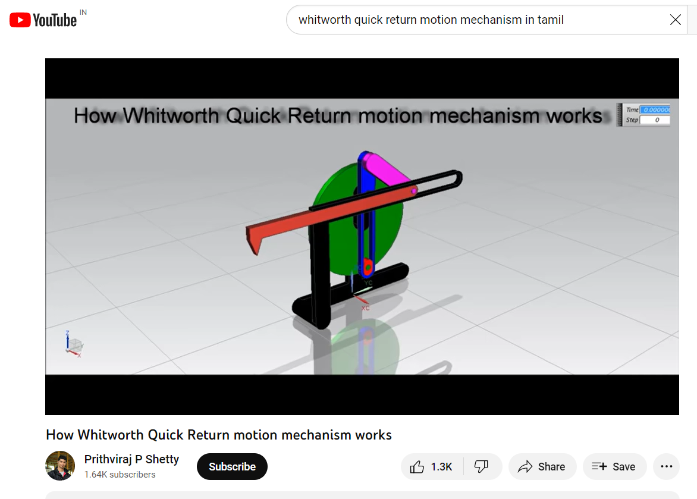

4.3 Why this design?
Reason behind choosing this design

- This design shows all the links and their movement clearly
- Kinematical study on this design is easy than other design
- Design looks simple and beautiful
- Fabrication cost will be minimum than other designs due to simplicit

CHAPTER - 5

FABRICATION & ANALYSIS

5.1 FABRICATION DETAILS

Steps involved for the fabrication work are as follows

The first step comes in determining the design, concept or shape of the unit we want to build or weld. Sometimes it is something unique that we have designed ourselves. More frequently in industry we have to build a part that conforms to a blueprint or technical drawing. It is from that drawing or sketch that we determine the steps necessary for fabrication.

We need to put together a list of tools, equipment and machinery that will be required in the process of fabrication. Sometimes we have everything we need, but frequently we have to rent, borrow or buy some new equipment to meet the requirements of the job. You might even want to manufacture some jigs, fixtures, guides, templates or other specialty equipment necessary to complete the job.

The raw material will need to be cut to length or size depending upon the type of material. Bar, pipe and long shapes will need to be cut to length using a saw or other tool. Plate and she can be cut down with torches, shears and other shape cutting equipment. The bill of materials on the drawing will be a good guide for figuring out how many and what type of parts we need.

5.1.1 WOODWORK OPERATIONS:

Cutting of the plank with a saw into desired shapes, cutting of the coupler link, slider, crank and guards, cutting of the base and planning of the wooden surfaces.

5.1.2 MECHANICAL WORKSHOP OPERATIONS:

Drilling of holes with the use of the drilling machine based on the dimensions in the design drawing, making of the flange, fixing of the flange to the crank,

5.2 MATERIALS USED :-
Materials used for Prototype: Plywood, Bolt and nut of size 10 were used, Glue, bearings Screws, Printable Protractor, Feviquick

Plywood Bolt and nut

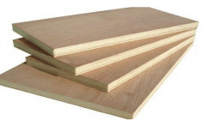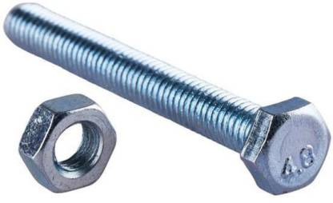

Fevicol Glue Screws

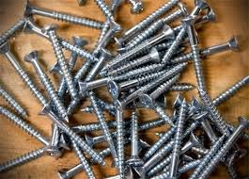

Printable Protractor Bearings

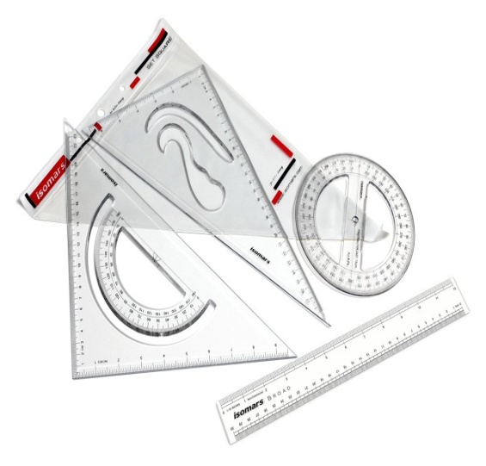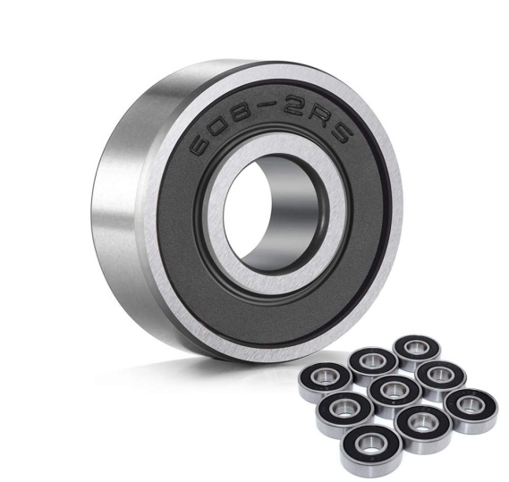

Feviquik Belt

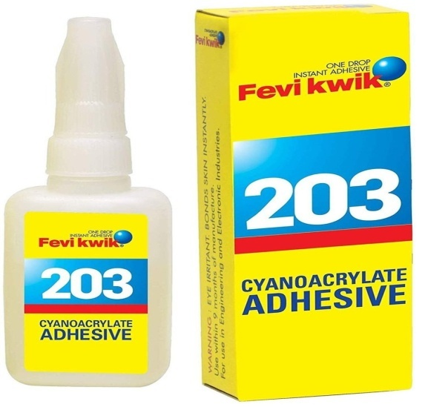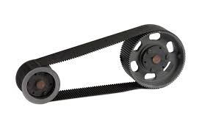

5.3 EQUIPMENT USED:

Saw, Hammer, Drilling machine, Planer, wrench and Chisel. Various procedures were used in the construction of the prototype, these include:
SAW
HAMMER


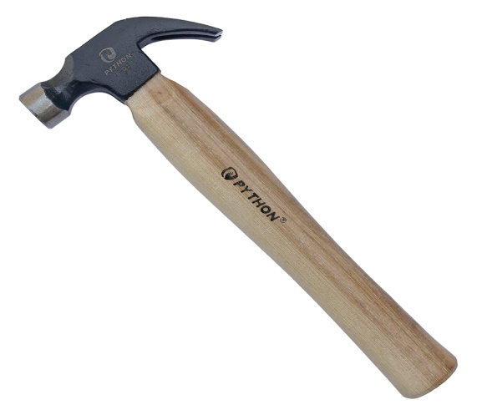
DRILLING MACHINE
CHISEL

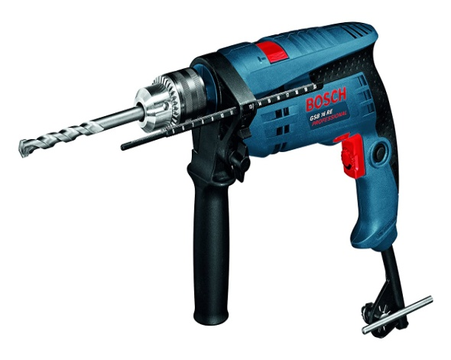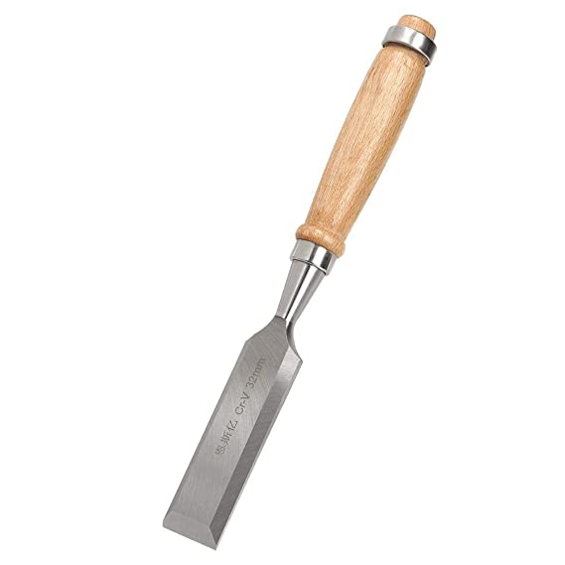
WRENCH

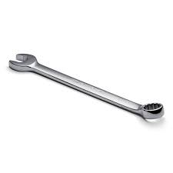

ANALYTICAL DETAIS:

We used following three methods for the analysis of different parameters related to the movement of different links of whitworth quick return mechanism and then compare them all to find best method among the given three methods.

Analytical Solution:

An analytical method is used when repetitive and extensive analysis of mechanisms is required, as the analytical equations and solutions obtained can be conveniently programmed on a computer. In this approach vector position, velocity and acceleration equations are formulated based on the fact that there are two different paths connecting the points on a vector loop. The equations thus obtained are simplified and programmed using computers. Desirable solutions are obtained by varying the parameters.

Graphical Solution:

The graphical solution consists of an investigation of velocity and acceleration field of important mechanism points. It provides information about kinematic parameters for a specific time moment, which means that it provides the information on the values corresponding to specific immediate mechanism position. This technique is based on vector polygon laws. Input and investigated parameters are plotted in a form of vectors, which lengths are drawn in needed scale, orientations are given by arrows and directions by directional angle

Solution with a Computer Aid:

A virtual model of the Whitworth mechanism () was created in software Autodesk Inventor Professional based on the kinematic diagram. After the preparation of 3D models of individual components, the needed connections were defined, such as pin joints, sliders and others, in order to the motion of the virtual mechanism corresponds with the real mechanism.

CHAPTER - 6

DISTRIBUTION OF COST

Costing is the process of accounting the total incurred in process service and equipment. The system of account which systematically and accurately record every expenditure in order to determine the cost of product.

SR. NO. | COMPONENT | QUANTITY | COST(RS)
1. | PLYWOOD | 1 | Rs. 500/-
2. | NUT, BOLTS & WASHERS | - | Rs.50 /-
3. | NAILS |  | Rs. 50/-
4. | FEVICOL | 1 | Rs. 50/-
5. | FEVIQUICK | 1 | Rs. 75/-
6. | SCREWS | - | Rs. 30/-
7. | TOOLS FOR MACHINING | 1 | Rs. 400/-
8. | SKILL WORKER CHARGE | 1 | Rs. 200/-
9. | PAINT | - | Rs. 75/-
10. | BELT | 1 | Rs. 50/-
11. | BEARINGS | 2 | Rs. 100/-
12. | PROJECT THESIS PRINTS | 7 | Rs. 3300/-
TOTAL |  |  | Rs.4,880 | /-

Table 6.1 : Costing Of Project
Total cost of this Project along with Project Thesis printing is Rs. 4880/-which when divided amongst 5 members comes out to be Rs. 976/- per head.

CHAPTER - 7

RESULT & CONCLUSION

RESULT & CONCLUSION

With the available time and resources, we have successfully met the objective of the project. We fabricated the prototype model of whitworth quick return mechanism and it is in working condition. And also we done the analysis of motions of different links by three methods that is analytical method, graphical method and computer aided method.

The values obtained by all three approaches to kinematic analysis are presented in Tab.1. It can be said that the results are the same and so the final decision which of methods to select for the solution depends only on the investigator and his possibilities. If he is good in math, he makes the analytical choice; if he disposes of hardware and software for kinematic analysis, he can use the second method. In both cases, he has to know the basic principles of mechanics.

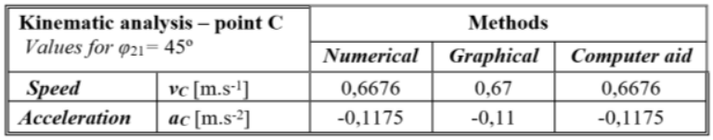

REFERENCES

How Whitworth Quick Return motion mechanism works
By Prithviraj P Shetty
https://youtu.be/XT4zt7sYPe0

Quick-return mechanism design and analysis projects
Ron P. Podhorodeski, Scott B. Nokleby and Jonathan D. Wittchen Robotics and Mechanisms Laboratory, Department of Mechanical Engineering, University of Victoria, PO Box 3055, Victoria, British Columbia, Canada, V8W 3P6 E-mail: podhoro@me.uvic.ca; snokleby@me.uvic.ca; jwittchen@crsrobotics.com

Dynamic, Kinematic and Static Analysis of a Shaper Machine Prof. Dr. M. A. Nasser, Dr. M. A. Asy mnasser2@hotmail.com mohamedasy2010@yahoo.com Department of Production Engineering & Mechanical Design University of Menoufia Shebin El-Kom, Menoufia, Egypt

"Three Views on Kinematic Analysis of Whitworth Mechanism of a Shaping Machine,"
Katarina Monkova and Peter P. Monka
Technical University in Kosice, Faculty of manufacturing technologies, Presov, Slovakia
UTB Zlin, Faculty of technology, Vavreckova 275, Zlin, Czech Republic

