PRACTICAL-3
Practical Definition:
Implementation of a Lexical Analyzer for C Language Compiler
Objective:
To design and implement a lexical analyser, the first phase of a compiler, for the C programming language. The lexical analyser should perform the following tasks: (1) tokenizing the input string (2) removing comments (3) removing white spaces (4) entering identifiers into the symbol table (5) generating lexical errors.
Language Constraint:
The program can be implemented in any programming language
Input Requirements:
• Accept a C source code file.
• The input can contain keywords, identifiers, constants, strings, punctuation, operators, comments, and white spaces.
Expected output
• Tokenized output categorizing tokens into five types: keyword, identifier, constant, punctuation, and operator.
• Symbol table with all identified identifiers stored.
• Detected lexical errors
Sample input output:
- int main() {
int a = 5 , 7H;
// assign value
char b = 'x';
/* return
value */
return a + b;
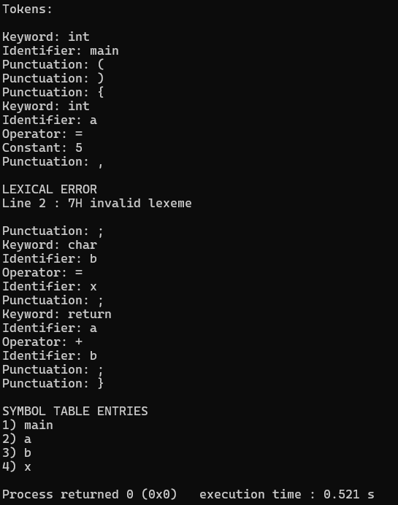


Testcases:
- /* salary calculation*/
void main( )
{
long int bs , da , hra , gs;
//take basic salary as input
scanf("%ld",&bs);
//calculate allowances
da=bs*.40;
hra=bs*.20;
gs=bs+da+hra;
// display salary slip
printf("\n\nbs : %ld",bs);
printf("\nda : %ld",da);
printf("\nhra : %ld",hra);
printf("\ngs : %ld",gs);
}
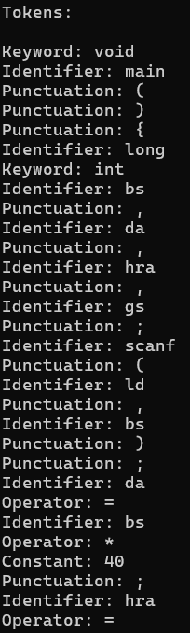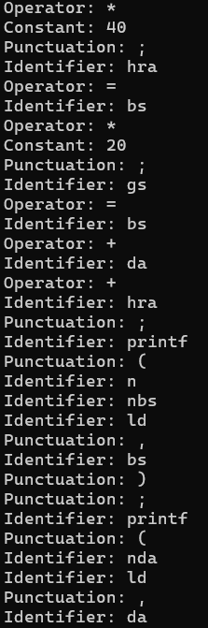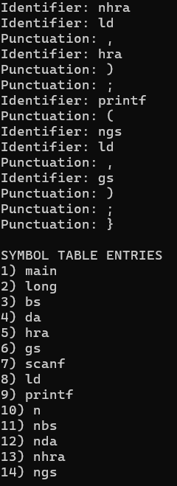

- // user defined data type
struct student
{
int id;
float cgpa;
}
void main( )
{
student s;
s.id = 10;
s.cgpa = 8.7;
}
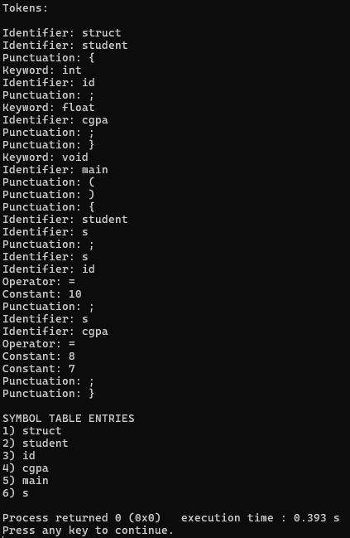

- //function prototype
void add ( int , int );
void main( )
{
int a , b;
a = 10;
b = 20;
// function call
add ( a , b );
}
void add ( int x , int y )
{
return x + y;
}

