PRACTICAL-8
Practical Definition:
Predictive Parsing Table Construction and LL(1) Grammar Validation
Objective:
Develop a program to construct a predictive parsing table for the given grammar. The program should analyse the generated parsing table to determine whether the grammar is LL(1) or not. If the grammar is LL(1), the program should also validate an input string against the given grammar.
Language Constraint:
The program can be implemented in any programming language
Input Requirements:
- First() and Follow() generated by practical 7
- A string that needs to be validated against the grammar
Expected output:
- A predictive parsing table generated for the given grammar.
- A message indicating whether the grammar is LL(1) or not.
- If the input string is valid according to the grammar, the program should print "Valid string".
- If the input string is invalid according to the grammar, the program should print "Invalid string".
Output:
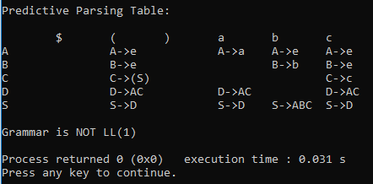
Conclusion:
This program constructs the predictive parsing table using the given FIRST and FOLLOW sets.
It checks for conflicts in the table to determine whether the grammar is LL(1) or not.
The program also validates an input string using predictive parsing techniques.
Thus, it helps in understanding LL(1) grammar analysis and parser construction in compiler design.

