PRACTICAL-2
Practical Definition:
String Validation Using Finite Automata
Objective:
To implement a program that validates a given string against rules defined in terms of finite automata.
Language Constraint:
The program can be implemented in any programming language.
Input Requirements:
• Accept rules in the form of finite automata (e.g., states, transitions, start state, accept states) as input.
• Accept a string to be validated against the provided finite automata rules.
Expected output
• If the string adheres to the rules of the finite automata, the program should output: "Valid String".
• If the string does not adhere to the rules, the program should output: "Invalid String".
Sample input output:
- Input:
Number of input symbols: 2
Input symbols: a b
Enter number of states: 4
Initial state: 1
Number of accepting states: 1
Accepting states: 2
Transition table:
1 to a -> 2
1 to b -> 3
2 to a -> 1
2 to b -> 4
3 to a -> 4
3 to b -> 1
4 to a -> 3
4 to b -> 2
Input string: abbabab

Output:
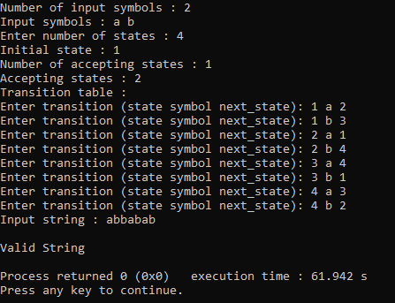
Testcases:
- String over 0 and 1 where every 0 immediately followed by 11
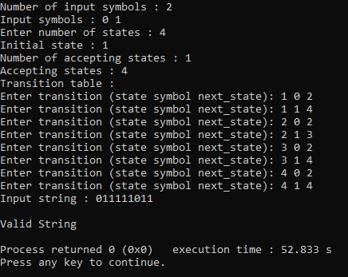

- String over a b c, starts and end with same letter.
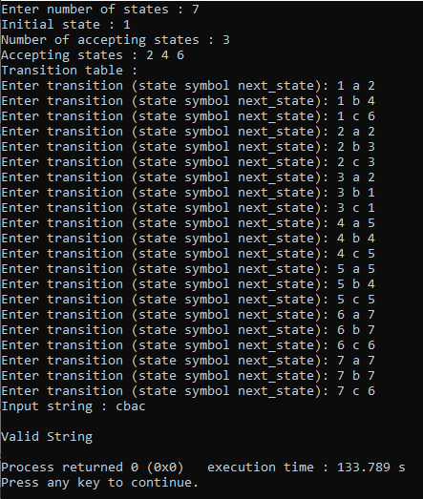

- String over lower-case alphabet and digits, starts with alphabet only.
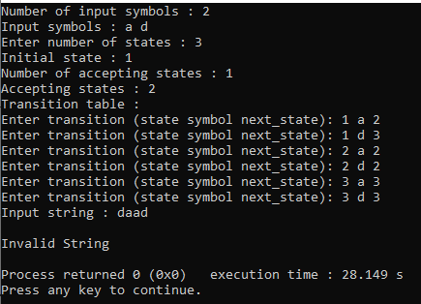
Hear, a=[a-z] and d=[0-9].

