PRACTICAL-1
Practical Definition:
String Validation Against Regular Expression
Objective:
To implement a program that validates a user-input string against the regular expression a*bb. The program should determine whether the input string is valid or invalid based on the defined pattern.
Language Constraint:
The program must be implemented in C language.
Input Requirements:
• Accept a character string from the user.
• Ensure the input is terminated with a newline character.
Expected output
• If the input string matches the pattern a*bb, the program should output: "Valid String".
• If the input string does not match the pattern, the program should output: "Invalid String".
Sample input output:
- aaabb:
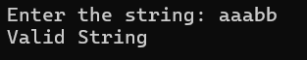

- abab:
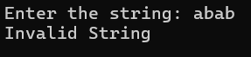
Testcases:
- ^
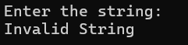

- bbbb
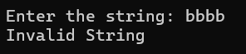
- aaa
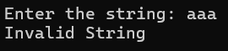

- baaabb
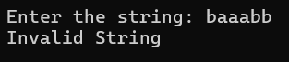

- aaabbb
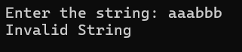

- aaaab
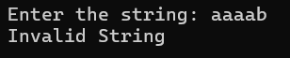

- abbabb
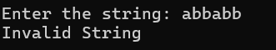

- abb
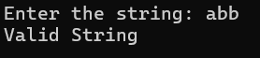

- aaaaabb
