PRACTICAL-10
Practical Definition:
Evaluating Arithmetic Expression with Bottom-Up Approach Using SDD
Objective:
Develop a program to evaluate arithmetic expressions containing operators using a bottom-up parsing approach and below given Syntax-Directed Definitions (SDD) for semantic evaluation. The program will compute the result of the expression by building a parse tree using and will incorporate semantic rules to evaluate sub-expressions during parsing.
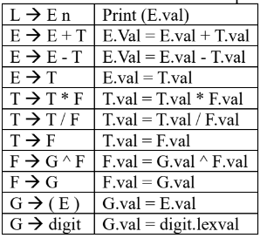
Language Constraint:
An input string
Input Requirements:
- An arithmetic expression in the form of a string that can contain
- Operands: Integers (e.g., 3, 5, 10) or decimals (e.g., 2.5, 0.75)
- Operators: +, -, *, /, ^ for addition, subtraction, multiplication, division, and exponentiation
- Parentheses: ( and ) for grouping sub-expressions
Expected output:
- The evaluated result of the arithmetic expression.
- If the input expression is invalid, the program should display “Invalid expression”.

Testcases:
- (3 + 5) * 2
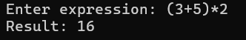

- 3 + 5 * 2
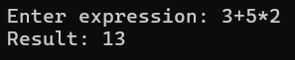

- 3 + 5 * 2 ^ 2
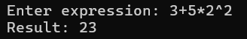

- 3 + (5 * 2)
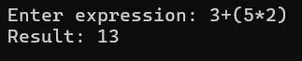

- 3 + 5 ^ 2 * 2
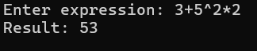

- 3 * (5 + 2)
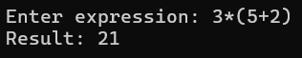

- (3 + 5) ^ 2
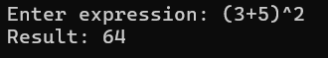

- 3 ^ 2 ^ 3
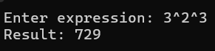

- 3 ^ 2 + 5 * 2
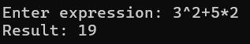

- 3 + ^ 5
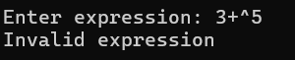

- (3 + 5 * 2
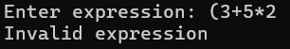

- (3 + 5 * 2 ^ 2 - 8) / 4 ^ 2 + 6
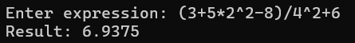

Conclusion:
The program evaluates arithmetic expressions using a bottom-up parsing approach with Syntax-Directed Definitions (SDD). It correctly applies operator precedence and associativity while computing values during parsing. The use of semantic rules enables efficient evaluation of sub-expressions. It also handles parentheses and detects invalid expressions. Thus, it provides a structured and accurate method for expression evaluation.

