PRACTICAL-11
Practical Definition:
Generate Intermediate Code Using Quadruple Table
Objective:
Develop a program that break down the input string according to the grammar and produce a sequence of quadruples representing the intermediate code for the expression.
E → E + T | E – T | T
T → T * F | T / F | F
F → (E) | digit
Language Constraint:
The program can be implemented in any programming language
Input Requirements:
An arithmetic expression in the form of a string that can contain
- Operands: Integers (e.g., 3, 5, 10) or decimals (e.g., 2.5, 0.75)
- Operators: +, -, *, /, ^ for addition, subtraction, multiplication, division, and exponentiation
- Parentheses: ( and ) for grouping sub-expressions
Expected output:
A quadruple table representing the intermediate code for the given expression
Testcases:
- 5 + 6 – 3
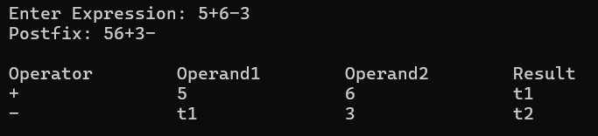

- 7 – ( 8 * 2 )
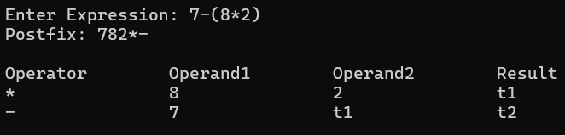

- ( 9 – 3 ) + ( 5 * 4 / 2)
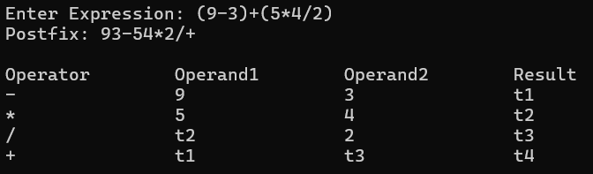

- (3 + 5 * 2 - 8) / 4 – 2 + 6
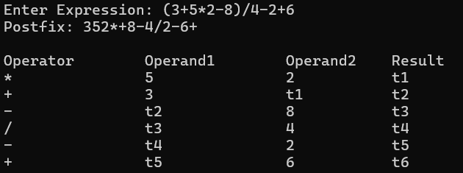

- 86 / 2 / 3
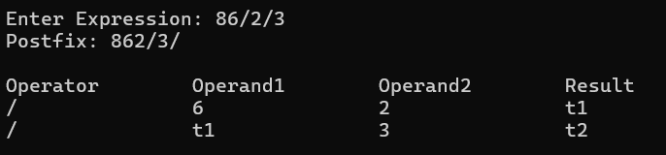

Conclusion:
The program successfully generates intermediate code in the form of quadruples for arithmetic expressions. It breaks down complex expressions into simpler operations using grammar rules. Each step produces a temporary result, ensuring systematic computation. This approach improves code optimization and ease of translation to machine code. Thus, quadruple representation provides an efficient method for intermediate code generation in compilers.

