PRACTICAL-12
Practical Definition:
Code Optimization Using Constant Folding
Objective:
Develop a program that identifies constant expressions at compile-time and replaces them with their evaluated results to enhance execution efficiency.
Language Constraint:
The program can be implemented in any programming language
Input Requirements:
An arithmetic expression in the form of a string that can contain
- Operands: Integers (e.g., 3, 5, 10) or decimals (e.g., 2.5, 0.75) or variables (e.g. a , abc , cgpa)
- Operators: +, -, *, / for addition, subtraction, multiplication, division, and exponentiation
Expected output
• Display the optimized expression after applying constant folding
Testcases:
- 2 + 3 * 4 – 1
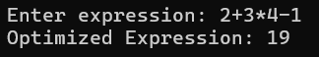

- X + (3 * 5) – 1
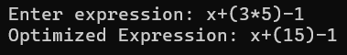

- 22 / 7 * r * r
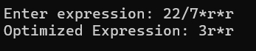

Conclusion:
Constant folding is a compile-time optimization that evaluates constant expressions in advance.
It reduces runtime computation and improves execution efficiency.
Thus, it helps in generating simpler and faster code without changing the output.

