PRACTICAL-7
Practical Definition:
Computing First and Follow Sets for a Context-Free Grammar (CFG)
Objective:
Develop a program computes the First and Follow sets for all non-terminal
symbols in for the below given grammar.
S → A B C | D
A → a | ε
B → b | ε
C → ( S ) | c
D → A C
Language Constraint:
The program can be implemented in any programming language
Input Requirements:
No input
Expected output:
Expected output
First(S) = {a, b, (, c}
First(A) = {a, ε}
First(B) = {b, ε}
First(C) = {(, c}
First(D) = {a, (, c}
Follow(S) = {), $}
Follow(A) = {b, (, c}
Follow(B) = {(, c}
Follow(C) = {), $}
Follow(D) = {), $}

expected output:
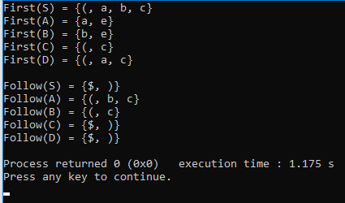

Conclusion:

This program computes the FIRST and FOLLOW sets for a context-free grammar using user input.
It correctly applies compiler design rules to analyze grammar productions.
The implementation is flexible and works for different grammars without modification.
It is useful for understanding parsing techniques and LL(1) parser construction.

