PRACTICAL-4
Practical Definition:
String validation using Lax tool
Objective - 1:
Write a program to identify and extract all numbers from input string and
display them one by one in new line.
Language Constraint:
Lex (Lexical analyser generator)
Input Requirements:
• Accept a character string, mix of text and numbers, from the user.
• Ensure the input is terminated with a newline character.
Expected output:
The program should print out each number found in the input, each on a new
line.
Test cases:
- Input:
power operation -> 12 ** 3 = 1728

- Output:
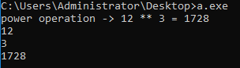

- Input:
You multiply 804569 with 1 then will be :

- Output:
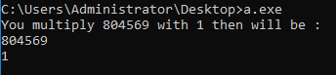

Objective - 2:
Write a program to replace the word "charusat" with “university” in the input
text.
Language Constraint:
Lex (Lexical analyser generator)
Input Requirements:
• Accept a character string from the user where the word "charusat" may appear multiple times.
• Ensure the input is terminated with a newline character.
Expected output:
The program should print the input text with all occurrences of "charusat" replaced by “university”.
Test cases:
- Input:
Charusat is in Anand district.

- Output:
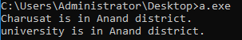

- Input:
Charusat , What is charusat?

- Output:
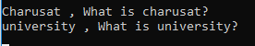

- Input:
I am doing my BTech from CHARSAT.

- Output:
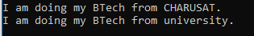

- Input:
Every where it is charusat , charusat and only charusat.

- Output:

Objective - 3:
Write a program to count number of characters, word and lines from the input file.
Language Constraint:
Lex (Lexical analyser generator)
Input Requirements:
Read contain from a text file containing multiple word and lines.
Expected output:
The program should print total number of characters (including spaces), words (separated by white spaces), lines (end with new line symbol).
Test cases:
- Input:
I want to calculate a number. The number of characters, words and lines.
All know that \n is ending character of line.

- Output:
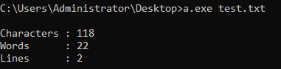

- Input:
45 + 89 =40

- Output:
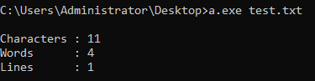

Objective - 4:
Write a program which validate the password as per given rules.
➢ length can be 9 to 15 characters
➢ includes lower case letter, upper case letter, digit, symbols (*, ; # $ @)
➢ minimum count for each category must be one
Language Constraint:
Lex (Lexical analyser generator)
Input Requirements:
- Accept a character string from the user which is mix of letters, numbers and symbols.
- Ensure the input is terminated with a newline character.
Expected output:
- If the password meets the given rules, the program should print "Valid password".
- If the password does not meet the rules, the program should print "Invalid password".
Test cases:

- Input:
aB1@
- Output:
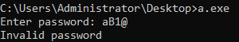

- Input:
Charusat
- Output:
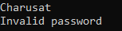

- Input:
Charusat@2024
- Output:
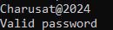

- Input:
aaBB11,#cdefg2345
- Output:
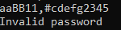

- Input:
CHArusat123
- Output:
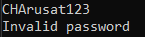

- Input:
Charu$80@20#24
- Output:
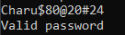

- Input:
CHARUSAT
- Output:
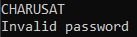

- Input:
Cspit-2024
- Output:
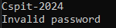

- Input:
charu*sAT;22
- Output:
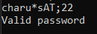

Conclusion:

In this practical, various string processing tasks were successfully implemented using the Lex tool. Programs were developed to extract numbers from a string, perform word replacement, count characters, words and lines from a file, and validate passwords based on specified rules. These tasks demonstrate the ability of Lex to recognize patterns using regular expressions and perform efficient text analysis. The experiment highlights how lexical analyzers can be applied beyond compilers for general string validation and manipulation. It also improves understanding of token recognition, pattern matching, and input handling. Thus, the objectives of implementing multiple string validation operations using Lex were achieved successfully.

