PRACTICAL-5
Practical Definition:
Implementation of a Lexical Analyzer for C Language Compiler
Objective:
To design and implement a lexical analyser to perform 1st, 2nd, 3rd, and 5th task as per the list given in practical 2.
Language Constraint:
Lex (Lexical analyser generator)
Input Requirements:
• Accept a C source code file.
• The input can contain keywords, identifiers, constants, strings, punctuation, operators, comments, and white spaces.
Expected output:
- Tokenized output categorizing tokens into six types: keyword, identifier, constant, string, punctuation, and operator.
- Detection and reporting of lexical errors
Test cases:
- Input:
/* salary calculation*/
void main( )
{
long int bs , da , hra , gs;
//take basic salary as input
scanf("%ld",&bs);
//calculate allowances
da=bs*.40;
hra=bs*.20;
gs=bs+da+hra;
// display salary slip
printf("\n\nbs : %ld",bs);
printf("\nda : %ld",da);
printf("\nhra : %ld",hra);
printf("\ngs : %ld",gs);
}

- Output:

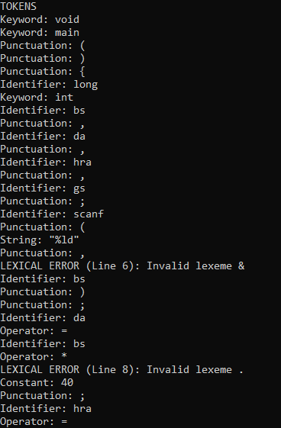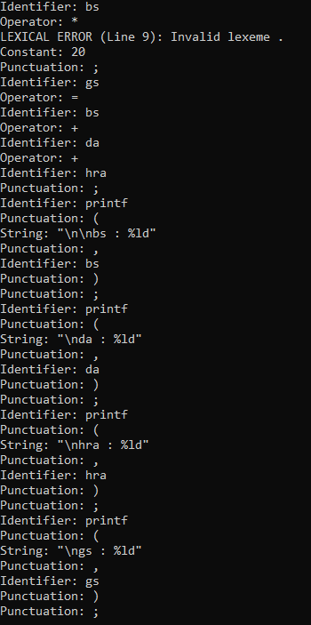

- Input:
// user defined data type
struct student
{
int id;
float cgpa;
}
void main( )
{
student s;
s.id = 10;
s.cgpa = 8.7;
}

- Output:
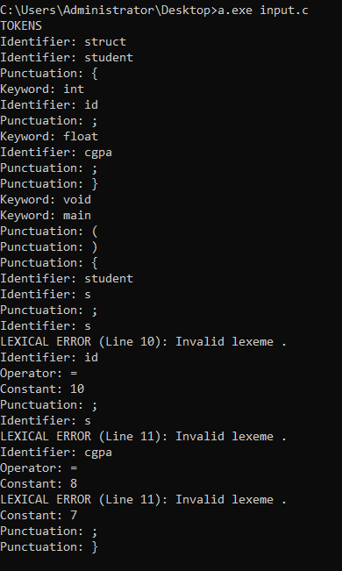

- Input
//function prototype
void add ( int , int );
void main( )
{
int a , b;
a = 10;
b = 20;
// function call
add ( a , b );
}
void add ( int x , int y )
{
return x + y;
}
- Output:
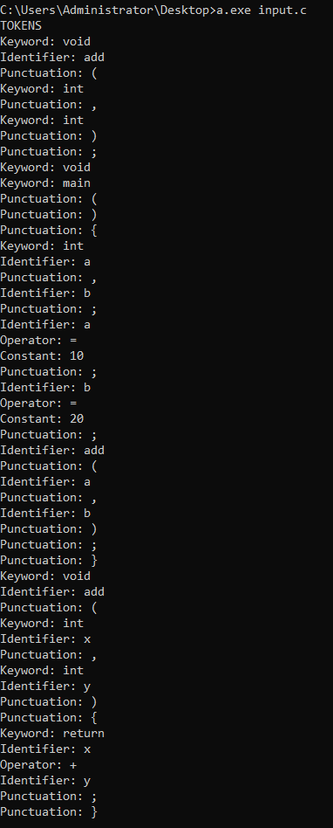

Conclusion:
The lexical analyzer for the C language was successfully designed and implemented using Lex. It reads a C source file, identifies tokens such as keywords, identifiers, constants, operators, and punctuation symbols, and ignores comments and white spaces. The analyzer also detects invalid lexemes and reports lexical errors with corresponding line numbers. Additionally, identifiers encountered during scanning can be recorded in a symbol table.

