## JADAVPUR UNIVERSITY

Database Management System Lab Assignment - 1

**Name:** SHRUTI PATHAK & ANNESA MONDAL **Roll No:** 002210503021 & 002210503022

**Dept:** Computer Science and Engineering

**Class:** MCA 1st Year 2nd Sem **Session:** 2022-2024

***ASSIGNMENT 1***

# *Question 1: Create the following tables:

**Table name: EMPLOYEE**

# Structure:

|  |  |
| --- | --- |
| EMP_CODE | char(16) |
| EMP_NAME | char(20) |
| DEPT_CODE | char(16) |
| DESIG_CODE | char(16) |
| SEX | char(1) |
| ADDRESS | char (25) |
| CITY | char (20) |
| STATE | char (20) |
| PIN | char (6) |
| BASIC | Number |
| JN_DT | Date |

Primary key is EMP_CODE

**Table name: DESIGNATION**

# Structure:

DESIG_CODE char(16) DESIG_DESC char(20)

Primary key is DESIG_CODE

**Table name: DEPARTMENT**

# Structure:

DEPT_CODE char(16)

DEPT_NAME char(20)

Primary key is DEPT_CODE.

# Solution:

# CREATE TABLE EMPLOYEE(

# EMP_CODE varchar(16) NOT NULL PRIMARY KEY,

# EMP_NAME varchar(20),

# DEPT_CODE varchar(16),

# DESIG_CODE varchar(16),

# SEX varchar(1),

# ADDRESS varchar(25),

# CITY varchar(20),

# STATE varchar(20),

# PIN varchar(6),

# BASIC int,

# JN_DT Date);

0 row(s) affected

CREATE TABLE DESIGNATION(

# DESIG_CODE varchar(16) NOT NULL PRIMARY KEY,

DESIG_DESC varchar(20));

0 row(s) affected

CREATE TABLE DEPARTMENT(

DEPT_CODE varchar(16) NOT NULL PRIMARY KEY,

DEPT_NAME varchar(20));

0 row(s) affected

# *Question 2: Display the structure of each table.

**Solution:**

DESC EMPLOYEE;

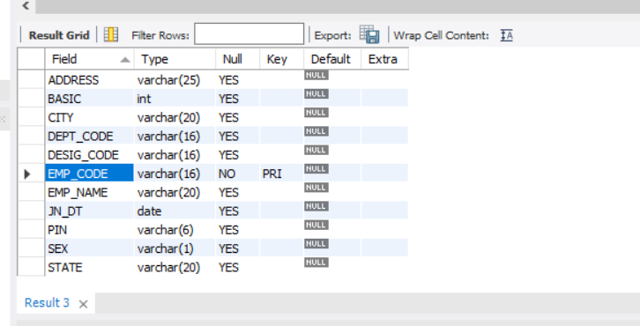

|  |  |
| --- | --- |
| DESC DESIGNATION; | |
| DESC DEPARTMENT; | |
|  |

# *Question 3. Insert few rows in each table.

**[While entering data in EMP table use DESIG_CODE which exists in DESIGNATION table and DEPT_CODE which is exists in DEPARTMENT table. In DESIGNATION table, assign code for Manager, Executive, officer, clerk and helper. In DEPARTMENT table, assign code for Personnel, Production, Purchase, Finance, Research departments]**

**Solution:**

INSERT INTO DEPARTMENT(DEPT_CODE, DEPT_NAME)

VALUES('PER','Personnel');

1 row(s) affected

INSERT INTO DEPARTMENT(DEPT_CODE, DEPT_NAME)

VALUES('PR','Production');

1 row(s) affected

INSERT INTO DEPARTMENT(DEPT_CODE, DEPT_NAME) VALUES('PUR','Purchase');

1 row(s) affected

INSERT INTO DEPARTMENT(DEPT_CODE, DEPT_NAME) VALUES('FI','Finance');

1 row(s) affeccted

INSERT INTO DEPARTMENT(DEPT_CODE, DEPT_NAME) VALUES('RE','Research');

1 row(s) affeccted

INSERT INTO DEPARTMENT(DEPT_CODE, DEPT_NAME) VALUES('MR','MARKETTIN);

1 row(s) affeccted

SELECT * FROM DEPARTMENT;

|  |  |
| --- | --- |
|  |  |

INSERT INTO DESIGNATION(DESIG_CODE, DESIG_DESC) VALUES('MN','Manager');

1 row(s) affected

INSERT INTO DESIGNATION(DESIG_CODE, DESIG_DESC)

VALUES('EXE','Executive');

1 row(s) affected

INSERT INTO DESIGNATION(DESIG_CODE, DESIG_DESC) VALUES('OFF','Officer');

1 row(s) affected

INSERT INTO DESIGNATION(DESIG_CODE, DESIG_DESC) VALUES('CL','Clerk');

1 row(s) affected

INSERT INTO DESIGNATION(DESIG_CODE, DESIG_DESC) VALUES('HL','Helper');

1 row(s) affected

SELECT * FROM DESIGNATION;

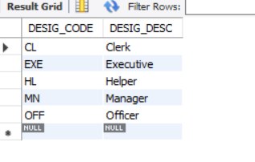

INSERT INTO EMPLOYEE(EMP_CODE, EMP_NAME, DEPT_CODE, DESIG_CODE, SEX, ADDRESS, CITY, STATE, PIN, BASIC, JN_DT) VALUES

('E101','Shruti Pathak','PR','EXE','F','Purulia','Purulia','West Bengal','723102',45000,DATE '2015-05-01');

1 row(s) affected

INSERT INTO EMPLOYEE(EMP_CODE, EMP_NAME, DEPT_CODE, DESIG_CODE, SEX, ADDRESS, CITY, STATE, PIN, BASIC, JN_DT) VALUES

('E102','Annesa Mondal','FI','OFF','F','Krishnagar','Nadia','West Bengal','741101',50000,DATE '2020-01-02')

1 row(s) affected

INSERT INTO EMPLOYEE(EMP_CODE, EMP_NAME, DEPT_CODE, DESIG_CODE, SEX, ADDRESS, CITY, STATE, PIN, BASIC, JN_DT) VALUES

('E103','Rahul Mahato','PUR','MN','M','Haldia','EastMidnapur','West Bengal','721108',60000,DATE '2020-05-01');

1 row(s) affected

INSERT INTO EMPLOYEE(EMP_CODE, EMP_NAME, DEPT_CODE, DESIG_CODE, SEX, ADDRESS, CITY, STATE, PIN, BASIC, JN_DT) VALUES

('E104','Nilesh Kundu','RE','HL','M','Durgapur','West Burdwan','West Bengal','700014',90000,DATE '2018-02-01');

1 row(s) affected

INSERT INTO EMPLOYEE(EMP_CODE, EMP_NAME, DEPT_CODE, DESIG_CODE, SEX, ADDRESS, CITY, STATE, PIN, BASIC, JN_DT) VALUES

('E105','Nitish Kumar Mondal','FI','CL','M','New Town','Kolkata','West Bengal','700026',25000,DATE '2022-01-02');

1 row(s) affected

INSERT INTO EMPLOYEE(EMP_CODE, EMP_NAME, DEPT_CODE, DESIG_CODE, SEX, ADDRESS, CITY, STATE, PIN, BASIC, JN_DT) VALUES

('E106','Himangsu Bauri','PUR','EXE','M','Thakurpukur','Kolkata','West Bengal','400020',40000,DATE '2021-08-01');

1 row(s) affected

INSERT INTO EMPLOYEE(EMP_CODE, EMP_NAME, DEPT_CODE, DESIG_CODE, SEX, ADDRESS, CITY, STATE, PIN, BASIC, JN_DT) VALUES

('E107','Ivy Dey','PR','MN','F','Garia','Kolkata','West Bengal','700009',

60000,DATE '2016-02-01');

1 row(s) affected

INSERT INTO EMPLOYEE(EMP_CODE, EMP_NAME, DEPT_CODE, DESIG_CODE, SEX, ADDRESS, CITY, STATE, PIN, BASIC, JN_DT) VALUES

('E108','Saraswati Murmu','PER','OFF','F','Jadavpur','Kolkata','West Bengal','760038',55000,DATE '2020-08-01');

1 row(s) affected

INSERT INTO EMPLOYEE(EMP_CODE, EMP_NAME, DEPT_CODE, DESIG_CODE, SEX, ADDRESS, CITY, STATE, PIN, BASIC, JN_DT) VALUES

('E109','Anjani Ahir','FI','CL','F','Naihati','North 24 Parbanas','West Bengal','710001',25000,DATE '2010-03-01');

1 row(s) affected

INSERT INTO EMPLOYEE(EMP_CODE, EMP_NAME, DEPT_CODE, DESIG_CODE, SEX, ADDRESS, CITY, STATE, PIN, BASIC, JN_DT) VALUES

('E110','Ankita Dutta','RE','EXE','F','Bankura','Bankura','West Bengal','700034',200000,DATE '2021-11-12');

1 row(s) affected

SELECT * FROM EMPLOYEE;

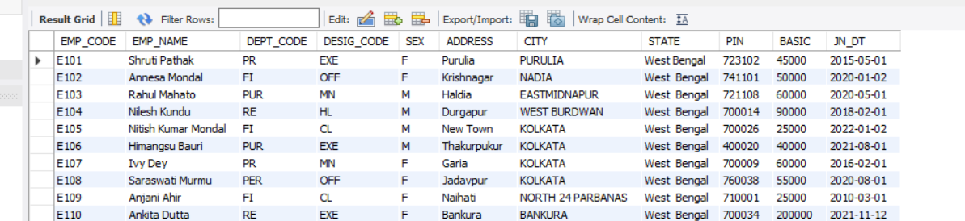

# *Question 4: In EMP table insert few rows without DEPT_CODE and BASIC.

**Solution**:

INSERT INTO EMPLOYEE(EMP_CODE, EMP_NAME, DEPT_CODE, DESIG_CODE, SEX, ADDRESS, CITY, STATE, PIN, BASIC, JN_DT) VALUES

('E111','Priyanka Ghosh',NULL,'EXE','F','Dumdum','Kolkata','West Bengal','700034',NULL,DATE '2021-11-12');

1 row(s) affected

INSERT INTO EMPLOYEE(EMP_CODE, EMP_NAME, DEPT_CODE, DESIG_CODE, SEX, ADDRESS, CITY, STATE, PIN, BASIC, JN_DT) VALUES

('E112','Robiul Islam',NULL,'HL','M','Durgapur','West Burdwan','West Bengal','700014',NULL,DATE '2022-01-03');

1 row(s) affected

SELECT * FROM EMPLOYEE;

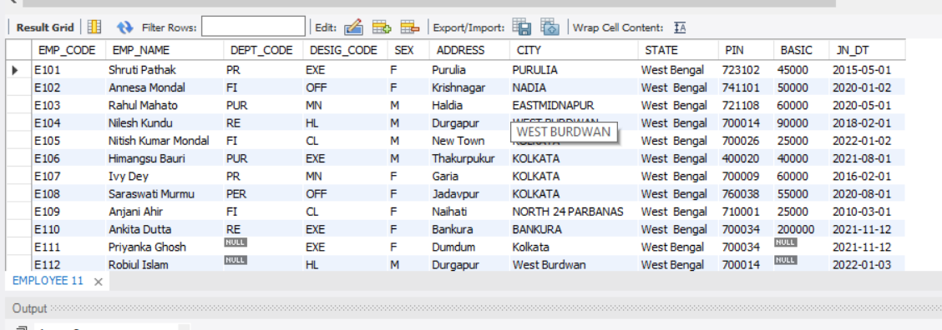

# *Question 5: Find the rows with unassigned DEPT_CODE. Solution.

SELECT * FROM EMPLOYEE WHERE DEPT_CODE IS NULL;

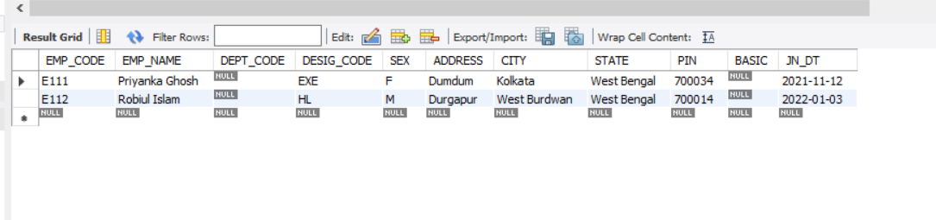

# *Question 6: Find the rows with BASIC equal to 0.

**Solution**:

INSERT INTO EMPLOYEE(EMP_CODE, EMP_NAME, DEPT_CODE, DESIG_CODE, SEX, ADDRESS, CITY, STATE, PIN, BASIC, JN_DT) VALUES

('E113','Priti Mondal',NULL,'OFF','F','Krishnagar','Nadia','West Bengal','741101',0,DATE '2022-06-02');

1 row(s) affected

INSERT INTO EMPLOYEE(EMP_CODE, EMP_NAME, DEPT_CODE, DESIG_CODE, SEX, ADDRESS, CITY, STATE, PIN, BASIC, JN_DT) VALUES

('E114','Rahul Lugun',NULL,'CL','M','New Town','Kolkata','West Bengal','700026',0,DATE '2022-01-02');

1 row(s) affected

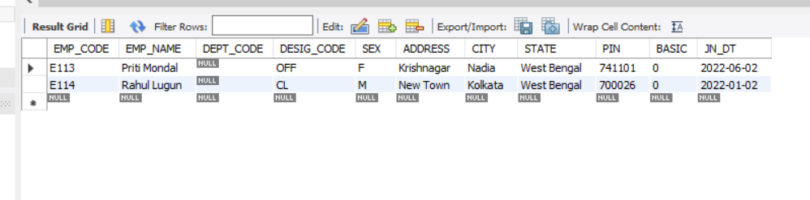SELECT * FROM EMPLOYEE WHERE BASIC = 0;

# *Question 7: Find the rows with unassigned Basic [note down the difference between the results obtained in Q.6 and Q.7] Solution:

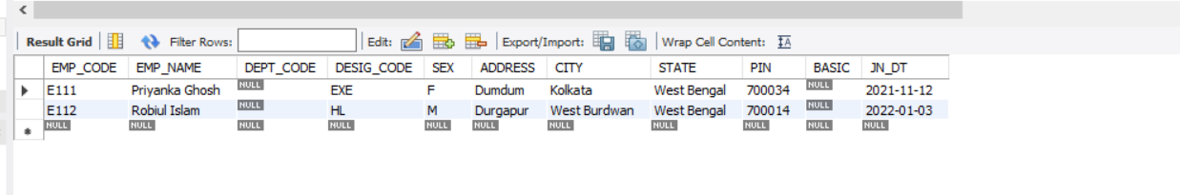 SELECT * FROM EMPLOYEE WHERE BASIC IS NULL;

# *Question 8: Find the average BASIC of the employees.

**Solution:**

SELECT AVG(BASIC) FROM EMPLOYEE;

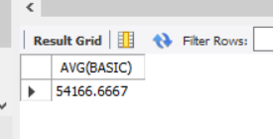

# *Question 9: Replace the BASIC with 0 for the rows with unassigned BASIC.

**Solution:**

UPDATE EMPLOYEE SET BASIC = 0

WHERE BASIC IS NULL;

2 row(s) affected Rows matched: 2 Changed: 2 Warnings:

# *Question 10. Find the average BASIC. (Note the difference of result obtained in Q.8 & Q.10.)

**Solution:**

SELECT AVG(BASIC) FROM EMPLOYEE;

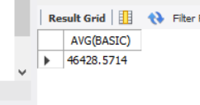

# *Question 11. Delete the rows with unassigned DEPT_CODE. Solution:

DELETE FROM EMPLOYEE WHERE DEPT_CODE IS NULL;

4 row(s) affected

# *Question 12: Say, Net pay of an employee= Basic+ HRA+ DA where HRA is 50% of the Basic & DA is 40% of Basic. Show the employee name & Net pay for all employees.

**Solution:**

SELECT EMP_NAME, BASIC * 0.4 + BASIC * 0.5 AS NET_PAY FROM EMPLOYEE;

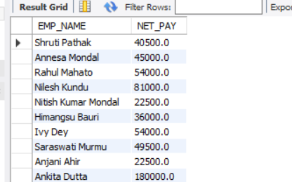

# *Question 13: Show the EMP_NAME & BASIC in the ascending order of DEPT_CODE. The employee name must appear in uppercase.

**Solution:**

SELECT UPPER(EMP_NAME), BASIC

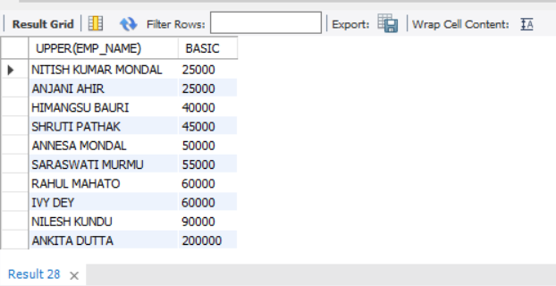FROM EMPLOYEE

ORDER BY BASIC;

# *Question 14: Find the employees who have joined after 1st January 2010

**Solution:**

SELECT EMP_NAME AS EMPLOYEE_NAME, JN_DT AS JOIN_DATE FROM EMPLOYEE WHERE JN_DT > DATE '2020-01-01';

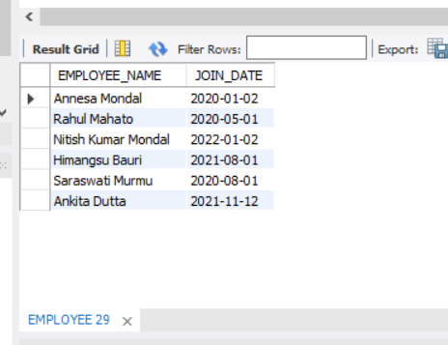

# *Question 15: Find, how many employees have joined in the month of January?

**Solution:**

SELECT COUNT(*) FROM EMPLOYEE WHERE SUBSTR(JN_DT,6,2) = '01';

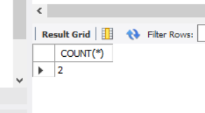

# *Question 16: Find the maximum & minimum Basic.

# 

# Solution:

SELECT MAX(BASIC), MIN(BASIC) FROM EMPLOYEE;

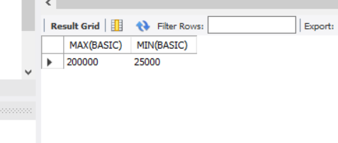

# *Question 17: Find how many Female employees are there?

**Solution:**

SELECT COUNT(*) FROM EMPLOYEE WHERE SEX = 'F'; COUNT(*)

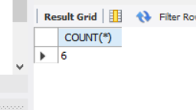

# *Question 18: Replace CITY with existing value converted into uppercase for all rows.

**Solution:**

UPDATE EMPLOYEE SET CITY = UPPER(CITY);

10 row(s) affected Rows matched: 10 Changed: 10 Warnings: 0

SELECT CITY FROM EMPLOYEE;

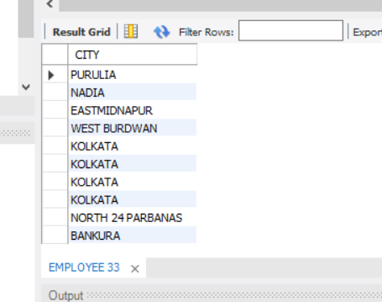

# *Question 19: Find in how many different cities various employees are residing?

**Solution:**

SELECT CITY, COUNT(*) FROM EMPLOYEE GROUP BY CITY;

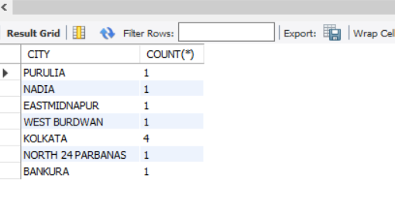

# *Question 20: Display the employee information in the ascending order of DEPT_CODE and within a Department, it should be in the descending order of BASIC.

**Solution:**

SELECT * FROM EMPLOYEE ORDER BY DEPT_CODE, BASIC DESC;

