## JADAVPUR UNIVERSITY

Database Management System Lab Assignment - 2

**Name:** SHRUTI PATHAK & ANNESA MONDAL **Roll No:** 002210503021 & 002210503022

**Dept:** Computer Science and Engineering

**Class:** MCA 1st Year 2nd Sem **Session:** 2022-2024

***ASSIGNMENT 2***

# Question 1: From the EMP table show the minimum, maximum and

# average basic for each department (show dept. Code). Solution:

SELECT DEPT_CODE, MIN(BASIC), MAX(BASIC), AVG(BASIC) FROM EMPLOYEE GROUP BY DEPT_CODE;

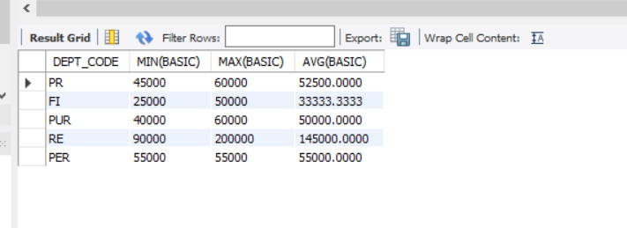

# Question 2: Find the number of female employees in each department (show dept. Code).

**Solution:**

SELECT DEPT_CODE , COUNT(*) FROM EMPLOYEE WHERE SEX = 'F'

GROUP BY DEPT_CODE;

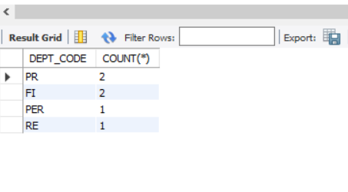

# Question 3: Find the city wise no. of employees for each department (show dept. Code).

**Solution:**

SELECT DEPT_CODE, CITY, COUNT(*) FROM EMPLOYEE GROUP BY DEPT_CODE, CITY;

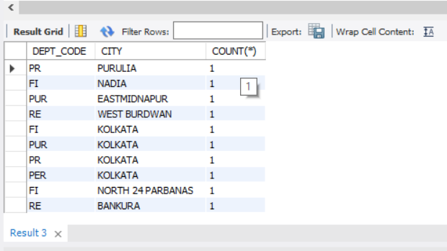

# Question 4: Show the designation wise no of employees who have joined in the year 2020 in each department. The listing should appear in the ascending order of no. of employees.

**Solution:**

SELECT DESIG_CODE , COUNT(*) FROM EMPLOYEE WHERE SUBSTR(JN_DT,8,2) = '20' GROUP BY DESIG_CODE ORDER BY COUNT(*);

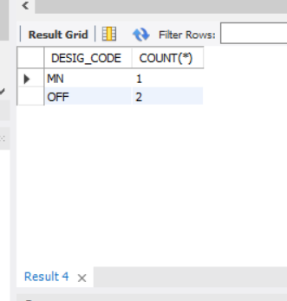

# Question 5: Find the department code wise total basic of male employees only for the departments for which such total is more than 50,000 and the listing should appear in the descending order of total basic.

# Solution:

SELECT DEPT_CODE , SUM(BASIC) AS TOTAL_BASIC FROM EMPLOYEE WHERE SEX = 'M' GROUP BY DEPT_CODE HAVING SUM(BASIC) > 50000 ORDER BY SUM(BASIC) DESC;

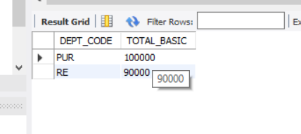

* **Question 6: Show the employee name, Designation description and basic for all employees.**

**Solution:**

SELECT e.EMP_NAME, d.DESIG_DESC , e.BASIC FROM EMPLOYEE e, DESIGNATION d WHERE e.DESIG_CODE = d.DESIG_CODE;

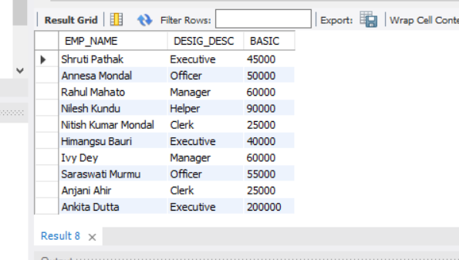

# Question 7: Show the employee name, Designation description, Department Name & Basic for all employees.

**Solution:**

SELECT e.EMP_NAME, d.DESIG_DESC, dp.DEPT_NAME, e.BASIC FROM EMPLOYEE e, DESIGNATION d, DEPARTMENT dp WHERE e.DESIG_CODE = d.DESIG_CODE AND e.DEPT_CODE = dp.DEPT_CODE;

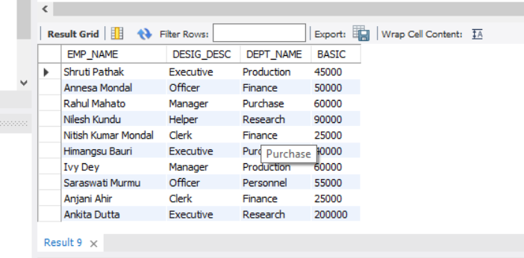

# Question 8: Find the department Codes in which no employee works.

**Solution:**

SELECT DEPT_CODE FROM DEPARTMENT WHERE DEPT_CODE NOT IN (SELECT DEPT_CODE FROM EMPLOYEE);

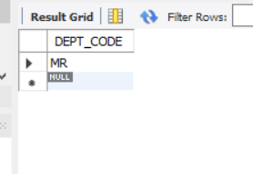

# Question 9: Find the department names where at least one employee works.

**Solution:**

SELECT DEPT_NAME FROM DEPARTMENT WHERE DEPT_CODE IN (SELECT DEPT_CODE FROM EMPLOYEE);

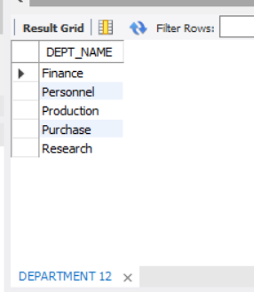

# Question 10: Find the department names where at least 10 employee’s works.

**Solution:**

# [I have not enough entries with respect to one department to run this query. So, I have added few more entries to run this query.]

INSERT INTO EMPLOYEE(EMP_CODE, EMP_NAME, DEPT_CODE, DESIG_CODE, SEX, ADDRESS, CITY, STATE, PIN, BASIC, JN_DT) VALUES ('E115', 'Meghashri Saha', 'PR', 'OFF', 'F', 'New P.O. Road', 'Pune', 'Maharashtra', '421345',70000,DATE '2020-04-03');

1 row(s) affected

INSERT INTO EMPLOYEE(EMP_CODE, EMP_NAME, DEPT_CODE,DESIG_CODE, SEX, ADDRESS, CITY, STATE, PIN, BASIC, JN_DT)VALUES('E116', 'Priyanka Roy', 'MN','F', 'Pali Hill', 'Mumbai','Maharashtra',

'400025', 65000, DATE '2019-09-02');

1 row(s) affected

INSERT INTO EMPLOYEE(EMP_CODE, EMP_NAME, DEPT_CODE, DESIG_CODE, SEX, ADDRESS, CITY, STATE, PIN, BASIC, JN_DT) VALUES ('E117', 'Sudip Ghosh', 'PR', 'OFF', 'M', 'Ashutosh Mukherjee Road', 'Kolkata', 'West Bengal', '700020',65000, DATE '2019-02-09')

1 row(s) affected

INSERT INTO EMPLOYEE(EMP_CODE, EMP_NAME, DEPT_CODE, DESIG_CODE, SEX, ADDRESS, CITY, STATE, PIN, BASIC, JN_DT) VALUES ('E118', 'Arijit Maity', 'PR', 'EXE', 'M', '20B Narkeldanga', 'Kolkata','West Bengal', '711097', 45000, DATE '2020-07-03');

1 row(s) affected

INSERT INTO EMPLOYEE(EMP_CODE, EMP_NAME, DEPT_CODE, DESIG_CODE, SEX, ADDRESS, CITY, STATE, PIN, BASIC, JN_DT) VALUES ('E119', 'Sneha Das', 'PR', 'CL', 'F', '5 Canning Street', 'Jalpaiguri', 'West Bengal', '723098', 35000, DATE '2021-08-03');

1 row(s) affected

INSERT INTO EMPLOYEE(EMP_CODE, EMP_NAME, DEPT_CODE, DESIG_CODE, SEX, ADDRESS, CITY, STATE, PIN, BASIC, JN_DT) VALUES ('E120', 'Imanur Rahaman', 'PR', 'OFF', 'M', '128 Danesh Shekh Lane', 'Howrah', 'West Bengal', '711204', 70000, DATE '2019-10-09');

1 row(s) affected

INSERT INTO EMPLOYEE(EMP_CODE, EMP_NAME, DEPT_CODE, DESIG_CODE, SEX, ADDRESS, CITY, STATE, PIN, BASIC, JN_DT) VALUES ('E121', 'Riya Parvin', 'PR', 'MN', 'F', 'Pune Lavasa Campus', 'Pune', 'Maharashtra', '400087', 65000, DATE '2020-09-03');

1 row(s) affected

INSERT INTO EMPLOYEE(EMP_CODE, EMP_NAME, DEPT_CODE, DESIG_CODE, SEX, ADDRESS, CITY, STATE, PIN, BASIC, JN_DT) VALUES ('E122', 'Reshmi Kundu', 'PR', 'Cl', 'F', 'Lajpat Nagar', 'Delhi', 'Delhi','100087', 25000, DATE '2021-07-03');

1 row(s) affected

INSERT INTO EMPLOYEE(EMP_CODE, EMP_NAME, DEPT_CODE, DESIG_CODE, SEX, ADDRESS, CITY, STATE, PIN, BASIC, JN_DT) VALUES ('E123', 'Manshi Shaw', 'PR', 'EXE', 'F', 'IT Building,Yojana Bhawan', 'Jaipur', 'Rajasthan', '302005',50000, DATE '2019-08-06');

1 row(s) affected

SELECT d.DEPT_NAME FROM DEPARTMENT d WHERE (SELECT COUNT(*) FROM EMPLOYEE e WHERE e.DEPT_CODE = d.DEPT_CODE) > 9;

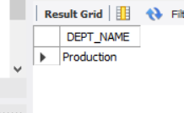

# Question 11: Find the department code in which employee with highest Basic works.

**Solution:**

SELECT DEPT_CODE, BASIC AS MAX_BASIC FROM EMPLOYEE WHERE BASIC = (SELECT MAX(BASIC) FROM EMPLOYEE);

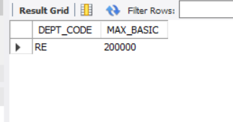

# Question 12: Find the Designation description of the employee with highest basic.

**Solution:**

SELECT d.DESIG_DESC , e.BASIC AS MAX_BASIC FROM EMPLOYEE e, DESIGNATION d WHERE e.DESIG_CODE = d.DESIG_CODE AND e.BASIC = (SELECT MAX(BASIC) FROM EMPLOYEE);

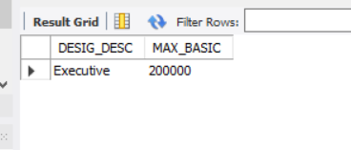

# Question 13: Find the no. of managers in each department.

**Solution:**

SELECT d.DEPT_NAME, COUNT(*) AS NO_OF_MANAGER FROM EMPLOYEE e, DEPARTMENT d WHERE e.DEPT_CODE = d.DEPT_CODE AND e.DESIG_CODE = (SELECT DESIG_CODE FROM DESIGNATION WHERE

DESIG_DESC = 'Manager') GROUP BY d.DEPT_NAME;

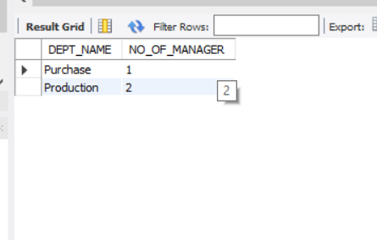

# Question 14: Find the maximum basic from EMP table without using MAX().

**Solution:**

SELECT DISTINCT BASIC AS MAX_BASIC FROM EMPLOYEE e WHERE

e.BASIC >= ALL(SELECT BASIC FROM EMPLOYEE);

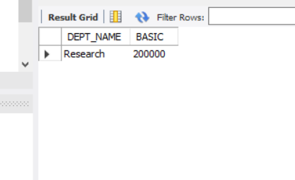

# Question 15: Find the minimum basic from EMP table without using MIN().

**Solution:**

SELECT DISTINCT BASIC AS MIN_BASIC FROM EMPLOYEE e WHERE e.BASIC <= ALL(SELECT BASIC FROM EMPLOYEE);

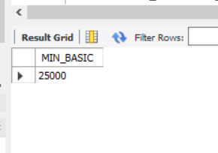

# Question 16: Find the name of the department with highest total basic. Do the same for highest average basic and maximum no. of employee.

**Solution:**

# Highest Total Basic:

SELECT d.DEPT_NAME, e.BASIC FROM EMPLOYEE e, DEPARTMENT d WHERE e.DEPT_CODE = d.DEPT_CODE AND e.BASIC >= ALL(SELECT BASIC FROM EMPLOYEE);



# Highest Average Basic:

SELECT DEPT_NAME, BASIC AS AVERAGE_BASIC FROM

(SELECT DEPT_NAME , AVG(BASIC) AS BASIC FROM EMPLOYEE e, DEPARTMENT d WHERE e.DEPT_CODE = d.DEPT_CODE GROUP BY DEPT_NAME)WHERE BASIC = (SELECT MAX(BASIC) FROM (SELECT DEPT_NAME, AVG(BASIC) AS BASIC FROM EMPLOYEE e, DEPARTMENT d WHERE e.DEPT_CODE = d.DEPT_CODE GROUP BY DEPT_NAME));

DEPT_NAME AVERAGE_BASIC

Personnel

55000

Purchase 55000

# Maximum Number of Employee:

SELECT DEPT_NAME, EMP_NO AS MAXIMUM_NO_OF_EMPLOYEE FROM

(SELECT DEPT_NAME, COUNT(EMP_CODE) AS EMP_NO FROM EMPLOYEE e DEPARTMENT d WHERE e.DEPT_CODE = d.DEPT_CODE GROUP BY DEPT_NAME) WHERE EMP_NO = (SELECT MAX(EMP_NO) FROM EMPLOYEE e, DEPARTMENT dWHERE e.DEPT_CODE = d.DEPT_CODE GROUP BY DEPT_NAME));

DEPT_NAME MAXIMUM_NO_OF_EMPLOYEE

Production 10

# Question 17: Insert same rows into EMP table with designation code not existing in DESIGNATION table.

**Solution:**

INSERT INTO EMPLOYEE(EMP_CODE,EMP_NAME, DEPT_CODE, DESIG_CODE, SEX,ADDRESS, CITY, STATE, PIN, BASIC, JN_DT) VALUES('E24','Sarthak dubey', 'PUR', 'SALES', 'M', '45B Gariahat Road', 'Kolkata', 'West Bengal','700034',45000,DATE '2019-02-01');

1 row(s) affected

INSERT INTO EMPLOYEE(EMP_CODE,EMP_NAME, DEPT_CODE, DESIG_CODE,SEX, ADDRESS, CITY, STATE, PIN, BASIC, JN_DT)VALUES ('E125','Saheli Das', 'PER', 'SALES', 'F', 'Budhdha Marg', 'Patna', 'Bihar', '600078',30000, DATE '2020-08-13');

1 row(s) affected

INSERT INTO EMPLOYEE(EMP_CODE,EMP_NAME, DEPT_CODE, DESIG_CODE,SEX, ADDRESS, CITY, STATE, PIN, BASIC, JN_DT)VALUES ('E126', 'Kastury Ganguli', 'OFF', 'REPRESENTATIVE', 'F', 'Panjiyan Bhawan','Kota', 'Rajasthan', '305001', 45000,DATE '2019-08-10');

1 row(s) affected

# Question 18: Delete the rows from EMP table with invalid DESIG_CODE.

**Solution:**

DELETE EMPLOYEE WHERE DESIG_CODE NOT IN (SELECT DESIG_CODE FROM DESIGNATION);

3 row(s) affected

# Question 19. Find the name of the female employees with basic greater than the average basic of their respective department

**Solution:**

SELECT e.EMP_NAME, e.BASIC FROM EMPLOYEE e, DEPARTMENT d WHERE e.DEPT_CODE = d.DEPT_CODE AND BASIC > (SELECT AVG(BASIC) FROM EMPLOYEE e, DEPARTMENT d WHERE e.DEPT_CODE = d.DEPT_CODE AND e.SEX = 'F') AND e.SEX = 'F';

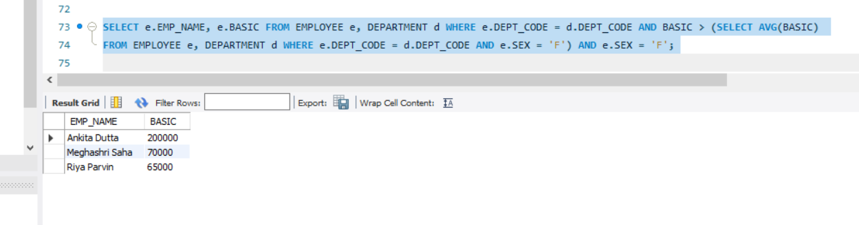

# Question 20: Find the number of female managers

# Solution:

# SELECT COUNT(*) AS NO_OF_FEMALE_MANAGER FROM EMPLOYEE e, DESIGNATION d WHERE e.DESIG_CODE = d.DESIG_CODE AND e.SEX = 'F' AND d.DESIG_CODE = 'MN';

