## JADAVPUR UNIVERSITY

Database Management System Lab Assignment - 3

**Name:** SHRUTI PATHAK & ANNESA MONDAL **Roll No:** 002210503021 & 002210503022

**Dept:** Computer Science and Engineering

**Class:** MCA 1st Year 2ndSem **Session:** 2022-2024

***ASSIGNMENT 3***

# Problem 1:

**In an organization, number of departments exists. Each department has a name & unique code. Number of employees work in each department. Each employee has unique employee code.**

**Detailed information like name, address, city, basic, date of join are also stored. In a leave register for each employee leave records are kept showing leave type (CL/EL/ML etc.), fromdate and to- date. When an employee retires or resigns then all the leave information pertaining to him are also deleted. Basic salary must be within Rs.5000 to Rs.9000. A department cannot be deleted if any employee record refers to it. Valid grades are A/B/C. Employee name must be in uppercase only.**

**Default value for joining date is system date. Design & implement the tables with necessary constraints to support the scenario depicted above.**

# Solution:

CREATE TABLE DEPARTMENT(

DEPT_CODE char(10) PRIMARY KEY,

DEPT_NAME char(30),

NO_OF_EMPLOYEE INTEGER);

0 row(s) affected

CREATE TABLE EMPLOYEE(

EMP_CODE char(10) PRIMARY KEY,

DEPT_CODE char(10),

EMP_NAME char(30) NOT NULL CONSTRAINT force_upcase CHECK(BINARY EMP_NAME = UPPER(EMP_NAME)),

ADDRESS char(50),

CITY char(20),

BASIC NUMERIC(5) CONSTRAINT salary_range CHECK(BASIC BETWEEN 5000 AND 9000),

JOIN_DATE DATE DEFAULT(CURRENT_DATE),

GRADE char(1) CHECK(GRADE IN ('A', 'B', 'C')),

CONSTRAINT DEPT_FOREIGN_KEY FOREIGN KEY(DEPT_CODE) REFERENCES DEPARTMENT(DEPT_CODE));

0 row(s) affected

CREATE TABLE LEAVE_REG(

RECORD_ID char(5) PRIMARY KEY,

EMP_CODE char(10),

TYPE char(2),

FROM_DATE DATE,

TO_DATE DATE,

CONSTRAINT VALID_TYPE CHECK(TYPE IN ('CL', 'EL', 'ML')),

FOREIGN KEY(EMP_CODE) REFERENCES EMPLOYEE(EMP_CODE));

0 row(s) affected

* ***Problem 2:***

**Try to violate the constraints that you have implemented in the table & note, what happens. [Try with suitable INSERT/UPDATE/DELETE instruction]**

# Solution:

INSERT INTO DEPARTMENT VALUES('D1', 'ACCOUNTS', 5);

1 row(s) affected

INSERT INTO DEPARTMENT VALUES('D2', 'MARKETING', 12);

1 row(s) affected

INSERT INTO DEPARTMENT VALUES('D3', 'DEVELOPMENT', 10);

1 row(s) affected

INSERT INTO DEPARTMENT VALUES('D4', 'SALES', 20);

1 row(s) affected

INSERT INTO DEPARTMENT VALUES('D5', 'PURCHASE', 18);

1 row(s) affected

INSERT INTO EMPLOYEE VALUES('E1', 'D2', 'Dhrub', '20B Old P.O. Road','Kolkata',5500,'2020-01-01', 'B');

Error Code: 3819. Check constraint 'force_upcase' is violated.

## NOTE: Here I have intentionally violated my mentioned constraint that employee names must be in uppercase letters. I note that I get an error saying “Check constraint 'force_upcase' is violated.”

INSERT INTO EMPLOYEE VALUES('E1', 'D2', 'DHRUV', '20B Old P.O. Road','Kolkata',5500,'2020-01-01', 'B');

1 row(s) affected

INSERT INTO EMPLOYEE VALUES('E2', 'D1', 'KAVYA', '35 Pali Hill','Mumbai',6000,'2020-06-01', 'A');

1 row(s) affected

INSERT INTO EMPLOYEE VALUES('E3', 'D2', 'PRIYA', '14A Gopal Banerjee Lane','Kolkata',7000,'2020-03-01', 'C');

1 row(s) affected

INSERT INTO EMPLOYEE VALUES('E4', 'D5', 'DIVYA', 'Lajpat Nagar','Delhi',6500,'2019-08-02', 'B');

1 row(s) affected

INSERT INTO EMPLOYEE VALUES('E5', 'D3', 'JIGYASA', 'New Palace Lane','Pune',8000,'2019-04-01', 'E');

Error Code: 3819. Check constraint 'employee_chk_1' is violated.

**NOTE: Here I have intentionally violated my mentioned constraint that Valid grades are A/B/C. I note that I get an error saying “Check constraint 'employee_chk_1' is violated.”**

INSERT INTO EMPLOYEE VALUES('E5', 'D3', 'JIGYASA', 'New Palace Lane','Pune',8000,'2019-04-01', 'A');

1 row(s) affected

INSERT INTO EMPLOYEE VALUES('E6', 'D3', 'SOURAV', '51A Shyama Prosad Road','Kolkata',5000,'2020-09-15', 'C');

1 row(s) affected

INSERT INTO EMPLOYEE VALUES('E7', 'D4', 'SHREYA', 'Mahatma Gandhi Sarani','Gujarat',8000,'2020-10-05', 'A');

1 row(s) affected

INSERT INTO EMPLOYEE VALUES('E7', 'D4', 'ANWESHA', 'Hill Road','Darjeeling',2000,'2019-05-02', 'B');

Error Code: 3819. Check constraint 'salary_range' is violated.

INSERT INTO EMPLOYEE VALUES('E8', 'D4', 'ANWESHA', 'Hill Road','Darjeeling',5500,'2019-05-02', 'B');

**NOTE: Here I have intentionally violated my mentioned constraint that BASIC must be between 5000-9000. I note that I get an error saying “Check constraint 'salary_range' is violated”.**

INSERT INTO EMPLOYEE VALUES('E8', 'D4', 'ANWESHA', 'Hill Road','Darjeeling',5500,'2019-05-02', 'B');

1 row(s) affected

INSERT INTO LEAVE_REG VALUES('L1', 'E4','EL', '2020-03-01','2020-06-01');

1 row(s) affected

INSERT INTO LEAVE_REG VALUES('L2', 'E2','ML', '2020-07-01','2020-09-01');

1 row(s) affected

INSERT INTO LEAVE_REG VALUES('L3', 'E5','ML', '2019-11-15','2019-12-10');

1 row(s) affected

INSERT INTO LEAVE_REG VALUES('L4', 'E7','CL', '2020-03-01','2020-04-01');

1 row(s) affected

SELECT * FROM EMPLOYEE;

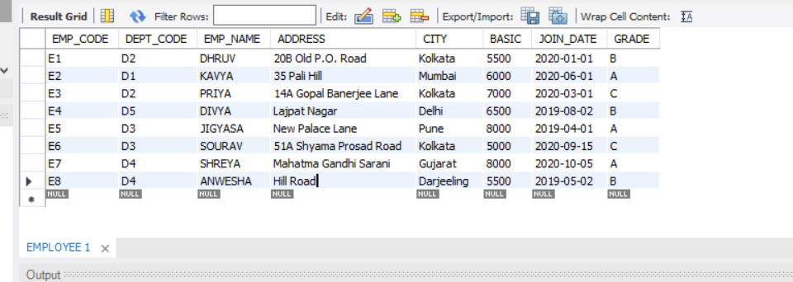

# Problem 3:

**3. a) Create a view showing employee code, name, dcode & Basic For a particular department.**

1. **Try to ensure a row into the view with valid department & also with invalid ones.**
2. **Find the newly inserted row in the table From which view was created.**
3. **Try to increment basic by Rs.100/-**
4. **Check it in the original table.**
5. **Delete the view.**

# Solution:

1. CREATE VIEW EMPLOYEE_DETAILS AS SELECT EMP_CODE, EMP_NAME, DEPT_CODE, BASIC FROM EMPLOYEE WHERE DEPT_CODE = 'D3';

0 row(s) affected

SELECT * FROM EMPLOYEE_DETAILS;

2 row(s) returned

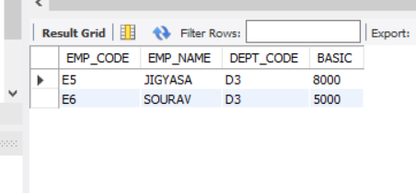

1. INSERT INTO EMPLOYEE_DETAILS VALUES('E9', 'ANANYA', 'D7', 6700);

Error Code: 1452. Cannot add or update a child row: a foreign key constraint fails (`ass3`.`employee`, CONSTRAINT `DEPT_FOREIGN_KEY` FOREIGN KEY (`DEPT_CODE`) REFERENCES `department` (`DEPT_CODE`))

# NOTE: Here I have intentionally tried to insert a row in the view with an invalid DEPT_CODE. I note that I have an error saying integrity constraint violated. This happens because there is no record in the Department table corresponding to the DEPT_CODE ‘D7’.

INSERT INTO EMPLOYEE_DETAILS VALUES('E9', 'ANANYA', 'D4', 6700);

1 row(s) affected

1. SELECT * FROM EMPLOYEE WHERE EMP_CODE = 'E9';

1 row(s) returned

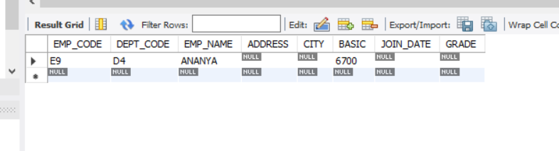

1. UPDATE EMPLOYEE_DETAILS SET BASIC = BASIC + 100;

2 row(s) affected Rows matched: 2 Changed: 2 Warnings: 0

1. SELECT * FROM EMPLOYEE_DETAILS;

2 row(s) returned

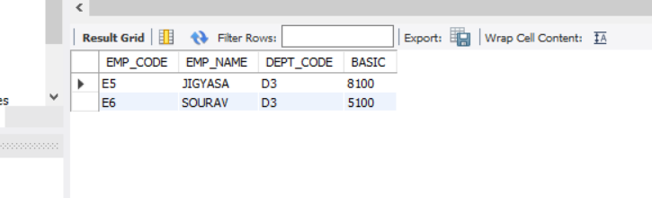

SELECT * FROM EMPLOYEE;

9 row(s) returned

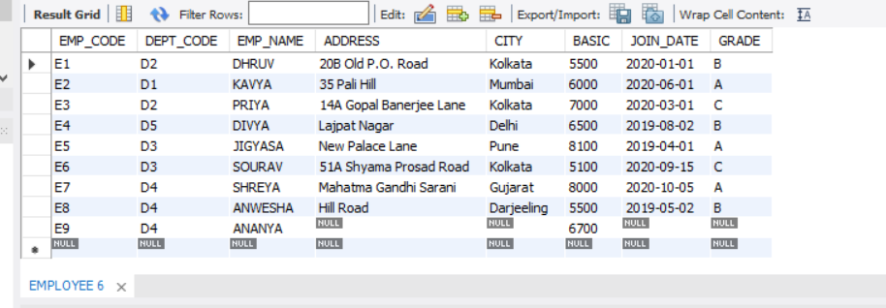

1. DROP VIEW EMPLOYEE_DETAILS;
2. row(s) affected

* ***Problem 4:***

1. **Create a view showing Emp_Code, name, Dept_Name, basic, leave type, From date & to date.**
2. **Try to insert a row in the view. Check what happens?**
3. **Try to increment basic by Rs.100.**
4. **Delete the view.**

***Solution:***

1. CREATE VIEW EMPLOYEE_LEAVE_DETAILS AS SELECT e.EMP_CODE, e.EMP_NAME, e. BASIC, e.DEPT_CODE, d.DEPT_NAME, l.TYPE, l.FROM_DATE, l.TO_DATE FROM EMPLOYEE e, DEPARTMENT d, LEAVE_REG l WHERE e.DEPT_CODE = d.DEPT_CODE AND e.EMP_CODE = l.EMP_CODE;
2. row(s) affected

1. INSERT INTO EMPLOYEE_LEAVE_DETAILS VALUES ('E10', 'PRAKASH', 5600,'D3', 'DEVELOPMENT', 'CL','02-JAN-2022', '20JAN-2022');

Error Code: 1394. Can not insert into join view 'ass3.employee_leave_details' without fields list

***NOTE: Here I have tried to insert a row in the view EMPLOYEE_LEAVE_DETAILS and I have faced an error. This action is not possible as I am trying to insert some values in three tables simultaneously of which two table’s Primary Key is not mentioned.***

1. UPDATE EMPLOYEE_LEAVE_DETAILS SET BASIC = BASIC + 100;

4 row(s) affected Rows matched: 4 Changed: 4 Warnings: 0

1. DROP VIEW EMPLOYEE_LEAVE_DETAILS;

0 row(s) affected

# Problem 5:

* + 1. **Create a table having Emp_code , Name, Dept_name, & basic From the existing tables along with the records of the employee who are in a particular department (say, d1) and with a basic Rs. 7000/-**
    2. **From the existing table, add the employees with the basic salary greater than or equal to 7000/-**
    3. **Alter the table to add a net pay column.**
    4. **Replace net pay with 1.5* Basic.**
    5. **Try to remove the net net pay column. [It may require no. of steps]**

**Solution:**

1. CREATE TABLE PERSONNEL(

EMP_CODE char(10) PRIMARY KEY, EMP_NAME char(30) , DEPT_NAME char(30), BASIC NUMERIC(5))

AS SELECT EMP_CODE, EMP_NAME, DEPT_NAME, BASIC FROM EMPLOYEE, DEPARTMENT

WHERE EMPLOYEE.DEPT_CODE = DEPARTMENT.DEPT_CODE AND BASIC = 7000 AND DEPARTMENT.DEPT_CODE = 'D3';

0 row(s) affected Records: 0 Duplicates: 0 Warnings: 0

1. INSERT INTO PERSONNEL SELECT EMP_CODE, EMP_NAME, DEPT_NAME, BASIC FROM EMPLOYEE, DEPARTMENT WHERE EMPLOYEE.DEPT_CODE = DEPARTMENT.DEPT_CODE AND BASIC >= 7000 AND EMP_CODE NOT IN (SELECT DISTINCT EMP_CODE FROM PERSONNEL);

3 row(s) affected Records: 3 Duplicates: 0 Warnings: 0

1. ALTER TABLE PERSONNEL ADD (NET_PAY NUMERIC(9,2));

0 row(s) affected Records: 0 Duplicates: 0 Warnings: 0

1. UPDATE PERSONNEL SET NET_PAY = 1.5 * BASIC;

3 row(s) affected Rows matched: 3 Changed: 3 Warnings: 0

1. ALTER TABLE PERSONNEL DROP COLUMN NET_PAY;

0 row(s) affected Records: 0 Duplicates: 0 Warnings: 0

# Problem 6:

# Drop all the tables that you have created.

# Solution:

# DROP TABLE PERSONNEL;

# 0 row(s) affected

# 

# DROP TABLE LEAVE_REG;

# 0 row(s) affected

# DROP TABLE EMPLOYEE;

# 0 row(s) affected

# 

# DROP TABLE DEPARTMENT;

# 0 row(s) affected