**Brain MR Image Segmentation Using RBF Neural Network**

submitted by

Shruti Pathak

Class Roll No: 002210503021

Exam Roll: MCA244020

Master of Computer Application

under the supervision of

Prof. ( Dr. ) Jamuna Kanta Sing

in the

Department of Computer Science and Engineering

Faculty of Engineering and Technology

Jadavpur University

2024

Faculty of Engineering and Technology

Jadavpur University

**CERTIFICATE OF RECOMMENDATION**

**To Whom It May Concern**

I hereby recommend that the project report entitled “Brain MR Image Segmentation Using RBF Neural Network” has been carried out by Shruti Pathak (Reg. No.: 163613 of 2022-23, Roll No.: 002210503021, Exam Roll: MCA244020), under my guidance and supervision and be accepted in partial fulfilment of the requirement for the degree of Master of COMPUTER APPLICATION in DEPARTMENT of COMPUTER SCIENCE and ENGINEERING, JADAVPUR UNIVERSITY during the academic year 2023-2024.

_____________________________________

Prof. (Dr.) Jamuna Kanta Sing

Project Supervisor

Dept. of Computer Science and Engineering

Jadavpur University

_________________________________

Prof. Dipak Laha

Dean, Faculty Council

of Engineering & Technology

Jadavpur University, Kolkata-032

___________________________________

Prof. (Dr.) Nandini Mukhopadhyay

Head of the Department

Dept. of Computer Science & Engineering

Jadavpur University

Faculty of Engineering and Technology

Jadavpur University

**CERTIFICATE OF APPROVAL**

This is to certify that the project report entitled **“Brain MR Image Segmentation Using RBF Neural Network”** is a bonafide record of work carried out by SHRUTI PATHAK, in fulfillment of the requirements for the award of the degree of Master of Computer Application in the Department of Computer Science and Engineering, Jadavpur University. It is understood that by this approval the undersigned do not necessarily endorse or approve any statement made, opinion expressed or conclusion drawn therein but approve the project report only for the purpose for which it has been submitted.

_____________________________

Signature of Examiner 1

Date :

_____________________________

Signature of Examiner 2

Date :

Faculty of Engineering and Technology

Jadavpur University

**DECLARATION OF COMPLIANCE WITH ACADEMIC ETHICS**

I hereby declare that this project report entitled “Brain MR Image Segmentation Using RBF Neural Network” is an outcome of my genuine and independent work, as part of my Master of Computer Application program.

All information in this document has been obtained and presented in accordance with academic rules and ethical conduct.

I also declare that, as required by these rules and conduct, all materials and results that are not original to this work have been fully cited and referenced.

Shruti Pathak

Registration No.: 163613 of 2022-23

Examination Roll No.: MCA244020

Thesis Title :- Brain MR Image Segmentation Using RBF Neural Network

______________________

Signature with Date

**ACKNOWLEDGEMENT**

With my most sincere and gratitude, I would like to thank Prof. (Dr.) Jamuna Kanta Sing, Department of Computer Science & Engineering, my supervisor, for his overwhelming support throughout the duration of the project. His motivation always gave me the required inputs and momentum to continue with my work, without which the project work would not have taken its current shape. His valuable suggestions and numerous discussions have always inspired new ways of thinking. I feel deeply honored that I got this opportunity to work under him.

I would like to express my sincere thanks to all my teachers for providing sound knowledge base and cooperation.

I would like to thank all the faculty members of the Department of Computer Science & Engineering of Jadavpur University for their continuous support.

Last, but not the least, I would like to thank my batch mates for staying by my side when I needed them.

____________________________________

Shruti Pathak

Class Roll No.: 002210503021

Examination Roll No.: MCA244020

Department of Computer Science & Engineering

Jadavpur University

**INDEX**

**TOPIC PAGE NO.**

**1 ) Introduction :** ................ 8 - 18

1.1 ) Image Segmentation : ................ 9

1.2) Brain MR Image Segmentation : ................ 10 - 12

A ) Need Of Brain MR Image Segmentation : ................ 10 - 11

B ) Challenges in Segmenting Brain Structures : ................ 11 - 12

1.3 ) Technique of Brain MR Image Segmentation : ................ 12 - 18

A ) Intensity-Based Approaches : ................ 12 - 13

i ) Thresholding : ................ 12 - 13

ii) Region-Based : ................ 13

iii) Clustering : ................ 13

B ) Machine Learning : ................ 14 - 17

i) Traditional : ................ 14 - 16

ii) Deep Learning : ................ 17 C ) Hybrid Segmentation Approaches : ................ 18

**TOPIC PAGE NO.**

**2 ) Proposed Method:** ................ 19 - 27

2.1 ) Discussion: ................ 19 - 23

A) Architecture: ................ 19 - 21

B) Mathematical Background: ................ 21 - 22

C) How RBFNN works? ................ 22 - 23

D) Visual Representation ................ 23

2.2) Training: ................ 23 - 25

2.3) RBFNN For Image Segmentation: ................ 25 - 27

**3 ) Experimental Results :** ................ 28 - 44

3.1 ) Database: ................ 28 - 35

A) Data Extraction: ................ 29 - 31

B ) Pre-processing: ................ 31 - 33

C ) Segmentation: ................ 33 - 35

3.2 ) Evaluation metrics: ................ 35 - 36

3.3 ) Results: ................ 36 - 47

**4 ) Conclusion :**  ................ 48

**5 ) References :**  ................ 49 - 51

**1 ) Introduction :**

**In medical image analysis, image segmentation is a fundamental task, especially when it comes to brain MRIs (Magnetic Resonance Imaging). It is essential for several applications, including surgical planning, brain tissue classification, and tumor identification. Among the numerous segmentation methods available, the Radial Basis Function (RBF) Neural Network [1] has gained significant attention and proven to be effective in handling the complexity and variability of brain MRI data.**

Image segmentation plays an important role in medical imaging, particularly when analyzing magnetic resonance imaging (MRI) scans of the brain. Since MRI offers detailed information on the brain, it is a valuable diagnostic and research tool for a wide range of neurological conditions. However, in order to extract useful information from these complex images, it is necessary to correctly segment the relevant brain structures.

The act of dividing an MRI scan of the brain into distinct areas or structures, such as white matter, gray matter, cerebrospinal fluid (CSF), and anatomical regions like the cortex, ventricles, or tumors, is known as brain MRI segmentation.

Accurate segmentation of brain MRI scans is complicated due to the inconsistencies and differences between brain structures, images, and the images obtained. To address these issues and produce dependable segmentation results, researchers and specialists have created a wide range of computational approaches, ranging from conventional image processing techniques to sophisticated machine learning and deep learning. It also provides an overview of commonly used segmentation techniques, highlighting their strengths, limitations, and future directions in the brain.

The Radial Basis Function Neural Network (RBFNN) method proves to be an effective tool for brain MRI segmentation, skilfully managing complicated data. It accurately delineate brain structures by modelling complex interactions in an efficient manner. RBF's effectiveness in capturing tissue boundaries and accommodating intensity variations bolsters medical image analysis. From surgical planning to neurological research, RBF helps with diagnosis, treatment planning, and advancements in neuro-imaging, and it promises further improvements in the use of MRIs.

**In this report, we investigate a distinctive approach using the Radial Basis Function (RBF) Neural Network for brain MR image segmentation across various data volumes with different noise and intensity. Our exploration aims to discern the algorithm's efficacy amidst diverse conditions, offering insights into its robustness and adaptability in real-world applications.**

**1.1 ) Image Segmentation :**

One popular technique for processing and analyzing digital images is image segmentation. Its goal is to separate the image into distinct sections or areas, usually using pixel attribute measurement. These concepts can influence how the foreground and background are separated, or they can group pixels together according to color or shape consistency. For instance, image segmentation is frequently used in medical science to recognize and label pixels or 3D voxels that represent tumors in the patient's brain or other organs.

To put it another way, image segmentation is the process of breaking apart an image into separate, recognizable areas or objects according to attributes like color, texture, shape, or brightness. The purpose of image segmentation is to simplify the image representation and transform it into a useful and identifiable form. In this process, each pixel is assigned a label so that pixels with similar characteristics can be placed in the same category.

Image segmentation is instrumental across multiple sectors. In medicine, it facilitates diagnosis and treatment planning by outlining organs and anomalies in images, while in satellite imagery, it supports land classification and disaster response efforts. Robotics and computer vision benefit from segmentation for object detection and navigation, while manufacturing relies on it for quality control. Similarly, in agriculture, segmentation aids in crop monitoring and yield estimation. Overall, segmentation enables precise analysis and automation, enhancing efficiency and decision-making in diverse domains.

Two types of image segmentation commonly used are:

* **Semantic Segmentation:** Semantic segmentation involves classifying each pixel in an image into predefined categories or classes, without distinguishing between instances of the same class. This type of segmentation assigns a label to every pixel in the image, resulting in a pixel-wise segmentation map that delineates different objects or regions.
* **Instance Segmentation:** Instance segmentation goes a step further than semantic segmentation by not only classifying pixels into categories but also distinguishing between individual object instances within the same class. In instance segmentation, each object instance in the image is uniquely identified and segmented, providing a more detailed understanding of the scene compared to semantic segmentation.

**1.2 ) Brain MR Image Segmentation :**

The brain, which is the body's central nervous system, controls speech, memory, cognition, and movement function in addition to acting as a warning system for body control. The rise in brain diseases caused by many factors like high stress, fast-paced lifestyle, stress on the brain and emotions, frequent injuries and the elderly has become more alarming in recent years. The health of people is gravely threatened by these circumstances.

Brain illnesses are commonly diagnosed in medicine using magnetic resonance imaging (MRI) equipment. The shape and function of the brain's tissues can be electronically visualized with magnetic resonance imaging (MRI), a cutting-edge medical procedure. Doctors can benefit from non-invasive, non-radiation, but more precise and superior solutions with comparable tissues by using this technique.

In general, brain image segmentation methods are categorized as intensity-based **[2]** , machine learning **[3]** , hybrid **[4]** etc. These methods are both progressive and collaborative. Segmenting (i) healthy brain tissues, (ii) brain sub-structures, and (iii) tumor and intra-tumor regions is the overall goal of the method. Conversely, a progressive approach makes the procedure more complex.

Tesla MRI **[5]** is generally used to detect tumours, aneurysms etc. in brain and any blockages in blood vessels in heart. A Tesla MRI produces substantially sharper images in less time by using magnetic fields that are twice as strong as a standard MRI.

**1.2.A ) Need of Brain MR Image Segmentation :**

There are several reasons why a brain MRI - which produces incredibly precise image might be necessary. If doctors asked for an MRI of the brain, its not indicate to the worst case such as brain tumor or some other deadly condition. But the reality is that brain MRI is a diagnostic tool for a wide range of disorders involving the brain and spinal cord.

* Stroke:

When a blood artery in the brain becomes blocked or starts to bleed, a stroke **[6]** occurs. Within minutes, brain tissue begins to degrade due to this disturbance of oxygenated circulation. Brain MRI is a useful diagnostic technique for determining whether a cerebral hemorrhage or stroke has caused brain tissue damage. It helps medical professionals to evaluate damage and decide quickly on the best course of action. Medical professionals can identify the next steps required for successful therapy by using information from brain MRIs.

## Tumors or Cysts:

In addition to helping diagnose brain disorders, magnetic resonance imaging (MRI) scans can find small cysts **[7]** that CT scans might miss. In certain instances, doctors may administer an intracranial injection of a specialized contrast agent prior to the scan in order to enhance the visibility of various brain regions. Doctors are able to spot tumors and cysts that are challenging to detect with other procedures thanks to the better and more detailed images provided by this modern technology.

* **Traumatic Brain Injury** and Abnormalities **:**

The severity of traumatic brain injuries **[8]** can vary, and a brain MRI is an important tool to accurately diagnose the location and extent of the injury. It offers crucial details regarding the impact of the damage, such as brain swelling or hemorrhage. Doctors can evaluate brain MRI results to identify treatment plans based on the severity of injury, such as cerebral palsy, birth defects, etc.

* **Multiple Sclerosis :**

The degenerative disease known as multiple sclerosis (MS) **[9]** affects the brain and central nervous system, leading to an immune system attack on the tissue surrounding the nerves. To quantify the severity and course of multiple sclerosis, as well as to confirm a diagnosis, doctors frequently use brain MRI scans.

* **Aneurysms or Hemorrhages :**

Brain MRI is important for identifying aneurysms **[10]** and bleeding in the brain. A ruptured aneurysm can lead to serious consequences such as brain damage, stroke, and even death. By performing an MRI of the brain, doctors can detect aneurysms and measure their size and location, allowing timely intervention to prevent rupture.

Moreover, irregular blood flow in the brain can be found with an MRI scan. An abnormal blood flow can result in the brain receiving insufficient oxygen, which may result in a stroke or other brain damage. Doctors can diagnose these issues with a brain MRI and develop a suitable treatment plan to restore blood flow and lower the risk of further complications.

**1.2.B ) Challenges in Segmenting Brain Structures :**

Segmenting brain structures presents several challenges, including the complexity of anatomical variations across individuals, the presence of noise and artifacts in imaging data, and the difficulty in distinguishing between adjacent structures with similar intensity or contrast. These challenges often require sophisticated algorithms and manual interventions to achieve accurate segmentation results.

* **Different shapes :**

Brain tumors can develop anywhere in the brain and have a variety of functions. Without prior knowledge, this heterogeneity makes it challenging to develop a predictive model, particularly for tiny tumors.

* **Intensity inhomogeneity:**

The difficulty in segmentation arise from the uneven utilization of homogenous tissue and changes in spatial density in each dimension.

* **Bias field:**

The bias field **[11]** is caused by the defects in the acquisition sequences or radiofrequency coil imperfections, which also makes problems when segmenting.

* **Imbalance Data:**

It is a main problem in Brain segmentation. It is the inconsistent information on MR images. This uncertainty is due to regional differences between healthy and abnormal brain regions.

* **Data scarcity :**

For supervised segmentation techniques, insufficient data is a challenge for analyzing medical images, particularly when the brain is involved. Limited training data often leads to overfitting and have difficulty generalizing to new, unseen data.

**1.3 ) Techniques of Brain MR Image Segmentation:**

1.3.A ) Intensity-Based Approaches :

i ) Thresholding :

Thresholding [12, 13] is a simple image segmentation approach that uses reference histograms to determine a specific value, called the threshold to distinguish between different classes. By specifying these thresholds, the segmentation process categorizes the pixels falling from the threshold, resulting in a segmented image.

The advantage of thresholding for image segmentation lies in its simplicity, speed, and computational efficiency, making it suitable for quickly separating objects or regions of interest based on intensity differences in images.

Thresholding is fast and computationally efficient method but sensitive to noise and intensity inhomogeneities. Although it use to separate background from the brain tissue in brain image segmentation.

ii ) Region-Based :

Region-based [14] methods help extract connected regions from an image based on predefined criteria such as pixel or voxel matching. This approach usually involves three steps: (a) select initial seed points, (b) identify points in objects or regions, and (c) select content-related points that start with similar results. In recent studies, regional methods have been widely used in the classification of brain tissue and show their effectiveness in this regard.

The advantage of using region-based methods for image segmentation lies in their ability to extract connected regions efficiently based on predefined criteria, facilitating the classification of complex structures like brain tissue accurately.

The main disadvantage of the region based method is its sensitivity to the initialization of seed point. By selecting a different seed point, the segmentation result can be completely different.

iii ) Clustering :

Clustering methods [4] are unsupervised segmentation techniques that group pixels/voxels with similar intensities in an image without relying on training data. These methods use the available image data to train themselves. segmentation and training happen in parallel by iterating between data clustering and estimating tissue class properties. The popular clustering methods are k-means clustering [15] and fuzzy C-means clustering [16] .

The advantage of using clustering methods for image segmentation lies in their ability to automatically group pixels/voxels with similar intensities, without requiring labelled training data, enabling unsupervised segmentation of images efficiently.

Clustering techniques may struggle with high-dimensional data and require predefined cluster numbers, making them sensitive to initialization and potentially leading to suboptimal results. Additionally, they might struggle with handling overlapping or irregularly shaped clusters, limiting their effectiveness in segmenting complex brain structures accurately.

1.3.B ) Machine Learning :

i ) Traditional Machine Learning :

Any fundamental algorithmic structure to solve given problem will come under Traditional Machine Learning **[17]** . These algorithms learn from the data, where choice of algorithm and features (inputs) to be fed into algorithm are made by subject matter experts. Traditional ML models expects all inputs are in the format of structured data like numbers. Traditional ML models can be used to solve classification, segmentation, regression, clustering, dimensionality reduction problems.

Some common types of traditional machine learning techniques used in brain MRI segmentation are: Support Vector Machines (SVM) **[18]** , k-Nearest Neighbours (k-NN) **[19]** , Naïve Bayes [20] , Artificial Neural Networks (ANN) **[21]** , Radial Basis Functions Neural Networks (RBFNN) **[1]** etc.

* **Support Vector Machines (SVM) :**

Support Vector Machines (SVM) work by finding the optimal hyperplane that best separates data points into different classes, maximizing the margin between them. In image segmentation, SVM can be employed to classify pixels or image regions into different classes based on features extracted from the images.

Advantages of SVM in image segmentation include its ability to handle high-dimensional feature spaces efficiently, robustness against overfitting, and effectiveness in handling non-linear decision boundaries through kernel tricks.

However, SVMs may struggle with large datasets due to their computational complexity, and they require careful selection of hyperparameters. Additionally, SVMs might not perform optimally when dealing with highly imbalanced datasets, where certain classes are underrepresented.

* **k-Nearest Neighbours (k-NN) :**

The k-Nearest Neighbours (KNN) algorithm works by assigning a class label to an input sample based on the majority class among its k nearest Neighbours in feature space.

For image segmentation, KNN can be applied by treating each pixel or image patch as a data point with features derived from its intensity values or other characteristics, and then assigning a class label based on the majority class among its nearest Neighbours.

Advantages of KNN in image segmentation include its simplicity and ease of implementation, as well as its ability to handle multi-class classification tasks without assuming any underlying distribution of the data.

However, KNN's performance can be sensitive to the choice of the number of Neighbours (k) and the distance metric used, which may require careful tuning. Additionally, KNN can be computationally expensive, especially with large datasets, as it requires calculating distances between the query point and all training samples. Furthermore, KNN may not perform well in high-dimensional feature spaces or when dealing with noisy or irrelevant features.

* **Naïve Bayes :**

Naive Bayes is a probabilistic classifier based on Bayes' theorem with the assumption of feature independence. Despite its simplicity, Naive Bayes has been widely used in various machine learning applications, particularly in text classification tasks, due to its computational efficiency and ease of implementation.

Naive Bayes can be applied to image segmentation by treating each pixel as a feature vector and assigning each pixel to a class based on the maximum posterior probability. By calculating the posterior probabilities for each class at each pixel location, Naive Bayes can segment the image into different regions or classes.

Naive Bayes offers several advantages for image segmentation tasks. It is computationally efficient and robust to noise and outliers in the data, making it suitable for real-time or resource-constrained environments. Its simplicity facilitates easy interpretation and implementation, making it accessible to users with limited machine learning expertise.

Despite its simplicity, Naive Bayes has limitations for image segmentation tasks. Its assumption of feature independence may lead to suboptimal segmentation results, especially in cases where spatial relationships among pixels are important. Additionally, it may struggle with handling high-dimensional or continuous feature spaces commonly encountered in image data, potentially resulting in reduced segmentation accuracy compared to more complex models.

* **Artificial Neural Networks (ANN) :**

Artificial Neural Networks (ANN) consist of interconnected nodes arranged in layers, including an input layer, one or more hidden layers, and an output layer. Each node applies a weighted sum of inputs followed by a non-linear activation function. During training, the network adjusts the weights to minimize the difference between predicted and actual outputs using techniques like backpropagation.

In image segmentation, Artificial Neural Networks (ANNs) work by processing input image data through interconnected layers of nodes, extracting features relevant to segmentation tasks. These features are then used to predict class labels or segmentation masks for each pixel or region in the image. Through training on labelled data, ANNs learn to map input images to corresponding segmentation outputs, optimizing their parameters to minimize prediction errors and accurately delineate object boundaries.

ANNs in image segmentation include their ability to capture complex relationships in data, adaptability to various image characteristics, and potential for high accuracy. Another advantage of Artificial Neural Networks (ANNs) in image segmentation is their capacity to learn from large datasets efficiently, enabling robust performance across diverse imaging modalities and complex segmentation tasks.

However, ANNs often require large amounts of labelled training data and significant computational resources for training, and they may be prone to overfitting if not properly regularized. Additionally, the interpretability of ANN-based segmentation models may be limited compared to simpler techniques like thresholding or clustering.

* **Radial Basis Functions Neural Network (RBFNN) :**

Radial Basis Function Neural Networks (RBFNN) are a type of artificial neural network that operates by mapping input data into a high-dimensional feature space using radial basis functions. The network consists of three layers: an input layer, a hidden layer with radial basis functions, and an output layer. During training, the centers and widths of the radial basis functions are adjusted to minimize the difference between predicted and actual outputs.

For image segmentation, RBF networks can be employed by treating pixel intensities or image features as input data and training the network to assign class labels to different regions of the image. RBF networks excel in capturing complex non-linear relationships in the data, making them well-suited for tasks like segmenting structures with irregular shapes or intensity distributions.

One advantage of RBF networks in image segmentation is their ability to approximate complex non-linear decision boundaries, allowing for accurate segmentation of intricate structures in images. Additionally, RBF networks are capable of handling high-dimensional feature spaces efficiently, making them suitable for segmentation tasks involving large and complex datasets. Another advantage of RBF networks is their inherent ability to generalize well to unseen data, thanks to their capability to model complex relationships between features and class labels. This enhances their robustness and ensures reliable performance even in scenarios with limited training data or noisy input images.

However, RBF networks may require careful tuning of hyperparameters, such as the number and distribution of radial basis functions, to achieve optimal segmentation performance. Moreover, training RBF networks typically requires a significant amount of computational resources, especially for large-scale image datasets, which can pose challenges in terms of time and computational cost. Despite these challenges, RBF networks remain a powerful tool for image segmentation, particularly in scenarios where capturing complex relationships in the data is crucial for achieving accurate segmentation results.

ii ) Deep Learning :

Deep learning [22, 23] encompasses a range of neural network architectures, notably Convolutional Neural Networks (CNNs) [24] , which excel in learning hierarchical features from data. For image segmentation, deep learning works by training CNNs to predict segmentation masks directly from input images, leveraging the network's ability to capture complex spatial relationships and features.

* **Convolutional Neural Networks (CNN) :**

Convolutional Neural Networks (CNNs) are a class of deep learning models specifically designed for processing structured grid-like data such as images. They have gained significant popularity in computer vision tasks due to their ability to automatically learn hierarchical representations from raw pixel data, making them highly effective for tasks like image classification, object detection, and image segmentation.

CNNs can be used for image segmentation by adapting architectures like U-Net [25] , SegNet [26] , DeepLab [27] etc. These architectures typically consist of an encoder-decoder structure, where the encoder extracts features from the input image, and the decoder generates segmentation masks from the learned features. CNNs learn to predict pixel-wise segmentation masks directly from raw image data, enabling them to capture complex spatial dependencies and produce high-quality segmentations.

CNNs offer several advantages for image segmentation tasks. They can automatically learn hierarchical representations from raw pixel data, eliminating the need for handcrafted features. Additionally, CNNs excel at capturing spatial dependencies among pixels, enabling them to produce accurate and detailed segmentations. Moreover, with the availability of pre-trained models and transfer learning techniques, CNNs can achieve impressive performance even with limited training data.

Despite their effectiveness, CNNs may struggle with class imbalance and boundary delineation issues, especially for small or overlapping objects in the image. Fine-tuning and optimizing CNN architectures for specific segmentation tasks are often required to achieve optimal performance.

1.3.C ) Hybrid Segmentation Approaches :

Brain MRI segmentation problems need to be continuously investigated and new methods introduced. Selecting the most appropriate technique for a given application can be difficult and often requires a combination of techniques to achieve accurate segmentation. Therefore, the hybrid or combined segmentation method [4] has gained great popularity in many brain MRIs. There are three sub category of Hybrid Segmentation Approaches :- a ) contour-based and machine learning, [28] (ii) metaheuristic, and machine learning [29] and (iii) deep learning and machine learning [30].

Several examples of hybrid brain MRI segmentation methods have been developed. Kapoor et al. [31] Segmentation of multiple brain tissues in adults in 2D MRI using a combination of Contour-Based and Machine Learning. Masutani et al. [32] Combining model-based region growth with local quality information for accurate segmentation of cerebral vessels. An unsupervised brain MRI segmentation is developed by Xue et al. [33] by combining minimum error global thresholding and a spatial-feature-based *FCM* clustering to segment 3D MRI in a “slice-by-slice” manner.

The main disadvantage of the hybrid (combined) segmentation method is its complexity, usually compared to the individual method. This challenge requires more time and more parameters to be adjusted for specific applications. Therefore, the design of the hybrid segmentation method must be carefully considered to ensure efficiency and high-quality segmentation results.

**2 ) Proposed Method :**

**In this project, a Radial Basis Function Neural Network (RBFNN) is employed specifically for the segmentation of brain MR images into cerebrospinal fluid (CSF), grey matter, and white matter regions. This methodology harnesses the unique capabilities of RBFNN to accurately delineate these crucial anatomical structures, thereby facilitating more precise medical image analysis and aiding in the diagnosis and treatment planning of neurological conditions. By leveraging the RBFNN's capacity to capture intricate relationships within the image data, this research contributes to advancements in brain MR image segmentation techniques, enhancing our understanding of brain anatomy and pathology.**

**2.1 ) Discussion:**

A radial basis function (RBF) neural network is a type of artificial neural network that uses radial basis functions as activation functions. Three layers usually make up this structure: an input layer, a hidden layer, and an output layer. The input is subjected to a radial basis function—typically a Gaussian function—by the hidden layer. The final output is then produced by the output layer by linearly combining these outputs. Due to their great adaptability, RBF neural networks are commonly used in many machine learning applications, function approximation, and pattern categorization tasks. They are particularly well-known for their proficiency with non-linear problems.

**2.1.A ) RBF Neural Network Architecture :**

The typical architecture of a radial basis functions neural network consists of an input layer, hidden layer, and output layer.

### Input Layer :

Each predictor variable has a single neuron in the input layer. Every neuron in the buried layer receives the value from the input neurons. For categorical values, N-1 neurons are employed, where N is the number of categories. By deducting the median and dividing by the interquartile range, the range of values is normalized. Pass the value to each neuron in the hidden layer. N-1 neurons are used for categorical values, where N denotes the number of categories. The range of values is standardized by subtracting the median and dividing by the interquartile range.

### Hidden Layer :

The hidden layer contains a variable number of neurons (the ideal number determined by the training process). A radial basis function centered on a point is present in every neuron. The number of predictor variables and the number of dimensions match. For every dimension, the RBF function's radius or spread can change.

A hidden neuron determines the Euclidean distance between the test case and the neuron's center point when it receives an x vector of input values from the input layer. Next, it uses the spread values to apply the Gaussian function. The summation layer receives the output value.

### Output Layer or Summation Layer :

The value derived from the hidden layer is sent to the summation after being multiplied by a neuron-related weight. In this case, the network's output is shown as the total of the weighted values. Each target category in a classification issue has a single output, the value of which is the likelihood that the instance under consideration falls into that category.

### The Input Vector :

It is the n-dimensional vector that we're attempting to classify. The whole input vector is presented to each of the RBF neurons.

### The RBF Neurons

### A prototype vector, often referred to as the neuron's center, is stored by each RBF neuron from among the training set's vectors. When an RBF neuron compares an input vector to its prototype, it produces a similarity score that ranges from 0 to 1. The output of the neuron is 1 if an input is the same as the prototype. The output decreases exponentially to zero as the disparity between the input and prototype increases. The RBF neuron's response takes the form of a bell curve. Another name for the response value is the activation value.

### The Output Nodes

The output of the network consists of a set of nodes for every category that has to be classified. For each output node, a score is calculated for the relevant category. When making a categorization choice, we typically allocate the input to the category that has the greatest score.

A weighted sum of the activation levels from each RBF neuron is used to compute the score. It often assigns a negative weight to other RBF neurons and a positive weight to those that fall into its group. Every output node possesses a unique set of weights.

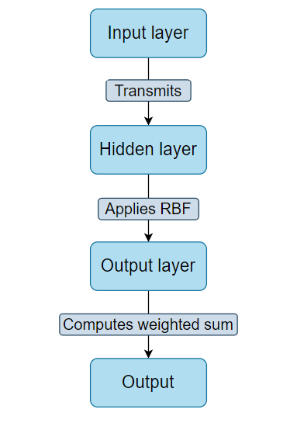

**Fig: 2.1 - The basic flow diagram of the RBF neural network**

### 2.1.B) Mathematical background :

The RBF network is a fully interconnected feed- forward network with one hidden layer. It can be mathematically described as follows:

(2.1)

Where, is the activation of the j-th output neuron,

is the number of hidden neurons,

is the weight between m-th hidden and j-th output neuron and

is the bias term.

The output of hidden layer neuron is usually generated by a Gaussian function as follows:

(2.2)

Here, represents the input vector,

is the fixed center position and

represents the fixed width of the m-th hidden layer neuron.

### 2.1.C) How RBFNN works? :

Radial basis function networks (RBFNs) work by comparing the input to known examples from the training data to classify it.

Here’s a simplified explanation:

* RBFNs start with an input vector. This vector is fed into the input layer of the network.
* The network also has a hidden layer, which comprises radial basis function (RBF) neurons.
* Each of these RBF neurons has a center, and they measure how close the input is to their center. They do this using the Gaussian function. The output of this function is higher when the input is close to the neuron’s center and lower when the input is far away.
* The outputs from the hidden layer are then combined in the output layer. Each node in the output layer corresponds to a different category or class of data. The network determines the input’s class by calculating a weighted sum of the outputs from the hidden layer.
* The final output of the network is a combination of these weighted sums, which is used to classify the input.

### 2.1.D) Visual Representation :

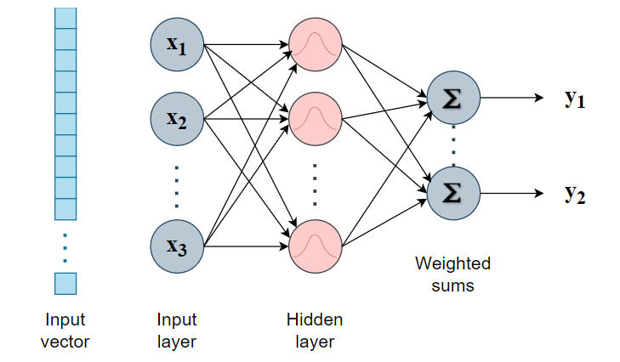

**Fig: 2.2 - The general architecture of an RBFNN**

## 2.2) Training :

The training process includes selecting these parameters:

* The prototype (µ)
* Beta coefficient (β) for every RBF neuron, and
* The matrix of output weights between the neurons and output nodes.

1. **Selecting the Prototypes :**

There doesn't appear to be a single "wrong" way to choose the RBF neuron prototypes. Actually, there are two ways to go about this: either build an RBF neuron for each training example, or choose k prototypes at random from the training set. The loose constraints stem from the fact that an RBF network can establish any arbitrarily complicated decision boundary provided an adequate number of RBF neurons. Put otherwise, we can always use additional RBF neurons to increase its accuracy.

Ultimately, the matter boils down to efficiency: utilizing fewer RBF neurons to attain high accuracy is preferable than employing more RBF neurons, which in turn require more computation time.

One of the approaches for making an intelligent selection of prototypes is to perform k-Means clustering on the training set and to use the cluster centers as the prototypes. When applying k-means, we first have to separate the training examples by category– we don’t want the clusters to include data points from multiple classes.

It is necessary to choose the number of clusters for each class "heuristically." Greater prototype numbers allow for a more intricate decision boundary, but they also increase the number of computations required to assess the network.

1. **Selecting Beta values :**

Setting sigma to the average distance between each point in the cluster and the cluster center is an easy way to specify the beta coefficients if you use k-means clustering to choose your prototypes.

(2.3)

Here, is the cluster centroid,

is the number of training samples belonging to this cluster, and

is the i-th training sample in the cluster.

Once we have the sigma value for the cluster, we compute beta as:

(2.4)

1. **Output Weights :**

The output weights are the final set of parameters to be trained. These can be trained using gradient descent (also known as least mean squares).

First, find the RBF neurons' activation levels for each data point in your training set. Gradient descent uses these activation values as training inputs.

We always start the vector of activation values with a fixed value of "1" since the linear equation requires a bias term.

It is necessary to conduct gradient descent independently for every output node, or every class in your data set.

## 2.3) RBFNN For Image Segmentation :

Radial Basis Function is a technique that's widely used in various fields, including image processing and machine learning. In image segmentation, the primary goal is to partition an image into multiple segments or regions to simplify its representation and make it more meaningful for analysis.

In the context of image segmentation, RBF networks can be applied by representing image features as inputs to the network. These features may include pixel intensities, texture descriptors, or other relevant characteristics extracted from the image. Each neuron in the hidden layer of the RBF network computes its activation based on the distance between the input data and its associated center, utilizing a radial basis function such as the Gaussian function. This transformation allows the network to capture complex relationships between input features and their corresponding classes.

Furthermore, the choice of radial basis function, such as the Gaussian function, allows for the flexibility to capture various types of relationships between input features and classes. The Gaussian function assigns higher weights to inputs closer to the center, effectively emphasizing their influence on the network's decision-making process. This localized activation enables RBF networks to adaptively adjust to the distribution of input data, effectively handling non-linear separability between classes. Additionally, by employing multiple radial basis functions with different centers and spreads, the network can learn to represent different regions of the input feature space, enhancing its ability to discriminate between different classes accurately. Overall, this approach facilitates the creation of a highly expressive model capable of capturing the intricate patterns and variations present in image data, thereby enabling effective image segmentation tasks.

1. **How it Works:**

* **Feature Representation**: Initially, features are extracted from the image. These features could be intensity values, texture information, color, gradients, etc.
* **Feature Space Transformation**: RBF transforms the feature space into a higher-dimensional space using a kernel function. The most commonly used kernel is the Gaussian kernel.
* **Centroid Initialization**: The centroids or centers of each cluster are initialized either randomly or using a specific algorithm.
* **Cluster Assignment**: Each feature vector is assigned to the cluster whose center is nearest to it in the transformed feature space. This step is often performed iteratively until convergence.
* **Centroid Update**: After assigning points to clusters, the centroids are updated to the mean of all points assigned to that cluster.
* **Convergence**: The iteration continues until the centroids stabilize, i.e., they no longer change significantly.

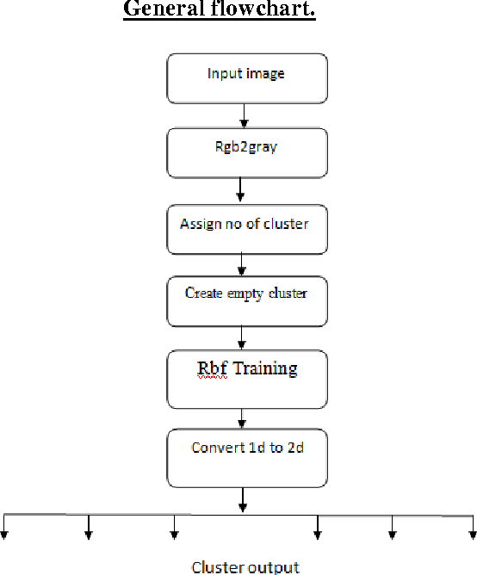

**Fig: 2.3 – General flow diagram of how RBF works for image segmentation**

1. **Training:**

Training an RBF network for image segmentation involves the following steps:

* + **Data Preparation:** Pre-process the images and label the regions to be segmented.
  + **Network Configuration:** Determine the number of hidden neurons and their centers, as well as the output layer structure.
  + **Training Data:** Use labelled image data to train the network using appropriate algorithms.
  + **Validation:** Validate the trained model on a separate dataset to ensure its generalization ability.

1. **Applications:**

* **Medical Imaging**: RBF-based segmentation is widely used in medical imaging for tasks like tumor detection, organ segmentation, and cell analysis.
* **Remote Sensing**: It's employed in satellite image analysis for land cover classification, urban growth monitoring, and environmental assessment.
* **Biometrics**: RBF-based segmentation is used in facial recognition systems, fingerprint analysis, and iris segmentation.
* **Robotics**: In robotics, it's utilized for scene understanding, object recognition, and navigation.

1. **Advantages:**

* **Flexibility**: RBFNN can handle complex, non-linear relationships between features, making it suitable for a wide range of segmentation tasks.
* **Robustness**: It's relatively robust to noise and outliers in the data, making it suitable for real-world applications where data may not be perfect.
* **Scalability**: RBFNN can scale well with large datasets and high-dimensional feature spaces.
* **Ease of Implementation**: Implementing RBF-based segmentation is straightforward and computationally efficient compared to some other segmentation techniques.

Radial Basis Function Neural Network offers a powerful approach to image segmentation, with its ability to handle complex relationships in the data, robustness to noise, and ease of implementation making it a popular choice in various applications across different domains.

1. **) Experiments & Results :**

**3.1) Database:**

The dataset of this study is downloaded from BrainWeb. The BrainWeb is acquired from the McConnell Brain Imaging Center of the Montreal Neurological Institute, McGill University . This database contains a set of realistic MRI data produced by an MRI simulator.

**BainWeb** - Database of human brain images derived from a realistic phantom and generated using a sophisticated MRI simulator. Custom simulations may be generated to match a user's selected parameters. The goal is to aid validation of computer-aided quantitative analysis of medical image data. The SBD (Stimulated Brain Database) contains a set of realistic MRI data volumes produced by an MRI simulator. These data can be used by the neuroimaging community to evaluate the performance of various image analysis methods in a setting where the truth is known. The SBD contains simulated brain MRI data based on two anatomical models: normal and multiple sclerosis (MS). For both of these, full 3-dimensional data volumes have been simulated using three sequences (T1-, T2-, and proton-density- (PD-) weighted) and a variety of slice thicknesses, noise levels, and levels of intensity non-uniformity (INU) .

 As “Ground Truth” I use the discrete anatomical model which consists of a class label (integer) at each voxel, representing the tissue which contributes the most to that voxel (0=Background, 1=CSF, 2=Grey Matter, 3=White Matter, 4=Fat, 5=Muscle/Skin, 6=Skin, 7=Skull, 8=Glial Matter, 9=Connective).

The BrainWeb dataset in our work consists of 11 T1-weighted MRI volumes on normal brain, each yielding 51 images of dimensions 181 pixels by 217 pixels, constituting a rich repository of neuroimaging data. Notably, these volumes are intentionally afflicted with varying degrees of noise and intensity non-uniformity (INU), as meticulously delineated in **Table 3.1**. This deliberate manipulation accurately simulates the complexities encountered in real-world MRI scans, rendering the dataset invaluable for benchmarking and validating image processing algorithms. By encapsulating a diverse spectrum of noise and intensity variations, the BrainWeb dataset serves as a crucial resource for advancing computational techniques aimed at enhancing image quality, facilitating segmentation, and extracting meaningful features from neuroimaging data. Its meticulous characterization of noise and INU levels underscores its utility in fostering innovation and excellence in medical image analysis and neuroimaging research, positioning it as a cornerstone in the pursuit of enhanced diagnostic accuracy and clinical utility in MRI-based procedures.

**Table 3.1: Information about the simulated MRI image Volumes:**

|  |  |  |  |  |  |  |  |  |  |  |  |
| --- | --- | --- | --- | --- | --- | --- | --- | --- | --- | --- | --- |
|  | **Volume 1 (%)** | **Volume 2 (%)** | **Volume 3 (%)** | **Volume 4 (%)** | **Volume 5(%)** | **Volume 6 (%)** | **Volume 7 (%)** | **Volume 8 (%)** | **Volume 9 (%)** | **Volume 10 (%)** | **Volume 11 (%)** |
| Noise | 0 | 1 | 1 | 3 | 3 | 5 | 5 | 7 | 7 | 9 | 9 |
| INU | 0 | 20 | 40 | 20 | 40 | 20 | 40 | 20 | 40 | 20 | 40 |

### 3.1.A) Data Extraction :

In my project, I conducted an extensive exploration of the BrainWeb dataset, focusing on extracting volumes with varying degrees of noise and intensity non-uniformity (INU). Utilizing raw data files (RAWB) from the BrainWeb dataset, I developed a pipeline to extract these volumes and convert them into portable graymap (PGM) files, a common format for representing grayscale images. Leveraging Python programming, I then transformed the PGM files into the more widely used JPEG format for easier visualization and analysis. This comprehensive pre-processing approach allowed me to generate a diverse dataset of brain volumes, each representing different levels of noise and INU distortions. These volumes serve as invaluable resources for training and evaluating algorithms aimed at mitigating the effects of noise and INU in magnetic resonance imaging (MRI) data. To assess the accuracy of the Radial Basis Function (RBF) model, I employed these varied volumes as input data. By systematically evaluating the model's performance across different noise levels and INU variations, I aimed to comprehensively understand its robustness and generalization capabilities. **Fig: 3.1** displays MRI images with varying percentages of noise and intensity non-uniformity (INU). And **Fig: 3.2** displays the ground truth images.

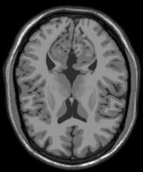 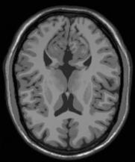 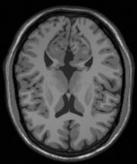 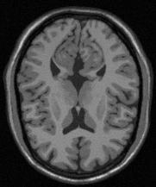 **(a) (b) (c) (d)**

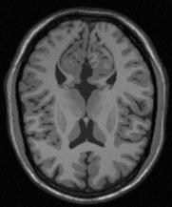 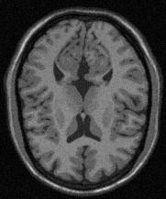 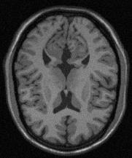 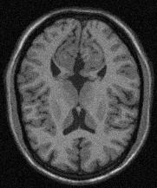

**(e) (f) (g) (h)**

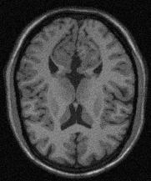 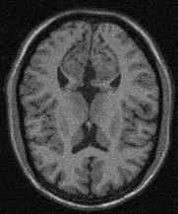 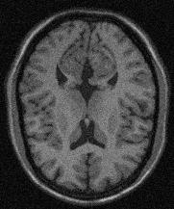

**(i) (j) (k)**

**Fig: 3.1 – A random slice (slice– 80) from every volumes:** (a) noise- 0% INU- 0% (b) noise- 1% INU- 20% (c) noise- 1% INU- 40% (d) noise- 3% INU- 20% (e) noise- 3% INU- 40% (f) noise- 5% INU- 20% (g) noise- 5% INU- 40% (h) noise- 7% INU- 20% (i) noise- 7% INU- 40% (j) noise- 9% INU- 20% (k) noise- 9% INU- 40%

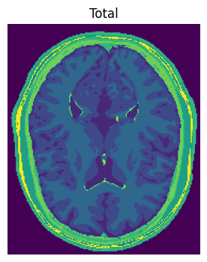

(a)

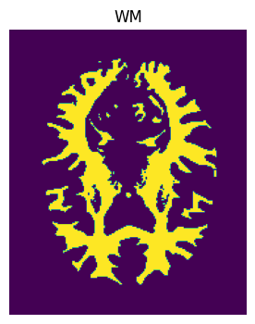 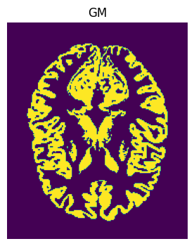 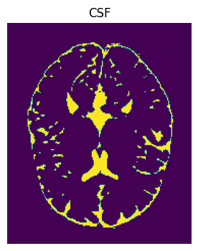

**(b) (c) (d)**

**Fig: 3.2 - Ground truth images of a random slice( Slice – 80) from volume - 1 of the simulated brain MRI images: (a) Total; (b) WM; (c) GM; (d) CSF.**

### 3.1.B) Pre-processing :

A vast amount of anatomical and functional information is made possible by medical imaging technologies, and this information, when combined with quantitative image processing tools, improves patient care and diagnosis. Pre-processing brain MR images is a basic step in ensuring that the quantitative image analysis pipeline produces a good output. The pre-processing stage consists of many operations designed to either enhance its quality or removal of the non-brain tissues. The groundwork for precise and trustworthy segmentation is laid during this initial stage.

* **Skull-stripping:**

Skull-stripping, a crucial step in pre-processing MRI images for segmentation, involves the removal of non-brain tissues such as the skull and scalp to focus specifically on the brain structures. This process is essential to ensure accurate segmentation results by eliminating extraneous information that may interfere with the analysis. Various techniques can be employed for skull stripping, ranging from simple thresholding methods to more sophisticated algorithms like Brain Extraction Tool (BET) or machine learning-based approaches. By effectively isolating the brain from surrounding tissues, skull stripping sets the stage for subsequent segmentation processes, enabling precise delineation of anatomical structures and enhancing the overall quality of quantitative image analysis for improved patient care and diagnosis.

In my project, I developed a custom skull stripping algorithm to pre-process MRI images, a pivotal step in medical image analysis pipelines. Leveraging Python and libraries such as NumPy and scikit-image, the algorithm automates the removal of non-brain tissues, particularly the skull and scalp, from the images. By implementing intensity thresholding and a depth-first search (DFS) approach, the algorithm accurately identifies and isolates the skull region. Additionally, it incorporates techniques to handle variations in image intensity and size, ensuring robust performance across diverse datasets. The resulting "skull-stripped" images exhibit enhanced clarity and focus specifically on the brain structures, setting the stage for subsequent segmentation and analysis tasks. After applying skull stripping, any pixels outside of the brain were mapped to zero as background. **Fig. 3.3** shows the effect of this step for a sample slice.

 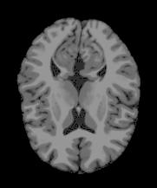

(a) (b)

**Fig: 3.3 – (a) Before Skull-Stripping and (b) After Skull-Stripping of a random slice (slice- 80) from volume – 1**

* **Normalisation :**

In pre-processing, normalization is a crucial step to ensure that numerical data is on a standardized scale, typically between 0 and 1 or -1 and 1. By scaling the features to a common range, normalization prevents certain features from dominating the learning process due to differences in their scales. It enables machine learning algorithms to converge faster and often leads to better performance. Common methods include Min-Max Scaling, Z-score Standardization, Robust Scaling, and Unit Vector Scaling, each suited to different data distributions and modelling requirements.

In my project, I employed a straightforward yet effective method for normalizing pixel intensities in the pre-processing stage. By dividing each pixel intensity by the maximum intensity value, I ensured that all pixel values were scaled to a range between 0 and 1. This normalization step is crucial for enhancing the performance of machine learning algorithms, as it helps prevent certain features from dominating others solely due to their larger scale. Moreover, by bringing all pixel values into a common range, the model can better discern patterns and relationships within the data, leading to more accurate and robust predictions. This simple yet powerful normalization technique lays a solid foundation for the subsequent stages of the project, facilitating the extraction of meaningful insights and the development of reliable models.

### 3.1.C) Segmentation :

In this study, the Radial Basis Function (RBF) Neural Network is used for segmenting brain MRI volumes into white matter, grey matter, and cerebrospinal fluid (CSF), accommodating variations in noise and intensity non-uniformity (INU) percentages across multiple volumes.

By systematically applying the RBFNN to each volume, I ensure comprehensive analysis that captures the inherent variability present in real-world MRI data. This meticulous approach enables us to account for nuanced anatomical features and variations, yielding reliable segmentation results that generalize effectively across different imaging conditions.

* **Splitting the datasets:**

After pre-processing each volumes, to validate the segmentation model's performance, I divide each pre-processed dataset into training, validation and testing sets, with different ratios for evaluating model’s performance. By systematically varying the ratios, I explore different scenarios to validate the model's consistency and adaptability across diverse data compositions. Each iteration contributes valuable insights into the model's behaviour under different conditions, enhancing our understanding of its strengths and limitations.

* **Standardization:**

Before training the RBFNN model, I standardize the features within the training set using the StandardScaler from the scikit-learn library. Standardization ensures that each feature has a mean of 0 and a standard deviation of 1, which can improve the convergence of the RBFNN algorithm.

* **Training the RBFNN Model:**

I then train an RBFNN model on the standardized training data. In training, I follow a structured process aimed at optimizing its performance and ensuring robustness in handling our dataset. Here’s a detailed breakdown of the steps involved:

Here I define the RBFNN model architecture using TensorFlow's Keras API. The model consists of three main layers:

1. **Input Layer:** Comprising a Dense layer with ReLU activation, it serves as the entry point for our data.
2. **RBF Hidden Layer:** Implemented as a custom RBFLayer, this layer utilizes the Radial Basis Function activation function to introduce non-linearity and capture complex relationships within the data.
3. **Output Layer:** Another Dense layer, this time with a single neuron representing the output.

Before training, I compile the model using an appropriate optimizer and loss function. Here, I use the Adam optimizer for its effectiveness in handling sparse gradients and the Mean Squared Error (MSE) loss function.

I train the model using the fit() function, passing in the training data (X_train and y_train) along with validation data (X_val and y_val). During training, the model iteratively adjusts its weights to minimize the defined loss function, optimizing its ability to predict the target variable.

* **Evaluation of the RBFNN model:**

After training, I evaluate the model's performance on unseen data—the testing set (X_test and y_test). The evaluate() function computes the loss value of the model on the test data, providing a quantitative measure of its predictive accuracy. I asses the segmentation accuracy using metrics such as accuracy score, precision, recall, and f1 score.

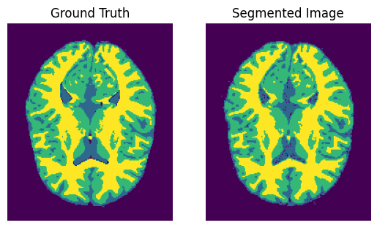

**Fig: 3.4 – After Segmentation The original ground truth and the segmented image of a random slice (slice- 80) from volume – 1**

**3.2) Evaluation Metrics :**

In this Experimentation, Accuracy Score and F1 Score is general commonly

used method. F1 Score is one of the most widely used evaluation metrics. F1 Score provides a more balanced evaluation on imbalanced dataset also. F1 Score not only considers True Positives (TP) but also considers both false positives (FP) and false negatives (FN). Firstly I have to compute Precision and Recall. Precision and Recall can be computed using the equation mentioned below –

(3.1)

(3.2)

In above equations, TP, FP, FN represent True Positive (Model has predicted Positive class whether it is actually positive), False Positive (Model has predicted Positive class whether it is actually negative) and False Negative (Model has predicted Negative class whether it is actually positive) respectively. Accuracy Score and F1 Score can be computed using the equation mentioned below –

(3.3)

(3.4)

Accuracy Score and F1 Score both lie between [0,1], higher the values better Recognition has been done.

Also During the training of the model, Mean Squared Error (MSE) was employed as the loss function. MSE is a commonly used loss function for regression tasks. It measures the average squared difference between the predicted and actual values. The MSE value is between [0.0 , 1.0], but its value near to 0.0 is considered better.

The formula for calculating MSE is as follows:

(3.5)

Where:

* is the number of samples
* is the true label for sample
* is the predicted label for sample

Using MSE as the loss function aims to minimize the discrepancy between the predicted and actual values, thus improving the overall accuracy of the model.

**3.3) Results:**

I conduct extensive experimentation to assess the performance of my Radial Basis Function Neural Network (RBFNN) model under diverse data partitioning schemes. Specifically, I employ varying ratios for dividing the dataset into training, validation, and testing sets. By systematically exploring these different ratios, I aim to evaluate the model's consistency and adaptability across a spectrum of data distributions. Each configuration is rigorously tested to ensure a comprehensive understanding of the model's performance under different conditions.

Experiment Results with Different Data Partitioning Ratios –

* **Table 3.2: Dataset- 70% Train, 15% Validation, 15% Test :-**

|  |  |  |  |  |  |  |
| --- | --- | --- | --- | --- | --- | --- |
| **Volume**  **(Noise, IIH)** | **Region** | **Precision** | **Recall** | **F1 score** | **Accuracy**  **(Total)** | **Loss –‘MSE’**  **(Total)** |
| Volume 1  (0,0) | WM  GM  CSF | 0.9877  0.9204  0.8804 | 0.9461  0.9696  0.8818 | 0.9665  0.9444  0.8811 | 0.9650 | 0.0396 |
| Volume 2 (1,20) | WM  GM  CSF | 0.9654  0.9244  0.8469 | 0.9507  0.9385  0.8035 | 0.9580  0.9314  0.8246 | 0.9539 | 0.04901 |
| Volume 3 (1,40) | WM  GM  CSF | 0.9549  0.8816  0.8386 | 0.9069  0.9308  0.7067 | 0.9303  0.9055  0.7670 | 0.9362 | 0.0626 |
| Volume 4 (3,20) | WM  GM  CSF | 0.9747  0.8958  0.8212 | 0.9181  0.9433  0.7184 | 0.9455  0.9189  0.7664 | 0.9420 | 0.0584 |
| Volume 5 (3,40) | WM  GM  CSF | 0.9551  0.8753  0.8343 | 0.9046  0.9339  0.6664 | 0.9292  0.9037  0.7410 | 0.9330 | 0.0658 |
| Volume 6 (5,20) | WM  GM  CSF | 0.9312  0.9162  0.8327 | 0.9538  0.9060  0.6510 | 0.9424  0.9111  0.7307 | 0.9367 | 0.0638 |
| Volume 7 (5,40) | WM  GM  CSF | 0.9327  0.8759  0.8076 | 0.9118  0.9090  0.6234 | 0.9221  0.8921 0.7037 | 0.9252 | 0.0728 |
| Volume 8 (7,20) | WM  GM  CSF | 0.9093  0.8689  0.8034 | 0.9116  0.8785  0.6417 | 0.9104  0.8736  0.7135 | 0.9207 | 0.0764 |
| Volume 9 (7,40) | WM  GM  CSF | 0.8968  0.8570  0.8090 | 0.9114  0.8766  0.5571 | 0.9040  0.8667  0.6598 | 0.9133 | 0.0823 |
| Volume 10 (9,20) | WM  GM  CSF | 0.8751  0.8081  0.7494 | 0.8581  0.8458  0.5964 | 0.8665  0.8265  0.6642 | 0.8962 | 0.0933 |
| Volume 11 (9,40) | WM  GM  CSF | 0.8607  0.8090  0.7566 | 0.8679 0.8341  0.5273 | 0.8643  0.8214  0.6215 | 0.8915 | 0.0975 |

* **Table 3.3: Dataset- 60% Train, 20% Validation, 20% Test :-**

|  |  |  |  |  |  |  |
| --- | --- | --- | --- | --- | --- | --- |
| **Volume**  **(Noise, IIH)** | **Region** | **Precision** | **Recall** | **F1 score** | **Accuracy**  **(Total)** | **Loss –‘MSE’**  **(Total)** |
| Volume 1  (0,0) | WM  GM  CSF | 0.9822 0.9343 0.8539 | 0.9541 0.9561 0.8934 | 0.9680  0.9451  0.8732 | 0.9654 | 0.0458 |
| Volume 2 (1,20) | WM  GM  CSF | 0.9614  0.9226  0.8585 | 0.9492  0.9422  0.7986 | 0.9552  0.9323 0.8275 | 0.9547 | 0.0472 |
| Volume 3 (1,40) | WM  GM  CSF | 0.9496 0.8940 0.8247 | 0.9167 0.9257 0.7188 | 0.9329 0.9096 0.7681 | 0.9387 | 0.0595 |
| Volume 4 (3,20) | WM  GM  CSF | 0.9737 0.9023 0.8130 | 0.9202 0.9419 0.7320 | 0.9462 0.9216 0.7704 | 0.9443 | 0.0552 |
| Volume 5 (3,40) | WM  GM  CSF | 0.9420 0.8996 0.8107 | 0.9254 0.9144 0.6864 | 0.9336 0.9070 0.7434 | 0.9360 | 0.0619 |
| Volume 6 (5,20) | WM  GM  CSF | 0.9341  0.9154 0.8239 | 0.9514 0.9135 0.6661 | 0.9426 0.9145 0.7367 | 0.9391 | 0.0602 |
| Volume 7 (5,40) | WM  GM  CSF | 0.9267 0.8833 0.7990 | 0.9152 0.9044 0.6415 | 0.9209 0.8937 0.7116 | 0.9272 | 0.0694 |
| Volume 8 (7,20) | WM  GM  CSF | 0.9010  0.8830 0.7836 | 0.9221 0.8688 0.6708 | 0.9114 0.8759 0.7228 | 0.9232 | 0.0718 |
| Volume 9 (7,40) | WM  GM  CSF | 0.9026 0.8634 0.7775 | 0.9031 0.8768 0.5940 | 0.9028 0.8700 0.6735 | 0.9157 | 0.0779 |
| Volume 10 (9,20) | WM  GM  CSF | 0.8760  0.8168  0.7436 | 0.8567 0.8453 0.6007 | 0.8662 0.8308 0.6646 | 0.8988 | 0.0894 |
| Volume 11 (9,40) | WM  GM  CSF | 0.8626  0.8186  0.7361 | 0.8632  0.8291  0.5466 | 0.8629  0.8239  0.6274 | 0.8938 | 0.0936 |

* **Table 3.4: Dataset- 50% Train, 25% Validation, 25% Test :-**

|  |  |  |  |  |  |  |
| --- | --- | --- | --- | --- | --- | --- |
| **Volume**  **(Noise, IIH)** | **Region** | **Precision** | **Recall** | **F1 score** | **Accuracy**  **(Total)** | **Loss –‘MSE’**  **(Total)** |
| Volume 1  (0,0) | WM  GM  CSF | 0.9814  0.9338  0.8663 | 0.9565  0.9569  0.8686 | 0.9688  0.9452  0.8675 | 0.9659 | 0.0363 |
| Volume 2  (1,20) | WM  GM  CSF | 0.9654  0.9212  0.8526 | 0.9489  0.9426  0.8034 | 0.9571  0.9318  0.8273 | 0.9561 | 0.0445 |
| Volume 3  (1,40) | WM  GM  CSF | 0.9497  0.8979  0.8280 | 0.9239  0.9223  0.7188 | 0.9367  0.9099  0.7696 | 0.9414 | 0.0574 |
| Volume 4  (3,20) | WM  GM  CSF | 0.9708  0.9061  0.8349 | 0.9327  0.9466  0.7220 | 0.9514  0.9259  0.7744 | 0.9482 | 0.0518 |
| Volume 5  (3,40) | WM  GM  CSF | 0.9428  0.8979  0.8256 | 0.9312  0.9198  0.6834 | 0.9370  0.9087  0.7478 | 0.9392 | 0.0605 |
| Volume 6  (5,20) | WM  GM  CSF | 0.9491  0.9141  0.7926 | 0.9419  0.9123  0.6882 | 0.9455  0.9132  0.7367 | 0.9408 | 0.0587 |
| Volume 7  (5,40) | WM  GM  CSF | 0.9227  0.8923  0.7974 | 0.9283  0.8938  0.6444 | 0.9255  0.8930  0.7127 | 0.9300 | 0.0667 |
| Volume 8  (7,20) | WM  GM  CSF | 0.8971  0.8859  0.7925 | 0.9323  0.8641  0.6661 | 0.9144  0.8749  0.7238 | 0.9256 | 0.0697 |
| Volume 9  (7,40) | WM  GM  CSF | 0.9020  0.8708  0.7682 | 0.9132  0.8670  0.6102 | 0.9075  0.8689 0.6802 | 0.9189 | 0.0749 |
| Volume 10  (9,20) | WM  GM  CSF | 0.8553  0.8420  0.7487 | 0.9001  0.8106  0.5998 | 0.8771  0.8260  0.6661 | 0.9030 | 0.0864 |
| Volume 11  (9,40) | WM  GM  CSF | 0.8546  0.8268  0.7575 | 0.8872  0.8182  0.5328 | 0.8706  0.8225  0.6256 | 0.8980 | 0.0909 |

* **Table 3.5: Dataset- 40% Train, 30% Validation, 30% Test :-**

|  |  |  |  |  |  |  |
| --- | --- | --- | --- | --- | --- | --- |
| **Volume**  **(Noise, IIH)** | **Region** | **Precision** | **Recall** | **F1 score** | **Accuracy**  **(Total)** | **Loss –‘MSE’**  **(Total)** |
| Volume 1  (0,0) | WM  GM  CSF | 0.9907  0.9179  0.8348 | 0.9375  0.9554  0.8974 | 0.9633  0.9363  0.8650 | 0.9636 | 0.0427 |
| Volume 2  (1,20) | WM  GM  CSF | 0.9570  0.9334  0.8515 | 0.9625  0.9297  0.8075 | 0.9597  0.9315  0.8289 | 0.9581 | 0.0426 |
| Volume 3  (1,40) | WM  GM  CSF | 0.9504  0.8995  0.8353 | 0.9299  0.9224  0.7197 | 0.9400  0.9108  0.7732 | 0.9442 | 0.0545 |
| Volume 4  (3,20) | WM  GM  CSF | 0.9718  0.9109  0.8128 | 0.9357  0.9363  0.7381 | 0.9534  0.9234  0.7737 | 0.9494 | 0.0509 |
| Volume 5  (3,40) | WM  GM  CSF | 0.9467  0.8961  0.8514 | 0.9339  0.9247  0.6616 | 0.9402  0.9102  0.7446 | 0.9420 | 0.0568 |
| Volume 6  (5,20) | WM  GM  CSF | 0.9498  0.9135  0.8250 | 0.9488  0.9217  0.6702 | 0.9493  0.9176  0.7396 | 0.9446 | 0.0553 |
| Volume 7  (5,40) | WM  GM  CSF | 0.9077  0.9011  0.8199 | 0.9467  0.8773  0.6271 | 0.9268  0.8890  0.7107 | 0.9317 | 0.0655 |
| Volume 8  (7,20) | WM  GM  CSF | 0.8981  0.8875  0.7999 | 0.9390  0.8626  0.6616 | 0.9181  0.8748  0.7242 | 0.9284 | 0.0718 |
| Volume 9  (7,40) | WM  GM  CSF | 0.9030  0.8706  0.7841 | 0.9202  0.8681  0.5987 | 0.9115  0.8693  0.6789 | 0.9221 | 0.0719 |
| Volume 10  (9,20) | WM  GM  CSF | 0.8786  0.8297  0.7465 | 0.8856  0.8350  0.6041 | 0.8821  0.8323  0.6678 | 0.9074 | 0.0834 |
| Volume 11  (9,40) | WM  GM  CSF | 0.8714  0.8237  0.7525 | 0.8822  0.8302  0.5454 | 0.8768  0.8269  0.6325 | 0.9028 | 0.0862 |

* **Table 3.6: Dataset- 30% Train, 35% Validation, 35% Test :-**

|  |  |  |  |  |  |  |
| --- | --- | --- | --- | --- | --- | --- |
| **Volume**  **(Noise, IIH)** | **Region** | **Precision** | **Recall** | **F1 score** | **Accuracy**  **(Total)** | **Loss –‘MSE’**  **(Total)** |
| Volume 1  (0,0) | WM  GM  CSF | 0.9784  0.9357  0.8785 | 0.9633  0.9575  0.8714 | 0.9708  0.9465  0.8749 | 0.9679 | 0.0363 |
| Volume 2  (1,20) | WM  GM  CSF | 0.9680  0.9204  0.8619 | 0.9495  0.9445  0.7975 | 0.9587  0.9323  0.8284 | 0.9575 | 0.0443 |
| Volume 3  (1,40) | WM  GM  CSF | 0.9491  0.8926  0.8341 | 0.9235  0.9234  0.7240 | 0.9361  0.9077  0.7752 | 0.9421 | 0.0573 |
| Volume 4  (3,20) | WM  GM  CSF | 0.9738  0.9042  0.8490 | 0.9334  0.9511  0.7203 | 0.9532  0.9270  0.7794 | 0.9502 | 0.0501 |
| Volume 5  (3,40) | WM  GM  CSF | 0.9390  0.9030  0.8441 | 0.9412  0.9159  0.6777 | 0.9401 0.9094  0.7518 | 0.9416 | 0.0577 |
| Volume 6  (5,20) | WM  GM  CSF | 0.9440  0.9171  0.8098 | 0.9520  0.9140  0.6886 | 0.9479  0.9155  0.7443 | 0.9432 | 0.0571 |
| Volume 7  (5,40) | WM  GM  CSF | 0.9255  0.8930  0.7933 | 0.9306  0.8934  0.6576 | 0.9280  0.8932  0.7191 | 0.9320 | 0.0652 |
| Volume 8  (7,20) | WM  GM  CSF | 0.8847  0.8997  0.7680 | 0.9448  0.8326  0.6901 | 0.9138  0.8649  0.7270 | 0.9247 | 0.0728 |
| Volume 9  (7,40) | WM  GM  CSF | 0.9230  0.8535  0.7507 | 0.8897  0.8811  0.6273 | 0.9061  0.8671  0.6835 | 0.9192 | 0.0784 |
| Volume 10  (9,20) | WM  GM  CSF | 0.8608  0.8389 0.7607 | 0.9022 0.8165 0.5944 | 0.8810 0.8276 0.6674 | 0.9058 | 0.0846 |
| Volume 11  (9,40) | WM  GM  CSF | 0.8761  0.8207  0.7271 | 0.8719 0.8303 0.5776 | 0.8740  0.8254 0.6438 | 0.9010 | 0.0884 |

* **Some Segmented pictures:**

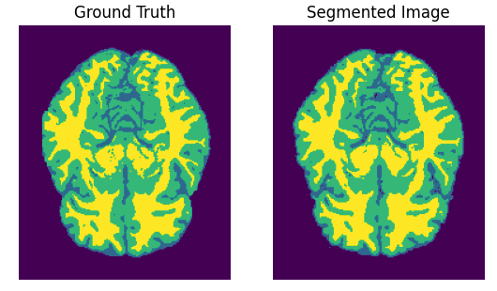

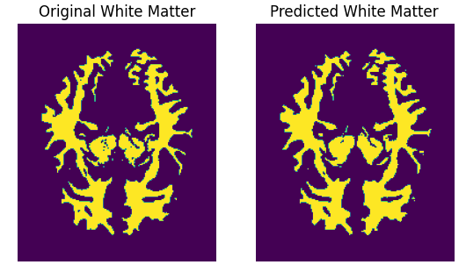

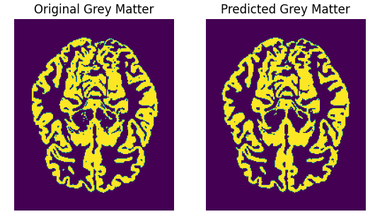

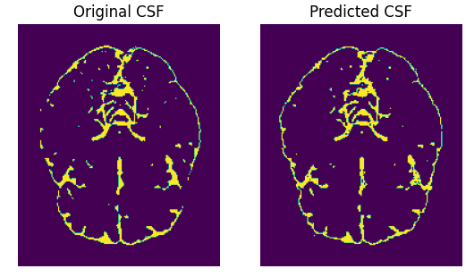

**Fig:3.5 - The original and the predicted masks of a random slice (slice- 62) from volume – 1(0,0)**

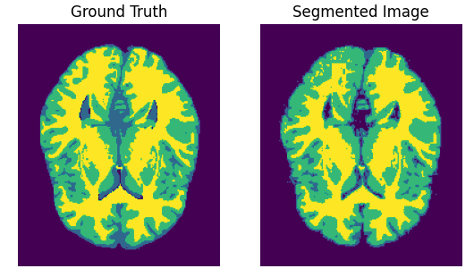

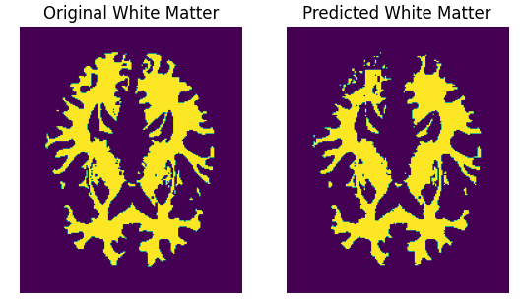

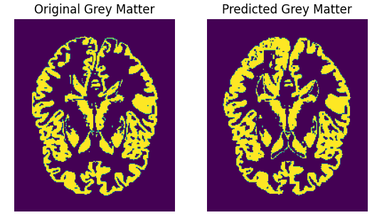

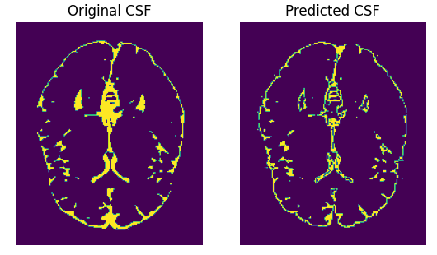

**Fig:3.6 - The original and the predicted masks of a random slice (slice- 73) from volume – 3(1,40)**

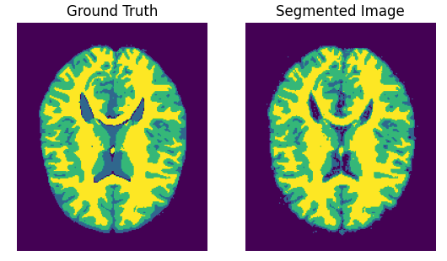

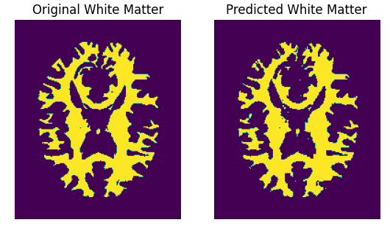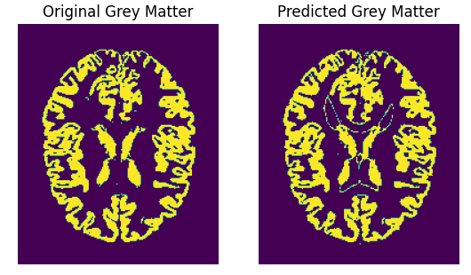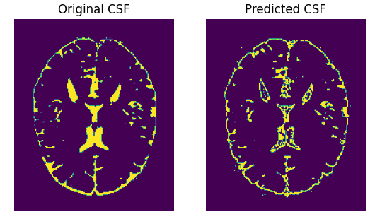

**Fig:3.7 - The original and the predicted masks of a random slice (slice- 85) from volume – 4(3,20)**

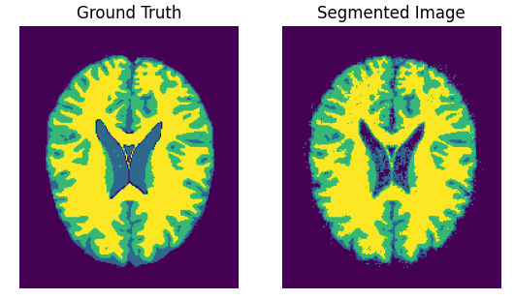

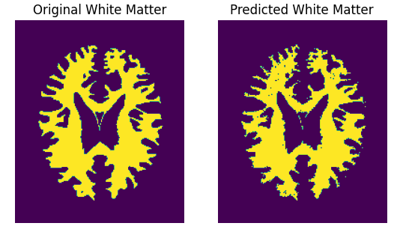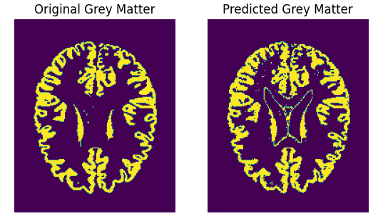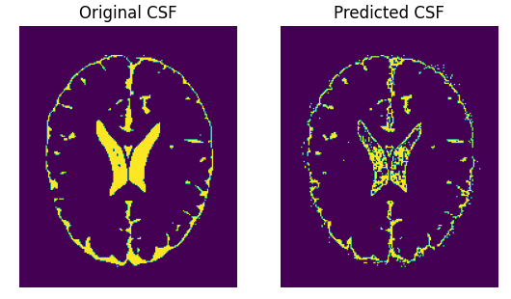

**Fig:3.8 - The original and the predicted masks of a random slice (slice- 92) from volume – 6(5,20)**

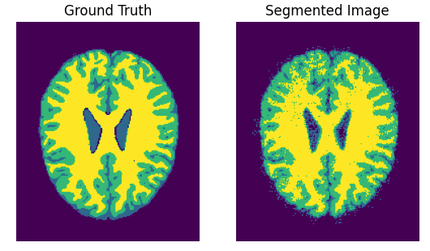

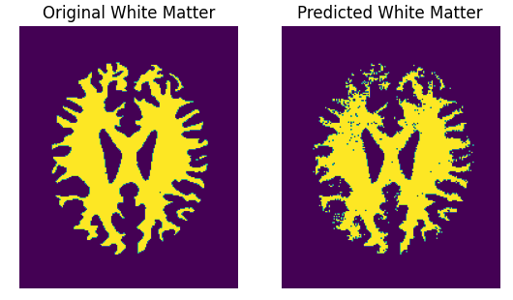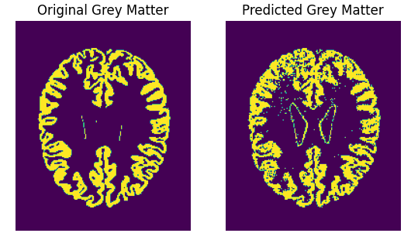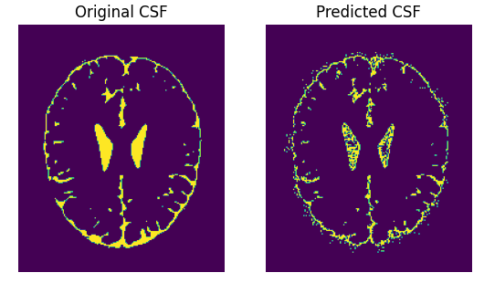

**Fig:3.9 - The original and the predicted masks of a random slice (slice- 98) from volume – 9(7,40)**

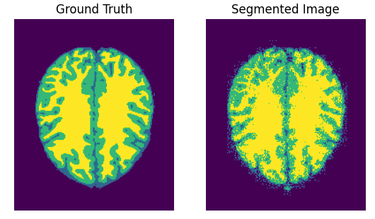

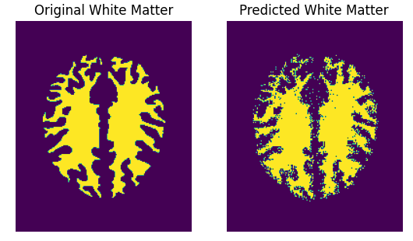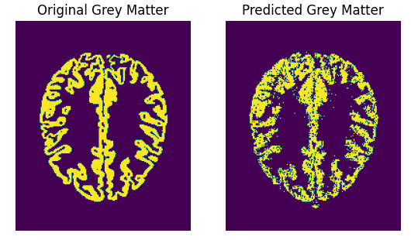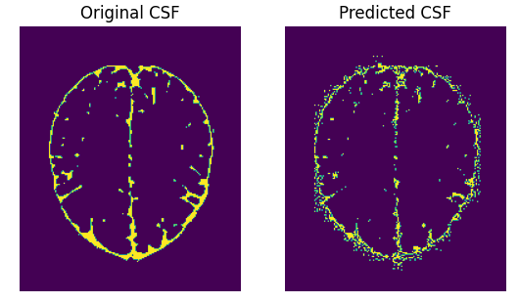

**Fig:3.10 - The original and the predicted masks of a random slice (slice- 108) from volume – 11(9,40)**

**4) Conclusion:**

The utilization of medical image segmentation in real clinical settings is a crucial aspect that warrants significant attention. Image segmentation is an essential step in many medical applications that involve 3D visualization, computer-aided diagnosis, measurements, and registration. Without a doubt, computerized segmentation techniques have demonstrated their usefulness and potential for computer-aided diagnosis and treatment planning. This work has given a thorough review of the basic ideas and frequently used techniques for human brain MRI segmentation.

New segmentation problems for diverse applications keep coming up as a result of the ongoing and quick development of medical models; this leads to ongoing study and the introduction of new techniques. As was previously indicated, in many circumstances, combining multiple strategies will be essential to achieve the intended segmentation goal.

In this paper, we have demonstrated the effectiveness of utilizing the Radial Basis Function Neural Network (RBFNN) for segmenting brain MRI images. Through our implementation, we achieved promising outcomes in accurately delineating brain structures into cerebrospinal fluid (CSF), grey matter, and white matter regions.

Precise segmentation was made possible by the RBFNN, which demonstrated exceptional skill in identifying intricate patterns and correlations in the high-dimensional MRI data. We were able to obtain reliable segmentation results by utilizing the RBFNN's capacity to identify ideal decision boundaries in feature space.

Although our focus was on RBFNN-based segmentation, it's essential to acknowledge the potential of alternative methods, such as other deep learning approaches or hybrid aproaches, in this domain. While our study showcased the efficacy of the RBFNN, future research could explore the integration of convolutional neural networks (CNNs) or other deep learning and hybrid architectures for MRI segmentation tasks.

It is important to acknowledge that the proposed algorithm is not without challenges. The increased complexity and computational requirements may lead to longer processing times. However, it is hopeful that future advancements and refinements of the RBFNN will further elevate its accuracy and efficiency.

Ultimately, our research emphasizes the usefulness of the RBFNN as a consistent and efficient method for brain MRI segmentation. By accurately delineating brain structures, this approach contributes to advancing our understanding of neuroanatomy and holds potential for enhancing clinical diagnosis and treatment planning in neurological disorders.

**5) References:**

1. Sing, J. K., D. K. Basu, M. Nasipuri, and M. Kundu. "Self-adaptive RBF neural network-based segmentation of medical images of the brain." In Proceedings of 2005 International Conference on Intelligent Sensing and Information Processing, 2005., pp. 447-452. IEEE, 2005.
2. Andriy Myronenko, Xubo Song, “Intensity-based image registration by minimizing residual complexity”, IEEE Trans Med Imaging. 2010 Nov; 29(11): 1882-91.
3. Hyunseok Seo, Masoud Badiei Khuzani, Varun Vasudevan, Charles Huang, Hongyi Ren, Ruoxiu Xiao, Xiao Jia, Lei Xing1, “Machine Learning Techniques for Biomedical Image Segmentation: An Overview of Technical Aspects and Introduction to State-of-Art Applications”, Med Phys. 2020 Jun; 47(5): e148–e167.
4. Ivana Despotovic, Bart Goossens, Wilfried Philips, “MRI Segmentation of the Human Brain: Challenges, Methods, and Applications ”, Computational Intelligence Techniques in Medicine, Vol-2015, Article ID 450341, 2015.
5. R Wood, K Bassett, Foerster, V, C Spry, L Tong “1.5 Tesla Magnetic Resonance Imaging Scanners Compared with 3.0 Tesla Magnetic Resonance Imaging Scanners: Systematic Review of Clinical Effectiveness”, CADTH Technol Overv. 2012; 2(2): e2201.
6. R. Gilberto González, “Clinical MRI of Acute Ischemic Stroke”, J Magn Reson Imaging. 2012 Aug; 36(2): 259–271.
7. Evangelos Perdikakis, Vasilios Skiadas “MRI characteristics of cysts and “cyst-like” lesions in and around the knee: what the radiologist needs to know”, Insights Imaging. 2013 Jun; 4(3): 257–272.
8. Bruce Lee, Andrew Newberg, “Neuroimaging in Traumatic Brain Imaging”, NeuroRx. 2005 Apr, 2(2): 372–383.
9. Christopher C. Hemond, Rohit Bakshi “Magnetic Resonance Imaging in Multiple Sclerosis”, Cold Spring Harb Perspect Med. 2018 May; 8(5): a028969.
10. Jill Novitzke, “The Basics of Brain Aneurysms: A Guide for Patients”, J Vasc Interv Neurol. 2008 Jul; 1(3): 89–90.
11. C. M. Collins, W. Liu, W. Schreiber, Q. X. Yang, and M. B. Smith, “Central brightening due to constrctive interference with, without, and despite dielectric resonance,” Journal of Magnetic Resonance Imaging , vol. 21, no. 2, pp. 192–196, 2005.
12. M. Sezgin and B. Sankur, “Survey over image thresholding techniques and quantitative performance evaluation,” Journal of Electronic Imaging , vol. 13, no. 1, pp. 146–168, 2004.
13. Sezgin M., Sankur B. Survey over image thresholding techniques and quantitative performance evaluation.Journal of Electronic Imaging*.* 2004
14. R. M. Haralick and L. G. Shapiro, “Image segmentation techniques,” Computer Vision, Graphics, and Image Processing, vol. 29, no. 1, pp. 100–132, 1985.
15. G. B. Coleman and H. C. Andrews, “Image segmentation by clustering,” Proceedings of the IEEE, vol. 67, no. 5, pp. 773–785, 1979.
16. J.C. Bezdek, R. Ehrlich, and W. Full, "FCM: The Fuzzy C-Means Clustering Algorithm," Computers & Geosciences, vol. 10, no. 2-3, pp. 191-203, 1984.
17. Zhan T., Shen F., Hong X., Wang X., Chen Y., Lu Z., Yang G. A glioma segmentation method using cotraining and superpixel-based spatial and clinical constraints. IEEE Access. 2018.
18. Bo Feng, Meihua Zhang, Hanlin Zhu, Lingang Wang, Yanli Zheng, “MRI Image Segmentation Model with Support Vector Machine Algorithm in Diagnosis of Solitary Pulmonary Nodule”, Contrast Media Mol Imaging. 2021;
19. Runya Li, Shenglian Li, “Multimedia Image Data Analysis Based on KNN Algorithm”, Comput Intell Neurosci. 2022;
20. Yash Pershad, Siddharth Govindan, Amy K. Hara, Mitesh J. Borad, Tanios Bekaii-Saab, Alex Wallace, Hassan Albadawi, Rahmi Oklu1, “Using Naïve Bayesian Analysis to Determine Imaging Characteristics of KRAS Mutations in Metastatic Colon Cancer”, Diagnostics (Basel). 2017 Sep; 7(3): 50.
21. Ali Fawzi, Anusha Achuthan, Bahari Belaton, “ Brain Image Segmentation in Recent Years: A Narrative Review ”, Brain Sci. 2021 Aug; 11(8): 1055.
22. Zeynettin Akkus, Alfiia Galimzianova, Assaf Hoogi, Daniel L. Rubin, Bradley J. Erickson, “Deep Learning for Brain MRI Segmentation: State of the Art and Future Directions”, Journal of Digital Imaging 30, 449–459, 2017.
23. Srigiri Krishnapriya, Yepuganti Karuna, “ Pre-trained deep learning models for brain MRI image classification ”, Front. Hum. Neurosci., Sec. Brain-Computer Interfaces, Vol 17, 2023.
24. Ramzan, Farheen, Muhammad Usman Ghani Khan, Sajid Iqbal, Tanzila Saba, and Amjad Rehman. "Volumetric segmentation of brain regions from MRI scans using 3D convolutional neural networks." IEEE Access 8 (2020): 103697-103709.
25. Olaf Ronneberger, Philipp Fischer, Thomas Brox, “U-Net: Convolutional Networks for Biomedical Image Segmentation”, MICCAI 2015.
26. Vijay Badrinarayanan, Alex Kendall, Roberto Cipolla, “ SegNet: A Deep Convolutional Encoder-Decoder Architecture for Image Segmentation ”, IEEE, 2016.
27. Sanxing Zhang, Zhenhuan Ma, Gang Zhang, Tao Lei, Rui Zhang, Yi Cui, “Semantic Image Segmentation with Deep Convolutional Neural Networks and Quick Shift”, 2020.
28. Ma C., Luo G., Wang K. Concatenated and connected random forests with multiscale patch driven active contour model for automated brain tumor segmentation of MR images. IEEE Trans. Med. Imaging. 2018
29. Mishro P.K., Agrawal S., Panda R., Abraham A. A novel type-2 fuzzy c-means clustering for brain MR image segmentation.IEEE Trans. Cybern. 2020:1–12.
30. Ito R., Nakae K., Hata J., Okano H., Ishii S. Semi-supervised deep learning of brain tissue segmentation. Neural Netw. 2019
31. Kapur T., Eric W., Grimson L., Wells W. M., III, Kikinis R. Segmentation of brain tissue from magnetic resonance images.
32. Masutani Y., Schiemann T., Hohne K. H. Medical Image Computing and Computer-Assisted Interventation—MICCAI’98: Proceedings of the 1st International Conference Cambridge, MA, USA, October 11–13, 1998*.* Vol. 1496. Berlin, Germany: Springer; 1998. Vascular shape segmentation and structure extraction using a shape-based region-growing model
33. Xue J.-H., Pizurica A., Philips W., Kerre E., van de Walle R., Lemahieu I. An integrated method of adaptive enhancement for unsupervised segmentation of MRI brain images.