CLOUD SECURITY PBL
UNIT 2 — Evidence & Explanation Report
IAM & Least Privilege Enforcement

Student Details
Name: Shruti Patharkar
Registration No.: 2124UCSF1013

Included Evidence
- PBL-Admins, PBL-Developers and PBL-Auditors groups
- Administrator group-based permissions
- Developer and Auditor least-privilege policies
- EC2-to-S3 IAM role and instance profile
- Admin MFA device assignment evidence

Submission Status
MFA device assignment for pbl-terraform-admin is now included.
If the instructor requires policy-level deny-without-MFA enforcement, that separate policy evidence is not shown in the supplied screenshots.
Prepared from the supplied project evidence. No university name included.

UNIT 2 — Evidence Summary
No. | Evidence | Purpose / Section | Status
1 | Initial Admin Group Creation | Unit 2 → IAM Groups | Current evidence
2 | IAM Groups — Admins, Auditors and Developers | Unit 2 → IAM Groups | Current evidence
3 | IAM Users | Unit 2 → IAM Users | Current evidence
4 | Terraform Administrator User | Unit 2 → Admin User / Group-Based Permission | sCurrent evidence
5 | Auditor and Developer Least-Privilege Policies | Unit 2 → Least-Privilege Policies | Current evidence
6 | Developer, EC2-S3 Policies and EC2 Role | Unit 2 → Custom Policies and EC2 Role | Current evidence
7 | EC2 Role Policy Attachments | Unit 2 → EC2 IAM Role | Current evidence
8 | EC2 Role Policy Attachments — Duplicate Evidenc | eUnit 2 → EC2 IAM Role | Duplicate/reference
9 | Least-Privilege Policy Plan — Reference Copy | Unit 2 → Least-Privilege Policies | Duplicate/reference
10 | Custom IAM Policy Plan — Reference Copy | Unit 2 → Custom Policies | Duplicate/reference

Evidence 1: Initial Admin Group Creation
Place in: Unit 2 → IAM Groups
Status: Current evidence
What it proves: Shows creation of the PBL-Admins IAM group.
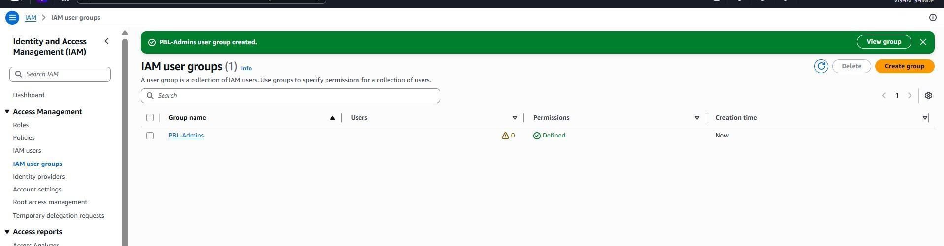
Figure 1: Initial Admin Group Creation.

Evidence 2: IAM Groups — Admins, Auditors and Developers
Place in: Unit 2 → IAM Groups Status: Current evidence
What it proves: Shows all three required IAM groups: PBL-Admins, PBL-Auditors and PBL-Developers.
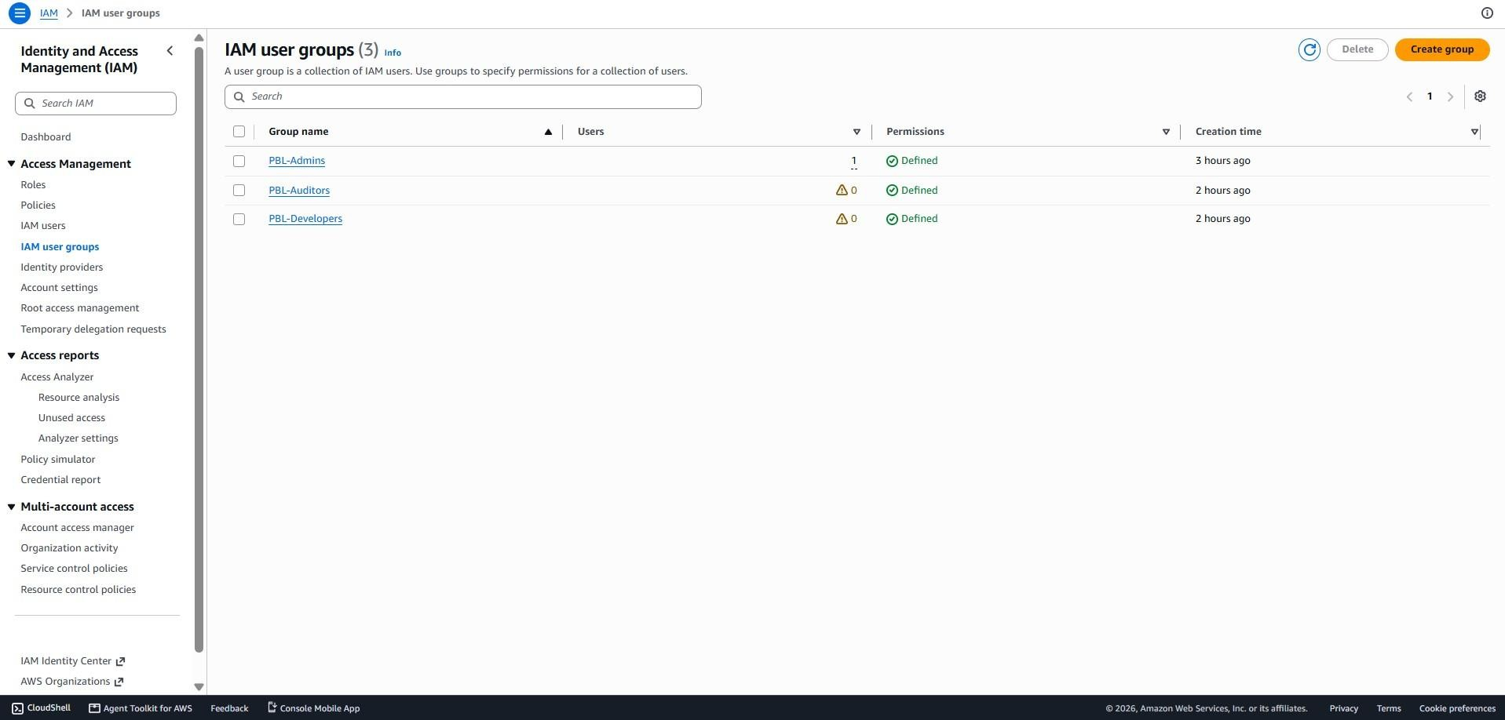
Figure 2: IAM Groups — Admins, Auditors and Developers.

Evidence 3: IAM Users
Place in: Unit 2 → IAM Users
Status: Current evidence
What it proves: Shows IAM users and the Groups column, providing evidence of IAM user administration.
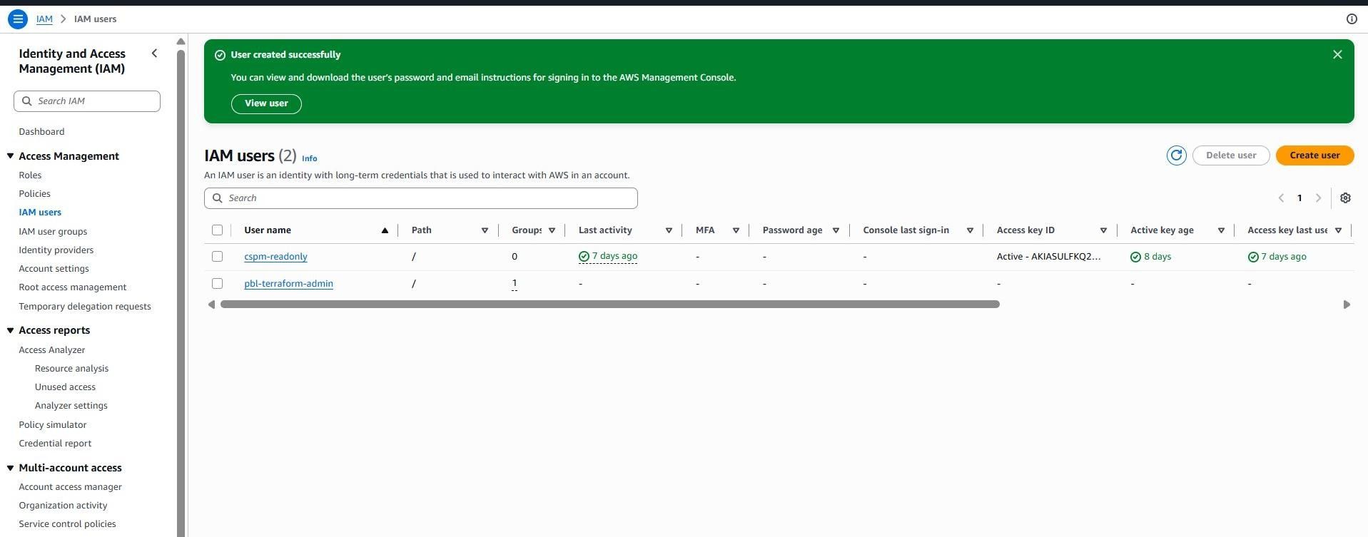
Figure 3: IAM Users.

Evidence 4: Terraform Administrator User
Place in: Unit 2 → Admin User / Group-Based Permissions
Status: Current evidence
What it proves: Shows the pbl-terraform-admin user and that AdministratorAccess is attached through the PBL-Admins group.
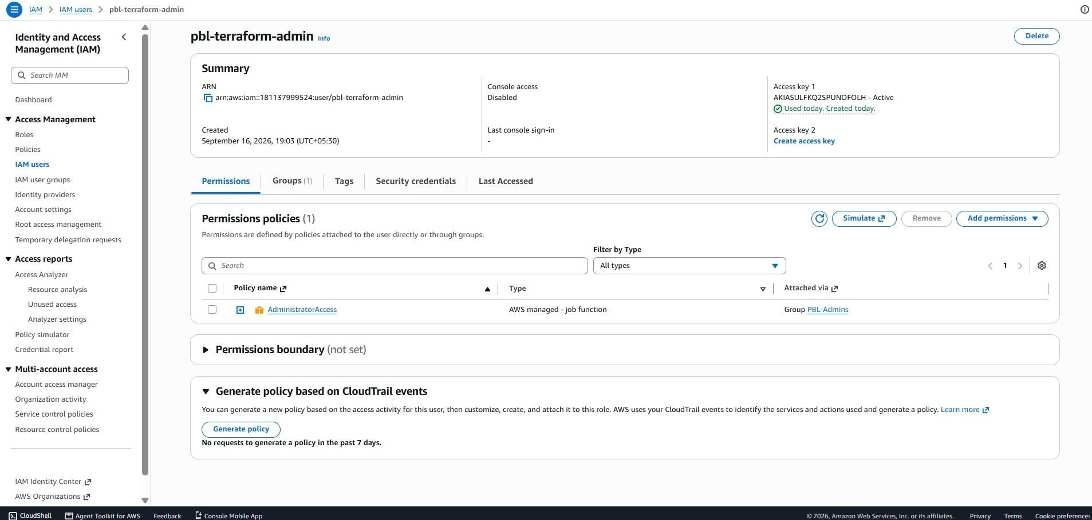
Figure 4: Terraform Administrator User.

Evidence 5: Auditor and Developer Least-Privilege Policies
Place in: Unit 2 → Least-Privilege Policies
Status: Current evidence
What it proves: Shows Terraform definitions for PBL-Auditor-ReadOnly and PBL-Developer-LeastPrivilege and their group attachments.
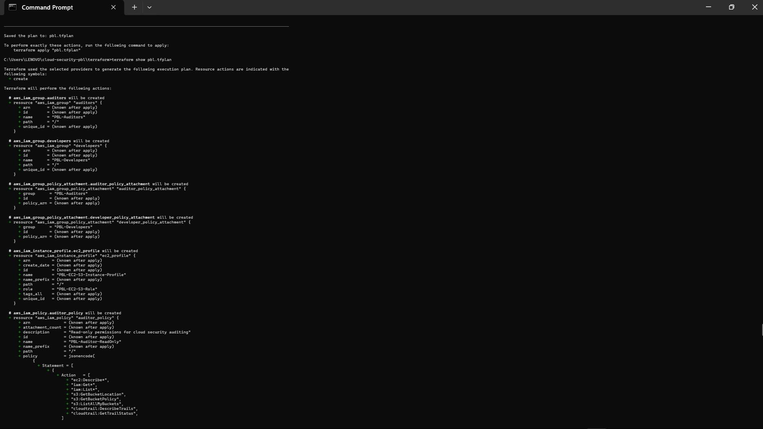
Figure 5: Auditor and Developer Least-Privilege Policies.

Evidence 6: Developer, EC2-S3 Policies and EC2 Role
Place in: Unit 2 → Custom Policies and EC2 Role
Status: Current evidence
What it proves: Shows the custom Developer policy, EC2-S3 least-privilege policy and PBL-EC2-S3-Role trust relationship.
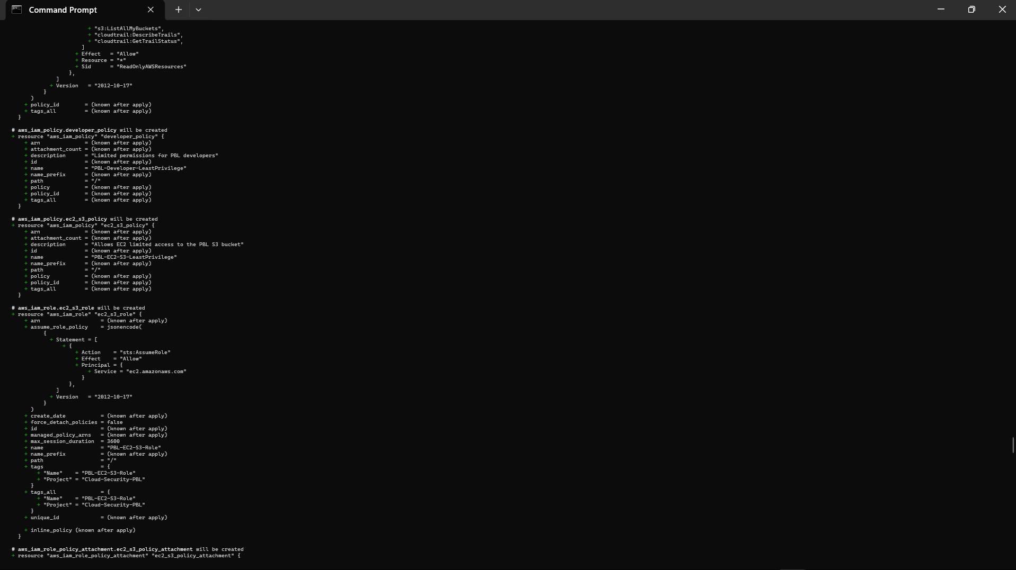
Figure 6: Developer, EC2-S3 Policies and EC2 Role.

Evidence 7: EC2 Role Policy Attachments
Place in: Unit 2 → EC2 IAM Role
Status: Current evidence
What it proves: Shows PBL-EC2-S3-LeastPrivilege and AmazonSSMManagedInstanceCore attached to the EC2 role.
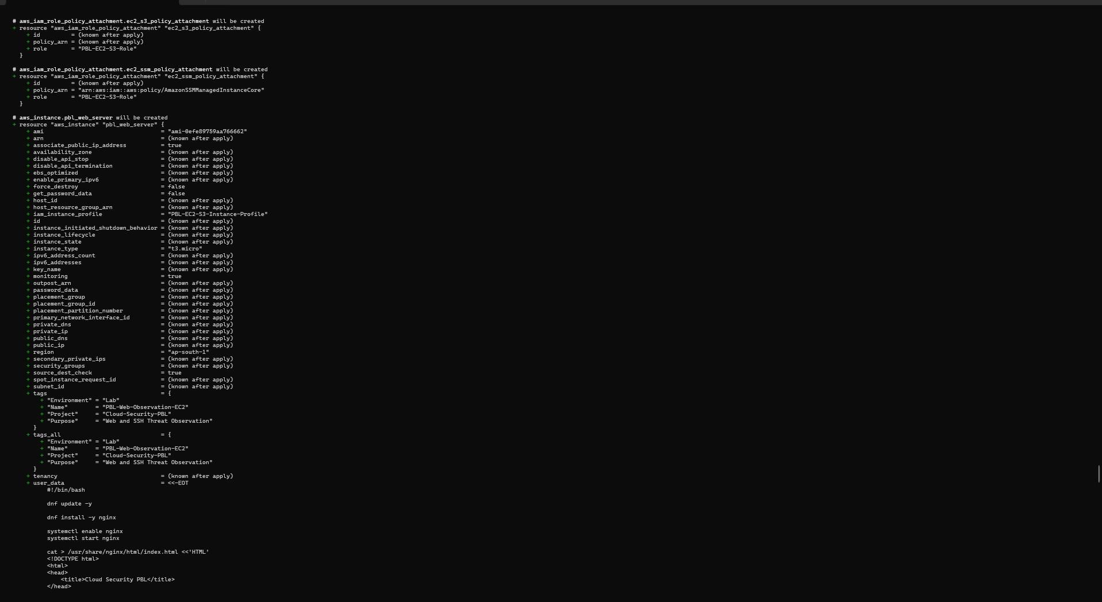
Figure 7: EC2 Role Policy Attachments.

UNIT 2 — Submission Notes
Unit 2 evidence covers IAM groups, users, group-based administrator access, leastprivilege policies, EC2 IAM role/instance profile, and Admin MFA.
Admin MFA evidence: pbl-terraform-admin has one passkey/security-key MFA device assigned, as shown in the AWS IAM Security Credentials screenshot on the next page.
Important accuracy note:
The supplied screenshot proves MFA device assignment. It does not, by itself, prove a policy-level DenyWithoutMFA enforcement rule. Add that policy screenshot only if the instructor explicitly requires policy-level enforcement.
Security note: do not publish AWS access-key material or other credentials.

UNIT 2 — Admin MFA Evidence
User: pbl-terraform-admin | Security Credenti
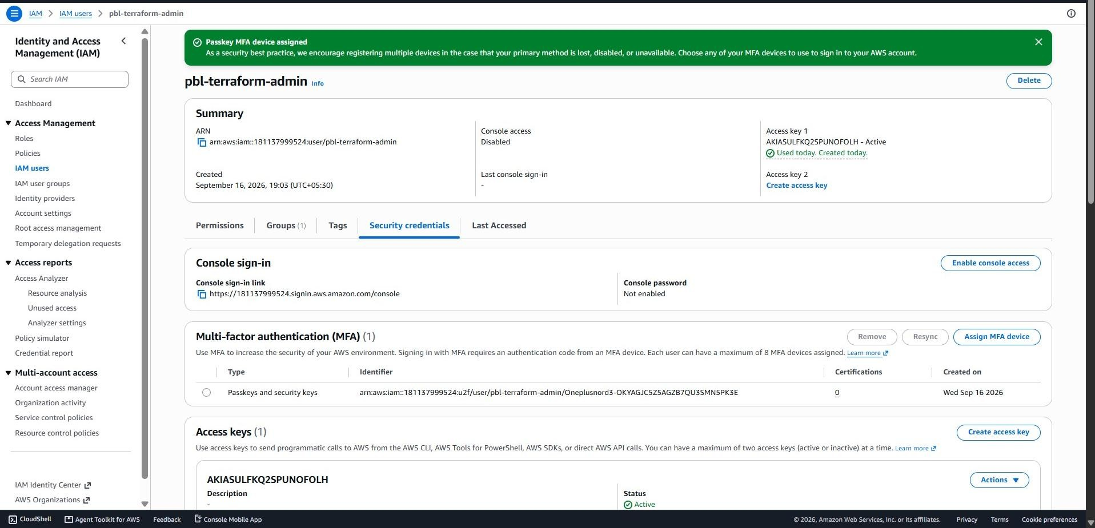
als

