**SonarQube Installation and Integration with Jenkins on Linux**

sonarqube-9.9.3.79811.zip

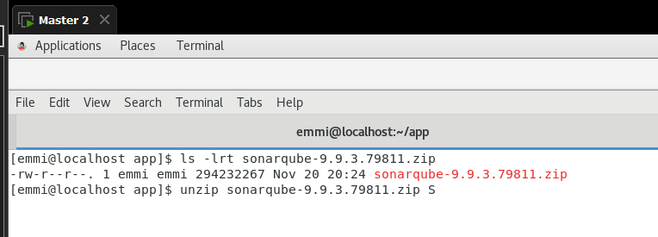

Unzipsonarqube-9.9.3.79811.zip

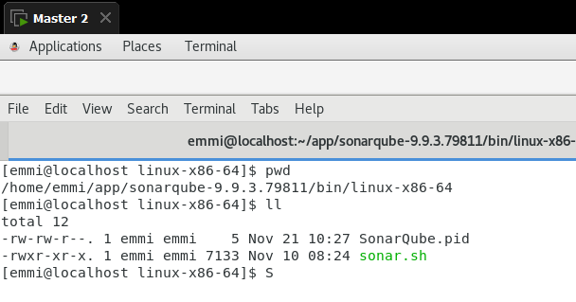

sonarqube-9.9.3.79811/bin/linux-x86-64 direct to the given path and run ./sonar.sh start

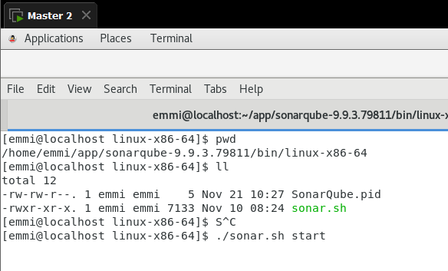

Dashboard - Manage Jenkins - System

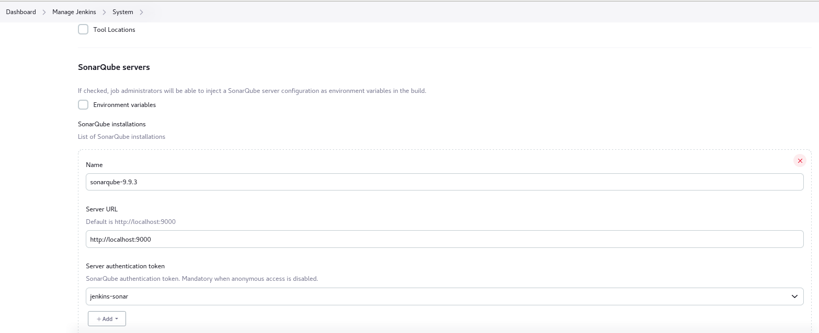

Give path and name make sure the name should match with the pipeline.

Download sonar scanner plugin

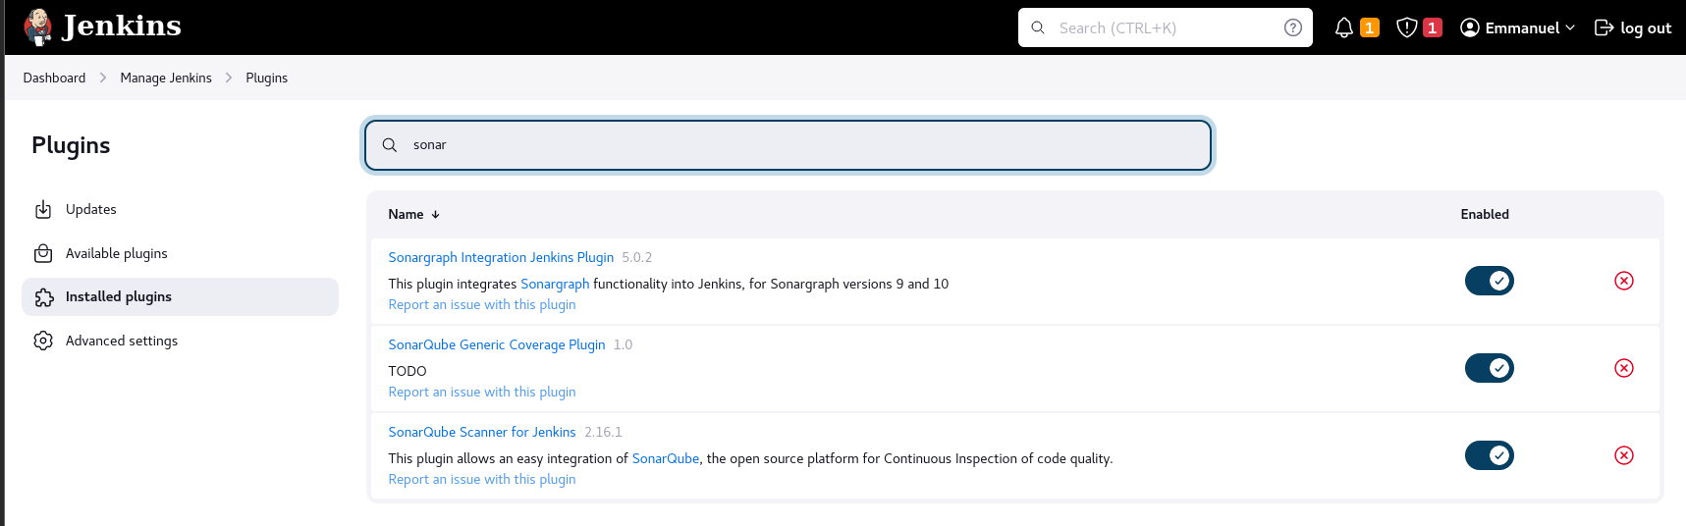

**IMP Create Sonar token from Administrator**

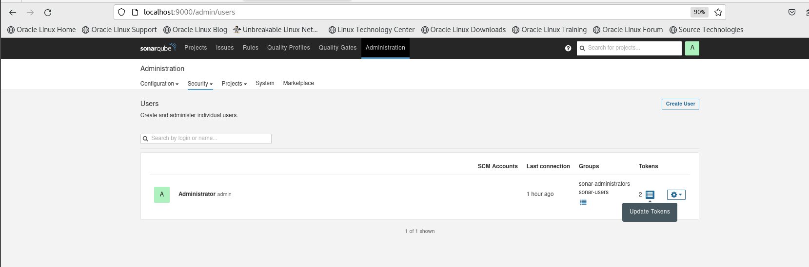

Provide Execute Analysis rights

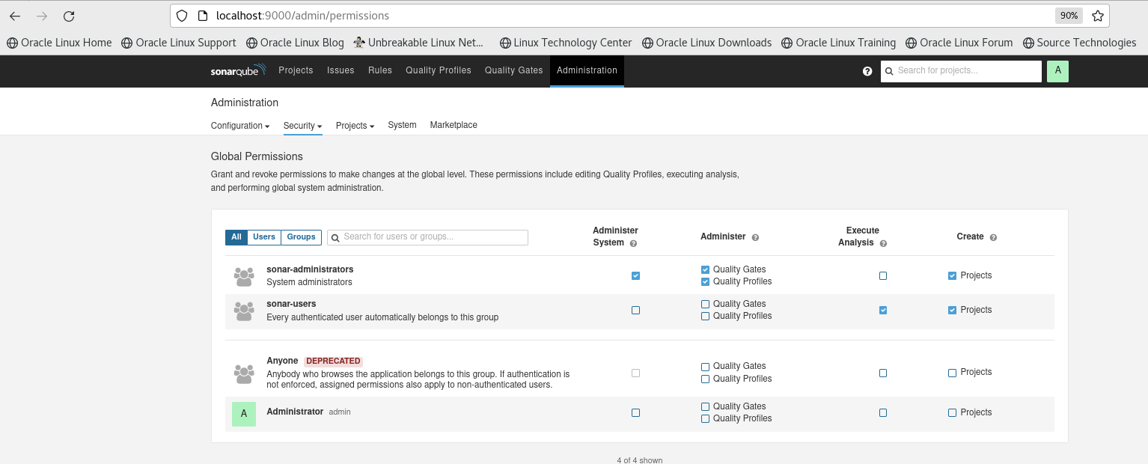

Create job in Jenkins naming FirstSonarProject

Use the below pipeline

pipeline{

agent any

tools{

maven 'MAVEN'

}

stages{

stage('checkout'){

steps{

echo "checkout from github"

checkout scmGit(branches: [[name: '*/main']], extensions: [], userRemoteConfigs: [[url: 'https://github.com/sandqw/dev.git']])

}

}

stage('build'){

steps{

echo "building with maven"

sh 'mvn clean package'

}

}

stage('SonarQube analysis') {

// def scannerHome = tool 'SonarScanner 4.0';

steps{

withSonarQubeEnv('sonarqube-9.9.3') {

// If you have configured more than one global server connection, you can specify its name

// sh "${scannerHome}/bin/sonar-scanner"

sh "mvn clean verify sonar:sonar -Dsonar.login=squ_1363ed91fad4a928cb6aadd29a187128b5169858"

}

}

}

}

}

withSonarQubeEnv('sonarqube-9.9.3') {

change the 'sonarqube-9.9.3' above and name as what u have configured in Jenkins

Dsonar.login=squ_1363ed91fad4a928cb6aadd29a187128b5169858"

Change squ_1363ed91fad4a928cb6aadd29a187128b5169858 with your generated token