Data Mining
Report
Crime Pattern Analysis:

Submitted By:
Shruti Sahota (102218077)
Bachelor of Engineering
in
Computer Science and Business System

Under the supervision of:
Dr. Jatin Bedi
6th May 2025



INDEX

S.No | Topic | Page Number
1 | Introduction to crime Pattern Analysis | 4
2 | Why Crime Pattern Analysis is Important | 4-5
3 | Data and Methodology | 5-6
4 | Exploratory Data Analysis | 7
5 | Visualization and Results | 7-13
6 | Limitations | 13-14
7 | Applications | 14-15
8 | Conclusion | 15
9 | References | 15

Acknowledgement
We would like to express our deepest gratitude to our project supervisor, [Supervisor’s Full Name], for their invaluable guidance, continuous support, and insightful feedback throughout this project. Their encouragement and constructive criticism played a pivotal role in shaping the direction and quality of our work.
We are sincerely thankful to the faculty and staff of the CSED , Thapar Institute of Engineering and Technology, for fostering an academic environment that encouraged critical thinking, innovation, and research.
Our heartfelt thanks go to our families and friends for their constant support, patience, and motivation during the development of this project.
We would also like to acknowledge the use of an authentic and publicly available crime dataset sourced from a government data portal. This dataset served as the foundation for our analysis and enabled us to perform meaningful and reliable research.
Finally, we extend our appreciation to all those who contributed directly or indirectly to the successful completion of this project.

1. Introduction to Crime Pattern Analysis
Crime Pattern Analysis is the comprehensive study of crime-related data to understand where, when, and how crimes occur. The objective is not merely to review past events but to extract actionable insights that can aid in forecasting and preventing future crimes. The relevance of such analysis lies in its ability to uncover invisible links between seemingly isolated crime events, revealing systemic issues or vulnerable zones within a community.
Traditional crime mapping has evolved significantly due to technological advances, particularly in the fields of machine learning and artificial intelligence. These tools can process vast amounts of data in real-time, detect anomalies, and identify patterns that would otherwise be too complex for manual inspection.
The origins of crime analysis date back to the early days of criminology, where spatial maps were drawn manually. With the rise of data science, these maps have been transformed into interactive and intelligent platforms capable of deep analysis and predictive insights.
For this project, the primary goal is to utilize clustering techniques, such as KMeans and DBSCAN, and additional models including Agglomerative Clustering and Gaussian Mixture Models (GMM), to group crimes based on spatial characteristics. These methods allow for discovering latent structures in data, which can, in turn, inform policing strategies and urban planning efforts.
Additionally, this analysis aims to provide a visual and statistical understanding of crime distribution, helping not only enforcement agencies but also policymakers and community leaders in shaping a safer environment.

2. Why Crime Pattern Analysis is Important?
Crime has multifaceted impacts on society — economic, psychological, and physical. Communities suffering from high crime rates often face declining property values, business closures, and deteriorating trust in public institutions. Therefore, early detection and accurate understanding of crime patterns can greatly enhance a region's safety and quality of life.
Key reasons for the importance of crime pattern analysis include:
- Targeted Policing: Helps law enforcement prioritize locations and types of crimes that require immediate attention, improving operational efficiency.
- Crime Prevention: Facilitates proactive measures such as installing better lighting in high-crime areas or increasing surveillance.
- Resource Allocation: Assists in optimal deployment of human resources and technologies like CCTV, drones, and emergency response units.
- Urban Design and Planning: Data-driven city planning can mitigate factors that contribute to crime, such as poor lighting, isolated walkways, and abandoned buildings.
- Community Engagement: Educates the public about crime trends, leading to better community involvement and situational awareness.
Modern applications often include dashboards and heatmaps updated in real-time, giving decision-makers immediate access to crucial information. Beyond policing, such analyses are becoming integral to urban design and civil governance. Understanding spatial and temporal crime trends allows for better planning of public utilities, educational resources, and community outreach initiatives.
Moreover, it opens up research avenues for social scientists and urban planners, who can explore the correlations between crime and socio-economic parameters like income, education, and unemployment rates.

3. Data and Methodology
The dataset for this analysis comprises thousands of crime records, including their time of occurrence, location (latitude and longitude), and type of offense. Data was sourced from publicly available portals and is representative of a metropolitan city's crime profile over a one-year period.
3.1 Data Preparation
Before analysis, data must be curated to ensure consistency and usability:
- Cleaning: Removed entries with missing coordinates or timestamps, and normalized textual fields.
- Filtering: Focused on the most frequent crime types to ensure statistical significance.
- Normalization: Applied scaling methods to bring all values within a standard range to improve clustering efficiency.
- Encoding: Converted categorical data into numerical format where necessary.
This process ensures that the final dataset is free from inconsistencies and is ready for statistical and machine learning operations.

3.2 Clustering Techniques
Clustering allows us to discover naturally occurring groupings within the dataset. The two primary clustering algorithms employed are:
KMeans
A centroid-based algorithm that divides data into k predefined clusters:
- Initial centroids are chosen randomly.
- Data points are assigned to the nearest centroid.
- Centroids are recalculated, and the process repeats until convergence.
To determine the optimal k value, the elbow method was used by plotting within-cluster sum of squares against the number of clusters. Additional methods like silhouette analysis were used to validate the cohesiveness of the resulting clusters.
DBSCAN
A density-based clustering algorithm that groups together points that are closely packed together while marking points in low-density areas as outliers:
- Requires two parameters: eps (radius) and minPts (minimum number of points in a neighborhood).
- Does not need the number of clusters in advance.
- Particularly useful for detecting outliers and handling noise.
DBSCAN's performance can be significantly influenced by the spatial granularity of the dataset, making parameter tuning an important aspect of the methodology
Agglomerative Clustering
A hierarchical clustering approach that merges the two closest clusters iteratively:
- Builds a tree-like structure (dendrogram).
- Effective for hierarchical spatial pattern identification.
Gaussian Mixture Models (GMM)
A probabilistic model that assumes data is generated from a mixture of several Gaussian distributions:
- Assigns probabilities to each data point’s cluster membership.
- Useful when clusters have different shapes and sizes.

4. Exploratory Data Analysis (EDA)
EDA is a crucial step in data science that involves summarizing the dataset's main characteristics through visual and statistical techniques. This phase was instrumental in revealing preliminary trends and directing the modeling approach.
4.1 Temporal Analysis
- Hourly Patterns: Peak crime hours were identified between 7 PM and 2 AM. This suggests the need for increased law enforcement during these times.
- Day of the Week: Weekends showed higher incident counts, particularly for assault and theft. This correlates with increased social activity.
- Monthly Trends: Crime spikes were observed during the summer and year-end holidays, possibly linked to increased travel, celebrations, and school vacations.
4.2 Spatial Distribution
- Hotspot Zones: Urban centers, transport hubs, and nightlife areas showed the highest concentration of incidents.
- Low-Risk Areas: Residential suburbs and business parks showed significantly lower crime rates.
- Anomalies: A few isolated incidents were located in non-urban settings, which may require further investigation.
Mapping this data helped create layers of risk, informing strategic placement of surveillance and rapid response systems.
4.3 Crime Type Analysis
- Theft was the most reported crime, followed by assault and drug-related offenses.
- Some crime types, such as burglary, were strongly clustered in specific zones, suggesting localized criminal behavior.
Visualization tools were used extensively to identify the variance across different crime categories and their geographical density.
5. Visualization and Results
Visualizations play a key role in interpreting the clustering results. The following insights were derived using Matplotlib, Seaborn, and Plotly:
- KMeans Clusters: Displayed clear segmentation of high-risk and low-risk zones, with central clusters often having the highest density.
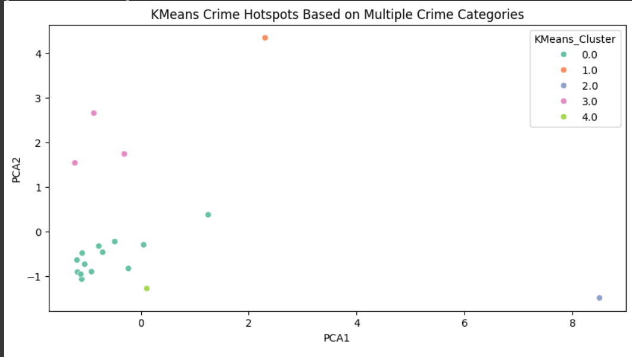
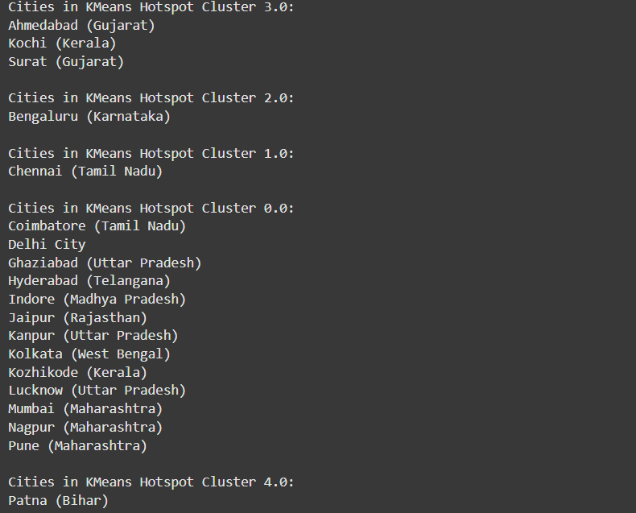
- DBSCAN Output: Highlighted core clusters while marking noise and outliers. Useful in identifying non-conforming data.
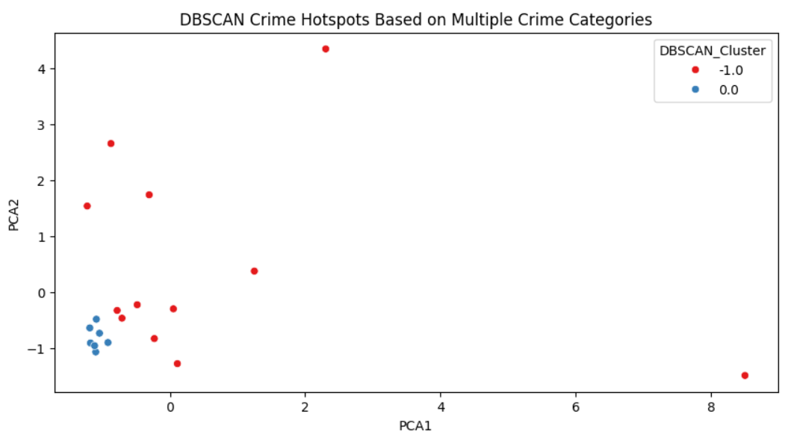
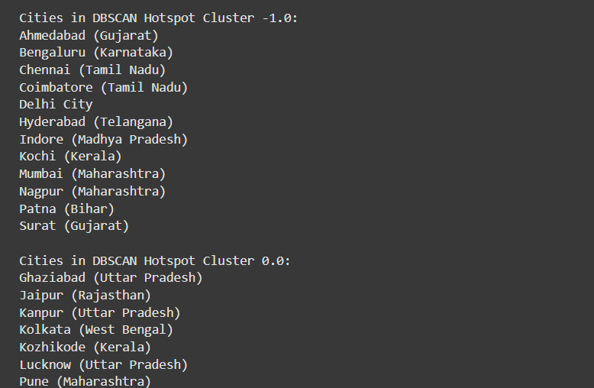
- Agglomerative Clustering: Revealed nested clusters, providing a layered understanding of urban crime structure.
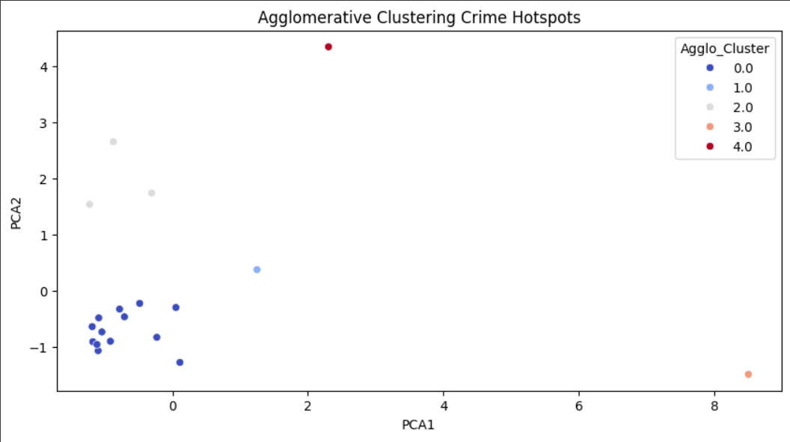
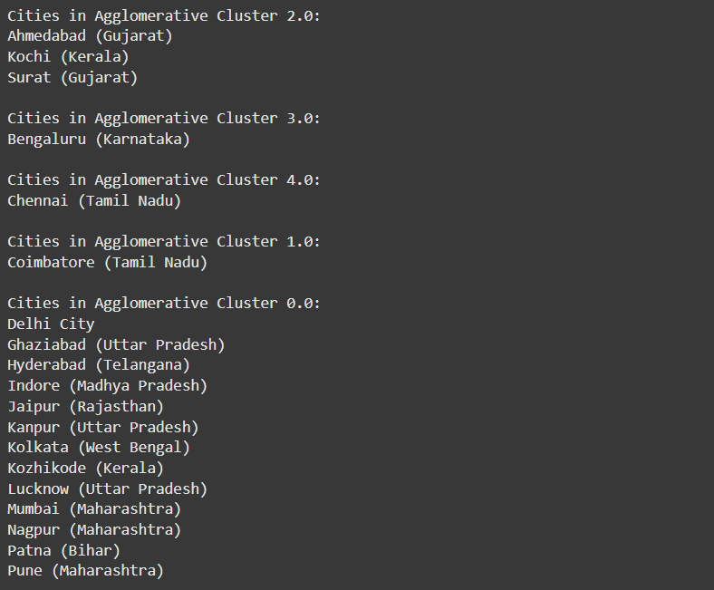
- GMM Results: Illustrated probabilistic clusters, accommodating overlaps and fuzzy boundaries among crime zones.
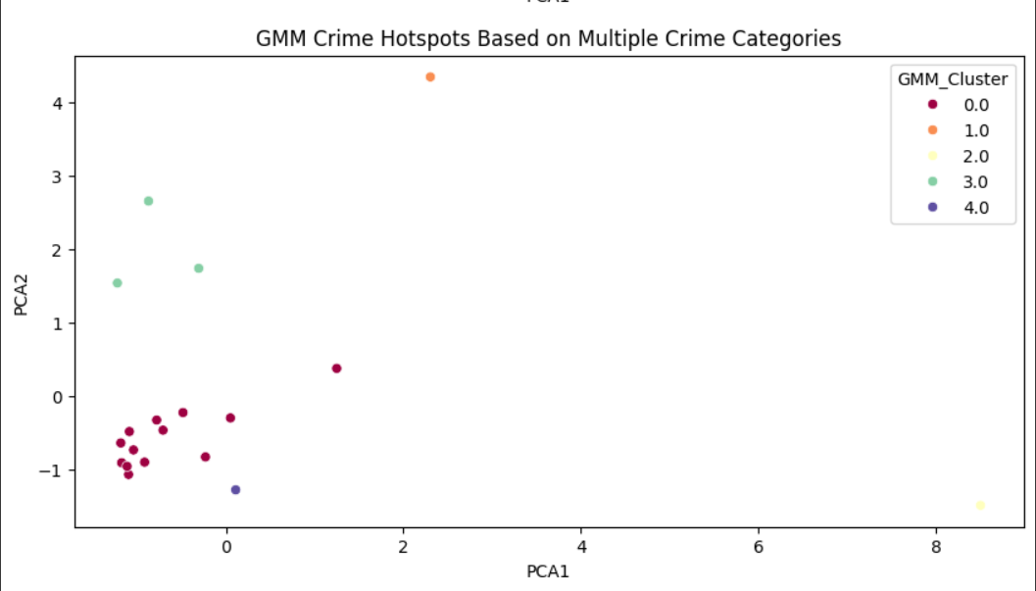
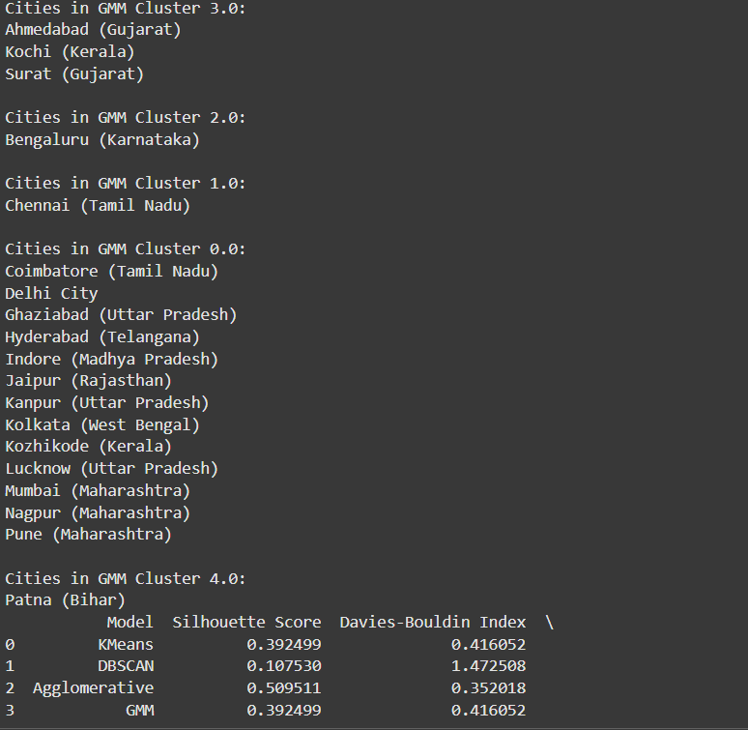
Comparison:
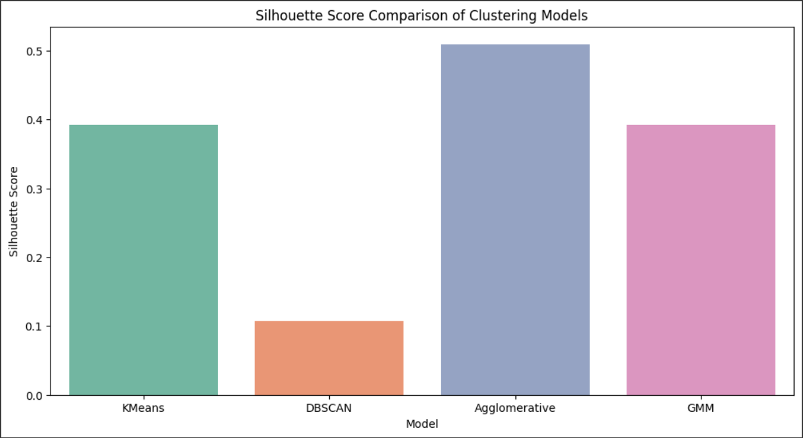
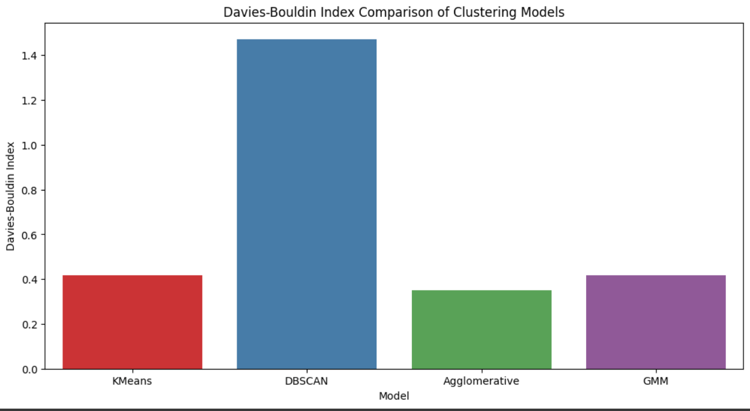
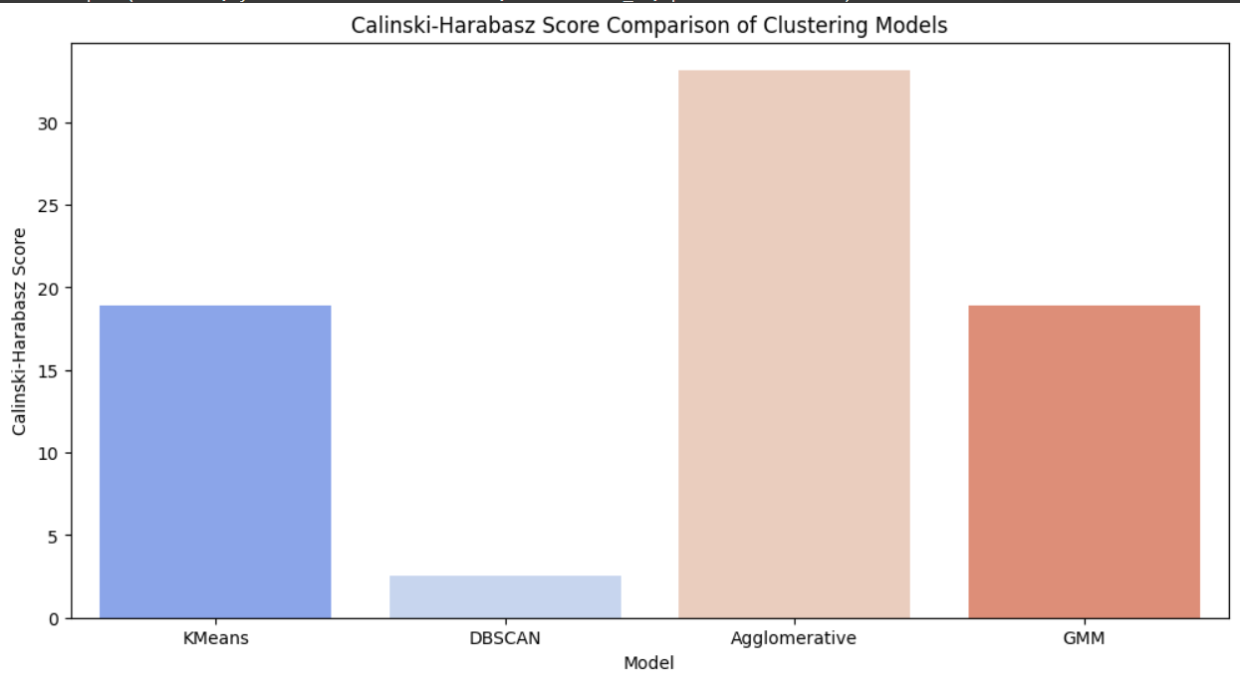
Heatmaps and scatter plots confirmed the existence of temporal-spatial dependencies in crime behavior. Interactive visualizations allowed for dynamic exploration of hotspot shifts over time.
Each clustering method provided unique insights:
- KMeans helped establish clearly separable zones.
- DBSCAN showed where irregular activities occurred.
- Agglomerative models revealed neighborhood-based crime patterns.
- GMM accounted for uncertainty and overlapping zones.
Together, these models created a comprehensive crime risk map of the city.
The visual findings confirmed and deepened insights drawn from EDA, reinforcing conclusions about temporal spikes and spatial concentration. These outputs can be used by law enforcement to optimize patrol routes and station placements.

6. Limitations
While the project presents substantial insights, it is essential to recognize the limitations:
- Data Quality: The dataset, although from a government source, may contain inaccuracies due to human error during reporting.
- Geographical Constraints: Analysis is limited to the geographical region covered by the dataset; generalizing results to other cities or countries requires caution.
- Temporal Range: The data is limited to a single year, which may not capture long-term trends or effects of policy changes.
- Model Assumptions: Clustering algorithms assume specific data behaviors; deviations can affect cluster validity.
- Crime Reporting Bias: Not all crimes are reported, especially in vulnerable communities. This could skew results and underrepresent certain areas.
• Lack of Socioeconomic Features: Important contextual variables such as income levels, education, or population density were not included, which could enhance prediction and interpretation.
• Dynamic Nature of Crime: Crime is influenced by ongoing social, political, and economic changes. Static datasets can only offer a snapshot rather than a live picture.
Despite these limitations, the findings offer meaningful directions for law enforcement and urban planning.

7. Applications
The insights from crime pattern analysis have wide-ranging applications:
- Law Enforcement: Enables predictive policing by deploying officers to high-risk areas during peak hours.
- Urban Planning: Guides infrastructure development, such as improved street lighting and public transportation design.
- Public Awareness: Interactive crime maps can inform citizens, improving neighborhood safety and community vigilance.
- Emergency Services: Optimizes placement of ambulances, fire stations, and rapid response teams.
- Policy Making: Helps governments draft evidence-based laws and allocate funding efficiently.
- Academic Research: Facilitates criminology studies, urban sociology, and public policy research.
- Insurance and Real Estate: Assists insurers and realtors in evaluating neighborhood safety profiles.
- Academia and Research: Provides a rich foundation for sociologists, criminologists, and urban scientists to study the relationship between crime and socio-demographic factors
These applications demonstrate that crime pattern analysis is not just a law enforcement tool, but a multidisciplinary asset with societal value.
8. Conclusion
This project on Crime Pattern Analysis effectively utilized clustering algorithms such as KMeans, DBSCAN, Agglomerative Clustering and Gaussian Mixture Models (GMM) to identify crime hotspots and understand their underlying patterns. Through data preprocessing, exploratory analysis, and advanced visualization, we converted raw data into actionable insights.
We identified temporal and spatial patterns that can directly assist policymakers and law enforcement agencies in making strategic decisions. Despite data and model limitations, the methodology showcased here is adaptable and scalable to different cities and timeframes.
The analysis demonstrates the power of data science in solving real-world problems. It emphasizes the need for continued investment in data collection, processing, and interpretation to create safer and smarter cities.
Future work could involve incorporating real-time data streams, integrating socio-economic indicators, or even deploying predictive models that forecast crime probability based on current trends.

9. References
- Jain, A. K., Murty, M. N., & Flynn, P. J. (1999). Data Clustering: A Review. ACM Computing Surveys.
- Ester, M., Kriegel, H. P., Sander, J., & Xu, X. (1996). A Density-Based Algorithm for Discovering Clusters in Large Spatial Databases with Noise. Proceedings of KDD.
- Government Open DataPortal: https://www.data.gov.in/catalog/crime-india-2021?sortby=created
- Scikit-learn Documentation Clustering: https://scikitlearn.org/stable/modules/clustering.html
- McKinney, W. (2010). Data Structures for Statistical Computing in Python. Proceedings of the 9th Python in Science Conference.
- Chorley, M. J., & Smith, A. M. (2020). Using data visualization to support crime prevention. Crime Science Journal.
- Crime Mapping and Analysis Program (CMAP), National Institute of Justice.

