Report
Streamlit
import streamlit as st
import pandas as pd
df=pd.read_csv(r" Stores.csv")
st.title("Supermarket Data Analysis")
st.line_chart(df)
st.bar_chart(df)

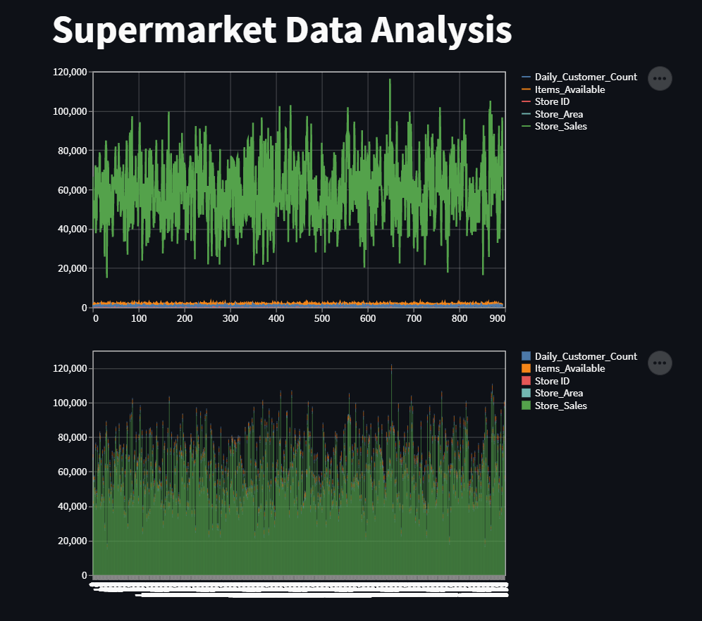

Heroku

