WEEK 1 ASSIGNMENT REPORT
Data Acquisition, Cleaning, and Exploratory Data Analysis
Dataset: Scikit-learn Diabetes Dataset
Prepared by: [shruti Saxena]
Course/Program: [ yuvainternship ]
Date: 23 October 2026
Prepared using Python, pandas, Matplotlib, and scikit-learn.

1. Introduction
This report documents the acquisition, inspection, data-quality checks, and exploratory analysis of a public diabetes regression dataset supplied by scikit-learn. The aim is to understand the dataset, determine whether cleaning is needed, visualize distributions and relationships, and summarize initial findings.

2. Dataset Source and Description
The dataset was loaded with scikit-learn's load_diabetes(as_frame=True) function. It contains 442 observations and 11 columns: 10 input features (age, sex, bmi, bp, s1, s2, s3, s4, s5, s6) and a quantitative target representing disease progression one year after baseline. Predictor values are standardized, not raw clinical measurements.
Public documentation: https://scikit-learn.org/stable/datasets/toy_dataset.html#diabetes-dataset

2.1 Acquisition code
from sklearn.datasets import load_diabetes
diabetes = load_diabetes(as_frame=True)
df_raw = diabetes.frame
print("Dataset dimensions:", df_raw.shape)
display(df_raw.head())
df_raw.to_csv("diabetes_raw.csv", index=False)
The function loads the public dataset. The frame attribute returns it as a pandas DataFrame. shape reports the number of rows and columns, head() displays the first five records, and to_csv() saves a raw CSV without the DataFrame index.

3. Initial Inspection and Data Quality
The dataset has 442 rows and 11 columns. Checks found 0 missing cells and 0 exact duplicate rows.

3.1 Data-quality check code
print(df_raw.isnull().sum()) # Missing values per column
print(df_raw.duplicated().sum()) # Duplicate rows
print(df_raw.dtypes) # Column data types
isnull().sum() counts missing cells by column. duplicated().sum() counts exact duplicate rows. dtypes displays the stored data type of each column.

4. Cleaning Method and Rationale
A separate working copy was created to preserve the original data. No missing values or duplicate rows were found, so imputation and duplicate removal were not necessary. Potential outliers were not automatically deleted because unusual values are not necessarily errors.
df = df_raw.copy()
print(df.shape)
print(df.isnull().sum().sum())
print(df.duplicated().sum())
df.to_csv("diabetes_cleaned.csv", index=False)
The working copy remains 442 × 11. Because the checks did not identify issues requiring correction, the cleaned CSV contains the same observations as the raw CSV. This is a valid outcome when cleaning checks find no problems.

5. Exploratory Data Analysis
The target mean is 152.13 and the median is 140.5. The strongest absolute correlation between an input feature and the target is for bmi (r = 0.586).

5.1 Histogram — target distribution
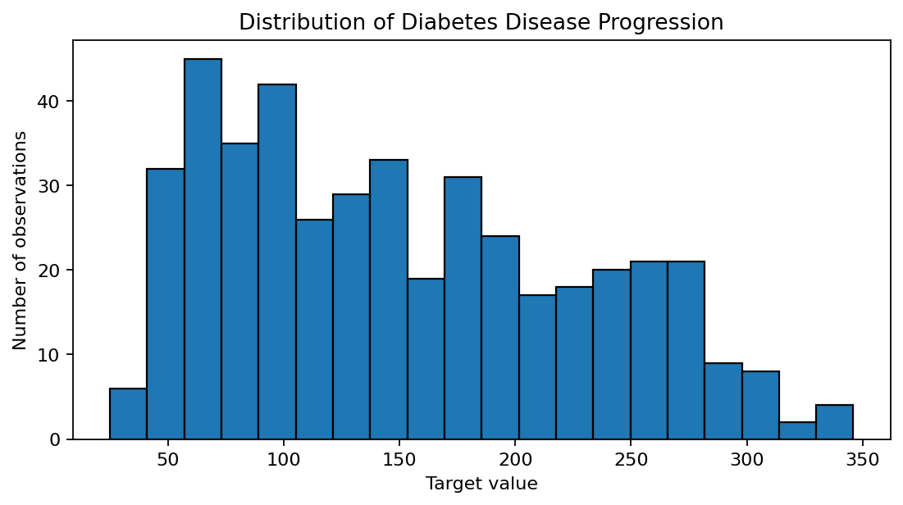
Figure: target distribution.
The histogram shows how frequently target values occur in different ranges. The target is a quantitative disease-progression measure, not a yes/no diagnosis.

5.2 Bar chart — missing values
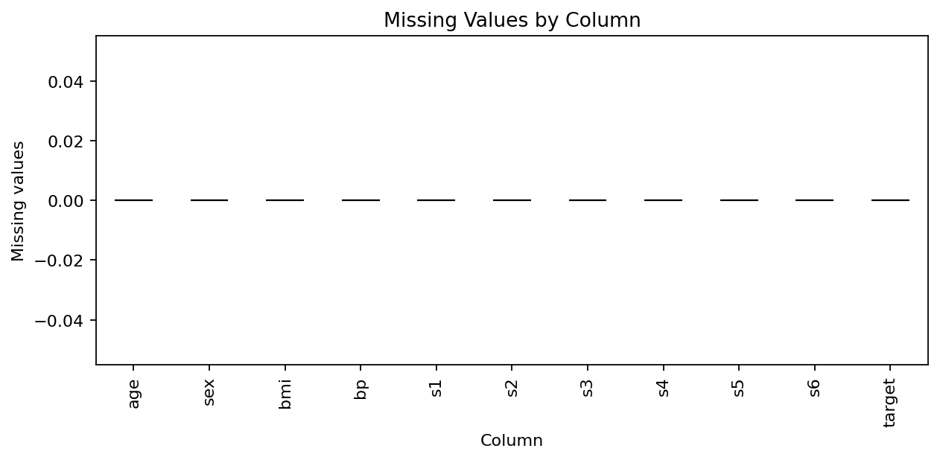
Figure: missing values.
All columns have zero missing values, so the bars have zero height. This supports the decision not to impute missing values.

5.3 Heatmap — correlations
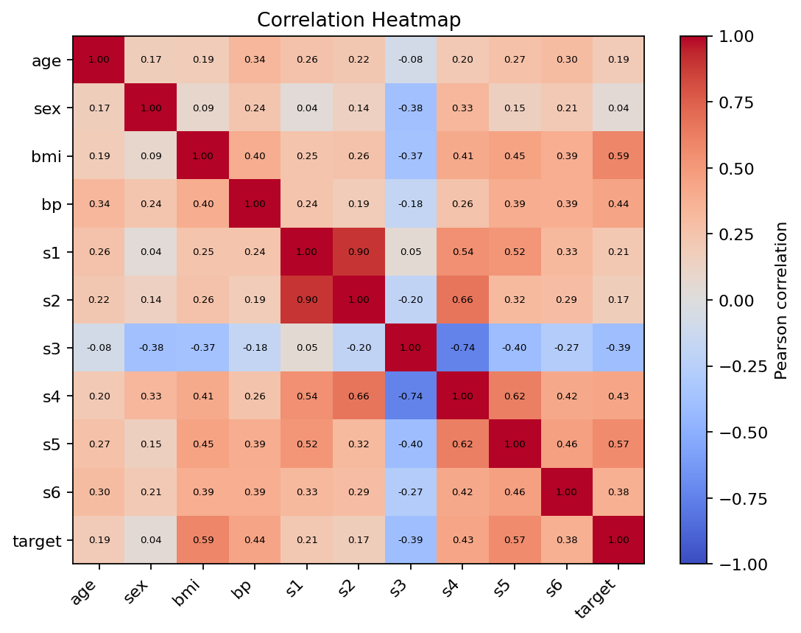
Figure: correlations.
The heatmap shows pairwise Pearson correlations. Positive values indicate variables that tend to increase together; negative values indicate an inverse linear association. Correlation does not establish causation.

5.4 Scatter plot — BMI and target
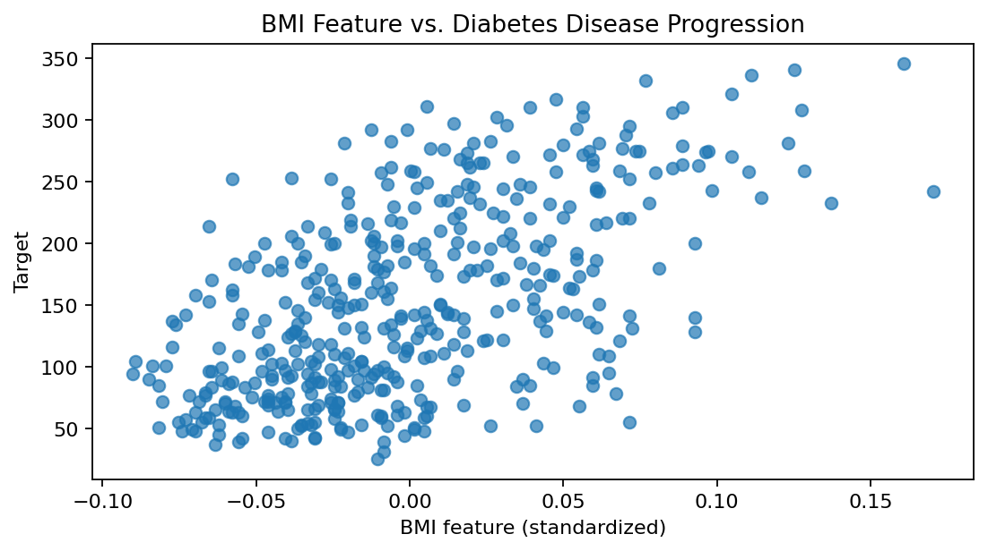
Figure: BMI and target.
The BMI feature has a positive correlation with the target (r = 0.586). The scatter plot provides a visual check of this association. BMI values here are standardized feature values.

5.5 Box plot — target
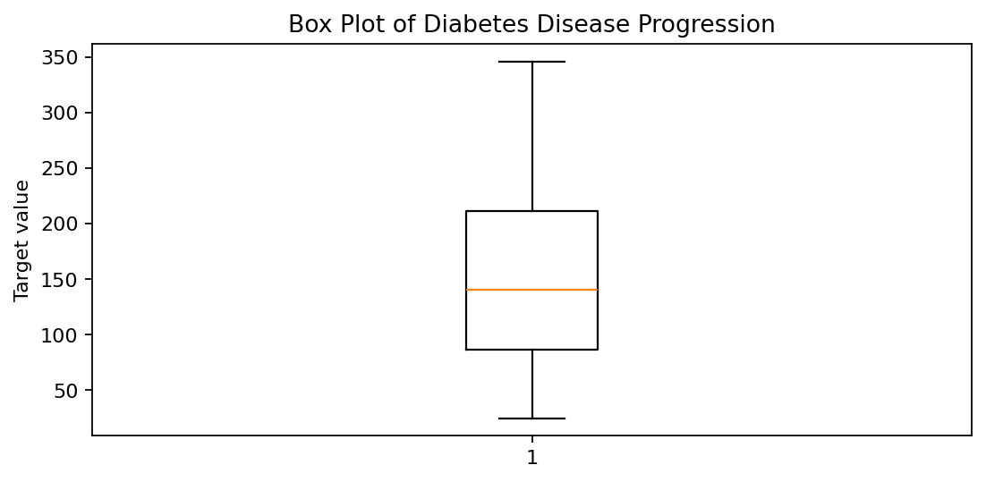
Figure: target.
The box plot summarizes the median, interquartile range, and potential outliers under the standard box-plot rule. Potential outliers were not removed automatically.

6. Key Findings
- The dataset contains 442 observations and 11 columns.
- No missing cells or exact duplicate rows were found.
- The target mean is 152.13, and the median is 140.5.
- BMI has the strongest absolute correlation with the target among the input features (r = 0.586).
- The s5 feature is positively correlated with the target (r = 0.566), while s3 has a negative correlation (r = -0.395).
- The predictor features are standardized and should not be interpreted as ordinary clinical units.

7. Limitations
This is a small, pre-packaged educational dataset. The predictor features are standardized, so they do not represent ordinary clinical units. This report is descriptive; correlations do not demonstrate cause and effect. No predictive model was trained or evaluated.

8. Conclusion
The public diabetes dataset was loaded, inspected, and saved as a raw CSV. Data-quality checks found no missing values or duplicate rows, so no imputation or row removal was required. Five visualizations were used to examine the target distribution, missingness, correlations, BMI-target association, and target spread. BMI showed the strongest correlation with the target among the input features. These results provide a starting point for further analysis while recognizing that correlation is not causation.

Appendix: Libraries used
import pandas as pd
import numpy as np
import matplotlib.pyplot as plt
import seaborn as sns
from sklearn.datasets import load_diabetes
Before submitting, replace [Your Name] and [Your Course or Program] on the cover page and check any additional formatting requirements from your instructor.

