YUVA INTERNSHIP
WEEK 2 PROJECT REPORT
Data Visualization and Storytelling
Submitted by: Shruti Saxena
Yuva Internship

1. Introduction
This project builds on the Week 1 exploratory analysis and focuses on using visualizations to communicate patterns clearly to a non-technical audience. Six charts examine the distribution of the target, relationships between variables, differences between groups, and patterns involving multiple features.
The analysis uses the diabetes dataset included with scikit-learn. It contains 442 observations, ten input features, and a quantitative target measuring disease progression one year after baseline. The target is not a binary diabetes diagnosis, and input features are standardized rather than expressed in their original clinical units.

2. Objectives
- Create at least five informative visualizations.
- Explain the purpose and message of each chart.
- Build a coherent data story using evidence from the charts.
- Discuss potential scientific implications and limitations.

3. Dataset and Methodology
The dataset was loaded with scikit-learn's load_diabetes(as_frame=True) function and analyzed in Pandas. Matplotlib and Seaborn were used to create the charts. Pearson correlation summarizes linear relationships. For the group comparison, observations were divided into three approximately equal-sized groups using tertiles of the standardized BMI feature.
Week 1 quality checks found no missing values and no duplicate rows. The dataset has 442 rows and 11 columns including the target.

4. Visual Analysis and Storytelling

Figure 1. Distribution of Disease Progression
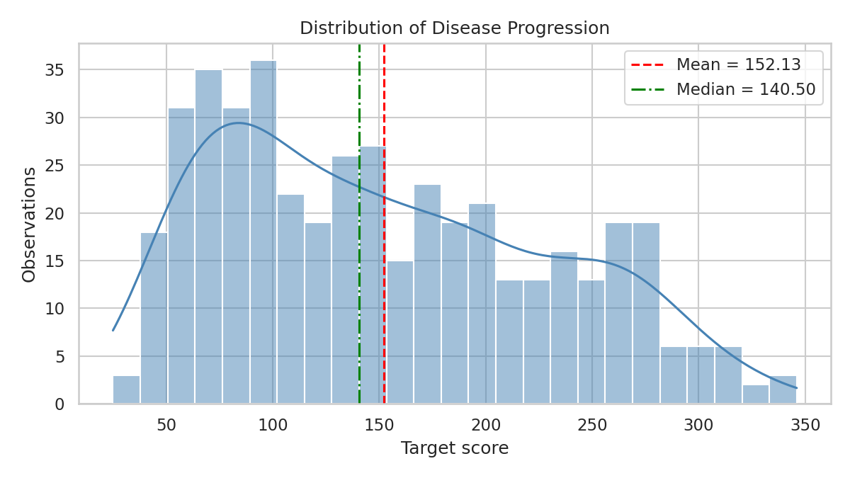
Figure 1. Distribution of Disease Progression.
The histogram and density curve show how target scores are distributed. The mean is 152.13 and the median is 140.50. The mean being above the median suggests higher scores may pull the average upward. This chart introduces the shape and spread of the outcome distribution.
Why this chart: A histogram is suitable for showing the shape and spread of a quantitative variable.

Figure 2. Correlation Heatmap
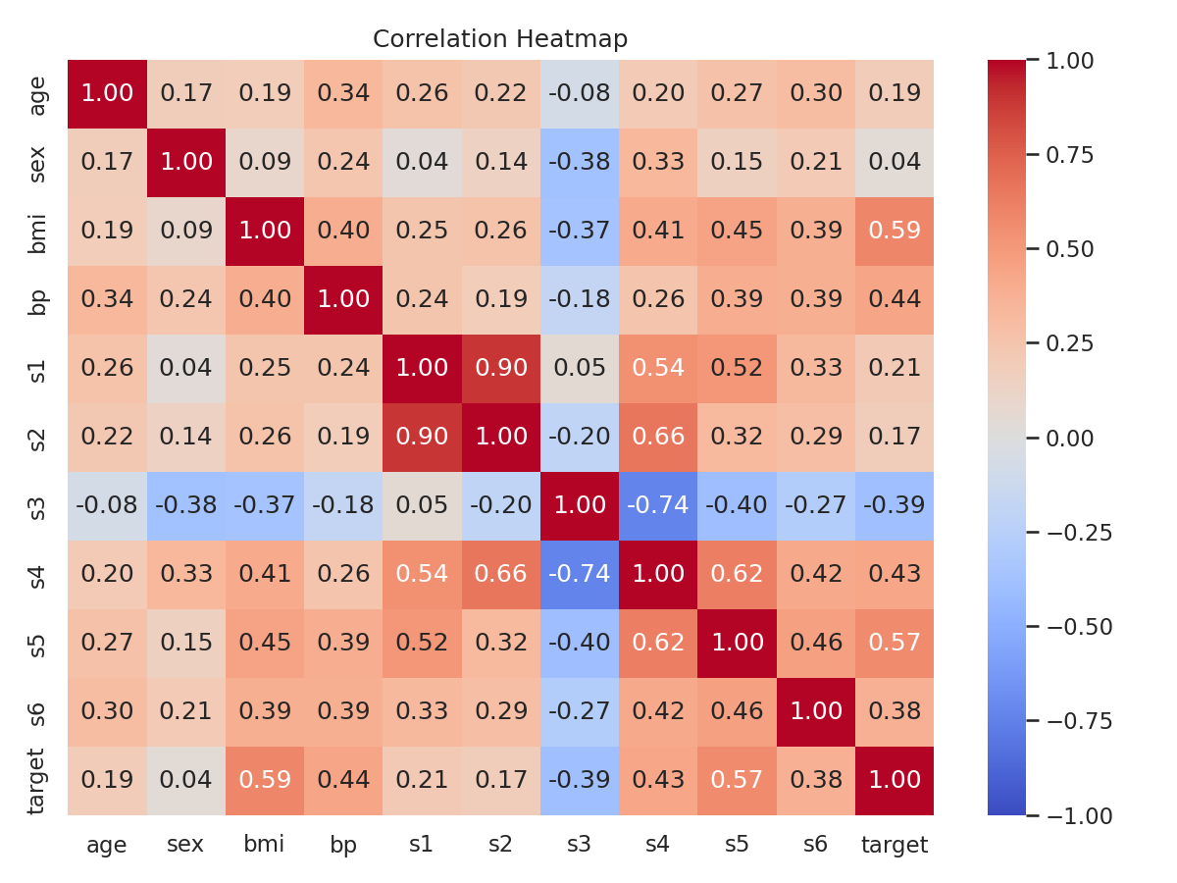
Figure 2. Correlation Heatmap.
The heatmap displays Pearson correlations between numeric variables. BMI has the strongest positive correlation with the target (r = 0.586). Color and coefficient labels show the direction and strength of relationships. Correlation does not prove causation.
Why this chart: A heatmap lets readers compare many relationships in one compact visual.

Figure 3. BMI and Disease Progression
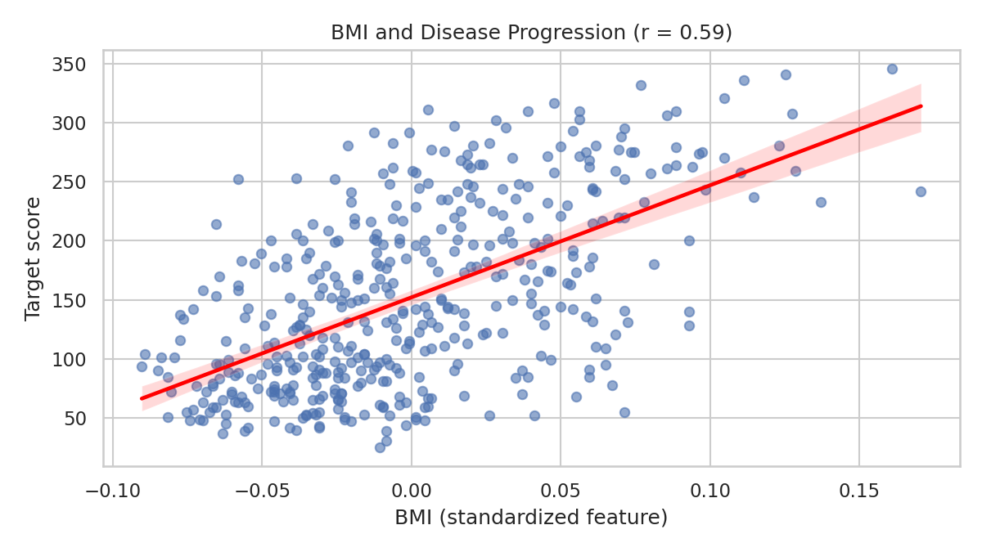
Figure 3. BMI and Disease Progression.
The scatter plot and fitted line show a positive association between standardized BMI and the target (r = 0.586). The spread of points around the line shows BMI alone does not explain all differences in target scores.
Why this chart: A scatter plot shows direction, spread, and possible outliers in a two-variable relationship.

Figure 4. Disease Progression Across BMI Groups
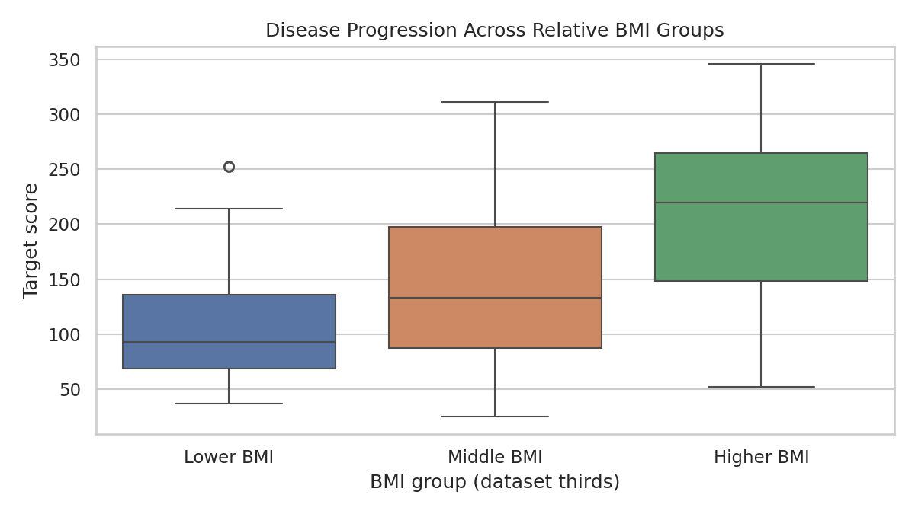
Figure 4. Disease Progression Across BMI Groups.
The box plot compares target distributions among lower, middle, and higher BMI thirds within this dataset. Medians, interquartile ranges, whiskers, and possible outliers help compare the groups. These are relative groups, not clinical BMI categories.
Why this chart: Box plots compare group distributions while showing variation, not only averages.

Figure 5. Feature Correlation Ranking
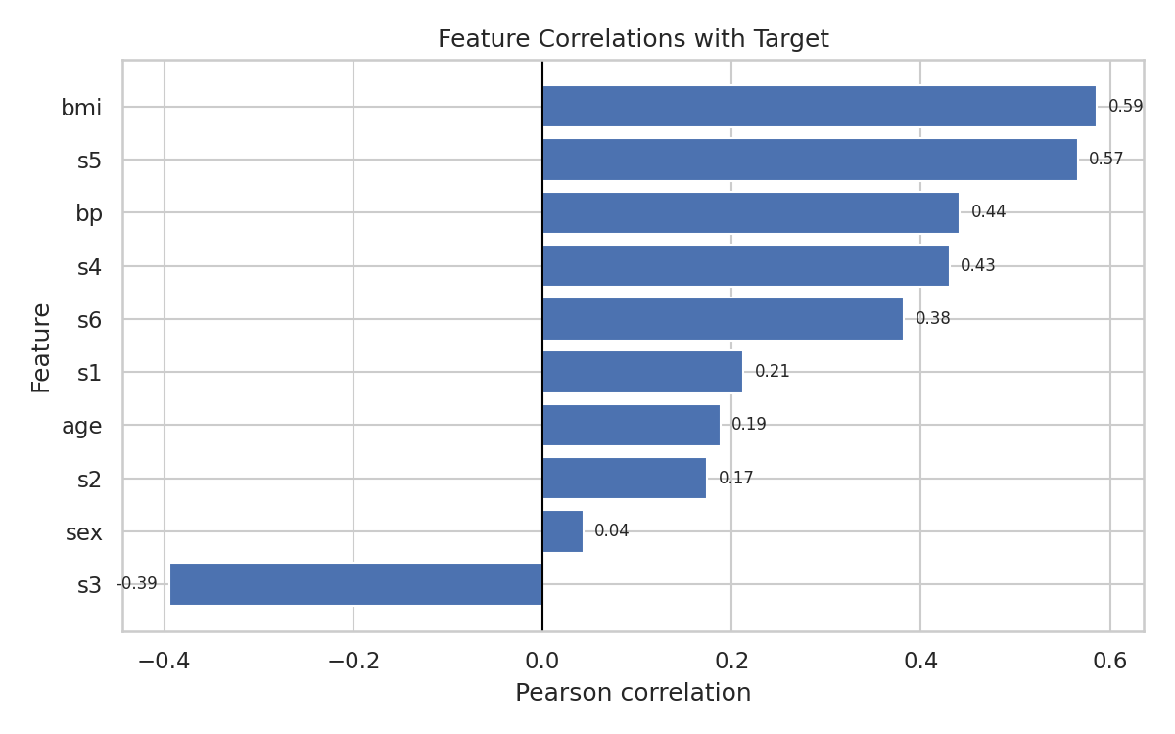
Figure 5. Feature Correlation Ranking.
The horizontal bar chart ranks features by Pearson correlation with the target. Positive values indicate variables that tend to increase with the target; negative values indicate inverse linear relationships. BMI has the strongest positive correlation among input features. Correlation does not prove causation or automatically establish predictive importance.
Why this chart: A ranked bar chart makes relative strengths easier to compare than a matrix.

Figure 6. Age, BMI, and Disease Progression
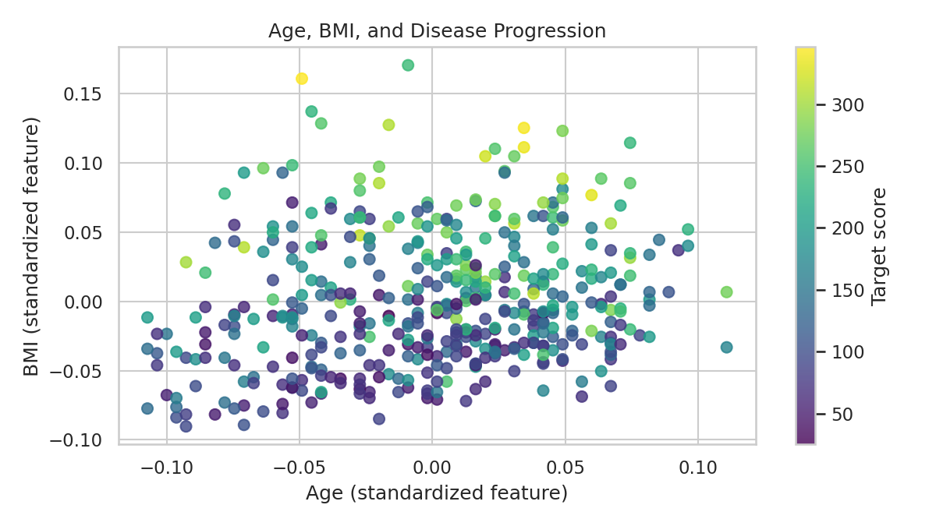
Figure 6. Age, BMI, and Disease Progression.
This scatter plot compares standardized age and BMI, with color representing the target. It lets the reader inspect three variables at once and look for regions with different target values. It is exploratory; apparent patterns require further analysis.
Why this chart: Using color for a third variable adds context while preserving each observation's position.

5. Overall Data Story
Together, the charts first describe the target distribution, then explore its relationships with available features. BMI stands out as the input feature with the strongest positive linear correlation with the target. The scatter plot and group comparison show variation among observations, while the multivariable plot broadens the exploration to age and BMI together. The central message is that visualization can highlight patterns for further study while making variation visible.

6. Potential Scientific Implications
The positive association between BMI and the target may motivate further investigation of BMI alongside other variables. These charts can help analysts communicate exploratory findings and formulate questions for more rigorous study. Any clinical or policy conclusions would require appropriate statistical analysis and validation on suitable independent data.

7. Limitations
- The analysis is observational; correlation does not establish causation.
- The target measures disease progression one year after baseline, not whether someone has diabetes.
- Input features are standardized and do not use ordinary clinical units.
- Visual patterns depend on the sample and chart design.
- These charts should not be used alone to make clinical decisions.

8. Conclusion
This project demonstrates how carefully selected charts can turn a dataset into an understandable visual narrative. The six visualizations show distribution, correlation, a two-variable association, group differences, ranked relationships, and a multivariable view. BMI has the strongest positive linear correlation with the target in this dataset. Clear design, plain-language interpretation, and explicit limitations help communicate findings responsibly.

9. Tools and References
Tools: Python, Pandas, NumPy, Matplotlib, Seaborn, scikit-learn, Jupyter Notebook, and Microsoft Word.
Dataset documentation: scikit-learn, “Toy datasets — Diabetes dataset.”
https://scikit-learn.org/stable/datasets/toy_dataset.html#diabetes-dataset

