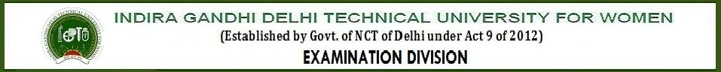
ADMIT CARD - END TERM EXAMINATION
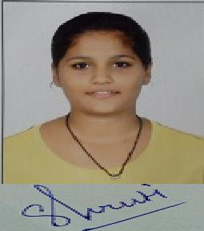

(May, 2015)

Enrollment No. : 03301032013 Name : SHRUTI SETHIA

Programme : B.Tech IT Session : 4th Semester

PAPERS REGISTERED FOR THE END TERM EXAMINATION(May, 2015)

BAS 202 Advanced Engineering Mathematics

BCS 204 Computer Organization & Architecture

BCS 206 Analysis & Design of Algorithms

BIT 208 Operating System

BIT 210 Object Oriented Software Engineering

BCS 254 Computer Organization & Architecture Lab

BCS 256 Analysis & Design of Algorithms Lab

BIT 258 Operating System Lab

BIT 260 Object Oriented Software Engineering Lab
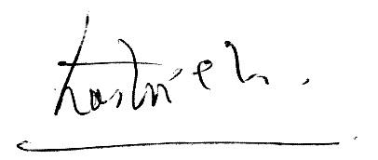

Prof. R.K. Singh

Dean Of Examination Division

Powered by TCPDF (www.tcpdf.org)

