1.Git Setup https://confluence.atlassian.com/bitbucket/set-up-git-744723531.html

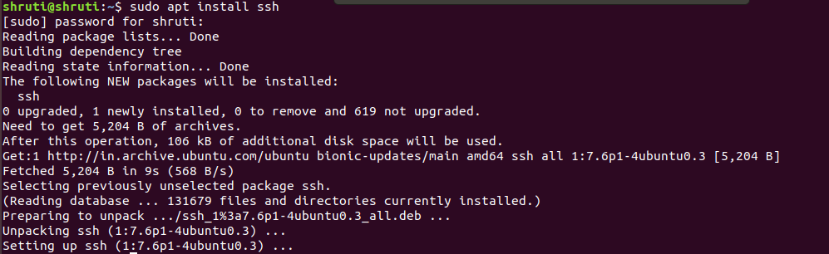

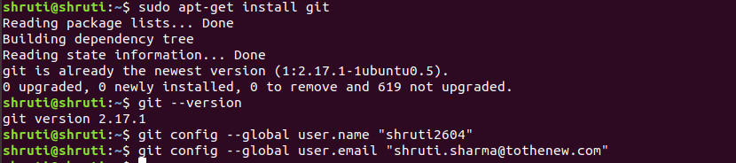

2.Initialize a Git Repository

3.Add files to the repository
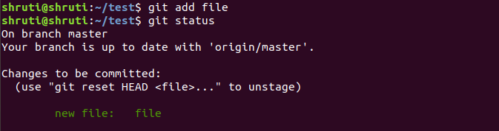

4.Unstage 1 file
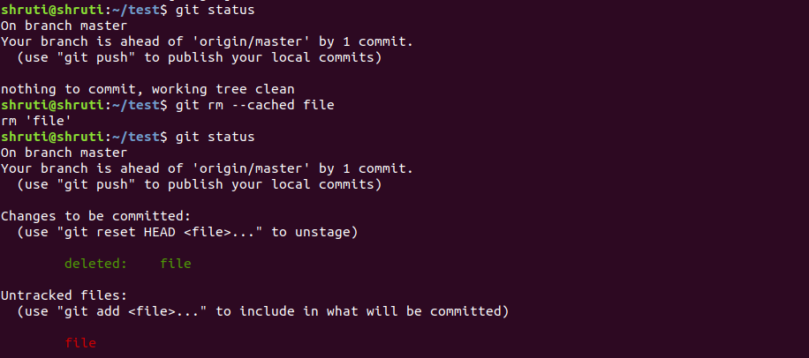
5.Commit the file

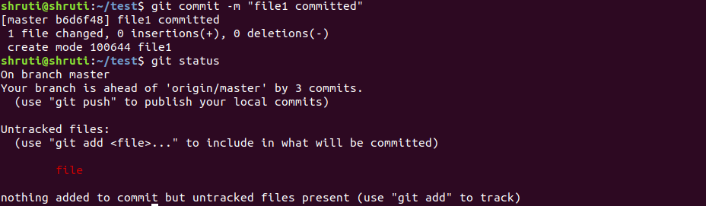
6.Add a remote

7.Undo changes to a particular file

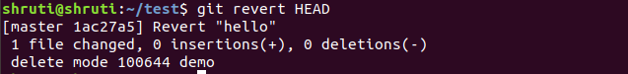

8.Push changes to Github

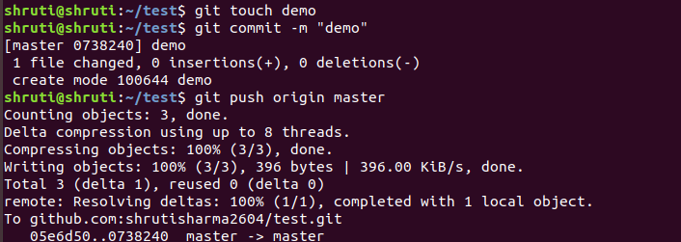
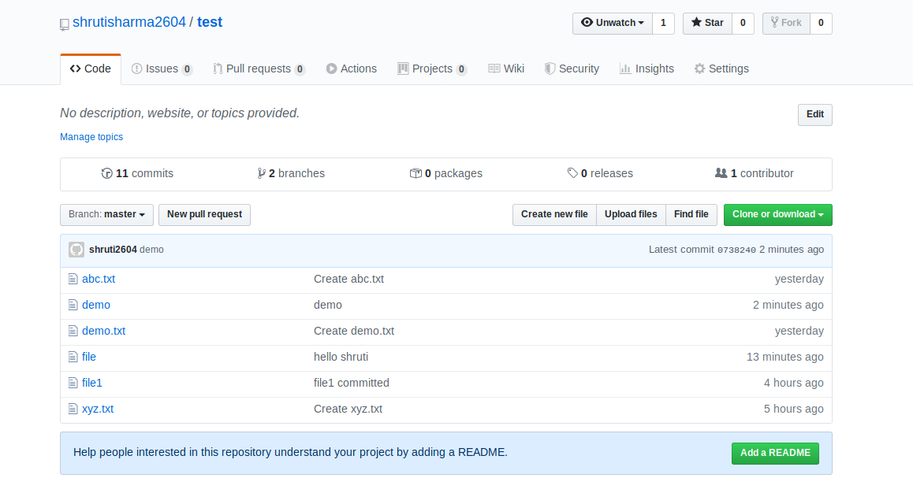

9.Clone the repository

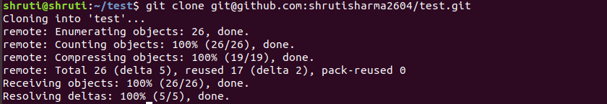

10.Add changes to one of the copies and pull the changes in the other.

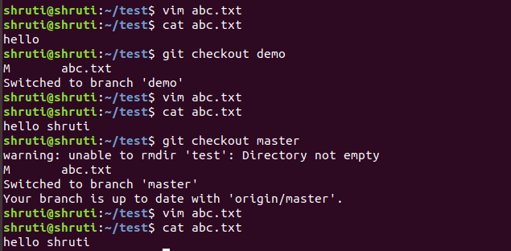

11.Check differences between a file and its staged version
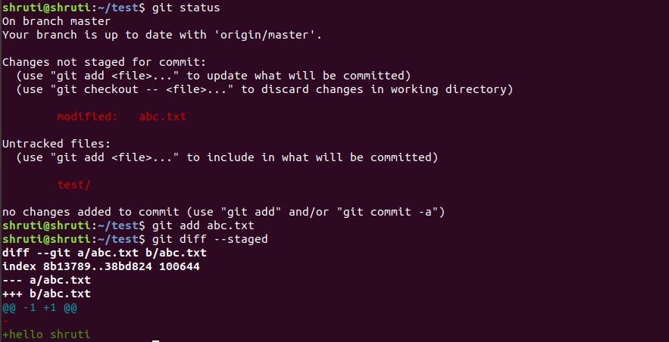

12.Ignore a few files to be checked in
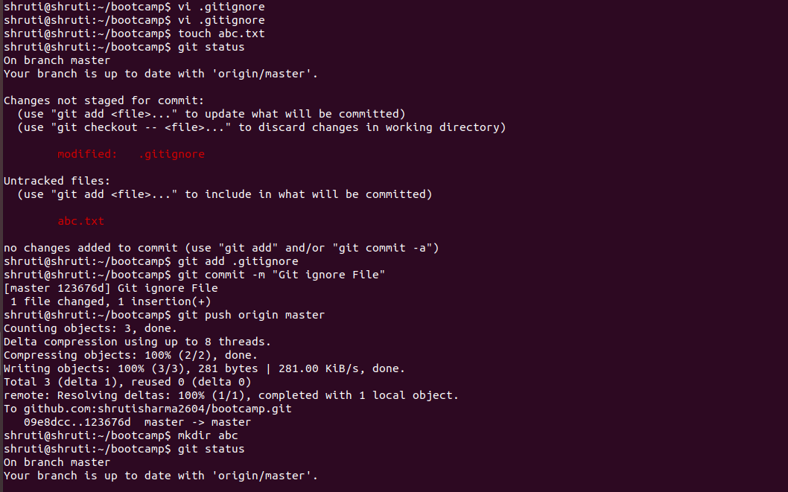

13.Create a new branch.

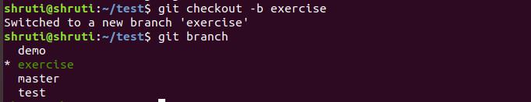
14.Diverge them with commits

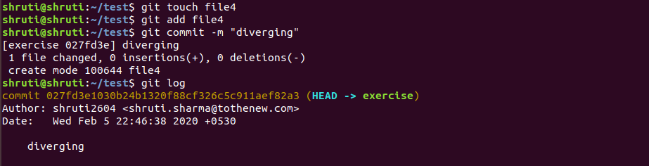

15.Edit the same file at the same line on both branches and commit
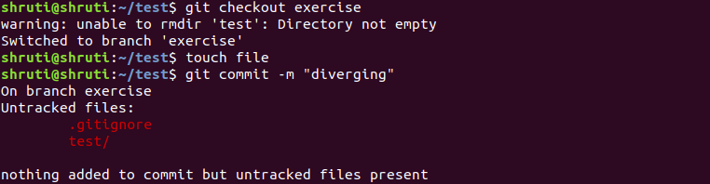
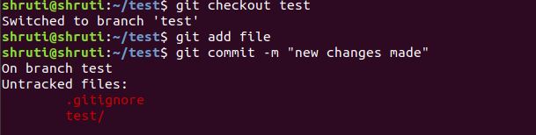
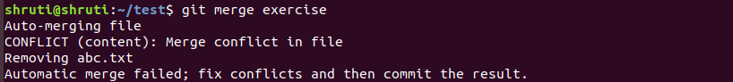

16.Try merging and resolve merge conflicts

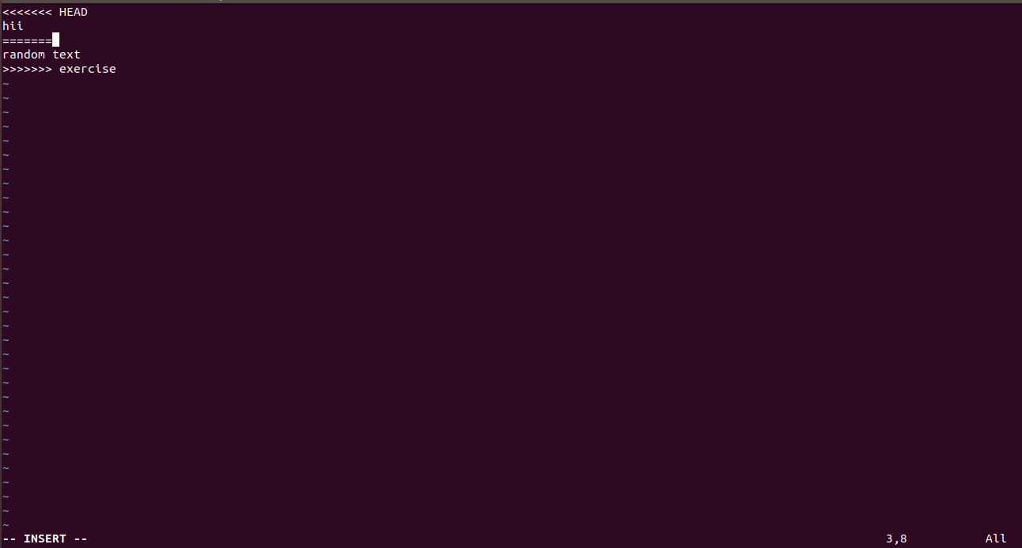
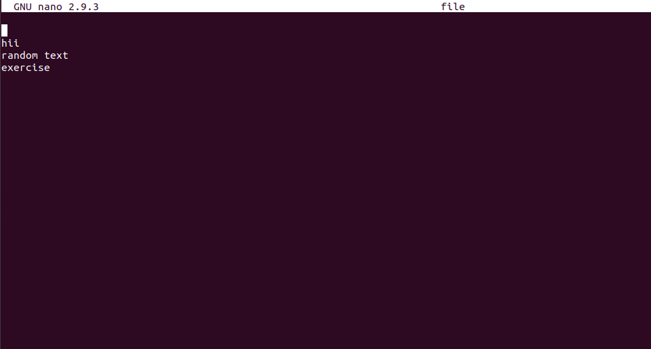
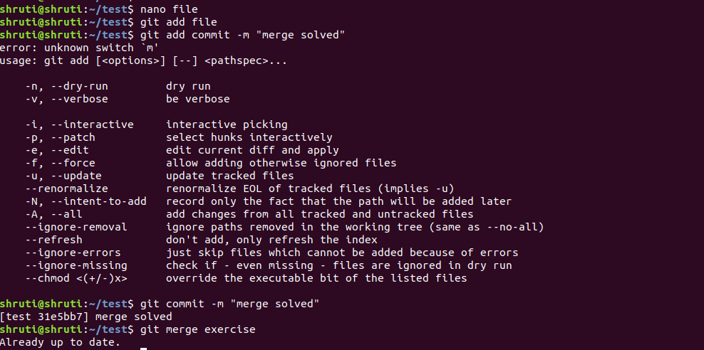

17.Stash the changes and pop them
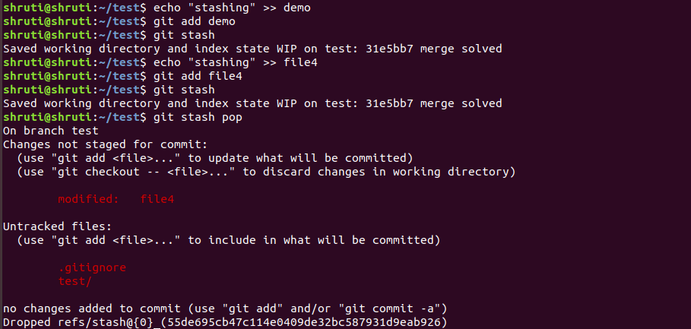

18.Add the following code to your .bashrc file : color_prompt="yes"
parse_git_branch() {
git branch 2> /dev/null | sed -e '/^[^*]/d' -e 's/* \(.*\)/(\1)/'
}
if [ "$color_prompt" = yes ]; then
PS1='\u@\h\[\033[00m\]:\[\033[01;34m\]\W\[\033[01;31m\] $(parse_git_branch)\[\033[00m\]\$ '
else
PS1='\u@\h:\W $(parse_git_branch)\$ '
fi
unset color_prompt force_color_prompt


