Spring Data JPA part 1 Exercise

(1) Create an Employee Entity which contains following fields
Name
Id
Age
Location
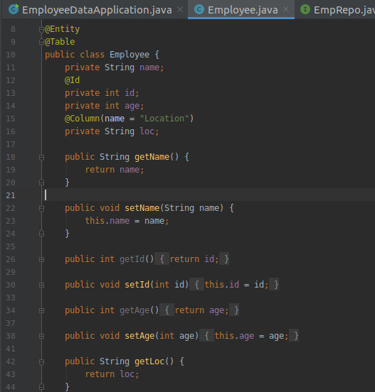
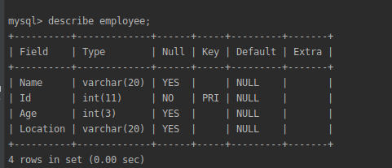
(2) Set up EmployeeRepository with Spring Data JPA
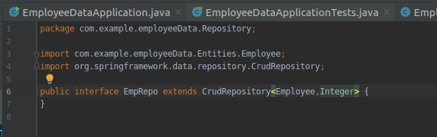
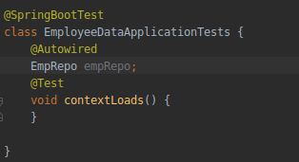
(3) Perform Create Operation on Entity using Spring Data JPA
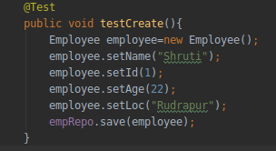
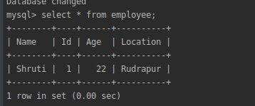
(4) Perform Update Operation on Entity using Spring Data JPA
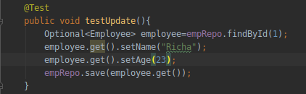
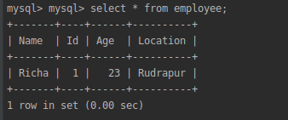
(5) Perform Delete Operation on Entity using Spring Data JPA
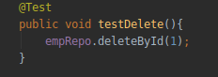


(5) Perform Read Operation on Entity using Spring Data JPA
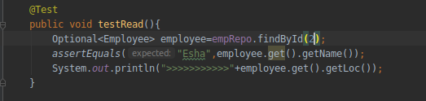
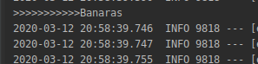
(6) Get the total count of the number of Employees
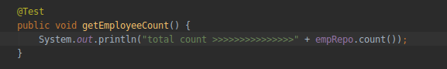
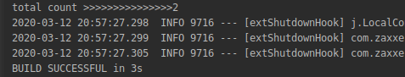
(7) Implement Pagination and Sorting on the bases of Employee Age
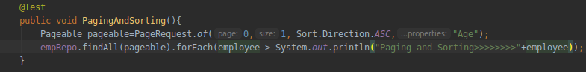
(8) Create and use finder to find Employee by Name
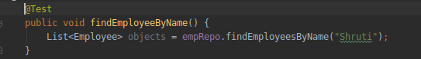
(9) Create and use finder to find Employees starting with A character
(10) Create and use finder to find Employees Between the age of 28 to 32
