Spring Framework Exercise
(1) Write a program to demonstrate Tightly Coupled code.
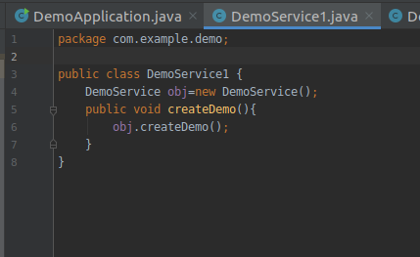

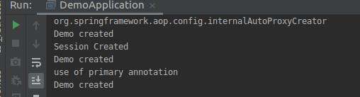

(2) Write a program to demonstrate Loosely Coupled code.

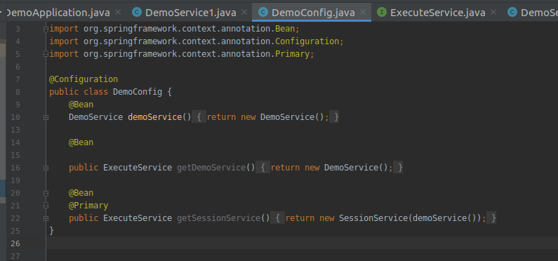

(3) Use @Compenent and @Autowired annotations to in Loosely Coupled code for dependency management
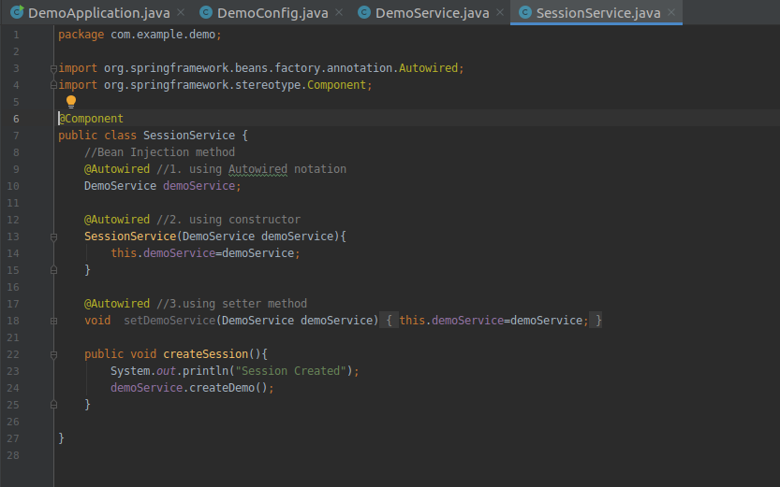
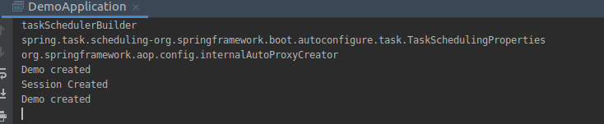
(4) Get a Spring Bean from application context and display its properties.
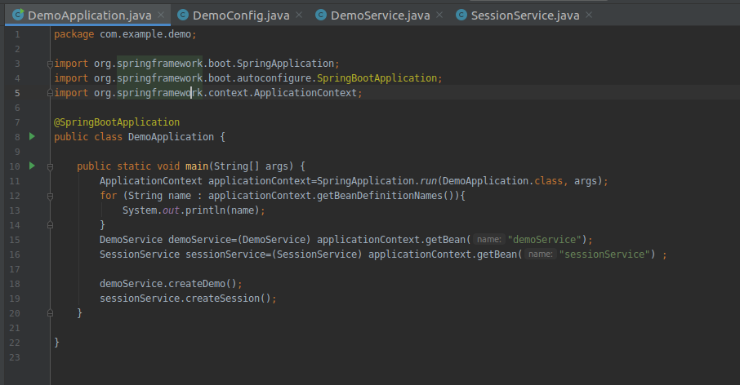
(5) Demonstrate how you will resolve ambiguity while autowiring bean (Hint : @Primary)
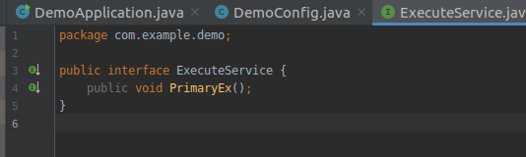
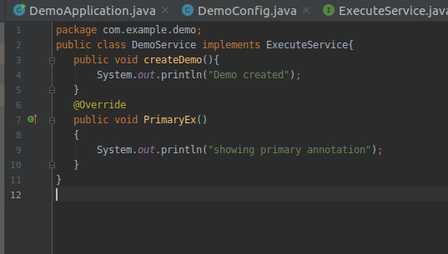
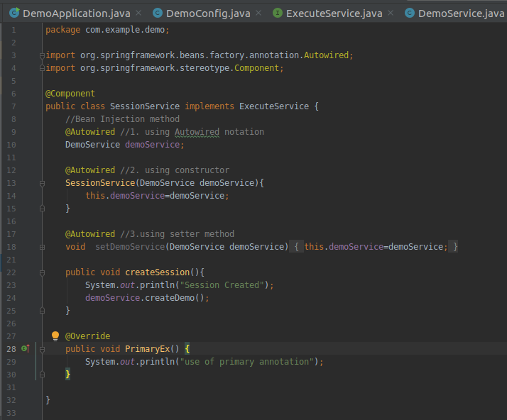
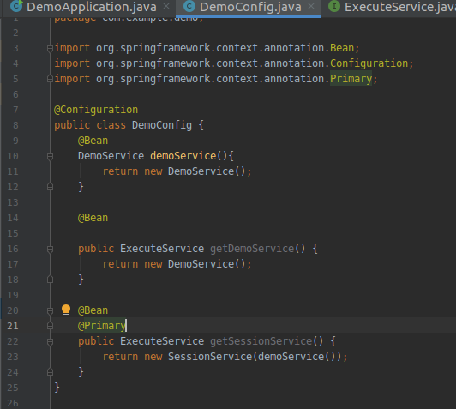
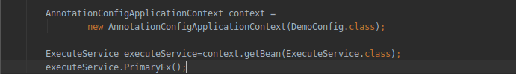
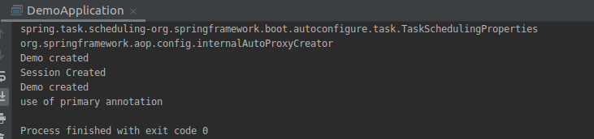
(6) Perform Constructor Injection in a Spring Bean
