HTML/CSS Exercise

1.How are inline and block elements different from each other?
Ans.Block Element: A block-level element always starts on a new line and takes up the full width available (stretches out to the left and right as far as it can).
Inline Element: An inline element does not start on a new line and only takes up as much width as necessary.
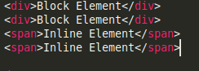
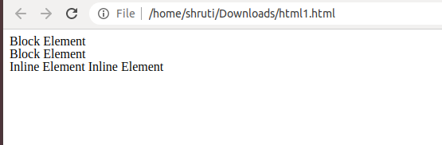
2.Explain the difference between visibility:hidden and display:none
Ans.Display:none
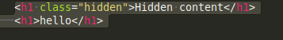
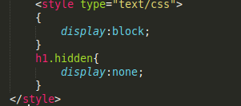

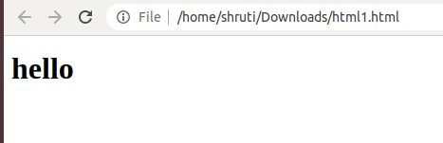
Visibility:hidden
also hides an element.
However, the element will still take up the same space as before. The element will be hidden, but still affect the layout
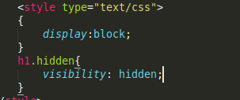
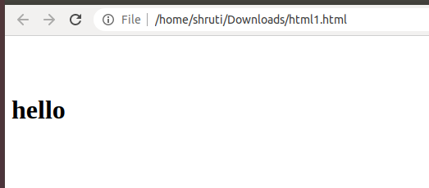

3. Explain the clear and float properties.
Ans. The CSS float property specifies how an element should float.
The CSS clear property specifies what elements can float beside the cleared element and on which side.

The float Property
The float property is used for positioning and formatting content e.g. let an image float left to the text in a container.
The float property can have one of the following values:
- left - The element floats to the left of its container
- right - The element floats to the right of its container
- none - The element does not float (will be displayed just where it occurs in the text). This is default
- inherit - The element inherits the float value of its parent
In its simplest use, the float property can be used to wrap text around images.

The clear Property
The clear property specifies what elements can float beside the cleared element and on which side.
The clear property can have one of the following values:
- none - Allows floating elements on both sides. This is default
- left - No floating elements allowed on the left side
- right- No floating elements allowed on the right side
- both - No floating elements allowed on either the left or the right side
- inherit - The element inherits the clear value of its parent
The most common way to use the clear property is after you have used a float property on an element.
When clearing floats, you should match the clear to the float: If an element is floated to the left, then you should clear to the left. Your floated element will continue to float, but the cleared element will appear below it on the web page.

4. explain difference between absolute, relative,fixed and static.

position: relative;
An element with position: relative; is positioned relative to its normal position.
Setting the top, right, bottom, and left properties of a relatively-positioned element will cause it to be adjusted away from its normal position. Other content will not be adjusted to fit into any gap left by the element.

position: fixed;
An element with position: fixed; is positioned relative to the viewport, which means it always stays in the same place even if the page is scrolled. The top, right, bottom, and left properties are used to position the element.
A fixed element does not leave a gap in the page where it would normally have been located.
Notice the fixed element in the lower-right corner of the page. Here is the CSS that is used:

position: absolute;
An element with position: absolute; is positioned relative to the nearest positioned ancestor (instead of positioned relative to the viewport, like fixed).
However; if an absolute positioned element has no positioned ancestors, it uses the document body, and moves along with page scrolling.
Note: A "positioned" element is one whose position is anything except static.

position: static;
HTML elements are positioned static by default.
Static positioned elements are not affected by the top, bottom, left, and right properties.
An element with position: static; is not positioned in any special way; it is always positioned according to the normal flow of the page:
5. Write the HTML code to create a table in which there are 4 columns( ID , Employee Name, Designation, Department) and at least 6 rows. Also do some styling to it.
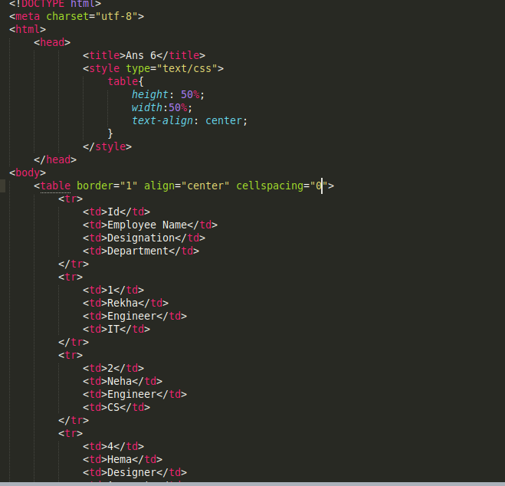
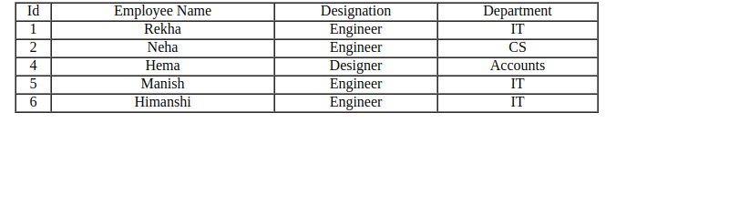
6. Why do we use meta tags?
Ans. Metadata is data (information) about data.
The <meta> tag provides metadata about the HTML document. Metadata will not be displayed on the page, but will be machine parsable.
Meta elements are typically used to specify page description, keywords, author of the document, last modified, and other metadata.
The metadata can be used by browsers (how to display content or reload page), search engines (keywords), or other web services.
7. Explain box model.

The CSS Box Model
All HTML elements can be considered as boxes. In CSS, the term "box model" is used when talking about design and layout.
The CSS box model is essentially a box that wraps around every HTML element. It consists of: margins, borders, padding, and the actual content. The image below illustrates the box model:
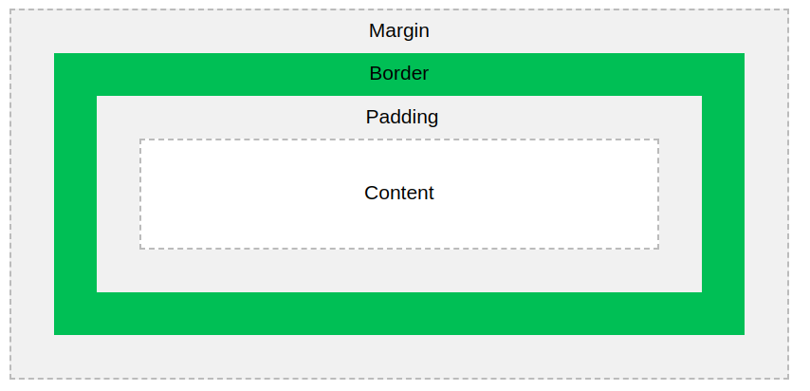
Explanation of the different parts:
- Content - The content of the box, where text and images appear
- Padding - Clears an area around the content. The padding is transparent
- Border - A border that goes around the padding and content
- Margin - Clears an area outside the border. The margin is transparent
The box model allows us to add a border around elements, and to define space between elements.
8. What are the different types of CSS Selectors?
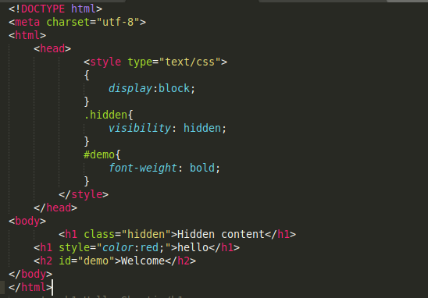
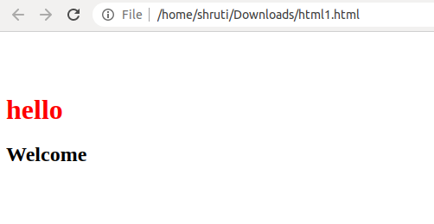
9. Define Doctype.
The <!DOCTYPE> declaration must be the very first thing in your HTML document, before the <html> tag.
The <!DOCTYPE> declaration is not an HTML tag; it is an instruction to the web browser about what version of HTML the page is written in.
In HTML 4.01, the <!DOCTYPE> declaration refers to a DTD, because HTML 4.01 was based on SGML. The DTD specifies the rules for the markup language, so that the browsers render the content correctly.
HTML5 is not based on SGML, and therefore does not require a reference to a DTD.

10. Explain 5 HTML5 semantic tags.
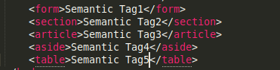
A semantic element clearly describes its meaning to both the browser and the developer.
Examples of semantic elements: <form>, <table>, and <article> - Clearly defines its content.

11. Create HTML for web-page.jpg (check resources, highest weightage for answers)
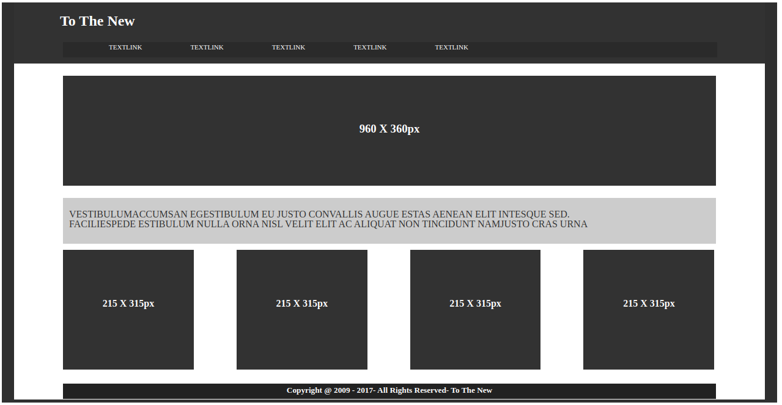

12. Create HTML for form.png (check resources, highest weightage for answers)
