Java 8 Exercise
- Write the following a functional interface and implement it using lambda:
  - (1) First number is greater than second number or not Parameter (int ,int ) Return boolean
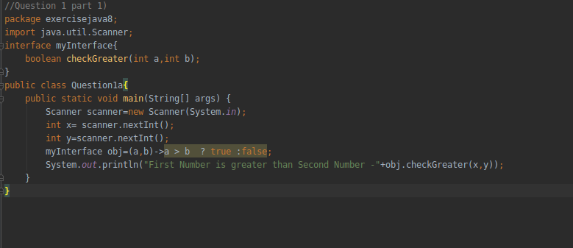
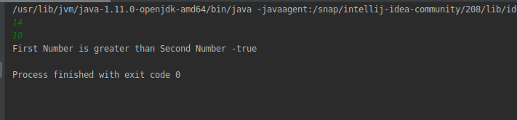
  - (2) Increment the number by 1 and return incremented value Parameter (int) Return int
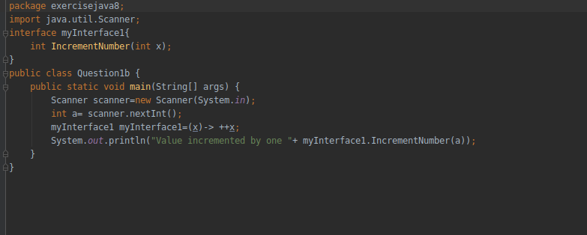
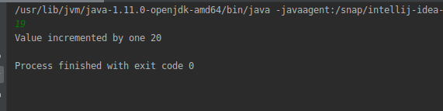
  - (3) Concatenation of 2 string Parameter (String , String ) Return (String)
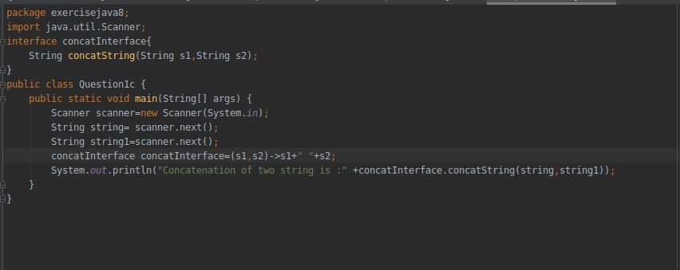
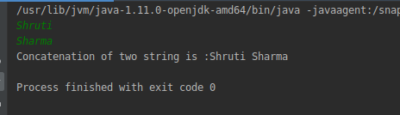
  - (4) Convert a string to uppercase and return . Parameter (String) Return (String)
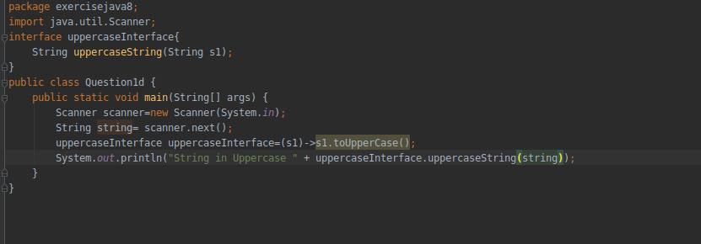
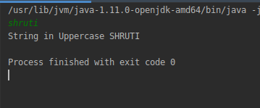
- Create a functional interface whose method takes 2 integers and return one integer.
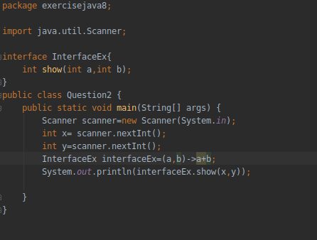
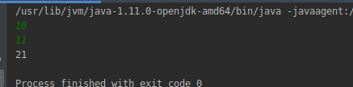
- Using (instance) Method reference create and apply add and subtract method and using (Static) Method reference create and apply multiplication method for the functional interface created.
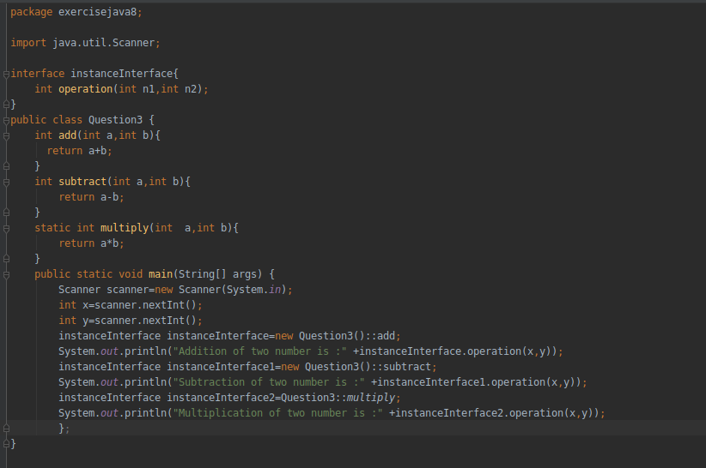
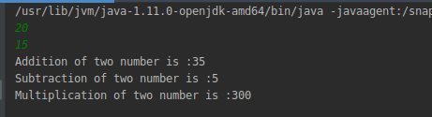
- Create an Employee Class with instance variables (String) name, (Integer)age, (String)city and get the instance of the Class using constructor reference
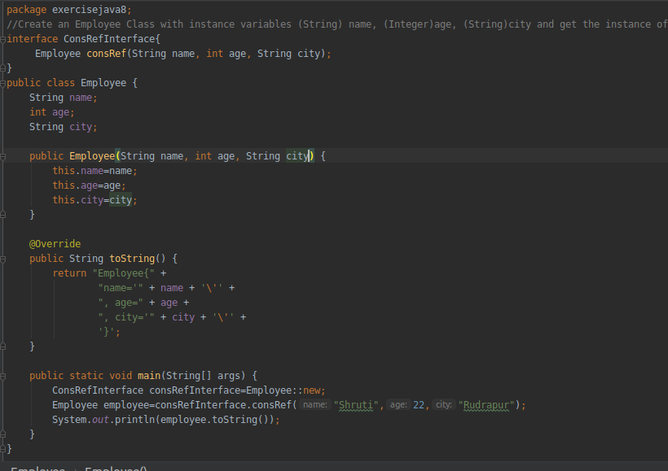
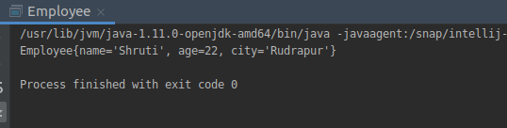
- Implement following functional interfaces from java.util.function using lambdas:
  - (1) Consumer
  - (2) Supplier
  - (3) Predicate
  - (4) Function
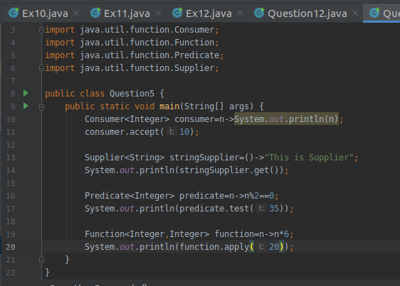
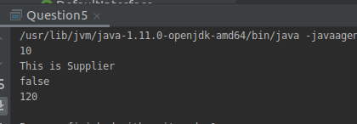
- Create and access default and static method of an interface.
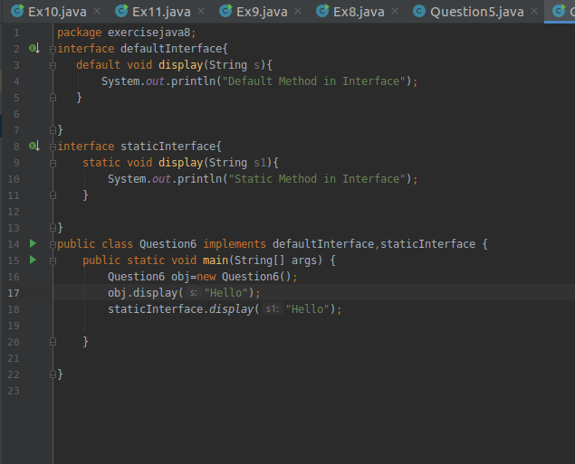
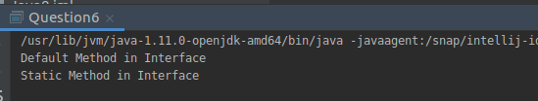
- Override the default method of the interface.
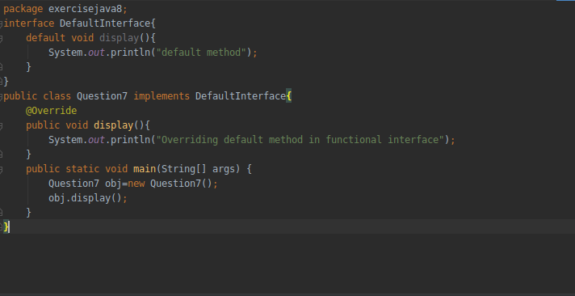
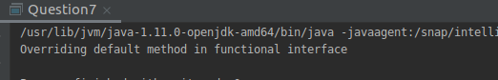
- Implement multiple inheritance with default method inside interface.
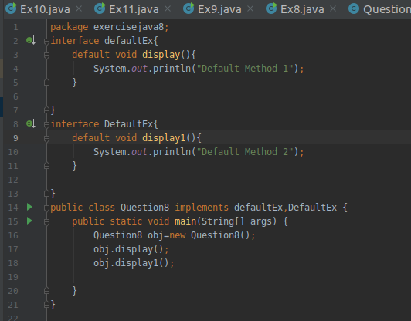
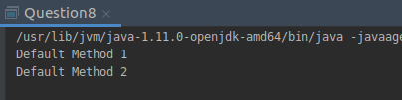
- Collect all the even numbers from an integer list.
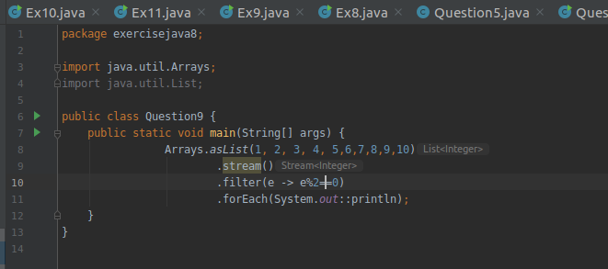
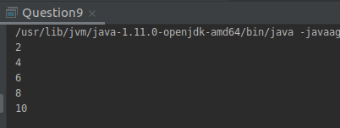
- Sum all the numbers greater than 5 in the integer list.
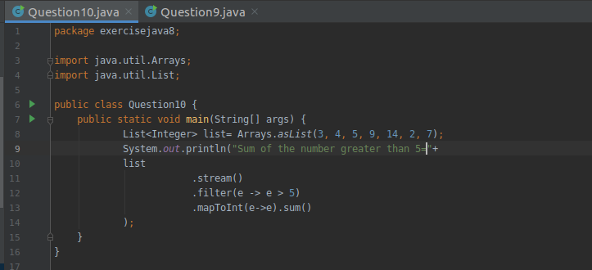
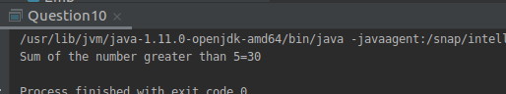
- Find average of the number inside integer list after doubling it.
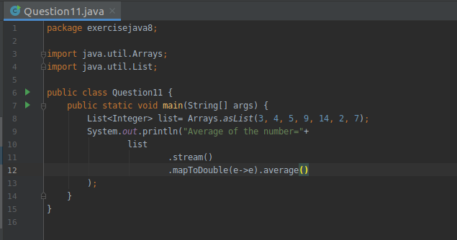
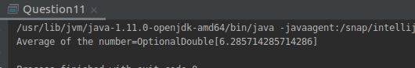
- Find the first even number in the integer list which is greater than 3.
