Database Exercise

Problem Statement:
Problem Statement: There can be multiple customers, who can place multiple orders on the site. Now a sales person can handle these orders will distribute into multiple sales persons (One order will be assign to one salesperson only). So a sales person can have multiple orders of multiple customers

1.Create Database
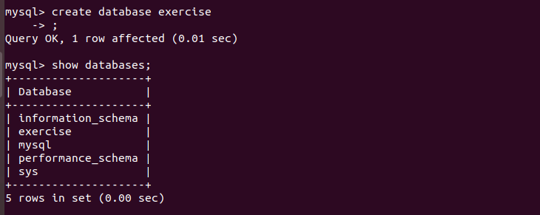

2.Design Schema
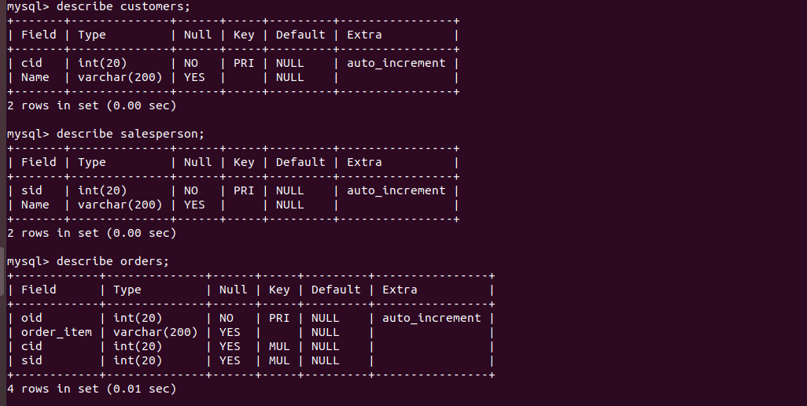

3.Create tables
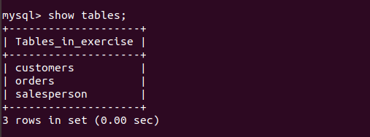

4.Insert sample data
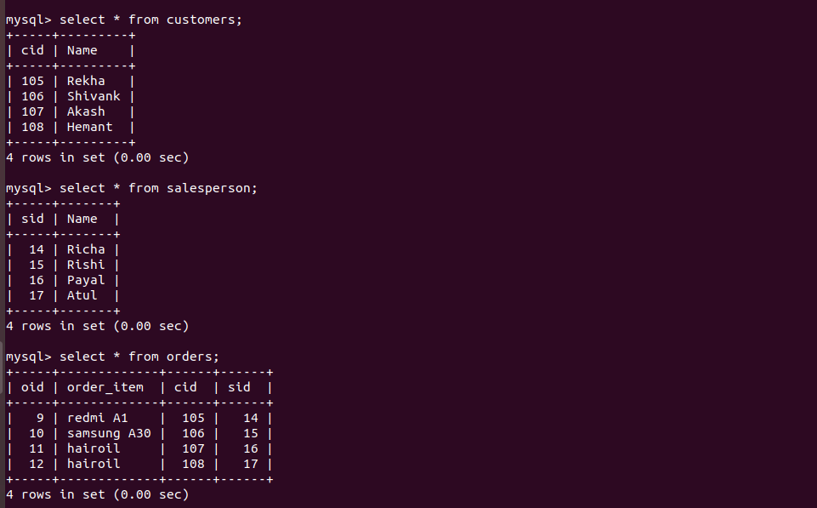

5.Find the sales person have multiple orders

.
6.Find the all sales person details along with order details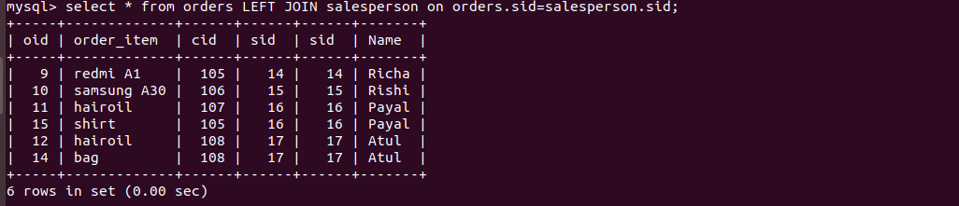

7.Create index

8.How to show index on a table
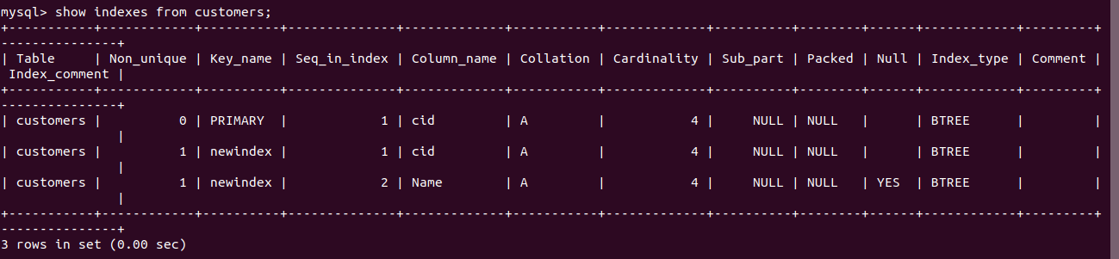

9.Find the order number, salesperson name, along with the customer to whom that order belongs to


