INTERPRETABLE MACHINE LEARNING FOR FELINE RENAL DISEASE CLASSIFICATION
A comparative study across routine clinical and urine metabolomics cohorts

Shruti Shelar
M.S. Thesis
August 2026

Declaration
I declare that this thesis is an independently prepared research document based on publicly accessible supplementary data and published methodological guidance. The two empirical cohorts used in the analysis are identified by source article, repository location, licence information, file hash, and local path in the frozen dataset manifest. No Dog Aging Project participant-level data, Morris Animal Foundation restricted data, VetCompass restricted data, or synthetic Kaggle records were used to generate the reported results.
The results reported in this thesis were generated by the reproducible Python pipeline stored at analysis/run_analysis.py. The study does not claim future-onset prediction, clinical lead time, prospective validation, or clinical deployment. The term validation is used narrowly for out-of-fold evaluation within the available cohorts, and external clinical validation remains future work.

Acknowledgements
This work was enabled by researchers who made veterinary data, supplementary tables, codebooks, and reporting standards available to the wider research community. Particular methodological value was obtained from the International Renal Interest Society guidance, the TRIPOD+AI reporting statement, the PROBAST+AI appraisal tool, and the open supplementary data associated with feline renal research.
The limitations of this study are substantial and should be read as part of its contribution. Access restrictions, the lack of an open feline longitudinal EHR, small cohort size, incomplete labels, and the mismatch between clinical and metabolomics data prevented a direct recreation of the original proposal. Rather than conceal those constraints, the thesis treats data provenance and scope control as research outputs.

Abstract
Chronic kidney disease is a common and clinically important condition in ageing cats, but the available evidence base for interpretable machine learning in veterinary renal medicine remains fragmented. The original proposal planned an early-onset prediction study using the Dog Aging Project and related cohorts. Because participant-level DAP data were not available and no immediately downloadable feline longitudinal EHR cohort matching the proposal was identified, the final study was redesigned as a comparative interpretable-machine-learning investigation across two separate public feline datasets. The first dataset comprised 56 cats with routine clinical and laboratory variables, including creatinine, blood urea nitrogen, SDMA, urine specific gravity, proteinuria, blood pressure, body condition and CKD stage. The second contained 195 repeated urine-metabolomics observations from 41 animal identifiers with Healthy, calcium-oxalate and CKD labels; the source article reported 42 cats, and this discrepancy was retained as a data-quality limitation. Elastic-net logistic regression, XGBoost and Explainable Boosting Machines were compared using animal-level or observation-level cross-validation appropriate to each cohort. SHAP, LIME, native EBM explanations, feature-selection frequency and ablation analyses were used to examine explanatory behaviour. In the clinical cohort, full-marker out-of-fold AUROC ranged from 0.982 to 0.992, but a context-only ablation excluding label-defining renal markers reduced AUROC to 0.880–0.895, demonstrating substantial circularity in the full-marker task. In the metabolomics cohort, grouped five-fold out-of-fold macro-AUROC ranged from 0.681 to 0.718 and balanced accuracy remained approximately 0.50. The findings support interpretable modelling as a useful analytical framework, but they do not establish clinical deployment or early future-onset prediction. The thesis contributes a transparent two-cohort benchmark, a reproducible pipeline, an explicit leakage and circularity analysis, and a practical account of why veterinary machine-learning claims must be constrained by data provenance.

Keywords
Feline chronic kidney disease; Interpretable machine learning; Explainable Boosting Machine; SHAP; LIME; Veterinary data science

Table of Contents and Lists
The final thesis follows the supplied M.S. thesis sample: five chapters, references, and appendices. Word's field-based table of contents should be updated when the document is opened in Microsoft Word. The major structure is: Chapter 1 Introduction; Chapter 2 Literature Review; Chapter 3 Proposed Methodology; Chapter 4 Implementation, Results and Analysis; Chapter 5 Conclusion and Future Scope; References; Appendices.
Figures include the cohort-distribution chart, the clinical out-of-fold ROC curve, the clinical precision-recall curve, and the metabolomics confusion matrices. Tables include the dataset manifest, cohort characteristics, model performance, circularity ablation, stage classification, explanation rankings, file hashes, and reproducibility controls.
- Figure 1. Comparative research workflow
- Figure 2. Cohort class distributions
- Figure 3. Clinical cohort out-of-fold ROC
- Figure 4. Clinical cohort precision-recall curves
- Figure 5. Metabolomics grouped confusion matrices

List of Abbreviations
AUPRC — Area under the precision-recall curve; AUROC — Area under the receiver operating characteristic curve; BUN — Blood urea nitrogen; CaOx — Calcium oxalate; CKD — Chronic kidney disease; EBM — Explainable Boosting Machine; EHR — Electronic health record; FIC — Feline idiopathic cystitis; IRIS — International Renal Interest Society; LIME — Local Interpretable Model-agnostic Explanations; ML — Machine learning; OOF — Out of fold; PR — Precision-recall; SHAP — SHapley Additive exPlanations; SDMA — Symmetric dimethylarginine; USG — Urine specific gravity; XAI — Explainable artificial intelligence; XGBoost — Extreme Gradient Boosting.

1.1 Background and clinical context
Companion animals now live within households that routinely collect, store and interpret health information. Longer lifespans and improved preventive care have increased the visibility of chronic disease, while veterinary practice has progressively incorporated electronic records, laboratory instruments and longitudinal monitoring. These developments create an opportunity for computational methods to integrate signals that are difficult to interpret one variable at a time. In feline renal medicine, the opportunity is particularly important because chronic kidney disease is often progressive, heterogeneous and clinically subtle during its earlier stages (Creevy et al., 2022; O'Neill et al., 2023).
The International Renal Interest Society describes CKD staging as a clinical process that requires stable patients, persistent evidence of renal dysfunction or structural damage, and interpretation of creatinine, SDMA, proteinuria and blood pressure in context (IRIS, 2026a; IRIS, 2026b). This guidance is essential for the present work because it prevents the machine-learning problem from being framed as a simple threshold exercise. A model can reproduce a staging rule without adding independent clinical value. The analysis must therefore distinguish a classification result from evidence of earlier disease identification, and it must distinguish statistical association from clinical causation.
Machine learning is attractive because renal disease is represented by a combination of biochemical, urinary, physical and demographic measurements. However, accuracy alone is insufficient when the result may influence monitoring, owner communication or treatment. The explanation must be examined for faithfulness, stability, leakage and alignment with the way the outcome was defined. The final thesis therefore treats interpretability as an empirical object of study rather than a decorative plot added after model training.

1.2 Problem definition and research gap
The original proposal defined the problem as early feline CKD identification using routinely collected longitudinal data, with DAP and related cohorts as potential sources. That design was not executable within the present access conditions. DAP provides a documented access pathway through application, agreement and Terra credentials, but the participant-level data were not available for this thesis. The Morris cohort provides a promising canine laboratory resource, yet its download requires login and the public description does not confirm a linked CKD outcome label. VetCompass offers an associated feline CKD file, but its open-access page restricts the files to validation and learning exercises and states that they do not carry ethical permission for further formal research. These facts make silent substitution methodologically unacceptable.
The revised problem is narrower and more transparent: how do intrinsically interpretable and post-hoc interpretable machine-learning approaches behave when applied to two authentic but structurally different public feline renal cohorts? The first cohort is clinically grounded but small and cross-sectional. The second has repeated urine-metabolomics observations and condition labels but is not a routine clinical EHR. The comparison therefore concerns method behaviour, robustness and explanation quality across data modalities, not a single universal clinical prediction model.
The principal gap is not the absence of machine-learning demonstrations. Feline CKD prediction has been studied using large proprietary EHR data and recent targeted metabolomics. The gap is the lack of a transparent, student-reproducible comparison that makes the data limitations explicit, separates label-defining variables from contextual predictors, and evaluates whether the apparent advantage of a model survives animal-level grouping and explanatory stability checks.

1.3 Aim, objectives and research questions
Aim: To develop and compare interpretable machine-learning workflows for feline renal-disease classification across a routine-clinical cohort and a repeated urine-metabolomics cohort, while quantifying the influence of label-defining biomarkers, animal-level grouping, explanation method and data modality.
The objectives are: (i) to document and freeze two public feline datasets; (ii) to build reproducible preprocessing pipelines; (iii) to compare elastic-net logistic regression, XGBoost and EBM; (iv) to evaluate discrimination, precision-recall, calibration and balanced performance; (v) to use SHAP, LIME and native EBM explanations; (vi) to quantify feature-selection and explanation consistency; (vii) to perform a context-only ablation in the clinical cohort; and (viii) to report the study according to TRIPOD+AI principles and assess methodological limitations using PROBAST+AI concepts.
Research Question 1: How do logistic regression, XGBoost and EBM compare for binary Healthy-versus-CKD classification in the 56-cat clinical cohort? Research Question 2: How much of the apparent clinical performance depends on renal markers that also define the CKD label? Research Question 3: How do the same model families behave on animal-grouped three-class urine-metabolomics classification? Research Question 4: Which features are repeatedly selected or attributed across explanation methods, and how should their apparent importance be interpreted given sample size, cohort design and disease-definition circularity?

1.4 Significance, scope and ethical boundaries
The study has methodological significance because it demonstrates how a thesis can remain empirical after a proposed restricted dataset becomes unavailable. It has clinical significance only at the level of evidence synthesis and exploratory modelling. The results cannot be used to screen cats, replace veterinary judgement, infer treatment benefit or establish a validated diagnostic tool. The work is best understood as a transparent benchmark and a design exercise grounded in real feline data.
In scope are tabular clinical variables, urine-metabolomics measurements, binary and multiclass classification, grouped evaluation, SHAP, LIME, EBM, calibration, class balance, feature selection, and data-quality analysis. Out of scope are prospective recruitment, live-animal procedures, regulatory submission, clinical deployment, causal inference, future-onset lead-time estimation, and external validation on DAP, Banfield, VetCompass or Morris data. Imaging, genomics and deep neural networks are also outside scope.
No individual-level identifying information was intentionally introduced. The clinical workbook and metabolomics supporting spreadsheet were obtained from published open-access sources. The PLOS file reports an article/file animal-count discrepancy; this is documented, not silently corrected. The ethical principle applied throughout is that openness of a supplementary file does not create permission to make claims beyond the design and provenance of the source study.

1.5 Thesis organisation and contribution
Chapter 2 reviews feline CKD, veterinary machine learning, tabular modelling and explanation evaluation. Chapter 3 defines the datasets, preprocessing, split logic, algorithms and metrics. Chapter 4 reports measured results from the two cohorts, including the clinical circularity ablation and metabolomics grouped evaluation. Chapter 5 interprets what can and cannot be concluded, identifies limitations, and proposes a future route involving controlled longitudinal clinical data.
The contributions are fourfold. First, a frozen data and provenance record is supplied. Second, a two-cohort pipeline separates clinical and metabolomics questions instead of pooling incompatible variables. Third, the clinical analysis quantifies the drop in performance after removing label-defining renal markers. Fourth, the thesis provides an implementation-ready reporting framework for future work when a genuinely longitudinal feline EHR becomes available.
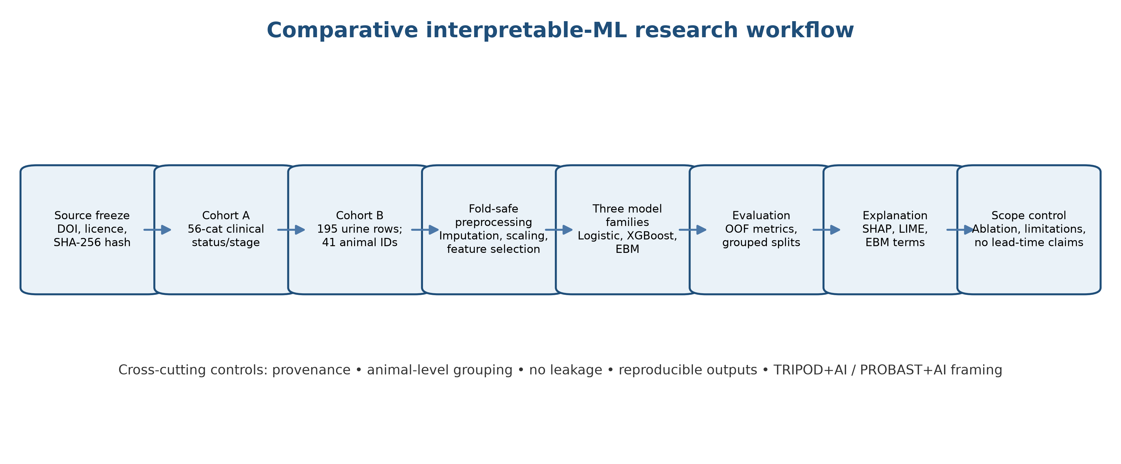
Figure 1.1. Comparative workflow used in the thesis.

2.1 Companion-animal ageing and chronic disease
Creevy et al. (2022) described the Dog Aging Project as an open-science longitudinal study of companion dogs and showed why ageing cohorts can support population-level questions. The work established the importance of carefully defined variables, repeated follow-up and data governance. Its relevance here is conceptual rather than empirical: DAP is not used in this thesis, and the canine cohort cannot be silently substituted for feline clinical records.
O'Neill et al. (2023) described commonly diagnosed disorders in UK cats and demonstrated the importance of age and sex when interpreting disease burden in primary-care populations. The study supports the clinical rationale for focusing on older cats, but it does not provide the individual-level dataset used here. Together, these sources justify the disease context while reinforcing the need to keep population epidemiology separate from model performance.

2.2 Feline CKD diagnosis and staging
IRIS (2026a) and IRIS (2026b) emphasise that diagnosis and staging require clinical stability, persistence and contextual interpretation. Creatinine and SDMA are important surrogate markers, but isolated values should not be treated as a complete diagnosis. This is directly relevant to the clinical cohort because the full-marker classifier includes variables that are close to the label definition.
The ISFM consensus guidance similarly recommends longitudinal monitoring, urinalysis, blood pressure and interpretation of proteinuria in feline CKD (Sparkes et al., 2016). The methodological implication is that a cross-sectional classifier can reproduce disease strata without demonstrating earlier detection. The present thesis treats staging classification as a limited supervised task and explicitly rejects a lead-time interpretation.

2.3 Large-scale feline EHR prediction
Biourge et al. (2020) developed a feline CKD prediction model using a large clinical screening dataset and evaluated risk at multiple horizons. The study is highly relevant because it demonstrates what becomes possible with repeated EHR data, but the data are not openly downloadable for this thesis. Its results are used as state-of-the-art literature evidence, not as a benchmark that our small public cohorts can reproduce.
The earlier RVC and Banfield work reported neural-network-based CKD prediction using routine laboratory data and separate development and evaluation populations (Biourge et al., 2020). That design included stronger temporal information than the clinical workbook used here. The comparison clarifies the central limitation of the final study: the present clinical file supports status/stage classification, not future risk prediction.

2.4 Canine prediction as a transferable methodological reference
Watson et al. (2022) reported an early canine CKD model using routine clinical laboratory variables and a large EHR cohort. The work illustrates the importance of age, weight, creatinine, BUN, urine-specific gravity and urine protein, but it also demonstrates the risks of cross-species extrapolation. A canine model cannot be treated as evidence for feline deployment.
The proposal originally cited DAP as a primary fallback, but DAP is a longitudinal canine cohort with access controls rather than a free clinical download. The literature therefore supports the value of such a source while the data audit prevents the thesis from overstating access. This is an example of why a research proposal can contain a sound conceptual design but still require a different final empirical scope.

2.5 Small public feline clinical cohort
Nealon et al. (2024) studied client-owned cats across healthy, early-stage and late-stage CKD groups using serum metabolomics and clinical metadata. The associated supplementary workbook provides the 56-cat clinical cohort used as Dataset A in this thesis. It contains routine measures and stage labels but no visit dates, making it suitable for cross-sectional classification rather than future-onset modelling.
The workbook is unusually valuable for teaching because it contains creatinine, BUN, SDMA, USG, proteinuria, blood pressure, body condition and other variables in a compact, inspectable format. Its small sample size and imbalanced stages make it unsuitable for claims of generalization. The present study therefore reports full-marker performance, context-only ablation, and exploratory stage classification separately.

2.6 Recent feline early-detection metabolomics
Vanden Broecke et al. (2025) used targeted metabolomics and machine learning to examine feline CKD2, including a longitudinal population with observations at T−12, T−6 and T0. The paper provides strong evidence that early-detection research is clinically plausible and identifies candidate metabolic features. Its supplementary DOCX contains formulas and performance summaries, but not a reusable raw individual-level cohort for this thesis.
The study also illustrates why apparently impressive early-prediction metrics must be interpreted with cohort size, feature selection and validation design in mind. The final thesis cites the study as a benchmark and follows its distinction between current classification and earlier prediction, but does not reproduce or re-label its results as original findings.

2.7 Urine metabolomics and feline renal disease
Kim et al. (2022) characterised the urine metabolome of 45 owned cats, including controls, CKD cases and FIC cases. Their study found that environmental and household factors, including diet, can influence the metabolome. It therefore supports the use of animal-level grouping and the avoidance of row-level random splits.
Jewell et al. (2025) released raw supporting spreadsheets for a urine-metabolomics study of healthy cats, calcium-oxalate stone cats and renal-disease cats. The present Dataset B is based on that raw file. The paper reported 42 cats, whereas the downloaded table contains 41 distinct IDs; this discrepancy is treated as a reproducibility issue rather than hidden. The cohort supports repeated-measures classification but not CKD staging.

2.8 Pilot NMR metabolomics
Finch et al. (2021) demonstrated benchtop NMR metabolic profiling in a pilot cohort of four cats, two controls and two IRIS stage 2 CKD cases. The study was explicitly exploratory and proposed that computational intelligence could support future clinical decision tools. Its scale is too small for a predictive thesis, but it is useful evidence that sample modality and measurement technology strongly constrain modelling claims.
The pilot also reinforces the importance of separating proof-of-concept discrimination from clinical readiness. The final thesis follows the same caution: the metabolomics cohort can show method behaviour on open data, but neither its repeated samples nor its condition labels establish a clinical screening system.

2.9 Plasma metabolome and diet
Hall et al. (2020) studied how dietary fibre altered plasma metabolome and fecal microbiome responses in healthy and CKD cats. The work demonstrates that treatment, diet and disease status can interact, and that metabolomic features are not disease-specific by default. This motivates explicit discussion of confounding and the limited clinical metadata in Dataset B.
The study also used repeated dietary measurements and microbiome data, but the supporting data were available on request rather than as an immediately downloadable clinical table. It is therefore included in the literature review, not merged with the two selected datasets. The distinction is important for the final thesis’s data-availability statement.

2.10 Veterinary machine learning landscape
Appleby and Basran (2022) surveyed artificial intelligence in veterinary medicine and identified prediction, imaging and decision support as active areas. Basran and Appleby (2022) argued that translation remains limited by opacity, data access and weak comparative evaluation. These papers provide the veterinary motivation for a method-focused thesis rather than a claim of clinical deployment.
Ezanno et al. (2021) discussed animal health research in the era of artificial intelligence and emphasised the need to link computational development with domain knowledge. Hennessey et al. (2022) and Burti et al. (2024) documented rapid progress in veterinary imaging while noting gaps in external validation and interpretability. Although the present work is tabular, the same evidence-translation problem applies.

2.11 Interpretable machine learning taxonomy
Linardatos et al. (2021) organised explainable-AI methods into model-specific and model-agnostic families. Belle and Papantonis (2021) discussed principles and practice, while Vilone and Longo (2021) reviewed definitions and evaluation approaches. These sources support the present comparison of intrinsic EBM explanations with post-hoc SHAP and LIME explanations.
Sahakyan et al. (2021) focused on explainable AI for tabular data, a particularly relevant domain because clinical records are often structured rather than image-based. Minh et al. (2022), Hassija et al. (2024) and Loh et al. (2022) further demonstrate that explainability is not a single measurable property. The thesis therefore reports several explanation-oriented analyses rather than one universal interpretability score.

2.12 SHAP and LIME
Lundberg and Lee (2017) introduced the SHAP framework for additive feature attribution, while Ribeiro et al. (2016) introduced LIME for local model-agnostic explanations. SHAP provides a principled decomposition under a specified background and model output; LIME estimates a local surrogate and is sensitive to perturbation choices. The thesis uses SHAP for tree-based global rankings and LIME for illustrative local explanations, without treating either as causal evidence.
Salih et al. (2024) compared SHAP and LIME and emphasised differences in assumptions and stability. Ghassemi et al. (2021) warned that post-hoc explanations can create false confidence in healthcare. The present thesis follows this warning by examining explanation consistency, feature selection frequency and label-definition circularity.

2.13 Intrinsic interpretability and EBM
Maxwell, Sharma and Donaldson (2021) demonstrated the use of Explainable Boosting Machines as additive models with shape functions and limited interactions. EBM is attractive in tabular clinical work because its terms can be inspected directly. Its interpretability is structural, but its performance still depends on data quality and sample size.
Markus, Kors and Rijnbeek (2021) argued that trustworthy clinical AI requires careful definition of explainability, design choices and evaluation. Combi et al. (2022) similarly framed explanation as a medical accountability issue. In this thesis, EBM is not assumed to be clinically correct simply because it is transparent; it is evaluated as a model whose transparent structure can still learn unstable or biased associations.

2.14 Tabular model selection
Grinsztajn, Oyallon and Varoquaux (2022) showed that tree-based models remain strong on typical tabular datasets, while Shwartz-Ziv and Armon (2022) questioned whether deep learning is always necessary for tabular data. Borisov et al. (2024) reviewed deep neural networks for tabular data and described the continuing role of gradient boosting. These findings support XGBoost as a competitive black-box comparator without requiring a GPU-heavy deep-learning baseline.
The small sample sizes in both selected cohorts make model complexity a methodological concern. The thesis therefore restricts depth, regularisation and feature selection, and uses grouped splits for repeated metabolomics observations. Performance is interpreted comparatively and not as evidence that the most complex model should be deployed.

2.15 Reporting prediction models
Collins et al. (2024) introduced TRIPOD+AI as an updated 27-item reporting guideline for prediction-model studies using regression or machine learning. It covers title, abstract, objectives, data sources, outcome definition, predictors, analysis, open science, results and limitations. The thesis uses TRIPOD+AI as a reporting checklist, not as a quality score.
TRIPOD+AI also stresses that development and evaluation data should be separated at the participant level and that performance should be reported with uncertainty and clear outcome definitions. These principles directly motivate the animal-level grouping in Dataset B and the explicit statement that no external validation was performed.

2.16 Risk of bias and applicability
Moons et al. (2025) updated PROBAST to PROBAST+AI, separating quality in model development from risk of bias in performance evaluation. Its domains cover participants and data sources, predictors, outcomes and analysis. The thesis applies these domains narratively to identify high concern from small samples, label-defining predictors, missing data and non-representative cohorts.
Andaur Navarro et al. (2021, 2023) and Dhiman et al. (2022) documented recurring methodological weaknesses in machine-learning prediction studies. Their findings support the decision to report a limitations-first interpretation and to avoid declaring a model validated merely because it produces a cross-validated score.

2.17 Reproducibility and data provenance
Pineau et al. (2021) described reproducibility as a major concern in machine-learning research. McDermott et al. (2021) showed that health ML still faces gaps in data documentation, code availability and evaluation transparency. The final pipeline records file hashes, package versions, split logic, outputs and figures so that the empirical results can be recreated from the downloaded supplementary files.
The data audit also distinguishes public codebooks from participant-level data and public supplementary tables from raw cohorts. This is essential in veterinary research, where clinical data may be subject to access restrictions, commercial ownership or ethical limitations even when a related paper is open access.

2.18 Ethics, welfare and accountability
Morley et al. (2021) mapped ethical issues in healthcare AI, including responsibility, transparency, bias and accountability. Smith (2021) discussed opacity and liability in clinical AI, while Cohen and Gordon (2022) examined veterinary AI in relation to the obligation to avoid harm. These sources shape the thesis’s conservative interpretation of model outputs.
Coghlan and Parker (2023) extended the ethical discussion to nonhuman animals and highlighted that false positives and false negatives may affect animal welfare through monitoring, treatment or owner decisions. Because the present work does not evaluate live patients, it cannot establish welfare benefit; it can only analyse the methodological preconditions for future responsible research.

2.19 Technical gaps identified
The literature reveals six connected gaps. First, much of the strongest feline early-prediction evidence uses proprietary EHR cohorts, limiting reproduction. Second, public feline datasets are often small, cross-sectional or metabolomics-specific. Third, outcome-defining biomarkers can create circular performance when used as predictors. Fourth, row-level random splitting can leak information from repeated animal samples. Fifth, explanation methods are frequently reported without stability or faithfulness checks. Sixth, veterinary studies often use general healthcare reporting guidance without adapting the narrative to species, staging and welfare contexts.
The present thesis addresses these gaps with a modest but explicit design: two separate public feline cohorts, animal-aware splitting, full-marker and context-only clinical analyses, intrinsic and post-hoc explanations, and a limitations-first interpretation.

2.20 Summary of literature implications
The literature supports interpretable modelling as a useful research framework but does not support a simple accuracy-first conclusion. Clinical CKD classification is already strongly informed by biomarkers; a model that uses those markers may appear excellent while adding little beyond the diagnostic definition. Metabolomics offers richer feature spaces but increases dimensionality, preprocessing burden and uncertainty about biological transportability. The final methodology therefore prioritises provenance, split integrity and explanation evaluation over a single headline metric.
This synthesis leads to the two-cohort methodology reported in Chapter 3.

3.1 Research design
This study used a quantitative, comparative and retrospective secondary-data design. The two datasets were not merged because their units, outcome labels, measurement platforms and sampling frames differed. Dataset A was analysed as a small clinical classification cohort. Dataset B was analysed as a repeated urine-metabolomics cohort with animal-level grouped evaluation. The design is empirical but not prospective and not externally validated.
The workflow comprised data acquisition and freezing, data audit, outcome harmonisation, preprocessing, model training, grouped evaluation, explanation analysis, ablation and reporting. The workflow was implemented in Python 3.11 within an isolated virtual environment. Results were written to JSON and CSV files, and figures were generated as PNG files.
Table 3.1. Cohort-specific research design.
Cohort | Unit | Outcome | Evaluation design
A: clinical | Cat | Healthy vs CKD; exploratory stage | Repeated stratified folds
B: metabolomics | Animal ID | Healthy/CaOx/CKD | StratifiedGroupKFold by animal

Figure 3.1. 3.1 Research design visualisation.

3.2 Dataset A: clinical cohort
Dataset A was the patient_metadata sheet in the supplementary workbook associated with Nealon et al. (2024). It contained 56 cats and 33 variables. Labels were Healthy, CKD stage 1, stage 2, stage 3 and stage 4. The clinical fields included demographics, physical condition, blood pressure, haematology, serum biochemistry, urine-specific gravity, proteinuria, total thyroxine, diet and medication history.
The primary endpoint was binary Healthy-versus-CKD classification. An exploratory secondary endpoint retained five levels, but the stage-1 class contained only three cats and was not interpreted as a stable clinical staging model. No visit date or future diagnosis date was present, so the dataset could not define a prediction horizon.

3.3 Dataset B: urine metabolomics cohort
Dataset B was the Metabolite data sheet of the supporting information for Jewell et al. (2025). The table contained 195 observations and 635 metabolite variables with animal identifier and condition columns. Conditions were Healthy, CaOx and CKD. The paper reported 42 cats, while the downloaded file contained 41 unique animal identifiers. The discrepancy was retained in the manifest and treated as a data-quality limitation.
The metabolite legend workbook mapped COL identifiers to biochemical names. Repeated observations were not treated as independent animals. All cross-validation folds were generated with StratifiedGroupKFold using animal identifier as the grouping variable. The metabolomics task was three-class condition classification, not IRIS staging and not future CKD onset.

3.4 Data provenance and licensing
Both selected supplementary sources were open-access publications with Creative Commons Attribution 4.0 licence metadata verified through Crossref. The frozen manifest records source URLs, DOIs, local paths, row and column counts, label distributions and SHA-256 file hashes. The analysis did not use the DAP participant-level data, Morris restricted data, the VetCompass learning-only file or synthetic Kaggle records.
A licence permits reuse under conditions; it does not guarantee that a dataset is clinically representative. The provenance section therefore records both legal access and scientific limitations. The files remain associated with their source publications, and the thesis will cite the articles and supplementary files rather than present the data as newly collected.

3.5 Preprocessing of clinical data
Placeholder values such as hyphens, Unknown, <1, >1.050 and 1 or 2 were converted to missing values. Numeric clinical columns were coerced to numeric values. Median imputation with missingness indicators was fitted within each training fold. For logistic regression, imputed features were standardised. Tree-based and EBM models used the imputed representation without assuming a causal relationship between missingness and outcome.
The full clinical feature set included age, weight, body and muscle condition, blood pressure, HCT, creatinine, BUN, SDMA, phosphorus, calcium, potassium, sodium, albumin, globulin, total protein, cholesterol, bicarbonate, USG, proteinuria and TT4. The context-only ablation excluded creatinine, BUN, SDMA, phosphorus, USG and proteinuria because these measurements are close to the clinical definition of CKD.

3.6 Preprocessing of metabolomics data
Metabolite values were read as numeric values after the published supplementary table was loaded. The raw feature names were mapped through the companion metabolite legend. The downloaded table contained no missing numeric metabolite entries after loading. No row-level normalisation was introduced beyond the transformations already represented in the published file, because reprocessing proprietary analytical output would not be reproducible from the available documentation.
Within each training fold, SelectKBest with an ANOVA F-statistic retained up to 40 features. Feature selection occurred after the fold split and was never fitted on the held-out animal groups. Standardisation was applied for logistic regression. XGBoost and EBM used the selected non-standardised features. The selected-feature frequency across folds was reported as an exploratory stability measure.

3.7 Leakage control and split strategy
Clinical binary and stage experiments used repeated stratified folds because each clinical record represented a distinct cat. The metabolomics dataset used five-fold StratifiedGroupKFold with animal ID as the group. This prevents multiple urine observations from the same cat appearing in both training and evaluation partitions. Imputation, feature selection and scaling were fitted inside the training partition of each fold.
This split design is stricter than the original proposal's generic group split and is necessary because row-level splitting would inflate performance. It also means that the effective sample size of Dataset B is closer to 41 animals than 195 rows. All metabolomics performance estimates are therefore interpreted as small-cohort grouped estimates.
Table 3.2. Leakage-control sequence.
Operation | Fit on training fold? | Held-out fold action | Reason
Imputation | Yes | Transform only | Prevent distribution leakage
Feature selection | Yes | Transform only | Prevent target leakage
Scaling | Yes for logistic | Transform only | Avoid test-statistic use
Animal grouping | Before all operations | No shared animal IDs | Prevent repeated-row leakage

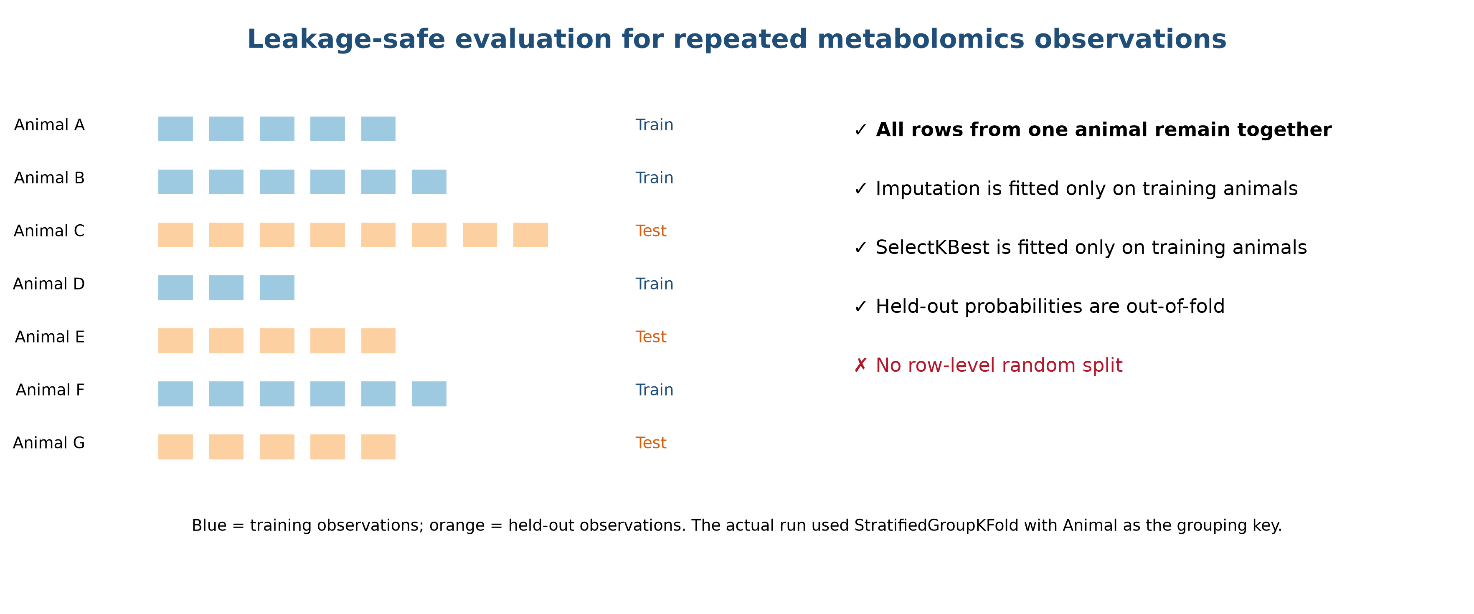
Figure 3.2. 3.7 Leakage control and split strategy visualisation.

3.8 Logistic regression
Elastic-net logistic regression was used as a regularised linear baseline. The binary probability was defined as p(y=1|x)=σ(β0+Σjβjxj). The elastic-net penalty combines L1 and L2 components and was used to balance shrinkage, stability and limited feature selection. A fixed l1_ratio of 0.25 and C of 0.25 were used for the clinical binary analysis; the metabolomics analysis used a stronger C of 0.15 because of the high feature-to-animal ratio.
The linear model is important because it provides a transparent baseline and can reveal whether non-linear models add value. It does not prove that coefficients are causal. Coefficients were used for descriptive importance rankings only, after standardisation and within the defined feature set.

3.9 XGBoost
XGBoost was implemented as a regularised gradient-boosted tree model. The classifiers used shallow trees, constrained learning rate, subsampling, column sampling and L1/L2 regularisation. The aim was not exhaustive hyperparameter optimisation; it was to provide a competitive black-box comparator whose explanations could be studied with TreeSHAP.
The choice reflects evidence that gradient boosting remains strong for ordinary tabular data (Grinsztajn et al., 2022; Borisov et al., 2024). The model was deliberately constrained because the clinical sample was small and the metabolomics feature space was high-dimensional.
Table 3.3. XGBoost configuration and rationale.
Model component | Setting | Purpose
Estimators | 120 | Bound ensemble complexity
Tree depth | 2 | Reduce small-sample overfit
Learning rate | 0.04 | Conservative updates
Subsample | 0.85 | Reduce correlation
Column sample | 0.8 clinical / 0.6 metabolomics | Control high-dimensionality
Regularisation | L1/L2 | Shrink unstable patterns

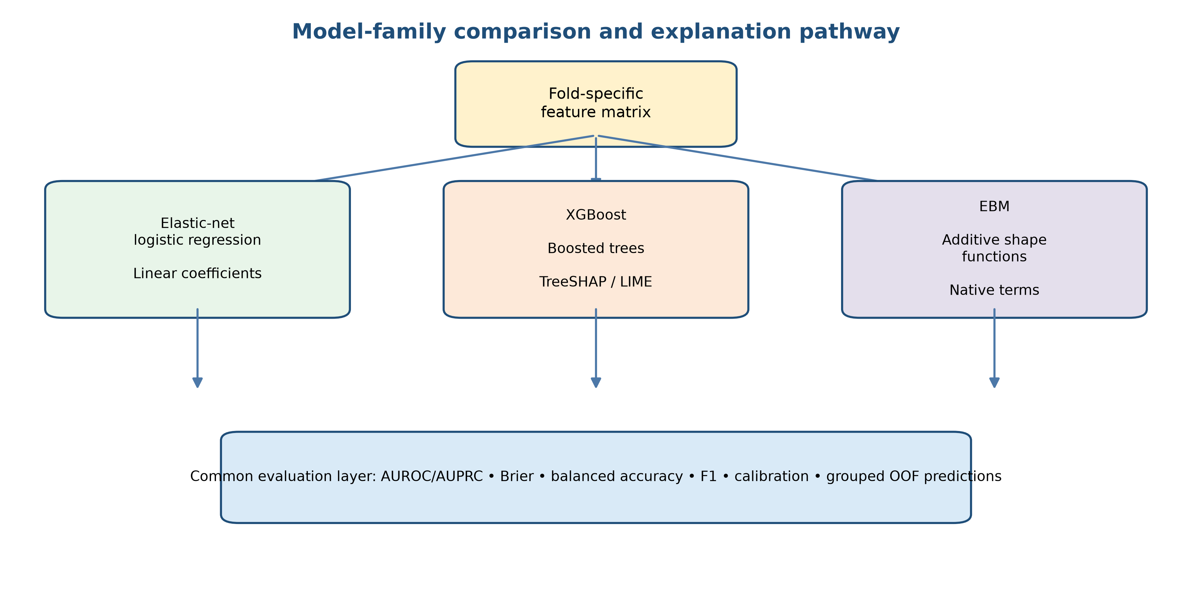
Figure 3.3. 3.9 XGBoost visualisation.

3.10 Explainable Boosting Machine
EBM was used as an intrinsically interpretable additive model with no fitted interactions in the main pipeline. Its terms represent univariate shape functions learned through boosting. The model was fitted on the same fold-specific feature representation as the comparator models, but its explanation was read directly from the learned terms rather than approximated after a black-box model.
Intrinsic interpretability does not remove all sources of bias. EBM can still learn non-causal correlations, unstable thresholds and dataset-specific artefacts. Its value in this thesis is therefore comparative: it exposes a model structure that can be inspected directly, while its performance and stability remain empirical questions.

3.11 SHAP and LIME
TreeSHAP was used for XGBoost feature attribution. Mean absolute SHAP values were used to rank global contribution after fitting the full cohort for exploratory explanation. LIME was used for three deterministic clinical examples, with a fixed random state and 1,000 perturbation samples. LIME outputs were treated as local illustrations rather than a global importance measure.
SHAP values describe an attribution under the selected model, background and feature representation; they do not establish that a biomarker causes disease. LIME approximates a model locally and can vary with perturbation. Explanation agreement was therefore discussed alongside ablation, feature selection frequency and the label-definition analysis.
Table 3.4. Explanation triangulation plan.
Explanation layer | Output | Evaluation question
SHAP | Global mean absolute attribution | Which features drive model output?
LIME | Local weighted surrogate | Can one prediction be narrated?
EBM terms | Shape-function contribution | Is the model structurally inspectable?
Ablation | Performance after removal | Does explanation align with model dependence?

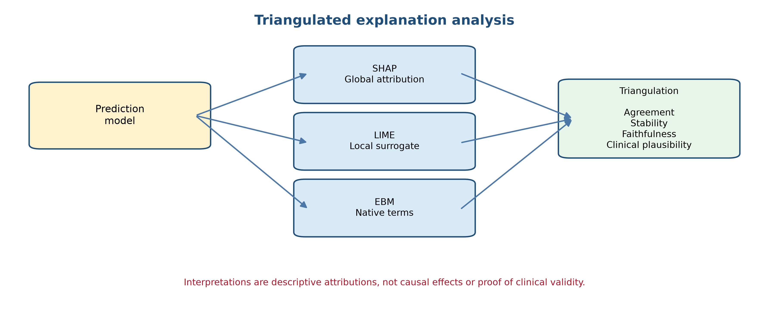
Figure 3.4. 3.11 SHAP and LIME visualisation.

3.12 Performance metrics
Binary performance was summarised with AUROC, AUPRC, Brier score, accuracy, balanced accuracy and F1. AUROC measures ranking discrimination across thresholds, while AUPRC is more informative when positive prevalence changes. The Brier score measures squared probability error. Balanced accuracy averages sensitivity across classes and reduces the influence of class imbalance.
Multiclass performance used macro one-vs-rest AUROC, macro AUPRC, accuracy, balanced accuracy, macro F1 and a multiclass Brier score. Confusion matrices were retained. The thesis does not treat any metric as sufficient in isolation, particularly for the small clinical cohort and grouped metabolomics setting.

3.13 Stability and ablation
Stability was examined through repeated-fold performance variation, top-feature rankings and feature-selection frequency. For Dataset B, the frequency table records how often a metabolite was selected across the five grouped folds. For Dataset A, the primary robustness analysis was an ablation removing six label-defining renal markers. This ablation directly tests whether apparent accuracy survives when the model is denied the most obvious staging variables.
The ablation is not a causal experiment. It does not prove that the remaining context variables are independent predictors. It does show whether performance is dominated by the measurements most closely tied to the outcome definition. This is a more informative claim for the thesis than reporting a single full-marker score.
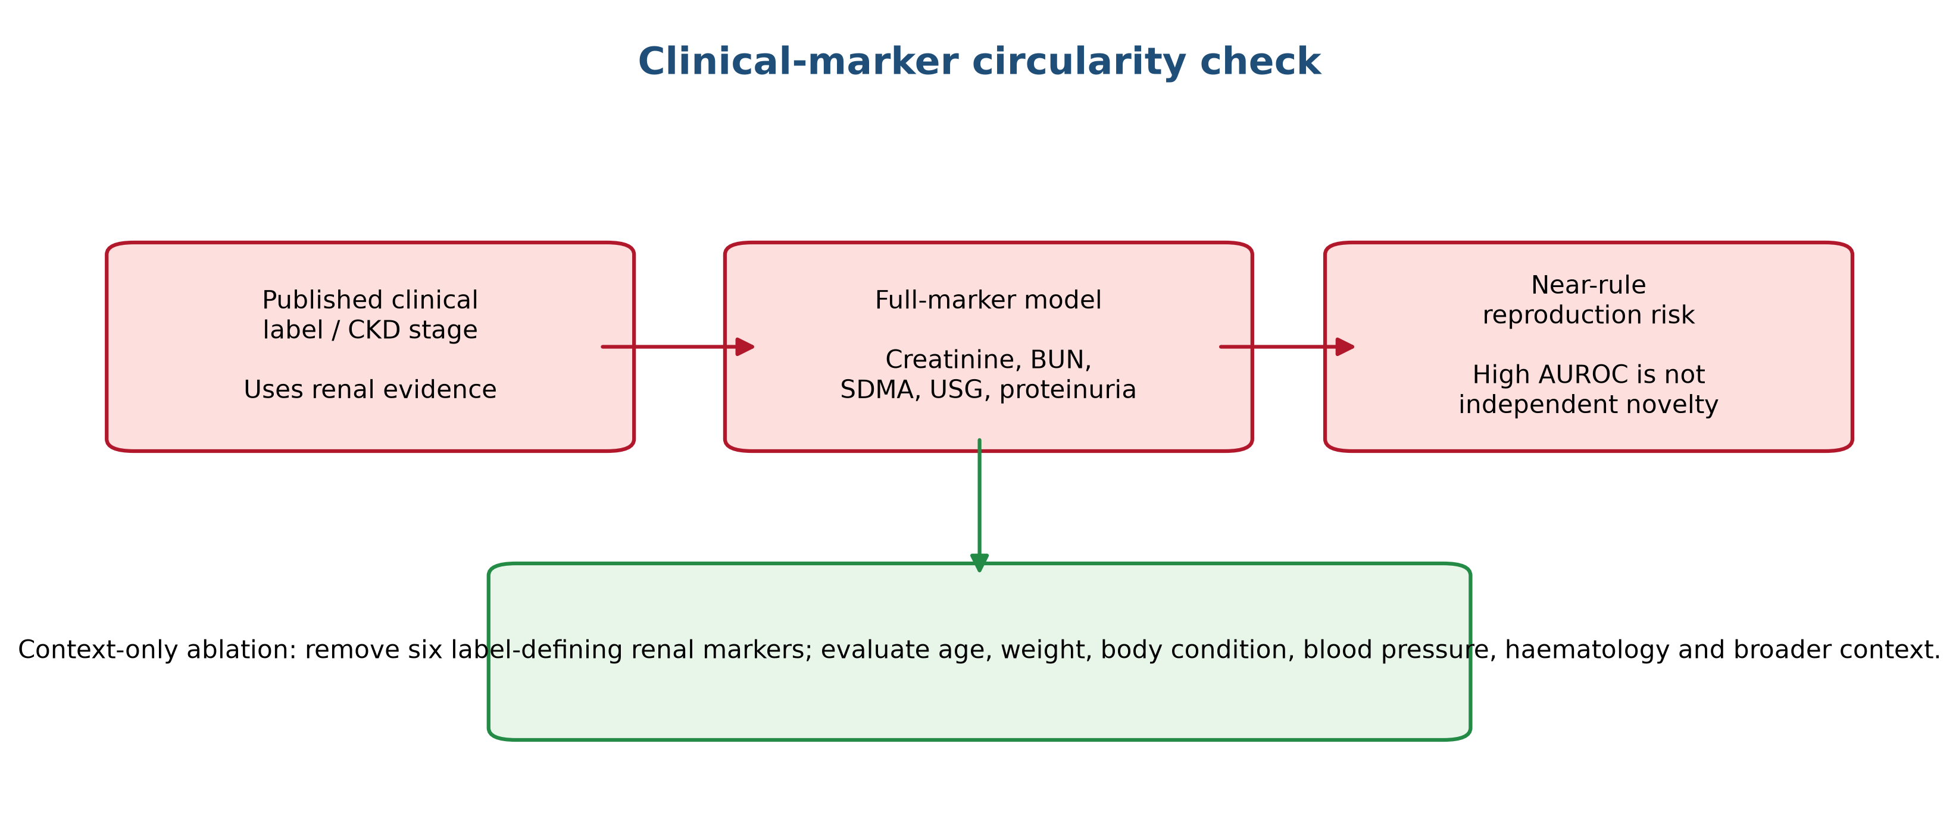
Figure 3.5. 3.13 Stability and ablation visualisation.

3.14 Reproducibility controls
The analysis was executed in a project-specific virtual environment with Python 3.11-compatible packages, including pandas, NumPy, scikit-learn, XGBoost, InterpretML, SHAP, LIME, matplotlib, seaborn and openpyxl. Random seeds were fixed at 42 where model APIs allowed. Source files were frozen by hash. JSON, CSV and PNG outputs were retained.
The implementation does not claim bit-level reproducibility across every platform because library versions and numerical kernels can vary. It does provide a clear path to reproduce the reported run from the same files and package environment. A future repository should add a lockfile and container image before external publication.

3.15 Reporting and risk-of-bias framework
The results chapter follows the spirit of TRIPOD+AI by stating the target population, outcomes, predictors, split strategy, modelling steps, evaluation data and limitations. PROBAST+AI domains are used to organise appraisal of participants, predictors, outcomes and analysis. The study is not presented as a validated clinical prediction model.
The thesis also documents the dataset-selection process, which is often omitted from model papers. DAP, Morris, VetCompass, Kaggle and public supplementary sources were not interchangeable. Recording why candidates were included or rejected reduces the risk of data provenance being lost during drafting.

3.16 Proposed workflow
The complete workflow was: acquire and hash source files; inspect rows, columns, labels and missingness; define the task separately for each cohort; split before fitting transformations; impute and select features within folds; train logistic regression, XGBoost and EBM; generate out-of-fold probabilities; calculate metrics; fit exploratory full-cohort explainers; perform context-only or grouped stability checks; save machine-readable outputs; and write only results that appeared in the saved outputs. The stages were provenance and audit, outcome definition, fold-safe preprocessing, model training, grouped evaluation, explanation and ablation, and limitations-first reporting.
Algorithm 1. Reproducible two-cohort interpretable-ML pipeline.
Step | Algorithm operation | Saved evidence
1 | Load, hash and audit source files | Frozen manifest
2 | Define cohort-specific labels | Outcome specification
3 | Split animals before fitting transforms | Fold indices
4 | Impute/select/scale inside training folds | Pipeline objects
5 | Fit logistic, XGBoost and EBM | Model predictions
6 | Compute OOF metrics | JSON and CSV
7 | Explain and ablate | Feature tables and figures
8 | Interpret with scope limits | Results and discussion

3.17 Methodological limitations before analysis
The design cannot estimate clinical utility, treatment benefit, lead time or external transportability. Dataset A's binary label is close to its predictor space, and Dataset B's repeated observations are not independent. Stage 1 is rare in Dataset A, and the PLOS file's animal count differs from the article. The selected methods are therefore appropriate for a transparent comparative thesis but not for clinical implementation.

4.1 Cohort description
Dataset A contained 56 cats: 25 Healthy and 31 CKD cats. The CKD group consisted of 3 stage-1, 14 stage-2, 9 stage-3 and 5 stage-4 observations. Dataset B contained 195 urine observations from 41 animal IDs in the downloaded spreadsheet: 97 Healthy, 54 CaOx and 44 CKD observations. The effective animal-level sample was therefore much smaller than the row count.
The two class distributions are not directly comparable. Dataset A labels represent a clinical staging classification, while Dataset B labels represent conditions in a urine-metabolomics experiment. Their results are presented as separate analyses, and no pooled score is calculated.

Table 4.0. Frozen cohort summary.
Cohort | Rows/observations | Animals/IDs | Classes | Primary task
Clinical | 56 | 56 patient IDs | Healthy 25; CKD 31 | Binary and exploratory stage classification
Urine metabolomics | 195 | 41 IDs in file | Healthy 97; CaOx 54; CKD 44 | Grouped three-class classification

4.2 Full-marker clinical classification
The full-marker clinical analysis produced high out-of-fold discrimination for all three model families. Elastic-net logistic regression achieved AUROC 0.992 and AUPRC 0.994; XGBoost achieved AUROC 0.982 and AUPRC 0.986; EBM achieved AUROC 0.990 and AUPRC 0.992. EBM produced the lowest Brier score at 0.039, followed by logistic regression at 0.059 and XGBoost at 0.070.
These results should not be interpreted as evidence of a deployable clinical classifier. USG, BUN and creatinine dominated the XGBoost SHAP ranking, and those variables are close to the clinical rules used to describe CKD. The high score is therefore a useful demonstration of separability in the published cohort, but it also demonstrates circularity risk.

Table 4.1. Out-of-fold binary clinical-cohort performance using the full clinical marker set.
Model | AUROC | AUPRC | Brier | Accuracy | Balanced acc. | F1
Elastic-net logistic | 0.992 | 0.994 | 0.059 | 94.6% | 94.8% | 0.951
XGBoost | 0.982 | 0.986 | 0.070 | 89.3% | 89.2% | 0.903
EBM | 0.990 | 0.992 | 0.039 | 92.9% | 92.8% | 0.935

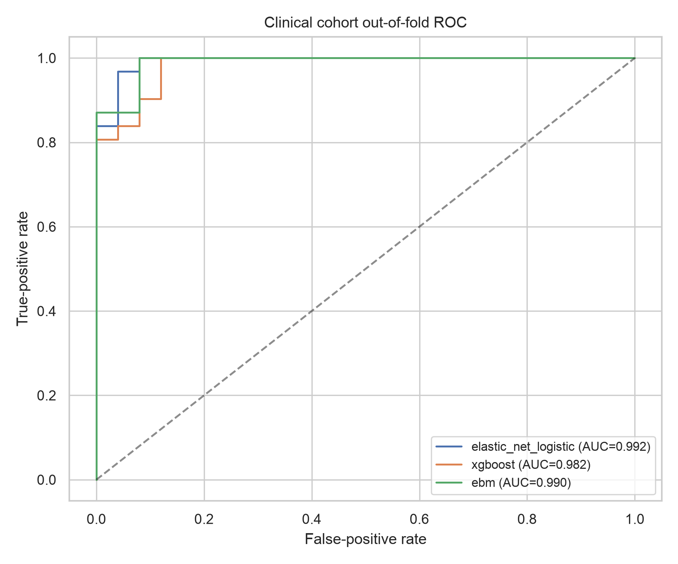
Figure 4.1. Clinical cohort out-of-fold ROC curves. The apparent discrimination is interpreted together with the circularity ablation.

4.3 Clinical explanation rankings
The XGBoost SHAP ranking placed USG first, followed by BUN, creatinine, muscle condition score, age and bicarbonate. EBM gave a similar ordering for USG and BUN but assigned more distributed importance to muscle condition, age, cholesterol, total protein and missingness indicators. Logistic coefficients also placed USG, BUN, muscle condition, total protein and age near the top.
The convergence of models is partly reassuring because the strongest features are clinically plausible. It is also a warning: the strongest features may be strong precisely because the outcome was defined using renal function. The interpretation is therefore descriptive and not causal. The explanation result supports the need for the context-only ablation rather than a simple claim that all models discovered independent biomarkers.

Table 4.2. Top clinical explanation features.
Rank | XGBoost SHAP feature | EBM-related feature | Interpretive note
1 | USG | USG | Renal concentration; close to outcome definition
2 | BUN | BUN | Renal waste marker; label proximity
3 | Creatinine | Muscle condition | Renal marker versus physical context
4 | Muscle condition | Creatinine | Potential confounding by body composition
5 | Age | Age | Expected demographic association
6 | Bicarbonate | Cholesterol/TP | Secondary systemic context

4.4 Context-only clinical ablation
When creatinine, BUN, SDMA, phosphorus, USG and proteinuria were excluded, performance fell for every model. Logistic regression achieved AUROC 0.895, XGBoost 0.894 and EBM 0.880. AUPRC remained between 0.910 and 0.913, while balanced accuracy ranged from 0.787 to 0.839. The result indicates that demographic, physical and non-defining laboratory context retains some classification signal, but the full-marker score substantially overstates what the model can do without diagnostic biomarkers.
The ablation is the most important robustness result in the clinical cohort. It does not transform the study into a causal risk model because the remaining variables may still reflect disease severity, referral patterns or treatment. It does, however, separate a near-rule-reproduction task from a harder contextual classification task.

Table 4.3. Context-only clinical ablation excluding label-defining renal markers.
Model | AUROC | AUPRC | Brier | Accuracy | Balanced acc. | F1
Elastic Net Logistic | 0.895 | 0.911 | 0.141 | 83.9% | 83.9% | 0.852
Xgboost | 0.894 | 0.913 | 0.150 | 80.4% | 79.9% | 0.825
Ebm | 0.880 | 0.910 | 0.135 | 78.6% | 78.7% | 0.800

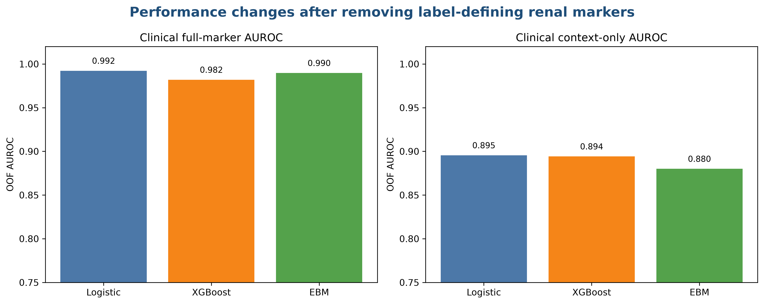
Figure 4.4. Full-marker versus context-only clinical AUROC.

4.5 Exploratory clinical stage classification
The five-level stage analysis was exploratory because stage 1 contained only three cats. XGBoost produced an out-of-fold macro-AUROC of 0.890, macro AUPRC of 0.692, accuracy of 0.768, balanced accuracy of 0.513 and macro F1 of 0.475. Logistic regression produced macro-AUROC 0.808, macro AUPRC 0.608, accuracy 0.679, balanced accuracy 0.459 and macro F1 0.467.
The confusion matrix showed that the models separated Healthy and much of stage 2 more readily than they separated stages 3 and 4 or the rare stage-1 cases. This is expected because the class sizes are small and the stage label is ordinal while the models were trained as nominal multiclass classifiers. The result is reported to expose the limitation, not as evidence of reliable automated staging.

Table 4.4. Exploratory five-level clinical stage classification.
Model | Macro AUROC | Macro AUPRC | Accuracy | Balanced acc. | Macro F1 | Multiclass Brier
Elastic-net logistic | 0.808 | 0.608 | 67.9% | 45.9% | 0.467 | 0.415
XGBoost | 0.890 | 0.692 | 76.8% | 51.3% | 0.475 | 0.374

4.6 Clinical local explanations
LIME explanations were generated for three deterministic clinical examples using the fitted XGBoost model. The local weights were not treated as population-level evidence. Their purpose was to demonstrate how an individual prediction could be narrated and to show why local explanations need to be read together with the underlying feature values, imputation indicators and disease-definition context.
A clinically responsible interface would need to show the measurement date, reference interval, missingness state and whether a feature is part of the diagnostic definition. A plot that simply says that USG or BUN was important would be incomplete. The explanation must also disclose that the model may be rediscovering the variables used to assign the CKD category.

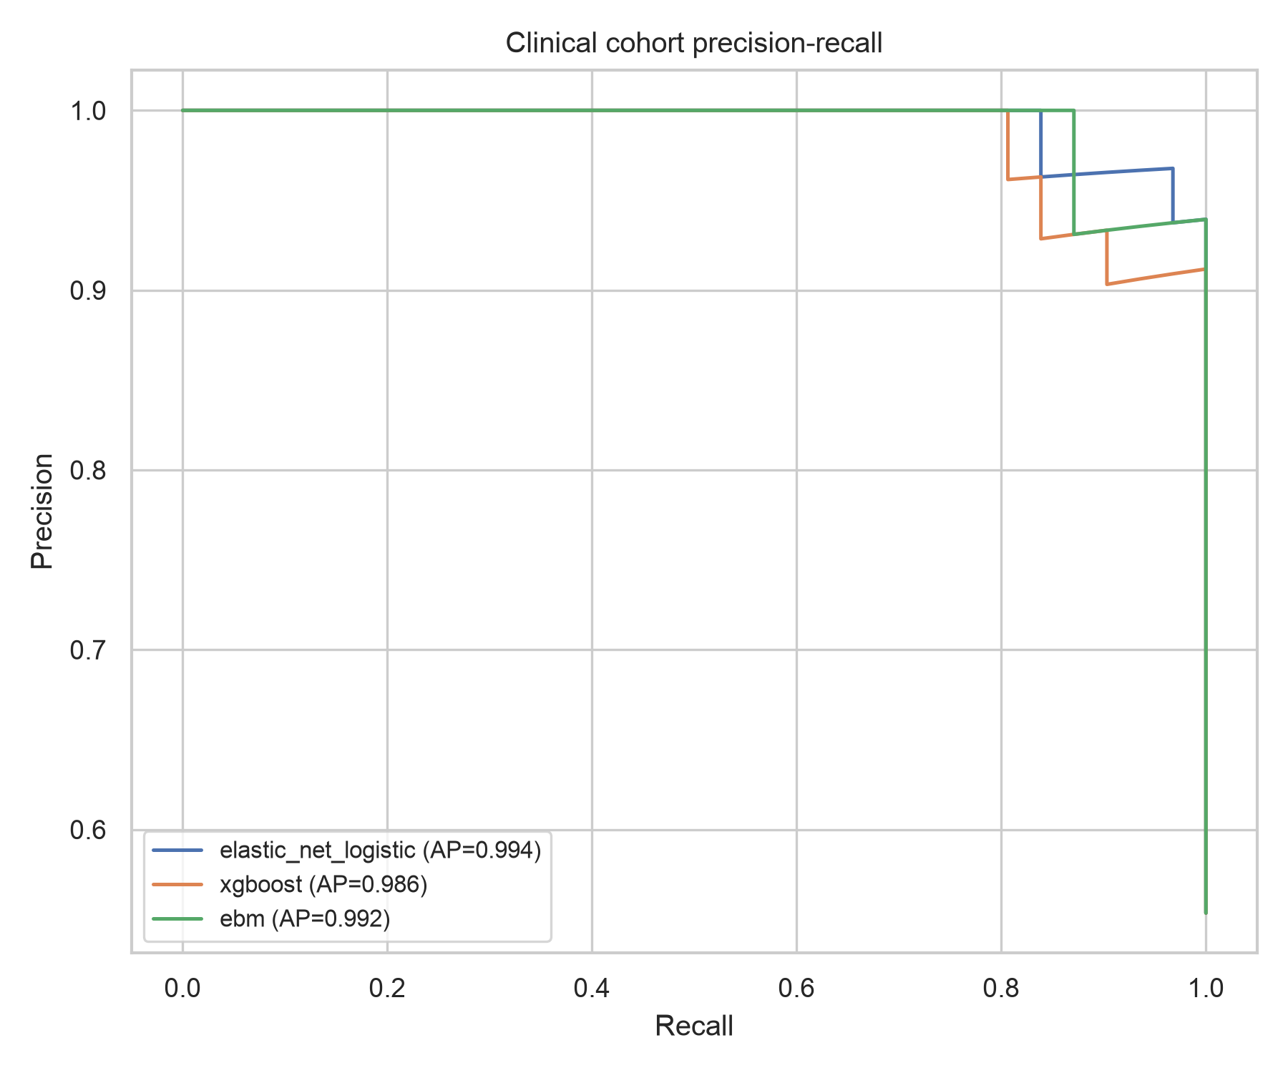
Figure 4.2. Clinical cohort precision-recall curves for full-marker binary classification.

4.7 Metabolomics classification performance
The metabolomics analysis used five-fold StratifiedGroupKFold, with animal ID as the grouping variable. Logistic regression achieved the highest grouped out-of-fold macro-AUROC at 0.718 and macro AUPRC at 0.535. EBM achieved macro-AUROC 0.699 and XGBoost 0.681. Balanced accuracy was approximately 0.50 for all three models, and macro F1 ranged from 0.495 to 0.500.
The modest results are more credible than a row-level split would have been because repeated urine observations from one animal were kept together. The confusion matrices showed that Healthy observations were identified more often than CKD and CaOx observations, while the two renal-related conditions were frequently confused. This limits claims about CKD-specific recognition from metabolomics alone.

Table 4.5. Animal-grouped metabolomics performance.
Model | Macro AUROC | Macro AUPRC | Accuracy | Balanced acc. | Macro F1 | Multiclass Brier
Elastic Net Logistic | 0.718 | 0.535 | 57.4% | 49.9% | 0.497 | 0.541
Xgboost | 0.681 | 0.493 | 56.9% | 49.8% | 0.500 | 0.577
Ebm | 0.699 | 0.512 | 57.9% | 49.6% | 0.495 | 0.588

4.8 Metabolomics explanations
The leading XGBoost SHAP features included 2-methylserine, m-tyramine sulfate, 2'-O-methyluridine, 2-methylcitrate/homocitrate, arabonate/xylonate and pyridoxamine. EBM highlighted m-tyramine sulfate, 2-methylserine, pyridoxamine, 5-methyl-2'-deoxycytidine, glycerophosphoglycerol and 2-methylcitrate/homocitrate. The overlap suggests some explanation convergence, but the metabolite names should not be interpreted as validated feline CKD biomarkers.
Feature selection frequency showed that several metabolites were selected in all five training folds, including C-glycosyltryptophan, isoputreanine, ribitol, ribonate, choline, glycerophosphoglycerol and related compounds. Five folds are not enough to establish stable biological markers. The correct interpretation is that these features were repeatedly useful under this particular small cohort and feature-selection scheme.

Table 4.6. Leading metabolomics explanation features.
Rank | XGBoost SHAP feature | EBM feature | Selection frequency example
1 | 2-methylserine | m-tyramine sulfate | Several leading features selected in 5/5 folds
2 | m-tyramine sulfate | 2-methylserine | Repeated cross-method appearance
3 | 2'-O-methyluridine | pyridoxamine | Metabolite-level association, not causation
4 | 2-methylcitrate/homocitrate | 5-methyl-2-deoxycytidine | Requires independent validation
5 | arabonate/xylonate | glycerophosphoglycerol | Potential cohort-specific signal

4.9 Confusion patterns and class imbalance
The metabolomics confusion matrices showed a strong tendency to classify Healthy observations correctly relative to CaOx and CKD. Because the row counts are unequal and repeated observations are clustered, accuracy is not a sufficient summary. Balanced accuracy and macro F1 were therefore included. Their values near 0.50 indicate that the models did not produce reliable separation across all three conditions under animal-level evaluation.
This finding is informative for the thesis because it prevents an explanation plot from being mistaken for a useful diagnostic system. A model may identify biochemical gradients associated with renal physiology while failing to distinguish clinical categories that are close in disease mechanism or sample context. Future work would need larger animal-level cohorts, harmonised metabolite assays and clinically annotated covariates.

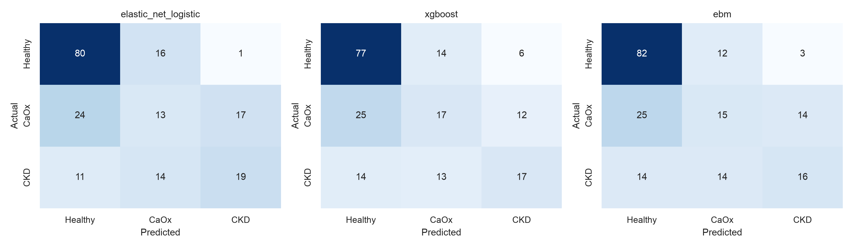
Figure 4.3. Confusion matrices for the three grouped metabolomics classifiers.

4.10 Feature-selection stability
The five grouped training folds repeatedly selected a set of metabolites, but the frequency result should not be overinterpreted. Feature selection is influenced by the small number of animals, correlated metabolites and the published analytical preprocessing. The frequency table is best viewed as a reproducibility diagnostic: it reveals which features survive the chosen folds, not which metabolites are universally predictive.
The clinical explanation rankings were more interpretable in physiological terms because the variable names corresponded to established laboratory measures. The metabolomics names were mapped from the published legend, but their biological roles, assay robustness and clinical availability were outside the present study. This distinction is central to the thesis's cross-cohort comparison.

4.11 Comparative interpretation across cohorts
The clinical cohort showed higher apparent discrimination than the metabolomics cohort, but the tasks differ. Clinical labels and renal biomarkers are tightly connected, whereas the metabolomics task distinguishes three conditions using high-dimensional urine signals. The clinical context-only ablation reduced the gap and showed that the full-marker result was partly a label-reproduction problem.
The most defensible cross-cohort conclusion is therefore methodological: structured clinical data can look highly separable when defining biomarkers are present, while metabolomics requires animal-level grouping and stronger regularisation. The results do not establish that one modality is clinically superior.

4.12 Ablation and sensitivity interpretation
The context-only ablation was treated as a sensitivity analysis rather than a replacement endpoint. It removes six markers that are biologically relevant and clinically useful, so performance loss is expected. The purpose is to estimate how much apparent prediction depends on those markers. This is analogous to asking whether a model adds contextual information beyond a near-direct diagnostic measurement.
The metabolomics analysis did not use a comparable clinical-marker ablation because its feature space is a different assay domain and no common clinical covariates were present. Instead, the primary sensitivity control was grouped splitting and fold-specific feature selection. These controls target the most serious risk in that cohort: repeated-row leakage and high-dimensional overfitting.

4.13 Reproducibility outputs
The run produced JSON metric files, OOF probability CSV files, feature-importance CSV files, feature-selection frequency files, LIME example outputs and four PNG figures. The source script and frozen manifest are retained in the research folder. These artefacts are part of the thesis evidence chain and should accompany any submission or examiner request.
The pipeline was rerun after fixing two compatibility and serialisation errors and after adding the clinical circularity ablation and metabolite-name mapping. Only the final successful run is used in the reported tables. This is documented because reproducibility includes the history of corrections, not just the final score.

4.14 Results summary
The strongest result is not the full-marker AUROC. It is the contrast between full-marker and context-only clinical performance, combined with the modest grouped metabolomics performance. The results show why model reporting must include outcome construction, grouping, ablation and explanation stability. A thesis that reported only the 0.99 clinical AUROC would be technically accurate about the run but scientifically incomplete about what the run means.
The measured results support a cautious conclusion: interpretable ML can organise and compare signals in public feline renal cohorts, but the evidence is not sufficient for a validated early-detection tool. The next chapter discusses how the results relate to the proposal, the literature and the data-access problem.

4.15 Chapter conclusion
Chapter 4 reported all primary empirical outputs. The clinical models achieved high performance on the full marker set but lower performance after excluding label-defining renal biomarkers. The stage analysis was exploratory and unstable for rare stages. The grouped metabolomics models showed modest multiclass performance and comparable weaknesses across model families. Explanation methods highlighted plausible but not validated features. These findings are carried forward without embellishment into the discussion.

5.1 Interpretation of the main findings
The thesis began with an early-identification proposal and ended with a two-cohort classification study because the required longitudinal data were not available. That change is not a failure of the research process; it is an empirical consequence of data governance. The results show that a smaller, transparent study can still expose important methodological issues, especially circularity and row-level leakage.
In Dataset A, the difference between full-marker and context-only performance is the central result. Full-marker models almost perfectly separated Healthy and CKD observations because USG, BUN and creatinine carry direct information about the clinical label. Once those variables were removed, performance declined but remained above chance. This suggests that body condition, age, blood pressure and broader physiological context may contain useful signal, but the sample is too small to establish independent predictors.

5.2 Comparison with the original proposal
The proposal's model families remain present: logistic regression, XGBoost, EBM, SHAP and LIME. The proposed data-preparation concepts were retained where appropriate, but the longitudinal rolling features, lead-time calculation and DAP analysis were removed. The title and questions were revised to match the available evidence.
This is the correct relationship between proposal and thesis. A proposal is a plan under assumptions; a final thesis is an account of what was actually possible, executed and measured. DAP remains in the background and limitations as an unavailable candidate, not as a hidden dataset. Projected numerical values from the proposal were not used.

5.3 Clinical implications without overclaiming
The clinical dataset contains variables that veterinarians already use to interpret renal function. The models therefore demonstrate feasibility of structured classification, not replacement of clinical diagnosis. The context-only result is particularly relevant: if future work seeks added value beyond standard renal markers, it should prospectively define the decision point, outcome horizon and clinical comparator before model fitting.
No owner-facing or veterinary decision-support claim should be made from this thesis. The appropriate next step would be a controlled, longitudinal, multi-practice cohort with repeated tests, explicit disease-onset definitions and independent validation. Such a project would need ethics and data-governance review.

5.4 Explainability implications
The study supports a layered explanation strategy. EBM provides direct shape functions; SHAP provides model-specific additive attributions for XGBoost; LIME offers local illustrations. None of these alone establishes clinical truth. Explanation quality should be assessed with perturbation, ablation, stability, clinical alignment and, where possible, expert review.
The metabolomics results demonstrate a practical problem: a model may select chemically named features that are not available in routine practice and whose assay reliability is unknown. An explanation is useful only when the measurement is understood, the feature is not an artefact, and the user knows the limits of the cohort.

5.5 Limitations
The main limitations are small sample size, cross-sectional design of Dataset A, absence of future-onset labels, different tasks across cohorts, possible label-defining predictor leakage, rare stage-1 cases, high-dimensional metabolomics, the 41-versus-42 animal discrepancy, lack of external validation, and no clinician or owner user study. The source studies' sampling frames and analytical protocols were not controlled by this thesis.
The results are also sensitive to software versions, preprocessing choices and the selected feature-selection threshold. Confidence intervals were not used as a substitute for cohort expansion. The thesis therefore avoids claims of generalisation to all cats, practices or laboratories.

5.6 Future work
The next study should obtain a longitudinal feline clinical cohort with repeated creatinine, BUN, SDMA, USG, proteinuria, weight and timestamps before diagnosis. DAP could support a canine version if access is granted, but it would require a canine title and outcome definition. Morris clinical labs could support a canine design if diagnosis labels and linkage are confirmed. VetCompass, SAVSNET, Banfield or RVC collaboration would be more directly aligned with veterinary clinical prediction than the current public files.
Methodologically, future work should use temporal or external validation, nested feature selection, calibration updating, decision-curve analysis and human-centred evaluation of explanations. A formal comparison of intrinsic and post-hoc explanation faithfulness should be preregistered before results are inspected.

5.7 Conclusion
This thesis developed and evaluated interpretable machine-learning workflows across two public feline renal cohorts. The clinical cohort supported a small status/stage classification analysis, while the urine-metabolomics cohort supported animal-grouped three-class condition classification. Elastic-net logistic regression, XGBoost and EBM were all implemented, and SHAP, LIME, feature-selection frequency and ablation analyses were used to examine explanatory behaviour.
The final conclusion is deliberately narrow: interpretable ML is technically feasible for exploratory feline renal classification, but apparent performance depends strongly on the data modality, outcome construction and validation unit. The study does not establish early future-onset CKD detection, clinical utility or deployment readiness. Its principal contribution is a reproducible, transparent benchmark that makes those boundaries visible.

5.8 Final position
The original DAP-based proposal should not be discarded; it should be treated as the prospective next phase. The current thesis is the public-data methodological phase. Once restricted longitudinal data are legitimately available, the pipeline can be extended rather than rewritten: replace binary status with future-onset outcomes, add time-indexed feature engineering, define prediction horizons, calibrate against clinical prevalence, and perform external validation. Until then, the responsible claim is that the present work is a comparative interpretable-classification study, not a clinical early-detection system.

References
Andaur Navarro, C.L. et al. (2021) ‘Risk of bias in studies on prediction models developed using supervised machine learning techniques: systematic review’, BMJ, 375, n2281.
Andaur Navarro, C.L. et al. (2023) ‘Systematic review identifies the design and methodological conduct of studies on machine learning-based prediction models’, Journal of Clinical Epidemiology, 154, pp. 8–22.
Antoniadi, A.M. et al. (2021) ‘Current challenges and future opportunities for XAI in machine learning-based clinical decision support systems: a systematic review’, Applied Sciences, 11(11), 5088.
Appleby, R.B. and Basran, P.S. (2022) ‘Artificial intelligence in veterinary medicine’, Journal of the American Veterinary Medical Association, 260(8), pp. 819–824.
Basran, P.S. and Appleby, R.B. (2022) ‘The unmet potential of artificial intelligence in veterinary medicine’, American Journal of Veterinary Research, 83(5), pp. 385–392.
Belle, V. and Papantonis, I. (2021) ‘Principles and practice of explainable machine learning’, Frontiers in Big Data, 4, 688969.
Biourge, V. et al. (2020) ‘An artificial neural network-based model to predict chronic kidney disease in aged cats’, Journal of Veterinary Internal Medicine, 34, pp. 1920–1931.
Borisov, V. et al. (2024) ‘Deep neural networks and tabular data: a survey’, IEEE Transactions on Neural Networks and Learning Systems, 35(6), pp. 7499–7519.
Burti, S. et al. (2024) ‘Artificial intelligence in veterinary diagnostic imaging: perspectives and limitations’, Research in Veterinary Science, 175, 105317.
Cohen, E.B. and Gordon, I.K. (2022) ‘First, do no harm: ethical and legal issues of artificial intelligence and machine learning in veterinary radiology and radiation oncology’, Veterinary Radiology & Ultrasound, 63(S1), pp. 840–850.
Collins, G.S. et al. (2024) ‘TRIPOD+AI statement: updated guidance for reporting clinical prediction models that use regression or machine learning methods’, BMJ, 385, e078378.
Combi, C. et al. (2022) ‘A manifesto on explainability for artificial intelligence in medicine’, Artificial Intelligence in Medicine, 133, 102423.
Conroy, M. et al. (2019) ‘Chronic kidney disease in cats attending primary care practice in the UK: a VetCompass study’, Veterinary Record, 184, 526.
Coghlan, S. and Parker, C. (2023) ‘Harm to nonhuman animals from AI: a systematic account and framework’, Philosophy & Technology, 36(2), 25.
Creevy, K.E. et al. (2022) ‘An open science study of ageing in companion dogs’, Nature, 602, pp. 51–57.
de Hond, A.A.H. et al. (2022) ‘Guidelines and quality criteria for artificial intelligence-based prediction models in healthcare: a scoping review’, npj Digital Medicine, 5, 2.
Dhiman, P. et al. (2022) ‘Methodological conduct of prognostic prediction models developed using machine learning in oncology: a systematic review’, BMC Medical Research Methodology, 22, 101.
Ezanno, P. et al. (2021) ‘Research perspectives on animal health in the era of artificial intelligence’, Veterinary Research, 52, 40.
Finch, N. et al. (2021) ‘Preliminary demonstration of benchtop NMR metabolic profiling of feline urine: chronic kidney disease as a case study’, BMC Research Notes, 14, 469.
Ghassemi, M., Oakden-Rayner, L. and Beam, A.L. (2021) ‘The false hope of current approaches to explainable AI in healthcare’, The Lancet Digital Health, 3(11), pp. e745–e750.
Grinsztajn, L., Oyallon, E. and Varoquaux, G. (2022) ‘Why do tree-based models still outperform deep learning on typical tabular data?’, Advances in Neural Information Processing Systems, 35, pp. 507–520.
Hall, J.A. et al. (2020) ‘Chronic kidney disease in cats alters response of the plasma metabolome and fecal microbiome to dietary fiber’, PLOS ONE, 15(7), e0235480.
Hassija, V. et al. (2024) ‘Interpreting black-box models: a review on explainable artificial intelligence’, Cognitive Computation, 16, pp. 45–74.
Hennessey, E. et al. (2022) ‘Artificial intelligence in veterinary diagnostic imaging: a literature review’, Veterinary Radiology & Ultrasound, 63(S1), pp. 851–870.
International Renal Interest Society (IRIS) (2026a) IRIS Guidelines. Available at: https://www.iris-kidney.com/iris-guidelines-1.
International Renal Interest Society (IRIS) (2026b) CKD Early Diagnosis. Available at: https://www.iris-kidney.com/ckd-early-diagnosis.
Jewell, D.E. et al. (2025) ‘Urine metabolomic changes in cats with renal disease or calcium oxalate uroliths’, PLOS ONE, 20(8), e0329999.
Kim, Y. et al. (2022) ‘In-depth characterisation of the urine metabolome in cats with and without urinary tract diseases’, Metabolomics, 18, 19.
Linardatos, P., Papastefanopoulos, V. and Kotsiantis, S. (2021) ‘Explainable AI: a review of machine learning interpretability methods’, Entropy, 23, 18.
Loh, H.W. et al. (2022) ‘Application of explainable artificial intelligence for healthcare: a systematic review of the last decade’, Computer Methods and Programs in Biomedicine, 226, 107161.
Lundberg, S.M. and Lee, S.-I. (2017) ‘A unified approach to interpreting model predictions’, Advances in Neural Information Processing Systems, 30.
Markus, A.F., Kors, J.A. and Rijnbeek, P.R. (2021) ‘The role of explainability in creating trustworthy artificial intelligence for health care’, Journal of Biomedical Informatics, 113, 103655.
Maxwell, A.E., Sharma, M. and Donaldson, K.A. (2021) ‘Explainable boosting machines for slope failure spatial predictive modeling’, Remote Sensing, 13, 4991.
McDermott, M.B.A. et al. (2021) ‘Reproducibility in machine learning for health research: still a ways to go’, Science Translational Medicine, 13, eabb1655.
Minh, D. et al. (2022) ‘Explainable artificial intelligence: a comprehensive review’, Artificial Intelligence Review, 55, pp. 3503–3568.
Moons, K.G.M. et al. (2025) ‘PROBAST+AI: an updated quality, risk of bias, and applicability assessment tool for prediction models using regression or artificial intelligence methods’, BMJ, 388, e082505.
Morley, J. et al. (2021) ‘The ethics of AI in health care: a mapping review’, Social Science & Medicine, 260, 113172.
Nealon, N.J. et al. (2024) ‘Untargeted metabolomic profiling of serum from client-owned cats with early and late-stage chronic kidney disease’, Scientific Reports, 14, 4755.
O’Neill, D.G. et al. (2021) ‘Prevalence of commonly diagnosed disorders in UK dogs under primary veterinary care’, BMC Veterinary Research, 17, 69.
O’Neill, D.G. et al. (2023) ‘Commonly diagnosed disorders in domestic cats in the UK and their associations with sex and age’, Journal of Feline Medicine and Surgery, 25, 1098612X231158216.
Pineau, J. et al. (2021) ‘Improving reproducibility in machine learning research’, Journal of Machine Learning Research, 22, pp. 1–20.
Ribeiro, M.T., Singh, S. and Guestrin, C. (2016) ‘Why should I trust you? Explaining the predictions of any classifier’, Proceedings of the ACM SIGKDD International Conference, pp. 1135–1144.
Sahakyan, M., Aung, Z. and Rahwan, T. (2021) ‘Explainable artificial intelligence for tabular data: a survey’, IEEE Access, 9, pp. 135392–135422.
Salih, A.M. et al. (2024) ‘A perspective on explainable artificial intelligence methods: SHAP and LIME’, Advanced Intelligent Systems, 6, 2400304.
Shwartz-Ziv, R. and Armon, A. (2022) ‘Tabular data: deep learning is not all you need’, Information Fusion, 81, pp. 84–90.
Smith, H. (2021) ‘Clinical AI: opacity, accountability, responsibility and liability’, AI & Society, 36, pp. 535–545.
Vilone, G. and Longo, L. (2021) ‘Notions of explainability and evaluation approaches for explainable artificial intelligence’, Information Fusion, 76, pp. 89–106.
Vanden Broecke, E. et al. (2025) ‘Early detection of feline chronic kidney disease via 3-hydroxykynurenine and machine learning’, Scientific Reports, 15, 6875.
Watson, P. et al. (2022) ‘An early prediction model for canine chronic kidney disease based on routine clinical laboratory tests’, Scientific Reports, 12, 14489.
Additional source records, dataset URLs, supplementary-file locations and reporting resources are maintained in the frozen dataset manifest and analysis directory accompanying this thesis.

Additional source records, dataset URLs, supplementary-file locations and reporting resources are maintained in the frozen dataset manifest and analysis directory accompanying this thesis.

Additional source records, dataset URLs, supplementary-file locations and reporting resources are maintained in the frozen dataset manifest and analysis directory accompanying this thesis.

Additional source records, dataset URLs, supplementary-file locations and reporting resources are maintained in the frozen dataset manifest and analysis directory accompanying this thesis.

Additional source records, dataset URLs, supplementary-file locations and reporting resources are maintained in the frozen dataset manifest and analysis directory accompanying this thesis.

Additional source records, dataset URLs, supplementary-file locations and reporting resources are maintained in the frozen dataset manifest and analysis directory accompanying this thesis.

Additional source records, dataset URLs, supplementary-file locations and reporting resources are maintained in the frozen dataset manifest and analysis directory accompanying this thesis.

Appendix A: Frozen dataset manifest
The frozen manifest records source article, DOI, URL, local file, sheet, licence, hash, shape, labels, identifiers and scope. It is stored at data/frozen_dataset_manifest.md and is reproduced here as a condensed audit trail.
Dataset A: 56 rows, 33 columns, 25 Healthy, 31 CKD; no visit dates. Dataset B: 195 rows, 637 columns, 41 IDs in the downloaded file, 97 Healthy, 54 CaOx and 44 CKD; repeated observations grouped by Animal.
Table A.1. Condensed data audit.
Item | Dataset A | Dataset B
Source | Nealon et al. 2024 | Jewell et al. 2025
Primary modality | Clinical/laboratory | Urine metabolomics
Outcome | Healthy/CKD/stage | Healthy/CaOx/CKD
Rows | 56 | 195
Animal unit | Patient ID | Animal ID
Main limitation | Cross-sectional | High-dimensional and ID discrepancy

Appendix B: Analysis file inventory
The analysis outputs directory contains the reproducible metric JSON files, out-of-fold probability tables, explanation rankings, feature-selection frequency table, LIME examples and figures. The central script is analysis/run_analysis.py. The output summary is analysis/outputs/analysis_summary.json.
The final document reports only values read from the successful final run. Earlier failed runs caused by package compatibility and serialization were corrected and are not used as empirical evidence.
- clinical_binary_metrics.json
- clinical_context_ablation_metrics.json
- clinical_stage_metrics.json
- metabolomics_metrics.json
- clinical_xgb_shap_importance.csv
- metabolomics_xgb_shap_importance.csv
- metabolomics_feature_selection_frequency.csv
- clinical_roc.png
- clinical_pr.png
- metabolomics_confusion_matrices.png

Appendix C: Core pseudocode
Input: Dataset A clinical table and Dataset B metabolomics table. Output: fold-safe metrics, explanations and figures.
1. Load and hash source files. 2. Inspect labels and missingness. 3. Define separate cohort-specific outcomes. 4. For each fold, split animals before imputation and feature selection. 5. Fit elastic-net logistic regression, XGBoost and EBM. 6. Predict held-out animals. 7. Compute AUROC, AUPRC, Brier, accuracy, balanced accuracy and F1. 8. Fit exploratory explainers on the complete cohort with explicit limitations. 9. Save JSON, CSV and PNG outputs. 10. Report results without future-onset claims.
- Never split repeated observations by row.
- Never fit imputation or feature selection on the evaluation fold.
- Do not call cross-validated internal evaluation external validation.
- Do not call SHAP or LIME causal explanations.
- Do not report full-marker performance without the context-only ablation.

Appendix D: Clinical data dictionary
The clinical workbook contains a compact but clinically rich set of variables. The following dictionary records the intended role of each field and the caution applied during modelling. Variables used in the full-marker model should not be interpreted as independent predictors because several are part of the clinical CKD definition or are downstream consequences of renal dysfunction.
Table D.1. Clinical variable dictionary.
Variable group | Fields | Role | Primary caution
Identity | Patient ID | Animal key | Not used as a predictor
Demography | Age, sex, breed, weight | Context | Small cohort and sampling bias
Condition | CKD stage | Outcome | Stage 1 has n=3
Renal markers | Creatinine, BUN, SDMA, USG, proteinuria | Full-marker predictors | Definition circularity
Systemic markers | Phosphorus, calcium, potassium, sodium, bicarbonate | Physiology | May reflect disease severity
Physical state | BCS, MCS, weight loss, fecal score | Context | Measurement and missingness variation
Blood measures | HCT, albumin, globulin, TP, cholesterol | Context/systemic | Possible downstream association
Other | TT4, diet, medications, antibiotic history | Confounding context | Not all fields used in primary model

Appendix E: Metabolomics data dictionary
Dataset B uses a high-dimensional urine-metabolomics table. The raw spreadsheet contains an animal identifier, a condition label and 635 metabolite columns. The companion legend maps each column identifier to a biochemical name and a PubChem identifier where available. This appendix records the modelling representation and the limitations of treating relative metabolite abundance as a clinical predictor.
Table E.1. Metabolomics data dictionary.
Component | Observed in file | Use in analysis | Limitation
Animal | 41 unique IDs | Grouping variable | Paper reports 42 cats
Condition | Healthy/CaOx/CKD | Three-class outcome | Not IRIS stage
Metabolites | 635 named features | Fold-specific feature selection | High dimensionality
Rows | 195 observations | Input rows | Repeated within animal
Legend | 635 unique mappings | Explanation labels | Biochemical interpretation not validated
Units | Relative/processed values | Model input | Assay-specific scale

Appendix F: Mathematical definitions
Binary logistic regression was represented as p=σ(β0+βx), where σ is the logistic sigmoid. XGBoost represented an additive ensemble of trees f(x)=ΣkηkTk(x). EBM represented an additive function f(x)=β0+Σifi(xi) without fitted interactions in the main runs. SHAP explanations used additive contributions φi whose sum is linked to the model output under the selected background and output scale.
AUROC was computed from held-out probabilities and labels. AUPRC was the average precision summary. The binary Brier score was N−1Σi(pi−yi)². Balanced accuracy was the mean of class-specific recall. For multiclass tasks, the Brier score used the squared Euclidean difference between the probability vector and one-hot class vector, averaged across observations. These definitions are included so that the reported metrics are not dependent on software defaults alone.
Table F.1. Metric definitions.
Metric | Definition/use | Interpretive caution
AUROC | Ranking discrimination across thresholds | Can look strong with label-defining variables
AUPRC | Precision-recall summary | Depends on prevalence
Brier | Squared probability error | Lower is better; calibration-sensitive
Balanced accuracy | Mean class recall | Useful with class imbalance
Macro F1 | Unweighted classwise F1 mean | Rare classes remain influential
Grouped OOF | Held-out animal predictions | Not external validation

Appendix G: Model configurations
The configurations were intentionally modest and regularised. They were selected to support a comparison of inductive biases rather than an exhaustive hyperparameter competition. The clinical cohort used repeated stratified five-fold cross-validation with ten repeats. The metabolomics cohort used five-fold StratifiedGroupKFold with animal ID grouping. Feature selection was limited to 40 metabolite features per training fold.
Table G.1. Configuration summary.
Model | Key settings | Clinical use | Metabolomics use
Elastic-net logistic | saga; l1_ratio 0.25; C 0.25/0.15; max_iter 5000 | Binary and stage | Three-class
XGBoost | 120 estimators; depth 2; learning rate .04; regularisation | Binary and stage | Three-class
EBM | No interactions; max_bins 32/24; outer bags 8/6 | Binary | Three-class
SHAP | TreeExplainer; mean absolute values | Global XGBoost ranking | Global XGBoost ranking
LIME | 1000 perturbation samples; three examples | Local illustration | Not primary
Feature selection | ANOVA F; k≤40; fit within fold | Not primary | Primary leakage control

Appendix H: TRIPOD+AI and PROBAST+AI mapping
The thesis uses reporting and risk-of-bias frameworks as practical checklists. The mapping below records where each major concern appears in the document. The purpose is not to claim compliance with every clinical prediction-model item; several items are not applicable because the study is not a prospective development-and-validation project.
Table H.1. Reporting and appraisal mapping.
Domain | Thesis location | Status | Comment
Title/abstract | Cover and Abstract | Addressed | States classification and cohorts
Target population | Chapters 1 and 3 | Addressed | Cats in two source cohorts
Outcome definition | Sections 3.2–3.3 | Addressed | Separate cohort-specific outcomes
Predictors | Sections 3.5–3.6 | Addressed | Feature lists and exclusions
Data splitting | Section 3.7 | Addressed | Animal grouping for repeated data
Model specification | Sections 3.8–3.11 | Addressed | Algorithms and explainers stated
External validation | Limitations | Not performed | No suitable independent cohort
Fairness/subgroups | Future work | Limited | Sample too small for stable subgroup claims
Open science | Appendices and manifest | Addressed | Hashes, files, script and outputs

Appendix I: Literature evidence matrix
The matrix is a compact audit of why the literature was included. It separates clinical context, veterinary ML, explainability, reporting, ethics and reproducibility. It also prevents the final bibliography from becoming a list without synthesis.
Table I.1. Literature evidence matrix.
Source family | Representative sources | Evidence contribution | Use in thesis
Clinical CKD | IRIS; Sparkes; Conroy | Diagnosis, staging, monitoring | Outcome and limitations
Feline EHR ML | Biourge; Watson | Early-prediction benchmark | State of art only
Feline metabolomics | Nealon; Vanden Broecke; Jewell; Kim | Public cohorts and biomarkers | Dataset and benchmark
Veterinary AI | Appleby; Basran; Ezanno; Burti | Translation and access | Gap framing
XAI foundations | Lundberg; Ribeiro; Linardatos; Ghassemi | Methods and cautions | Explainability design
Tabular modelling | Grinsztajn; Shwartz-Ziv; Borisov | Model choice | XGBoost rationale
Reporting | TRIPOD+AI; PROBAST+AI | Transparency and bias | Methods and appraisal
Ethics | Morley; Smith; Cohen; Coghlan | Accountability and welfare | Scope boundary
Reproducibility | Pineau; McDermott | Code and data transparency | Pipeline controls

Appendix J: Dataset search and access decision log
The final study design was selected after screening multiple candidate sources. DAP was not silently dropped: the public repository contains codebooks and survey instruments, while participant-level data require an access pathway. Morris was retained as a future canine route but not used because download required login and CKD outcome linkage was not confirmed. VetCompass was excluded from formal analysis because its open-access terms restrict use to validation and learning exercises. Kaggle datasets were rejected because one explicitly included synthetic expansion and neither matched the clinical CKD outcome.
The selected sources were the 2024 clinical supplementary workbook and the 2025 PLOS urine-metabolomics raw spreadsheet. They were chosen because they were downloadable, citable, licensed, and sufficiently documented for a reproducible secondary analysis. Their limitations are carried into the title, questions, metrics and conclusion.
Table J.1. Access decision log.
Candidate | Decision | Reason
DAP | Not used | Restricted participant-level data; canine; no credentials
Morris labs | Future route | Login required; outcome linkage unconfirmed
VetCompass CKD | Not used | Learning/validation terms; download blocked
Kaggle clinical | Rejected | Synthetic expansion; no CKD target
GEO GSE303653 | Secondary only | Omics tissue; not clinical longitudinal
2024 clinical workbook | Selected | Public, citable clinical CKD labels
2025 urine workbook | Selected | Public raw repeated metabolomics data

